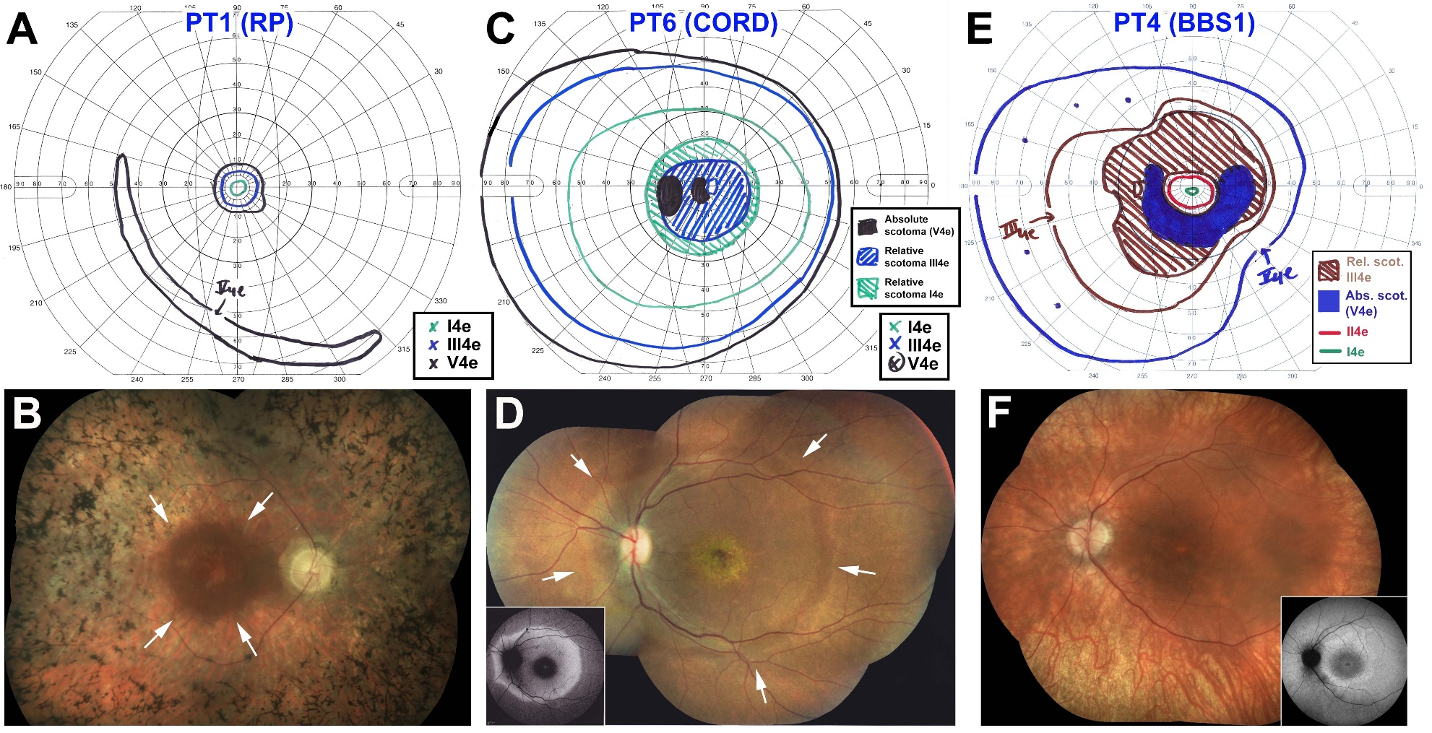
Additional file 1
Figure S1. Examples of visual field and disease patterns included in this study. A. PT1, Example of typical Goldmann visual fields (GVFs) in RP (peripheral field loss). B. Note the small central GVF residue in RP matching closely the area of best RPE/retina preservation (white arrows) visible ophthalmoscopically. C. PT6, Example of typical GVF in CORD (central scotoma of variable density). Note how the density of the scotoma matches closely the area of metallic reflexes seen in D (white arrows) – the inset shows a fundus autofluorescence (FAF) image from the same case, further emphasizing the close match between GVF function loss and the hyper-AF area. E, PT4, Example of GVF in early to mid- stage BBS1 with an essentially full field to the V4e target, a ring scotoma (mostly relative in nature), and a tiny area of central I4e detection. F. The fundus of PT4 is relatively modest in clinical findings, but the FAF image (inset) shows a pericentral ring of hyper-AF and an additional internal (paracentral) ring of hypo-AF, matching closely the edges of the denser part of the ring scotoma and the gap in sensitivity between the III4e target and the I4e target on GVF testing, respectively.

