Supplementary Materials

Role of Short-wavelength Blue Light in the Formation of Cataract and Expression of Caspase-1, Caspase-11 and Gasdermin D in rat Lens Epithelium Cells: Insight into the Novel Pathogenesis of Cataract.
Yamin Wang¹*, Min Zhang¹*, Ying Sun²*, Xiaohui Wang¹, Zhaowei Song¹, Huazhang Li¹, Kexin Liu¹, Zhijian Li^{1†}
1Department of Ophthalmology, First Affiliated Hospital, Harbin Medical University, China
2 Department of Ophthalmology, Second Hospital of Heilongjiang Province, Harbin, China
†Corresponding author: Zhijian Li, Department of Ophthalmology, First Affiliated Hospital, Harbin Medical University. 23 Youzheng Street, Harbin, China. E-mail: lzj6515@sina.com
* These three authors contributed equally in the preparation of this manuscript.

Contents
1. Supplementary materials and methods
2. Supplementary full-length gels and blots in western blots
3.Supplementary tables
- Supplementary Materials and Methods
  - Evaluation of lens clarity The rats were anesthetized at 4, 8, and 12
weeks short-wavelength blue light exposure with 10% chloral hydrate (at a dose of 0.5ml/100g) by i.p. injection. After successful anesthesia, lens clarity changes in all rats were examined by a slit-lamp microscopy (Suzhou 66 Vision Corp., China) biweekly. Lens clarity was subjectively grouped into the following 4 grades: (1) clear, (2) cortical vacuoles, (3) cortical opacities, and (4) total opacity. Evaluations were preceded by mydriasis with 1% tropicamide hydrochloride. In order to prevent cataracts caused by general anesthesia, the rats were dripped with 0.9% Nacl, which was repeated every 10 min until the end of the anesthesia. The experimental environment was maintained at a relatively constant temperature (23°C).

  - Quantitative real-time PCR (qRT-PCR).
Total RNA was isolated using TRIzol Reagent (Invitrogen, Carlsbad, CA, USA) according to the manufacturer’s protocols. Primers were designed with Primer Premier-5 software (Premier Biosoft International, Palo Alto, CA, USA) and are listed in Suppl. Table 1. qRT-PCR was performed with SYBR Green dye (RR820A, TaKaRa, Japan) using an ABI 7500 Fast Real-Time PCR System (Applied Biosystems, Foster City, CA, USA) and fold changes in RNA expression were normalized to glyceraldehyde 3-phosphate dehydrogenase (GAPDH) expression.

  - Western blotting analysis and antibodies.
Western blotting was used to quantify tissue protein expression as previously described ²⁷. The total proteins in the lenses were extracted using a PARI kit (Beyotime, China). Proteins were separated using 10% sodium dodecyl sulfate-polyacrylamide gel electrophoresis (SDS-PAGE), transferred to polyvinylidene difluoride (PVDF) membranes and incubated with a primary mouse anti-caspase-1 antibody (1:500) (Abcam, Cambridge, London, United Kingdom), anti-caspase-11 antibody (1:500) (Novus Biologicals, LLC, USA), anti-DFNA5/GSDMD antibody (1:500) (Abbexa Biotechnology Co., Ltd., United Kingdom), anti-GAPDH antibody (1:1000) (Kangchen Biotechnology Co., Ltd., China) and anti-β-actin antibody (1:1000) (ZSGB Biotechnology Co., Ltd., Beijing, China) at 4°C overnight.

2. Supplementary full-length gels and blots in western blots
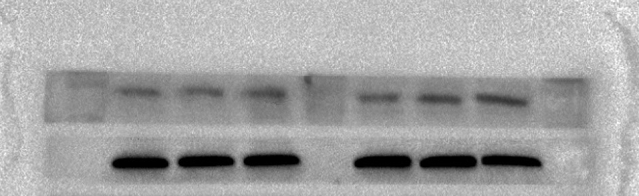
a
b
A

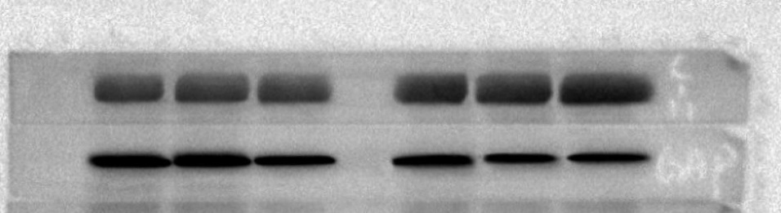
a
b
B

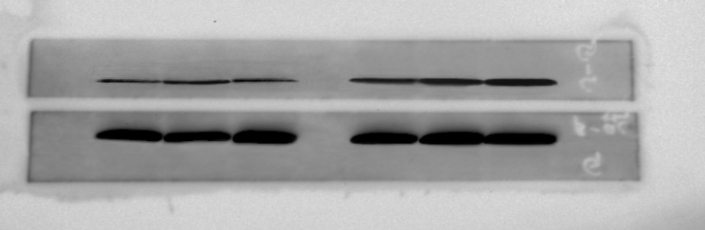
b
a
C
S.1. Full-length gels and blots in western blots
A(a): Cleaved-Caspase-1; A(b): GAPDH. B(a): Cleaved-Caspase-11; B(b): GAPDH. C(a): Cleaved-GSDMD; C(b): ᵦ-actin.

3. Supplementary Table
Supplementary Table 1. DNA sequences of primers used for real-time PCR.
Genes Primers(5’–3’)
Caspase-1:
Forward primer: 5’- TCTTGTGACTTGGAGGAC -3’
Reverse primer: 5’- GTGGTTGGCATCTGTAGT -3’
Caspase-11:
Forward primer: 5’- GCTATGATGTGGTGGTGAA -3’
Reverse primer: 5’- AGGAATGTGCTGTCTGATC -3’
GSDMD:
Forward primer: 5’-CAGCATCCTTGAGTGTCT -3’
Reverse primer: 5’- GAGCCTTAGTAGCCAGTAG-3’
GAPDH:
Forward primer: 5’-AAGTTCAACGGCACAGTCAAG -3’
Reverse primer: 5’-ACATACTCAGCACCAGCATCA-3’
β-actin:
Forward primer: 5’- GAGAGGGAAATCGTGCGTGAC -3’
Reverse primer: 5’- CATCTGCTGGAAGGTGGACA -3’

