Supplemental Online Content for Prevalence of Dry Eye and Meibomian Gland Dysfunction in Central and South America: A Systematic Review and Meta-analysis
Table of contents:

eFigure 1 PRISMA Search Flow Diagram
eFigure 2 Forest plot of dry eye prevalence among population-based studies
eFigure 3 Meta-analysis of dry eye prevalence among student and indoor working populations exposed to sustained computer use
eTable 1 MEDLINE and Embase search strategies
eTable 2 Risk of bias assessments for prevalence studies
eTable 3 Stratified associations with dry eye and meibomian gland dysfunction
eTable 4 Univariable model associations with dry eye and meibomian gland dysfunction
eTable 5 Multivariable model associations with dry eye and meibomian gland dysfunction

Identification of new studies via other methods
Identification of new studies via databases and registers

Records identified from:
Organisations (n = 0)
Practice guidelines (n = 0)
Systematic review citations screening (n = 0)
Citation searching (n = 0)

Records removed before screening:
Duplicate records removed
(n = 2612)

Records identified from:
Databases (n = 13745)
- Ovid Medline (n = 5825)
- Embase (n = 7920)

Identification

Records excluded
- Irrelevant populations (n = 11317)

Records screened
(n = 11333)

Reports not retrieved
(n = 0)
Reports sought for retrieval
(n = 0)

Screening

Reports excluded:
(n = 0)

Reports assessed for eligibility
(n = 0)
Records excluded:
- Ineligible population (n = 1)
- Ineligible outcome (n = 1)

Reports assessed for eligibility
- Total (n = 16)

Included
Total studies included in review
(n = 14)
Reports of total included meta-analysis (n = 8)

eFigure 2 Forest plot of dry eye prevalence among population-based studies
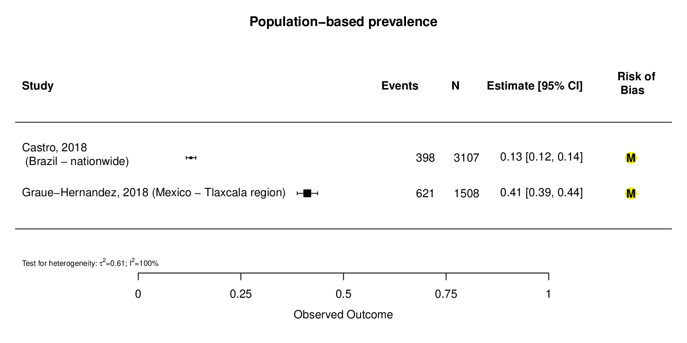
eFigure 3 Meta-analysis of dry eye prevalence among student and indoor working populations exposed to sustained computer use
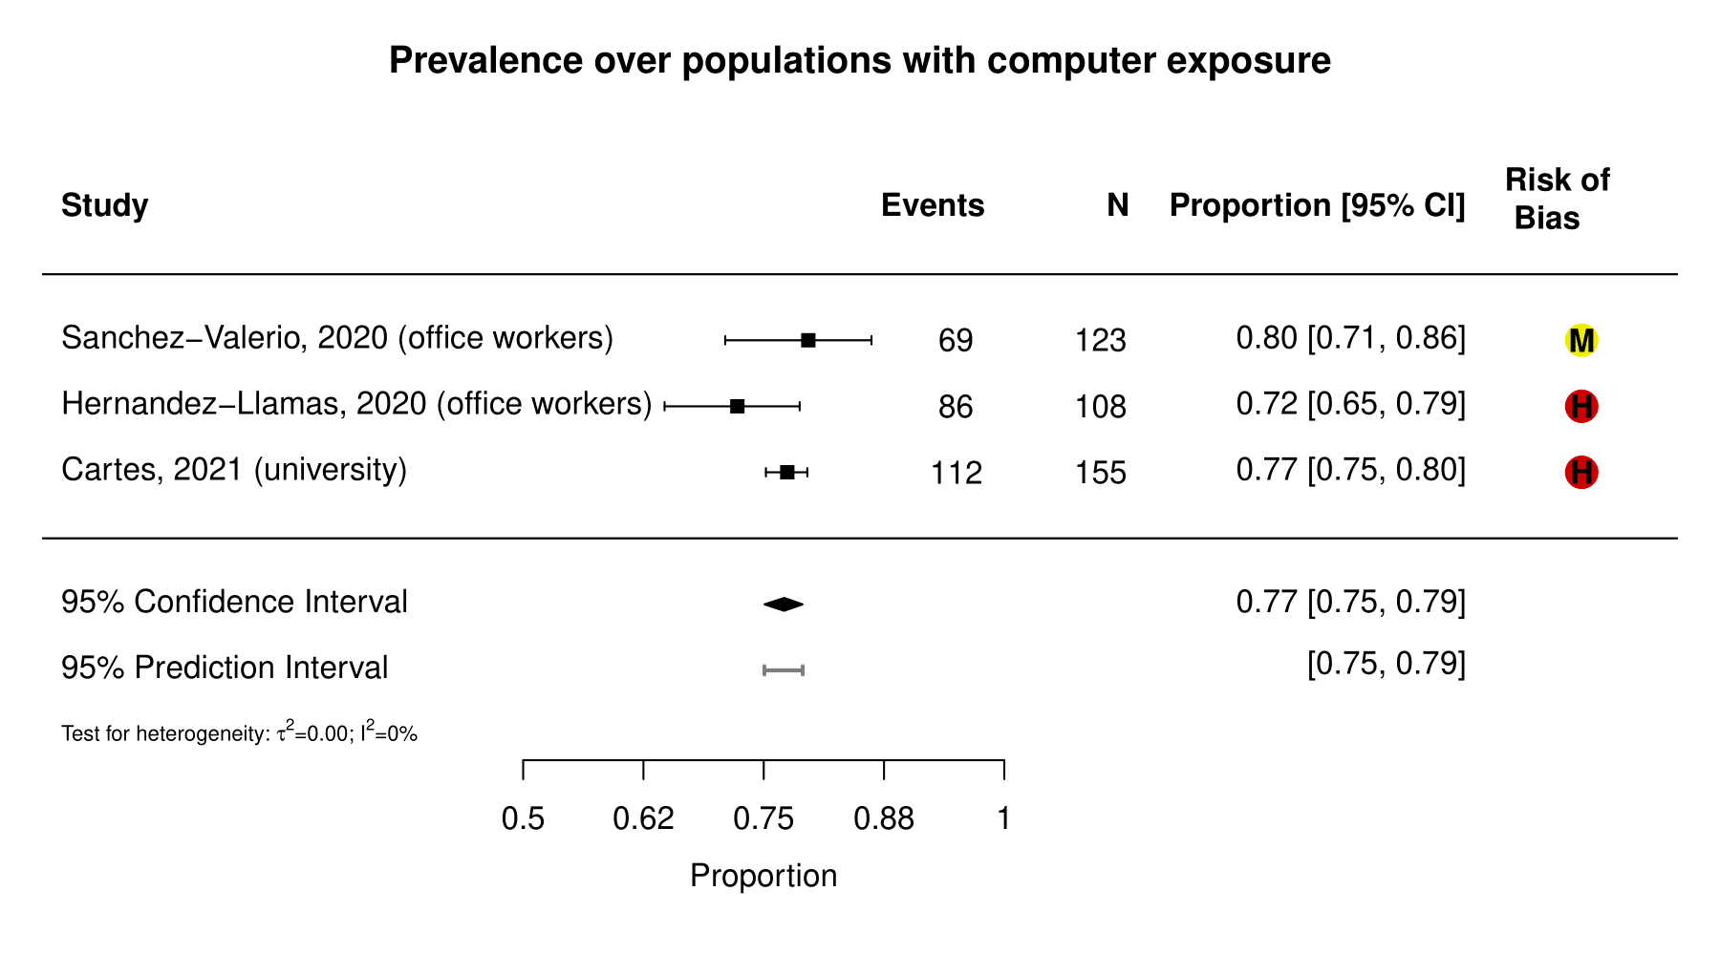

eTable 1 MEDLINE and Embase search strategies
MEDLINE (via Ovid MEDLINE® ALL)
1 exp Dry Eye Syndromes/
2 exp Keratoconjunctivitis Sicca/
3 exp Xerophthalmia/
4 exp Meibomian Glands/
5 (dry* adj3 eye*).tw,kf.
6 ((keratoconjunctivitis or kerato-conjunctivitis) adj1 sicca).tw,kf.
7 xerophthalmi*.tw,kf.
8 meibomian gland dysfunction.tw,kf.
9 exp Sjogren's Syndrome/
10 ((Sjogren* or Sjoegren*) adj1 (syndrom* or disease*)).tw,kf.
11 (9 or 10) and (exp Eye/ or eye*.mp. or ocular*.mp. or ophthalm*.mp.)
12 or/1-8,11
13 exp Epidemiology/
14 exp Epidemiologic Methods/
15 epidemiology.fs.
16 burden of disease.tw,kf.
17 DALY*.tw,kf.
18 death rate*.tw,kf.
19 Disability Adjusted Life Years.tw,kf.
20 disease burden.tw,kf.
21 endemic*.tw,kf.
22 epidemic*.tw,kf.
23 epidemiolog*.tw,kf.
24 frequency.tw,kf.
25 incidence*.tw,kf.
26 morbidities.tw,kf.
27 morbidity.tw,kf.
28 occurrence.tw,kf.
29 outbreak*.tw,kf.
30 prevalence.tw,kf.
31 surveillance.tw,kf.
32 survival rate*.tw,kf.
33 years lived with disability.tw,kf.
34 years of life lost.tw,kf.
35 YLD*.tw,kf.
36 YLL*.tw,kf.
37 or/13-36
38 12 and 37
39 38 NOT (exp animals/ NOT exp humans/)
40 limit 39 to yr="2010 -Current"
Embase (via Elsevier)
#1 'dry eye'/exp
#2 'dry eye syndrome'/exp
#3 'evaporative dry eye disease'/exp
#4 'keratoconjunctivitis sicca'/exp
#5 'xerophthalmia'/exp
#6 'meibomian gland'/exp
#7 (dry* NEAR/3 eye*):ab,ti,kw
#8 ((keratoconjunctivitis or kerato-conjunctivitis) NEAR/1 sicca):ab,ti,kw
#9 xerophthalmi*:ab,ti,kw
#10 'meibomian gland dysfunction':ab,ti,kw
#11 'Sjoegren syndrome'/exp
#12 ((Sjogren* or Sjoegren*) NEAR/1 (syndrom* or disease*)):ab,ti,kw
#13 (#11 OR #12) AND ('eye'/exp OR eye* OR ocular* OR ophthalm*)
#14 #1 OR #2 OR #3 OR #4 OR #5 OR #6 OR #7 OR #8 OR #9 OR #10 OR #13
#15 'epidemiology'/exp
#16 epidemiology:lnk
#17 'burden of disease':ab,ti,kw
#18 DALY*:ab,ti,kw
#19 'death rate*':ab,ti,kw
#20 'Disability Adjusted Life Years':ab,ti,kw
#21 'disease burden':ab,ti,kw
#22 endemic*:ab,ti,kw
#23 epidemic*:ab,ti,kw
#24 epidemiolog*:ab,ti,kw
#25 frequency:ab,ti,kw
#26 incidence*:ab,ti,kw
#27 morbidities:ab,ti,kw
#28 morbidity:ab,ti,kw
#29 occurrence:ab,ti,kw
#30 outbreak*:ab,ti,kw
#31 prevalence:ab,ti,kw
#32 surveillance:ab,ti,kw
#33 'survival rate*':ab,ti,kw
#34 'years lived with disability':ab,ti,kw
#35 'years of life lost':ab,ti,kw
#36 YLD*:ab,ti,kw
#37 YLL*:ab,ti,kw
#38 #15 OR #16 OR #17 OR #18 OR #19 OR #20 OR #21 OR #22 OR #23 OR #24 OR #25 OR #26 OR #27 OR #28 OR #29 OR #30 OR #31 OR #32 OR #33 OR #34 OR #35 OR #36 OR #37
#39 #14 AND #38
#40 #39 NOT ([animals]/lim NOT [humans]/lim)
#41 #40 AND [2010-2021]/py

eTable 2 Risk of bias assessments for prevalence studies
 |  | General population-based studies |  | Working populations |  |  | Student populations |  |  | Hospital- and clinic-based populations
Risk of bias domains | Risk of bias items | Castro, 2018 | Graue-Hernandez, 2018 | Castellanos-Gonzalez, 2016 | Sanchez-Valerio, 2020 | Hernandez-Llamas, 2020 | Garza-Leon, 2016 | Cartes, 2021 | Garza-Leon, 2021 | Skare, 2012 | Martinez JD, 2016 | Garza-Leon, 2017 | da Cruz, 2018 | Surmacz, 2021 | De Freitas, 2021
External validity | Representativeness of target population to national population | N | N | N | N | N | N | N | N | N | N | N | N | N | N
Internal validity | Representativeness of sampling frame to target population | Y | N | Y | N | Y | Y | N | Y | N | Y | N | N | N | N
Sampling bias | Sampling: random or census | Y | Y | Y | N | Y | Y | N | Y | N | N | Y | Y | N | N
Sampling bias | Minimal non-response bias | Y | N | Y | N | N | Y | N | Y | N | Y | Y | N | N | N
Ascertainment bias | Data collected directly from participants | Y | Y | Y | Y | Y | Y | Y | Y | Y | Y | Y | Y | Y | Y
Ascertainment bias | Acceptable case definition | Y | Y | Y | Y | Y | Y | Y | Y | Y | Y | Y | Y | Y | Y
Ascertainment bias | Valid and reliable instrument | Y | Y | Y | Y | Y | Y | Y | Y | Y | Y | Y | Y | Y | Y
Ascertainment bias | Same mode of data collection for all participants | Y | Y | Y | Y | Y | Y | Y | Y | Y | Y | Y | Y | Y | Y
Information bias | Prevalence period appropriate | Y | Y | Y | Y | Y | Y | Y | Y | Y | Y | Y | Y | Y | Y
Information bias | Numerator(s) and denominator(s) appropriate | Y | Y | Y | Y | Y | Y | Y | Y | Y | Y | Y | Y | Y | Y
Overall bias | Overall risk of bias | M | M | M | M | H | M | H | M | H | M | M | H | H | H

eTable 3 Stratified associations with dry eye and meibomian gland dysfunction
Author, Year | Dry eye test used | Sex | Age (years) | Race/  Ethnicity | Severity of dry eye symptoms | Ocular comorbidities | Medical comorbidities | Medication use | Other
Castellanos-Gonzalez, 2016 | OSDI, TBUT <10s, MGD, Oxford | Males:  52%¹  Females:  67%¹ | - | - | OSDI  Mild: 21%  Moderate: 18%  Severe: 17% | (TBUT, Oxford)  Chronic eye disease: 58%, 16%  Contact lenses: 81%, 44%  Refractive surgery: 68%, 14% | (TBUT, Oxford)  Allergies: 66%, 16% | (TBUT, Oxford)  Hormonal contraceptives: 56%, 13% | (TBUT, Oxford)  Residency year  1st: 79%, 33%  2nd: 63%, 17%  3rd: 47%, 15%  4th: 68%, 35%  5th: 32%, 14%  6th: 56%, 11%  7th: 12%, 0%  Smoking: 50%, 24%  Makeup use:  71%, 12%  Microscope use:  68%, 22%
Sanchez-Valerio, 2020 | OSDI | - | - | - | - | - | - | - | Computer exposure time  Mild exposure: 65%  Moderate exposure: 76%  Severe exposure: 92%
Castro, 2018 | Previous clinical dry eye diagnosis or presence of severe dry eye symptoms (WHS questionnaire for DES) | (Total dry eye, severe dry eye)  Males:  9.8%, 3.2%¹  Females:  14.4%, 5.8%¹ | (Total dry eye, severe dry eye)  18-39: 9.9%, 3.1%¹  40-60: 13.2%, 4.9%¹  60+: 21.1%, 10.3%¹ | - | - | (Total dry eye, severe dry eye)  Ocular surgery:  24.1%, 12.5%¹  Contact lens use:  19.4%, 4.8%¹ | (Total dry eye, severe dry eye)  Diabetes:  16.6%, 7.3%¹  Menopause:  23.8%, 11.9%¹  Rheumatologic diseases:  22.4%, 9.1%¹  Cancer treatment:  31.4%, 11.4%¹ | (Total dry eye, severe dry eye) Antidepressants:  24.1%, 9.3%¹  Anti-allergy:  23.9%, 10.3%¹ | (Total dry eye, severe dry eye)  Smoking:  15.5%, 8.3%¹  Computer use >6h/day:  15.7%, 5.4%¹  North region:  11.2%, 3.6%¹  Northeast region:  18.2%, 15.7%¹  Central-west region:  12.8%, 9.3%¹  Southeast region:  11.3%, 8.8%¹  South region:  17.4%, 15.5%¹
Cartes, 2021 | DEQ-5 | Males:  63%¹  Females:  85.4%¹ | - | - | Mild/moderate: 42.8%  Severe: 34.7% | Keratoconus: 87.5%¹  Allergic conjunctivitis: 92.3%¹  LASIK: 87.5%¹  Contact lens use: 91.4%¹ | Hypertension: 91.6%¹  Diabetes mellitus: 70%¹  Thyorid disease: 85.7%¹  Acne: 81.7%¹  Rosacea: 84.6%¹  Rheumatoid arthritis: 66.6%¹  Systemic Erythematosus: 100%¹  Depression: 80.7%¹  Allergies: 16.7%¹ | Antidepressants: 81.4%¹  Oral contraceptives: 15.6%¹  Anti-allergy: 83.6%¹  Isotretinoin: 73.3%¹ | Smoking: 79.1%¹
De Freitas, 2021 | OSDI | - | - | - | Normal: 50%², 60.8%³  Mild: 13.3%₂, 21.7%₃  Moderate: 16.6%², 8.6%³  Severe 20.0%², 8.6%³ | - | Diabetes:  38.3%  Menopause:  89.2%⁴ | Metformin: 82.6%⁴  Insulin: 54.3%⁴ | Smoking: 8.6%⁴
Surmacz, 2021 | Schirmer I without anesthesia  ≤ 5mm (≥1 eye) | Males:  31.8%¹  Females:  50.5%¹ | - | Euro-descent  50%¹  Afro-descent  25.7%¹  Asian  50%¹ | Moderate: 28.1%⁴  Severe: 17.0%⁴ | - | Diabetes mellitus: 50%¹  Hypertension: 60%¹  Dyslipedemia: 50%¹ | - | Ever-smokers: 37.5%¹  Ex-smokers: 50%¹  Never-smokers: 44.9%¹  Categorical BMI  Underweight: 33%¹  Normal: 37%¹  Overweight: 51%¹  Obese: 46.2%¹
Skare, 2012 | Schirmer I without anesthesia  ≤ 10mm (≥1 eye) | N/A (100% female cohort) | - | - | - | - | Pregnant: 17.3%¹  Nonpregnant: 6.6%¹ | - | -
Garza-Leon, 2021 | OSDI | Males:  60.4%¹  Females:  69.3%¹ | - | - | Mild: 18.6%  Moderate: 15.7%  Severe: 31.1% | - | - | - | -
Garza-Leon, 2016 | OSDI | Males:  63.7%¹  Females:  74.8%¹ | - | - | Mild: 19.9%  Moderate: 14.8%  Severe 35.7% | - | - | - | -
Garza-Leon, 2017 | OSDI | Males:  84.2%¹  Females:  88.4%¹ | 18-30: 83.5%  31-40: 82.9%  41-50: 86.5%  51-60: 89.3%  61-70: 86.9%  71-80: 89.7%  81-90: 93.4%  91-100: 100% | - | Mild: 13.6%  Moderate: 13.4%  Severe: 59.6% | - | - | - | -
Graue-Hernandez, 2018 | DEQ-5 | Males:  35.0%¹  Females:  45.3%¹ | - | - | Mild/Moderate: 30.2%  Severe: 11.0% | Normal visual acuity:  38.9%¹  Moderate visual impairment:  59.4%¹  Severe visual impairment/ blindness:  68.6%¹  Cataract surgery:  45.2%¹  Wears glasses:  45.2%¹ | Diabetes mellitus: 43.1%¹  Hypertension: 44%¹ | Antihypertensive:  49.4%¹  Hypoglycemic:  42.9%¹ | Smoking ≥ 10 pack years: 58.4%¹  Smoking < 10 pack years: 46.3%¹  Nonsmokers: 36.1%¹  Current alcohol use: 42.6%¹  Former alcohol use: 45.0%¹  Never alcohol use: 35.1%¹  Less than elementary school education: 41.5%¹  Elementary school or higher: 41.1%¹  Rural: 42.8%¹  Urban: 40.7%¹
Martinez-JD, 2016 | OSDI, DEQ-5, Schirmer's ≤5, TBUT, MGD, corneal staining | Severe DES per OSDI  Female: 44%¹  Male: 42%¹ | DES per  DEQ-5 (not reported for all age ranges)  46-55: 36%  66-75: 18%  76-85: 38% | - | OSDI  Mild/moderate:  35%  Severe: 43%  DEQ-5  Mild: 44%  Severe: 30% | Severe DES per OSDI  Contact lens use: 27.2%¹  Previous surgery:  51.7%¹ | Severe DES per OSDI  Diabetes: 45%¹  Arthritis: 43.8%¹  Thyroid problems: 75%¹  Dry mouth: 65.5%¹  Acne: 55%¹  Depression: 60%¹ | Severe DES per OSDI  Eyedrops: 48%¹  Antihypertensive: 54.7%¹  Antihistamine: 55.6%¹  Diuretics: 33.3%¹  GI ulcer medication: 62.1%¹  Multivitamins: 42.9%¹ | Severe DES per OSDI  indoor occupation:  37.3%¹  Current smoker:  45.5%¹  Air conditioning exposure:  48.3%¹
Hernandez-Llamas, 2020 | OSDI | - | - | - | Construction workers  Mild: 13.4%  Moderate: 9.4%  Severe: 12.8%  Office workers:  Mild: 18.1%  Moderate: 13.5%  Severe: 40.6% | - | - | - | -
n.r.: not reported
1 Among all with the characteristic
2 Among normal controls
3 Among diabetes cases
4 among dry eye cases

eTable 4 Univariable model associations with dry eye and meibomian gland dysfunction
Author, Year | Dry eye test used | Sex  (OR [95% CI]) | Age  (OR [95% CI]) | Ocular comorbidities  (OR [95% CI]) | Medical comorbidities  (OR [95% CI]) | Medication use  (OR [95% CI]) | Other  (OR [95% CI])
Sanchez-Valerio, 2020 | OSDI >12 | - | - | - | - | - | Computer exposure time  TBUT (Spearman's rank correlation test, p<= 0.05)  cumulative hours/total years of work: Rho -0.376, p <0.000  Hours/day: Rho -0.467, p <0.000  Days/week: Rho -0.134, p 0.167  Hours/week: Rho -0.463, p <0.000  Hours/year: Rho -0.463, p <0.000
Castro, 2018 | Previous clinical dry eye diagnosis or presence of severe dry eye symptoms (WHS questionnaire for DES) | Female:  1.49 [1.15- 1.92]¹ | ≥ 40y:  1.47 [1.16-1.87]  ≥60y:  2.02 [1.53-2.66] | Ocular Surgery:  2.31 [1.70-3.13]  Contact Lens use:  1.82 [1.31-2.53] | Diabetes  1.45 [0.99-2.13]  Menopause:  1.92 [1.37-2.68]  Connective Tissue Disorder  1.93 [1.23-3.02]  Cancer Treatment:  3.59 [1.71-7.55] | Antidepressants:  2.21 [1.57-3.09]  Anti-allergy:  2.33 [1.73-3.14] | Smoking:  1.44 [0.83-2.48]  Computer Use >6h:  1.49 [1.16-1.92]
Cartes, 2021 | DEQ-5 >6 | Female:  2.57 [1.97–3.35]¹ | - | Keratoconus:  5.56 [1.27–24.44]  Contact lens use:  1.77 [1.24–2.53] | Depression:  1.57 [0.99–2.48]  Allergies:  1.63 [1.24–2.13] | Isotretinoin:  2.10 [0.86–4.99] | Smoking:  1.32 [0.94–1.84]  Screen exposure (hrs)  1.02 [1.01–1.05]
Surmacz, 2021 | Schirmer I without anesthesia  ≤ 10mm (≥1 eye) | Female  2.1 [1.02-4.6]¹ | 1.04 [1.01-1.06] | - | - | - | -
Garza-Leon, 2021 | OSDI >22 | Female  1.84 [1.37-2.46] | - | Contact lens use:  2.76 [1.44-5.26]  Contact lens type:  RGP 0.69 [0.15-3.09]²  Contact lens use overnight:  1.11 [0.24-5.16] | - | - | -
Garza-Leon, 2016 | OSDI | Female:  1.29 [1.13-1.48] | - | Refractive surgery:  0.82 [0.61, 1.09]  Contact lens use:  1.12 [0.84-1.48] | - | Eyedrop use:  2.00 [1.65-2.4] | Smoking:  1.24 [1.06-1.46]  Hrs in front of computer:  0.82 [0.72-0.93]
Garza-Leon, 2017 | OSDI | Female:  1.17 [1.08-1.28] | 1.32 [1.21-1.43] | - | - | - | Physician specialty³  Ocular inflammatory diseases:  0.44 [0.34-0.57]  Retina:  0.82 [0.67-0.98]  Cornea:  1.01 [0.90-1.14]  Glaucoma:  1.05 [0.90-1.23]
Martinez-JD, 2016 | OSDI, DEQ-5, Schirmer's ≤5, TBUT, MGD, corneal staining | MGD  Male:  1.7 [1.04-2.6] | MGD  1.07 [1.05-1.09] | Contact lens use:  MGD  0.01 [0.02-0.5] | Dry mouth:  OSDI 3.0 [1.6-5.5]  ATD 1.9 [1.02-3.6]  MGD  Arthritis: 7.7 [1.001-59] | OSDI  GI ulcer medication:  2.3 [1.1-5.1]  ATD  Diuretic use:  7.4 [1.3–41]  MGD  Antihypertensive  2.7 [1.3-5.7] | -
Hernandez-Llamas, 2020 | OSDI | Female:  3.82 [2.48-5.91] | - | Contact lens use:  4.67 [1.88-11.57]  Ocular disease significant OR>1 but specific OR and CI not reported | Systemic disease significant OR>1 but specific OR and CI not reported | - | Office workers  4.15 [2.52-6.85]⁴
1 Reference: Male
2 Reference: soft contact lens
3 Reference: anterior segment
4 Reference: construction workers
MGD: International Workshop on Meibomian Gland Dysfunction (2011)

eTable 5 Multivariable model associations with dry eye and meibomian gland dysfunction
Author, Year | Dry eye test used | Sex  (OR [95% CI]) | Age  (OR [95% CI]) | Ocular comorbidities  (OR [95% CI]) | Medical comorbidities  (OR [95% CI]) | Medication use  (OR [95% CI]) | Other  (OR [95% CI])
Castro, 2018 | Previous clinical dry eye diagnosis or presence of severe dry eye symptoms (WHS questionnaire for DES) | Female:  1.47 [1.12-1.93] | ≥60y:  2.00 [1.44-2.77] | Ocular Surgery:  1.84 [1.30-2.60]  Contact Lens use:  1.93 [1.36-2.73] | Cancer treatment:  3.03 [1.39-6.59] | Antidepressants:  1.61 [1.12-2.31]  Anti-allergy:  2.11 [1.54-2.89] | Computer use >6h:  1.77 [1.36-2.31]
Cartes, 2021 | VDT-related symptoms aggregate score | Female:  3.38 [2.72–4.04] | - | - | - | Anti-allergy:  1.96 [1.15–2.79] | Screen exposure (hrs):  0.15 [0.09–0.20]
Garza-Leon, 2021 | OSDI >22 | Female  4.71[1.10-20.17] | - | Contact lens use:  2.61 [1.36-5.01]  Contact lens type:  RGP 0.90 [0.34-2.443]²  Contact lens use overnight:  0.98 [0.19-5.07] | - | - | -
Graue-Hernandez, 2018 | DEQ-5 | Female:  2.26 [1.70-3.00] | - | - | - | Antihypertensive:  1.29 [1.00-1.65] | Smoking ≥ 10 pack years: 2.29 [1.44-3.63]  Smoking < 10 pack years: 1.40 [1.05-1.87]  Ever alcohol use:  1.31 [1.02-1.70]
Martinez-JD, 2016 | OSDI, DEQ-5, Schirmer's ≤5, TBUT, MGD, corneal staining | - | Older age significant association with MGD [n.r.] | Contact lens use significant association with lower MGD [n.r.] | Dry mouth significant association with severe DE symptoms per OSDI [n.r.] | GI ulcer medication significant association with severe DE symptoms per OSDI [n.r.] | -
Hernandez-Llamas, 2020 | OSDI | - | - | Ocular disease significant OR>1 but specific OR and CI not reported | Systemic disease significant OR>1 but specific OR and CI not reported | - | -
1 Reference: Male
2 Reference: soft contact lens

