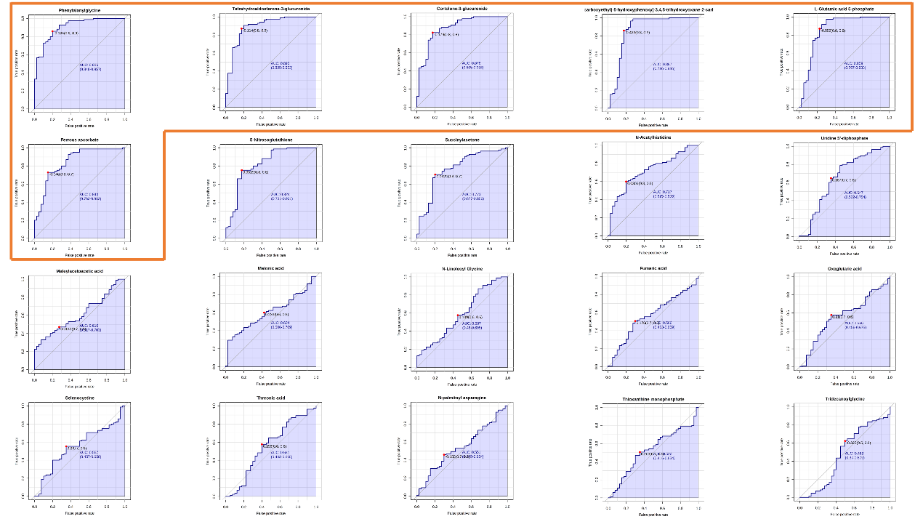
Figure S1. ROC curves for all differential metabolites. The red boxes indicate the differential metabolites in the top 6 AUC values, which were used as six candidate metabolites for DR diagnostic markers

Table S1 Liquid phase conditions
Instrument model | Thermo Scientific Vanquish ultra-high performance liquid chromatograph
Column | ACQUITY UPLC® HSS T3, 1.8 µm, 2.1×100 mm
mobile phase | mobile phase B: ACN  Mobile phase A: H₂O + 0.1% FA (volume fraction)  Column temperature: 35℃  Flow rate: 0.35 mL/min  Sample volume : 10 µL  Gradient elution as specified in the table below:
Time (min) | Mobile phase A (％) | Mobile phase B (％)
0.0 | 98 | 2
0.5 | 98 | 2
1.5 | 80 | 20
4.0 | 35 | 65
11.0 | 5 | 95
15.0 | 5 | 95
15.1 | 98 | 2
20.0 | 98 | 2

Table S2 Mass spectrometry conditions
Instrument Model | Quadrupole/electrostatic field orbit trap high-resolution mass spectrometer  Q-Exactive
Ionization mode | ES+/-
Capillary temperature (°C) | 320
Spray voltage (V) | 3.7k (+) 3.0(-)
Auxiliary gas heater temperature (°C) | 350
Capillary (kV) | 3.0
S-lens RF level | 60
Sheath gas flow rate (Arb) | 35
Auxiliary gas flow rate (Arb) | 10

Table S3 Mass spectrometry acquisition methods
Ionization mode | Full MS/dd-MS² (Top N)
General
Runtime | 0–20 min
Polarity | Positive/negative
Default charge state | 1
Full MS
Resolution |  | 70,000
AGC target |  | 1e⁶
Maximum IT |  | 100 ms
Scan range |  | 70–1000 m/z
dd-MS²
Resolution |  | 17,500
AGC target |  | 1e⁵
Maximum IT |  | 50 ms
Loop count |  | 10
TopN |  | 10
Isolation window |  | 1.5 m/z
（N）CE/stepped NCE |  | 20, 40, 60
dd Settings
Minimum AGC target |  | 8.00 e³
Apex trigger |  | 4–8s
Exclude isotopes |  | on
Dynamic exclusion |  | 10.0 s

