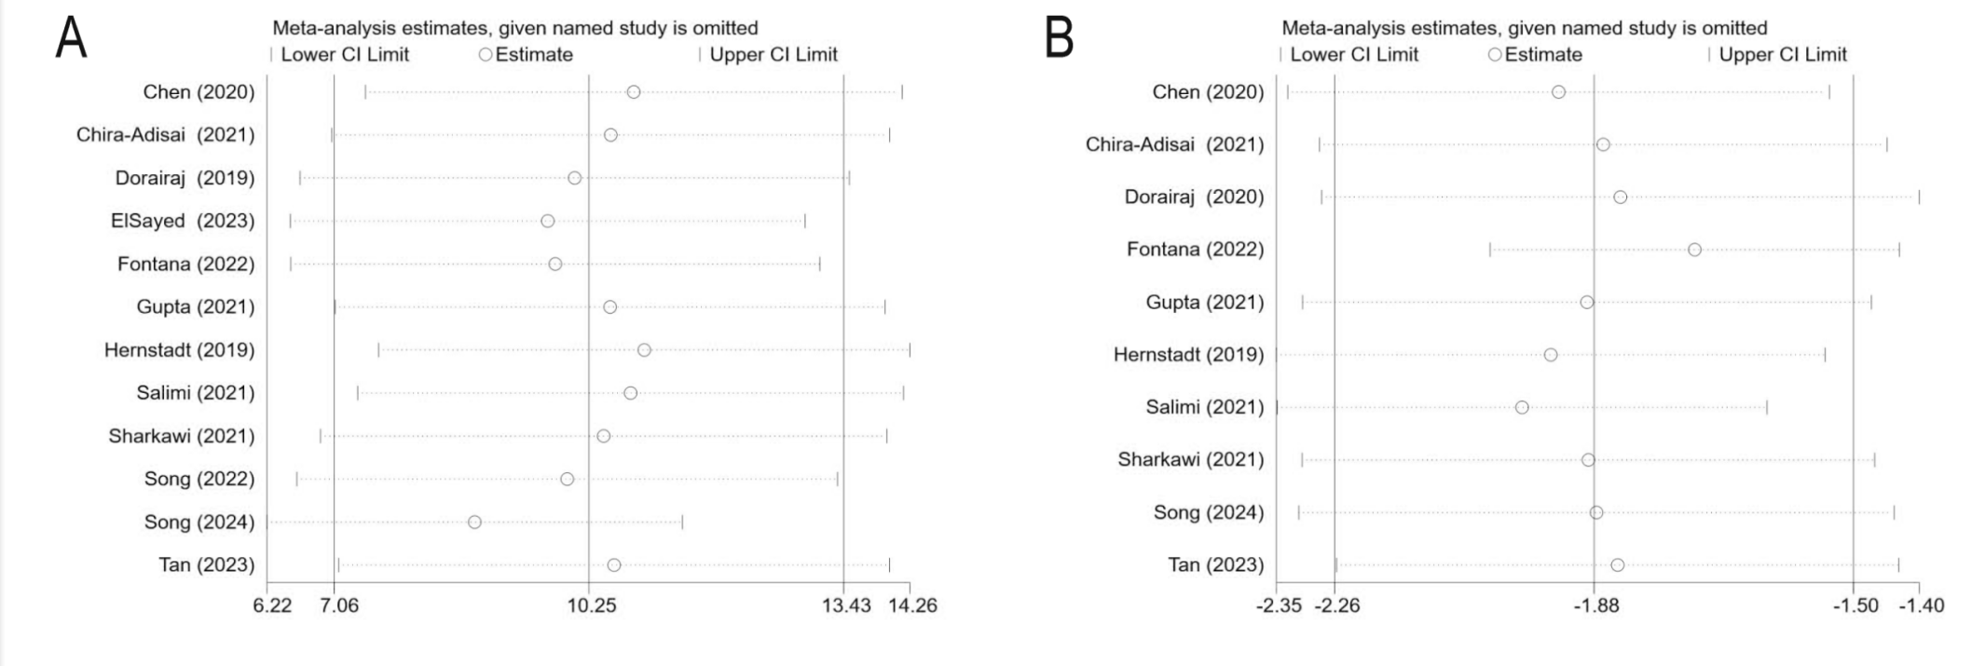
Figure S1. Leave-one-out sensitivity analysis. (A) Sensitivity analysis of IOP changes 12 months postoperatively; (B) Sensitivity analysis of AGMs changes 12 months postoperatively; AGM: anti-glaucoma medication; IOP: intraocular pressure.

