Table S1 Results of balance diagnosis
Variable | Type | SMD (after weighting)
Age (years) | Continuous | -0.007
Gender (Male vs Female) | Binary | 0.007
Axial length (mm) | Continuous | -0.062
Lens nucleus hardness
Grade II | Binary | -0.025
Grade III | Binary | -0.005
Grade IV | Binary | 0.008
Grade V | Binary | 0.022
ECD (cells/mm²) | Continuous | -0.017
BCVA_pre (logMAR) | Continuous | -0.013
IOP_pre (mmHg) | Continuous | 0.014

Table S2 Association between surgical methods with outcome in sensitivity analysis
Variable | β | SE | 95% CI | P
Group
CPS | Reference
FLACS | -0.169 | 0.098 | -0.365, 0.027 | 0.090
BCVA_pre (logMAR) | 0.320 | 0.101 | 0.119, 0.521 | 0.002
Age (years) | -0.013 | 0.007 | -0.026, 0.001 | 0.067
Gender
Female | Reference
Male | -0.043 | 0.117 | -0.277, 0.191 | 0.714
Axial length (mm) | -0.014 | 0.021 | -0.056, 0.028 | 0.498
ECD (cells/mm²) | 0.00034 | 0.00014 | 0.00006, 0.00063 | 0.017
IOP_pre (mmHg) | 0.01 | 0.02 | -0.030, 0.049 | 0.619
Lens nucleus hardness
Grade II | Reference
Grade III | 0.201 | 0.173 | -0.144, 0.546 | 0.250
Grade IV | 0.281 | 0.218 | -0.155, 0.716 | 0.203
Grade V | -0.070 | 0.157 | -0.385, 0.244 | 0.657
Time since PPV | -0.002 | 0.03 | -0.062, 0.058 | 0.941
Silicone oil history
No | Reference
Yes | -0.094 | 0.221 | -0.537, 0.348 | 0.672

Table S3 BCVA (logMAR) group×time contrasts: estimated marginal mean differences (FLACS−CPS) with 95% CIs
Time Point | β | SE | 95% CI | t | P
Pre-op | -0.0563 | 0.119 | -0.292 – 0.1796 | -0.473 | 0.6373
Post-op 1d | -0.2911 | 0.119 | -0.527 – -0.0553 | -2.445 | 0.016
Post-op 1w | -0.2161 | 0.119 | -0.452 – 0.0197 | -1.815 | 0.0721
Post-op 1m | -0.1813 | 0.119 | -0.417 – 0.0546 | -1.522 | 0.1306
Post-op 3m | -0.1578 | 0.119 | -0.394 – 0.0781 | -1.325 | 0.1877
Per-time-point tests are exploratory and unadjusted for multiplicity; primary inference relies on Type III omnibus tests.

Table S4 IOP group×time contrasts: estimated marginal mean differences (FLACS−CPS) with 95% CIs
Time Point | β | SE | 95% CI | t | P
Pre-op | -0.336 | 0.933 | [-2.179, 1.510] | -0.36 | 0.7194
Post-op 1d | -0.832 | 0.933 | [-2.675, 1.010] | -0.892 | 0.3739
Post-op 1w | 1.729 | 0.933 | [-0.114, 3.570] | 1.852 | 0.0658
Post-op 1m | 0.05 | 0.933 | [-1.793, 1.890] | 0.053 | 0.9576
Post-op 3m | -0.723 | 0.933 | [-2.566, 1.120] | -0.775 | 0.4396
Per-time-point tests are exploratory and unadjusted for multiplicity; primary inference relies on Type III omnibus tests.

Table S5 Sensitivity analysis in Linear mixed-effects model for longitudinal BCVA
Variable | β | SE | t | P
(Intercept) | 0.8360 | 0.9376 | 0.8917 | 0.8360
Group
CPS
FLACS | -0.0035 | 0.1242 | -0.0285 | -0.0035
Time
pre
time1d | -0.6167 | 0.0643 | -9.5831 | <0.001
time1w | -0.7976 | 0.0643 | -12.3952 | <0.001
time1m | -0.9048 | 0.0643 | -14.0602 | <0.001
time3m | -0.9500 | 0.0643 | -14.7632 | <0.001
Age | -0.0092 | 0.0058 | -1.5910 | 0.1167
Gender
Female
Male | -0.1272 | 0.1124 | -1.1313 | 0.2623
Axial length | 0.0134 | 0.0268 | 0.4994 | 0.6193
Lens nucleus hardness
Grade II
Grade III | 0.2125 | 0.1621 | 1.3108 | 0.1948
Grade IV | 0.3264 | 0.1816 | 1.7967 | 0.0773
Grade V | 0.1039 | 0.2012 | 0.5163 | 0.6075
ECD | 0.0003 | 0.0002 | 1.6980 | 0.0945
IOP_pre | 0.0067 | 0.0175 | 0.3863 | 0.7006
Interaction
FLACS × time1d | -0.2633 | 0.0997 | -2.6415 | 0.0087
FLACS × time1w | -0.1924 | 0.0997 | -1.9298 | 0.0546
FLACS × time1m | -0.1619 | 0.0997 | -1.6241 | 0.1055
FLACS × time3m | -0.1333 | 0.0997 | -1.3370 | 0.1821

Table S6 Sensitivity analysis in Linear mixed-effects model for longitudinal IOP
Variable | β | SE | t | P
(Intercept) | 11.038 | 6.521 | 1.693 | 0.096
Group
CPS
FLACS | -0.496 | 0.974 | -0.509 | 0.611
Time
pre
time1d | 0.726 | 0.635 | 1.143 | 0.254
time1w | 0.736 | 0.635 | 1.158 | 0.248
time1m | -0.679 | 0.635 | -1.068 | 0.287
time3m | -0.517 | 0.635 | -0.813 | 0.417
Age | -0.038 | 0.040 | -0.956 | 0.343
Gender
Female
Male | 1.090 | 0.758 | 1.438 | 0.155
Axial length | 0.274 | 0.186 | 1.472 | 0.146
Lens nucleus hardness
Grade II
Grade III | 0.602 | 1.134 | 0.531 | 0.598
Grade IV | 2.667 | 1.203 | 2.216 | 0.030
Grade V | 1.641 | 1.380 | 1.189 | 0.239
ECD | -0.001 | 0.001 | -1.053 | 0.296
Pre-op BCVA | 0.172 | 0.905 | 0.190 | 0.850
Interaction
FLACS × time1d | -0.493 | 0.984 | -0.501 | 0.617
FLACS × time1w | 2.084 | 0.984 | 2.117 | 0.035
FLACS × time1m | 0.332 | 0.984 | 0.337 | 0.736
FLACS × time3m | -0.357 | 0.984 | -0.362 | 0.717

Table S7 Overall Nd:YAG capsulotomy by follow-up window
Time window | Nd:YAG cumulative, n/N | Cumulative incidence (%) | 95% CI (Wilson) | Notes
Month-1 (≈30 days) | 5/77 | 6.5% | 2.8% to 14.3% | 5 eyes underwent Nd:YAG at the 1-month visit.
Month-3 (≈90 days) | 8/77 | 10.4% | 5.4% to 19.2% | 3 additional eyes underwent Nd:YAG by the 3-month visit.
Values are cumulative incidences with Wilson 95% CIs. Nd:YAG was recorded at scheduled visits; exact per-eye dates were not available. Group totals are presented in Table 8.

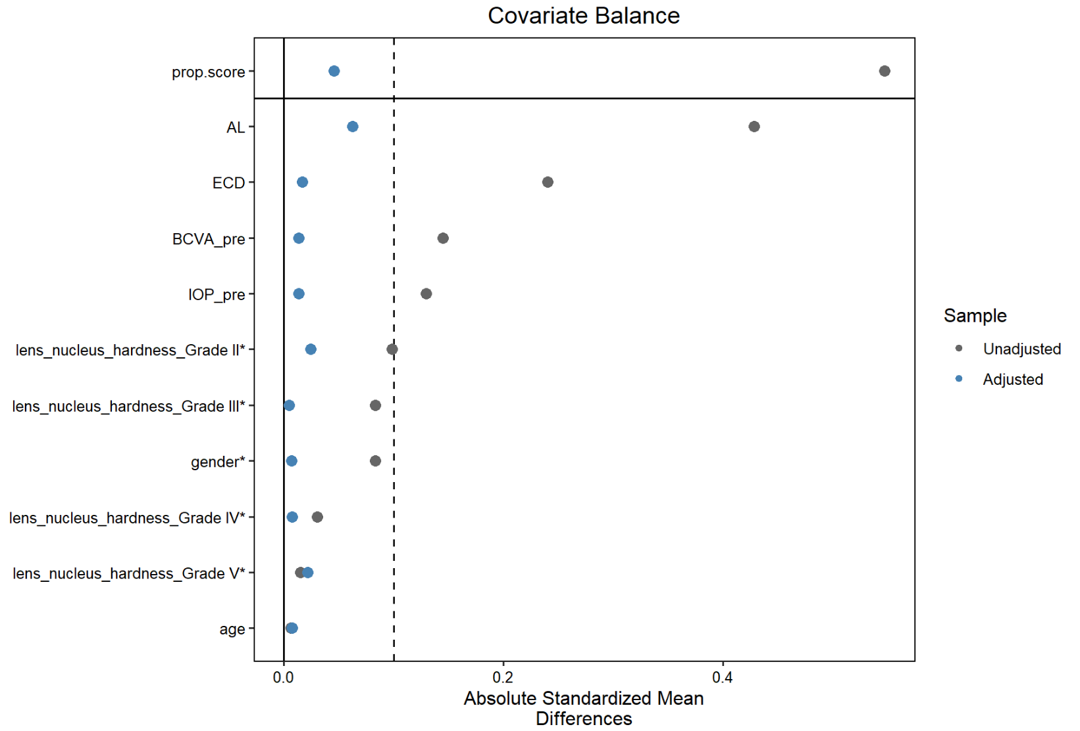
Figure S1 Covariate balance results(ESS = 71)

