Appendix I: Summary of findings:
[atropine 0.05% eye drop] compared to [placebo] for [controlling myopia progression]
Patient or population: [school children]
Setting: hospital
Intervention: atropine 0.05% eye drop]
Comparison: [placebo]
Outcomes | Anticipated absolute effects*(95% CI) |  | Relative effect  (95% CI) | № of participants  (studies) | Certainty of the evidence  (GRADE) | Comments
Outcomes | Risk with [comparison] | Risk with [intervention]
spherical equivalent change (SE)  assessed with: diopters  follow-up: mean 1 years | - | SMD 1.26 SD lower  (0.69 higher to 1.84 higher) | - | 1967  (11 RCTs) | ⨁⨁⨁◯  Moderate^{a,b} | this effect size showed that atropine 0.05% may control the myopia progression significantly
axial length change (AL)  assessed with: mm  follow-up: mean 1 years | - | SMD 0.89 SD lower  (1.07 lower to 0.7 lower) | - | 1796  (9 RCTs) | ⨁⨁⨁◯  Moderateª | [intervention] probably reduces axial length change.
*The risk in the intervention group (and its 95% confidence interval) is based on the assumed risk in the comparison group and the relative effect of the intervention (and its 95% CI).
CI: confidence interval; SMD: standardised mean difference
GRADE Working Group grades of evidence
High certainty: we are very confident that the true effect lies close to that of the estimate of the effect.
Moderate certainty: we are moderately confident in the effect estimate: the true effect is likely to be close to the estimate of the effect, but there is a possibility that it is substantially different.
Low certainty: our confidence in the effect estimate is limited: the true effect may be substantially different from the estimate of the effect.
Very low certainty: we have very little confidence in the effect estimate: the true effect is likely to be substantially different from the estimate of effect.
Explanations a. high heterogeneity noticed between studies b. large confidence interval specially in the non-Asian studies

Appendix II: Studies excluded on title and abstract screening

Akagun N, Altiparmak E. Evaluating combination therapies for myopia control: Insights from a retrospective studyâcombining atropine %0.05 with peripheric defocus progressive addition lenses. Actaophthalmologica (Oxford, England) [Internet]. 2025;103(S284):n/a-n/a. Available from: https://go.exlibris.link/zM72n099

AkagÃ¼n N, AltÄ±parmak UE. Combination therapy with Atropine 0.05% and Myopi-XÂ® glasses: is it effective in myopia control? Turkish Journal of Ophthalmology. 2025;55(1):1.

Akdemir SC, AkalÄ±n I, GÃ¼nay BÃ. One-Year Results of 0.01% and 0.05% Atropine Eye Drops in Childhood Myopia Progression. Journal of pediatric ophthalmology and strabismus [Internet]. 2025;62(4):297–302. Available from: https://go.exlibris.link/cP3rSJ5T

Breliant RE, Pang Y, Bandstra A, Kattouf V. Effect of Low-dose Atropine on Binocular Vision and Accommodation in Children Aged 6 to 17 Years. Optometry and vision science [Internet]. 2023;100(8):550–6. Available from: https://go.exlibris.link/0yFY4rYH

Brennan NA, Nixon AD, Cheng X, Bullimore MA. Can we really distinguish “responders” from “non-responders” to myopia control interventions? Ophthalmic Physiol Opt. 2024;44(7):1363–7.

Cho H, Seo Y, Han S-H, Han J. Factors Related to Axial Length Elongation in Myopic Children Who Received 0.05% Atropine Treatment. Journal of ocular pharmacology and therapeutics [Internet]. 2022;38(10):703–8. Available from: https://go.exlibris.link/qdr37yGq

Erdinest N, London N, Lavy I, Landau D, Ben Ephraim Noyman D, Levinger N, et al. Low-concentration atropine monotherapy vs. combined with MiSight1 day contact lenses for myopia management. Vision. 2022;6(4):73.

Farooq N, Aadil N, Mazhar SA, Ghauri H, Nawaz R, Ullah MZ. A Comparative Study to Assess the Effect of Low Dose Atropine Eye Drops in Slowing Myopia Progression. Ophthalmology Update. 2021;19(3).

Gogate P. Atropine 0.05% for rapid progressive childhood myopia. Indian Journal of Ophthalmology. 2025;73(7):1075.

Hou P, Wu D, Nie Y, Wei H, Liu L, Yang G. Comparison of the efficacy and safety of different doses of atropine for myopic control in children: a meta-analysis. Frontiers in pharmacology [Internet]. 2023;14:1227787. Available from: https://go.exlibris.link/slvrz67Y

Jason Y, Zhang X, Zhang Y, Kam KW, Tang F, Ling X, et al. Five-Year Clinical Trial of Low-concentration Atropine for Myopia Progression (LAMP) Study: Phase 4 Report. Investigative Ophthalmology &amp; Visual Science. 2024;65(7):426–426.

Jiang H, Liu Y. Meta-analysis of low-concentration atropine eye drops for the management of myopia: Evaluating the limit of 0.05 % concentration. Asian journal of surgery [Internet]. 2025;48(2):1446–9. Available from: https://go.exlibris.link/g6V8Nbw0

Khalid N, Ahmad CN, Muslim I, Javed K, Basit A. Effectiveness 0.05% Atropine for Controlling Myopia Progression in School Going Children: Doi: 10.36351/pjo.v39i4.1608. Pakistan journal of ophthalmolog (Norton, Va) [Internet]. 2023;39(4). Available from: https://go.exlibris.link/p307VS2R

KobiaâAcquah E, Lingham G, Flitcroft DI, Loughman J. Twoâyear changes of macular choroidal thickness in response to 0.01% atropine eye drops: Results from the myopia outcome study of atropine in children (MOSAIC) clinical trial. ActaOphthalmologica. 2024;

Lee J-J, Fang P-C, Yang IH, Chen C-H, Lin P-W, Lin S-A, et al. Prevention of Myopia Progression with 0.05% Atropine Solution. Journal of ocular pharmacology and therapeutics [Internet]. 2006;22(1):41–6. Available from: https://go.exlibris.link/FJpTx6QJ

Li FF, Yam JC. Low-Concentration Atropine Eye Drops for Myopia Progression. Asia-Pacific journal of ophthalmology (Philadelphia, Pa) [Internet]. 2019;8(5):360–5. Available from: https://go.exlibris.link/DGWdLKvZ

Li FF, Zhang Y, Zhang X, Yip BHK, Tang SM, Kam KW, et al. Age Effect on Treatment Responses to 0.05%, 0.025%, and 0.01% Atropine: Low-Concentration Atropine for Myopia Progression Study. Ophthalmology. 2021;128(8):1180–7.

Li W, Cao Y, Zhou J. Effects of low-concentration atropine eye drops on the optical quality of the eyes in myopic children. Indian Journal of Ophthalmology [Internet]. 2022;70(6):2107–10. Available from: https://go.exlibris.link/GYqfwxjx

Li Y, Zhang XJ, Zhang Y, Tham CC, Pang CC, Yam JC. Effect of 0.01%, 0.025%, and 0.05% Atropine Eye Drops on Peripapillary Gamma Zone Changes. Investigative Ophthalmology &amp; Visual Science. 2025;66(8):5897–5897.

McCrann S, Flitcroft I, Strang NC, Saunders KJ, Logan NS, Lee SS, et al. Myopia Outcome Study of Atropine in Children (MOSAIC): an investigator-led, double-masked, placebo-controlled, randomised clinical trial protocol. HRB Open Research. 2019;2:15.

Nathania S, Jutamulia J, Badruddin GH. Assessing Low-Concentration Atropine in Myopia Progression: A Systematic Review. Siriraj Medical Journal [Internet]. 2023;75(12). Available from: https://go.exlibris.link/mgLyksmB

Neena R, Nasheetha A, Prakash N, Giridhar A. Atropine in myopiaâ“Does it reduce progression? Results of Phase 1 clinical trial in children attending a tertiary eye care center in South India. Kerala Journal of Ophthalmology. 2022;34(1):21–6.

Parida S, Das M, Dash S, Chakraborty S, Mohanty S, Dash S, et al. Effect of Low-Dose Atropine on Choroidal Thickness in Children With Myopia Progression. Cureus. 2025;17(7).

Ruan Y, Qian L, Chen S. Effect of combined use of orthokeratology and atropine eye drops on correction of myopia in young children, and its influencing factors. Tropical journal of pharmaceutical research [Internet]. 2023;21(11):2479–85. Available from: https://go.exlibris.link/QLDw6z87

Sankaridurg P, Tran HD. The lowdown on low-concentration atropine for myopia progression. Ophthalmology. 2019;126(1):125–6.

Santos-Neto E dos, Dantas DO, Amaral DC, Castro Neto FC de, Louzada RN, Alves MR. Changes in accommodation and vergence parameters with topical use of 0.025% and 0.05% atropine in myopes aged between 7 and 17 years. Eye (London) [Internet]. 2025; Available from: https://go.exlibris.link/FxJ3hFm2

Surachatkumtonekul T, Jutasompakorn P, Wiriyaudomchart S, Hokierti K, Sri-in J. Efficacy of Atropine Eye Drops for Suppressing Myopia Progression in Thai Children. Siriraj Medical Journal [Internet]. 2023;75(11). Available from: https://go.exlibris.link/yv2SY7xN

Tariq F, Mobeen R, Wang X, Lin X, Bao Q, Liu J, et al. Advances in myopia prevention strategies for school-aged children: a comprehensive review. Frontiers in public health [Internet]. 2023;11:1226438. Available from: https://go.exlibris.link/lmgZKxNN

Usmani E, Callisto S, Chan WO, Taranath D. Realâworld outcomes of lowâdose atropine therapy on myopia progression in an Australian cohort during the COVID â19 pandemic. Clinical &amp; experimental ophthalmology [Internet]. 2023;51(8):775–80. Available from: https://go.exlibris.link/SdBW2696

Wang J-D, Liu M-R, Chen C-X, Cao K, Zhang Y, Zhu X-H, et al. Effects of atropine eyedrops at ten different concentrations for myopia control in children: A systematic review on meta-analysis. European journal of ophthalmology [Internet]. 2024;34(5):1355–64. Available from: https://go.exlibris.link/BMZpqM9z

Wei S, Li S-M, An W, Du J, Liang X, Sun Y, et al. Safety and efficacy of low-dose atropine eyedrops for the treatment of myopia progression in Chinese children: a randomized clinical trial. JAMA ophthalmology. 2020;138(11):1178–84.

Wen L, Liu H, Xu Q, Pan W, Lin Z, Xiao Z, et al. Add-on effect of using 0.05% atropine in fast progressors of orthokeratology: A preliminary retrospective study. Contact Lens and Anterior Eye. 2025;48(1):102282.

Wu P-C, Yang Y-H, Fang P-C. The Long-Term Results of Using Low-Concentration Atropine Eye Drops for Controlling Myopia Progression in Schoolchildren. Journal of ocular pharmacology and therapeutics [Internet]. 2011;27(5):461–6. Available from: https://go.exlibris.link/4JHVW9NM

Xu D, Wang Y, Ai L, Feng B, Yang Z, Li F. Efficacy and Safety Analysis of 0.01% and 0.05% Atropine Combined with OK Lens in Children with Progressive Myopia. 2025;

Xu S, Li Z, Zhao W, Zheng B, Jiang J, Ye G, et al. Effect of atropine, orthokeratology and combined treatments for myopia control: a 2-year stratified randomised clinical trial. British Journal of Ophthalmology. 2023;107(12):1812–7.

Yam JC, Zhang XJ, Zhang Y, Yip BHK, Tang F, Wong ES, et al. Effect of Low-Concentration Atropine Eyedrops vs Placebo on Myopia Incidence in Children: The LAMP2 Randomized Clinical Trial. JAMA: the journal of the American Medical Association [Internet]. 2023;329(6):472–81. Available from: https://go.exlibris.link/gBzQKh2H

Yum HR, Han SY, Park SH, Shin SY. Synergistic Effect of Dual-Focus Soft Contact Lenses and 0.05% Atropine on Myopia Control in Children with Rapidly Progressing Myopia. Eye &amp; Contact Lens [Internet]. 2025;51(2):92–7. Available from: https://go.exlibris.link/GH38PMxw

Zhang H, Yang P, Li Y, Zhang W, Li S. Effect of low-concentration atropine eye drops in controlling the progression of myopia in children: a one-and two-year follow-up study. Ophthalmic epidemiology. 2024;31(3):240–8.

Zhou P, Wang D-D, Fan L, Yang L, Zhao M-W. Comparing the Efficacy of Low-Dose Atropine Eye Drops, Orthokeratology, and Combined Treatment for Myopia Progression Control. 2023;

APPENDIX III: a forest plot on the effect of atropine 0.05% eye drop Vs placebo using mean difference
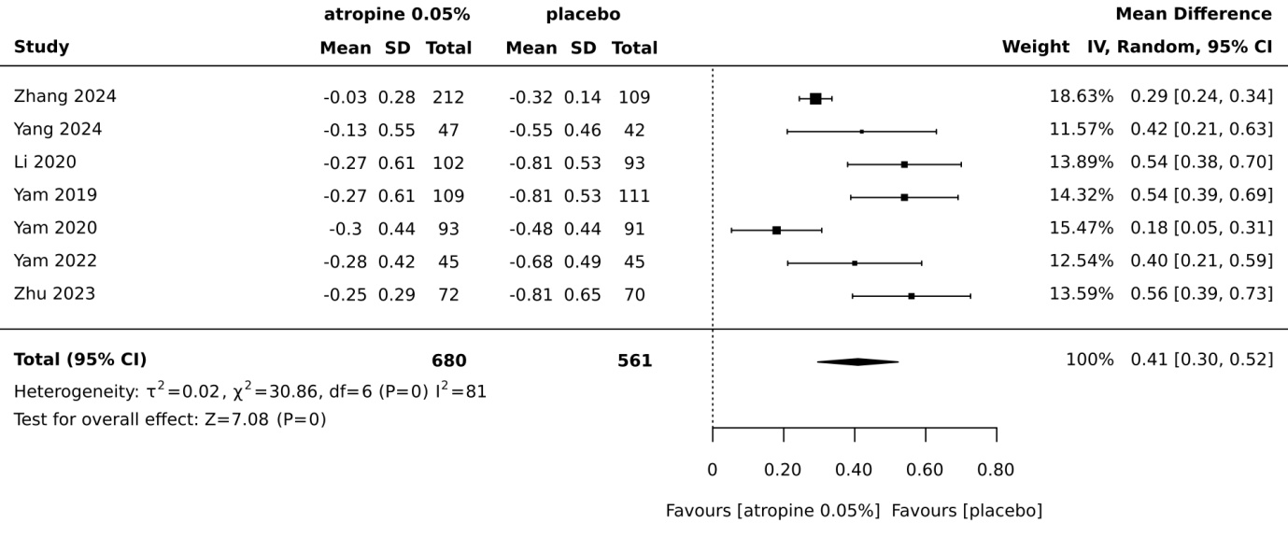

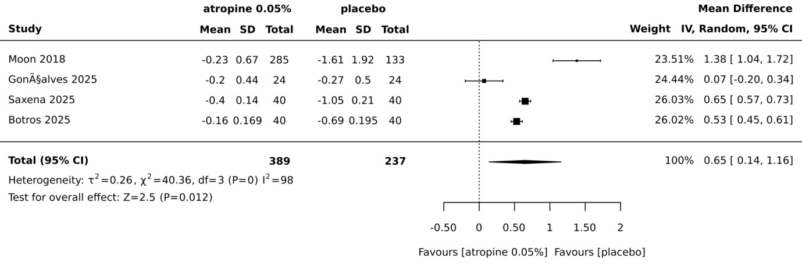

Appendix IV: Characteristics of Included Studies

Table: Characteristics of Included Studies - Randomized Controlled Trial Form

Study | Country | Setting | Participant characteristics | Groups | Outcomes measured | Description of main results
Saxena R, Gupta V, Thakur H, Dhiman R, Velpandian T, Phuljhele S, et al. 2025. | India | hospital | school age children(6-12years) | forty children with a spherical diptoric power from-2.00 to -6.00Ds and more than 0.75Ds myopia progression | SE and AL mean change | the mean myopia progression and axial elongation in comparing before and after treatment within the same group of children
Zhang H, Yang P, Li Y, Zhang W, Li S. 2024. | China | school and hospital | schoolchildren aged 6 to 12 years old who had mild to moderate myopia, defined as objective spherical equivalence (SE) and binocular astigmatism between −1.00 to −6.00 D, and astigmatism ≤ 1.50 D | 424 children grouped with atropine treatment group and placebo group | SE and AL mean change | the effect of atropine on myopia progression and axial length change
Moon J-S, Shin SY. 2018. | south Korea | hospital | children 5-14years old with spherical equivalent upto -6.00Ds | 285 children in four groups with three different concentrations of diluted atropine (0.01%,0.025% and 0.05%) compared with before treatment | SE and AL mean change | the effect of the three concentrations of atropine eye drops on slowing the myopia progression
Botros MM, Sultan MA, Seif BS, Aboud SAM. 2025. | Egypt | hospital | 6 to 15 years old myopic children with mean age of 11.4 years | four groups with different dose of treatment and placebo | SE and AL mean change | the effect of 0.015, 0.025% and 0.05% eye drop on myopic refractive change compared with placebo
Zhu Q, Tang G-Y, Hua Z-J, Xue L-P, Zhou Y, Zhang J-Y, et al. 2023. | China | hospital | school children with 7 to 12 years old | The 142 participants completed the 3-year study (72 cases in the atropine group and 70 cases in the placebo group). | SE and AL mean change | myopia progression and axial length change difference between the treatment and placebo group
Yang Y, Xue M, Hao J, Lin Z, Xi X, Wu H, et al. 2024. | China | hospital | aged 6–14 years; (2) had a refractive error of spherical equivalent (SE) between − 0.50 D and − 5.00 D in both eyes | three groups with similar 0.05% eye drop treatment but applied in different frequency | peripheral retinal defocus and SE myopia | the effect of atropine 0.05% eye drops in different frequency on peripheral retinal prophile and spherical equivalent myopia change
Yam JC, Zhang XJ, Zhang Y, Wang YM, Tang SM, Li FF, et al. 2022. | China | hospital | 4 to 12 years of children with myopia | the treatment continued group and washout group | SE and AL mean change | the mean myopia progression change compared with washout group
GonÃ§alves MS, BrÃ­zido M, Aerts F, Ching F, Azevedo AR, Almeida AC. 2025. | Portugal | hospital | 55 children with The mean age at the start of treatment was 10.83 years of age (range 6-16) and mean SE was -5.39 (±2.37) D, and mean AL was 25.21 (±1.45) mm. | single arm | SE and AL mean change | the change in the myopia and axial length change with treatment
Yam JC, Li FF, Zhang X, Tang SM, Yip BHK, Kam KW, et al. 2020. | China | hospital | 4 to 12 years children | four groups with 0.01%, 0.025%, 0.05% continued and placebo groups switched to 0.05% atropine treatment | SE and AL mean change | the mean change of myopia and axial length across different concentration of atropine group
Yam JC, Jiang Y, Tang SM, Law AKP, Chan JJ, Wong E, et al. 2019. | China | hospital | 4 to 12 years children | four groups with 0.01%, 0.025%, 0.05% atropine eye drop and placebo | SE and AL mean change | the mean change of myopia and axial length across the different concentration of atropine
Li FF, Kam KW, Zhang Y, Tang SM, Young AL, Chen LJ, et al. 2020. | China | hospital | 4 to 12 years children | four groups with 0.01%, 0.025%, 0.05% and placebo | spherical equivalent myopia ocular biometry including axial length | the mean change of myopia and ocular biometry across different concentrations of atropine

