Supplementary Table1. Characteristics of Patients With or Without HIV-Related Systematic Diseases
Covariate | Total | Systematic Diseases Related to HIV | Systemic diseases that are not related to HIV | P value
 | (n=345) | (n=298) | (n=47)
Age(year) | 46.00(32.00-56.00) | 45.00(32.00-55.00) | 48.00(33.00-57.00) | 0.4666
Male (%) | 278(80.58%) | 246(82.55%) | 32(68.09%) | 0.0198(*)
Duration of AIDS (month) | 1.00(0.00-33.00) | 1.00(0.00-21.75) | 60.00(6.00-156.0) | ＜0.0001(****)
CD4⁺ T cell counts(cell/μL)
＜100 | 258(74.78%) | 240(80.54%) | 18(38.3%) | ＜0.0001(****)
≥100 | 80(23.19%) | 53(17.79%) | 27(57.45%) | ＜0.0001(****)
Reasons for Ophthalmic Consultation
Blurred Vision | 65(18.84%) | 47(15.77%) | 18(38.3%) | 0.0002(***)
For Fundus Examination | 252(73.04%) | 227(76.17%) | 25(53.19%) | 0.0010(***)
Other Discomfort besides Blurred Vision | 16(4.64%) | 14(4.7%) | 2(4.26%) | ＞0.9999
Previous HIV-related Eye Disease | 5(1.45%) | 4(1.34%) | 1(2.13%) | 0.5214
Previous non-HIV-related Eye Disease | 4(1.16%) | 3(1.01%) | 1(2.13%) | 0.4449
For Ocular Operations without HIV-related Eye Disease | 3(0.87%) | 3(1.01%) | 0 | ＞0.9999
Fundus Lesions
No Fundus Lesions | 228(66.09%) | 190(63.76%) | 38(80.85%)
Opportunistic Infections | 42(12.17%) | 39(13.09%) | 3(6.38%) | 0.159
Microangiopathy | 70(20.29%) | 64(21.48%) | 6(12.77%) | 0.0949
Uveitis caused by syphilis | 5(1.45%) | 5(1.68%) | 0 | ＞0.9999

Supplementary Table2. Characteristics of Patients With or Without Blurred Vision
Covariate | Total | Blurred Vision | Other Reasons besides Blurred Vision | P value
Covariate | (n=345) | (n=65) | (n=280)
Age(year) | 46.00(32.00-56.00) | 48.00(34.00-57.00) | 45.00(32.00-55.00) | 0.447
Male(%) | 289(83.77%) | 51(78.46%) | 238(85.00%) | 0.1978
Duration of AIDS (month) | 1.00(0.00-32.00) | 18.50(0.00-93.00) | 1.00(0.00-24.00) | 0.0002(***)
CD4⁺ T cell counts(cell/μL)
＜100 | 258(74.78%) | 33(50.77%) | 225(80.36%) | ＜0.0001(****)
≥100 | 80(23.19%) | 30(46.15%) | 50(17.86%) | ＜0.0001(****)
No Fundus Lesions | 228(66.09%) | 37(56.92%) | 191(68.21%) | 0.0832
Fundus Lesions | 117(33.91%) | 28(43.08%) | 89(31.79%) | 0.0832
Systematic Diseases Related to HIV
Pneumocystis Carinii Pneumonia | 117(33.91%) | 13(20%) | 104(37.14%) | 0.0085(**)
Mycobacterial Infection | 31(8.99%) | 3(4.62%) | 28(10%) | 0.2301
Mycobacterium Free Bacterial Infection | 8(2.32%) | 2(3.08%) | 6(2.14%) | 0.6482
Fungal Infection | 65(18.84%) | 10(15.38%) | 55(19.64%) | 0.429
Virus Infection | 21(6.09%) | 5(7.69%) | 16(5.71%) | 0.5652
Parasitic Infection | 4(1.16%) | 0 | 4(1.43%) | >0.9999
Treponema Pallidum Infection | 14(4.06%) | 5(7.69%) | 9(3.21%) | 0.1523
Infection With Other Pathogens | 15(4.35%) | 4(6.15%) | 11(3.93%) | 0.4961
Immune Reconstitution Inflammatory Syndrome | 3(0.87%) | 0 | 3(1.07%) | >0.9999
Kaposi's Sarcoma | 5(1.45%) | 1(1.54%) | 4(1.43%) | >0.9999
Hematological System Diseases | 15(4.35%) | 4(6.15%) | 11(3.93%) | 0.4961
Systemic diseases that are not related to HIV | 47(13.62%) | 18(27.69%) | 29(10.36%) | 0.0002(***)
Total | 345 | 65 | 280

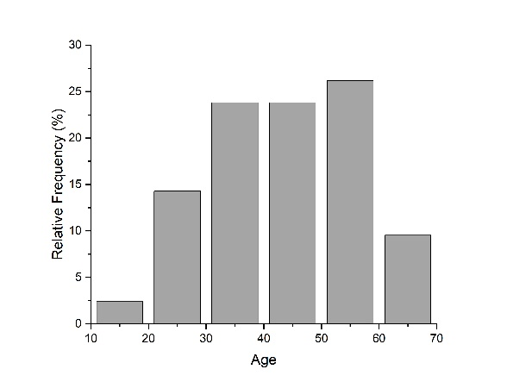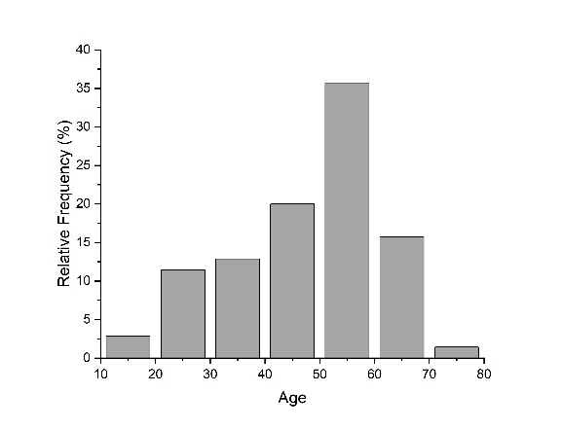
Supplementary Figure 1. Age Distribution of Opportunistic Infections (left) and Microangiopathy (right)

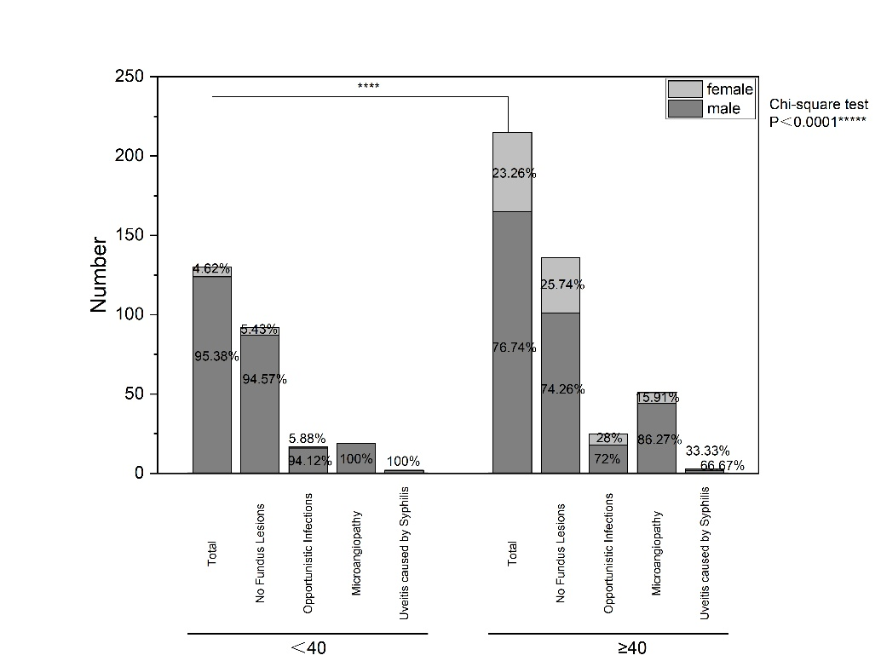
Supplementary Figure 2. Distribution of people in Two Age Group

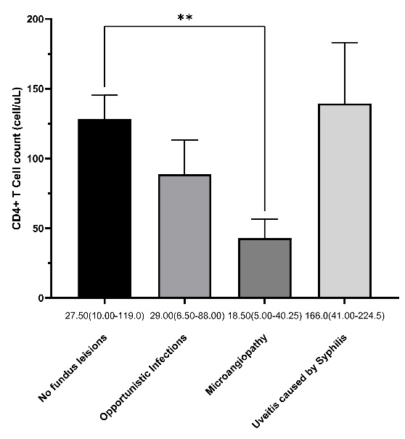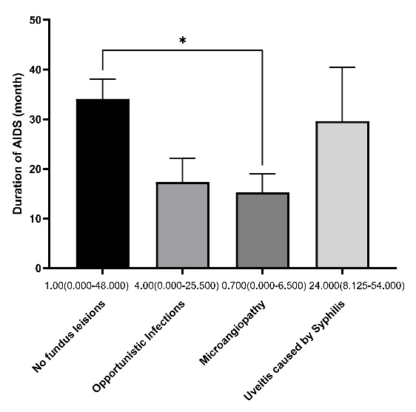
Supplementary Figure 3A. Distribution of CD4⁺ T cell counts in different groups
Supplementary Figure 3B. Distribution of Durations of AIDS in different groups

