Tables:
 |  | POAG | Glaucoma Suspects | Controls | Total
Age in years | Mean ± S.D. | 57.28 ± 14.10 | 41.05 ± 16.11 | 38.92 ±13.75 | 46.44 ± 16.83
Sex | Males | 40 (47.37%) | 29 (46.77%) | 30 (46.15%) | 99 (48.8%)
Sex | Females | 36 (52.63%) | 33 (53.23%) | 35 (53.85%) | 104 (51.2%)
RE BCVA in LOG MAR | Median | 0.18 | 0.00 | 0.00 | 0.00 (0.00 - 0.18)
LE BCVA in LOG MAR | Median | 0.18 | 0.00 | 0.00 | 0.00 (0.00 - 0.18)
RE IOP (mm Hg) | Mean | 16.70 ± 4.81 | 15.89 ± 2.78 | 15.54 ± 2.60 | 16.08 ± 3.65
LE IOP (mm Hg) | Mean | 16.14 ± 4.01 | 16.39 ± 2.93 | 16.01 ± 3.15 | 16.18 ± 3.43
RE CCT (µm) | Mean | 523.67 ± 33.02 | 535.19 ± 32.41 | 537.32 ± 21.97 | 531.56 ± 30.22
LE CCT (µm) | Mean | 526.30 ± 29.92 | 537.43 ± 29.92 | 538.49 ± 21.30 | 533.61 ± 27.90
Table 1. Baseline demographic and clinical characteristics of study participants (n=203).
Values are presented as mean ± SD unless otherwise stated. BCVA = best corrected visual acuity; IOP = intraocular pressure; CCT = central corneal thickness; RE = right eye; LE = left eye.
Parameters | POAG | Glaucoma Suspects | Controls
Average GCC (µm) | 83.30 ± 11.46 (53-118) | 93.76 ± 7.74 (70-114) | 96.54 ± 10.09 (76-163)
Superior GCC (µm) | 83.88 ± 12.29 (53-128) | 94.02 ± 8.03 (71-127) | 96.68 ± 10.91 (76-179)
Inferior GCC (µm) | 81.94 ± 13.19 (52-114) | 93.82 ± 8.27 (69-115) | 96.43 ± 9.60 (73-147)
Table 2. Mean Macular ganglion cell complex (GCC) thickness (Unadjusted) in primary open-angle glaucoma (POAG), glaucoma suspects, and controls. Values are average of both ayes and are presented as mean ± SD (range).
GCC Parameter | Diagnosis | Mean (µm) | SE | 95% CI | Comparison | Difference (ß) | P-value
Average GCC | Control | 95.77 | 1.14 | 93.52–98.02
 | Glaucoma Suspect | 93.20 | 1.15 | 90.94–95.46 | vs Control | -2.56 | 0.31
 | POAG | 84.41 | 1.11 | 82.22–86.61 | vs Control | -11.36 | <0.001
 |  |  |  |  | vs Suspect | -8.79 | <0.001
 | Age per year | -.097 |  |  |  |  | 0.02
 | Sex | 1.42 |  |  |  |  | 0.26
Superior GCC | Control | 96.03 | 1.22 | 93.63–98.44
 | Glaucoma Suspect | 93.55 | 1.22 | 91.141 - 95.966 | vs Control | -2.48 | 0.42
 | POAG | 84.81 | 1.19 | 82.46 - 87.16 | vs Control | -11.23 | <0.001
 |  |  |  |  | vs Suspect | -8.75 | <0.001
 | Age (per year) | -.08 |  |  |  |  | 0.03
 | Sex | 1.24 |  |  |  |  | 0.35
Inferior GCC | Control | 95.60 | 1.22 | 93.20–98.02
 | Glaucoma Suspect | 93.23 | 1.23 | 90.81–95.65 | vs Control | -2.38 | 0.48
 | POAG | 83.13 | 1.19 | 80.74–85.38 | vs Control | -12.48 | <0.001
 |  |  |  |  | vs Suspect | -10.11 | <0.001
 | Age (per year) | -0.10 |  |  |  |  | 0.03
 | Sex | 1.99 |  |  |  |  | 0.14
Table 3. Age- and sex-adjusted estimated marginal means (computed after mixed effects model for both eyes adjusted for age and sex) of Macular ganglion cell complex (GCC) thickness in primary open-angle glaucoma (POAG), glaucoma suspects, and controls, and pairwise comparisons. Values presented as mean ± SD.

Parameters | AUC for POAG/Control groups | AUC for POAG/ Glaucoma Suspects
RE Average GCC | 0.83  (95% CI = 0.77 - 0.90, p<0.05) | 0.77  (95% CI = 0.69 - 0.85, p<0.05)
RE Superior GCC | 0.82  (95% CI = 0.75 - 0.89, p<0.05) | 0.78  (95% CI = 0.70 - 0.85, p<0.05)
RE Inferior GCC | 0.83  (95% CI = 0.76 - 0.90, p<0.05) | 0.79  (95% CI = 0.72 - 0.86, p<0.05)
Table 4. Area under the Curve (AUC) for Right Eye GCC parameters in discriminating POAG with controls and Glaucoma suspects.
Parameter | Cutoff (µm) | Sensitivity (%) | Specificity (%) | LR+ | LR- | PPV (%) | NPV (%)
RE Average GCC
Youden optimal | ≤86.5 | 63.2 | 86.6 | 4.72 | 0.43 | 7.12 | 99.31
Higher specificity | ≤85.5 | 61.8 | 87.4 | 4.90 | 0.44 | 7.42 | 99.30
Higher sensitivity | ≤90.5 | 72.4 | 74.0 | 2.78 | 0.37 | 4.33 | 99.47
RE Superior GCC
Youden optimal | ≤89.5 | 72.4 | 78.0 | 3.29 | 0.35 | 5.05 | 99.45
Higher specificity | ≤86.5 | 63.2 | 86.6 | 4.72 | 0.43 | 7.12 | 99.31
Higher sensitivity | ≤92.5 | 75.0 | 64.6 | 2.12 | 0.39 | 3.34 | 99.52
RE Inferior GCC
Youden optimal | ≤87.5 | 68.4 | 83.5 | 4.15 | 0.38 | 6.28 | 99.34
Higher specificity | ≤85.5 | 63.2 | 85.8 | 4.45 | 0.43 | 6.71 | 99.32
Higher sensitivity | ≤91.5 | 80.3 | 70.1 | 2.68 | 0.28 | 4.18 | 99.58
RE Inferior GCC | ≤87.50 | 68.40 | 83.50 | 4.15 | 0.38 | 6.28 | 99.34
Table 5. Youden optimal cutoff of co-ordinates of ROC curves (POAG vs Controls), and their respective Sensitivity, Specificity, Positive Likelihood ratio (LR+), Negative Likelihood Ration (LR-), Positive Predictive Value (PPV) and Negative Predictive Value (NPV) for Right eyes. Prevalence of POAG was taken as 1.60%.

Parameters | AUC for POAG/Control groups | AUC for POAG/ Glaucoma Suspects
LE Average GCC | 0.81  (95% CI = 0.74 - .88, p<0.05) | 0.79  (95% CI = 0.71 - 0.86, p<0.05)
LE Superior GCC | 0.82  (95% CI = 0.76 - 0.89, p<0.05) | 0.78  (95% CI = 0.70 - 0.86, p<0.05)
LE Inferior GCC | 0.80  (95% CI = 0.73 - 0.87, p<0.05) | 0.76  (95% CI = 0.68 - 0.84, p<0.05)
Table 6. Area under the Curve (AUC) for Left Eye GCC parameters in discriminating POAG with controls and Glaucoma suspects.
Parameter | Cutoff (µm) | Sensitivity (%) | Specificity (%) | LR+ | LR- | PPV (%) | NPV (%)
LE Average GCC
Youden optimal | ≤86.5 | 60.5 | 90.6 | 6.44 | 0.44 | 9.45 | 99.24
Higher specificity | ≤85.5 | 55.3 | 90.6 | 5.88 | 0.49 | 8.66 | 99.21
Higher sensitivity | ≤90.5 | 72.4 | 77.2 | 3.18 | 0.36 | 4.92 | 99.37
LE Superior GCC
Youden optimal | ≤87.5 | 64.5 | 86.6 | 4.81 | 0.41 | 7.30 | 99.31
Higher specificity | ≤86.5 | 59.2 | 91.3 | 6.80 | 0.45 | 9.94 | 99.22
Higher sensitivity | ≤90.5 | 72.4 | 76.4 | 3.07 | 0.36 | 4.76 | 99.38
LE Inferior GCC
Youden optimal | ≤88.5 | 65.8 | 86.6 | 4.91 | 0.39 | 7.55 | 99.30
Higher specificity | ≤85.5 | 59.2 | 89.8 | 5.80 | 0.45 | 8.58 | 99.24
Higher sensitivity | ≤91.5 | 71.1 | 74.0 | 2.73 | 0.39 | 4.23 | 99.41
Table 7. Youden optimal cutoff of co-ordinates of ROC curves (POAG vs Controls), and their respective Sensitivity, Specificity, Positive Likelihood ratio (LR+), Negative Likelihood Ration (LR-), Positive Predictive Value (PPV) and Negative Predictive Value (NPV) for Right eyes. Prevalence of POAG was taken as 1.60%.

Figures:
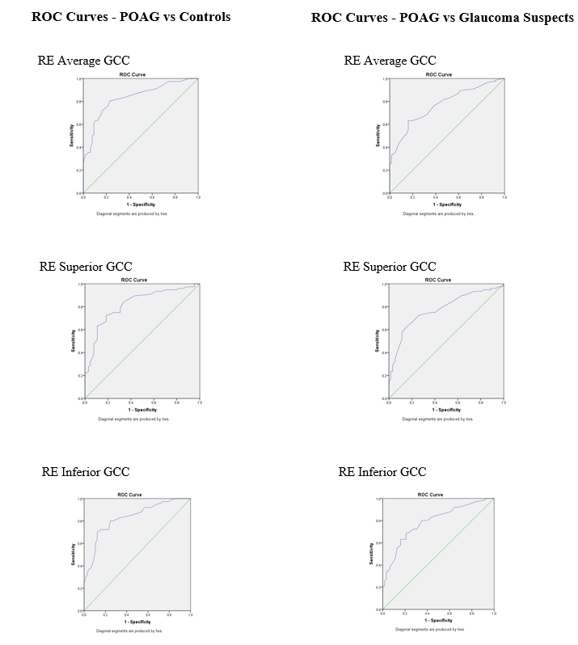
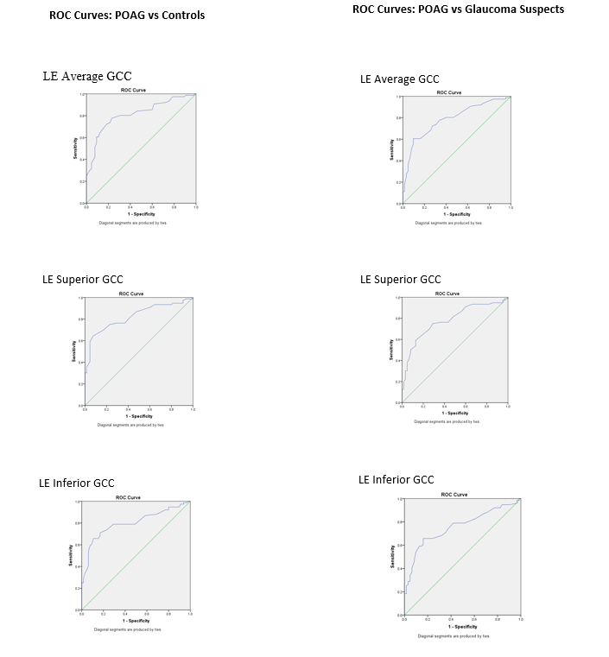
Figure 1. Receiver Operating Characteristic (ROC) curves of RE GCC parameters
(a) ROC curves comparing average, superior, and inferior GCC thickness between POAG and Controls.
(b) ROC curves comparing average, superior, and inferior GCC thickness of right eyes between POAG and Glaucoma Suspects.

Figure 2. Receiver Operating Characteristic (ROC) curves of LE GCC parameters
(a) ROC curves comparing average, superior, and inferior GCC thickness between POAG and Controls.
(b) ROC curves comparing average, superior, and inferior GCC thickness between POAG and Glaucoma suspects

