Supplementary Materials

Supplementary Table S1. Proportion of predictions within predefined absolute-error thresholds.
Model | Output | +/-0.25 D (%) | +/-0.50 D (%) | +/-1.00 D (%)
DT | DS | 26.506 | 49.699 | 80.422
DT | J0 | 76.807 | 94.277 | 99.699
DT | J45 | 93.675 | 99.398 | 100
DT | SE | 28.916 | 48.494 | 81.928
BPNN | DS | 27.139 | 48.378 | 84.956
BPNN | J0 | 74.041 | 92.920 | 99.410
BPNN | J45 | 90.855 | 99.410 | 100
BPNN | SE | 25.664 | 53.687 | 84.956
GBN | DS | 28.228 | 51.051 | 79.279
GBN | J0 | 79.279 | 96.997 | 100
GBN | J45 | 91.892 | 98.198 | 100
GBN | SE | 30.030 | 53.754 | 79.880
LR | DS | 26.426 | 48.949 | 80.480
LR | J0 | 64.565 | 91.291 | 98.799
LR | J45 | 90.991 | 98.198 | 100
LR | SE | 31.532 | 50.150 | 80.781

Supplementary Table S2. SE prediction errors stratified by refractive category.
Model | Group | Number | RMSE | MAE
DT | Myopia | 242 | 0.7117 | 0.5577
DT | Emmetropia | 41 | 0.6024 | 0.4717
DT | Hyperopia | 49 | 1.1504 | 0.9824
BPNN | Myopia | 240 | 0.7742 | 0.5955
BPNN | Emmetropia | 42 | 0.5782 | 0.4736
BPNN | Hyperopia | 57 | 0.8128 | 0.6345
GBN | Myopia | 237 | 0.9594 | 0.6406
GBN | Emmetropia | 41 | 0.7265 | 0.4911
GBN | Hyperopia | 55 | 1.0010 | 0.8045
LR | Myopia | 237 | 0.9990 | 0.6709
LR | Emmetropia | 41 | 0.7141 | 0.5617
LR | Hyperopia | 55 | 0.8771 | 0.6728

Supplementary Table S3. Subgroup analysis by age and axial length.
Model | Output | Subgroup | Number | RMSE | R²
DT | DS | Age <=6 | 36 | 0.9010 | 0.8342
DT | DS | Age >6 | 296 | 0.7598 | 0.7183
DT | DS | AL <22 mm | 18 | 1.0860 | 0.5392
DT | DS | AL 22-24 mm | 152 | 0.7740 | 0.6485
DT | DS | AL >24 mm | 162 | 0.7363 | 0.6711
DT | J0 | Age <=6 | 36 | 0.2227 | 0.7202
DT | J0 | Age >6 | 296 | 0.2446 | 0.6156
DT | J0 | AL <22 mm | 18 | 0.2093 | 0.6084
DT | J0 | AL 22-24 mm | 152 | 0.2276 | 0.6787
DT | J0 | AL >24 mm | 162 | 0.2586 | 0.5719
DT | J45 | Age <=6 | 36 | 0.1834 | 0.1888
DT | J45 | Age >6 | 296 | 0.1340 | 0.0198
DT | J45 | AL <22 mm | 18 | 0.2229 | -0.0656
DT | J45 | AL 22-24 mm | 152 | 0.1223 | 0.0768
DT | J45 | AL >24 mm | 162 | 0.1440 | 0.0722
DT | SE | Age <=6 | 36 | 0.9892 | 0.7844
DT | SE | Age >6 | 296 | 0.7513 | 0.7524
DT | SE | AL <22 mm | 18 | 1.1989 | 0.4435
DT | SE | AL 22-24 mm | 152 | 0.7556 | 0.6673
DT | SE | AL >24 mm | 162 | 0.7438 | 0.7335
BPNN | DS | Age <=6 | 43 | 0.7233 | 0.7075
BPNN | DS | Age >6 | 296 | 0.7557 | 0.7238
BPNN | DS | AL <22 mm | 19 | 0.7478 | 0.7921
BPNN | DS | AL 22-24 mm | 161 | 0.7269 | 0.7302
BPNN | DS | AL >24 mm | 159 | 0.7763 | 0.5417
BPNN | J0 | Age <=6 | 43 | 0.3156 | 0.6990
BPNN | J0 | Age >6 | 296 | 0.2591 | 0.5177
BPNN | J0 | AL <22 mm | 19 | 0.2417 | 0.4299
BPNN | J0 | AL 22-24 mm | 161 | 0.2710 | 0.6272
BPNN | J0 | AL >24 mm | 159 | 0.2656 | 0.5086
BPNN | J45 | Age <=6 | 43 | 0.1811 | -0.0879
BPNN | J45 | Age >6 | 296 | 0.1281 | 0.0396
BPNN | J45 | AL <22 mm | 19 | 0.1723 | -0.2764
BPNN | J45 | AL 22-24 mm | 161 | 0.1499 | -0.0201
BPNN | J45 | AL >24 mm | 159 | 0.1145 | 0.1083
BPNN | SE | Age <=6 | 43 | 0.6998 | 0.7629
BPNN | SE | Age >6 | 296 | 0.7678 | 0.7265
BPNN | SE | AL <22 mm | 19 | 0.8602 | 0.7679
BPNN | SE | AL 22-24 mm | 161 | 0.7051 | 0.7018
BPNN | SE | AL >24 mm | 159 | 0.7987 | 0.6164
GBN | DS | Age <=6 | 42 | 1.4420 | 0.6466
GBN | DS | Age >6 | 291 | 0.8195 | 0.7811
GBN | DS | AL <22 mm | 27 | 1.1584 | 0.5580
GBN | DS | AL 22-24 mm | 165 | 0.7045 | 0.7220
GBN | DS | AL >24 mm | 141 | 1.0805 | 0.6466
GBN | J0 | Age <=6 | 42 | 0.2310 | 0.7378
GBN | J0 | Age >6 | 291 | 0.2065 | 0.6176
GBN | J0 | AL <22 mm | 27 | 0.1787 | 0.7529
GBN | J0 | AL 22-24 mm | 165 | 0.2041 | 0.6483
GBN | J0 | AL >24 mm | 141 | 0.2215 | 0.6449
GBN | J45 | Age <=6 | 42 | 0.2776 | -0.0307
GBN | J45 | Age >6 | 291 | 0.1207 | 0.0117
GBN | J45 | AL <22 mm | 27 | 0.2187 | -0.0092
GBN | J45 | AL 22-24 mm | 165 | 0.1482 | -0.0360
GBN | J45 | AL >24 mm | 141 | 0.1348 | 0.0316
GBN | SE | Age <=6 | 42 | 1.5552 | 0.6060
GBN | SE | Age >6 | 291 | 0.8151 | 0.8013
GBN | SE | AL <22 mm | 27 | 1.2629 | 0.5383
GBN | SE | AL 22-24 mm | 165 | 0.6961 | 0.6954
GBN | SE | AL >24 mm | 141 | 1.1041 | 0.6806
LR | DS | Age <=6 | 42 | 1.3044 | 0.7109
LR | DS | Age >6 | 291 | 0.7955 | 0.7937
LR | DS | AL <22 mm | 27 | 0.8936 | 0.7370
LR | DS | AL 22-24 mm | 165 | 0.7048 | 0.7218
LR | DS | AL >24 mm | 141 | 1.0386 | 0.6735
LR | J0 | Age <=6 | 42 | 0.4120 | 0.1662
LR | J0 | Age >6 | 291 | 0.2924 | 0.2334
LR | J0 | AL <22 mm | 27 | 0.3141 | 0.2365
LR | J0 | AL 22-24 mm | 165 | 0.2940 | 0.2704
LR | J0 | AL >24 mm | 141 | 0.3271 | 0.2254
LR | J45 | Age <=6 | 42 | 0.2766 | -0.0234
LR | J45 | Age >6 | 291 | 0.1203 | 0.0172
LR | J45 | AL <22 mm | 27 | 0.2207 | -0.0280
LR | J45 | AL 22-24 mm | 165 | 0.1472 | -0.0228
LR | J45 | AL >24 mm | 141 | 0.1342 | 0.0408
LR | SE | Age <=6 | 42 | 1.4634 | 0.6512
LR | SE | Age >6 | 291 | 0.8491 | 0.7843
LR | SE | AL <22 mm | 27 | 1.0428 | 0.6852
LR | SE | AL 22-24 mm | 165 | 0.7005 | 0.6915
LR | SE | AL >24 mm | 141 | 1.1590 | 0.6481

Supplementary Table S4. GEE validation of predictor-outcome associations.
Output | Variable | Coeff | Robust SE | Wald | P-value | 95% CI
DS | Intercept | 59.9276 | 3.1531 | 361.22 | 0.0000 | [53.7475, 66.1077]
DS | Age | -0.0014 | 0.0187 | 0.01 | 0.9418 | [-0.0380, 0.0353]
DS | AL | -1.4238 | 0.0744 | 366.49 | 0.0000 | [-1.5696, -1.2781]
DS | AST | -0.0798 | 0.1398 | 0.33 | 0.5683 | [-0.3538, 0.1942]
DS | K1+K2 | -0.3076 | 0.0193 | 254.92 | 0.0000 | [-0.3453, -0.2698]
DS | UCVA | 1.2474 | 0.1936 | 41.50 | 0.0000 | [0.8679, 1.6269]
J0 | Intercept | -1.3855 | 4.3907 | 0.10 | 0.7523 | [-9.9912, 7.2202]
J0 | Age | 0.0401 | 0.0312 | 1.65 | 0.1986 | [-0.0211, 0.1013]
J0 | AL | -0.0812 | 0.0282 | 8.27 | 0.0040 | [-0.1365, -0.0259]
J0 | AST | -0.0321 | 0.2048 | 0.02 | 0.8755 | [-0.4335, 0.3693]
J0 | K1+K2 | 0.0341 | 0.0476 | 0.51 | 0.4741 | [-0.0593, 0.1275]
J0 | UCVA | -0.4470 | 0.3789 | 1.39 | 0.2381 | [-1.1897, 0.2957]
J45 | Intercept | 2.8264 | 2.2931 | 1.52 | 0.2177 | [-1.6680, 7.3208]
J45 | Age | -0.0162 | 0.0163 | 0.99 | 0.3194 | [-0.0482, 0.0157]
J45 | AL | -0.0083 | 0.0110 | 0.57 | 0.4488 | [-0.0298, 0.0132]
J45 | AST | -0.1734 | 0.1103 | 2.47 | 0.1161 | [-0.3897, 0.0429]
J45 | K1+K2 | -0.0280 | 0.0251 | 1.25 | 0.2635 | [-0.0772, 0.0211]
J45 | UCVA | 0.1513 | 0.1935 | 0.61 | 0.4344 | [-0.2281, 0.5306]
SE | Intercept | 61.4636 | 5.8237 | 111.39 | 0.0000 | [50.0492, 72.8780]
SE | Age | -0.0445 | 0.0385 | 1.33 | 0.2487 | [-0.1200, 0.0311]
SE | AL | -1.3278 | 0.0818 | 263.55 | 0.0000 | [-1.4881, -1.1675]
SE | AST | -0.1799 | 0.2380 | 0.57 | 0.4499 | [-0.6464, 0.2867]
SE | K1+K2 | -0.3475 | 0.0559 | 38.70 | 0.0000 | [-0.4570, -0.2380]
SE | UCVA | 1.7525 | 0.4405 | 15.83 | 0.0001 | [0.8890, 2.6159]

Supplementary Figures
Supplementary Figure S1. Refractive-error distribution in the cohort. The distribution was myopia-predominant, with smaller emmetropic and hyperopic subgroups and a limited high-astigmatism subgroup.
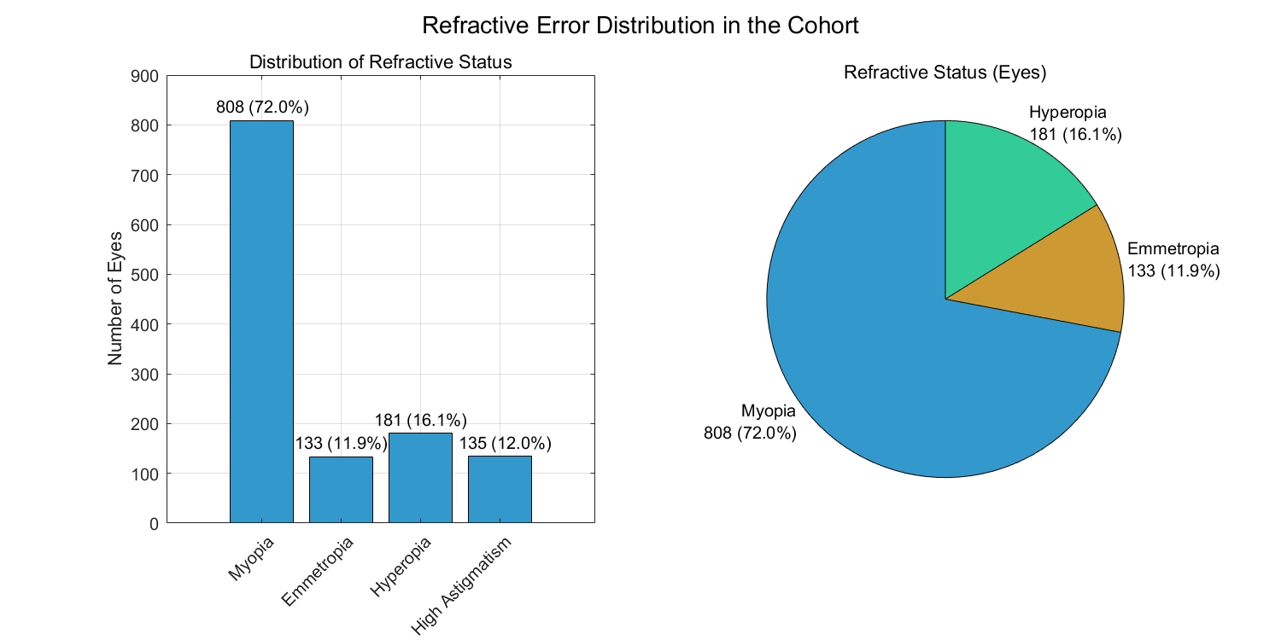
Supplementary Figure S2. Regression, residual, and error-distribution diagnostics for retained models. These plots provide the full diagnostic context beyond the key J0 verification shown in the main manuscript.
