Supplementary material:

Supplementary Figure 1: RNFL trend analysis of one Trabeculectomy case.
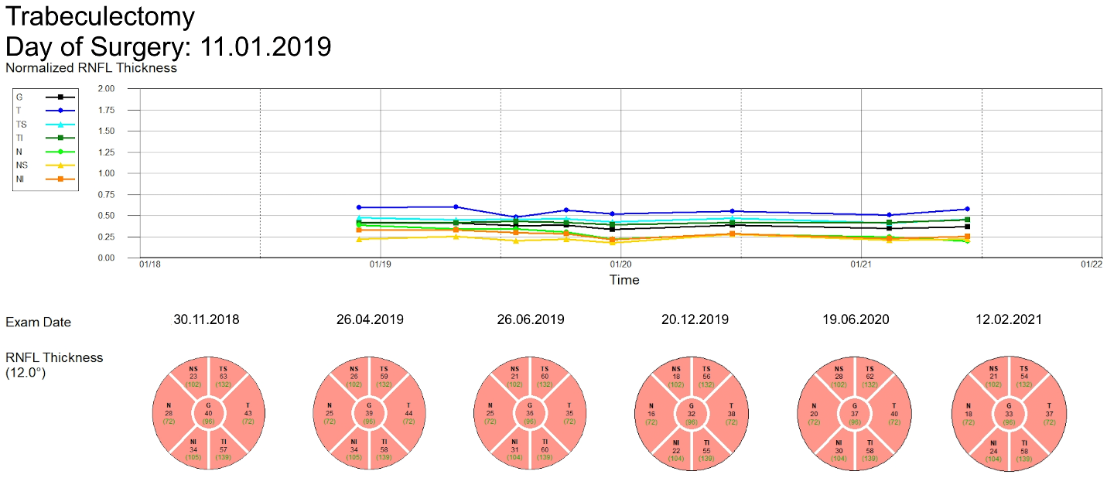

Supplementary Figure 2: RNFL trend analysis of one Deep Sclerectomy case.
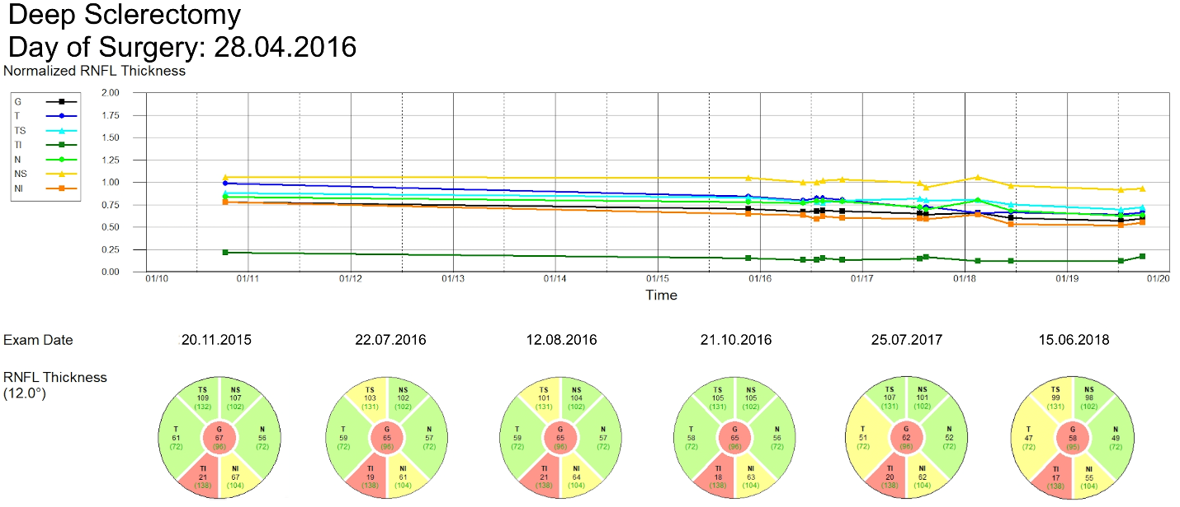

Supplementary Figure 3: RNFL trend analysis of one XEN Microstent case.
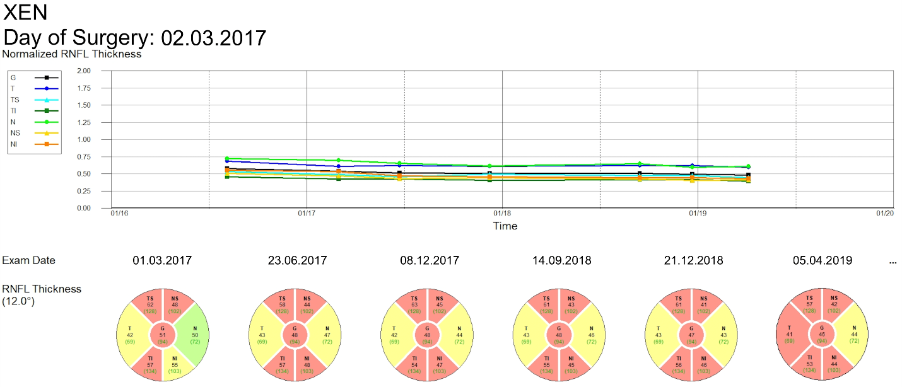

Supplementary Figure 4: RNFL trend analysis of one Preserflo Microshunt case.
