FIGURE S1. Patient flow diagram.
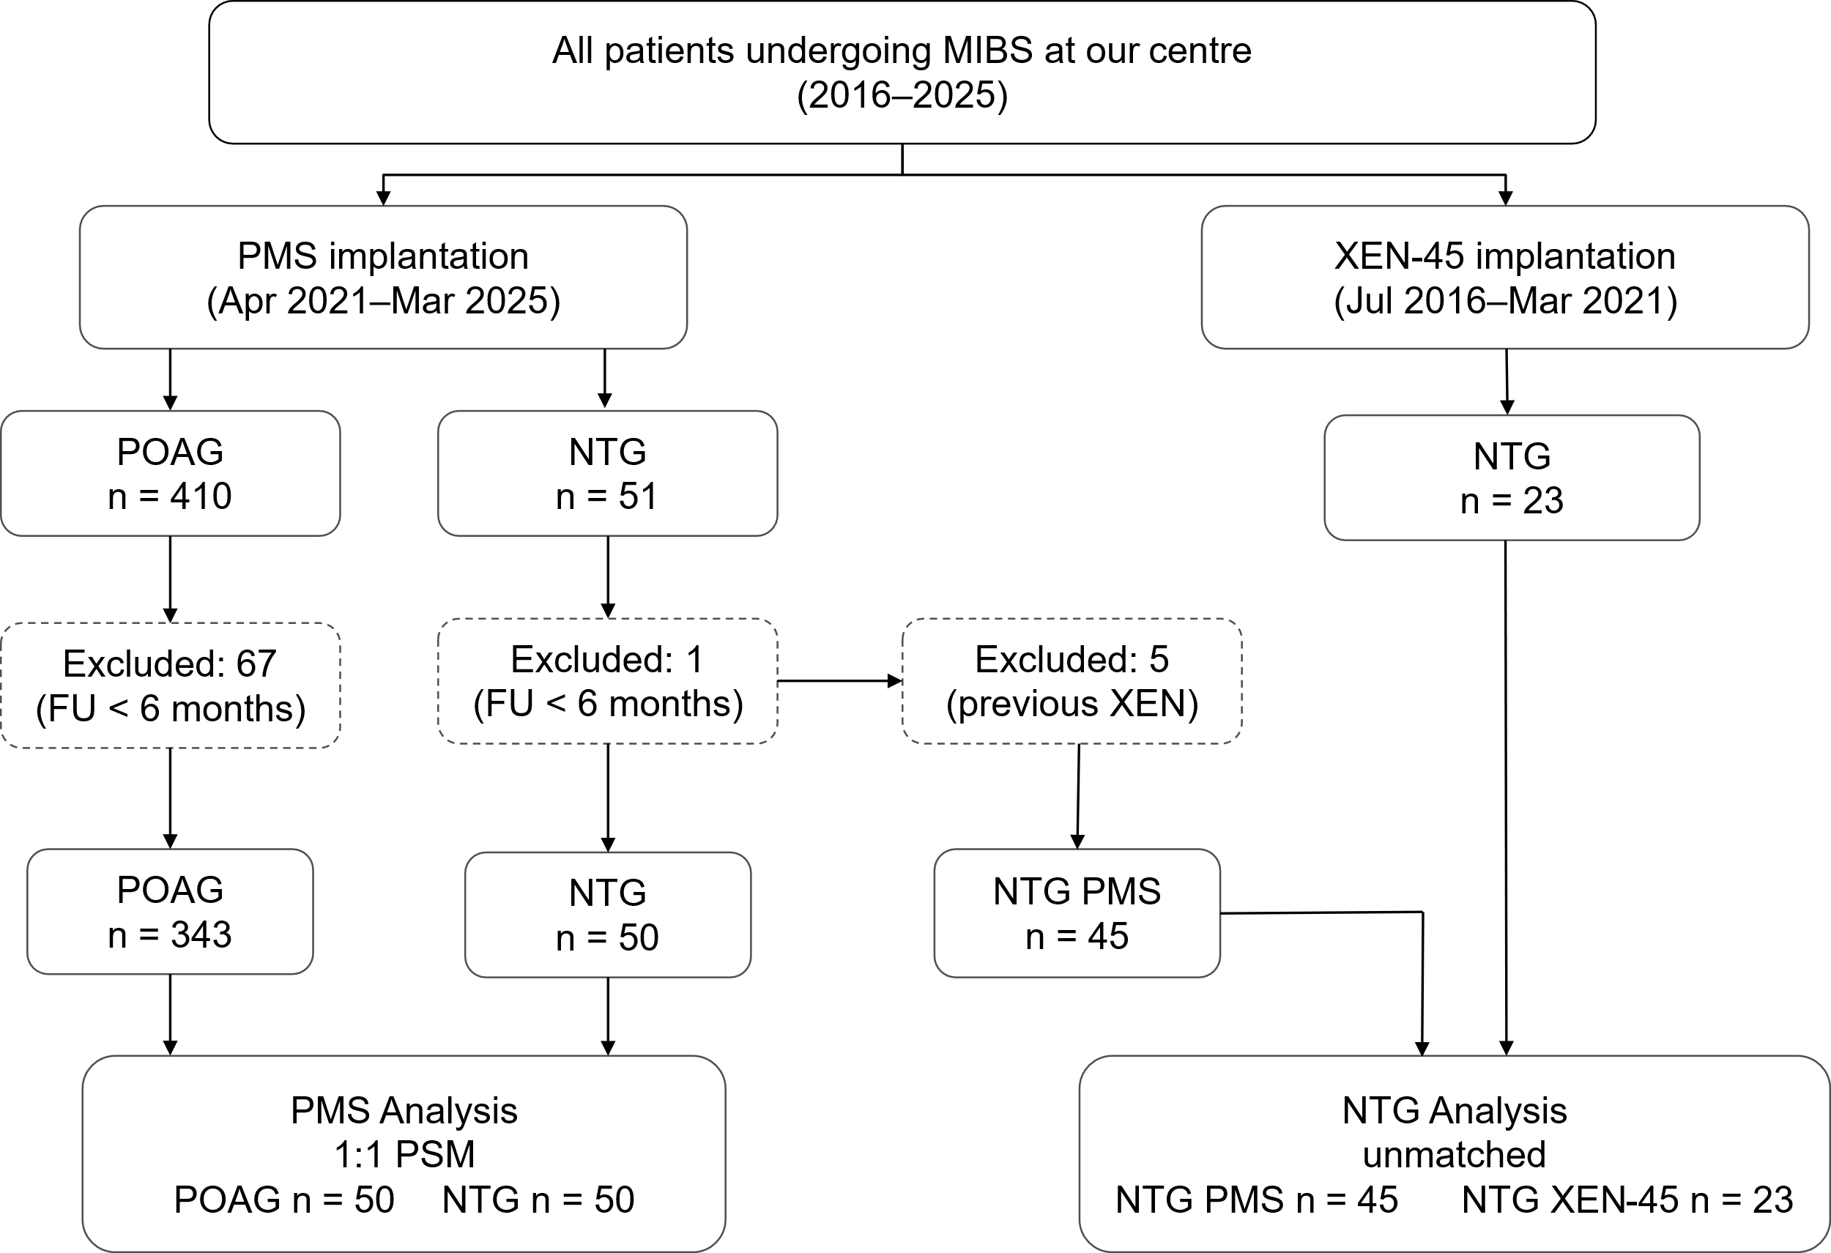
MIBS, minimally invasive bleb surgery; NTG, normal-tension glaucoma; PMS, PRESERFLO MicroShunt; POAG, primary open-angle glaucoma; PSM, propensity score matching.

FIGURE S2. Kaplan–Meier survival curves for surgical success of the PMS in NTG versus POAG – sensitivity analysis 1: incisional bleb revisions not considered failure.
Same as Figure 2: Kaplan–Meier estimates were used to compare complete and qualified surgical success for category 1 (A and D), category 2 (B and E), and category 3 (C and F) between patients with NTG (orange) and POAG (blue) using the log-rank test. The 95% confidence intervals are represented in lighter orange and blue colours, respectively.

FIGURE S3. Kaplan–Meier survival curves for surgical success of the PMS in NTG versus POAG – sensitivity analysis 2: percentage IOP reduction only.
Same as Figure 2: Kaplan–Meier estimates were used to compare complete and qualified surgical success for category 1 (A and D), category 2 (B and E), and category 3 (C and F) between patients with NTG (orange) and POAG (blue) using the log-rank test. The 95% confidence intervals are represented in lighter orange and blue colours, respectively.

FIGURE S4. Kaplan–Meier survival curves for surgical success in of the PMS NTG versus POAG – sensitivity analysis 3: percentage IOP reduction only and incisional bleb revisions not considered failure.
Same as Figure 2: Kaplan–Meier estimates were used to compare complete and qualified surgical success for category 1 (A and D), category 2 (B and E), and category 3 (C and F) between patients with NTG (orange) and POAG (blue) using the log-rank test. The 95% confidence intervals are represented in lighter orange and blue colours, respectively.

FIGURE S5. Kaplan–Meier survival curves for surgical success in NTG following PMS versus XEN-45 implantation – sensitivity analysis: administrative right truncation at 24 months.

Same as Figure 4: Kaplan–Meier estimates were used to compare complete and qualified surgical success for category 1 (A and D), category 2 (B and E), and category 3 (C and F) between NTG eyes that received the PMS (orange) and XEN-45 implant (blue) using the log-rank test. The 95% confidence intervals are represented in lighter orange and blue colours, respectively.

