Figure.3
Right eye
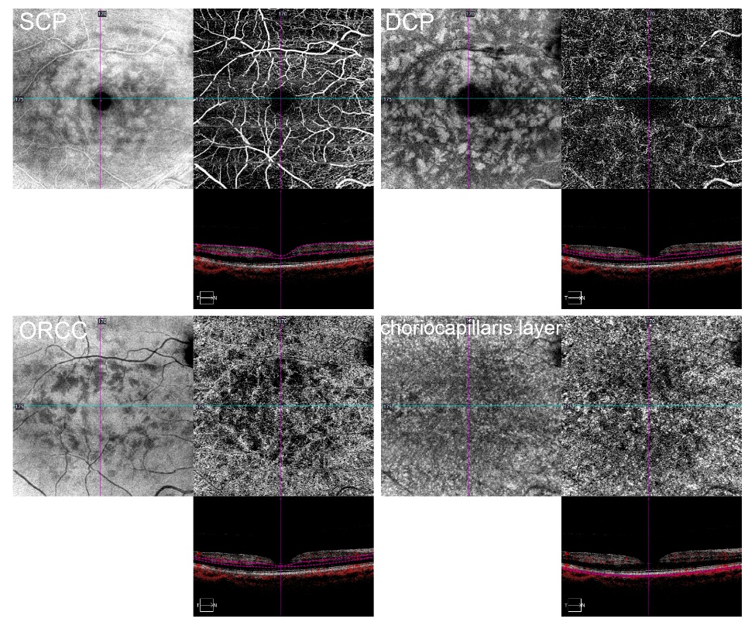
Left eye
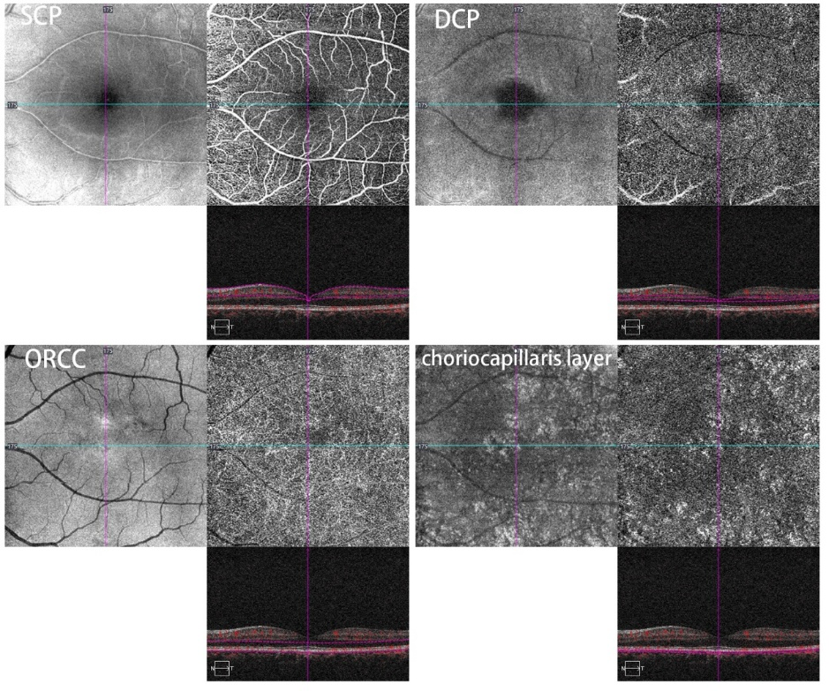
OCT‑A of the right eye revealed significantly reduced flow signal within the deep capillary plexus and choriocapillaris.
The 2019 ACR/EULAR classification criteria for IgG4-related disease  （involved organ in this patient） | numeric weight | classification score in this patient
Serum IgG4 concentration  Normal or not checked 0  > Normal but <2× upper limit of normal  2–5× upper limit of normal  >5× upper limit of normal |  | +6
 | 0 | +6
 | +4 | +6
 | +6 | +6
 | +11 | +6
Pancreas and biliary tree  Not checked or none of the items listed is present 0  Diffuse pancreas enlargement (loss of lobulations)  Diffuse pancreas enlargement (loss of lobulations)  Pancreas (either of above) and biliary tree involvement +19 |  | +11
 | +0 | +11
 | +8 | +11
 | +11 | +11
 | +19 | +11
Kidney  Not checked or none of the items listed is present 0  Hypocomplementemia  Renal pelvis thickening/soft tissue  Bilateral renal cortex low-density areas | +0  +6  +8  +10 | +10
Table. 1 The ACR/EULAR score calculation for this patient

