S1 | Search strategies for the eight primary electronic databases (PubMed, Cochrane Library, Web of Science, Embase, CNKI, Wanfang Data, VIP, and SinoMed) and supplementary search procedures using Google Scholar, ClinicalTrials.gov, and ChiCTR
- Primary electronic databases
Pubmed: 87
#1 "Sleep Apnea Syndromes"[Mesh] Sort by: Most Recent
#2 ((((((((((((((((((((((((((((((((((((((((((((((((((((((((Sleep Apnea Syndromes[Title/Abstract]) OR (Apnea Syndrome, Sleep[Title/Abstract])) OR (Apnea Syndromes, Sleep[Title/Abstract])) OR (Sleep Apnea Syndrome[Title/Abstract])) OR (Apnea, Sleep[Title/Abstract])) OR (Apneas, Sleep[Title/Abstract])) OR (Sleep Apnea[Title/Abstract])) OR (Sleep Apneas[Title/Abstract])) OR (Sleep Hypopnea[Title/Abstract])) OR (Hypopnea, Sleep[Title/Abstract])) OR (Hypopneas, Sleep[Title/Abstract])) OR (Sleep Hypopneas[Title/Abstract])) OR (Hypersomnia with Periodic Respiration[Title/Abstract])) OR (Sleep Apnea, Mixed Central[Title/Abstract] AND Obstructive[Title/Abstract])) OR (Mixed Central[Title/Abstract] AND Obstructive Sleep Apnea[Title/Abstract])) OR (Sleep Apnea, Mixed[Title/Abstract])) OR (Mixed Sleep Apnea[Title/Abstract])) OR (Mixed Sleep Apneas[Title/Abstract])) OR (Sleep Apneas, Mixed[Title/Abstract])) OR (Sleep-Disordered Breathing[Title/Abstract])) OR (Breathing, Sleep-Disordered[Title/Abstract])) OR (Sleep Disordered Breathing[Title/Abstract])) OR (apnea during sleep[Title/Abstract])) OR (apnea syndrome[Title/Abstract])) OR (apnea syndromes[Title/Abstract])) OR (apnea, sleep[Title/Abstract])) OR (apneas during sleep[Title/Abstract])) OR (apnoea, sleep[Title/Abstract])) OR (hypopnea during sleep[Title/Abstract])) OR (hypopnea syndrome[Title/Abstract])) OR (hypopneas during sleep[Title/Abstract])) OR (nocturnal apnea[Title/Abstract])) OR (nocturnal apneas[Title/Abstract])) OR (nocturnal apnoea[Title/Abstract])) OR (nocturnal apnoeas[Title/Abstract])) OR (sleep apnea[Title/Abstract])) OR (sleep apnea syndrome[Title/Abstract])) OR (sleep apnea-hypopnea[Title/Abstract])) OR (sleep apnea/hypopnea syndrome[Title/Abstract])) OR (sleep apneas[Title/Abstract])) OR (sleep apnoea[Title/Abstract])) OR (sleep apnoea syndrome[Title/Abstract])) OR (sleep apnoea syndromes[Title/Abstract])) OR (sleep apnoeas[Title/Abstract])) OR (sleep disordered breathing[Title/Abstract])) OR (sleep hypopnea[Title/Abstract])) OR (sleep hypopneas[Title/Abstract])) OR (sleep related breathing abnormalities[Title/Abstract])) OR (sleep related breathing abnormality[Title/Abstract])) OR (sleep related breathing disorder[Title/Abstract])) OR (sleep related breathing disturbance[Title/Abstract])) OR (unspecified sleep apnea[Title/Abstract])) OR (sleep apnea syndromes[Title/Abstract])) OR (Sleep Apneas; Apneas, Sleep[Title/Abstract])) OR (Apnea, Sleep; Hypopnea, Sleep[Title/Abstract])) OR (Mixed Central[Title/Abstract] AND Obstructive Sleep Apnea[Title/Abstract])) OR (Sleep Apnea, Mixed Central[Title/Abstract] AND Obstructive[Title/Abstract])
#3 (RNFL[Title/Abstract]) OR (RNFLT[Title/Abstract]) OR (Retinal nerve fiber layer[Title/Abstract]) OR (Retinal nerve fibre layer[Title/Abstract]) OR (Retina nerve fiber layer[Title/Abstract]) OR (Retina nerve fibre layer[Title/Abstract])
#4 #1 OR #2
#5 #3 AND #4

Cochrane Library: 9
#1 MeSH descriptor: [Sleep Apnea Syndromes] explode all trees
#2 (Sleep Apnea Syndromes):ti,ab,kw OR (Apnea Syndrome, Sleep):ti,ab,kw OR (Apnea Syndromes, Sleep):ti,ab,kw OR (Sleep Apnea Syndrome):ti,ab,kw OR (Apnea, Sleep):ti,ab,kw OR (Apneas, Sleep):ti,ab,kw OR (Sleep Apnea):ti,ab,kw OR (Sleep Apneas):ti,ab,kw OR (Sleep Hypopnea):ti,ab,kw OR (Hypopnea, Sleep):ti,ab,kw OR (Hypopneas, Sleep):ti,ab,kw OR (Sleep Hypopneas):ti,ab,kw OR (Hypersomnia with Periodic Respiration):ti,ab,kw OR (Sleep Apnea, Mixed Central and Obstructive):ti,ab,kw OR (Mixed Central and Obstructive Sleep Apnea):ti,ab,kw OR (Sleep Apnea, Mixed):ti,ab,kw OR (Mixed Sleep Apnea):ti,ab,kw OR (Mixed Sleep Apneas):ti,ab,kw OR (Sleep Apneas, Mixed):ti,ab,kw OR (Sleep-Disordered Breathing):ti,ab,kw OR (Sleep Disordered Breathing):ti,ab,kw OR (apnea during sleep):ti,ab,kw OR (apnea syndrome):ti,ab,kw OR (apnea syndromes):ti,ab,kw OR (apnea, sleep):ti,ab,kw OR (apneas during sleep):ti,ab,kw OR (apnoea, sleep):ti,ab,kw OR (hypopnea during sleep):ti,ab,kw OR (hypopnea syndrome):ti,ab,kw OR (hypopneas during sleep):ti,ab,kw OR (nocturnal apnea):ti,ab,kw OR (nocturnal apneas):ti,ab,kw OR (nocturnal apnoea):ti,ab,kw OR (nocturnal apnoeas):ti,ab,kw OR (sleep apnea):ti,ab,kw OR (sleep apnea syndrome):ti,ab,kw OR (sleep apnea-hypopnea):ti,ab,kw OR (sleep apneas):ti,ab,kw OR (sleep apnoea):ti,ab,kw OR (sleep apnoea syndrome):ti,ab,kw OR (sleep apnoea syndromes):ti,ab,kw OR (sleep apnoeas):ti,ab,kw OR (sleep disordered breathing):ti,ab,kw OR (sleep hypopnea):ti,ab,kw OR (sleep hypopneas):ti,ab,kw OR (sleep related breathing abnormalities):ti,ab,kw OR (sleep related breathing abnormality):ti,ab,kw OR (sleep related breathing disorder):ti,ab,kw OR (sleep related breathing disturbance):ti,ab,kw OR (unspecified sleep apnea):ti,ab,kw OR (sleep apnea syndromes):ti,ab,kw OR (Sleep Apneas; Apneas, Sleep):ti,ab,kw OR (Apnea, Sleep; Hypopnea, Sleep):ti,ab,kw OR (Mixed Central and Obstructive Sleep Apnea):ti,ab,kw OR (Sleep Apnea, Mixed Central and Obstructive):ti,ab,kw
#3 (RNFL):ti,ab,kw OR (RNFLT):ti,ab,kw OR (Retinal nerve fiber layer):ti,ab,kw OR (Retinal nerve fibre layer):ti,ab,kw OR (Retina nerve fiber layer):ti,ab,kw OR (Retina nerve fibre layer):ti,ab,kw
#4 #1 OR #2
#5 #4 AND #3

Embase: 125
#1 'sleep apnea syndromes'/exp
#2 'rnfl':ti,ab,kw OR 'rnflt':ti,ab,kw OR 'retinal nerve fiber layer':ti,ab,kw OR 'retinal nerve fibre layer':ti,ab,kw OR 'retina nerve fiber layer':ti,ab,kw OR 'retina nerve fibre layer':ti,ab,kw
#3 'apnea syndrome, sleep':ti,ab,kw OR 'apnea syndromes, sleep':ti,ab,kw OR 'apneas, sleep':ti,ab,kw OR 'hypopnea, sleep':ti,ab,kw OR 'hypopneas, sleep':ti,ab,kw OR 'hypersomnia with periodic respiration':ti,ab,kw OR 'sleep apnea, mixed':ti,ab,kw OR 'mixed sleep apnea':ti,ab,kw OR 'mixed sleep apneas':ti,ab,kw OR 'sleep apneas, mixed':ti,ab,kw OR 'sleep-disordered breathing':ti,ab,kw OR 'breathing, sleep-disordered':ti,ab,kw OR 'apnea during sleep':ti,ab,kw OR 'apnea syndrome':ti,ab,kw OR 'apnea syndromes':ti,ab,kw OR 'apnea, sleep':ti,ab,kw OR 'apneas during sleep':ti,ab,kw OR 'apnoea, sleep':ti,ab,kw OR 'hypopnea during sleep':ti,ab,kw OR 'hypopnea syndrome':ti,ab,kw OR 'hypopneas during sleep':ti,ab,kw OR 'nocturnal apnea':ti,ab,kw OR 'nocturnal apneas':ti,ab,kw OR 'nocturnal apnoea':ti,ab,kw OR 'nocturnal apnoeas':ti,ab,kw OR 'sleep apnea':ti,ab,kw OR 'sleep apnea syndrome':ti,ab,kw OR 'sleep apnea-hypopnea':ti,ab,kw OR 'sleep apnea/hypopnea syndrome':ti,ab,kw OR 'sleep apneas':ti,ab,kw OR 'sleep apnoea':ti,ab,kw OR 'sleep apnoea syndrome':ti,ab,kw OR 'sleep apnoea syndromes':ti,ab,kw OR 'sleep apnoeas':ti,ab,kw OR 'sleep disordered breathing':ti,ab,kw OR 'sleep hypopnea':ti,ab,kw OR 'sleep hypopneas':ti,ab,kw OR 'sleep related breathing abnormalities':ti,ab,kw OR 'sleep related breathing abnormality':ti,ab,kw OR 'sleep related breathing disorder':ti,ab,kw OR 'sleep related breathing disturbance':ti,ab,kw OR 'unspecified sleep apnea':ti,ab,kw OR 'sleep apnea syndromes':ti,ab,kw OR 'sleep apneas; apneas, sleep':ti,ab,kw OR 'apnea, sleep; hypopnea, sleep':ti,ab,kw OR 'mixed central and obstructive sleep apnea':ti,ab,kw OR 'sleep apnea, mixed central and obstructive':ti,ab,kw
#4 #1 OR #3
#5 #4 AND #2

WOS: 126
#1 TS=(Sleep Apnea Syndromes OR Apnea Syndrome, Sleep OR Apnea Syndromes, Sleep OR Sleep Apnea Syndrome OR Apnea, Sleep OR Apneas, Sleep OR Sleep Apnea OR Sleep Apneas OR Sleep Hypopnea OR Hypopnea, Sleep OR Hypopneas, Sleep OR Sleep Hypopneas OR Hypersomnia with Periodic Respiration OR Sleep Apnea, Mixed Central and Obstructive OR Mixed Central and Obstructive Sleep Apnea OR Sleep Apnea, Mixed OR Mixed Sleep Apnea OR Mixed Sleep Apneas OR Sleep Apneas, Mixed OR Sleep-Disordered Breathing OR Breathing, Sleep-Disordered OR Sleep Disordered Breathing OR apnea during sleep OR apnea syndrome OR apnea syndromes OR apnea, sleep OR apneas during sleep OR apnoea, sleep OR hypopnea during sleep OR hypopnea syndrome OR hypopneas during sleep OR nocturnal apnea OR nocturnal apneas OR nocturnal apnoea OR nocturnal apnoeas OR sleep apnea OR sleep apnea syndrome OR sleep apnea-hypopnea OR sleep apnea/hypopnea syndrome OR sleep apneas OR sleep apnoea OR sleep apnoea syndrome OR sleep apnoea syndromes OR sleep apnoeas OR sleep disordered breathing OR sleep hypopnea OR sleep hypopneas OR sleep related breathing abnormalities OR sleep related breathing abnormality OR sleep related breathing disorder OR sleep related breathing disturbance OR unspecified sleep apnea OR sleep apnea syndromes OR Sleep Apneas; Apneas, Sleep OR Apnea, Sleep; Hypopnea, Sleep OR Mixed Central and Obstructive Sleep Apnea OR Sleep Apnea, Mixed Central and Obstructive)
#2 TS=(RNFL OR RNFLT OR Retinal nerve fiber layer OR Retinal nerve fibre layer OR Retina nerve fiber layer OR Retina nerve fibre layer)
#3 #1 AND #2

Sinomed: 25
("睡眠呼吸暂停综合征"[常用字段:智能] OR "睡眠过度伴周期性呼吸"[常用字段:智能] OR "睡眠呼吸暂停"[常用字段:智能] OR "睡眠呼吸障碍"[常用字段:智能] OR "睡眠呼吸暂停, 混合中枢性阻塞性"[常用字段:智能] OR "混合中枢性阻塞性睡眠呼吸暂停"[常用字段:智能] OR "混合睡眠呼吸暂停"[常用字段:智能] OR "睡眠低通气"[常用字段:智能]) AND ("视网膜神经纤维层"[常用字段:智能] OR "RNFL"[常用字段:智能])

Wanfang Data: 77
(睡眠呼吸暂停综合征 OR 睡眠过度伴周期性呼吸 OR 睡眠呼吸暂停 OR 睡眠呼吸障碍 OR 睡眠呼吸暂停, 混合中枢性阻塞性 OR 混合中枢性阻塞性睡眠呼吸暂停 OR 混合睡眠呼吸暂停 OR 睡眠低通气) AND (RNFL OR 视网膜神经纤维层 OR 视网膜神经纤维层厚度)

VIP:20
(M=(睡眠呼吸暂停综合征 OR 睡眠过度伴周期性呼吸 OR 睡眠呼吸暂停 OR 睡眠呼吸障碍 OR 睡眠呼吸暂停, 混合中枢性阻塞性 OR 混合中枢性阻塞性睡眠呼吸暂停 OR 混合睡眠呼吸暂停 OR 睡眠低通气)) AND (M=(RNFL OR 视网膜神经纤维层 OR 视网膜神经纤维层厚度))

CNKI: 33
(TKA%=('睡眠呼吸暂停综合征' + '睡眠过度伴周期性呼吸' + '睡眠呼吸暂停' + '睡眠呼吸障碍' + '睡眠呼吸暂停, 混合中枢性阻塞性' + '混合中枢性阻塞性睡眠呼吸暂停' + '混合睡眠呼吸暂停' + '睡眠低通气')) AND (TKA%=('RNFL' + '视网膜神经纤维层' + '视网膜神经纤维层厚度'))

- Supplementary search sources
Google Scholar: Google Scholar was used as a supplementary search source. Searches were performed using combinations of OSA-related terms (“obstructive sleep apnea”, “sleep apnea”, and “OSA”) and RNFL-related terms (“RNFL”, “retinal nerve fiber layer”, and “retinal nerve fibre layer”). Because Google Scholar returns a large number of relevance-ranked results, the first 500 results ranked by relevance were screened for potentially eligible studies, and relevant records were further assessed according to the predefined eligibility criteria. No additional eligible studies were identified.

ClinicalTrials.gov: ClinicalTrials.gov was searched using combinations of OSA-related terms (“obstructive sleep apnea”, “sleep apnea”, and “OSA”) and RNFL-related terms (“RNFL” and “retinal nerve fiber layer”). All retrieved registry records were screened to identify potentially relevant ongoing, completed, or unpublished studies and were assessed according to the predefined eligibility criteria. No additional eligible studies were identified.

Chinese Clinical Trial Registry (ChiCTR): ChiCTR was searched using corresponding English and Chinese terms related to OSA and RNFL, including “obstructive sleep apnea”, “sleep apnea”, “OSA”, “阻塞性睡眠呼吸暂停”, “睡眠呼吸暂停”, “RNFL”, and “视网膜神经纤维层”. All retrieved registry records were screened for potentially relevant studies and assessed according to the predefined eligibility criteria. No additional eligible studies were identified.

Supplementary Table 1. Characteristics of the studies included in the meta-analysis.
Supplementary Table 1 is provided in a separate Supplementary Material file.
Supplementary Table 2 Results of Bias Risk Assessment in Observational Cohort Studies and Cross-Sectional Studies
First author | Year | ① | ② | ③ | ④ | ⑤ | ⑥ | ⑦ | ⑧ | ⑨ | ⑩ | ⑪ | ⑫ | ⑬ | ⑭ | quality grade
Adam M | 2013 | Yes | Yes | Yes | Yes | No | No | No | Yes | Yes | No | Yes | Unclear | No | No | Fair
Batum M | 2020 | Yes | Yes | Yes | Yes | No | Yes | Yes | Yes | Yes | Yes | Yes | Unclear | Yes | No | Good
Bayhan HA | 2015 | Yes | Yes | Yes | Yes | No | No | No | Yes | Yes | No | Yes | Yes | No | No | Good
Bonacci E | 2022 | Yes | Yes | Yes | Yes | No | No | No | No | Yes | No | Yes | Unclear | No | No | Fair
Bussan KA | 2022 | Yes | Yes | Yes | Yes | No | No | No | Yes | Yes | No | Yes | Unclear | No | No | Good
Cai Y | 2020 | Yes | Yes | Yes | Yes | No | No | No | Yes | Yes | No | Yes | Unclear | No | Yes | Good
Cai Y | 2022 | Yes | Yes | Yes | Yes | No | Yes | Yes | No | Yes | Yes | Yes | Unclear | Yes | Yes | Good
Chalkiadaki E | 2021 | Yes | Yes | Yes | Yes | No | No | No | Yes | Yes | No | Yes | Unclear | No | No | Good
Chirapapaisan N | 2016 | Yes | Yes | Yes | Yes | No | Yes | Yes | No | Yes | Yes | Yes | Unclear | Yes | No | Good
Cinici E | 2015 | Yes | Yes | Yes | Yes | No | No | No | No | Yes | No | Yes | Unclear | No | No | Fair
Devi TS | 2023 | Yes | Yes | Yes | Yes | No | No | No | Yes | Yes | No | Yes | Unclear | No | Yes | Good
Dogan, D | 2016 | Yes | Yes | Yes | Yes | No | No | No | No | Yes | No | Yes | Unclear | No | No | Fair
Ferrandez B | 2014 | Yes | Yes | Yes | Yes | No | No | Yes | No | Yes | No | Yes | Unclear | No | No | Good
Ferrandez B | 2016 | Yes | Yes | Yes | Yes | No | No | Yes | No | Yes | No | Yes | Unclear | No | No | Good
Fındık H | 2019 | Yes | Yes | Yes | Yes | No | Yes | Yes | Yes | Yes | No | Yes | Unclear | Yes | No | Good
Gutiérrez-Díaz E | 2012 | Yes | Yes | Yes | Yes | No | No | Yes | No | Yes | No | Yes | Unclear | No | No | Good
Guven S | 2021 | Yes | Yes | Yes | Yes | No | No | Yes | Yes | Yes | No | Yes | Unclear | No | No | Good
Kara N | 2018 | Yes | Yes | Yes | Yes | No | No | Yes | Yes | Yes | No | Yes | Unclear | No | No | Good
Kısabay Ak A | 2020 | Yes | Yes | Yes | Yes | No | Yes | Yes | Yes | Yes | Yes | Yes | Unclear | Yes | No | Good
Lee SSY | 2019 | Yes | Yes | Yes | Yes | No | No | Unclear | Yes | Yes | No | Yes | Unclear | No | Yes | Good
Lee SSY | 2020 | Yes | Yes | Yes | Yes | No | No | Yes | Yes | Yes | No | Yes | Unclear | No | Yes | Good
Lin PW(a) | 2011 | Yes | Yes | Yes | Yes | No | Yes | Yes | Yes | Yes | No | Yes | Unclear | Yes | No | Good
Lin PW | 2023 | Yes | Yes | Yes | Yes | No | Yes | Yes | Yes | Yes | No | Yes | Unclear | Yes | No | Good
Moyal L | 2018 | Yes | Yes | Yes | Yes | No | No | Yes | Yes | Yes | No | Yes | Unclear | No | No | Good
Ngoo QZ | 2021 | Yes | Yes | Yes | Yes | No | No | Yes | Yes | Yes | No | Yes | Unclear | No | Yes | Good
Ozge G | 2016 | Yes | Yes | Yes | Yes | No | No | Yes | Yes | Yes | No | Yes | Unclear | No | No | Good
Özkurt, Z G | 2019 | Yes | Yes | Yes | Yes | No | No | No | Yes | Yes | No | Yes | Unclear | No | No | Fair
Simsek A | 2016 | Yes | Yes | Yes | Yes | No | Yes | Yes | Yes | Yes | Yes | Yes | Unclear | Yes | No | Good
Ucak T | 2020 | Yes | Yes | Yes | Yes | No | Yes | Yes | Yes | Yes | No | Yes | Unclear | Yes | No | Good
Xin C | 2015 | Yes | Yes | Yes | Yes | No | No | Yes | No | Yes | No | Yes | Unclear | No | No | Good
Yu J | 2017 | Yes | Yes | Yes | Yes | No | No | Yes | Yes | Yes | No | Yes | Unclear | No | Yes | Good
Yuvaci I | 2016 | Yes | Yes | Yes | Yes | No | Yes | Yes | No | Yes | Yes | Yes | Unclear | Yes | No | Good
Zengin MO | 2014 | Yes | Yes | Yes | Yes | No | Yes | Yes | Yes | Yes | Yes | Yes | Unclear | Yes | No | Good
Shande Ju | 2023 | Yes | Yes | Yes | Yes | No | No | Yes | Yes | Yes | No | Yes | Unclear | No | Yes | Good
Xinyu Li | 2015 | Yes | Yes | Yes | Yes | No | Yes | Yes | Yes | Yes | Yes | Yes | Unclear | Yes | No | Good
Xing Liang | 2020 | Yes | Yes | Yes | Yes | No | Yes | Yes | Yes | Yes | Yes | Yes | Unclear | Yes | No | Good
Fucun Song | 2016 | Yes | Yes | Yes | Yes | No | Yes | Yes | Yes | Yes | Yes | Yes | Unclear | Yes | No | Good
Chen Xin | 2018 | Yes | Yes | Yes | Yes | No | No | Yes | Yes | Yes | No | Yes | Unclear | No | No | Good
Note: ①Was the research question or objective in this paper clearly stated?; ②Was the study population clearly specified and defined?; ③Was the participation rate of eligible persons at least 50%?; ④Were all the subjects selected or recruited from the same or similar populations (including the same time period)? Were inclusion and exclusion criteria for being in the study prespecified and applied uniformly to all participants?; ⑤Was a sample size justification, power description, or variance and effect estimates provided?; ⑥For the analyses in this paper, were the exposure(s) of interest measured prior to the outcome(s) being measured?; ⑦Was the timeframe sufficient so that one could reasonably expect to see an association between exposure and outcome if it existed?; ⑧For exposures that can vary in amount or level, did the study examine different levels of the exposure as related to the outcome (e.g., categories of exposure, or exposure measured as continuous variable)?; ⑨Were the exposure measures (independent variables) clearly defined, valid, reliable, and implemented consistently across all study participants?;⑩Was the exposure(s) assessed more than once over time?; ⑪Were the outcome measures (dependent variables) clearly defined, valid, reliable, and implemented consistently across all study participants?; ⑫Were the outcome assessors blinded to the exposure status of participants?; ⑬Was loss to follow-up after baseline 20% or less?; ⑭Were key potential confounding variables measured and adjusted statistically for their impact on the relationship between exposure(s) and outcome(s)?

Supplementary Table 3 Results of Bias Risk Assessment in Included Case-Control Studies
First author | Year | ① | ② | ③ | ④ | ⑤ | ⑥ | ⑦ | ⑧ | ⑨ | ⑩ | ⑪ | ⑫ | quality grade
Casas P | 2013 | Yes | Yes | No | Yes | Yes | Yes | Yes | Yes | Yes | Yes | Yes | Unclear | Good
Casas P | 2018 | Yes | Yes | No | Yes | Yes | Yes | Unclear | Yes | Yes | Yes | Yes | No | Good
Dalianis G | 2021 | Yes | Yes | No | Yes | Yes | Yes | Unclear | Yes | Yes | Yes | Unclear | Yes | Good
Davanian A | 2022 | Yes | Yes | No | Yes | Yes | Yes | Unclear | Yes | Yes | Yes | Yes | Yes | Good
Ermis S | 2025 | Yes | Yes | No | Yes | Yes | Yes | Unclear | Yes | Yes | Yes | Yes | No | Good
Huseyinoglu N | 2014 | Yes | Yes | No | Yes | Yes | Yes | Unclear | Yes | Yes | Yes | Unclear | No | Good
Kargi SH | 2005 | Yes | Yes | No | Yes | Yes | Yes | Unclear | Yes | Yes | Yes | Unclear | No | Good
Küçük B | 2019 | Yes | Yes | No | Yes | Yes | Yes | Unclear | Yes | Yes | Yes | Unclear | No | Good
Pusic Sesar A | 2025 | Yes | Yes | No | Yes | Yes | Yes | Unclear | Yes | Yes | Yes | Unclear | No | Good
Sagiv O | 2014 | Yes | Yes | No | Yes | Yes | Yes | Unclear | Yes | Yes | Yes | Unclear | No | Good
Sundaram V | 2022 | Yes | Yes | No | Yes | Yes | Yes | Unclear | Yes | Yes | Yes | Unclear | No | Good
Teberik K | 2018 | Yes | Yes | No | Yes | Yes | Yes | Unclear | Yes | Yes | Yes | Unclear | No | Good
Uslu H | 2021 | Yes | Yes | No | Yes | Yes | Yes | Unclear | Yes | Yes | Yes | Unclear | No | Good
Yazgan S | 2017 | Yes | Yes | No | Yes | Yes | Yes | Unclear | Yes | Yes | Yes | Unclear | No | Good
Yaming shan | 2019 | Yes | Yes | No | Yes | Yes | Yes | Unclear | Yes | Yes | Yes | Unclear | No | Good
Wenjun Dang | 2021 | Yes | Yes | No | Yes | Yes | Yes | Unclear | Yes | Yes | Yes | Unclear | No | Good
Lihua Gong | 2017 | Yes | Yes | No | Yes | Yes | Yes | Unclear | Yes | Yes | Yes | Unclear | No | Good
Lina Hao | 2019 | Yes | Yes | No | Yes | Yes | Yes | Unclear | Yes | Yes | Yes | Unclear | No | Good
Yating Liu | 2016 | Yes | Yes | No | Yes | Yes | Yes | Unclear | Yes | Yes | Yes | Unclear | No | Good
Hua Qiao | 2016 | Yes | Yes | No | Yes | Yes | Yes | Unclear | Yes | Yes | Yes | Unclear | No | Good
Yanhui Wang | 2019 | Yes | Yes | No | Yes | Yes | Yes | Unclear | Yes | Yes | Yes | Unclear | No | Good
Tianqi Yang | 2025 | Yes | Yes | No | Yes | Yes | Yes | Unclear | Yes | Yes | Yes | Unclear | No | Good
Yongshui Yao | 2014 | Yes | Yes | No | Yes | Yes | Yes | Unclear | Yes | Yes | Yes | Unclear | No | Good
Jing Zhang | 2015 | Yes | Yes | No | Yes | Yes | Yes | Unclear | Yes | Yes | Yes | Unclear | No | Good
Note: ①Was the research question or objective in this paper clearly stated and appropriate?; ②Was the study population clearly specified and defined?; ③Did the authors include a sample size justification?; ④Were controls selected or recruited from the same or similar population that gave rise to the cases (including the same timeframe)?; ⑤Were the definitions, inclusion and exclusion criteria, algorithms or processes used to identify or select cases and controls valid, reliable, and implemented consistently across all study participants?; ⑥Were the cases clearly defined and differentiated from controls?; ⑦If less than 100 percent of eligible cases and/or controls were selected for the study, were the cases and/or controls randomly selected from those eligible?; ⑧Was there use of concurrent controls?; ⑨Were the investigators able to confirm that the exposure/risk occurred prior to the development of the condition or event that defined a participant as a case?; ⑩Were the measures of exposure/risk clearly defined, valid, reliable, and implemented consistently (including the same time period) across all study participants?; ⑪Were the assessors of exposure/risk blinded to the case or control status of participants?; ⑫Were key potential confounding variables measured and adjusted statistically in the analyses? If matching was used, did the investigators account for matching during study analysis?

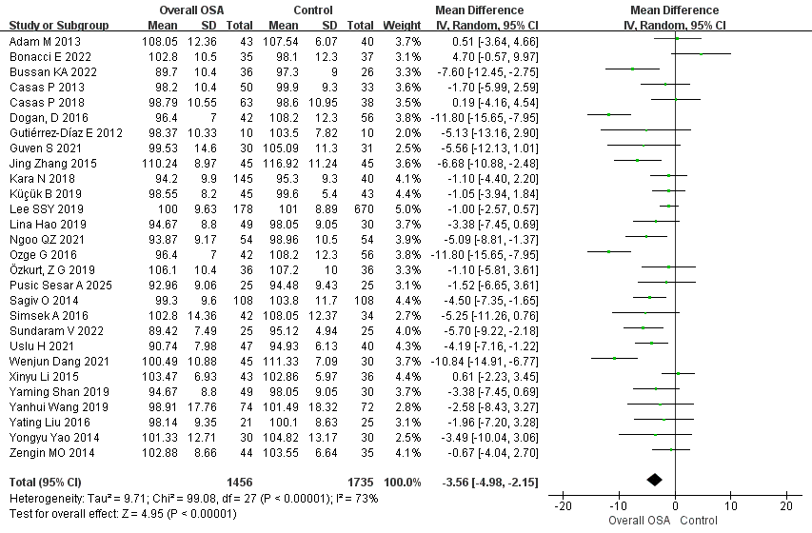
Supplementary Figure 1. Forest plot comparing Average RNFL thickness between patients with OSA and healthy controls.

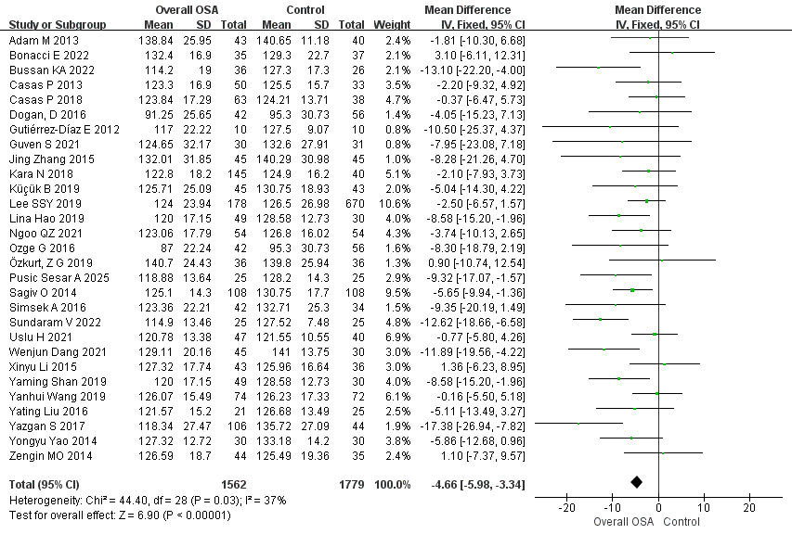
Supplementary Figure 2. Forest plot comparing I RNFL thickness between patients with OSA and healthy controls.
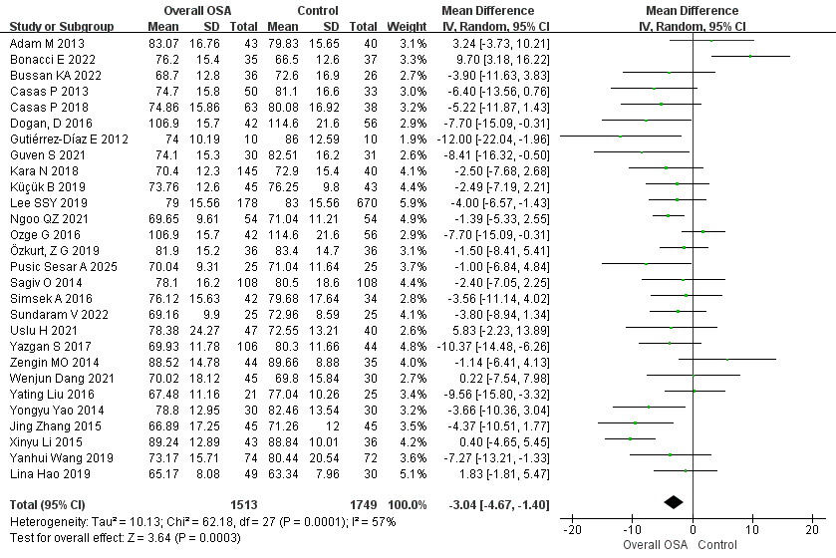
Supplementary Figure 3. Forest plot comparing N RNFL thickness between patients with OSA and healthy controls.

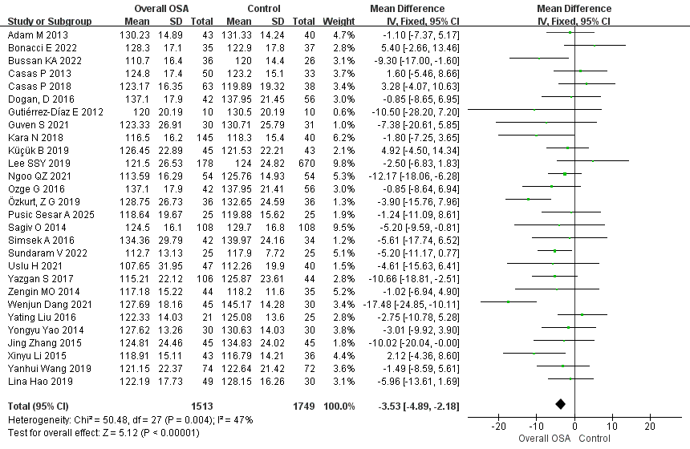
Supplementary Figure 4. Forest plot comparing S RNFL thickness between patients with OSA and healthy controls.
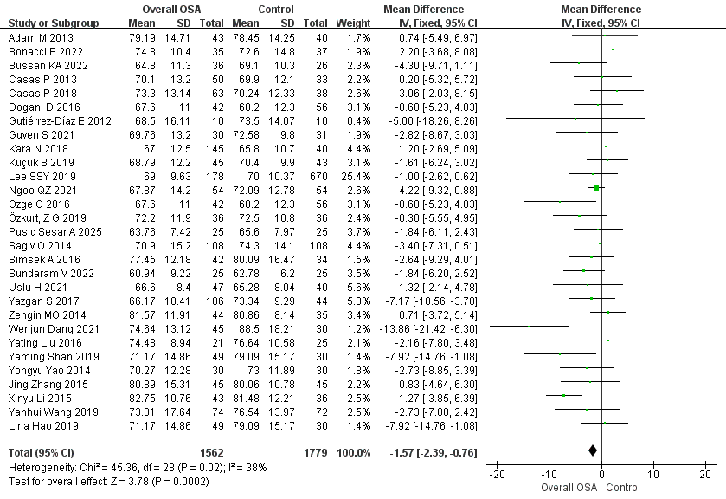
Supplementary Figure 5. Forest plot comparing T RNFL thickness between patients with OSA and healthy controls.

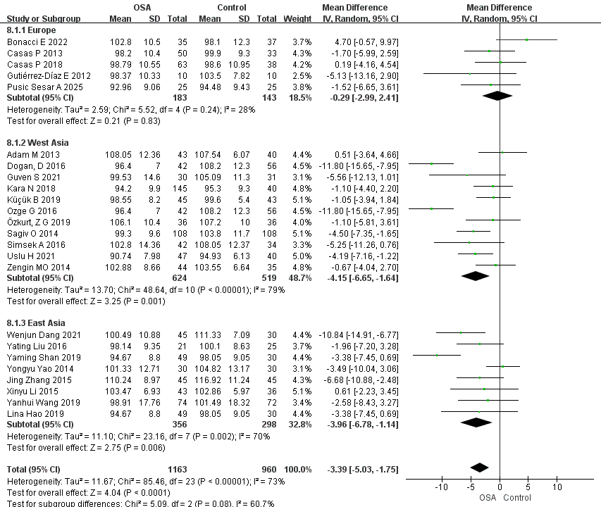
Supplementary Figure 6. Forest plot comparing Average RNFL thickness between patients with OSA and healthy controls, with subgroup analysis by geographic region.
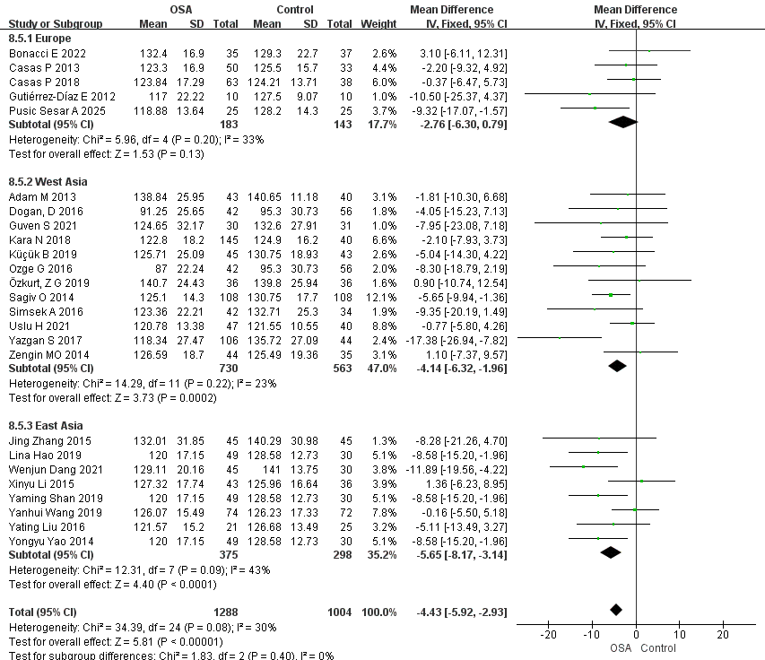
Supplementary Figure 7. Forest plot comparing I RNFL thickness between patients with OSA and healthy controls, with subgroup analysis by geographic region.
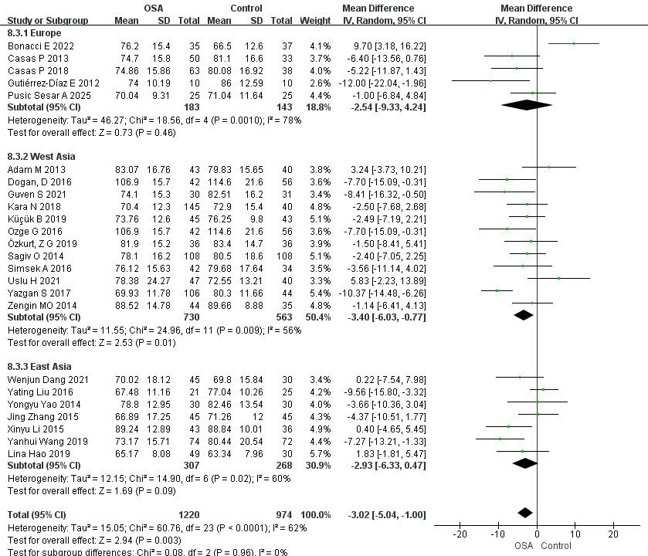
Supplementary Figure 8. Forest plot comparing N RNFL thickness between patients with OSA and healthy controls, with subgroup analysis by geographic region.

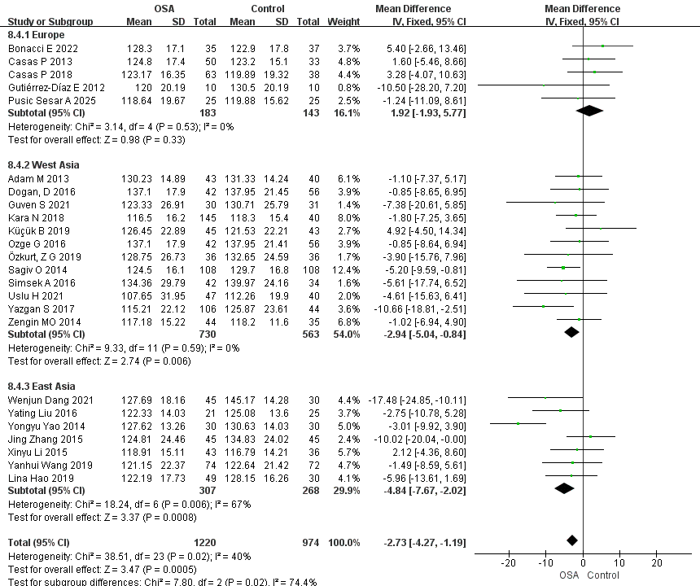
Supplementary Figure 9. Forest plot comparing S RNFL thickness between patients with OSA and healthy controls, with subgroup analysis by geographic region.

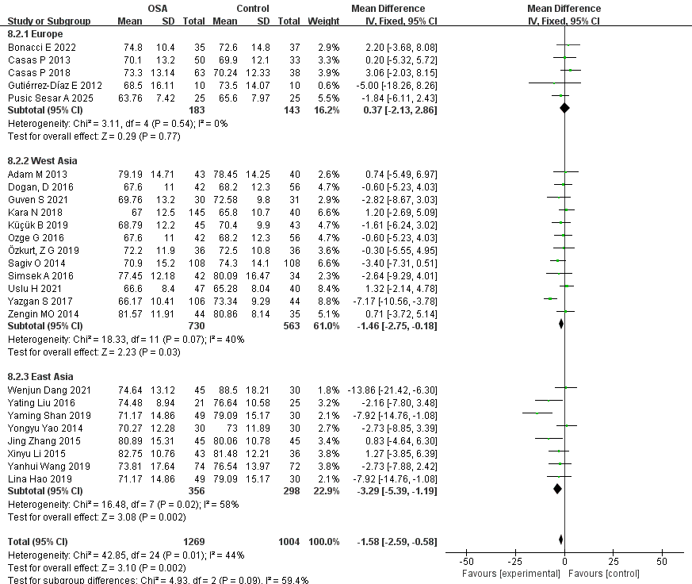
Supplementary Figure 10. Forest plot comparing T RNFL thickness between patients with OSA and healthy controls, with subgroup analysis by geographic region.
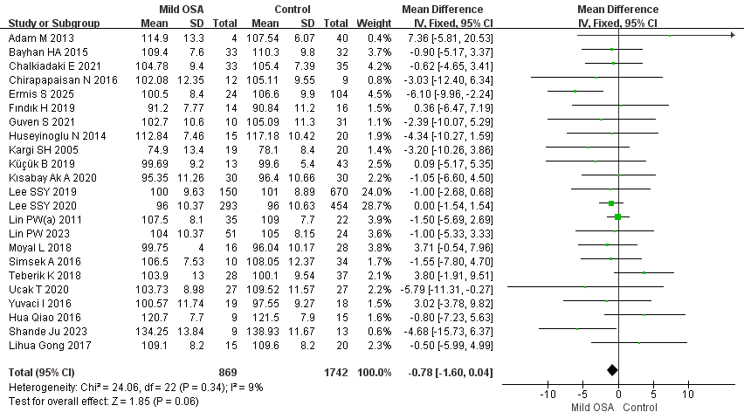
Supplementary Figure 11. Forest plot comparing Average RNFL thickness between patients with mild OSA and healthy controls.
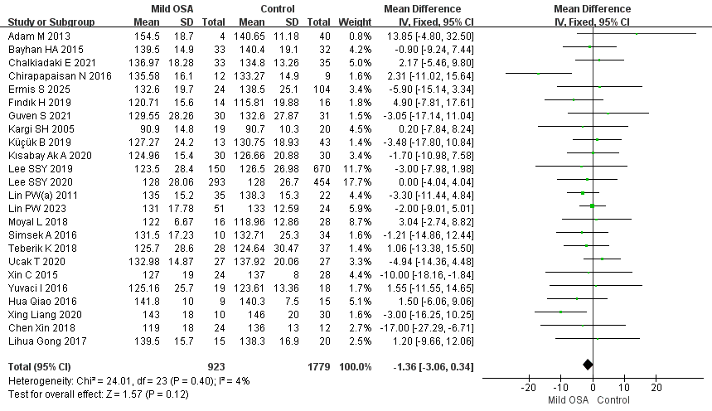
Supplementary Figure 12. Forest plot comparing I RNFL thickness between patients with mild OSA and healthy controls.
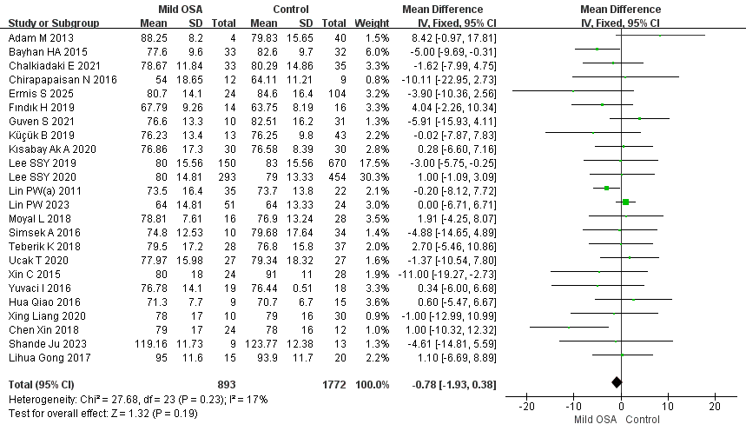
Supplementary Figure 13. Forest plot comparing N RNFL thickness between patients with mild OSA and healthy controls.
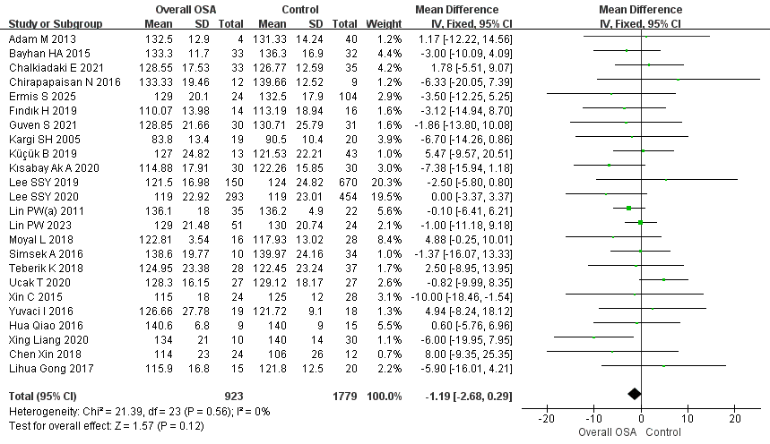
Supplementary Figure 14. Forest plot comparing S RNFL thickness between patients with mild OSA and healthy controls.
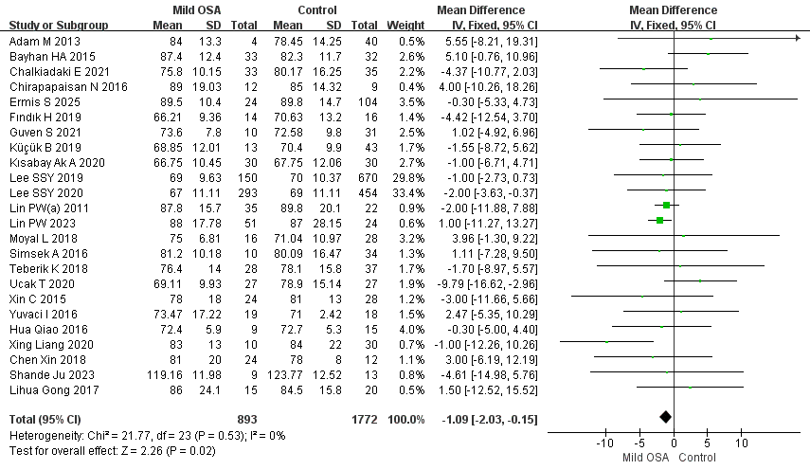
Supplementary Figure 15. Forest plot comparing T RNFL thickness between patients with mild OSA and healthy controls.
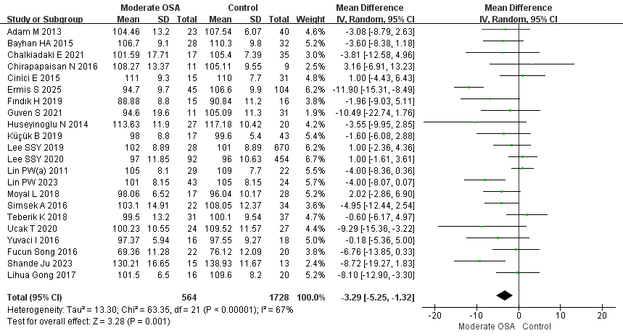
Supplementary Figure 16. Forest plot comparing Average RNFL thickness between patients with moderate OSA and healthy controls.
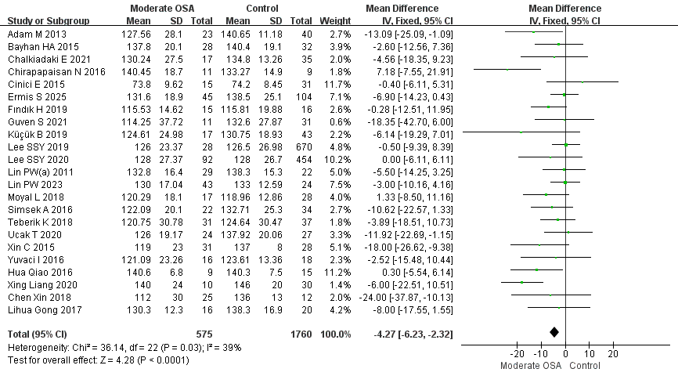
Supplementary Figure 17. Forest plot comparing I RNFL thickness between patients with moderate OSA and healthy controls.
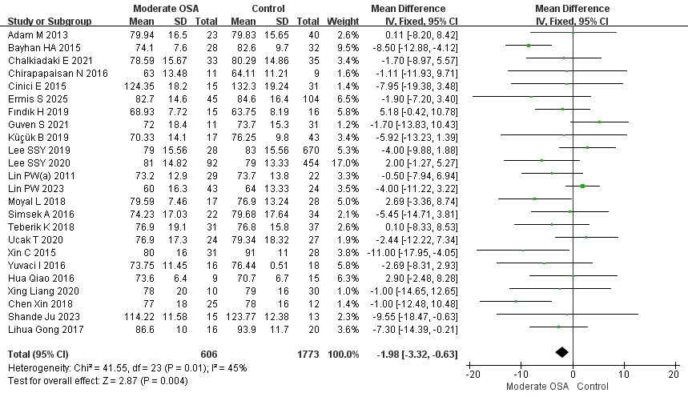
Supplementary Figure 18. Forest plot comparing N RNFL thickness between patients with moderate OSA and healthy controls.
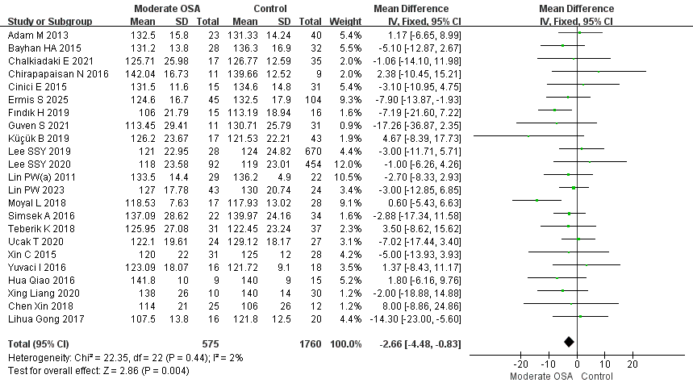
Supplementary Figure 19. Forest plot comparing S RNFL thickness between patients with moderate OSA and healthy controls.
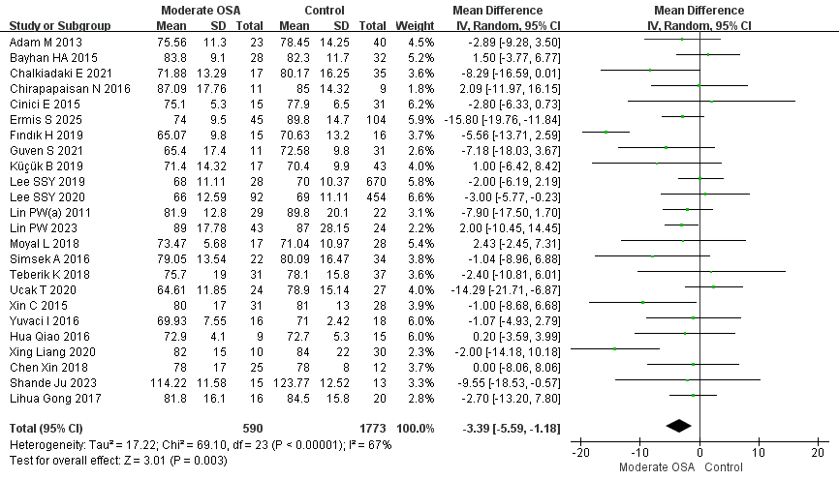
Supplementary Figure 20. Forest plot comparing T RNFL thickness between patients with moderate OSA and healthy controls.
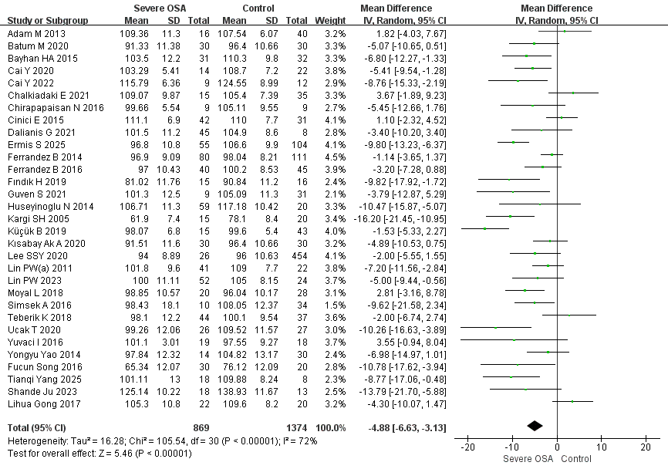
Supplementary Figure 21. Forest plot comparing Average RNFL thickness between patients with severe OSA and healthy controls.
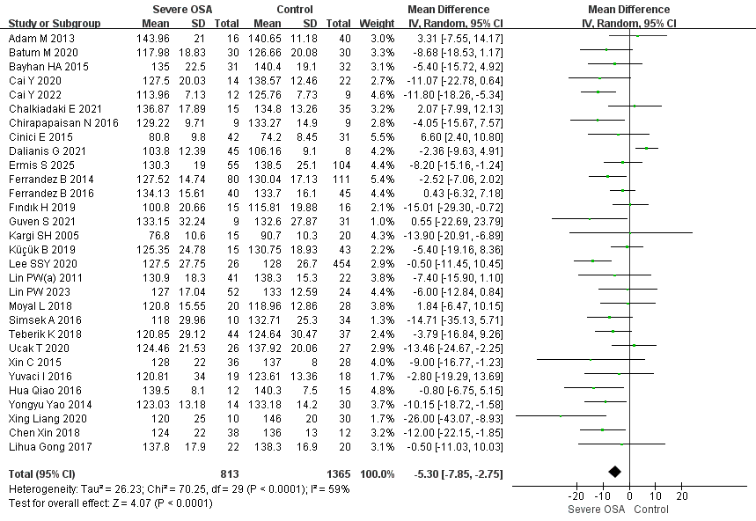
Supplementary Figure 22. Forest plot comparing I RNFL thickness between patients with severe OSA and healthy controls.
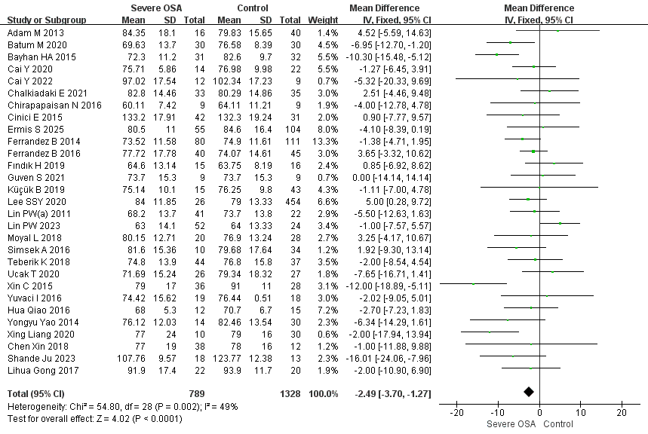
Supplementary Figure 23. Forest plot comparing N RNFL thickness between patients with severe OSA and healthy controls.
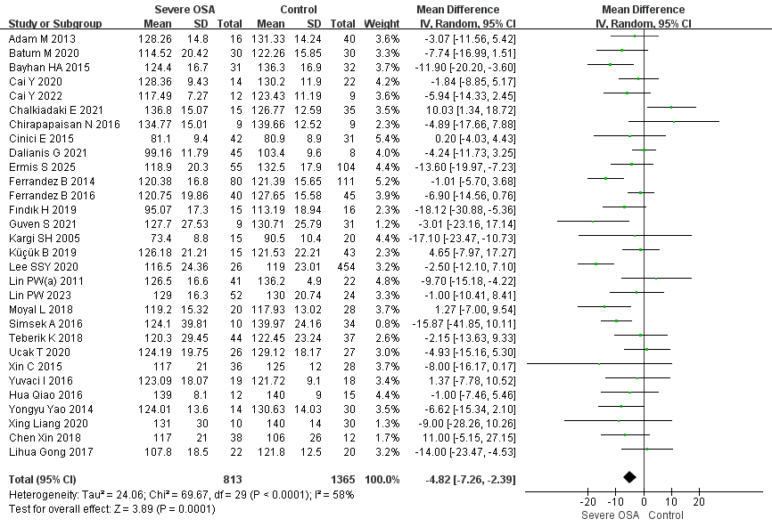
Supplementary Figure 24. Forest plot comparing S RNFL thickness between patients with severe OSA and healthy controls.
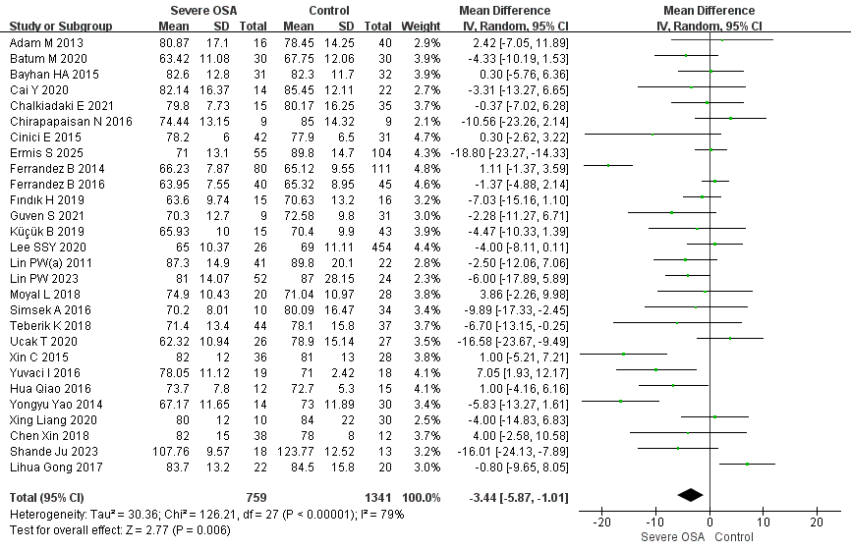
Supplementary Figure 25. Forest plot comparing T RNFL thickness between patients with severe OSA and healthy controls.
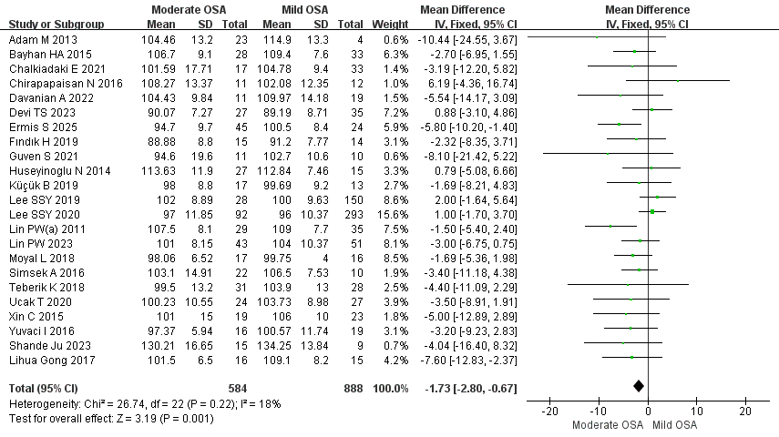
Supplementary Figure 26. Forest plot comparing Average RNFL thickness between patients with moderate and mild OSA.
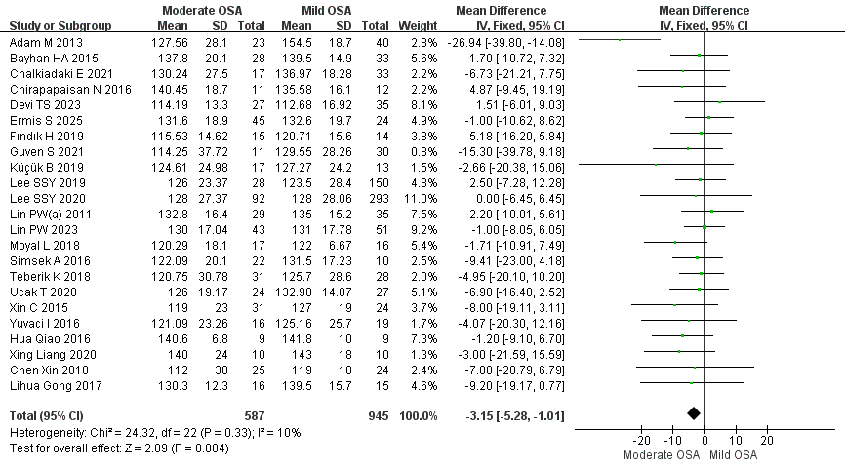
Supplementary Figure 27. Forest plot comparing I RNFL thickness between patients with moderate and mild OSA.
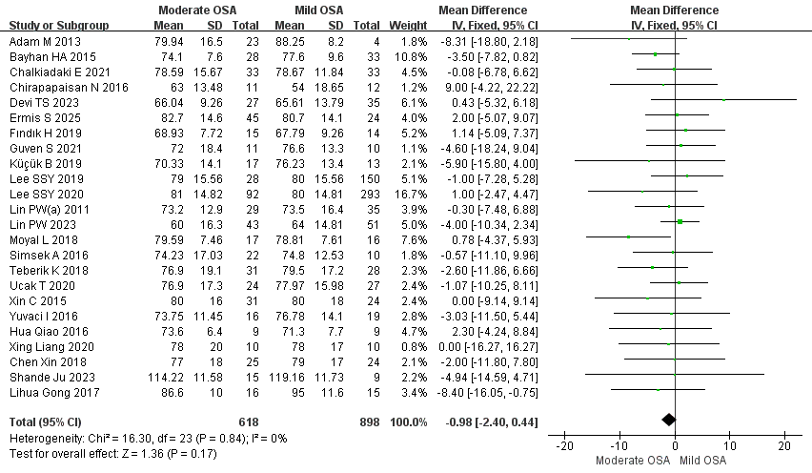
Supplementary Figure 28. Forest plot comparing N RNFL thickness between patients with moderate and mild OSA.
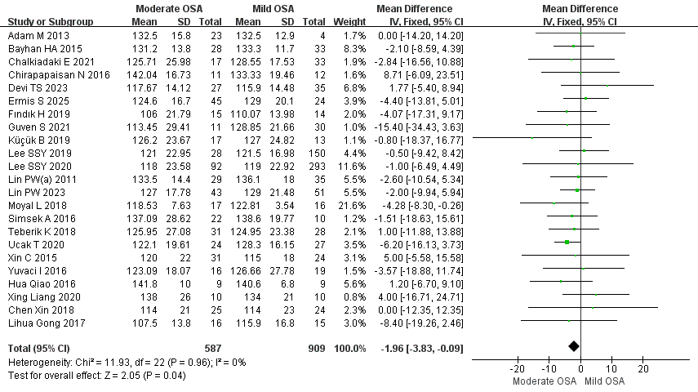
Supplementary Figure 29. Forest plot comparing S RNFL thickness between patients with moderate and mild OSA.
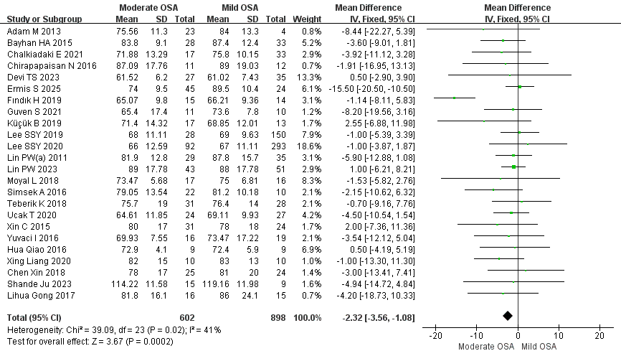
Supplementary Figure 30. Forest plot comparing T RNFL thickness between patients with moderate and mild OSA.
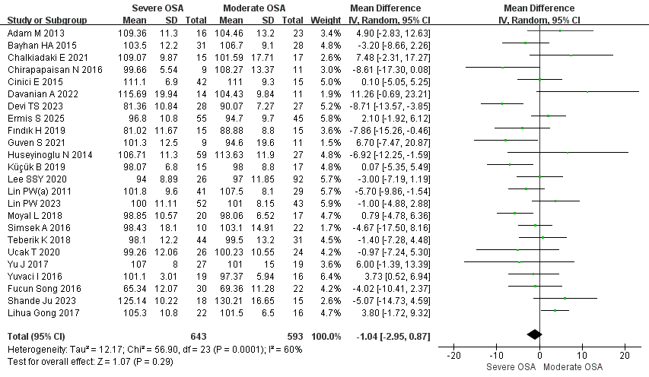
Supplementary Figure 31. Forest plot comparing Average RNFL thickness between patients with severe and moderate OSA.
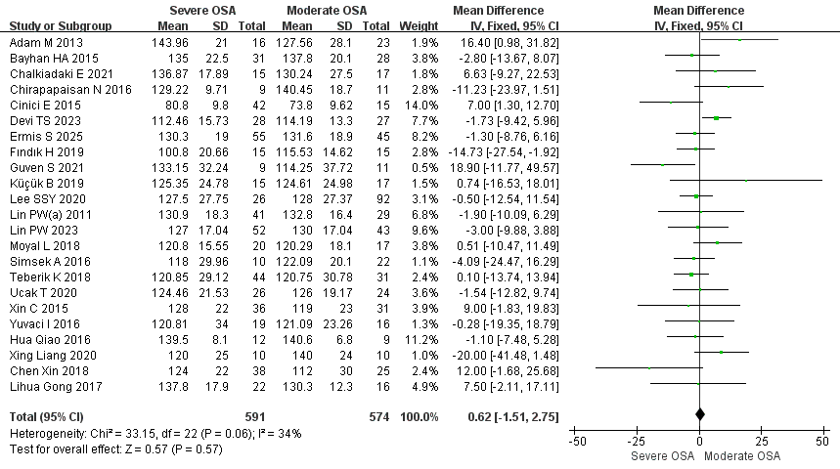
Supplementary Figure 32. Forest plot comparing I RNFL thickness between patients with severe and moderate OSA.
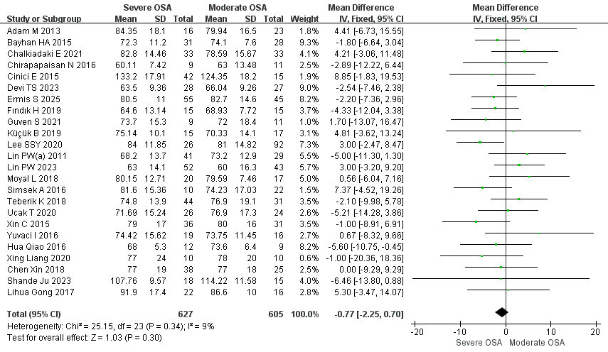
Supplementary Figure 33. Forest plot comparing N RNFL thickness between patients with severe and moderate OSA.
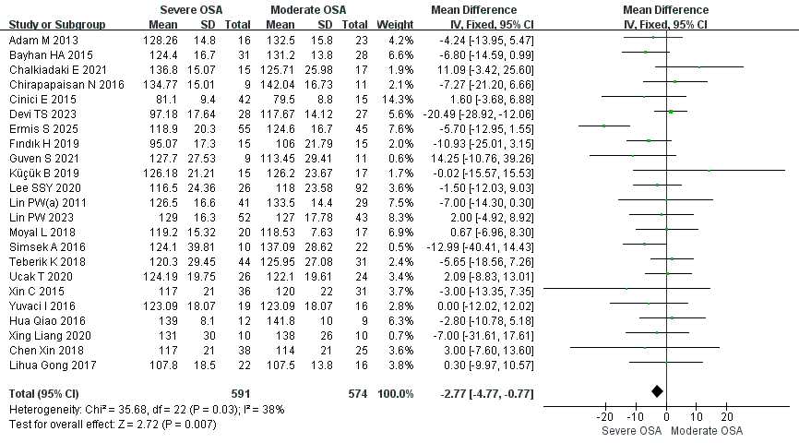
Supplementary Figure 34. Forest plot comparing S RNFL thickness between patients with severe and moderate OSA.
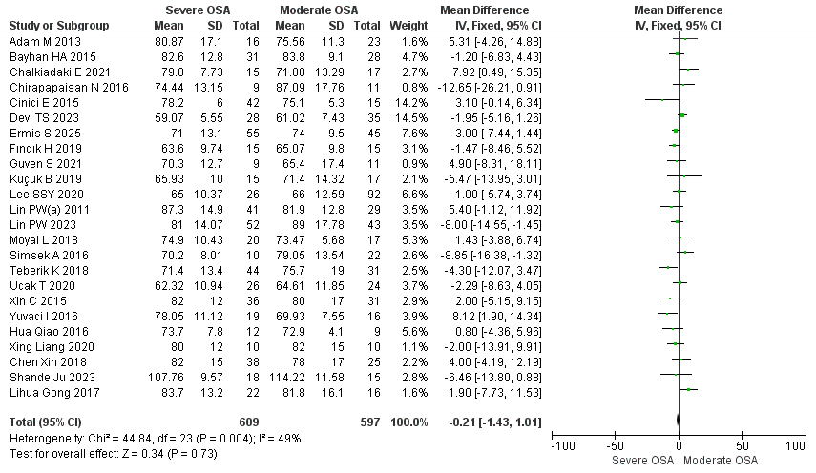
Supplementary Figure 35. Forest plot comparing T RNFL thickness between patients with severe and moderate OSA.
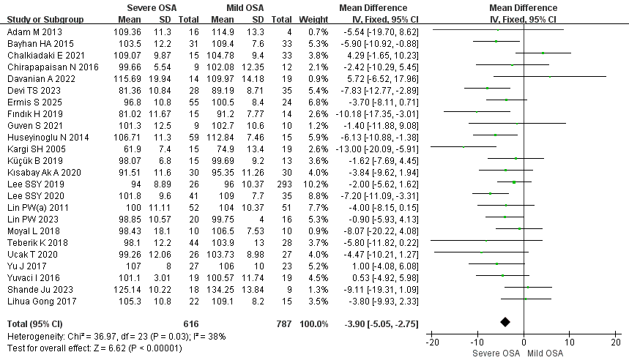
Supplementary Figure 36. Forest plot comparing Average RNFL thickness between patients with severe and mild OSA.
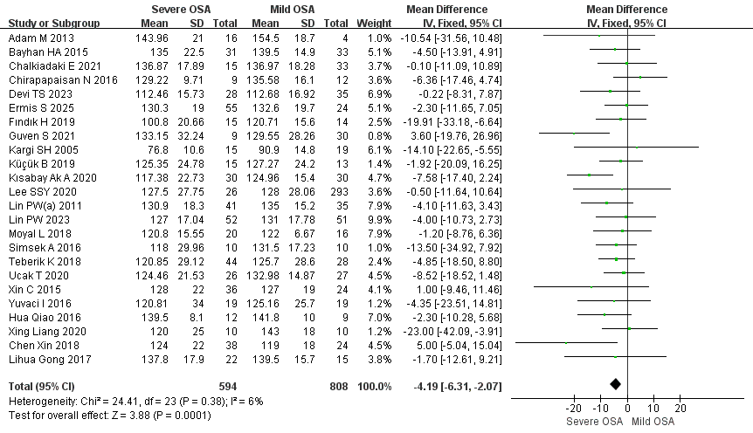
Supplementary Figure 37. Forest plot comparing I RNFL thickness between patients with severe and mild OSA.
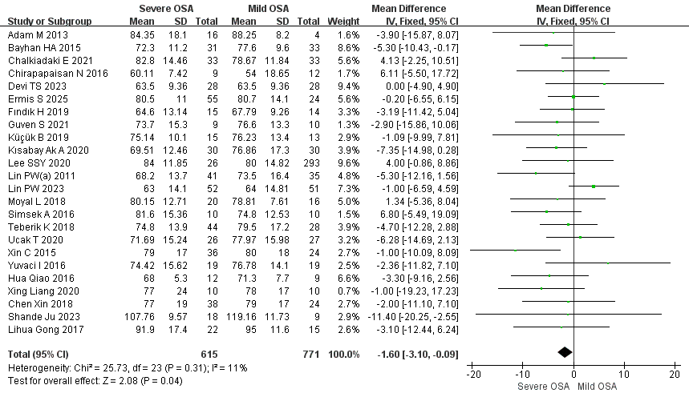
Supplementary Figure 38. Forest plot comparing N RNFL thickness between patients with severe and mild OSA.
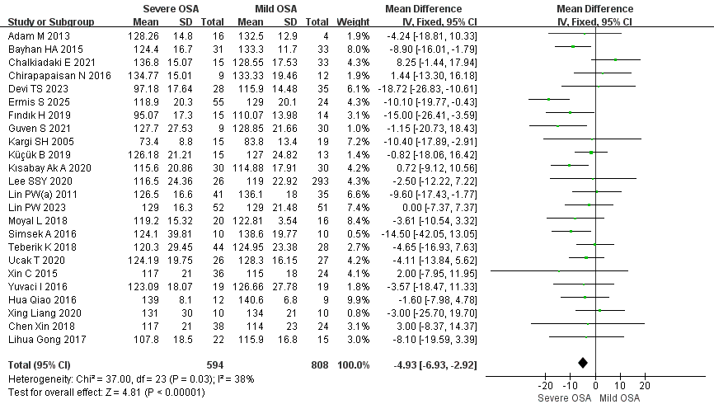
Supplementary Figure 39. Forest plot comparing S RNFL thickness between patients with severe and mild OSA.
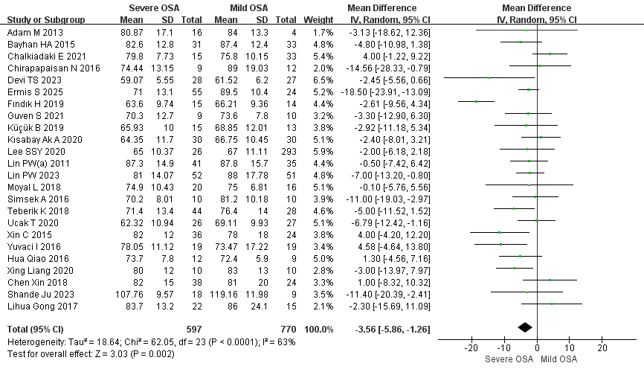
Supplementary Figure 40. Forest plot comparing T RNFL thickness between patients with severe and mild OSA.

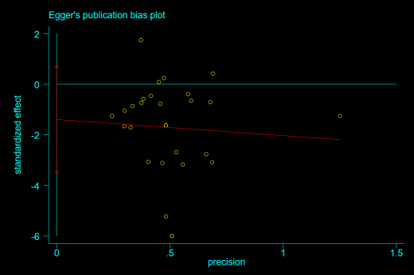
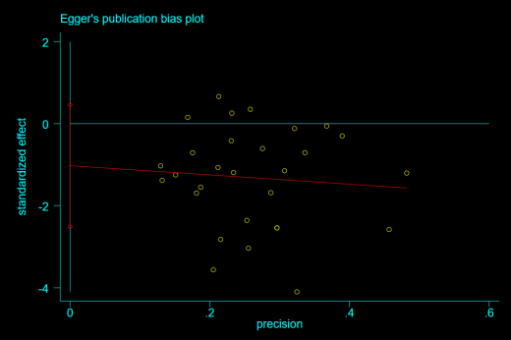
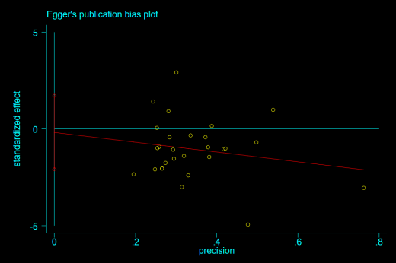
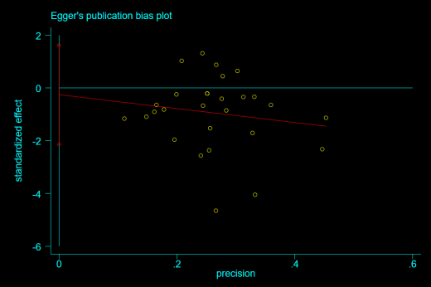
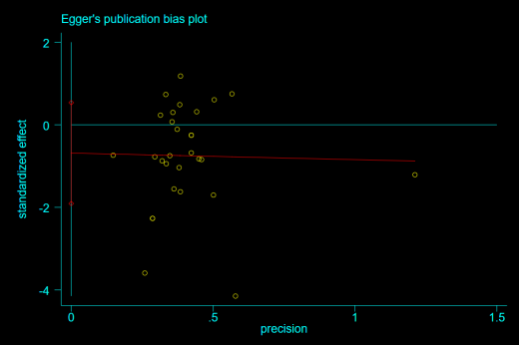
A.
B.
C.
D.
E.
Supplementary Figure 41. Egger’s test plots for publication bias in comparisons of RNFL thickness between patients with OSA and healthy controls. (A, Egger’s test plot for the average RNFL thickness in OSA versus healthy controls; B–E, Egger’s test plots for superior, inferior, nasal, and temporal RNFL thickness, respectively.)

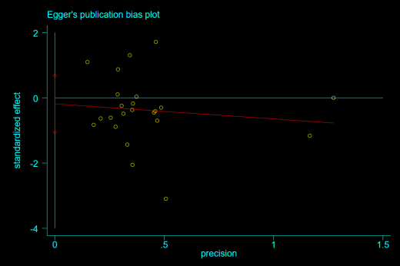
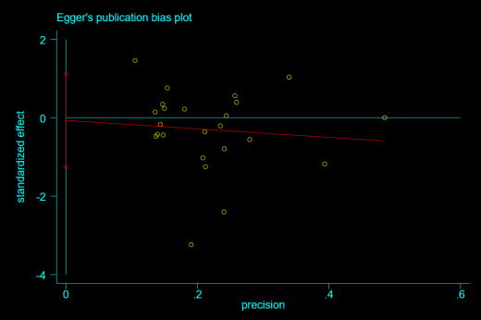
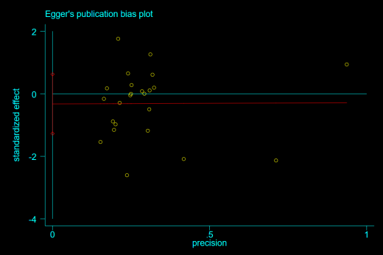
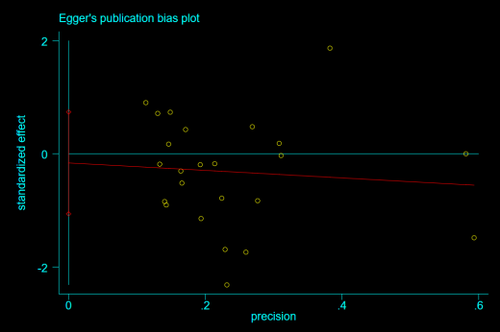
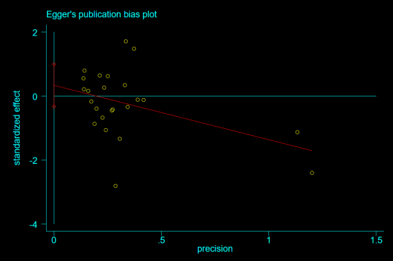
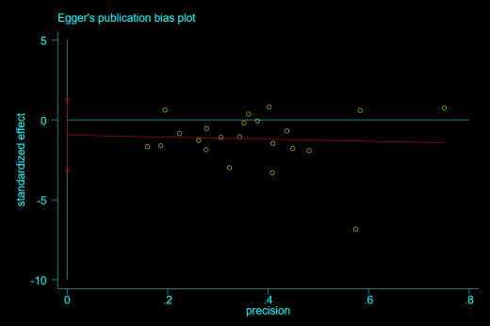
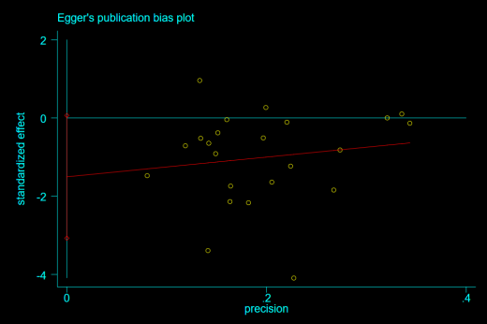
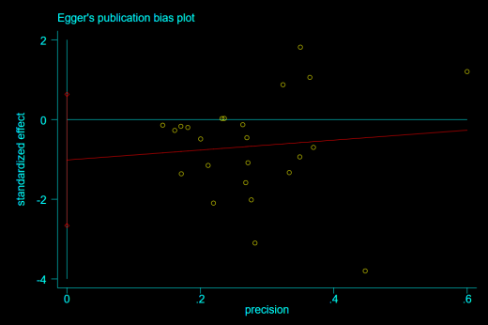
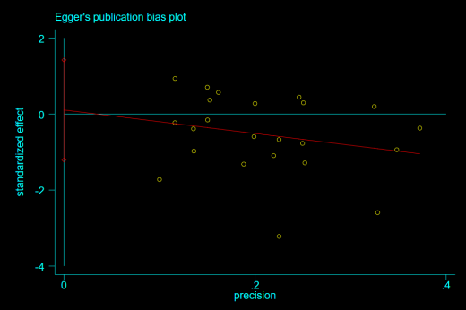
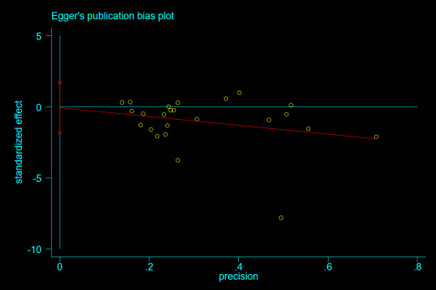
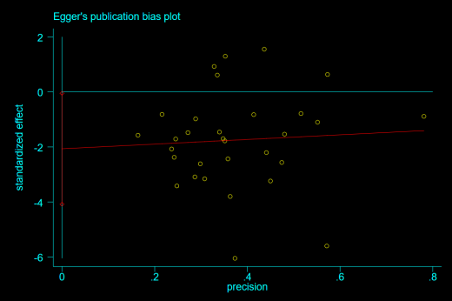
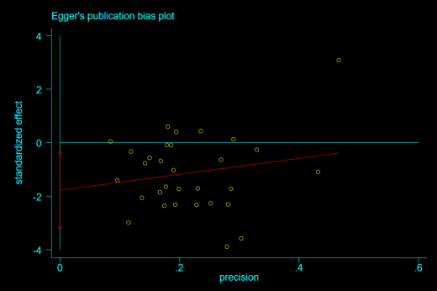
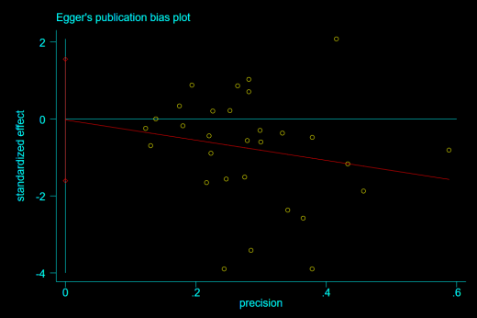
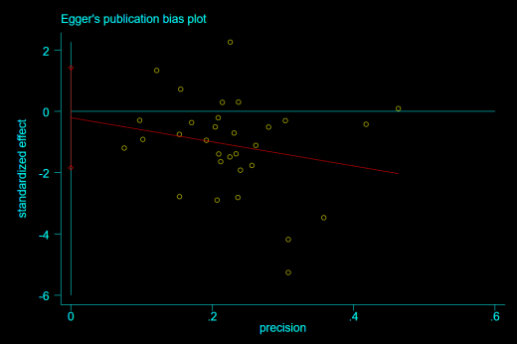
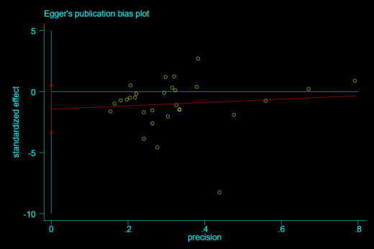
Supplementary Figure 42. Egger’s test plots for publication bias of RNFL thickness in mild, moderate, and severe OSA versus healthy controls. (A–E, mild OSA versus healthy controls; F–J, moderate OSA versus healthy controls; K–O, severe OSA versus healthy controls. The order is average, superior, inferior, nasal, and temporal RNFL thickness.)
A.
B.
C.
D.
E.
F.
G.
H.
I.
J.
K.
L.
M.
N.
O.

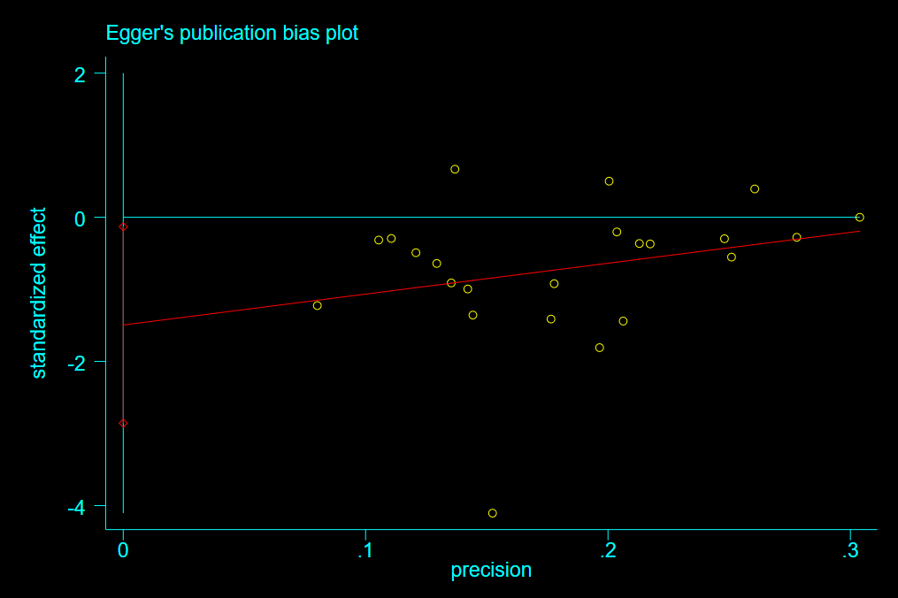
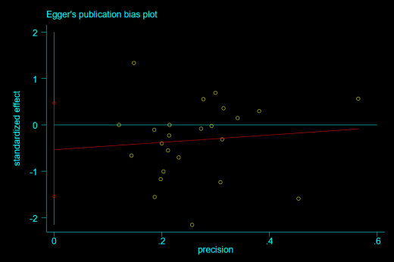
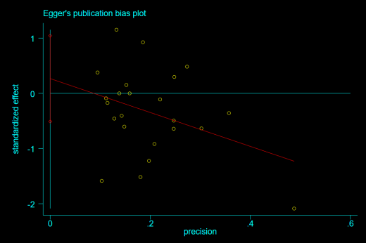
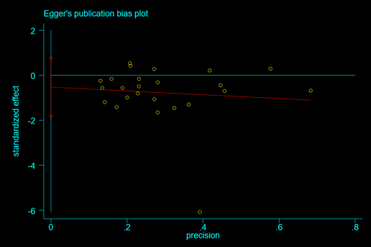
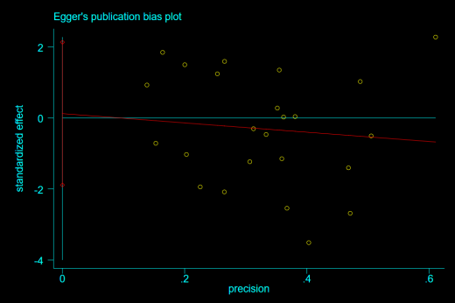
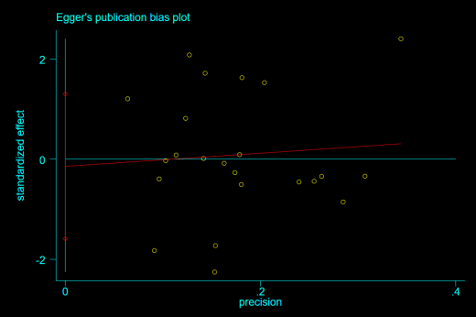
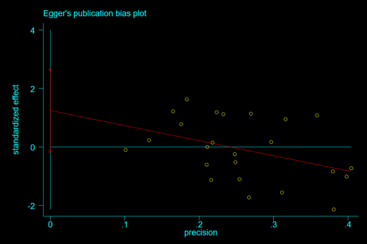
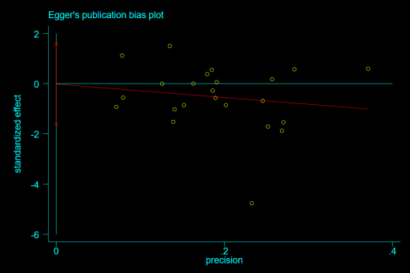
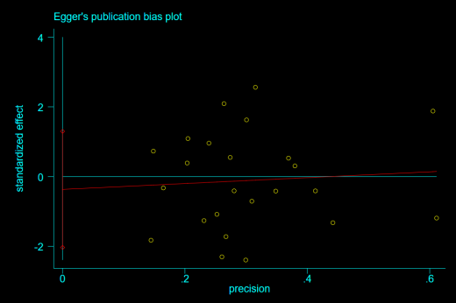
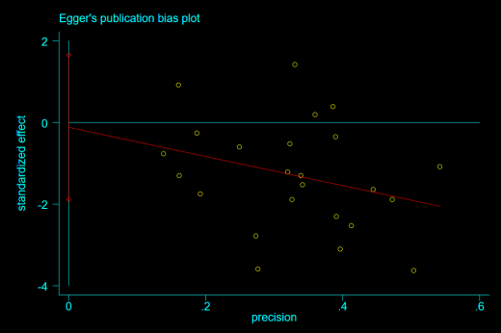
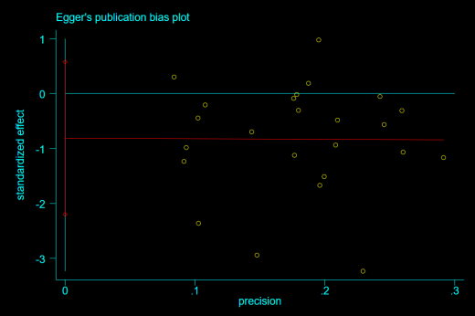
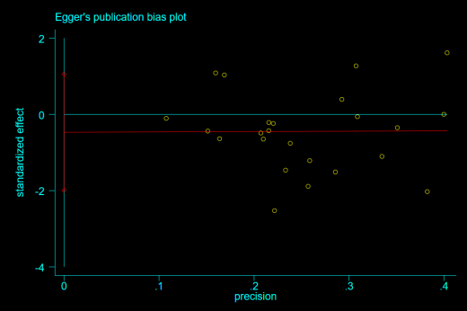
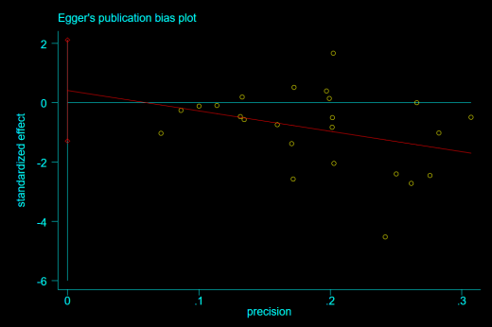
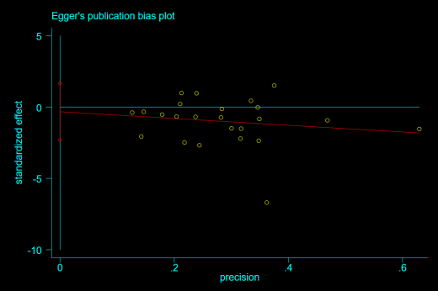
Supplementary Figure 43. Egger’s test plots for publication bias of RNFL thickness among patients with different severities of OSA. (A–E, moderate versus mild OSA; F–J, severe versus mild OSA; K–O, severe versus moderate OSA. In each group, the order is average, superior, inferior, nasal, and temporal RNFL thickness.)
A.
B.
C.
D.
E.
F.
G.
H.
I.
J.
K.
L.
L.
M.
N.

Supplementary Figure 44. Subgroup analysis of average RNFL thickness between patients with OSA and healthy controls according to OCT device platform.

Supplementary Figure 45. Subgroup analysis of average RNFL thickness between patients with OSA and healthy controls according to OCT technology.
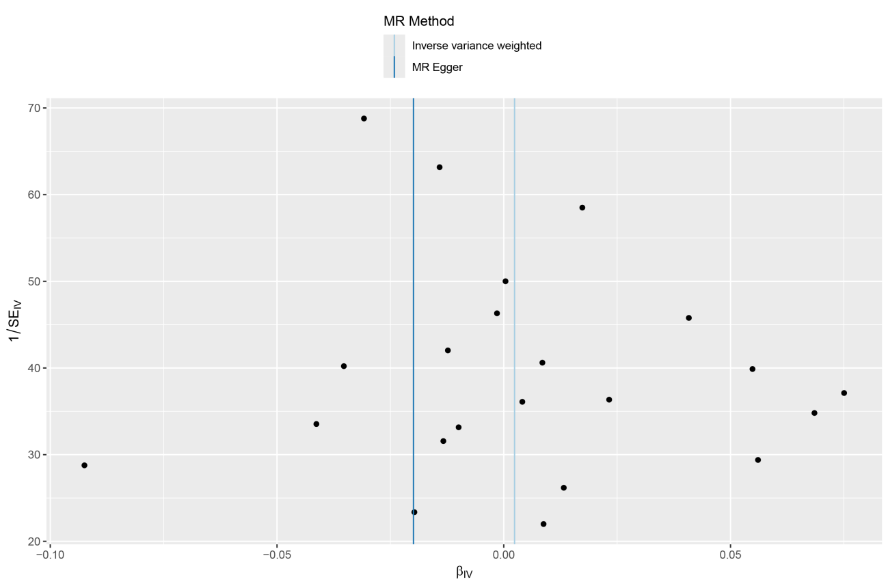
Supplementary Figure 46. Funnel plot of the Mendelian randomization analysis with RNFL thickness as the exposure and OSA as the outcome.
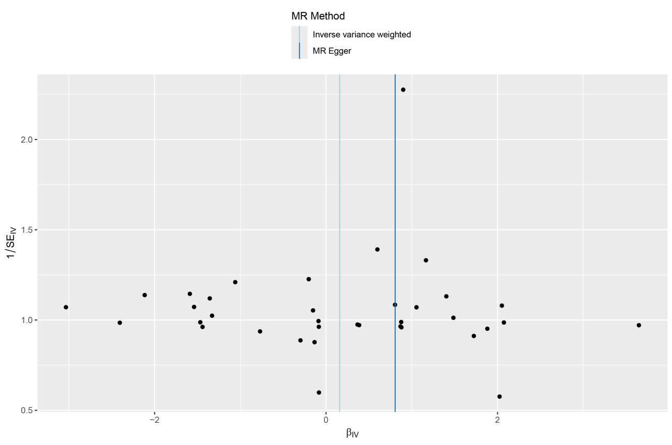
Supplementary Figure 47. Funnel plot of the Mendelian randomization analysis with OSA as the exposure and RNFL thickness as the outcome.

