APPENDICES

Web-appendix 1. Search methods: detailed search strategy 1
Web-appendix 2. Criteria for trial eligibility 5
Web-appendix 3. Extraction sheet for trials assessing efficacy/safety and effectiveness/impact of rotavirus vaccine 7
Web-appendix 4. Extraction sheet for risk of bias assessment in trials evaluating efficacy/safety of rotavirus vaccine 9
Web-appendix 5. Selected studies for efficacy/safety evaluation of rotavirus vaccine 10
Web-appendix 6. Risk of bias graph 13
Web-appendix 7. Summary of the characteristics of studies included for assessing efficacy/safety of rotavirus vaccines 14
Web-appendix 8. Forest plot of meta-analysis for severe diarrhea of any cause 15
Web-appendix 9. Forest plot of meta-analysis for treatment-related mortality 15
Web-appendix 10. Forest plot of meta-analysis for treatment-related intussusception 16
Web-appendix 12. Forest plot of meta-analysis for treatment-related severe adverse events 18
Web-appendix 13. Identified studies for effectiveness evaluation of rotavirus vaccine 19
Web-appendix 14. Summary of the characteristics of studies included for evaluate effectivenes of rotavirus vaccine 21
Web-appendix 15. Summary of results of studies assessing effectiveness of rotavirus vaccine 22

Web-appendix 1. Search methods: detailed search strategy

- Efficacy and Safety

- Search terms
- “Clinical Trials as Topic”[Mesh]
- Clinical Trial
- ‘clinical trial’/de
- ‘controlled clinical trial’/de
- ‘double blind procedure’/de‘randomized controlled trial’/de

- Search terms for rotavirus-induced gastroenteritis
- “Rotavirus infections”[Mesh]
- Rotavirus
- Infection
- Gastroenteritis

- Search terms for human rotavirus vaccines: RotarixTM and RotaTeq®
- “RIX4414 vaccine” [Supplementary Concept]
- “RotaTeq®” [Supplementary Concept]
- “Rotavirus Vaccines”[Mesh]
- RotarixTM
- RIX4414
- RotaTeq®
- rota teq
- “rotavirus vaccin*’
- ‘Rotarix TM vaccine’
- rv5
- rv1

- Search limits
- Age from 0-18 years
- Humans
- Date from 01/01/2000 to 31/12/2011

- Effectiveness

- Search terms
- “Comparative Effectiveness Research”[Mesh]
- “Evaluation Studies as Topic”[Mesh]
- “Treatment Outcome”[Mesh]
- “Program Evaluation”[Mesh]
- “Population Surveillance”[Mesh]
- “Epidemiological Studies”[Mesh]
- “Case-control Studies”[Mesh]
- “Cohort Studies”[Mesh]
- “Outcome Assessment (Health Care)”[Mesh]
- Impact
- Effectiveness
- Surveillance
- ‘case control study’/de
- ‘cohort analysis’/de
- ‘comparative study’/de
- ‘drug surveillance program’/de
- ‘postmarketing surveillance’/de
- ‘impact’
- ‘effectiveness’
- ‘surveillance’
- ‘comparative effectiveness research’
- ‘evaluation studies as topic’
- ‘treatment outcome’
- ‘program evaluation’
- ‘population surveillance’
- ‘epidemiologic studies’
- ‘outcome assessment’

- Search terms for rotavirus-induced gastroenteritis
- “Rotavirus”[Mesh]
- “Rotavirus Infections”[Mesh]
- Rotavirus
- “rotavirus infections’
- Gastroenteritis
- ‘rotavirus’/exp
- ‘rotavirus infections’/exp
- ‘rotavirus’/exp
- ‘infection’/exp
- ‘gastroenteritis’/exp

- Search terms for human rotavirus vaccines: RotarixTM and RotaTeq®
- “Rotavirus Vaccines”[Mesh]
- “RIX4414 vaccine” [Supplementary Concept]
- “RotaTeq®” [Supplementary Concept]
- (“Vaccination”[Mesh]
- “Mass Vaccination”[Mesh]
- “Immunization”[Mesh]
- “Immunization Programs”[Mesh]
- RotarixTM
- RotaTeq®
- RIX4414
- Vaccination
- vaccine*
- immunization
- “immunization programs”
- ‘rotavirus vaccines’/exp
- ‘rotateq’/exp
- ‘rix4414 vaccine’
- ‘rix4414’
- ‘rotarix’/exp
- ‘vaccination’/exp
- ‘mass vaccination’/exp
- ‘immunization’/exp
- ‘immunization program’

- Exclusion terms
- “Randomized Controlled Trial”[Publication Type]
- “Randomized Controlled Trials as Topic” [Mesh]
- “Editorial” [Publication Type]
- “Comment”[ Publication Type]
- “Review”[ Publication Type]
- “Review Literature as Topic”[Mesh]
- “Cost-Benefit Analysis”[Mesh]
- “Africa”[Mesh]
- “Asia”[Mesh]
- “Europe”[Mesh]
- “North America”[Mesh]
- “Oceania”[Mesh]
- ‘controled study’/de
- ‘double blind procedure’/de
- ‘interview’/de
- ‘nonhunam’/de
- ‘phase 2 clinical trial’/de
- ‘phase 3 clinical trial’/de
- ‘questionnaire’/de
- ‘randomized controlled trial’/de
- ‘randomized controlled trials as topic’
- ‘editorial’/de
- ‘comment’
- ‘review’/de
- ‘review literature as topic’
- ‘cost-benefit analysis’/de
- ‘africa’
- ‘asia’
- europe’
- ‘north america’
- ‘oceania’

- Search limits
- Age from 0-18 years
- Humans
- Date from 01/01/2000 to 31/12/2011

In LILACS we used the following search strategy: “( ( “ROTAVIRUS INFECTIONS”) or “ROTAVIRUS”) or “ROTAVIRUS VACCINES” or rotarix or rotateq or rix4414 or rv5 [Words] and “HUMANS” [Limits] and not “CONTROLLOLED CLINICAL TRIAL” [Publication type]”.
In Scielo the following search strategy was used: “rotavirus OR rotarix OR rotateq OR RIX4414 or RV5 OR “Rotavirus Vaccines””

Web-appendix 2. Criteria for trial eligibility

Inclusion criteria for trial eligibility of efficacy/safety or effectiveness assessment of rotavirus vaccine
EFFICACY AND SAFETY
Trial design | Target population, location objective of the trial and period of evaluation | Treatment |  |  |  | Evaluated outcomesª
Exclusively randomized clinical trials | Children aged <12 months  Trials conducted in countries from Latin America and the Caribbean  To assess efficacy and safety of Rotavirus-immunized infants  Trial conducted after year 2000 |  | - Experimental group received Rotavirus vaccine (RotaTeq® or RotarixTM)  - Placebo group  - Other Rotavirus vaccine  - None of the others |  | - Rotavirus gastroenteritis of any severity  - Severe Rotavirus gastroenteritis  - Rotavirus gastroenteritis requiring hospitalization  - All-cause diarrhea  - Emergency department visit due to diarrhea  - Mortality due to rotavirus  - Severe adverse event
EFFECTIVENESS
Study design | Target population, location, objective of the study and period of evaluation |  |  | Treatment and comparison of groups
Case-control studies | Children < 5 years old  Studies carried on in countries from Latin America and the Caribbean  Evaluation of effectiveness  Studies done after year 2000 |  | - One group exposed to any of currently licensed Rotavirus vaccines (RotaTeq® or RotarixTM)  - One unvaccinated group  - Comparison among immunized and unvaccinated groups |  | - Rotavirus gastroenteritis of any severity  - Severe Rotavirus gastroenteritis  - Rotavirus gastroenteritis requiring hospitalization  - All-cause diarrhea  - Emergency department visit due to diarrhea
ª Included trials evaluated at least one of these outcomes

Web-appendix 3. Extraction sheet for trials assessing efficacy/safety and effectiveness/impact of rotavirus vaccine

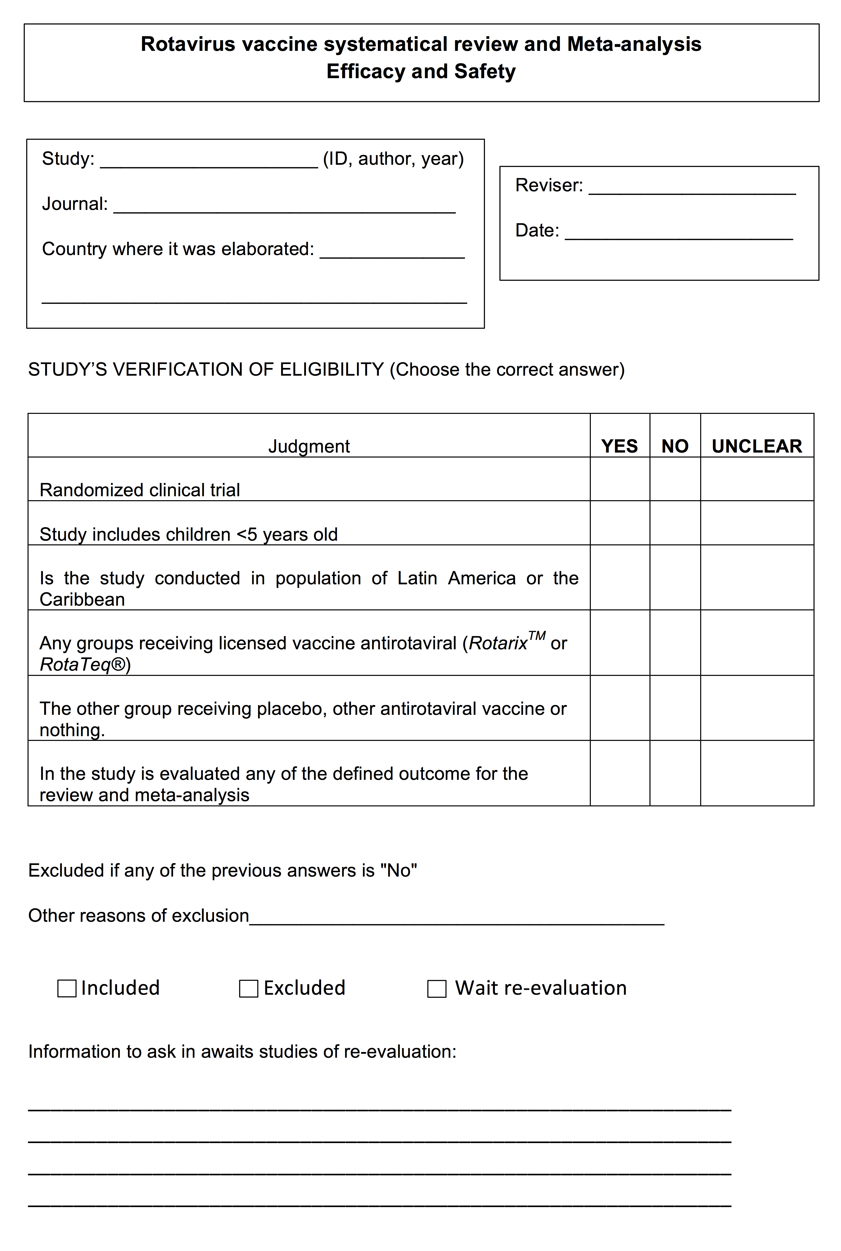
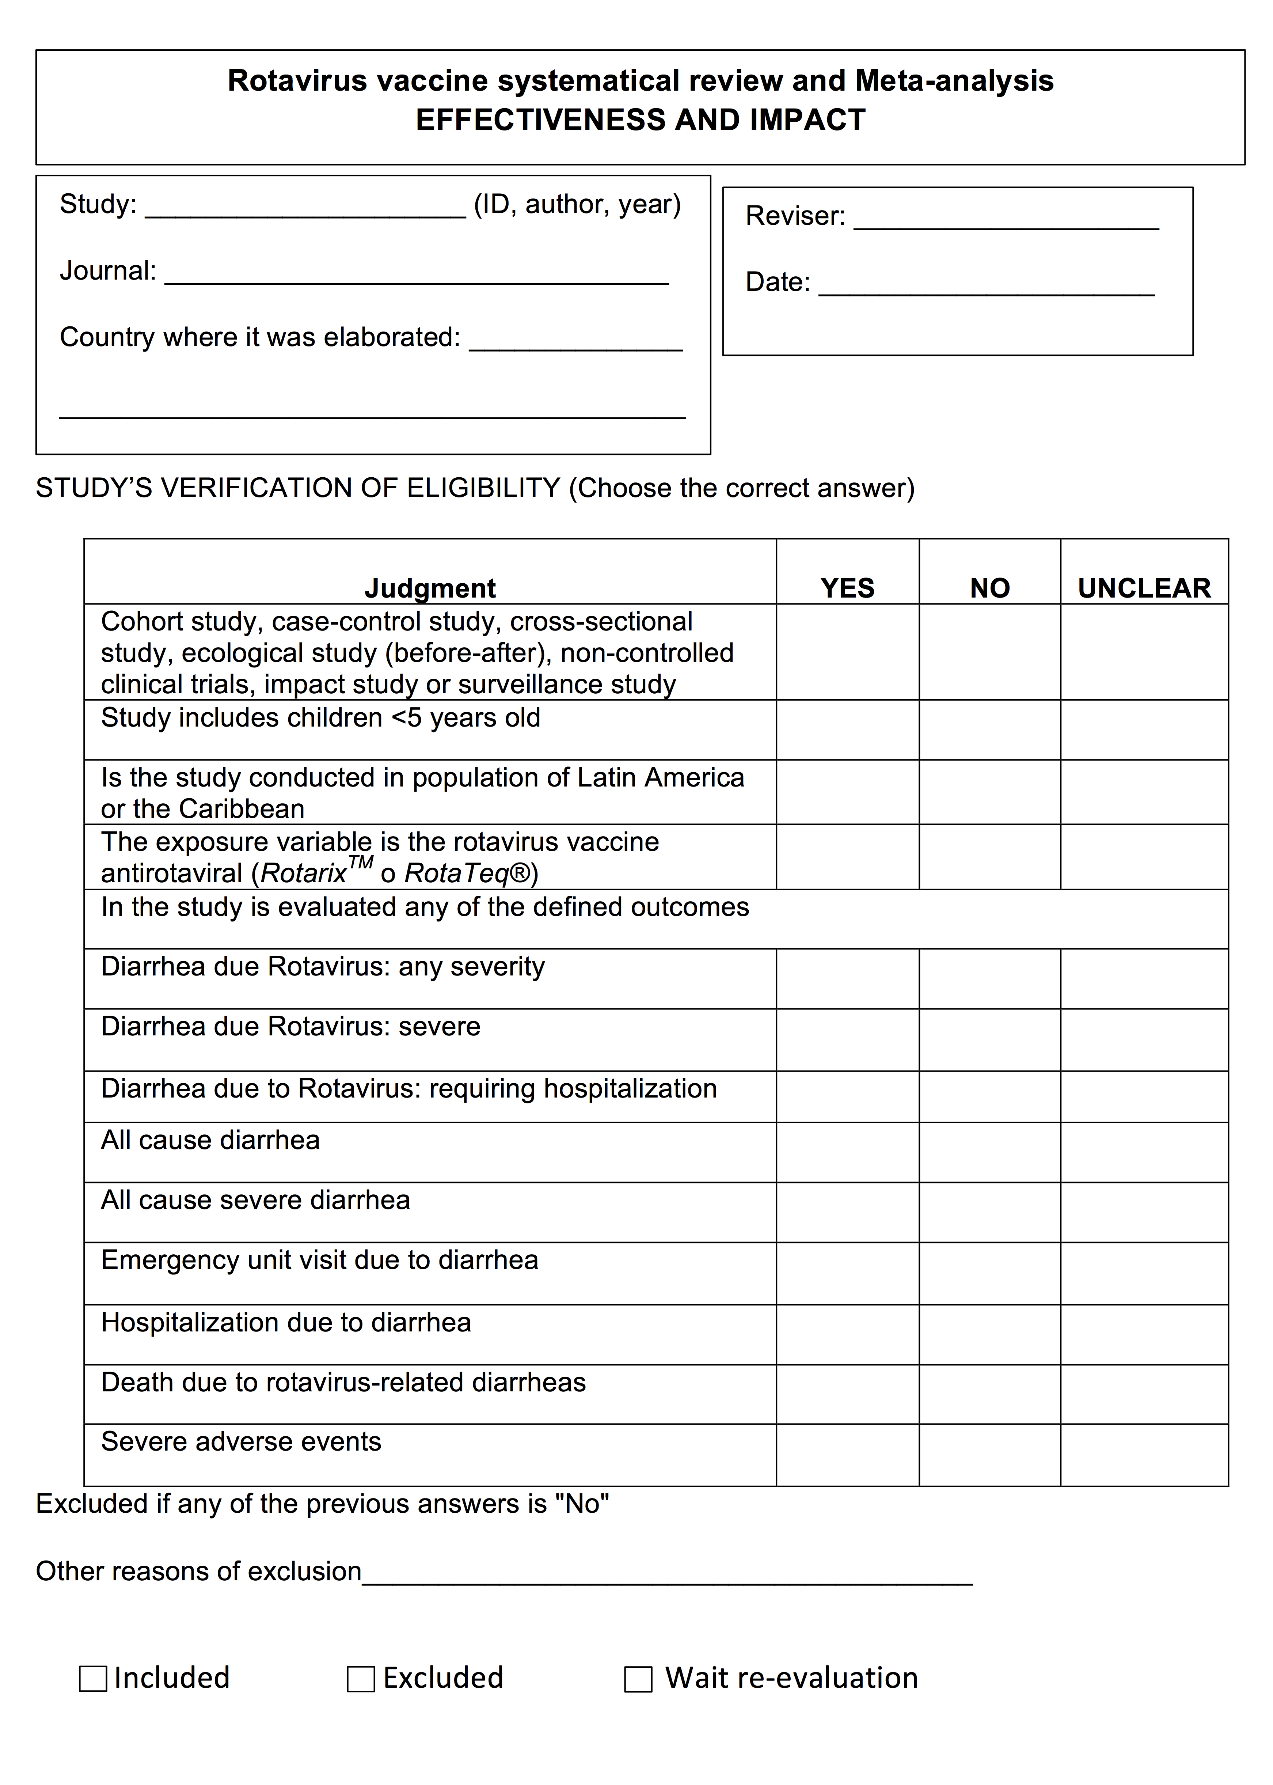

Web-appendix 4. Extraction sheet for risk of bias assessment in trials evaluating efficacy/safety of rotavirus vaccine

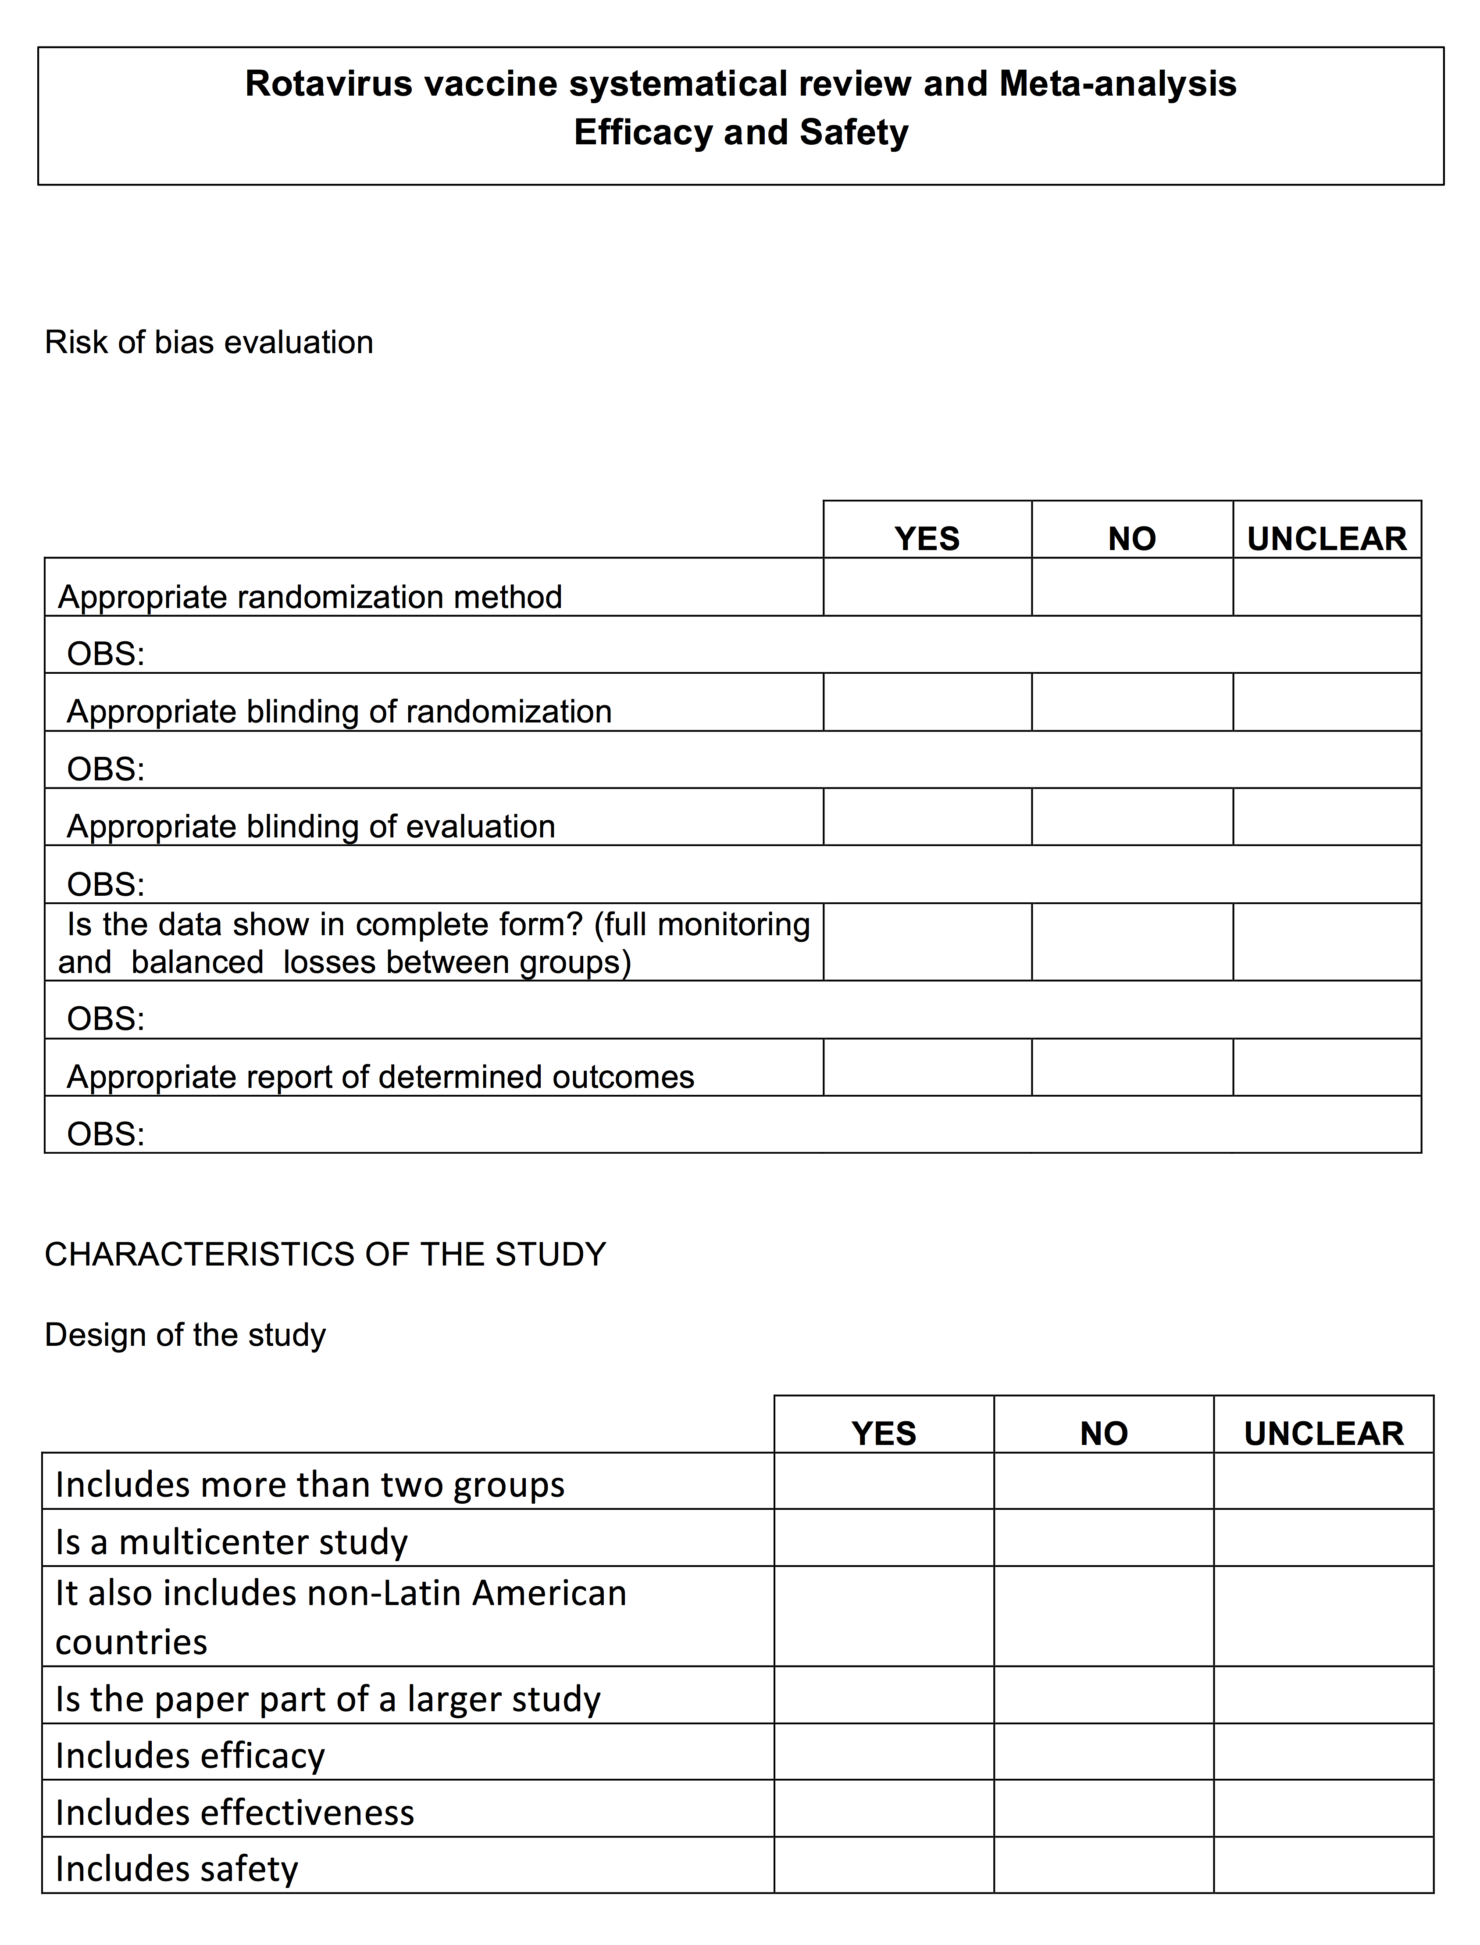

Web-appendix 5. Selected studies for efficacy/safety evaluation of rotavirus vaccine

Selected studies after applied PRISMA* flow chart for the systematic review to evaluate rotavirus vaccine efficacy and safety in countries from Latin America and the Caribbean.

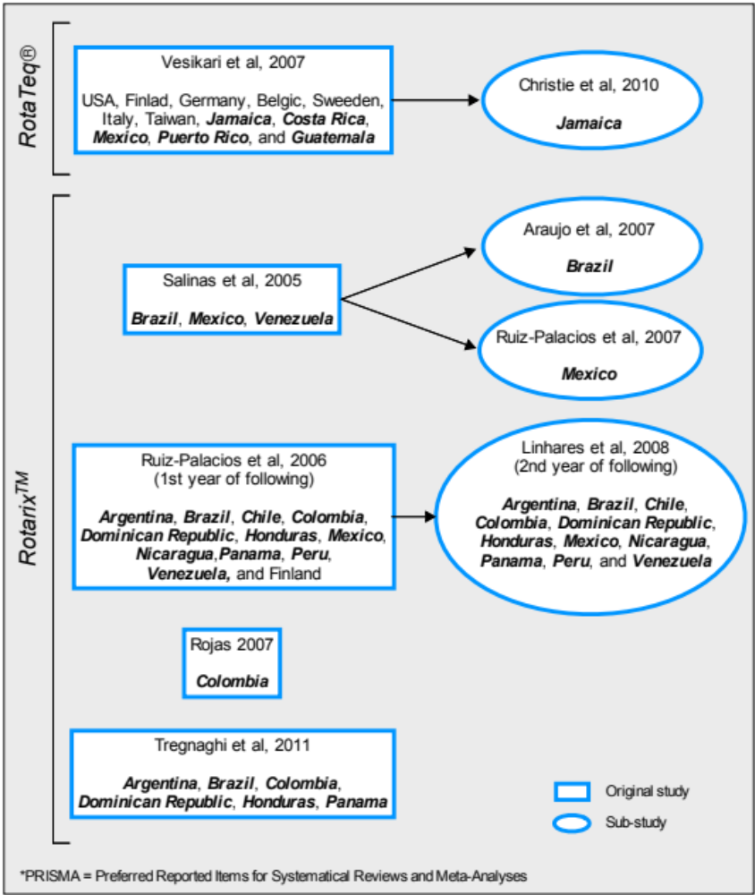

References of the included trials
Araujo EC, Clemens SAC, Oliveira CS, Justino MCA, Rubio P, Gabbay YB, et al. Safety, immunogenicity, and protective efficacy of two doses of RIX4414 live attenuated human rotavirus vaccine in healthy Brazilian infants. J. Pediatr. (Rio. J). 2007;83:217–224.
Christie CDC, Duncan ND, Thame KA, Onorato MT, Smith HD, Malcolm LG, et al. Pentavalent rotavirus vaccine in developing countries: safety and health care resource utilization. Pediatrics. 2010;126:e1499–506
Linhares AC, Velázquez FR, Pérez-Schael I, Sáez-Llorens X, Abate H, Espinoza F, et al. Efficacy and safety of an oral live attenuated human rotavirus vaccine against rotavirus gastroenteritis during the first 2 years of life in Latin American infants: a randomised, double-blind, placebo-controlled phase III study. Lancet. 2008;371:1181–9.
Rojas OL, Caicedo L, Guzmán C, Rodríguez L-S, Castañeda J, Uribe L, et al. Evaluation of circulating intestinally committed memory B cells in children vaccinated with attenuated human rotavirus vaccine. Viral Immunol. 2007;20:300–11.
Ruiz-Palacios GM, Pérez-Schael I, Velázquez FR, Abate H, Breuer T, Clemens SC, et al. Safety and efficacy of an attenuated vaccine against severe rotavirus gastroenteritis. N. Engl. J. Med. 2006;354:11–22.
Ruiz-Palacios GM, Guerrero ML, Bautista-Márquez A, Ortega-Gallegos H, Tuz-Dzib F, Reyes-González L, et al. Dose response and efficacy of a live, attenuated human rotavirus vaccine in Mexican infants. Pediatrics. 2007;120:e253–61
Salinas B, Pérez Schael I, Linhares AC, Ruiz Palacios GM, Guerrero ML, Yarzábal JP, et al. Evaluation of safety, immunogenicity and efficacy of an attenuated rotavirus vaccine, RIX4414: A randomized, placebo-controlled trial in Latin American infants. Pediatr. Infect. Dis. J. 2005;24:807–16
Tregnaghi MW, Abate HJ, Valencia A, Lopez P, Da Silveira TR, Rivera L, et al. Human rotavirus vaccine is highly efficacious when coadministered with routine expanded program of immunization vaccines including oral poliovirus vaccine in Latin America. Pediatr. Infect. Dis. J. 2011;30:e103–8
Vesikari T, Itzler R, Matson DO, Santosham M, Christie CDC, Coia M, et al. Efficacy of a pentavalent rotavirus vaccine in reducing rotavirus-associated health care utilization across three regions (11 countries). Int. J. Infect. Dis. 2007;11 Suppl 2:S29–35

Web-appendix 6. Risk of bias graph

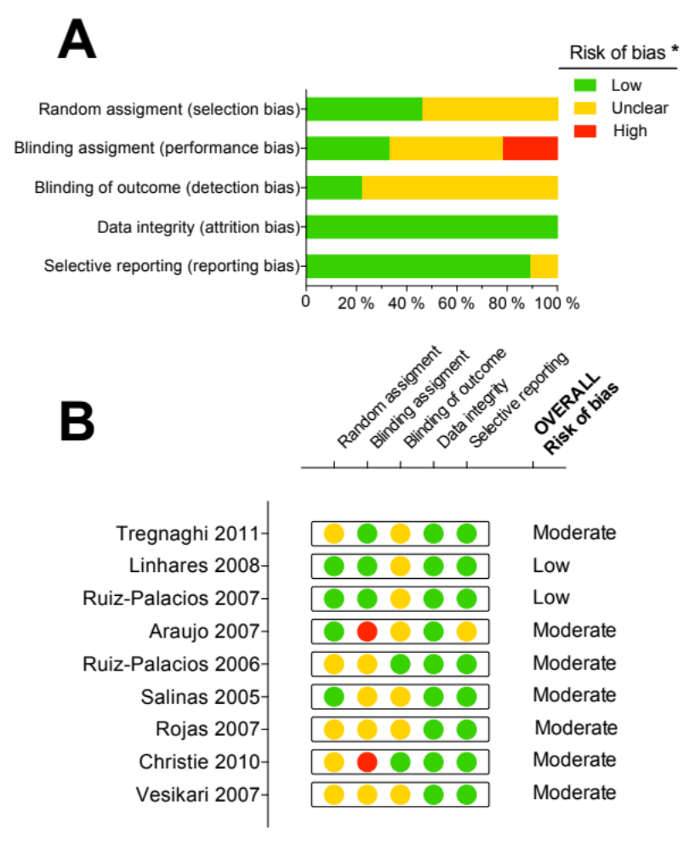
A) Graph illustrating the proportion of studies with judgments of risk of bias for each entry, and B) and risk of bias summary figure presenting study-specific judgment for each entry of included trials for efficacy/safety assessment of rotavirus vaccines in Latin America and the Caribbean. * Risk of Bias: High, clearly indicates bias in each domain; Low, clearly excludes bias in each domain; Unclear, insufficient information to permit judgment of risk of bias.

Web-appendix 7. Summary of the characteristics of studies included for assessing efficacy/safety of rotavirus vaccines

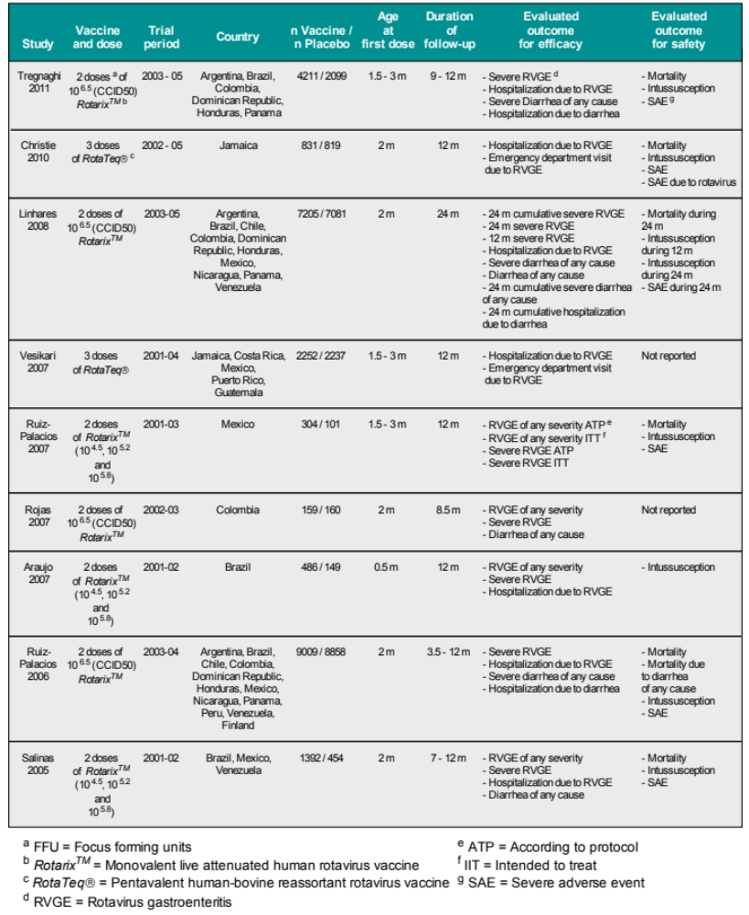

Web-appendix 8. Forest plot of meta-analysis for severe diarrhea of any cause

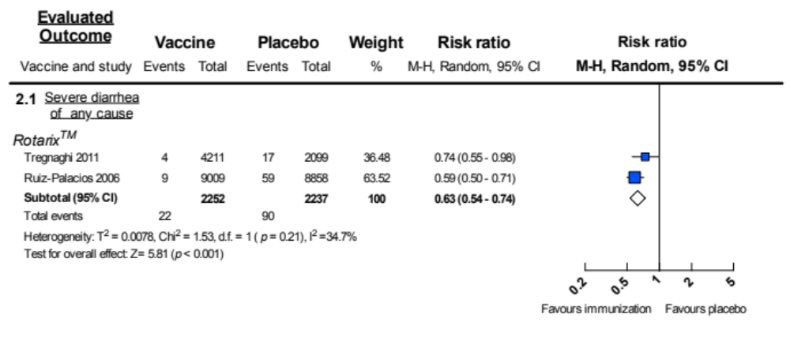

Rotavirus immunization vs. placebo: relative risk for preventing severe diarrhea of any cause.

Web-appendix 9. Forest plot of meta-analysis for treatment-related mortality

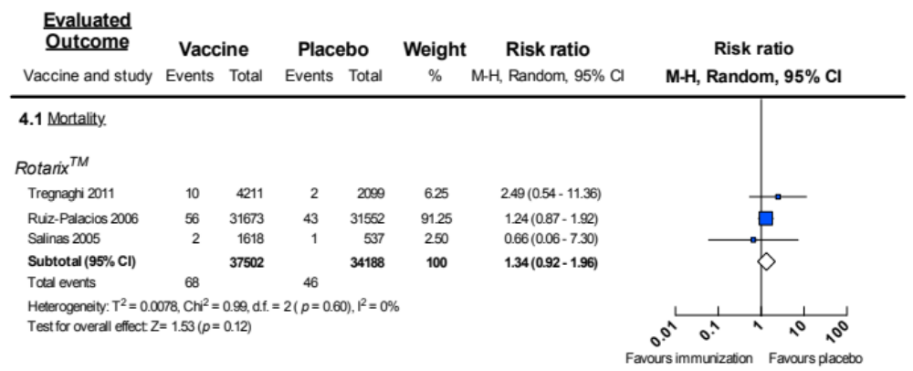

Rotavirus immunization vs. placebo: association between death and treatment

Web-appendix 10. Forest plot of meta-analysis for treatment-related intussusception

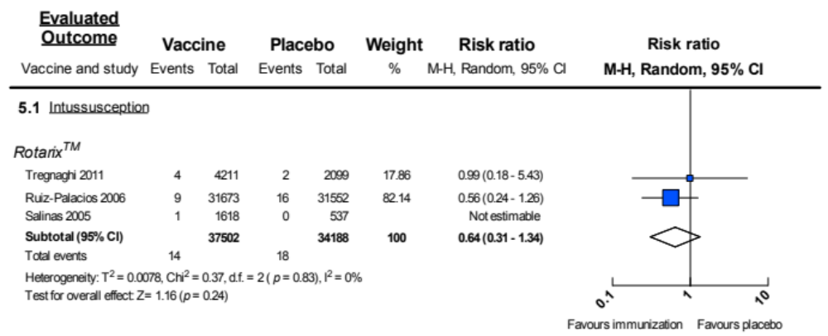

Rotavirus immunization vs. placebo: association between intussusception and treatment.

Web-appendix 11. Common severe adverse events occurring in rotavirus immunized and placebo groups.
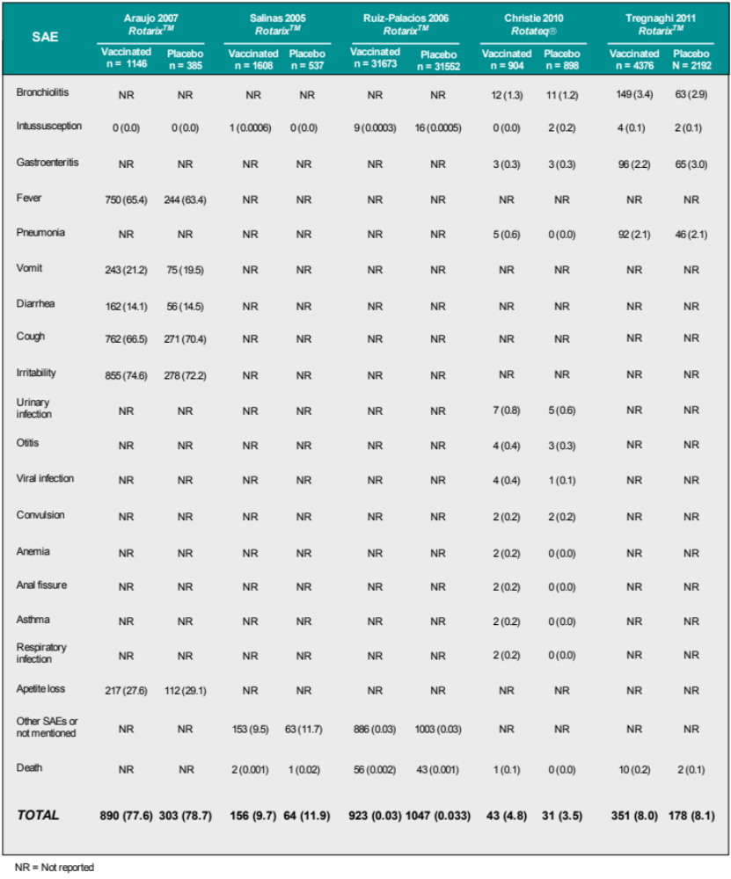

Web-appendix 12. Forest plot of meta-analysis for treatment-related severe adverse events

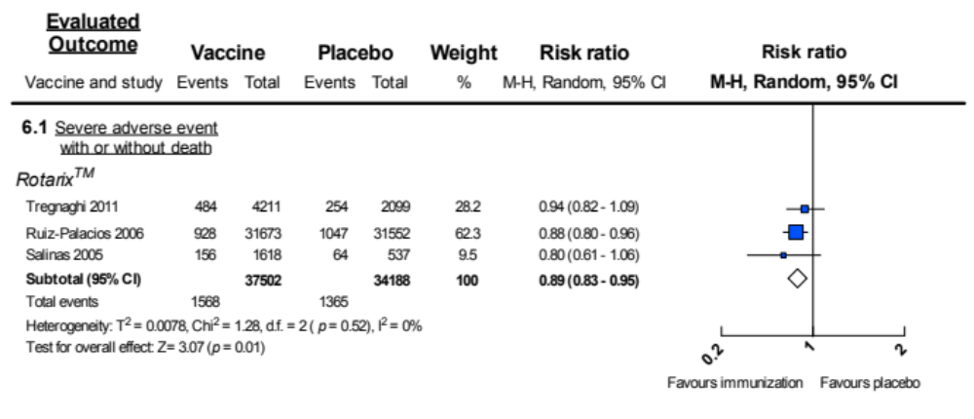

Rotavirus immunization vs. placebo: association between severe adverse events and treatment.

Web-appendix 13. Identified studies for effectiveness evaluation of rotavirus vaccine

Case-control studies selected after applied PRISMA* flow chart for the systematic review to evaluate rotavirus vaccine effectiveness in countries from Latin America and the Caribbean.
Case control

RotaTeq®
RotarixTM |  | 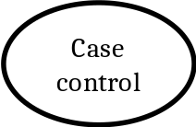
 | Analytical study
*PRISMA = Preferred Reported Items for Systematic Reviews and Meta-Analysis

Patel et al. 2009
de Palma et al. 2010
Correia et al. 2010
Justino et al. 2011

References of the included trials
Correia JB, Patel MM, Nakagomi O, Montenegro FMU, Germano EM, Correia NB, et al. Effectiveness of monovalent rotavirus vaccine (RotarixTM) against severe diarrhea caused by serotypically unrelated G2P[4] strains in Brazil. J. Infect. Dis. 2010;201(3):363–9
Justino MCA, Linhares AC, Lanzieri TM, Miranda Y, Mascarenhas JDP, Abreu E, et al. Effectiveness of the monovalent G1P[8] human rotavirus vaccine against hospitalization for severe G2P[4] rotavirus gastroenteritis in Belém, Brazil. Pediatr. Infect. Dis. J. 2011;30:396–401.
De Palma O, Cruz L, Ramos H, de Baires A, Villatoro N, Pastor D, et al. Effectiveness of rotavirus vaccination against childhood diarrhoea in El Salvador: case-control study. BMJ. 2010;340:c2825
Patel M, Pedreira C, De Oliveira LH, Tate J, Orozco M, Mercado J, et al. Association between pentavalent rotavirus vaccine and severe rotavirus diarrhea among children in Nicaragua. JAMA. 2009;301:2243–51.

Web-appendix 14. Summary of the characteristics of studies included for evaluate effectivenes of rotavirus vaccine

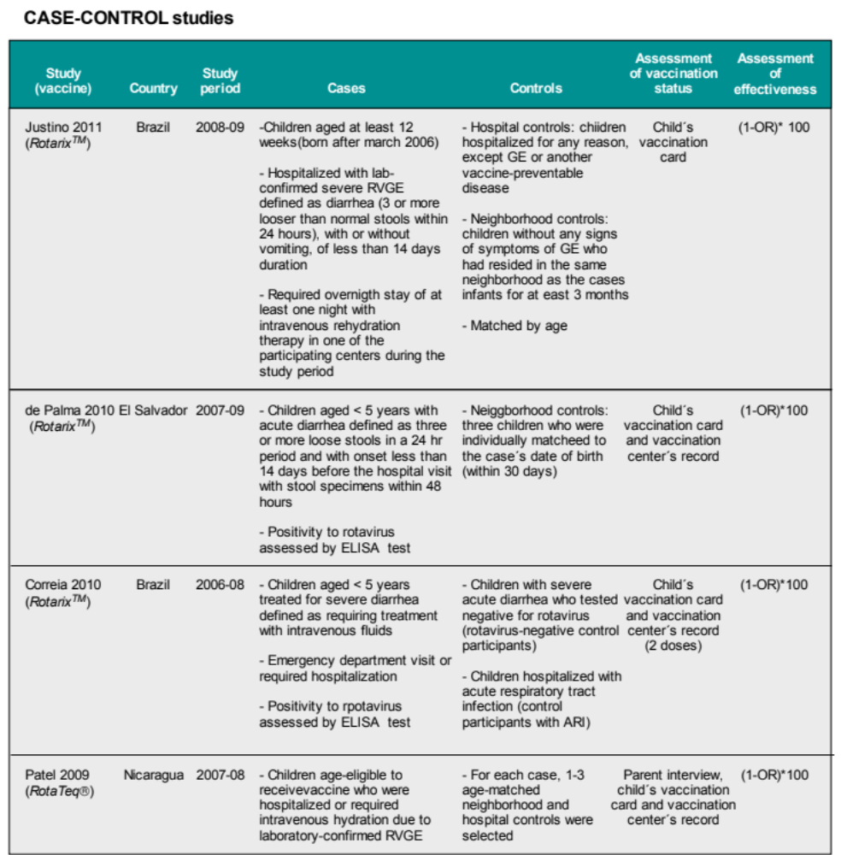

Web-appendix 15. Summary of results of studies assessing effectiveness of rotavirus vaccine

