SCREEN TIME QUESTIONNAIRE
(Please tick against your answer)

- Name of Child: ………………………………………………………………………………………………..
- Name of School: ……………………………………………………………………………………………..
- Father’s education and occupation: ……………………………………………………………………
- Mother’s education and occupation: ……………………………………………………………………

- Who takes care of the child at home
  - Parent
  - Grandparent
  - Maid
  - Older sibling

- Number of siblings
  - 1
  - 2
  - 3
  - 4
  - Others ………………………………………

- Order of the child in question
  - 1
  - 2
  - 3
  - 4
  - Others ……………………………………….

- Age of child:
- 0-18 months
- 18-24 months
- 2-5 years

- What is the average time your child spends on the screen?
- <1 hour ( ………. Mins)
- 1-3 hours (………. Hours)
- 3-5 hours (………… Hours)
- 5 hours (…………Hours)

- Which type of device does your child use?
- TV
- Mobile
- Tablet
- Video Games
- Computer/Laptop

- Do you supervise your child when he uses devices?
- All of the time
- Some of the time
- Never

- What is the content that your child sees on the devices?
- Gaming
- Cartoons/Movies
- YouTube
- Others, specify………………….

- At what age was your child introduced to screens/devices?
- Between 0- 12 months
- Between 1-3 years
- Between 3-5 years

- In what context does your child use the screen?
- On demand
- As a reward
- To pacify the child in stressful conditions
- Others, specify…………….

- Is the content that your child sees on the screen monitored?
- Yes
- No

- Do you co-view with your child as he/she uses the digital device?

- All the time
- Some of the time
- Never

11. Does your child have his/her own device?
- Yes
- No

12. Do you set a daily time limit for your child’s screen time?
- Yes
- No

13. Do you impose screen free time intervals/ screen free areas ?
- Yes
- No

14. How many hours does your child engage in physical activity?
- < 30 mins
- 30 mins – 1 hour
- 1-3 hours
- > 3 hours

15. Does your child show interest in activities other than digital devices?
- Playing with friends
- Drawing and colouring
- Arts and craft
- Spending time with older relatives
- Others, specify………………

16. Does your child show interest in interacting with children who are his/her age?
- Yes
- No

17. How many hours before bedtime is the digital device taken from the child?
- 1 hour
- 2 hours
- 3 hours
- More than 3 hours
- Child goes off to sleep while watching the digital device

18. Do you feel that your child has speech delay for his age?
- Yes
- No

19. Are you able to control your child’s screen time?
- Yes
- No

20. Does your child use any device during meal times?
- All of the time
- Some of the time
- Never

21. Does your child throw tantrums if refused any devices?
- All of the time
- Some of the time
- Never

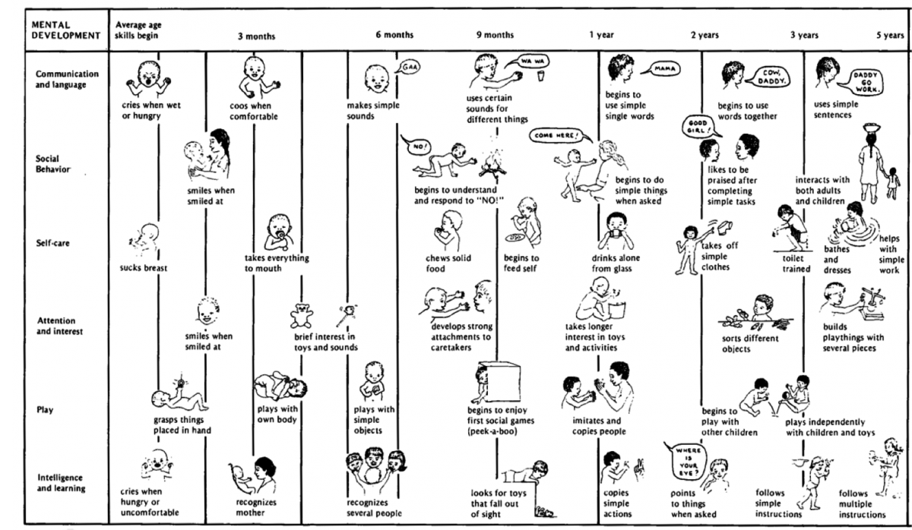
KINDLY MARK ON THE CHART WHAT YOUR CHILD IS CURRENTLY ABLE TO DO

