S Table: The burden of neural tube defects among African countries, 2020

S. No. | Country | Prevalence of neural tube defects per 10, 000 births (95 % CI)
1. | Ethiopia | 61.43 (46.70, 76.16)⃰
2. | Tunisia | 2.00 (1.87, 2.13)
3. | Nigeria | 32.77 (21.94, 43.59)⃰
4. | Algeria | 75.00 (64.98, 85.02)
5. | Eritrea | 39.00 (32.88, 45.12)
6. | DR of Congo | 10.00 (3.41, 16.60)
7. | Sudan | 30.69 (24.02, 37.36)
8. | Libya | 8.00 (3.61, 12.39)
9. | Egypt | 16.00 (4.92, 27.08)
10. | Cameron | 19.00 (15.28, 22.72)
11. | South Africa | 10.45 (7.72, 13.19)⃰
12. | Ghana | 14.22 (10.33, 18.12)
13. | Tanzania | 30.00 (24.19, 35.81)
14. | Kenya | 3.00 (-1.37, 7.37)
15. | Malawi | 6.00 (3.00, 9.00)
Total | D+L pooled | 21.42 (19.29, 23.56)⃰
⃰ : The difference within countries was statistically significant.

Influence analysis

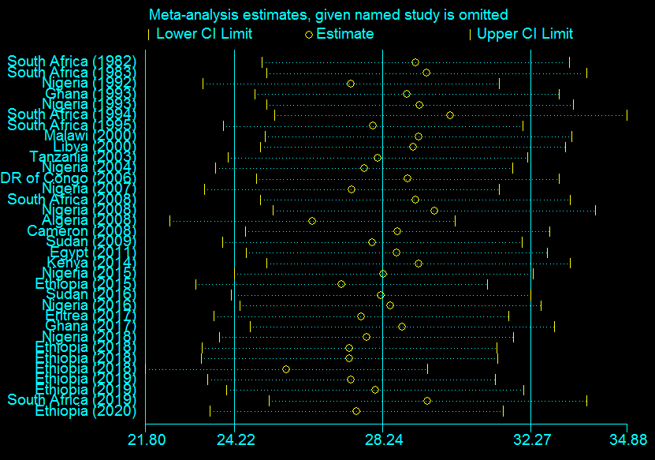

S Figure 1: Influence analysis after removing two studies (Tunisia 2014, 2015), 2020

The estimates of high quality studies

S Figure 2: The estimates of high quality studies (results after removing low quality studies) in Africa, 2020.

Trim and fill analysis

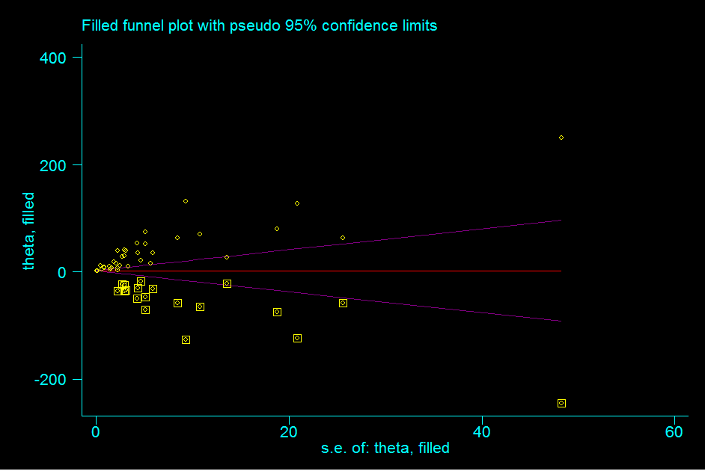

S Figure 3: Trim and fill analysis to minimize the publication bias among studies, 2020

Taking folic acid

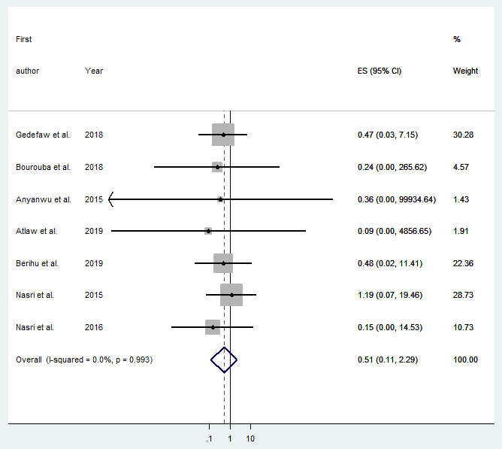

S Figure 4: Forest plot showing the pooled measure of association between neural tube defects and folic acid supplements, 2020

Galbraith plot

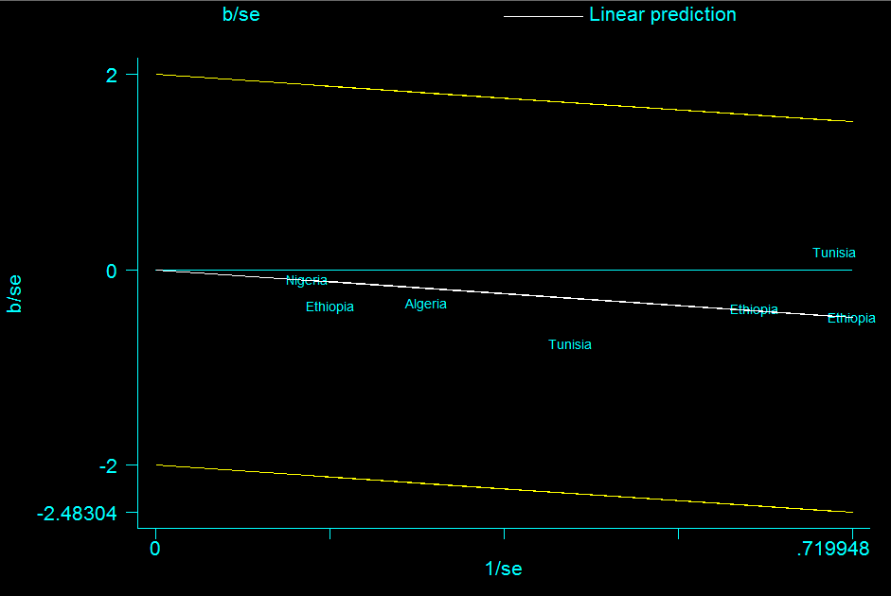

S Figure 5: Galbraith plot showing the variability of individual measure of association between neural tube defects and folic acid supplements, 2020

Consanguineous marriage

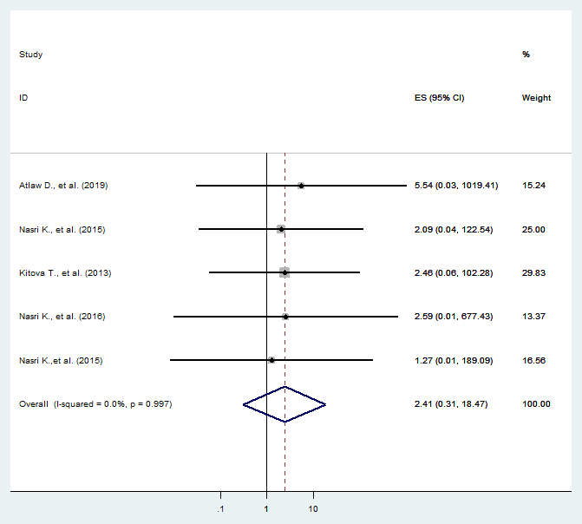

S Figure 6: Forest plot showing the association between neural tube defects and consanguineous marriage, 2020

Male newborn

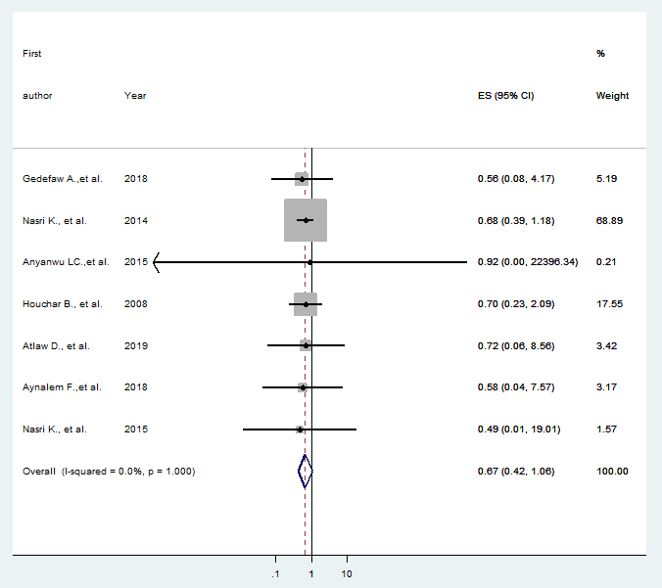

S Figure 7: Forest plot showing the association between neural tube defects and male newborn, 2020

Substance use during pregnancy

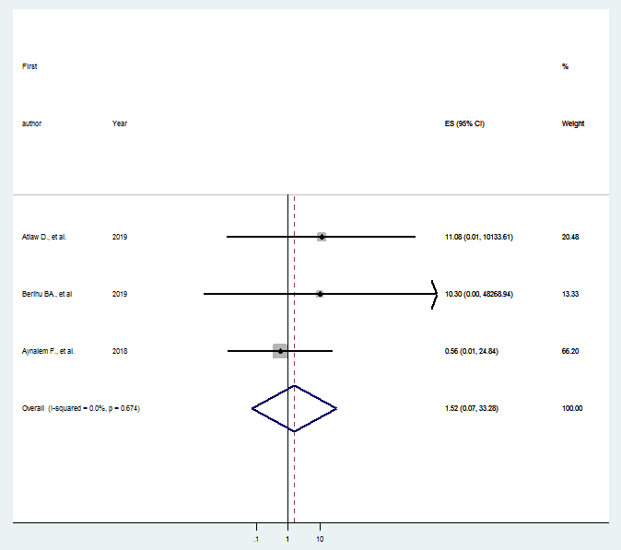

S Figure 8: Forest plot showing the association between neural tube defects and substance use during pregnancy, 2020

