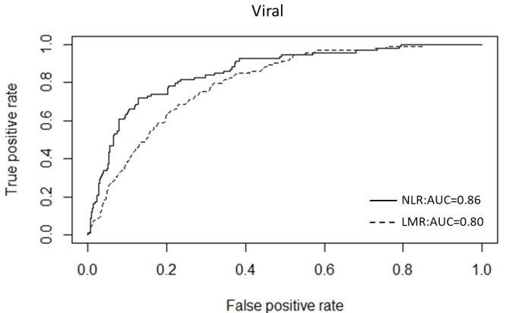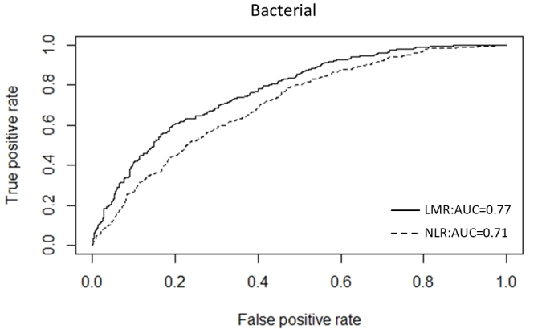

Supplementary Figure 1. The ROC curve for LMR and NLR to differentiate two different types of pneumonia against URTI

