Additional file 3. Scatter plot showing agreement on PedsQL Total Scores between parent proxy-report and child self-report
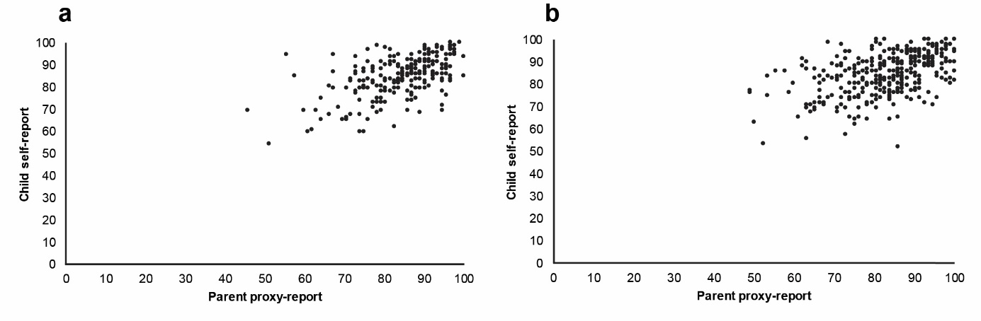
Panel a: 8–to-12-year-olds; panel b: 13–to-17-year-olds

