Appendix

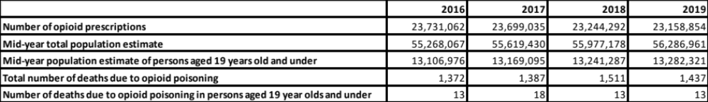

Table S1: Total number of opioid prescriptions, total number of deaths due to opioid poisoning, and mid-year population estimates in England between 2016 and 2019.

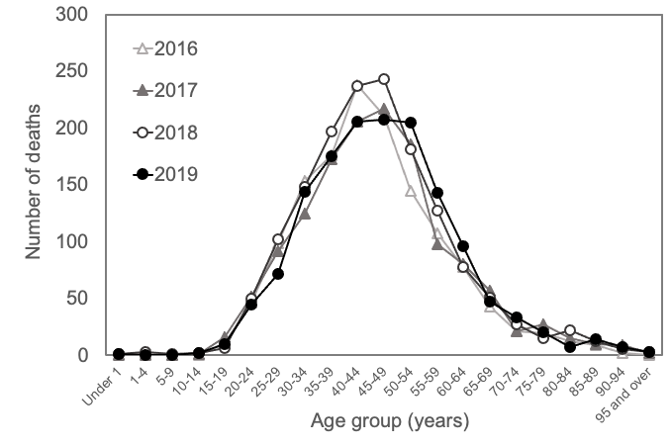
Figure S1: Distribution of deaths due to opioid poisoning by age group in England between 2016 and 2019.
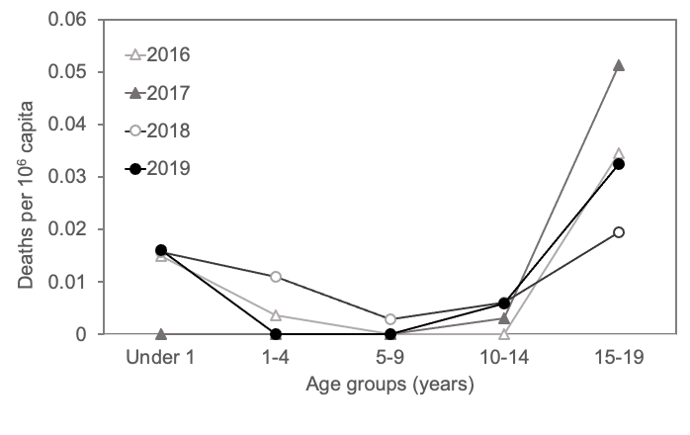
Figure S2: Distribution of deaths due to opioid poisoning by age group in children and teenagers in England between 2016 and 2019.

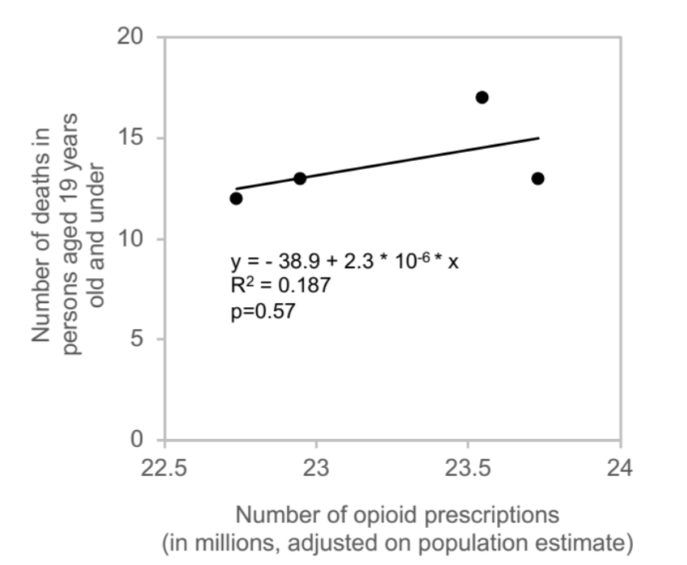
Figure S3: Number of community opioid prescriptions compared to the number of deaths in children and teenagers due to opioid poisoning in England between 2016 and 2019.

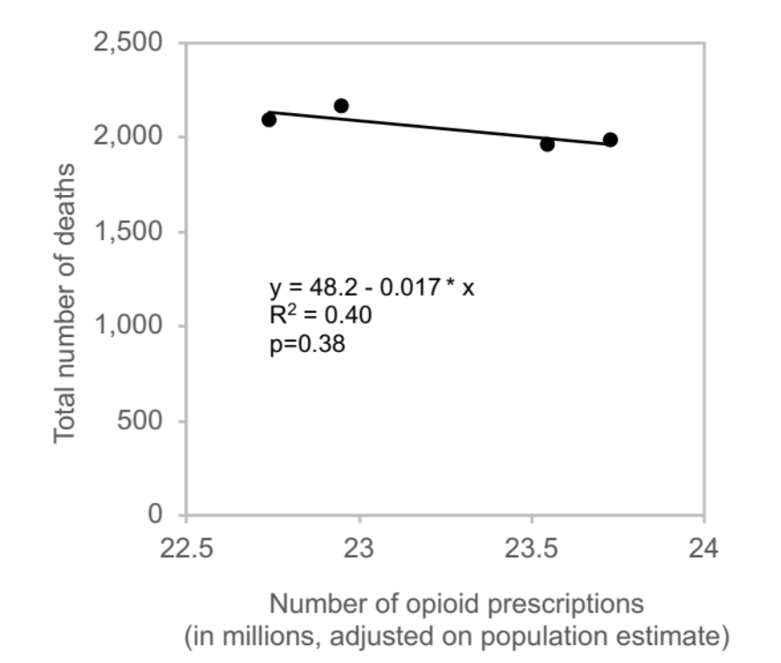
Figure S4: Number of community opioid prescriptions compared to the total number of deaths due to opioid poisoning in England between 2016 and 2019.

