Results of Bayesian Multilevel Analysis
Model comparison of Bayesian Multilevel logistic regressions
From Table A1 we see that the comparison of the fit of Bayesian multilevel logistic regression models using the summary of the fitted model. The model, which has small $DIC$, is the best model for the data set, so the result, shows that model 3 was an improved fit as compared to the rest models in any combination of variables in the data set. The average deviance from the complete set of iterations ($\hat{D}$) also decreased from model 1 to model 2 and from model 2 to model 3. $D(\hat{θ})$ shows that the deviance at the expected value of the unknown parameters and it also shows the decreasing trend from model 1 to model 2 and from model 2 to model 3. Also the model complexity is measured by $pD$ (The effective number of parameters in the model), the larger the $pD$ is easier to fit the data. Based on this fact, the third model has the largest value of this measure, it is selected again.
Table A1: DIC values for model comparisons
Model | $$\hat{D}$$ | $$D(\hat{θ})$$ | $$Pd$$ | $$DIC$$
Model 1 | 5097.64 | 4848.33 | 249.31 | 5346.95
Model 2 | 4699.42 | 4427.04 | 272.38 | 4971.79
Model 3 | 4612.55 | 4275.15 | 337.40 | 4949.95
Note: Model 1: null model; model 2: random intercept model; model 3: random coefficient model, DIC: Deviance Information Criterion , $\hat{D}$ : is the posterior mean of the deviance, measuring how well a model fits the data, $D(\hat{θ})$: The deviance at the expected value of the unknown parameters, $pD$ : is the effective number of parameters measuring model complexity.
Result of Bayesian Multilevel Empty Model
From Table A2, the between-region (level two) variance of ARI status of under five children was found to be significant because the credible interval of the respective parameters was greater than zero.
In order to get an idea of how much of the variation in ARI status of among children under five was attributable to the region level factors, it is useful to see the intra-region correlation coefficients $(ICC)$, so the $ICC$ was $0.233$, which measures the proportion of variance of the ARI of children under five that is between regions, not within regions. This means that around 23.3% of the variance in ARI of under five children are due to variation between regions. Whereas the remaining 76.7% attributable to individual level, i.e., within regional differences.
Table A2: Posterior summaries for parameters of the empty model
Model | Posterior mean | MC error | SD | 2.5% | 50% | 97.5%
Fixed intercept($β_{0}$) | -2.789 | 0.0003 | 0.072 | -2.936 | -2.789 | -2.652
Random intercept var($U_{0j}$) | 0.998 | 0.0006 | 0.136 | 0.750 | 0.989 | 1.279

Note: MC error: Monte Carlo error, SD: Standard deviations
Result of Random Intercept Bayesian Multilevel Model
The result of intercept model displayed in (Table A3) also estimates that, the variance of random effect at the regional level var (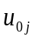) =1.107 since the 95% credible interval was greater than zero under the interval, which indicates that there is a significant regional variation.
Table A3: Bayesian Multilevel Logistic Regression of Random Intercept
Fixed effect
Variables | Category | Posterior mean | SD | MC error | 2.5% | 50% | 97.5%
- | Intercept | -3.280 | 0.367 | 0.0063 | -4.035 | -3.270 | -2.563
Sex | Male(ref)
 | Female | 0.007 | 0.080 | 0.0003 | -0.151 | 0.008 | 0.170
Child age | <6 (ref)
 | 6-11 | 0.245 | 0.162 | 0.0007 | -0.066 | 0.243 | 0.563
 | 12-23 | 0.087 | 0.147 | 0.0007 | -0.195 | 0.088 | 0.369
 | 24-35 | -0.177 | 0.169 | 0.0009 | -0.509 | -0.180 | 0.153
 | 36-47 | -0.193 | 0.186 | 0.001 | -0.556 | -0.193 | 0.176
 | 48-59 | -0.539 | 0.196 | 0.001 | -0.925 | -0.539 | -0.148
Maternal age | 15-19(ref)
 | 20-34 | 0.153 | 0.223 | 0.0022 | -0.264 | 0.146 | 0.626
 | 35-49 | 0.050 | 0.249 | 0.0021 | -0.419 | 0.043 | 0.556
Wealth index of household | Poorest (ref)
 | Poorer | -0.214 | 0.124 | 0.0005 | -0.459 | -0.214 | 0.024
 | Middle | -0.609 | 0.145 | 0.0005 | -0.892 | -0.609 | -0.331
 | Richer | -0.812 | 0.161 | 0.0006 | -1.130 | -0.813 | -0.509
 | Richest | -0.598 | 0.204 | 0.0009 | -0.994 | -0.595 | -0.213
Place of residence | Rural (ref)
 | Urban | 0.244 | 0.220 | 0.001 | -0.194 | 0.245 | 0.684
Breast feeding | Never breast feed(ref)
 | Ever breast feed, not currently | 0.229 | 0.253 | 0.0025 | -0.249 | 0.219 | 0.737
 | Still breast feed | 0.356 | 0.258 | 0.0028 | -0.150 | 0.349 | 0.868
Maternal  Education | No education(ref)
 | Primary | 0.154 | 0.105 | 0.0004 | -0.051 | 0.154 | 0.362
 | Secondary and higher | -0.449 | 0.201 | 0.0007 | -0.851 | -0.443 | -0.065
Vitamin A Supplement | No (ref)
 | Yes | -0.183 | 0.088 | 0.0003 | -0.355 | -0.184 | -0.010
Had diarrhea Recently | No(ref)
 | Yes | 1.435 | 0.096 | 0.0003 | 1.245 | 1.590 | 1.621
Fuel type | Unclean/unsafe(ref)
 | Safe/clean | -0.065 | 0.266 | 0.0009 | -0.587 | -0.061 | 0.454
Maternal Work | Not working(ref)
 | Working | 0.268 | 0.094 | 0.0003 | 0.084 | 0.268 | 0.459
Wasting | No(ref)
 | Yes | 0.122 | 0.120 | 0.0004 | -0.116 | 0.119 | 0.354
Stunting | No(ref)
 | Yes | 0.456 | 0.087 | 0.0003 | 0.292 | 0.456 | 0.632
Number of living child | 1-3 (ref)
 | 4-6 | 0.126 | 0.100 | 0.0004 | -0.070 | 0.123 | 0.319
 | Above 6 | 0.212 | 0.150 | 0.0006 | -0.088 | 0.213 | 0.499
Source of drinking water | Unprotected(ref)
 | Protected | -0.203 | 0.095 | 0.0003 | -0.387 | -0.202 | -0.016
Random effect
Var () = 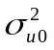 |  | 1.107 | 0.158 | 0.0007 | 0.829 | 1.095 | 1.456
Note: MC error: Monte Carlo error, SD: Standard Deviation,${ σ}_{u0}^{2}$=regions variance

The plots of Convergence test of wealth index of household and diarrhea status of under five children.
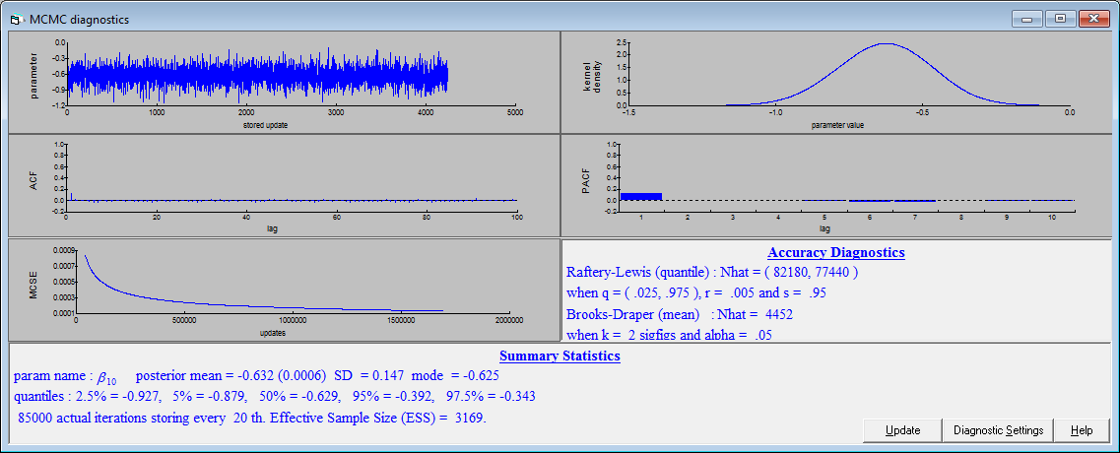
  - Figure 1: Plots of wealth index of household in middle class
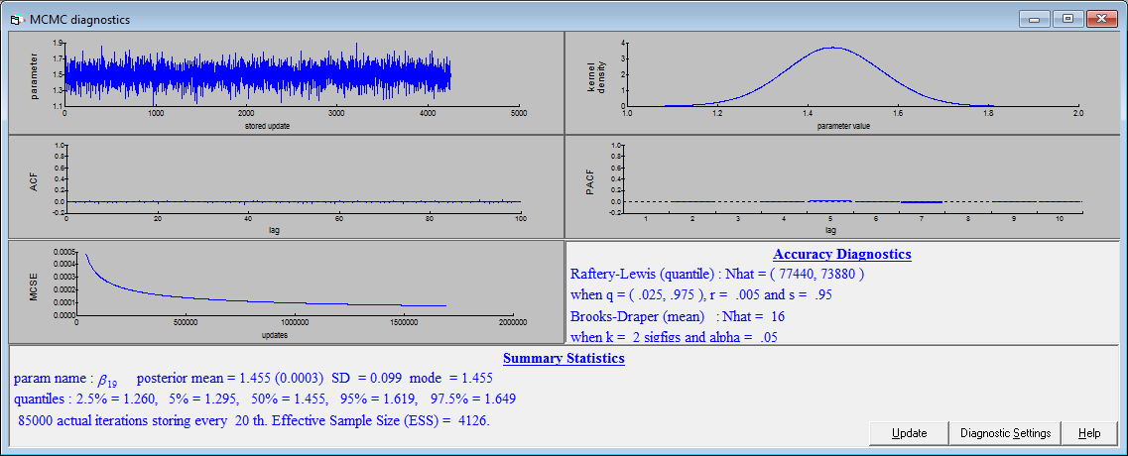
Figure 2: Plots of a child had diarrhea recently

