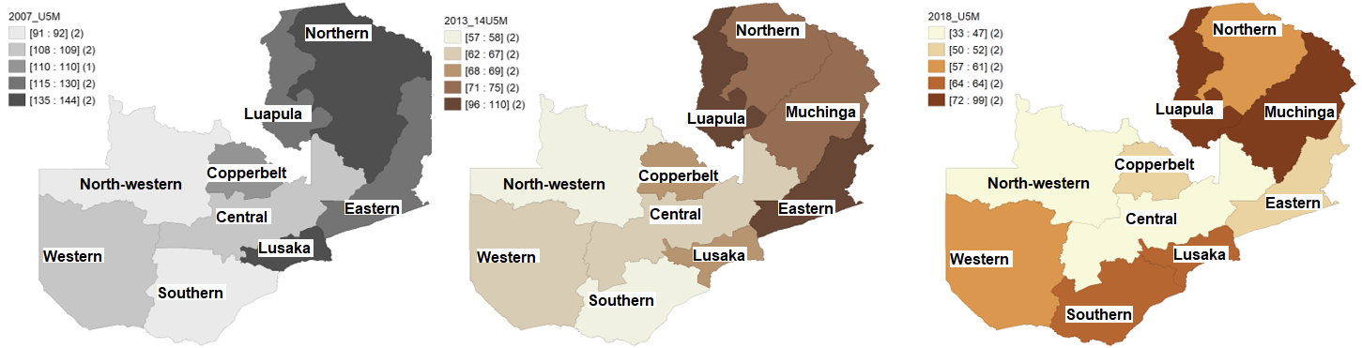
Figure B: Spatial distribution of under-five mortality rate per 1000 live births by regions of Zambia using data 2007, 2013-14, and 2018 Zambia Demographic and Health Surveys. Source: the map was produced by the authors using GeoDa 1.18.0

