Supplement Figure 1. Calculations of sample size and model power.
- Sample size calculated by pre-pregnancy underweight variable:
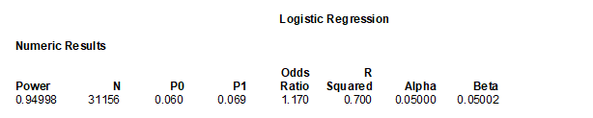
Note: N, number (sample size); P0, approximate proportion of the population exposed to this variable.
(2) Sample size calculated by age ≥35 variable:
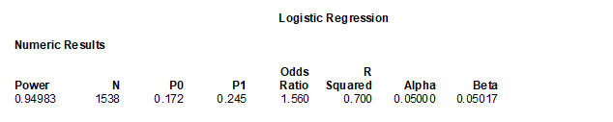
(3) Sample size calculated by pregnancy smoking variable:
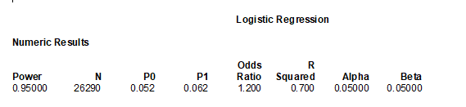
(4) Sample size calculated by gestation diabetes variable:
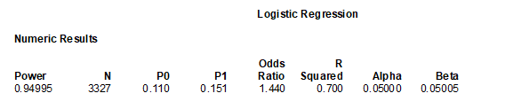
(5) Sample size calculated by gestation hypertension variable:
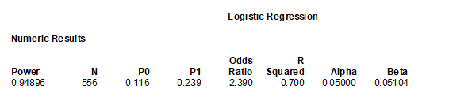
(6) Sample size calculated by previous preterm birth variable:
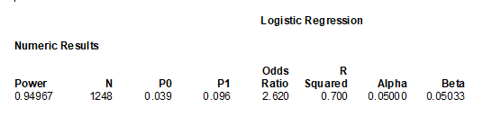
(7) Calculation of model power:
