Concurrent Validity of the Ages and Stages Questionnaire Inventory and the Bayley Scales of Infant and Toddler Development in Rural Bangladesh
Supplementary material

Figure S1. Materials used during ASQ:I assessment
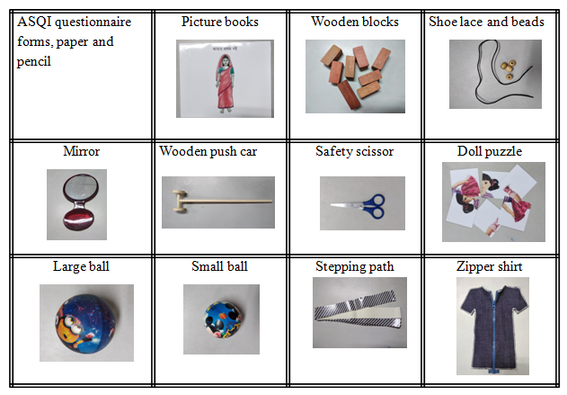
ASQ:I: Ages and Stages Questionnaire Inventory

Table S1. Number of direct assessment items by ASQ:I domain
Domain | Direct assessment items | Total items | %
Communication | 6 | 64 | 9.4%
Gross Motor | 11 | 65 | 16.9%
Fine Motor | 20 | 63 | 31.7%
Problem Solving | 9 | 68 | 13.2%
Personal Social | 4 | 50 | 8%
Total | 50 | 310 | 16%
ASQ:I: Ages and Stages Questionnaire Inventory
Table S2. Correlation between Bayley-III and ASQ:I assessments by child age and domain

 | BAYLEY-III domain
 | Cognitive | Receptive Language | Expressive Language | Fine Motor | Gross Motor | Total
ASQ:I domain
4-12 months
Problem Solving | 0.403 (0.18,0.59) | 0.335 (0.14,0.50) | 0.297 (0.02,0.54) | 0.198 (-0.06,0.41) | 0.299 (0.04,0.54) | 0.417 (0.16,0.62)
Communication | 0.280 (0.11,0.45) | 0.381 (0.16,0.58) | 0.228 (-0.05,0.49) | 0.192 (-0.02,0.41) | 0.200 (-0.03,0.44) | 0.324 (0.10,0.53)
Fine Motor | 0.178 (-0.05,0.39) | 0.254 (0.00,0.42) | 0.257 (0.12,0.39) | 0.189 (-0.01,0.37) | 0.255 (0.00,0.52) | 0.303 (0.09,0.49)
Gross Motor | 0.168 (-0.07,0.38) | 0.150 (-0.02,0.33) | 0.197 (0.04,0.36) | 0.078 (-0.08,0.24) | 0.619 (0.41,0.77) | 0.420 (0.21,0.61)
Personal Social | 0.064 (-0.18,0.28) | 0.370 (0.09,0.59) | 0.215 (0.02,0.42) | 0.243 (-0.01,0.46) | 0.196 (-0.06,0.45) | 0.291 (0.00,0.54)
Total | 0.270 (0.17,0.39) | 0.422 (0.19,0.59) | 0.293 (0.08,0.50) | 0.212 (0.01,0.41) | 0.401 (0.14,0.66) | 0.453 (0.22,0.63)
13-18 months
Problem Solving | 0.332 (0.20,0.46) | 0.326 (-0.01,0.56) | 0.260 (-0.02,0.49) | 0.236 (-0.02,0.44) | 0.078 (-0.15,0.32) | 0.335 (0.13,0.49)
Communication | 0.084 (-0.07,0.27) | 0.492 (0.22,0.65) | 0.381 (0.06,0.63) | 0.193 (-0.15,0.45) | 0.159 (-0.04,0.36) | 0.311 (0.11,0.49)
Fine Motor | 0.194 (0.04,0.36) | 0.196 (-0.09,0.39) | 0.243 (0.02,0.46) | 0.217 (0.00,0.40) | 0.110 (-0.17,0.33) | 0.239 (0.04,0.40)
Gross Motor | 0.076 (-0.12,0.26) | 0.247 (-0.01,0.49) | 0.101 (-0.04,0.24) | 0.118 (-0.17,0.36) | 0.595 (0.48,0.72) | 0.384 (0.26,0.50)
Personal Social | 0.140 (-0.04,0.38) | 0.245 (-0.01,0.41) | 0.206 (-0.01,0.38) | 0.252 (0.01,0.42) | 0.036 (-0.21,0.32) | 0.212 (0.02,0.37)
Total | 0.250 (0.08,0.43) | 0.385 (0.06,0.59) | 0.317 (0.04,0.53) | 0.274 (0.01,0.41) | 0.228 (0.01,0.48) | 0.391 (0.20,0.55)
19-26 months
Problem Solving | 0.216 (0.02,0.38) | 0.201 (-0.01,0.37) | 0.259 (0.17,0.33) | 0.419 (0.28,0.54) | 0.343 (0.21,0.45) | 0.286 (0.15,0.46)
Communication | 0.254 (0.01,0.42) | 0.304 (0.07,0.50) | 0.426 (0.22,0.59) | 0.268 (0.04,0.48) | 0.321 (0.11,0.48) | 0.305 (0.07,0.54)
Fine Motor | 0.214 (0.09,0.31) | 0.166 (-0.03,0.29) | 0.173 (0.03,0.27) | 0.309 (0.19,0.44) | 0.255 (0.06,0.38) | 0.155 (-0.05,0.33)
Gross Motor | 0.255 (0.03,0.43) | 0.179 (0.01,0.34) | 0.107 (-0.09,0.25) | 0.305 (0.15,0.45) | 0.385 (0.24,0.54) | 0.324 (0.14,0.48)
Personal Social | 0.257 (0.02,0.47) | 0.139 (-0.08,0.33) | 0.146 (-0.01,0.29) | 0.182 (-0.01,0.39) | 0.157 (-0.08,0.35) | 0.207 (0.01,0.41)
Total | 0.315 (0.12,0.47) | 0.186 (0.02,0.33) | 0.269 (0.08,0.41) | 0.336 (0.22,0.49) | 0.365 (0.22,0.53) | 0.389 (0.23,0.54)

Notes: Concordant domains across measures are represented in bold; Maximum n per age group: 4-12=73; 13-18=86; 19-26=85
Bayley-III: Bayley Scales of Infant and Toddler Development-III; ASQ:I: Ages and Stages Questionnaire Inventory

