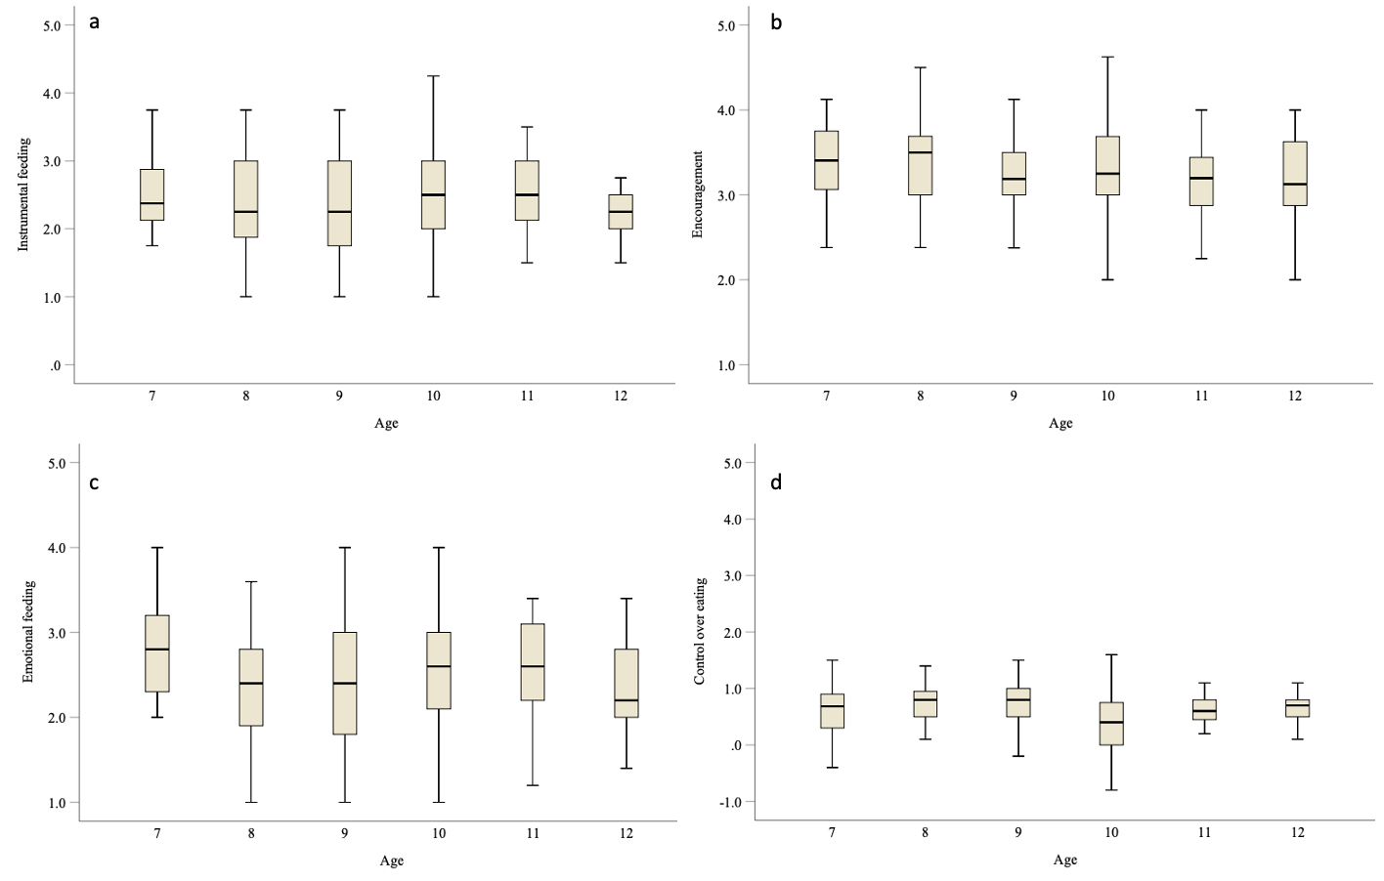
Figure S1 Parental feeding practices among children with ages
7 years old: n= 36, 8 years old: n= 62, 9 years old: n= 58, 10 years old: n= 46, 11 years old: n= 26, 12 years old: n= 15.
Differences among children with ages were analysed by using Kruskal-Wallis one-way ANOVA test.

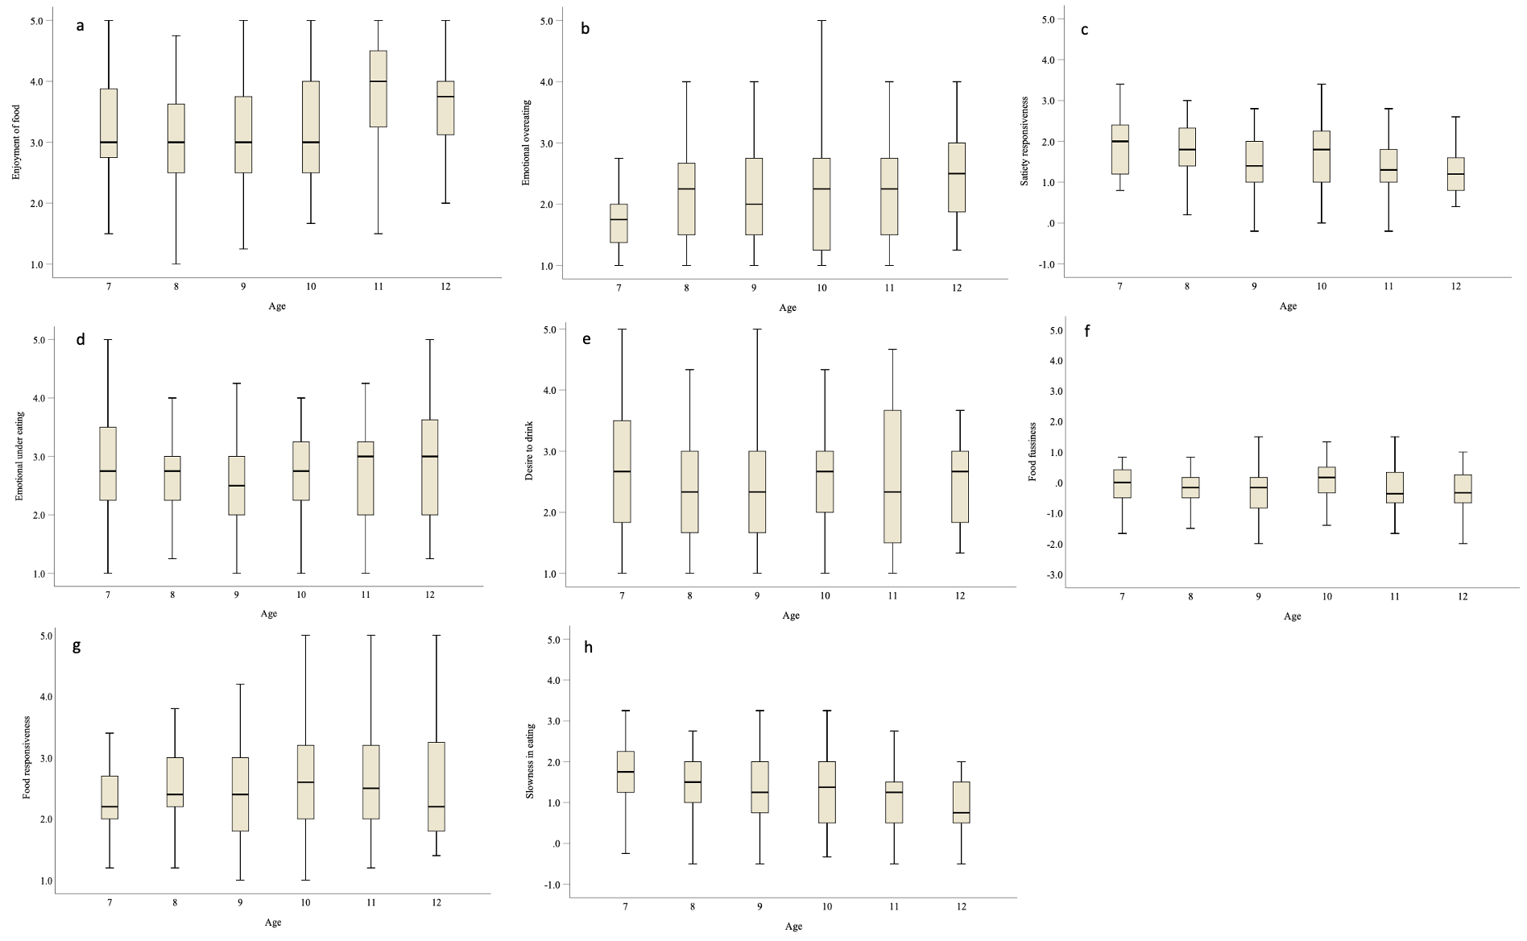
Figure S2 Eating behaviors among children with ages
7 years old: n= 36, 8 years old: n= 62, 9 years old: n= 58, 10 years old: n= 46, 11 years old: n= 26, 12 years old: n= 15.
Differences among children with ages were analysed by using Kruskal-Wallis one-way ANOVA test.

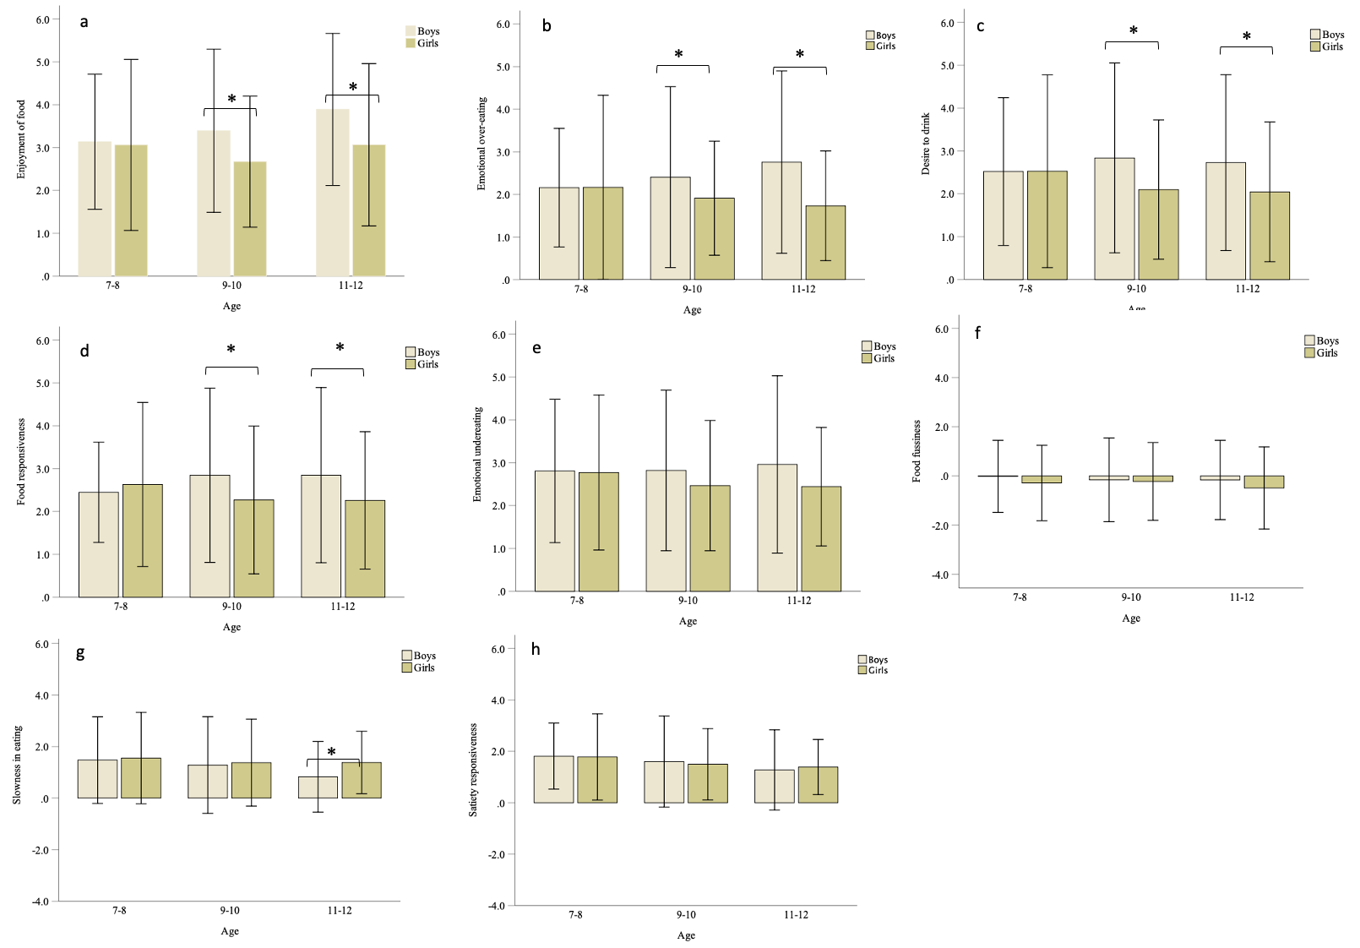
Figure S3 Differences in eating behaviors among children at different ages
Mann-Whitney U tests were used to assess differences between boys and girls. * as P-value < 0.05.

