Supplementary Information
Supplementary Table 1. Numbers of OROS-MPH users at each dose level among patients with at least one dose titration (Data for Fig. 2a: child group in the US cohort, N=30,237)
1st to 2nd daily dose level
Dose 1, md/day | Dose 2, md/day | Titrated patients | Upward titration, % |  | Downward titration, % |  | No further titration, %
18 (N=17,524) | -- | -- | 17,524 | 100.0% | 0 | 0.0% | -- | --
 | 27 | 11,153
 | 36 | 5,398
 | 45 | 126
 | 54 | 795
 | >54 | 52
27 (N=4,542) | 18 | 689 | 3,853 | 84.8% | 689 | 15.2% | -- | --
 | -- | --
 | 36 | 3,594
 | 45 | 50
 | 54 | 160
 | >54 | 49
36 (N=4,775) | 18 | 909 | 3,175 | 66.5% | 1,600 | 33.5% | -- | --
 | 27 | 691
 | -- | --
 | 45 | 284
 | 54 | 2,597
 | >54 | 294
45 (N=623) | 18 | 71 | 347 | 55.7% | 276 | 44.3% | -- | --
 | 27 | 115
 | 36 | 90
 | -- | --
 | 54 | 245
 | >54 | 102
54 (N=2,118) | 18 | 355 | 614 | 29.0% | 1,504 | 71.0% | -- | --
 | 27 | 87
 | 36 | 1,042
 | 45 | 20
 | -- | --
 | >54 | 614
>54 (N=655) | 18 | 21 | 0 | 0.0% | 655 | 100.0%
 | 27 | 24
 | 36 | 210
 | 45 | 3
 | 54 | 397
 | -- | --
2nd to 3rd daily dose level
Dose 2, md/day | Dose 3, mg/day | Titrated patients | Upward titration, % |  | Downward titration, % |  | No further titration, %
18 (N=2,045) | -- | -- | 1,249 | 61.1% | 0 | 0.0% | 796 | 38.9%
 | 27 | 490
 | 36 | 369
 | 45 | 25
 | 54 | 320
 | >54 | 45
27 (N=12,070) | 18 | 1,585 | 4,739 | 39.3% | 1,585 | 13.1% | 5,746 | 47.6%
 | -- | --
 | 36 | 4,401
 | 45 | 139
 | 54 | 150
 | >54 | 49
36 (N=10,334) | 18 | 1,305 | 3,056 | 29.6% | 2,482 | 24.0% | 4,796 | 46.4%
 | 27 | 1,177
 | -- | --
 | 45 | 332
 | 54 | 2,499
 | >54 | 225
45 (N=483) | 18 | 54 | 96 | 19.9% | 194 | 40.2% | 193 | 40.0%
 | 27 | 97
 | 36 | 43
 | -- | --
 | 54 | 91
 | >54 | 5
54 (N=4,194) | 18 | 345 | 731 | 17.4% | 1,855 | 44.2% | 1,608 | 38.3%
 | 27 | 119
 | 36 | 1,347
 | 45 | 44
 | -- | --
 | >54 | 731
>54 (N=1,111) | 18 | 25 | 0 | 0.0% | 661 | 59.5% | 450 | 40.5%
 | 27 | 34
 | 36 | 334
 | 45 | 4
 | 54 | 264
 | -- | --
3rd to 4th daily dose level
Dose 3, md/day | Dose 4, mg/day | Titrated patients | Upward titration, % |  | Downward titration, % |  | No further titration, %
18 (N=3,314) | -- | -- | 1,955 | 59.0% | 0 | 0.0% | 1,359 | 41.0%
 | 27 | 942
 | 36 | 568
 | 45 | 73
 | 54 | 327
 | >54 | 45
27 (N=1,917) | 18 | 232 | 846 | 44.1% | 232 | 12.1% | 839 | 43.8%
 | -- | --
 | 36 | 696
 | 45 | 55
 | 54 | 64
 | >54 | 31
36 (N=6,494) | 18 | 499 | 2,135 | 32.9% | 1,413 | 21.8% | 2,946 | 45.4%
 | 27 | 914
 | -- | --
 | 45 | 277
 | 54 | 1,593
 | >54 | 265
45 (N=544) | 18 | 53 | 113 | 20.8% | 231 | 42.5% | 200 | 36.8%
 | 27 | 120
 | 36 | 58
 | -- | --
 | 54 | 107
 | >54 | 6
54 (N=3,324) | 18 | 329 | 349 | 10.5% | 1,546 | 46.5% | 1,429 | 43.0%
 | 27 | 117
 | 36 | 1,049
 | 45 | 51
 | -- | --
 | >54 | 349
>54 (N=1,055) | 18 | 21 | 0 | 0.0% | 534 | 50.6% | 521 | 49.4%
 | 27 | 28
 | 36 | 205
 | 45 | 3
 | 54 | 277
 | -- | --
Child group: 6 to <13 years;

Supplementary Table 2. Numbers of OROS-MPH users at each dose level among patients with at least one dose titration (Data for Fig. 2b: adolescent group in the US cohort, N=11,365)
1st to 2nd daily dose level
Dose 1, md/day | Dose 2, md/day | Titrated patients | Upward titration, % |  | Downward titration, % |  | No further titration, %
18 (N=4,674) | -- | -- | 4,674 | 100.0% | 0 | 0.0% | -- | --
 | 27 | 2,042
 | 36 | 1,955
 | 45 | 31
 | 54 | 613
 | >54 | 33
27 (N=1,641) | 18 | 203 | 1,438 | 87.6% | 203 | 12.4% | -- | --
 | -- | --
 | 36 | 1,265
 | 45 | 18
 | 54 | 135
 | >54 | 20
36 (N=2,817) | 18 | 480 | 2,036 | 72.3% | 781 | 27.7% | -- | --
 | 27 | 301
 | -- | --
 | 45 | 90
 | 54 | 1,776
 | >54 | 170
45 (N=256) | 18 | 35 | 111 | 43.4% | 145 | 56.6% | -- | --
 | 27 | 75
 | 36 | 35
 | -- | --
 | 54 | 41
 | >54 | 70
54 (N=1,614) | 18 | 332 | 313 | 19.4% | 1,301 | 80.6% | -- | --
 | 27 | 77
 | 36 | 869
 | 45 | 23
 | -- | --
 | >54 | 313
>54 (N=363) | 18 | 26 | 0 | 0.0% | 363 | 100.0% | -- | --
 | 27 | 20
 | 36 | 152
 | 45 | 6
 | 54 | 159
 | -- | --
2nd to 3rd daily dose level
Dose 2, md/day | Dose 3, mg/day | Titrated patients | Upward titration, % |  | Downward titration, % |  | No further titration, %
18 (N=1,076) | -- | -- | 570 | 53.0% | 0 | 0.0% | 506 | 47.0%
 | 27 | 132
 | 36 | 191
 | 45 | 11
 | 54 | 195
 | >54 | 41
27 (N=2,515) | 18 | 256 | 896 | 35.6% | 256 | 10.2% | 1,363 | 54.2%
 | -- | --
 | 36 | 775
 | 45 | 25
 | 54 | 76
 | >54 | 20
36 (N=4,276) | 18 | 422 | 1,294 | 30.3% | 681 | 15.9% | 2,301 | 53.8%
 | 27 | 259
 | -- | --
 | 45 | 66
 | 54 | 1,104
 | >54 | 124
45 (N=168) | 18 | 23 | 32 | 19.0% | 50 | 29.8% | 86 | 51.2%
 | 27 | 15
 | 36 | 12
 | -- | --
 | 54 | 29
 | >54 | 3
54 (N=2,724) | 18 | 264 | 199 | 7.3% | 1,071 | 39.3% | 1,454 | 53.4%
 | 27 | 69
 | 36 | 719
 | 45 | 19
 | -- | --
 | >54 | 199
>54 (N=606) | 18 | 23 | 0 | 0.0% | 271 | 44.7% | 335 | 55.3%
 | 27 | 16
 | 36 | 85
 | 45 | 1
 | 54 | 146
 | -- | --
3rd to 4th daily dose level
Dose 3, md/day | Dose 4, mg/day | Titrated patients | Upward titration, % |  | Downward titration, % |  | No further titration, %
18 (N=988) | -- | -- | 496 | 50.2% | 0 | 0.0% | 492 | 49.8%
 | 27 | 132
 | 36 | 158
 | 45 | 27
 | 54 | 144
 | >54 | 35
27 (N=491) | 18 | 46 | 177 | 36.0% | 46 | 9.4% | 268 | 54.6%
 | -- | --
 | 36 | 114
 | 45 | 14
 | 54 | 30
 | >54 | 19
36 (N=1,782) | 18 | 153 | 569 | 31.9% | 286 | 16.0% | 927 | 52.0%
 | 27 | 133
 | -- | --
 | 45 | 46
 | 54 | 446
 | >54 | 77
45 (N=122) | 18 | 13 | 12 | 9.8% | 52 | 42.6% | 58 | 47.5%
 | 27 | 24
 | 36 | 15
 | -- | --
 | 54 | 11
 | >54 | 1
54 (N=1,550) | 18 | 184 | 152 | 9.8% | 649 | 41.9% | 749 | 48.3%
 | 27 | 58
 | 36 | 394
 | 45 | 13
 | -- | --
 | >54 | 152
>54 (N=387) | 18 | 14 | 0 | 0.0% | 214 | 55.3% | 173 | 44.7%
 | 27 | 11
 | 36 | 86
 | 45 | 3
 | 54 | 100
 | -- | --
Adolescent group: 13 to <18 years

Supplementary Table 3. Numbers of OROS-MPH users at each dose level among patients with at least one dose titration (Data for Fig. 2c: child group in the Japanese cohort, N=1,640)
1st to 2nd daily dose level
Dose 1, md/day | Dose 2, md/day | Titrated patients | Upward titration, % |  | Downward titration, % |  | No further titration, %
18 (N=1,447) | -- | -- | 1,447 | 100.0% | 0 | 0.0% | -- | --
 | 27 | 1,139
 | 36 | 26
 | 45 | 274
 | 54 | 3
 | >54 | 5
27 (N=28) | 18 | 14 | 14 | 50.0% | 14 | 50.0% | -- | --
 | -- | --
 | 36 | 8
 | 45 | 6
 | 54 | 0
 | >54 | 0
36 (N=48) | 18 | 1 | 47 | 97.9% | 1 | 2.1% | -- | --
 | 27 | 0
 | -- | --
 | 45 | 2
 | 54 | 33
 | >54 | 12
45 (N=91) | 18 | 28 | 15 | 16.5% | 76 | 83.5% | -- | --
 | 27 | 36
 | 36 | 12
 | -- | --
 | 54 | 10
 | >54 | 5
54 (N=0) | 18 | 0 | 0 | 0.0% | 0 | 0.0% | -- | --
 | 27 | 0
 | 36 | 0
 | 45 | 0
 | -- | --
 | >54 | 0
>54 (N=26) | 18 | 2 | 0 | 0.0% | 26 | 100.0% | -- | --
 | 27 | 1
 | 36 | 3
 | 45 | 2
 | 54 | 18
 | -- | --
2nd to 3rd daily dose level
Dose 2, md/day | Dose 3, mg/day | Titrated patients | Upward titration, % |  | Downward titration, % |  | No further titration, %
18 (N=45) | -- | -- | 34 | 75.6% | 0 | 0.0% | 11 | 24.4%
 | 27 | 12
 | 36 | 4
 | 45 | 16
 | 54 | 0
 | >54 | 2
27 (N=1,176) | 18 | 409 | 279 | 23.7% | 409 | 34.8% | 488 | 41.5%
 | -- | --
 | 36 | 156
 | 45 | 82
 | 54 | 9
 | >54 | 32
36 (N=49) | 18 | 13 | 11 | 22.4% | 19 | 38.8% | 19 | 38.8%
 | 27 | 6
 | -- | --
 | 45 | 5
 | 54 | 4
 | >54 | 2
45 (N=284) | 18 | 72 | 5 | 1.8% | 151 | 53.2% | 128 | 45.1%
 | 27 | 77
 | 36 | 2
 | -- | --
 | 54 | 0
 | >54 | 5
54 (N=64) | 18 | 1 | 16 | 25.0% | 35 | 54.7% | 13 | 20.3%
 | 27 | 1
 | 36 | 32
 | 45 | 1
 | -- | --
 | >54 | 16
>54 (N=22) | 18 | 0 | 0 | 0.0% | 17 | 77.3% | 5 | 22.7%
 | 27 | 0
 | 36 | 6
 | 45 | 0
 | 54 | 11
 | -- | --
3rd to 4th daily dose level
Dose 3, md/day | Dose 4, mg/day | Titrated patients | Upward titration, % |  | Downward titration, % |  | No further titration, %
18 (N=495) | -- | -- | 337 | 68.1% | 0 | 0.0% | 158 | 31.9%
 | 27 | 191
 | 36 | 23
 | 45 | 120
 | 54 | 2
 | >54 | 1
27 (N=96) | 18 | 22 | 39 | 40.6% | 22 | 22.9% | 35 | 36.5%
 | -- | --
 | 36 | 7
 | 45 | 24
 | 54 | 2
 | >54 | 6
36 (N=200) | 18 | 23 | 71 | 35.5% | 61 | 30.5% | 68 | 34.0%
 | 27 | 38
 | -- | --
 | 45 | 33
 | 54 | 13
 | >54 | 25
45 (N=104) | 18 | 21 | 7 | 6.7% | 56 | 53.8% | 41 | 39.4%
 | 27 | 29
 | 36 | 6
 | -- | --
 | 54 | 1
 | >54 | 6
54 (N=24) | 18 | 1 | 5 | 20.8% | 8 | 33.3% | 11 | 45.8%
 | 27 | 6
 | 36 | 1
 | 45 | 0
 | -- | --
 | >54 | 5
>54 (N=57) | 18 | 1 | 0 | 0.0% | 34 | 59.6% | 23 | 40.4%
 | 27 | 12
 | 36 | 13
 | 45 | 1
 | 54 | 7
 | -- | --
Child group: 6 to <13 years

Supplementary Table 4. Numbers of OROS-MPH users at each dose level among patients with at least one dose titration (Data for Fig. 2d: adolescent group in the Japanese cohort, N= 578)
1st to 2nd daily dose level
Dose 1, md/day | Dose 2, md/day | Titrated patients | Upward titration, % |  | Downward titration, % |  | No further titration, %
18 (N=457) | -- | -- | 457 | 100.0% | 0 | 0.0% | -- | --
 | 27 | 376
 | 36 | 25
 | 45 | 47
 | 54 | 3
 | >54 | 6
27 (N=35) | 18 | 18 | 17 | 48.6% | 18 | 51.4% | -- | --
 | -- | --
 | 36 | 9
 | 45 | 3
 | 54 | 2
 | >54 | 3
36 (N=21) | 18 | 0 | 21 | 100.0% | 0 | 0.0% | -- | --
 | 27 | 0
 | -- | --
 | 45 | 2
 | 54 | 14
 | >54 | 5
45 (N=42) | 18 | 5 | 12 | 28.6% | 30 | 71.4% | -- | --
 | 27 | 14
 | 36 | 11
 | -- | --
 | 54 | 0
 | >54 | 12
54 (N=3) | 18 | 0 | 0 | 0.0% | 3 | 100.0% | -- | --
 | 27 | 1
 | 36 | 2
 | 45 | 0
 | -- | --
 | >54 | 0
>54 (N=20) | 18 | 3 | 0 | 0.0% | 20 | 100.0% | -- | --
 | 27 | 4
 | 36 | 5
 | 45 | 3
 | 54 | 5
 | -- | --
2nd to 3rd daily dose level
Dose 2, md/day | Dose 3, mg/day | Titrated patients | Upward titration, % |  | Downward titration, % |  | No further titration, %
18 (N=26) | -- | -- | 17 | 65.4% | 0 | 0.0% | 9 | 34.6%
 | 27 | 7
 | 36 | 2
 | 45 | 8
 | 54 | 0
 | >54 | 0
27 (N=395) | 18 | 105 | 126 | 31.9% | 105 | 26.6% | 164 | 41.5%
 | -- | --
 | 36 | 84
 | 45 | 28
 | 54 | 5
 | >54 | 9
36 (N=52) | 18 | 6 | 15 | 28.8% | 13 | 25.0% | 24 | 46.2%
 | 27 | 7
 | -- | --
 | 45 | 10
 | 54 | 3
 | >54 | 2
45 (N=55) | 18 | 8 | 2 | 3.6% | 30 | 54.5% | 23 | 41.8%
 | 27 | 19
 | 36 | 3
 | -- | --
 | 54 | 0
 | >54 | 2
54 (N=24) | 18 | 0 | 6 | 25.0% | 6 | 25.0% | 12 | 50.0%
 | 27 | 1
 | 36 | 5
 | 45 | 0
 | -- | --
 | >54 | 6
>54 (N=26) | 18 | 0 | 0 | 0.0% | 16 | 61.5% | 10 | 38.5%
 | 27 | 1
 | 36 | 9
 | 45 | 3
 | 54 | 3
 | -- | --
3rd to 4th daily dose level
Dose 3, md/day | Dose 4, mg/day | Titrated patients | Upward titration, % |  | Downward titration, % |  | No further titration, %
18 (N=119) | -- | -- | 80 | 67.2% | 0 | 0.0% | 39 | 32.8%
 | 27 | 43
 | 36 | 5
 | 45 | 31
 | 54 | 0
 | >54 | 1
27 (N=35) | 18 | 12 | 10 | 28.6% | 12 | 34.3% | 13 | 37.1%
 | -- | --
 | 36 | 3
 | 45 | 6
 | 54 | 0
 | >54 | 1
36 (N=103) | 18 | 7 | 33 | 32.0% | 26 | 25.2% | 44 | 42.7%
 | 27 | 19
 | -- | --
 | 45 | 27
 | 54 | 3
 | >54 | 3
45 (N=49) | 18 | 4 | 3 | 6.1% | 25 | 51.0% | 21 | 42.9%
 | 27 | 17
 | 36 | 4
 | -- | --
 | 54 | 0
 | >54 | 3
54 (N=11) | 18 | 1 | 2 | 18.2% | 7 | 63.6% | 2 | 18.2%
 | 27 | 4
 | 36 | 1
 | 45 | 1
 | -- | --
 | >54 | 2
>54 (N=19) | 18 | 0 | 0 | 0.0% | 8 | 42.1% | 11 | 57.9%
 | 27 | 1
 | 36 | 5
 | 45 | 1
 | 54 | 1
 | -- | --
Adolescent group: 13 to <18 years

Supplementary Table 5. Numbers of OROS-MPH users at each dose level among MPH-naïve patients with at least one dose titration (Data for Supplementary Fig 1a: child group of sensitivity analysis in the US cohort, N=23,901)
1st to 2nd daily dose level
Dose 1, md/day | Dose 2, md/day | Titrated patients | Upward titration, % |  | Downward titration, % |  | No further titration, %
18 (N=14,854) | -- | -- | 14,854 | 100.0% | 0 | 0.0% | -- | --
 | 27 | 9,446
 | 36 | 4,615
 | 45 | 93
 | 54 | 656
 | >54 | 44
27 (N=3,382) | 18 | 512 | 2,870 | 84.9% | 512 | 15.1% | -- | --
 | -- | --
 | 36 | 2,668
 | 45 | 43
 | 54 | 120
 | >54 | 39
36 (N=3,426) | 18 | 654 | 2,269 | 66.2% | 1,157 | 33.8% | -- | --
 | 27 | 503
 | -- | --
 | 45 | 196
 | 54 | 1,853
 | >54 | 220
45 (N=446) | 18 | 54 | 230 | 51.6% | 216 | 48.4% | -- | --
 | 27 | 93
 | 36 | 69
 | -- | --
 | 54 | 159
 | >54 | 71
54 (N=1,465) | 18 | 251 | 394 | 26.9% | 1,071 | 73.1% | -- | --
 | 27 | 60
 | 36 | 747
 | 45 | 13
 | -- | --
 | >54 | 394
>54 (N=328) | 18 | 10 | 0 | 0.0% | 328 | 100.0% | -- | --
 | 27 | 16
 | 36 | 123
 | 45 | 2
 | 54 | 177
 | -- | --
2nd to 3rd daily dose level
Dose 2, md/day | Dose 3, mg/day | Titrated patients | Upward titration, % |  | Downward titration, % |  | No further titration, %
18 (N=1,481) | -- | -- | 885 | 59.8% | 0 | 0.0% | 596 | 40.2%
 | 27 | 373
 | 36 | 260
 | 45 | 13
 | 54 | 215
 | >54 | 24
27 (N=10,118) | 18 | 1,284 | 3,983 | 39.4% | 1,284 | 12.7% | 4,851 | 47.9%
 | -- | --
 | 36 | 3,726
 | 45 | 100
 | 54 | 118
 | >54 | 39
36 (N=8,222) | 18 | 1,076 | 2,410 | 29.3% | 1,980 | 24.1% | 3,832 | 46.6%
 | 27 | 904
 | -- | --
 | 45 | 254
 | 54 | 2,004
 | >54 | 152
45 (N=347) | 18 | 35 | 72 | 20.7% | 136 | 39.2% | 139 | 40.1%
 | 27 | 67
 | 36 | 34
 | -- | --
 | 54 | 69
 | >54 | 3
54 (N=2,965) | 18 | 248 | 406 | 13.7% | 1,329 | 44.8% | 1,230 | 41.5%
 | 27 | 89
 | 36 | 967
 | 45 | 25
 | -- | --
 | >54 | 406
>54 (N=768) | 18 | 18 | 0 | 0.0% | 436 | 56.8% | 332 | 43.2%
 | 27 | 26
 | 36 | 217
 | 45 | 3
 | 54 | 172
 | -- | --
3rd to 4th daily dose level
Dose 3, md/day | Dose 4, mg/day | Titrated patients | Upward titration, % |  | Downward titration, % |  | No further titration, %
18 (N=2,661) | -- | -- | 1,553 | 58.4% | 0 | 0.0% | 1,108 | 41.6%
 | 27 | 752
 | 36 | 467
 | 45 | 52
 | 54 | 257
 | >54 | 25
27 (N=1,459) | 18 | 164 | 655 | 44.9% | 164 | 11.2% | 640 | 43.9%
 | -- | --
 | 36 | 543
 | 45 | 40
 | 54 | 47
 | >54 | 25
36 (N=5,204) | 18 | 392 | 1,645 | 31.6% | 1,139 | 21.9% | 2,420 | 46.5%
 | 27 | 747
 | -- | --
 | 45 | 227
 | 54 | 1,249
 | >54 | 169
45 (N=395) | 18 | 34 | 83 | 21.0% | 158 | 40.0% | 154 | 39.0%
 | 27 | 76
 | 36 | 48
 | -- | --
 | 54 | 80
 | >54 | 3
54 (N=2,578) | 18 | 251 | 224 | 8.7% | 1,212 | 47.0% | 1,142 | 44.3%
 | 27 | 93
 | 36 | 827
 | 45 | 41
 | -- | --
 | >54 | 224
>54 (N=624) | 18 | 11 | 0 | 0.0% | 335 | 53.7% | 289 | 46.3%
 | 27 | 21
 | 36 | 125
 | 45 | 2
 | 54 | 176
 | -- | --
Child group: 6 to <13 years

Supplementary Table 6. Numbers of OROS-MPH users at each dose level among MPH-naïve patients with at least one dose titration (Data for Supplementary Fig 1b: adolescent group of sensitivity analysis in the US cohort, N=9,512)
1st to 2nd daily dose level
Dose 1, md/day | Dose 2, md/day | Titrated patients | Upward titration, % |  | Downward titration, % |  | No further titration, %
18 (N=4,294) | -- | -- | 4,294 | 100.0% | 0 | 0.0% | -- | --
 | 27 | 1,854
 | 36 | 1,818
 | 45 | 30
 | 54 | 565
 | >54 | 27
27 (N=1,354) | 18 | 163 | 1,191 | 88.0% | 163 | 12.0% | -- | --
 | -- | --
 | 36 | 1,048
 | 45 | 14
 | 54 | 111
 | >54 | 18
36 (N=2,222) | 18 | 383 | 1,608 | 72.4% | 614 | 27.6% | -- | --
 | 27 | 231
 | -- | --
 | 45 | 70
 | 54 | 1,411
 | >54 | 127
45 (N=190) | 18 | 20 | 84 | 44.2% | 106 | 55.8% | -- | --
 | 27 | 56
 | 36 | 30
 | -- | --
 | 54 | 33
 | >54 | 51
54 (N=1,203) | 18 | 260 | 229 | 19.0% | 974 | 81.0% | -- | --
 | 27 | 61
 | 36 | 636
 | 45 | 17
 | -- | --
 | >54 | 229
>54 (N=249) | 18 | 21 | 0 | 0.0% | 249 | 100.0% | -- | --
 | 27 | 14
 | 36 | 94
 | 45 | 6
 | 54 | 114
 | -- | --
2nd to 3rd daily dose level
Dose 2, md/day | Dose 3, mg/day | Titrated patients | Upward titration, % |  | Downward titration, % |  | No further titration, %
18 (N=847) | -- | -- | 444 | 52.4% | 0 | 0.0% | 403 | 47.6%
 | 27 | 92
 | 36 | 155
 | 45 | 6
 | 54 | 157
 | >54 | 34
27 (N=2,216) | 18 | 222 | 787 | 35.5% | 222 | 10.0% | 1,207 | 54.5%
 | -- | --
 | 36 | 691
 | 45 | 16
 | 54 | 66
 | >54 | 14
36 (N=3,626) | 18 | 374 | 1,077 | 29.7% | 579 | 16.0% | 1,970 | 54.3%
 | 27 | 205
 | -- | --
 | 45 | 55
 | 54 | 934
 | >54 | 88
45 (N=137) | 18 | 20 | 24 | 17.5% | 44 | 32.1% | 69 | 50.4%
 | 27 | 12
 | 36 | 12
 | -- | --
 | 54 | 21
 | >54 | 3
54 (N=2,234) | 18 | 228 | 154 | 6.9% | 873 | 39.1% | 1,207 | 54.0%
 | 27 | 51
 | 36 | 579
 | 45 | 15
 | -- | --
 | >54 | 154
>54 (N=452) | 18 | 19 | 0 | 0.0% | 205 | 45.4% | 247 | 54.6%
 | 27 | 11
 | 36 | 61
 | 45 | 0
 | 54 | 114
 | -- | --
3rd to 4th daily dose level
Dose 3, md/day | Dose 4, mg/day | Titrated patients | Upward titration, % |  | Downward titration, % |  | No further titration, %
18 (N=863) | -- | -- | 421 | 48.8% | 0 | 0.0% | 442 | 51.2%
 | 27 | 111
 | 36 | 140
 | 45 | 21
 | 54 | 120
 | >54 | 29
27 (N=371) | 18 | 34 | 127 | 34.2% | 34 | 9.2% | 210 | 56.6%
 | -- | --
 | 36 | 87
 | 45 | 9
 | 54 | 22
 | >54 | 9
36 (N=1,498) | 18 | 125 | 468 | 31.2% | 239 | 16.0% | 791 | 52.8%
 | 27 | 114
 | -- | --
 | 45 | 40
 | 54 | 374
 | >54 | 54
45 (N=92) | 18 | 11 | 9 | 9.8% | 36 | 39.1% | 47 | 51.1%
 | 27 | 14
 | 36 | 11
 | -- | --
 | 54 | 8
 | >54 | 1
54 (N=1,292) | 18 | 151 | 122 | 9.4% | 539 | 41.7% | 631 | 48.8%
 | 27 | 47
 | 36 | 330
 | 45 | 11
 | -- | --
 | >54 | 122
>54 (N=293) | 18 | 11 | 0 | 0.0% | 156 | 53.2% | 137 | 46.8%
 | 27 | 9
 | 36 | 62
 | 45 | 1
 | 54 | 73
 | -- | --
Adolescent group: 13 to <18 years;
Supplementary Fig. 1
Sensitivity analysis: Sankey diagrams of OROS-MPH dose titration patterns among MPH-naïve ADHD patients with at least one titration: Supplementary Fig. 1a Child OROS-MPH users in the US cohort (N=23,901); Supplementary Fig. 1b Adolescent OROS-MPH users in the US cohort (N=9,512). ‘1_18’ refers to patients whose initial OROS-MPH daily dose level was 18 mg/day, ‘2_27’ refers to patients whose second OROS-MPH daily dose level was 27 mg/day, and so on.

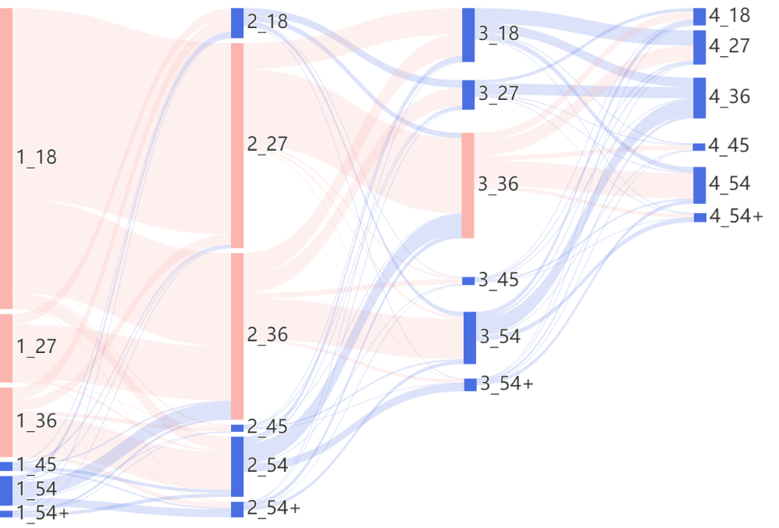
Supplementary Fig. 1a

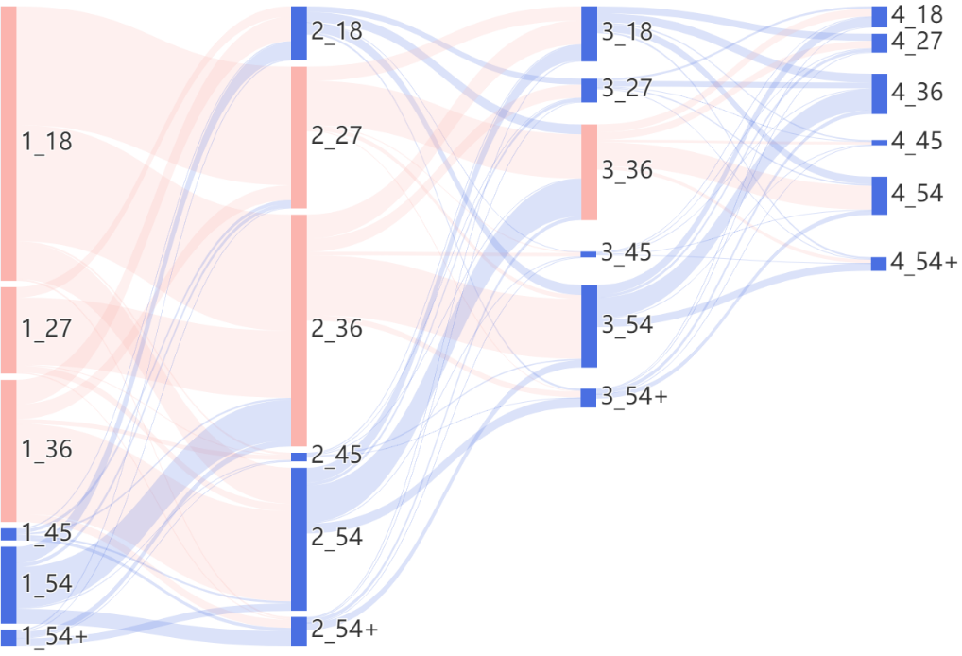
Supplementary Fig. 1b

