Additional files

Supplementary Figure 1 – Flow diagram of PICU admissions included for analysis
174,164 admissions to PICUs in England aged 0-18 years, 2008-2018
Excluded 75,093 admissions
aged >2 years
99,071 admissions to PICUs in England aged <2 years, 2008-2018
Excluded 14 admissions with missing length of stay data
Gestational age <22+0 (n=6) or ≥43+0 (n=29) changed to missing – children not excluded
99,057 admissions to PICUs in England aged <2 years, 2008-2018, with length of stay data (67,615 individual children)
Study population for analysis:
99,057 PICU admissions,
67,615 individual children

Supplementary Figure 2 - Percentage of children admitted to PICU who require a long-stay on any admission up to two years of age, comparison by gestational age at birth, assuming that missing values were birth at term
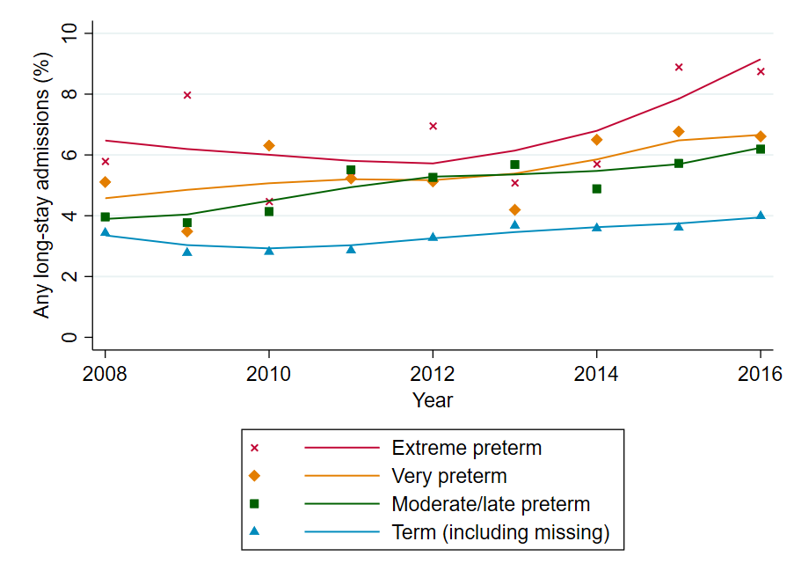

Supplementary Figure 3 - Percentage of children admitted to PICU who require a long-stay on any admission up to two years of age, comparison by gestational age at birth, including only data from units with <20% missing data for gestation
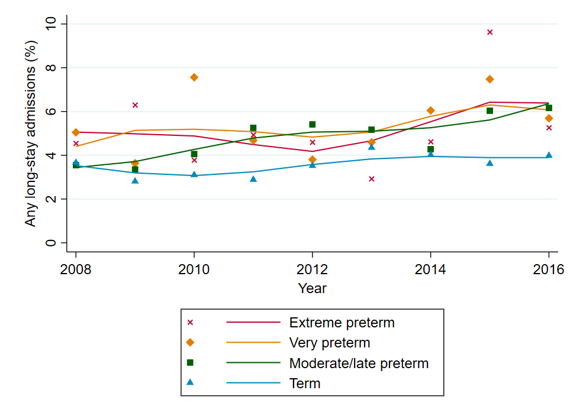

Supplementary Table 1 – Logistic regression analyses for any long-stay ≥28 days, from first PICU admission characteristics, comparing results of primary model (Model 1) and sensitivity analyses (Models 2 and 3).
 |  | Model 1: Complete case analysis |  | Model 2: Replace missing for term |  | Model 3: PICUs with high data-completeness only
 | N | 51,646 |  | 66,536 |  | 39,357
 | c-statistic | 0.685 |  | 0.703 |  | 0.6814
 | Brier Score | 0.0813 |  | 0.0813 |  | 0.0909
 |  | aOR (95% CI) | p | aOR (95% CI) | p | aOR (95% CI) | p
Gestation at birth (ref: term) | Term | Reference | - | Reference | - | Reference | -
Gestation at birth (ref: term) | Moderate/late preterm | 1.276 (1.142 to 1.426) | <0.001 | 1.380 (1.237 to 1.539) | <0.001 | 1.281 (1.124 to 1.460) | <0.001
Gestation at birth (ref: term) | Very preterm | 1.348 (1.146 to 1.585) | <0.001 | 1.453 (1.237 to 1.707) | <0.001 | 1.351 (1.116 to 1.636) | 0.002
Gestation at birth (ref: term) | Extreme preterm | 1.303 (1.116 to 1.521) | 0.001 | 1.385 (1.188 to 1.615) | <0.001 | 1.199 (0.994 to 1.445) | 0.058
Age (corrected if <37/40) | (months) | 0.981 (0.972 to 0.991) | <0.001 | 0.976 (0.967 to 0.984) | <0.001 | 0.976 (0.965 to 0.988) | <0.001
Sex | Male | Reference | - | Reference | - | Reference | -
Sex | Female | 1.091 (1.002 to 1.188) | 0.045 | 1.117 (1.032 to 1.209) | 0.006 | 1.115 (1.010 to 1.232) | 0.031
Primary diagnosis group | Respiratory | Reference | - | Reference | - | Reference | -
Primary diagnosis group | Neurological | 0.625 (0.509 to 0.767) | <0.001 | 0.602 (0.498 to 0.728) | <0.001 | 0.568 (0.444 to 0.725) | <0.001
Primary diagnosis group | Cardiovascular | 1.143 (1.028 to 1.271) | 0.014 | 1.188 (1.076 to 1.312) | 0.001 | 0.999 (0.882 to 1.132) | 0.991
Primary diagnosis group | Infection | 0.531 (0.419 to 0.672) | <0.001 | 0.521 (0.418 to 0.649) | <0.001 | 0.512 (0.385 to 0.680) | <0.001
Primary diagnosis group | Gastrointestinal | 0.543 (0.450 to 0.654) | <0.001 | 0.562 (0.471 to 0.671) | <0.001 | 0.525 (0.426 to 0.648) | <0.001
Primary diagnosis group | Other | 0.903 (0.782 to 1.043) | 0.167 | 0.868 (0.756 to 0.996) | 0.044 | 0.790 (0.666 to 0.937) | 0.007
PIM2 (%, grouped) | <1% | Reference | - | Reference | - | Reference | -
PIM2 (%, grouped) | 1% to <5% | 1.263 (1.105 to 1.443) | 0.001 | 1.374 (1.211 to 1.560) | <0.001 | 1.284 (1.088 to 1.516) | 0.003
PIM2 (%, grouped) | 5% to <15% | 2.145 (1.863 to 2.470) | <0.001 | 2.537 (2.221 to 2.899) | <0.001 | 2.250 (1.891 to 2.677) | <0.001
PIM2 (%, grouped) | 15% to <30% | 3.025 (2.533 to 3.613) | <0.001 | 3.649 (3.091 to 4.308) | <0.001 | 3.201 (2.590 to 3.957) | <0.001
PIM2 (%, grouped) | >30% | 3.069 (2.525 to 3.731) | <0.001 | 3.465 (2.883 to 4.164) | <0.001 | 3.469 (2.756 to 4.366) | <0.001
Previous neonatal or intensive care during hospitalisation | None | Reference | - | Reference | - | Reference | -
Previous neonatal or intensive care during hospitalisation | Mixed/adult ICU | 1.139 (0.836 to 1.551) | 0.410 | 1.371 (1.057 to 1.779) | 0.018 | 1.179 (0.806 to 1.724) | 0.397
Previous neonatal or intensive care during hospitalisation | PICU | 2.705 (2.211 to 3.310) | <0.001 | 2.596 (2.157 to 3.124) | <0.001 | 2.805 (2.231 to 3.528) | <0.001
Previous neonatal or intensive care during hospitalisation | Neonatal unit | 1.939 (1.751 to 2.148) | <0.001 | 1.925 (1.748 to 2.120) | <0.001 | 1.829 (1.620 to 2.064) | <0.001

