Supplementary
Supplemental Table 1: Data sources used to define study participant characteristics and variable operationalization
Characteristic | Data Source | Operationalization
Maternal
Age at delivery | MOMBABY | Continuous in years
Ethnicity | TARGet Kids! | African/Arab/Latin American/Mixed Ethnicity; East/Southeast/South Asian; and European
Child
Gestational age | MOMBABY + BORN | Categorical (<34, 34-36, 37-38, and ≥39 weeks)
Age at outcome | TARGet Kids! | Continuous in years
Sex | TARGet Kids! | Female; male
Weight | TARGet Kids! | Continuous in kg
Height | TARGet Kids! | Continuous in cm
Sociodemographic
Family income | TARGet Kids! | Less than $49,000; $50, 000 to $99, 999; $100, 000 to $149, 999; $150, 000 or more
BORN: The Better Outcomes Registry & Network, MOMBABY: Mother-Baby Linked Dataset

Supplemental Table 2: Model fit comparison of predicted values at specific time points for the outcome of weight trajectory between the original model (3 knot) and model with the best fit (4 knot).
Parameter | Estimate (SE) of 3 Knot model (knots= 3,12,84) | Estimate (SE) of 4 Knot model (knots= 2,8,12,84) | Difference between Estimates of Model 1 and Model 2 (SE) | Difference between SE of Model 1 and Model 2
Very/moderate preterm
1 month | 2.319 (0.424) | 2.23 (0.61) | 0.089 (0.743) | -.18601
3 months | 4.327 (0.838) | 3.787 (0.907) | 0.539 (1.235) | -.06947
12 months | 8.186 (0.378) | 7.883 (0.43) | 0.303 (0.573) | -.05151
50 months | 15.828 (0.338) | 15.859 (0.343) | -0.031 (0.482) | -.00564
100 months | 27.188 (0.379) | 27.126 (0.383) | 0.062 (0.539) | -.00399
150 months | 41.321 (0.594) | 41.333 (0.595) | -0.012 (0.841) | -.00044
Late preterm
1 month | 3.122 (0.338) | 3.126 (0.412) | -0.004 (0.532) | -.07408
3 months | 4.863 (0.564) | 4.699 (0.559) | 0.164 (0.794) | .00535
12 months | 9.384 (0.317) | 8.987 (0.348) | 0.397 (0.471) | -.03022
50 months | 16.386 (0.296) | 16.411 (0.298) | -0.025 (0.42) | -.00213
100 months | 26.867 (0.324) | 26.815 (0.326) | 0.053 (0.46) | -.00198
150 months | 40.042 (0.534) | 40.066 (0.536) | -0.024 (0.756) | -.00149
Early term
1 month | 3.785 (0.289) | 3.845 (0.325) | -0.06 (0.435) | -.03624
3 months | 5.627 (0.406) | 5.39 (0.404) | 0.238 (0.573) | .00185
12 months | 9.533 (0.276) | 9.084 (0.287) | 0.449 (0.399) | -.01104
50 months | 16.636 (0.27) | 16.691 (0.27) | -0.055 (0.382) | -.00046
100 months | 27.922 (0.276) | 27.844 (0.277) | 0.078 (0.391) | -.00066
150 months | 43.332 (0.335) | 43.39 (0.335) | -0.057 (0.473) | -.00031
Full term
1 month | 4.115 (0.266) | 4.195 (0.285) | -0.081 (0.39) | -.01829
3 months | 5.961 (0.313) | 5.717 (0.323) | 0.244 (0.45) | -.00979
12 months | 9.737 (0.263) | 9.218 (0.267) | 0.518 (0.374) | -.00408
50 months | 16.76 (0.26) | 16.829 (0.26) | -0.069 (0.368) | -.00028
100 months | 27.95 (0.263) | 27.864 (0.263) | 0.086 (0.371) | -.00021
150 months | 43.277 (0.29) | 43.364 (0.291) | -0.087 (0.411) | -.00028

Supplemental Table 3: Model fit comparison of predicted values at specific time points for the outcome of height trajectory between the original model (3 knot) and model with the best fit (4 knot).
Parameter | Estimate (SE) of 3 Knot model (knots= 3,12,84) | Estimate (SE) of 4 Knot model (knots= 4,12,24,84) | Difference between Estimates of Model 1 and Model 2 (SE) | Difference between SE of Model 1 and Model 2
Very/moderate preterm
1 month | 45.811 (0.783) | 45.906 (0.704) | -0.095 (1.053) | .079038
3 months | 54.96 (0.58) | 54.005 (0.547) | 0.955 (0.797) | .032581
12 months | 75.232 (0.532) | 73.585 (0.565) | 1.647 (0.776) | -.033058
50 months | 100.624 (0.518) | 101.045 (0.52) | -0.42 (0.734) | -.001813
100 months | 130.39 (0.555) | 129.803 (0.557) | 0.588 (0.787) | -.001580
150 months | 152.412 (0.794) | 152.816 (0.777) | -0.403 (1.111) | .016487
Late preterm
1 month | 51.307 (0.493) | 51.257 (0.489) | 0.05 (0.694) | .003873
3 months | 59.87 (0.49) | 58.87 (0.471) | 1 (0.68) | .019309
12 months | 77.2 (0.466) | 75.141 (0.483) | 2.059 (0.671) | -.017357
50 months | 101.387 (0.459) | 101.923 (0.459) | -0.537 (0.649) | -.000777
100 months | 129.908 (0.481) | 129.167 (0.482) | 0.741 (0.681) | -.000413
150 months | 151.408 (0.696) | 152.145 (0.683) | -0.737 (0.975) | .013751
Early term
1 month | 53.748 (0.427) | 53.646 (0.426) | 0.102 (0.604) | .000867
3 months | 61.553 (0.428) | 60.638 (0.423) | 0.915 (0.602) | .005434
12 months | 77.843 (0.422) | 75.931 (0.427) | 1.912 (0.6) | -.004707
50 months | 101.88 (0.42) | 102.399 (0.42) | -0.519 (0.594) | -.000084
100 months | 130.374 (0.425) | 129.741 (0.425) | 0.634 (0.601) | .000073
150 months | 152.214 (0.484) | 152.938 (0.48) | -0.725 (0.682) | .004144
Full term
1 month | 55.439 (0.409) | 55.36 (0.408) | 0.079 (0.577) | .000552
3 months | 62.609 (0.409) | 61.826 (0.406) | 0.784 (0.576) | .002446
12 months | 78.43 (0.406) | 76.436 (0.408) | 1.994 (0.575) | -.001884
50 months | 102.456 (0.405) | 102.984 (0.405) | -0.529 (0.572) | .000081
100 months | 130.671 (0.407) | 129.995 (0.407) | 0.675 (0.575) | .000182
150 months | 151.666 (0.435) | 152.446 (0.433) | -0.78 (0.614) | .002082

Supplemental Table 4: Predicted mean weight (kg) and 95% CI at each age (knot point) by gestational age category
Age | Very/Moderate preterm | Late preterm | Early term | Full term
1 mo | 2.3 (1.5, 3.1) | 3.1 (2.5, 3.8) | 3.8 (3.2, 4.4) | 4.1 (3.6, 4.6)
3 mo | 4.3 (2.7, 6.0) | 4.9 (3.8, 6.0) | 5.6 (4.8, 6.4) | 6.0 (5.3, 6.6)
12 mo | 8.2 (7.4, 8.9) | 9.4 (8.8, 10.0) | 9.5 (9.0, 10.1) | 9.7 (9.2, 10.3)
50 mo | 15.8 (15.2, 16.5) | 16.4 (15.8, 17.0) | 16.6 (16.1, 17.2) | 16.8 (16.3, 17.3)
100 mo | 27.2 (26.4, 27.9) | 26.9 (26.2, 27.5) | 27.9 (27.4, 28.5) | 27.9 (27.4, 28.5)
150 mo | 41.3 (40.2, 42.5) | 40.0 (39.0, 41.1) | 43.3 (42.7, 44.0) | 43.3 (42.7, 43.8)

Supplemental Table 5: Predicted mean height (cm) and 95% CI at each age (knot point) by gestational age category
Age | Very/Moderate preterm | Late preterm | Early term | Full term
1 mo | 45.8 (44.3, 47.3) | 51.3 (50.3, 52.3) | 53.7 (52.9, 54.6) | 55.4 (54.6, 56.2)
3 mo | 55.0 (53.8, 56.1) | 59.9 (58.9, 60.8) | 61.6 (60.7, 62.4) | 62.6 (61.8, 63.4)
12 mo | 75.2 (74.2, 76.3) | 77.2 (76.3, 78.1) | 77.8 (77.0, 78.7) | 78.4 (77.6, 79.2)
50 mo | 100.6 (99.6, 101.6) | 101.4 (100.5, 102.3) | 101.9 (101.1, 102.7) | 102.5 (101.7, 103.2)
100 mo | 130.4 (129.3, 131.5) | 129.9 (129.0, 130.9) | 130.4 (129.5, 131.2) | 130.7 (129.9, 131.5)
150 mo | 152.4 (150.9, 154.0) | 151.4 (150.0, 152.8) | 152.2 (151.3, 153.2) | 151.7 (150.8, 152.5)

Supplemental Table 6: Mean differences in monthly growth rates for zweight, zheight, and zBMI by gestational age categories during each growth period for study participants (N=4423)
Growth period | Growth rate (95% CI) very/moderate preterm | Mean difference (95% CI) between very/moderate preterm vs. full term | Growth rate (95% CI) late preterm | Mean difference (95% CI) between late preterm vs. full term | Growth rate (95% CI) early term | Mean difference (95% CI) between early term vs. full term | Growth rate (95% CI) full term
zWeight
0-3 months | 0.22 (0.15, 0.29) | 0.22 (0.15, 0.29) | 0.00 (0.00, 0.00) | 0.00 (-0.01, 0.00) | 0.00 (-0.01, 0.01) | 0.00 (-0.01, 0.01) | 0.00 (0.00, 0.01)
3-12 months | 0.27 (0.25, 0.28) | 0.23 (0.21, 0.24) | 0.17 (0.16, 0.18) | 0.13 (0.12, 0.14) | 0.08 (0.08, 0.08) | 0.04 (0.03, 0.04) | 0.04 (0.04, 0.05)
12-84 months | 0.01 (0.00, 0.01) | 0.01 (0.00, 0.01) | 0.00 (0.00, 0.00) | 0.00 (0.00, 0.00) | 0.00 (0.00, 0.00) | 0.00 (0.00, 0.00) | 0.00 (0.00, 0.00)
84-168 months | 0.00 (-0.01, 0.01) | -0.01 (-0.01, 0.00) | 0.01 (0.00, 0.01) | 0.00 (0.00, 0.01) | 0.00 (0.00, 0.01) | 0.00 (0.00, 0.00) | 0.00 (0.00, 0.01)
zHeight
0-3 months | 0.16 (0.07, 0.25) | 0.14 (0.04, 0.23) | 0.00 (0.00, 0.00) | -0.02 (-0.03, -0.02) | 0.02 (0.01, 0.03) | 0.00 (-0.01, 0.01) | 0.02 (0.02, 0.03)
3-12 months | 0.22 (0.21, 0.24) | 0.26 (0.24, 0.28) | 0.11 (0.10, 0.12) | 0.14 (0.13, 0.16) | 0.02 (0.01, 0.02) | 0.05 (0.05, 0.06) | -0.04 (-0.04, -0.03)
12-84 months | 0.01 (0.01, 0.01) | 0.01 (0.01, 0.02) | 0.00 (0.00, 0.00) | 0.00 (0.00, 0.01) | 0.00 (-0.01, 0.00) | 0.00 (0.00, 0.00) | -0.01 (-0.01, -0.01)
84-168 months | 0.00 (0.00, 0.01) | 0.00 (-0.01, 0.00) | 0.01 (0.00, 0.01) | 0.00 (0.00, 0.01) | 0.01 (0.01, 0.01) | 0.00 (0.00, 0.00) | 0.01 (0.01, 0.01)
zBMI
0-3 months | 0.14 (0.04, 0.23) | 0.16 (0.06, 0.25) | 0.00 (0.00, 0.00) | 0.02 (0.01, 0.02) | -0.01 (-0.02, -0.01) | 0.01 (0.00, 0.01) | -0.02 (-0.02, -0.01)
3-12 months | 0.18 (0.16, 0.20) | 0.09 (0.07, 0.11) | 0.15 (0.14, 0.16) | 0.06 (0.05, 0.07) | 0.10 (0.09, 0.10) | 0.01 (0.00, 0.02) | 0.09 (0.08, 0.09)
12-84 months | 0.00 (0.00, 0.00) | 0.00 (0.00, 0.00) | 0.00 (0.00, 0.00) | 0.00 (0.00, 0.00) | 0.00 (0.00, 0.00) | 0.00 (0.00, 0.00) | 0.00 (0.00, 0.00)
84-168 months | 0.00 (-0.01, 0.00) | 0.00 (-0.01, 0.00) | 0.00 (-0.01, 0.00) | 0.00 (-0.01, 0.00) | 0.00 (-0.01, 0.00) | 0.00 (0.00, 0.00) | 0.00 (0.00, 0.00)

10 897 children in TARGet Kids! data
5907 potentially eligible children
4990 without a valid ICES-specific key number or with birthdate < April 1, 2006, or > September 30, 2014
108 who were not Ontario residents or were not eligible for Ontario’s health care plan (OHIP) on their birthdate
5799 potentially eligible children
770 with no weight measurement, only one weight measurement, impractical weight, or impractical zBMI values
4423 final linked TARGet Kids! – ICES – BORN cohort
311 missing gestational age data
4718 potentially eligible children
295 who were twins, triplets, or part of other multiple birth
5029 potentially eligible children

Supplemental Figure 1: Flowchart of study participants with weight/height data
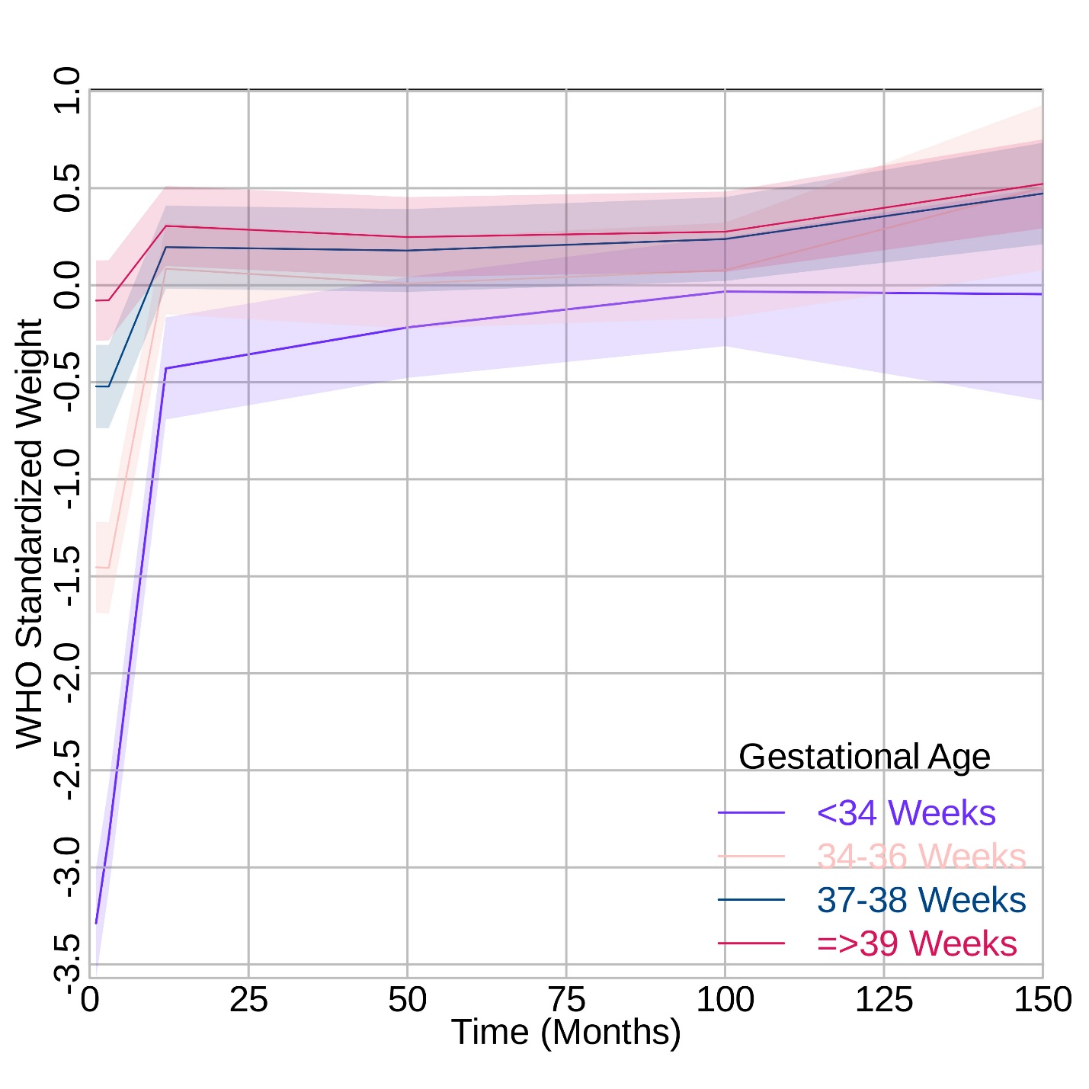
Supplemental Figure 2: Growth curves for World Health Organization (WHO) standardized weight trajectories from 0 to 150 months by gestational age categories. The lines represent the growth curve, and the shaded areas represent the 95% confidence intervals.
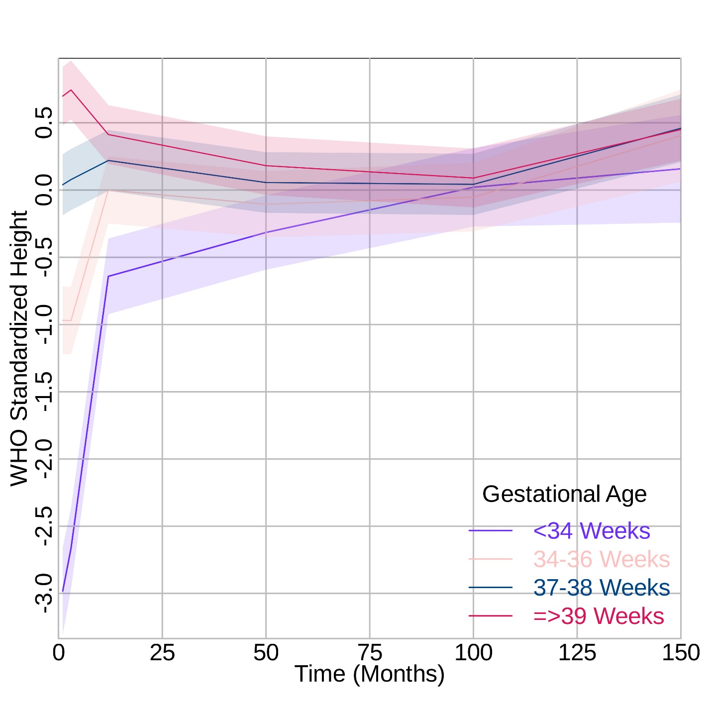
Supplemental Figure 3: Growth curves for World Health Organization (WHO) standardized height trajectories from 0 to 150 months by gestational age categories. The lines represent the growth curve, and the shaded areas represent the 95% confidence intervals.
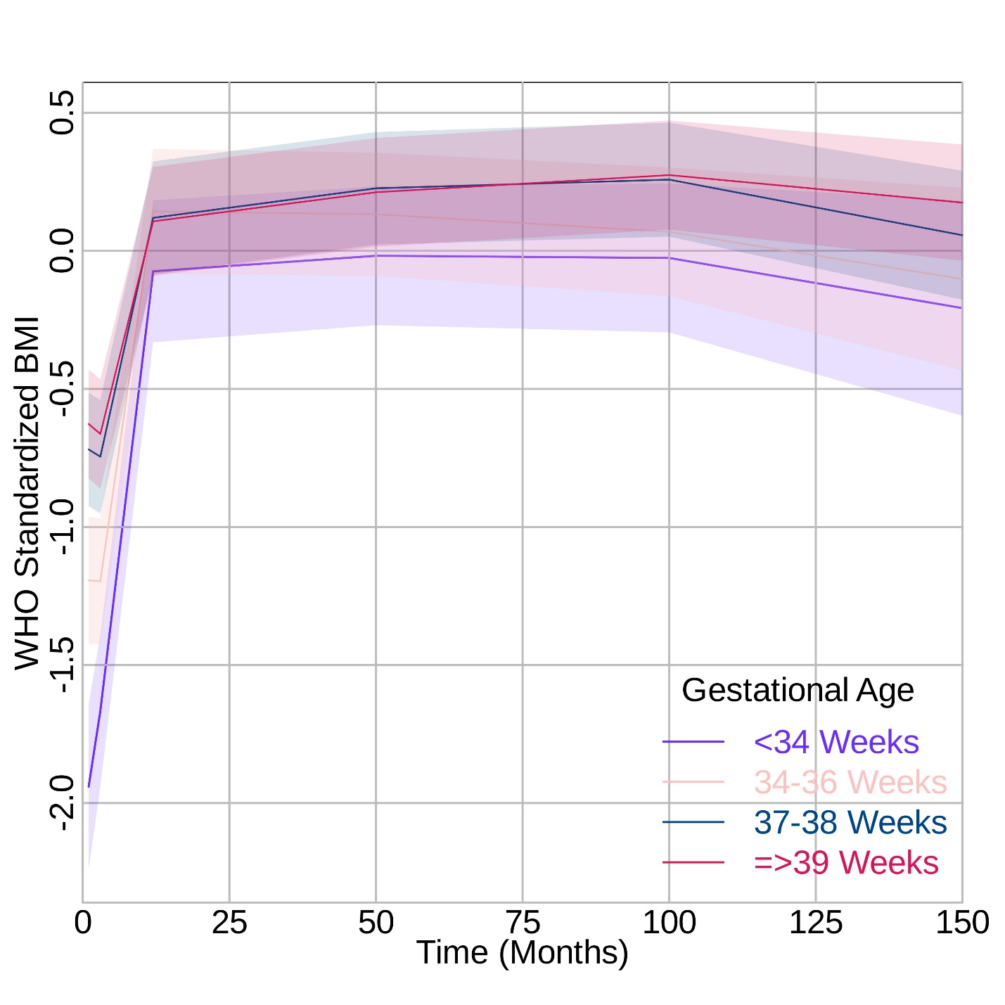
Supplemental Figure 4: Growth curves for World Health Organization (WHO) standardized BMI trajectories from 0 to 150 months by gestational age categories. The lines represent the growth curve, and the shaded areas represent the 95% confidence intervals.

