Related figures
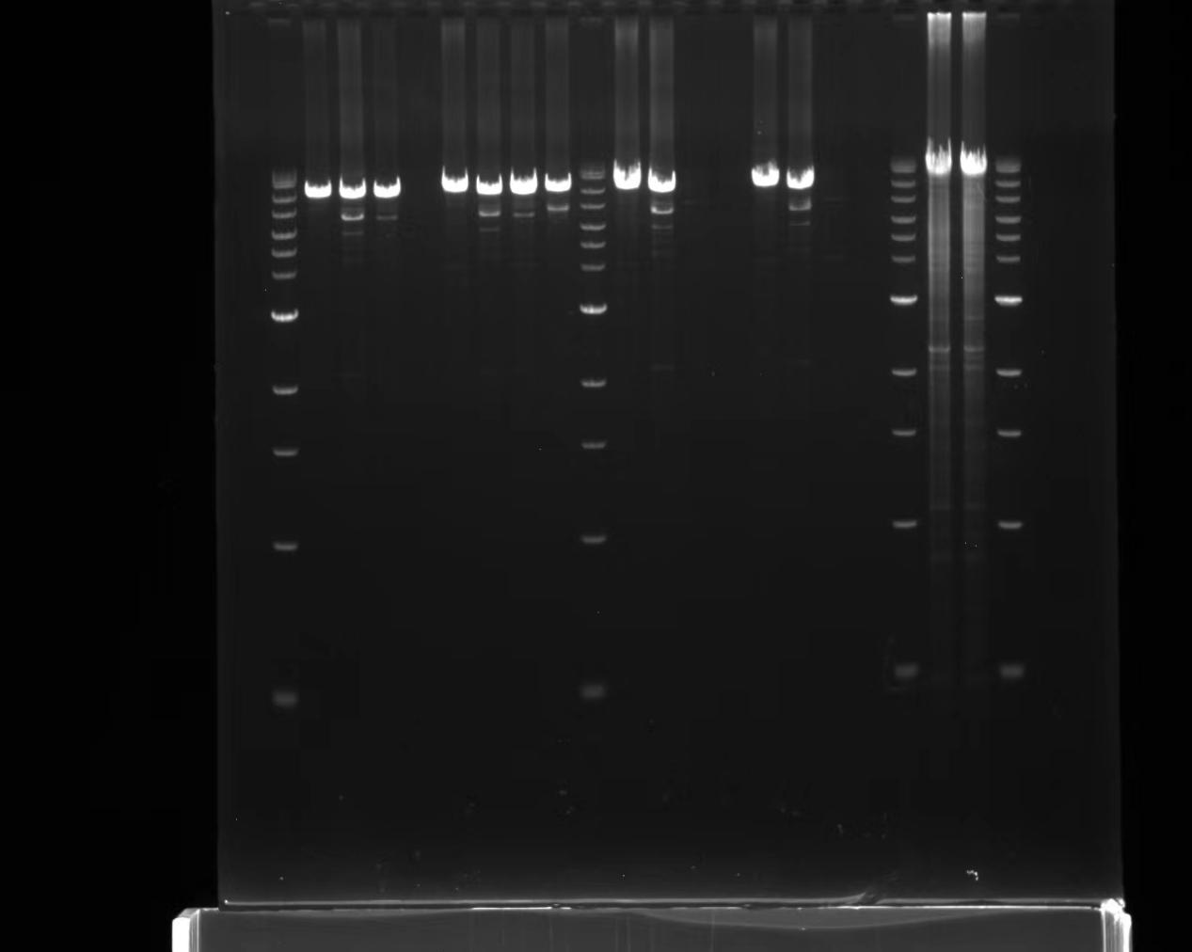
Figure R1. The original figure of figure 2d, PCR products including the chromosome rearrangement site of the breakpoint.
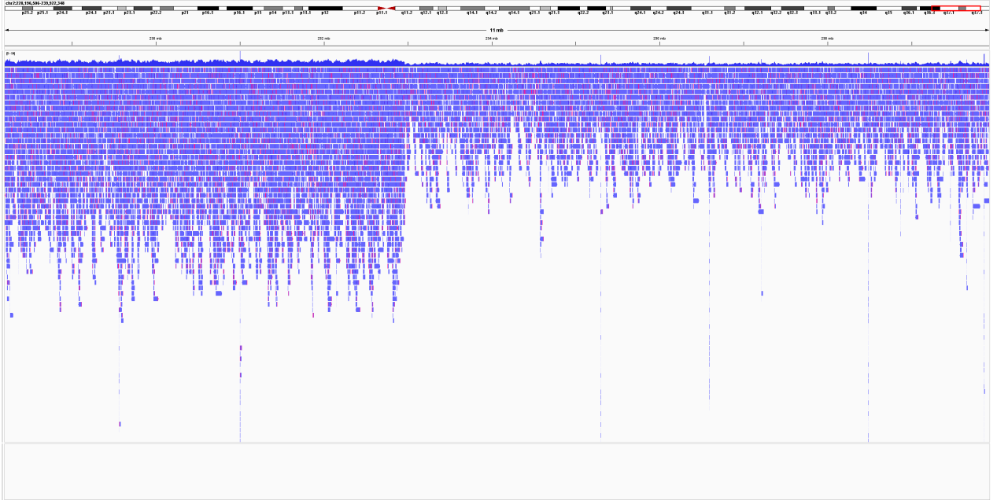
Figure R2. The enlargement of figure 3c, ONT shows the reads decrease aberrantly at 2q37.1-37.3.

