APPENDIX 4: SUMMARY OF THE STUDY CONCEPTUAL FRAMEWORK
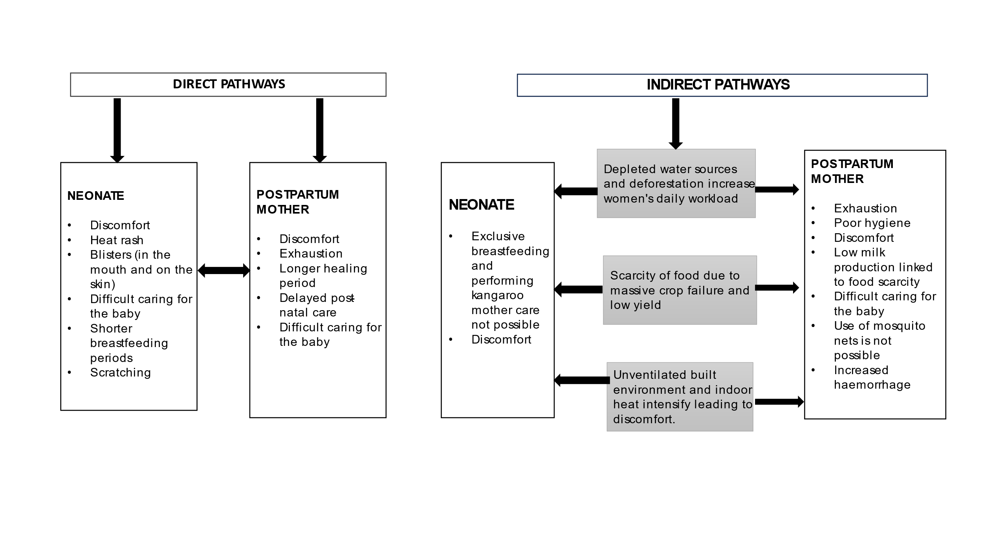FIGURE 1: DIRECT AND INDIRECT PATHWAYS OF HEAT EXPOSURE ON POSTPARTUM WOMEN AND THEIR NEONATES

