Supplementary Materials

Table 1 PUTS-C Inter-item Correlations-Total sample(n=204)
PUTS | PUTS-1 | PUTS-2 | PUTS-3 | PUTS-4 | PUTS-5 | PUTS-6 | PUTS-7 | PUTS-8 | PUTS-9
PUTS-1 | 1
PUTS-2 | 0.20** | 1
PUTS-3 | 0.36*** | 0.41*** | 1
PUTS-4 | 0.22** | 0.31*** | 0.31*** | 1
PUTS-5 | 0.17** | 0.24*** | 0.29*** | 0.36*** | 1
PUTS-6 | 0.15* | 0.41*** | 0.31*** | 0.33*** | 0.40*** | 1
PUTS-7 | 0.31*** | 0.40*** | 0.38*** | 0.34*** | 0.45*** | 0.56*** | 1
PUTS-8 | 0.26*** | 0.44*** | 0.39*** | 0.40*** | 0.47*** | 0.58*** | 0.71** | 1
PUTS-9 | 0.27*** | 0.35*** | 0.37*** | 0.43*** | 0.38*** | 0.39*** | 0.35** | 0.47** | 1
*p< 0.05, **p<0.01,***p<0.001
PUTS-C: Chinese version of Premonitory Urge for Tics Scale

Table 2 Maximum likelihood exploratory factor analysis with structure and pattern matrices for PUTS-C
 | Total sample(n= 204)
 | Structure Matrix |  | Pattern Matrix |  | Communalities
 | factor 1 | factor 2 | factor 1 | factor 2 | Communalities
1. Right before I do a tic, I feel like my insides are itchy | 0.32 | 0.53 | -0.08 | 0.58 | 0.28
2. Right before I do a tic, I feel pressure inside my brain or body | 0.52 | 0.57 | 0.26 | 0.39 | 0.36
3. Right before I do a tic, I feel “wound up” or tense inside | 0.43 | 0.65 | -0.02 | 0.67 | 0.43
4. Right before I do a tic, I feel like something is not “just right” | 0.47 | 0.55 | 0.17 | 0.44 | 0.32
5. Right before I do a tic, I feel like something is not complete | 0.54 | 0.45 | 0.43 | 0.16 | 0.31
6. Right before I do a tic, I feel like there is energy in my body that needs to get out | 0.70 | 0.50 | 0.67 | 0.05 | 0.49
7. I have these feelings almost all the time before I do a tic | 0.83 | 0.52 | 0.88 | -0.08 | 0.69
8. These feelings happen for every tic I have | 0.85 | 0.58 | 0.84 | 0.01 | 0.72
9. After I do the tic, the itchiness, energy, pressure, tense feelings, or feelings that something is not ‘‘just right’’ or complete go away, at least for a little while | 0.47 | 0.56 | 0.16 | 0.46 | 0.33
Eigen value | 3.97 | 1.03
Common variance (%) | 44.09 | 11.47
KMO | 0.87
Bold items indicate values which loaded onto a factor.
PUTS-C: Chinese version of Premonitory Urge for Tics Scale
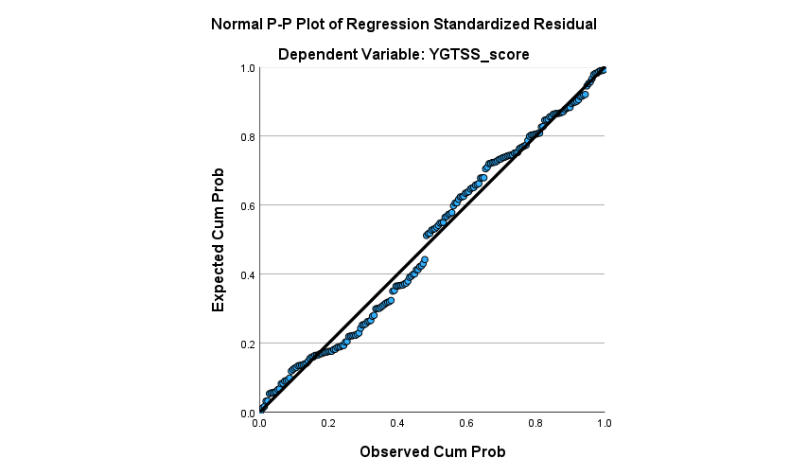

Figure1 Normal Probability Plot of Standardized Residuals for Tic Severity Score Regression Model

