List of figures and tables
(Table 2, Table 3 and Figures 1,2,4,5,6 can be placed in the main text)
(Table 1 and Figure 3 can be attached as index)
Efficacy of prebiotic, probiotic and synbiotic administration in improving growth in children aged 0-59 months living in low- and middle-income countries: a systematic review and meta–analysis
Marietou Khouma, Mamadou Diallo, Doudou Sow, Aicha Djigual, Ndeye Sokhna Diop, Stephen Allen, Babacar Faye
Correspondence
Marietou Khouma, Department of Animal Biology, Faculty of Science and Technology, Cheikh Anta Diop University of Dakar; Email: marietou.khouma@ucad.edu.sn;

Table 1: Search strategy for each database
Table 2: Studies excluded after reading the full text
Table 3: Characteristics of studies
Table 4: Rating the quality of evidence
Table 5: PRISMA checklist

Figure 1: PRISMA diagram
Figure 2: Risk of bias for the 8 RCTs (RoB 2) tool
Figure 3: Geographical distribution of included articles
Figure 4:
- A: Effect of prebiotic, probiotic and synbiotic on the weight gain (kg) of children living in LMICs.
- B: Effect of prebiotic, probiotic and synbiotic on the weight gain (kg) of children by intervention.
- C: Effect of prebiotic, probiotic and synbiotic on the weight gain (kg) of children by nutritional status.
- D: Effect of prebiotics, probiotics and synbiotics on weight gain (kg) by the duration of supplementation
- E: Effect of prebiotics, probiotics and synbiotics on weight gain (kg) by the year of publication
Figure 5:
- A: Effect of prebiotic, probiotic and synbiotic on the height gain (cm) of children living in LMICs.
- B: Effect of prebiotic, probiotic and synbiotic on the height gain (cm) of children by intervention.
- C: Effect of prebiotic, probiotic and synbiotic on the height gain (cm) of children by nutritional status.
- D: Effect of prebiotics, probiotics and synbiotics on height gain (cm) by the duration of supplementation

Figure 6: Effect of prebiotic, probiotic and synbiotic administration on the head circumference gain (cm) of children.
Figure 7:
- A: Sensitivity analysis Effect of prebiotic, probiotic and synbiotic on the weight gain (kg).
- B: Sensitivity analysis Effect of prebiotic, probiotic and synbiotic on the weight gain by intervention (kg).
- C: Sensitivity analysis effect of prebiotic, probiotic and synbiotic on the weight gain (kg) by nutritional status.
- D: Sensitivity analysis effect of prebiotics, probiotics and synbiotics on weight gain (kg) by the duration of supplementation.
- E: Sensitivity analysis effect of prebiotics, probiotics and synbiotics on weight gain (kg) by the year of publication.

Figure 8:
- A: Sensitivity analysis effect of prebiotic, probiotic and synbiotic on the height gain (cm) of children.
- B: Sensitivity analysis Effect of prebiotic, probiotic and synbiotic on the height gain (cm) by intervention.
- C: Sensitivity analysis effect of prebiotic, probiotic and synbiotic on the height gain (cm) by nutritional status.
- D: Effect of prebiotics, probiotics and synbiotics on height gain (cm) by the duration of supplementation.

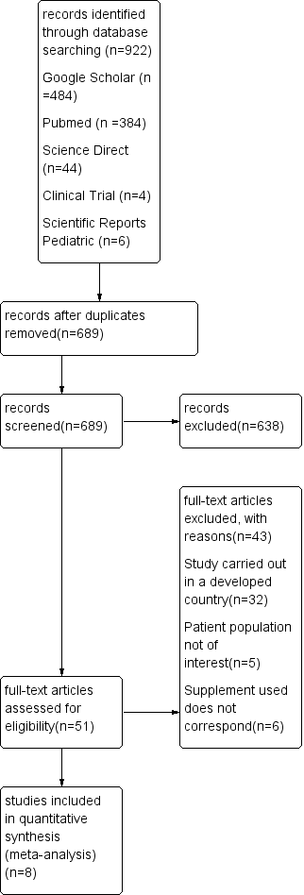
Eligibility
Included
Screening

Identification

Figure 1 : PRISMA diagram
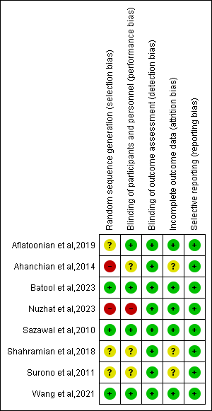
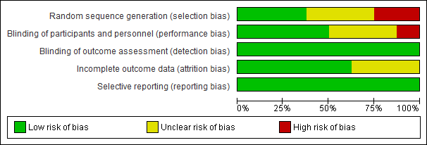
Figure 2 : Risk of bias for the 8 RCTs (RoB 2) tool (1).

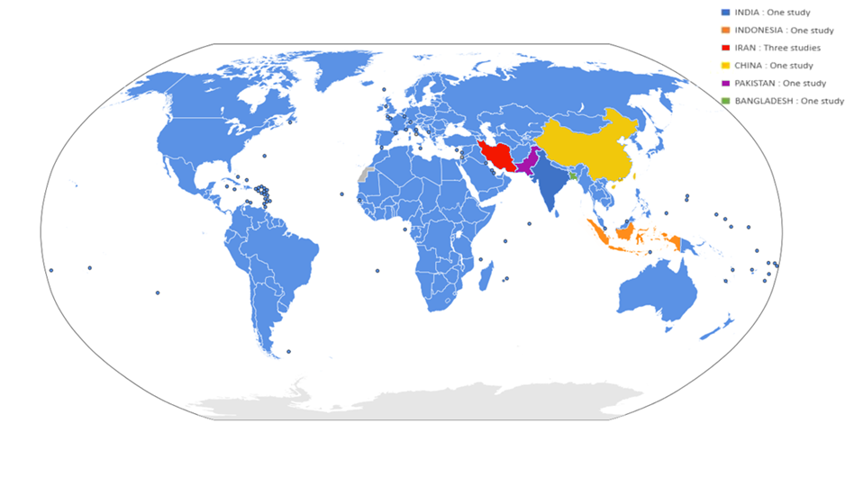
https://www.google.com/url?sa=i&url=https%3A%2F%2Fwww.populationdata.net%2Fcartes%2Fmonde-onu-pays-membres%2F&psig=AOvVaw2sOwENDwkSUOKEmngW2Lyj&ust=1728566476442000&source=images&cd=vfe&opi=89978449&ved=0CBQQjhxqFwoTCIiTkIijgYkDFQAAAAAdAAAAABAS

Figure 3: Geographical distribution of included studies

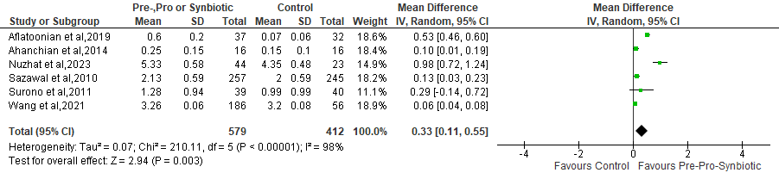
Fig.4. A: Effect of prebiotics, probiotics and synbiotics on the weight gain (kg) of children living in LMICs.
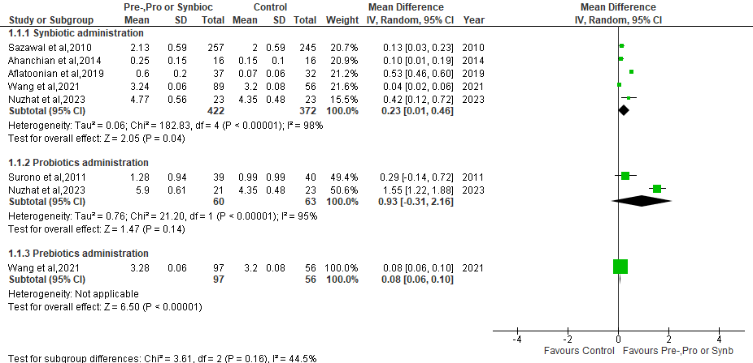

Fig.4. B: Effect of prebiotics, probiotics and synbiotics on the weight gain (kg) of children by intervention
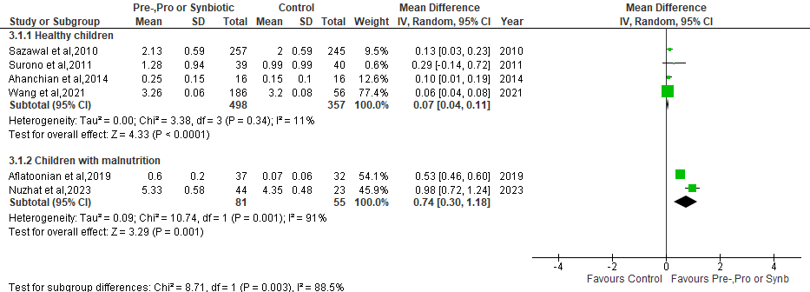
Fig.4. C: Effect of prebiotics, probiotics and synbiotics on the weight gain (kg) of children by nutritional status

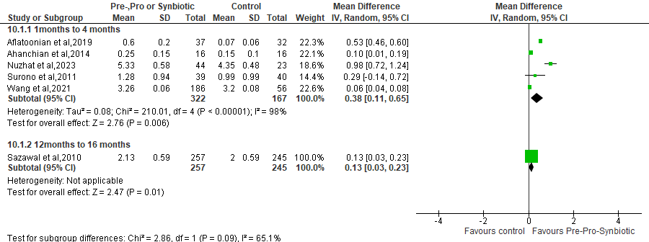

Fig.4. D: Effect of prebiotics, probiotics and synbiotics on weight gain (kg) by the duration of supplementation
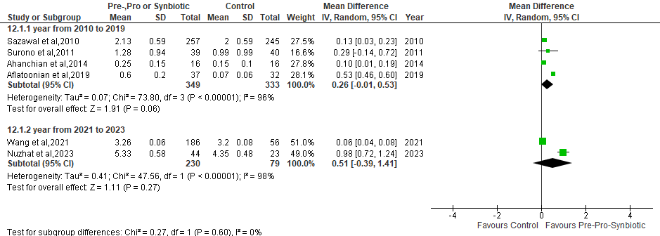

Fig.4. E: Effect of prebiotics, probiotics and synbiotics on weight gain (kg) by the year of publication

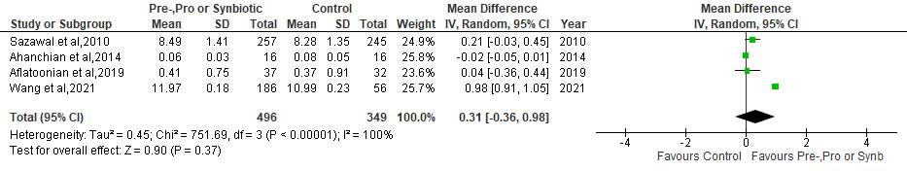
Fig.5. A: Effect of prebiotic, probiotic and synbiotic on the height gain (cm) of children living in LMICs
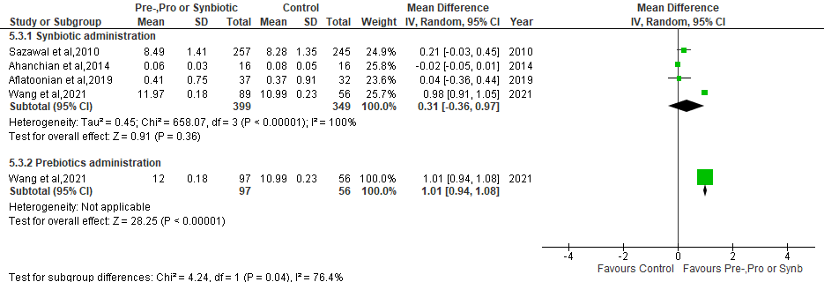
Fig.5. B: Effect of prebiotic, probiotic and synbiotic on the height gain (cm) of children by intervention.

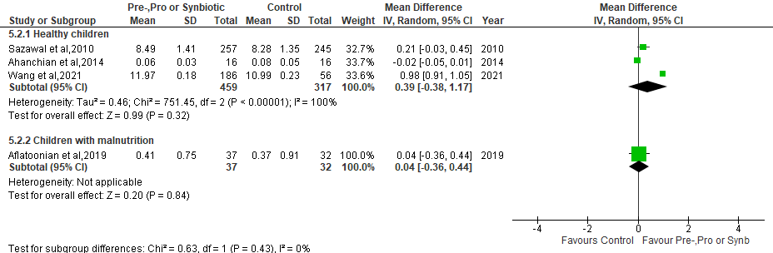

Fig.5. C: Effect of prebiotic, probiotic and synbiotic on the height gain (cm) of children by nutritional status

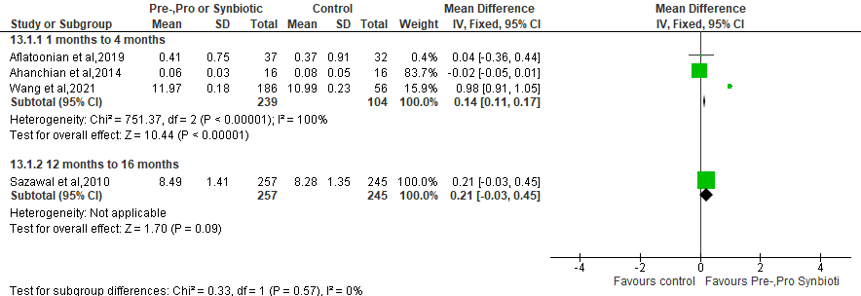

Fig.5. D: Effect of prebiotics, probiotics and synbiotics on height gain (cm) by the duration of supplementation

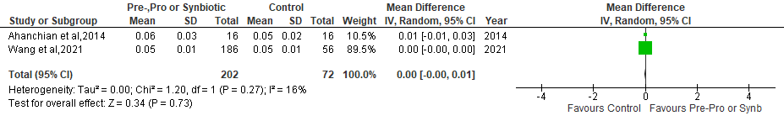
Fig.6: Effect of prebiotic, probiotic and synbiotic administration on the head circumference gain (cm) of children

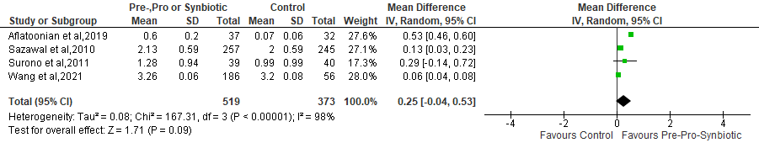
Fig.7. A: Sensitivity analysis Effect of prebiotic, probiotic and synbiotic on the weight gain (kg)
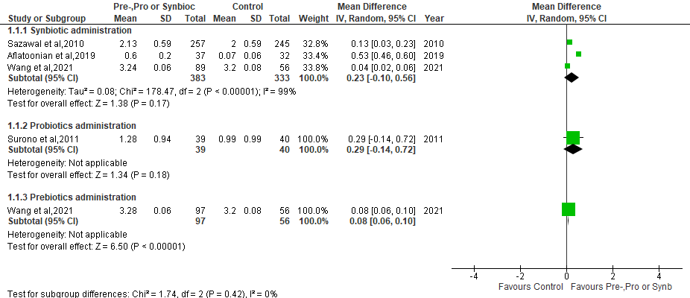
Fig.7. B: Sensitivity analysis Effect of prebiotic, probiotic and synbiotic on the weight gain by intervention (kg)
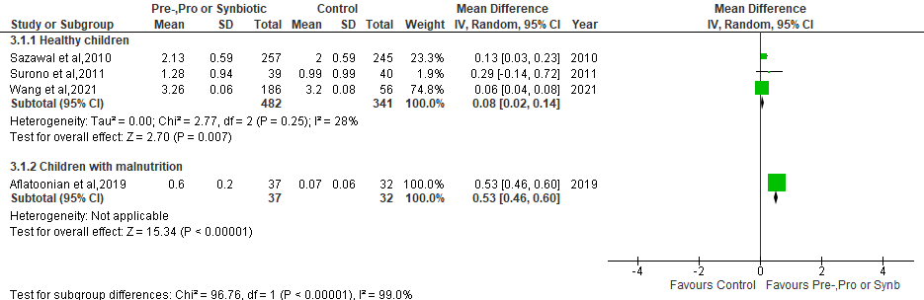
Fig.7. C: Sensitivity analysis effect of prebiotic, probiotic and synbiotic on the weight gain (kg) by nutritional status

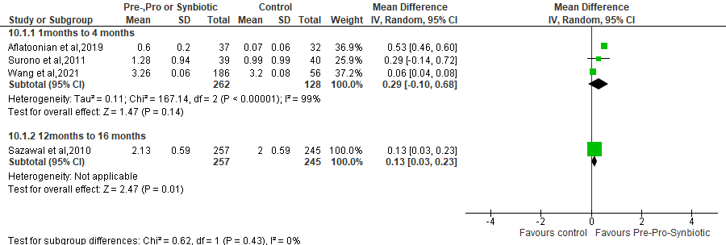
Fig.7. D: Sensitivity analysis effect of prebiotics, probiotics and synbiotics on weight gain (kg) by the duration of supplementation

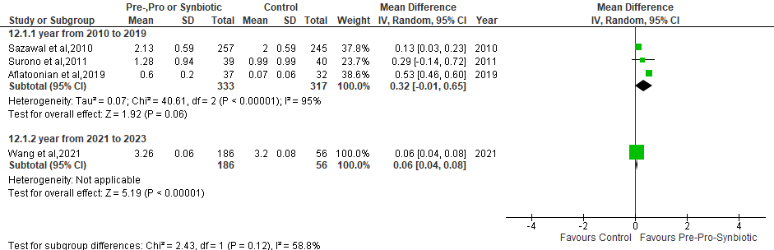

Fig.7. E: Sensitivity analysis effect of prebiotics, probiotics and synbiotics on weight gain (kg) by the year of publication

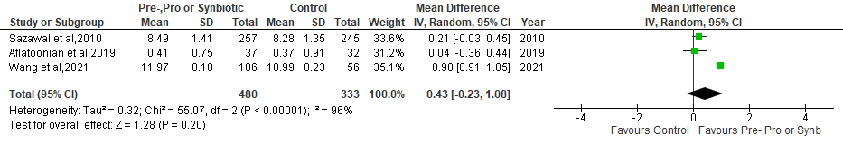
Fig.8. A: Sensitivity analysis effect of prebiotic, probiotic and synbiotic on the height gain (cm) of children
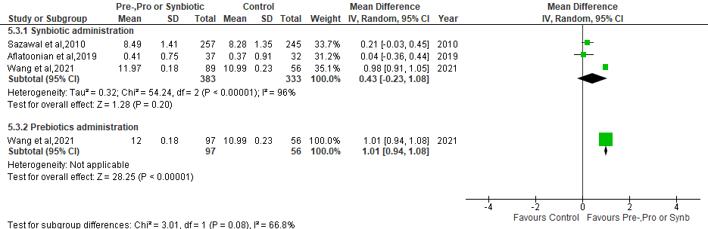
Fig.8. B: Sensitivity analysis Effect of prebiotic, probiotic and synbiotic on the height gain (cm) by intervention.
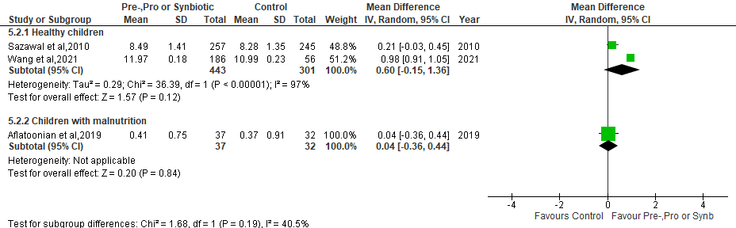
Fig.8. C: Sensitivity analysis effect of prebiotic, probiotic and synbiotic on the height gain (cm) by nutritional status
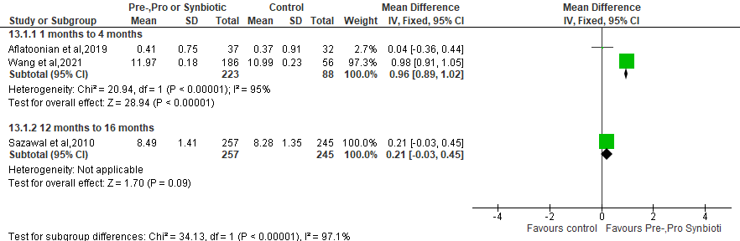

Fig.8.D: Sensitivity analysis effect of prebiotics, probiotics and synbiotics on height gain (cm) by the duration of supplementation

Table 1: Search strategy for each database
Database | Search strategy
Pubmed, Embase, web of sciences, Science direct, Google Scholar, Scopus | ((((probiotic) OR prebiotic OR synbiotic) AND children) AND growth) AND randomized clinical trials); ((((probiotics) OR (synbiotics) AND children) AND growth) AND non randomized clinical trials).
clinicaltrial.org | ((((probiotic) OR prebiotic OR synbiotic) AND children) AND growth) AND randomized clinical trials)
Cochrane Library | Appropriate combination of key words

Table 2: Studies excluded after reading the full text
Study (reference) | Reason for Exclusion
Scalabrin, DMF et al ; 2017(2) | 32 studies: conducted in High Income Countries (HICs)
Neumer, et al ; 2021(3) | 32 studies: conducted in High Income Countries (HICs)
Radke, et al ; 2017(4) | 32 studies: conducted in High Income Countries (HICs)
Ashley, et al ; 2012(5) | 32 studies: conducted in High Income Countries (HICs)
Rodriguez, et al ; 2019(6) | 32 studies: conducted in High Income Countries (HICs)
Johnston, et al ; 2015(7) | 32 studies: conducted in High Income Countries (HICs)
Scalabrin, et al ; 2009(8) | 32 studies: conducted in High Income Countries (HICs)
Cekola, et al ; 2015(9) | 32 studies: conducted in High Income Countries (HICs)
Al-Hosni, et al ; 2012(10) | 32 studies: conducted in High Income Countries (HICs)
Costalos, et al ; 2008(11) | 32 studies: conducted in High Income Countries (HICs)
Puccio, et al ; 2007(12) | 32 studies: conducted in High Income Countries (HICs)
Piemontese, et al ; 2011(13) | 32 studies: conducted in High Income Countries (HICs)
Wiezman, et al ; 2006(14) | 32 studies: conducted in High Income Countries (HICs)
Bocquet, et al ; 2013(15) | 32 studies: conducted in High Income Countries (HICs)
Chouraqui, et al ; 2008(16) | 32 studies: conducted in High Income Countries (HICs)
Pastor, et al ; 2020(17) | 32 studies: conducted in High Income Countries (HICs)
Rozé, et al ; 2012(18) | 32 studies: conducted in High Income Countries (HICs)
Ringel, et al ; 2015(19) | 32 studies: conducted in High Income Countries (HICs)
Wejryd, et al ; 2019(20) | 32 studies: conducted in High Income Countries (HICs)
Manzano, et al ; 2017(21) | 32 studies: conducted in High Income Countries (HICs)
Maldonado, et al ; 2019(22) | 32 studies: conducted in High Income Countries (HICs)
Saavedra, et al; 2004(23) | 32 studies: conducted in High Income Countries (HICs)
Gibson, et al ; 2009(24) | 32 studies: conducted in High Income Countries (HICs)
Dupont, et al ; 2015(25) | 32 studies: conducted in High Income Countries (HICs)
Wall, et al; 2019(26) | 32 studies: conducted in High Income Countries (HICs)
Campos, et al ; 2012(27) | 32 studies: conducted in High Income Countries (HICs)
Vlieger, et al; 2009(28) | 32 studies: conducted in High Income Countries (HICs)
Vendt, et al ; 2006(29) | 32 studies: conducted in High Income Countries (HICs)
Alliet et al ; 2022(30) | 32 studies: conducted in High Income Countries (HICs)
Meli, et al ; 2014(31) | 32 studies: conducted in High Income Countries (HICs)
Ahanchian, et al ; 2013 (32) | 32 studies: conducted in High Income Countries (HICs)
Kokke, et al ; 2008(33) | 32 studies: conducted in High Income Countries (HICs)
Kukkonen, et al ; 2008(34) | 5 studies: study population not of interest
Hays, et al ; 2016(35) | 5 studies: study population not of interest
Cooper, et al ; 2016(36) | 5 studies: study population not of interest
Martin, et al ; 2002(37) | 5 studies: study population not of interest
Xu, et al ; 2016(38) | 5 studies: study population not of interest
Helmyati, et al ; 2021(39) | 6 studies: appropriate supplement not used
Xiaonon, et al ; 2019(40) | 6 studies: appropriate supplement not used
Aly, et al ; 2017(41) | 6 studies: appropriate supplement not used
Zambrana, et al ; 2019(42) | 6 studies: appropriate supplement not used
Lee, et al; 2015(43)
Firmanshyah, et al; 2011(44)

Table 3: Characteristics of studies
Study | Country | Nutritional  Status | Study design and population | Intervention, Dosage, Duration | Control | No. (exp/control)
Prebiotic studies
Batool et al (2023) (45) | Pakistan | Severe acute malnutrition | 2-arm RCTs Double-blind ,children aged 6-59 months, ,hospital | RUTF with 4g of galacto-oligosaccharides per day for 2 months | starch | 204 (102/102)
Shahramian et al (2018)  (46) | Iran | Healthy | 3-arm RCT Double-blind, children aged 14 weeks-12 months,hospital, | Galacto-oligosaccharides and polydextrose, for 12 months | regular formula  breast-feeding | 180 (60/120)
Probiotic studies

Surono et al (2011)  (47) | Indonesia | Healthy | 2 arm RCT Double-blind,,children aged 15-54 months, community | Enterococcus faecium IS-27526 (2.31 x10⁸ CFU/day), 1mg daily for 3 months | 1 mg maltodextrin  in 125 ml commercial UHT low fat milk | 79 (39/40)
Probiotic/Synbiotic studies
Nuzhat et al (2023)  (49) | Bangladesh | Severe acute malnutrition | 3-arm RCT Single-blind, children aged 2-6 months, hospital | Bifidobacterium. infantis EVC001, Bifidobacterium. infantis EVC00 1.8 x10⁶ CFU/day) + (Lacto-N-neotetraose [LNnT]), 1.6g twice daily for 1 month | Lactose | 67 (44/23)
Synbiotic/ Prebiotic studies
Wang et al (2021)  (50) | China | Healthy | 3-arm RCT Double-blind,infants, aged 44 days-17 weeks, hospital | Bifidobacterium breve M-16V (3 x10⁷ CFU/g) + 0.8 g/100 ml scGOS/lcFOS, 0.8 g/100 ml scGOS/lcFOS daily for 4 months | breast-feeding | 242 (89/153)
Synbiotic studies
Aflatoonian et al (2020)  (51) | Iran | Mild to moderate growth retardation | 2-arm RCT Triple-blind trial, children aged 24 -59 months, hospital | Lactobacillus acidophilus, Lactobacillus rhamnosus, Lactobacillus bulgaricus, Lactobacillus casei, Bifidobacterium infantis, Bifidobacterium breve, and Streptococcus thermophiles10⁹ CFU and  FOS 1g daily for 1 month | placebo (unspecified) | 69 (37/32)
Ahanchian et al (2014)  (52) | Iran | Healthy | 2-arm RCT Double-blind; breastfed infants with cow`s milk protein allergy ,children aged 1-12 months,hospital | Lactobacillus casei, Lactobacillus rhamnosus, Streptococcus thermophilus, Bifidobacterium breve, Lactobacillus acidophilus, Bifidobacterium infantis, Lactobacillus bulgaricus 1 x10⁶ CFU + FOS (Protexin healthcare, Somerset, UK) daily for 1 month | Placebo (unspecified) | 32 (16/16)
Sazawal et al (2010)  (48) | India | Healthy | 2-arm RCT Double-blind, children aged 1-3 years, community | Bifidobacterium lactis HN019 1.9 x10⁷ CFU/day + 2.4 g of oligosaccharides 3 times daily for 12 months | control milk | 502 (257/245)

*Footnotes : RUTF, Ready to use therapeutic food ; CFU, Colony Forming Units; RCT, Randomized controlled trial;
UHT, Ultra High Temperature; GOS, galacto-oligosaccharides; FOS, fructo-oligosaccharides.

Table 4: Rating the quality of evidence

Certainty assessment |  |  |  |  |  |  | № of patients |  | Effect |  | Certainty | Importance
№ of studies | Study design | Risk of bias | Inconsistency | Indirectness | Imprecision | Other considerations | Administration of Prebiotics, Probiotics and Synbiotics | Control | Relative  (95% CI) | Absolute  (95% CI) | Certainty | Importance
Weight gain  6 | RCT | not serious | seriousª | not serious | Serious^{b} | none | 579 | 412 |  | MD 0.33 kg higher  (0.11 lower to 0.55higher) | ⨁⨁◯◯  Low | IMPORTANT
Height gain  4 | RCT | not serious | Seriousª | not serious | Serious^{b} | none | 496 | 349 |  | MD 0.31 cm higher  (0.36 lower to 0.98 higher) | ⨁⨁◯◯  Low | IMPORTANT
Head circumférence gain  2 | RCT | not serious | not serious | not serious | Serious^{b} | none | 202 | 72 |  | MD 0.00 cm lower  (0.00 lower to 0.01 higher | ⨁⨁⨁◯  Moderate | MPORTANT
Body Mass Index (BMI) gain  1 | RCT | not serious | not Serious | not serious | Serious^{b} | none | 37 | 32 |  | MD 0.37 KG/m² lower  (0.16 lower to 0.58 higher) | ⨁⨁⨁◯  Moderate | IMPORTANT

CI: confidence interval; MD: mean difference

*Explanations: a: Downgraded one level for considerable heterogeneity; b: Downgraded one level due to missing data

Table 5: PRISMA checklist

Section and Topic | Item # | Checklist item | Location where item is reported

TITLE
Title | 1 | Identify the report as a systematic review. | Page 1

ABSTRACT
Abstract | 2 | See the PRISMA 2020 for Abstracts checklist. | Page 2,3

INTRODUCTION
Rationale | 3 | Describe the rationale for the review in the context of existing knowledge. | Page 4
Objectives | 4 | Provide an explicit statement of the objective(s) or question(s) the review addresses. | Page 6

METHODS
Eligibility criteria | 5 | Specify the inclusion and exclusion criteria for the review and how studies were grouped for the syntheses. | Page 7
Information sources | 6 | Specify all databases, registers, websites, organisations, reference lists and other sources searched or consulted to identify studies. Specify the date when each source was last searched or consulted. | Page 7,8
Search strategy | 7 | Present the full search strategies for all databases, registers and websites, including any filters and limits used. | Page 7
Selection process | 8 | Specify the methods used to decide whether a study met the inclusion criteria of the review, including how many reviewers screened each record and each report retrieved, whether they worked independently, and if applicable, details of automation tools used in the process. | Page 8
Data collection process | 9 | Specify the methods used to collect data from reports, including how many reviewers collected data from each report, whether they worked independently, any processes for obtaining or confirming data from study investigators, and if applicable, details of automation tools used in the process. | Page 8
Data items | 10a | List and define all outcomes for which data were sought. Specify whether all results that were compatible with each outcome domain in each study were sought (e.g. for all measures, time points, analyses), and if not, the methods used to decide which results to collect. | Page 9,10
Data items | 10b | List and define all other variables for which data were sought (e.g. participant and intervention characteristics, funding sources). Describe any assumptions made about any missing or unclear information. | Page 14
Study risk of bias assessment | 11 | Specify the methods used to assess risk of bias in the included studies, including details of the tool(s) used, how many reviewers assessed each study and whether they worked independently, and if applicable, details of automation tools used in the process. | Page 8,9
Effect measures | 12 | Specify for each outcome the effect measure(s) (e.g. risk ratio, mean difference) used in the synthesis or presentation of results. | Page 9,10
Synthesis methods | 13a | Describe the processes used to decide which studies were eligible for each synthesis (e.g. tabulating the study intervention characteristics and comparing against the planned groups for each synthesis (item #5)). | Page 7
Synthesis methods | 13b | Describe any methods required to prepare the data for presentation or synthesis, such as handling of missing summary statistics, or data conversions. | Page 10
Synthesis methods | 13c | Describe any methods used to tabulate or visually display results of individual studies and syntheses. | Page 9
Synthesis methods | 13d | Describe any methods used to synthesize results and provide a rationale for the choice(s). If meta-analysis was performed, describe the model(s), method(s) to identify the presence and extent of statistical heterogeneity, and software package(s) used. | Page 9,10
Synthesis methods | 13e | Describe any methods used to explore possible causes of heterogeneity among study results (e.g. subgroup analysis, meta-regression). | Page 10
Synthesis methods | 13f | Describe any sensitivity analyses conducted to assess robustness of the synthesized results. | Page 10
Reporting bias assessment | 14 | Describe any methods used to assess risk of bias due to missing results in a synthesis (arising from reporting biases). | Page 13
Certainty assessment | 15 | Describe any methods used to assess certainty (or confidence) in the body of evidence for an outcome. | Page 9,24

RESULTS
Study selection | 16a | Describe the results of the search and selection process, from the number of records identified in the search to the number of studies included in the review, ideally using a flow diagram. | Page 10,11
Study selection | 16b | Cite studies that might appear to meet the inclusion criteria, but which were excluded, and explain why they were excluded. | Page 10
Study characteristics | 17 | Cite each included study and present its characteristics. | Page 14
Risk of bias in studies | 18 | Present assessments of risk of bias for each included study. | Page 13
Results of individual studies | 19 | For all outcomes, present, for each study: (a) summary statistics for each group (where appropriate) and (b) an effect estimate and its precision (e.g. confidence/credible interval), ideally using structured tables or plots. | Page 15 to 23
Results of syntheses | 20a | For each synthesis, briefly summarise the characteristics and risk of bias among contributing studies. | Page 13
Results of syntheses | 20b | Present results of all statistical syntheses conducted. If meta-analysis was done, present for each the summary estimate and its precision (e.g. confidence/credible interval) and measures of statistical heterogeneity. If comparing groups, describe the direction of the effect. | Page 15 to 23
Results of syntheses | 20c | Present results of all investigations of possible causes of heterogeneity among study results. | Page 15 to 22
Results of syntheses | 20d | Present results of all sensitivity analyses conducted to assess the robustness of the synthesized results. | Page 18, 21
Reporting biases | 21 | Present assessments of risk of bias due to missing results (arising from reporting biases) for each synthesis assessed. | Page 13
Certainty of evidence | 22 | Present assessments of certainty (or confidence) in the body of evidence for each outcome assessed. | Page 24

DISCUSSION
Discussion | 23a | Provide a general interpretation of the results in the context of other evidence. | Page 23,24
Discussion | 23b | Discuss any limitations of the evidence included in the review. | Page 24
Discussion | 23c | Discuss any limitations of the review processes used. | Page 26
Discussion | 23d | Discuss implications of the results for practice, policy, and future research. | Page 26

OTHER INFORMATION
Registration and protocol | 24a | Provide registration information for the review, including register name and registration number, or state that the review was not registered. | NAH1282357  Title: Efficacy of prebiotic, probiotic and synbiotics in improving growth in children under age five years in Africa: a protocol for a systematic review  DOI of the manuscript: 10.1177/02601060241282357  Journal: Nutrition and Health
Registration and protocol | 24b | Indicate where the review protocol can be accessed, or state that a protocol was not prepared. | DOI of the manuscript: 10.1177/02601060241282357
Registration and protocol | 24c | Describe and explain any amendments to information provided at registration or in the protocol.
Support | 25 | Describe sources of financial or non-financial support for the review, and the role of the funders or sponsors in the review. | Funding: This work is supported by RSTMH (Royal Society of Tropical Medicine and hygiene) as part of our 2022 Early Career Grants programme, member number 0022827
Competing interests | 26 | Declare any competing interests of review authors. | The authors declared no potential conflicts of interest with respect to the research, authorship, and/or publication of this article.
Availability of data, code and other materials | 27 | Report which of the following are publicly available and where they can be found: template data collection forms; data extracted from included studies; data used for all analyses; analytic code; any other materials used in the review. | Supplemental material for this article is available online

From: Page MJ, McKenzie JE, Bossuyt PM, Boutron I, Hoffmann TC, Mulrow CD, et al. The PRISMA 2020 statement: an updated guideline for reporting systematic reviews. BMJ 2021;372:n71. doi: 10.1136/bmj.n71

REFERENCES
1. Higgins JPT, Altman DG, Gøtzsche PC, Jüni P, Moher D, Oxman AD, et al. The Cochrane Collaboration’s tool for assessing risk of bias in randomised trials. BMJ. 18 oct 2011;343:d5928.
2. Scalabrin D, Harris C, Johnston WH, Berseth CL. Long-term safety assessment in children who received hydrolyzed protein formulas with Lactobacillus rhamnosus GG: a 5-year follow-up. Eur J Pediatr. févr 2017;176(2):217‑24.
3. Neumer F, Urraca O, Alonso J, Palencia J, Varea V, Theis S, et al. Long-Term Safety and Efficacy of Prebiotic Enriched Infant Formula-A Randomized Controlled Trial. Nutrients. 13 avr 2021;13(4):1276.
4. Radke M, Picaud JC, Loui A, Cambonie G, Faas D, Lafeber HN, et al. Starter formula enriched in prebiotics and probiotics ensures normal growth of infants and promotes gut health: a randomized clinical trial. Pediatr Res. 2017;81(4):622‑31.
5. Ashley C, Johnston WH, Harris CL, Stolz SI, Wampler JL, Berseth CL. Growth and tolerance of infants fed formula supplemented with polydextrose (PDX) and/or galactooligosaccharides (GOS): double-blind, randomized, controlled trial. Nutr J. 7 juin 2012;11:38.
6. Rodriguez-Herrera A, Mulder K, Bouritius H, Rubio R, Muñoz A, Agosti M, et al. Gastrointestinal Tolerance, Growth and Safety of a Partly Fermented Formula with Specific Prebiotics in Healthy Infants: A Double-Blind, Randomized, Controlled Trial. Nutrients. 5 juill 2019;11(7):1530.
7. Johnston WH, Ashley C, Yeiser M, Harris CL, Stolz SI, Wampler JL, et al. Growth and tolerance of formula with lactoferrin in infants through one year of age: double-blind, randomized, controlled trial. BMC Pediatr. 7 nov 2015;15:173.
8. Scalabrin DM, Johnston WH, Hoffman DR, P’Pool VL, Harris CL, Mitmesser SH. Growth and Tolerance of Healthy Term Infants Receiving Hydrolyzed Infant Formulas Supplemented With Lactobacillus rhamnosus GG: Randomized, Double-Blind, Controlled Trial. Clin Pediatr (Phila). 1 sept 2009;48(7):734‑44.
9. Cekola PL, Czerkies LA, Storm HM, Wang MH, Roberts J, Saavedra JM. Growth and Tolerance of Term Infants Fed Formula With Probiotic Lactobacillus reuteri. Clin Pediatr (Phila). oct 2015;54(12):1175‑84.
10. Al-Hosni M, Duenas M, Hawk M, Stewart LA, Borghese RA, Cahoon M, et al. Probiotics-supplemented feeding in extremely low-birth-weight infants. J Perinatol Off J Calif Perinat Assoc. avr 2012;32(4):253‑9.
11. Costalos C, Kapiki A, Apostolou M, Papathoma E. The effect of a prebiotic supplemented formula on growth and stool microbiology of term infants. Early Hum Dev. janv 2008;84(1):45‑9.
12. Puccio G, Cajozzo C, Meli F, Rochat F, Grathwohl D, Steenhout P. Clinical evaluation of a new starter formula for infants containing live Bifidobacterium longum BL999 and prebiotics. Nutr Burbank Los Angel Cty Calif. janv 2007;23(1):1‑8.
13. Piemontese P, Giannì ML, Braegger CP, Chirico G, Grüber C, Riedler J, et al. Tolerance and safety evaluation in a large cohort of healthy infants fed an innovative prebiotic formula: a randomized controlled trial. PloS One. 2011;6(11):e28010.
14. Weizman Z, Alsheikh A. Safety and tolerance of a probiotic formula in early infancy comparing two probiotic agents: a pilot study. J Am Coll Nutr. oct 2006;25(5):415‑9.
15. Bocquet A, Lachambre E, Kempf C, Beck L. Effect of infant and follow-on formulas containing B lactis and galacto- and fructo-oligosaccharides on infection in healthy term infants. J Pediatr Gastroenterol Nutr. août 2013;57(2):180‑7.
16. Chouraqui JP, Grathwohl D, Labaune JM, Hascoet JM, de Montgolfier I, Leclaire M, et al. Assessment of the safety, tolerance, and protective effect against diarrhea of infant formulas containing mixtures of probiotics or probiotics and prebiotics in a randomized controlled trial. Am J Clin Nutr. 2008;87(5):1365‑73.
17. Pastor-Villaescusa B, Hurtado J a., Gil-Campos M, Uberos J, Maldonado-Lobón J a., Díaz-Ropero M p., et al. Effects of Lactobacillus fermentum CECT5716 Lc40 on infant growth and health: a randomised clinical trial in nursing women. Benef Microbes. 11 mai 2020;11(3):235‑44.
18. Rozé JC, Barbarot S, Butel MJ, Kapel N, Waligora-Dupriet AJ, De Montgolfier I, et al. An α-lactalbumin-enriched and symbiotic-supplemented v. a standard infant formula: a multicentre, double-blind, randomised trial. Br J Nutr. juin 2012;107(11):1616‑22.
19. Ringel-Kulka T, Kotch JB, Jensen ET, Savage E, Weber DJ. Randomized, double-blind, placebo-controlled study of synbiotic yogurt effect on the health of children. J Pediatr. 2015;166(6):1475‑81.
20. Wejryd E, Marchini G, Frimmel V, Jonsson B, Abrahamsson T. Probiotics promoted head growth in extremely low birthweight infants in a double‐blind placebo‐controlled trial. Acta Paediatr. 2019;108(1):62‑9.
21. Manzano S, De Andrés J, Castro I, Rodríguez JM, Jiménez E, Espinosa-Martos I. Safety and tolerance of three probiotic strains in healthy infants: a multi-centre randomized, double-blind, placebo-controlled trial. Benef Microbes. 24 août 2017;8(4):569‑78.
22. Maldonado J, Gil-Campos M, Maldonado-Lobón JA, Benavides MR, Flores-Rojas K, Jaldo R, et al. Evaluation of the safety, tolerance and efficacy of 1-year consumption of infant formula supplemented with Lactobacillus fermentum CECT5716 Lc40 or Bifidobacterium breve CECT7263: a randomized controlled trial. BMC Pediatr. 21 oct 2019;19(1):361.
23. Saavedra JM, Abi-Hanna A, Moore N, Yolken RH. Long-term consumption of infant formulas containing live probiotic bacteria: tolerance and safety. Am J Clin Nutr. févr 2004;79(2):261‑7.
24. Gibson RA, Barclay D, Marshall H, Moulin J, Maire JC, Makrides M. Safety of supplementing infant formula with long-chain polyunsaturated fatty acids and Bifidobacterium lactis in term infants: a randomised controlled trial. Br J Nutr. juin 2009;101(11):1706‑13.
25. Dupont C, Hol J, Nieuwenhuis EES, Cow’s Milk Allergy Modified by Elimination and Lactobacilli study group. An extensively hydrolysed casein-based formula for infants with cows’ milk protein allergy: tolerance/hypo-allergenicity and growth catch-up. Br J Nutr. 14 avr 2015;113(7):1102‑12.
26. Wall CR, Hill RJ, Lovell AL, Matsuyama M, Milne T, Grant CC, et al. A multicenter, double-blind, randomized, placebo-controlled trial to evaluate the effect of consuming Growing Up Milk “Lite” on body composition in children aged 12–23 mo. Am J Clin Nutr. 1 mars 2019;109(3):576‑85.
27. Gil-Campos M, López MÁ, Rodriguez-Benítez MV, Romero J, Roncero I, Linares MD, et al. Lactobacillus fermentum CECT 5716 is safe and well tolerated in infants of 1–6 months of age: a randomized controlled trial. Pharmacol Res. 2012;65(2):231‑8.
28. Vlieger AM, Robroch A, Buuren S van, Kiers J, Rijkers G, Benninga MA, et al. Tolerance and safety of Lactobacillus paracasei ssp. paracasei in combination with Bifidobacterium animalis ssp. lactis in a prebiotic-containing infant formula: a randomised controlled trial. Br J Nutr. sept 2009;102(6):869‑75.
29. Vendt N, Grünberg H, Tuure T, Malminiemi O, Wuolijoki E, Tillmann V, et al. Growth during the first 6 months of life in infants using formula enriched with Lactobacillus rhamnosus GG: double-blind, randomized trial. J Hum Nutr Diet. 2006;19(1):51‑8.
30. Alliet P, Vandenplas Y, Roggero P, Jespers SNJ, Peeters S, Stalens JP, et al. Safety and efficacy of a probiotic-containing infant formula supplemented with 2’-fucosyllactose: a double-blind randomized controlled trial. Nutr J. 22 févr 2022;21(1):11.
31. Meli F, Puccio G, Cajozzo C, Ricottone GL, Pecquet S, Sprenger N, et al. Growth and safety evaluation of infant formulae containing oligosaccharides derived from bovine milk: a randomized, double-blind, noninferiority trial. BMC Pediatr. 20 déc 2014;14:306.
32. Ahanchian H, Kianifar HR, Farid R, Jafari SA. A New Synbiotic Can Increase Weight Gain in Infants with Cow’s Milk Allergy: A Randomized-Controlled Trial. J Allergy Clin Immunol. 1 févr 2013;131(2):AB183.
33. Kokke FT, Scholtens PA, Alles MS, Decates TS, Fiselier TJ, Tolboom JJ, et al. A Dietary Fiber Mixture versus Lactulose in the Treatment of Childhood Constipation: A Double-blind Randomized Controlled Trial. J Pediatr Gastroenterol Nutr. nov 2008;47(5):592.
34. Kukkonen K, Savilahti E, Haahtela T, Juntunen-Backman K, Korpela R, Poussa T, et al. Long-term safety and impact on infection rates of postnatal probiotic and prebiotic (synbiotic) treatment: randomized, double-blind, placebo-controlled trial. Pediatrics. 2008;122(1):8‑12.
35. Hays S, Jacquot A, Gauthier H, Kempf C, Beissel A, Pidoux O, et al. Probiotics and growth in preterm infants: A randomized controlled trial, PREMAPRO study. Clin Nutr. 1 août 2016;35(4):802‑11.
36. Cooper P, Bolton KD, Velaphi S, de Groot N, Emady-Azar S, Pecquet S, et al. Early Benefits of a Starter Formula Enriched in Prebiotics and Probiotics on the Gut Microbiota of Healthy Infants Born to HIV+ Mothers: A Randomized Double-Blind Controlled Trial. Clin Med Insights Pediatr. 2016;10:119‑30.
37. Martin F, Belinchón P, Martínez-Costa C, Perez M, Caro J, vasquez-garibay E, et al. Effect of Oral Nutritional Supplementation with or without Synbiotics on Sickness and Catch-up Growth in Preschool Children. Int Pediatr. 1 janv 2002;17.
38. Xu L, Wang Y, Wang Y, Fu J, Sun M, Mao Z, et al. A double-blinded randomized trial on growth and feeding tolerance with Saccharomyces boulardii CNCM I-745 in formula-fed preterm infants. J Pediatr (Rio J). 2016;92(3):296‑301.
39. Helmyati S, Shanti KM, Sari FT, Sari MP, Atmaka DR, Pratama RA, et al. Synbiotic Fermented Milk with Double Fortification (Fe-Zn) as a Strategy to Address Stunting: A Randomized Controlled Trial among Children under Five in Yogyakarta, Indonesia. Processes. mars 2021;9(3):543.
40. Xiao L, Gong C, Ding Y, Ding G, Xu X, Deng C, et al. Probiotics maintain intestinal secretory immunoglobulin A levels in healthy formula-fed infants: a randomised, double-blind, placebo-controlled study. Benef Microbes. 14 oct 2019;10(7):729‑39.
41. Aly H, Said RN, Wali IE, Elwakkad A, Soliman Y, Awad AR, et al. Medically Graded Honey Supplementation Formula to Preterm Infants as a Prebiotic: A Randomized Controlled Trial. J Pediatr Gastroenterol Nutr. juin 2017;64(6):966‑70.
42. Zambrana LE, McKeen S, Ibrahim H, Zarei I, Borresen EC, Doumbia L, et al. Rice bran supplementation modulates growth, microbiota and metabolome in weaning infants: a clinical trial in Nicaragua and Mali. Sci Rep. 26 sept 2019;9(1):13919.
43. Lee LY, Bharani R, Biswas A, Lee J, Tran LA, Pecquet S, et al. Normal growth of infants receiving an infant formula containing Lactobacillus reuteri, galacto-oligosaccharides, and fructo-oligosaccharide: A randomized controlled trial. Matern Health Neonatol Perinatol. 2015;1(1):1‑10.
44. Firmansyah A, Dwipoerwantoro PG, Kadim M, Alatas S, Conus N, Lestarina L, et al. Improved growth of toddlers fed a milk containing synbiotics. Asia Pac J Clin Nutr. 2011;20(1):69‑76.
45. Batool M, Saleem J, Zakar R, Iqbal S, Shahzad R, Butt MS, et al. Double-Blind Parallel Treatment Randomized Controlled Trial of Prebiotics Efficacy for Severe Acute Malnutrition Children in Southern Punjab, Pakistan. 26 avril 2023;10(5):783
46. Shahramian I, Kalvandi G, Javaherizadeh H, Khalili M, Noori NM, Delaramnasab M, et al. The effects of prebiotic supplementation on weight gain, diarrhoea, constipation, fever and respiratory tract infections in the first year of life. J Paediatr Child Health. août 2018;54(8):875‑80.
47. Surono IS, Koestomo FP, Novitasari N, Zakaria FR, Yulianasari null, Koesnandar null. Novel probiotic Enterococcus faecium IS-27526 supplementation increased total salivary sIgA level and bodyweight of pre-school children: a pilot study. Anaerobe. déc 2011;17(6):496‑500.
48. Sazawal S, Dhingra U, Hiremath G, Sarkar A, Dhingra P, Dutta A, et al. Effects of Bifidobacterium lactis HN019 and Prebiotic Oligosaccharide Added to Milk on Iron Status, Anemia, and Growth Among Children 1 to 4 Years Old. J Pediatr Gastroenterol Nutr. sept 2010;51(3):341‑6.
49. Nuzhat S, Hasan SMT, Palit P, Islam MR, Mahfuz M, Islam MM, et al. Effects of probiotic and synbiotic supplementation on ponderal and linear growth in severely malnourished young infants in a randomized clinical trial. Sci Rep. 1 févr 2023;13(1):1845.
50. Wang Y, Li Z, Wu JL, Zhang L, Liu M, Tan M, et al. A partially hydrolyzed formula with synbiotics supports adequate growth and is well tolerated in healthy, Chinese term infants: A double-blind, randomized controlled trial. Nutr Burbank Los Angel Cty Calif. 2021;91‑92:111472.
51. Aflatoonian M, Taghavi Ardakani A, Modarresi SZ, Modaresi V, Karimi M, Ordooei M, et al. The Effect of Synbiotic Supplementation on Growth Parameters in Mild to Moderate FTT Children Aged 2–5 Years. Probiotics Antimicrob Proteins. 1 mars 2020;12(1):119‑24.
52. Ahanchian H, Nouri Z, Jafari SA, Moghiman T, Amirian MH, Ezzati A, et al. Synbiotics in Children with Cow’s Milk Allergy: A Randomized Controlled Trial. Iran J Pediatr. févr 2014;24(1):29‑34.

