Table 1s: Comparison of Log-Likelihood, AIC, BIC, Autocorrelation, Moving Average, and Sigma Coefficients of Different Models for Selecting the Best-Fitted Model in Forecasting Hospitalization days in dead neonates in NICU

 | Log likelihood | AR  (SE) | MA  (SE) | Seasonal |  | Sigma  (SE) | AIC | BIC
 |  |  |  | AR  (SE) | MA  (SE) | Sigma  (SE) | AIC | BIC
LN. smooth long stay ARIMA (1,0,1) SARIMA(4,0,3,4) | 33.39 | 0.917  (0.173) | -0.0577(0.58) | -0.36(0.29) | -0.98(0.74) | 0.134(0.063) | -48.7 | -27.24
LN. smooth long stay ARIMA (1,0,1) SARIMA(1,0,1,4) | 27.72 | 0.912  ( 0.065) | 0.437  (0.126) | -0.05  (0.173) | -1.0  (0 .544) | 0.159  (0.061) | -43.42 | -29.05
LN. smooth long stay ARIMA (1,0,2) SARIMA(1,0,1,4) | 28.48 | 0.83  (0.094) | 0.159(0.182) | 0.136(0.172) | -1.0(0.575) | 0.158(0.062) | -42.96 | -26.21
LN. smooth long stay ARIMA (1,0,1) SARIMA(4,0,4,4) | 33.66 | 0.91(0.1) | 0.023(0.168) | -0.35(0.243) | -0.47(0.69) | 0.13(0.001) | -47.0 | -23.39

Table 2s: Comparison of Log-Likelihood, AIC, BIC, Autocorrelation, Moving Average, and Sigma Coefficients of Different Models for Selecting the Best-Fitted Model in Forecasting Hospitalization days in live neonates in NICU
 | Log likelihood | AR  (SE) | MA  (SE) | Seasonal |  | Sigma  (SE) | AIC | BIC
 |  |  |  | AR  (SE) | MA  (SE) | Sigma  (SE) | AIC | BIC
LN. smooth long stay ARIMA (1,0,1) SARIMA(1,0,1,4) | 71.49 | 0.981  (0.49) | 0.499(0.115  ) | -0.296(0.213) | -0.32(0.276) | 0.0 97(0.03) | -130.0 | -116.0
LN. smooth long stay ARIMA (1,0,1) SARIMA(4,0,1,4) | 72.76 | 0.99 (0.107) | 0.516(0.130) | 0.299(0.206) | -1.0  (0 .28) | 0.094(0.98) | -127.52 | -105.98
LN. smooth long stay ARIMA (2,0,1) SARIMA(1,0,1,4) | 78.66 | 1.94(0.042) | -0.427(0.107) | -0.328(0.228) | -0.442(0.224) | 0.158(0.062) | -143.32 | -126.56

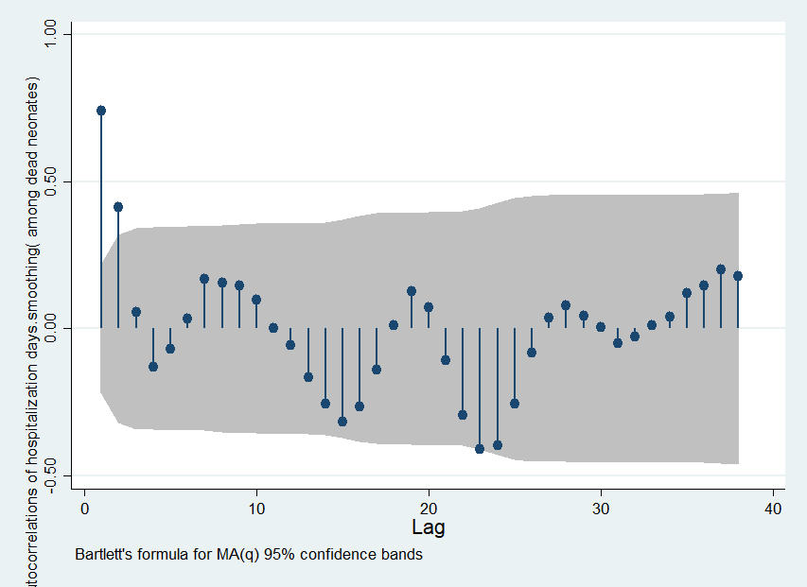

Figure1s: Autocorrelation function of length of stay in hospital among dead neonates
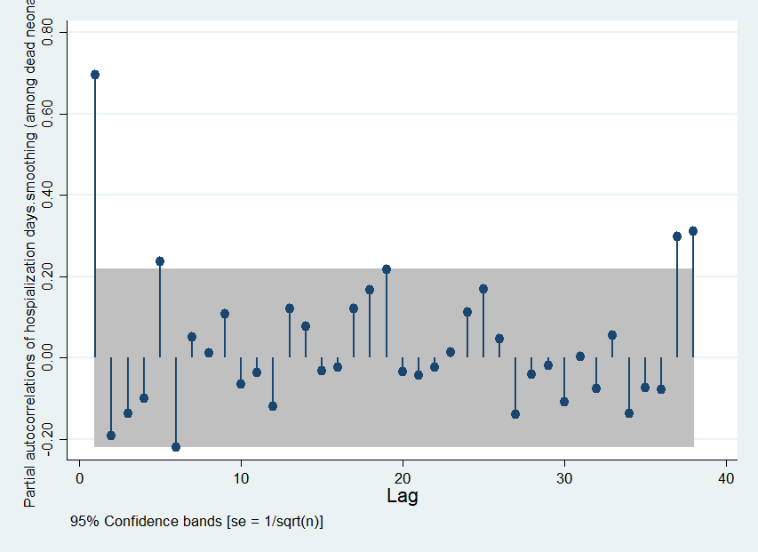
Figure2s: partial Autocorrelation function of stay in hospital among dead neonates
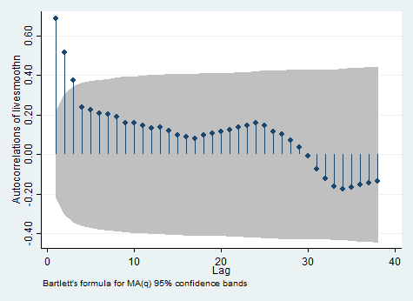
Figure3s: Autocorrelation function of length of stay in hospital among live neonates

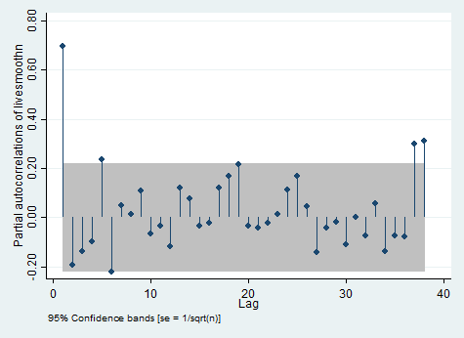
Figure4s: partial Autocorrelation function of length of stay in hospital among live neonates
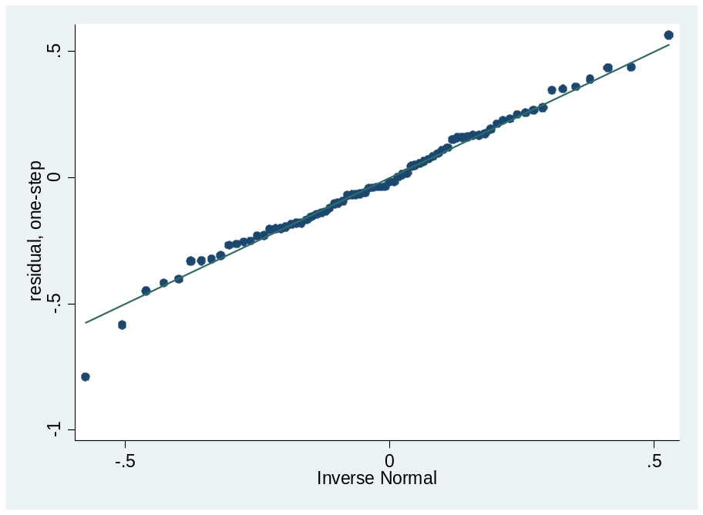
Figure5s: Normal Q-Q plot of standardized residuals for census numbers

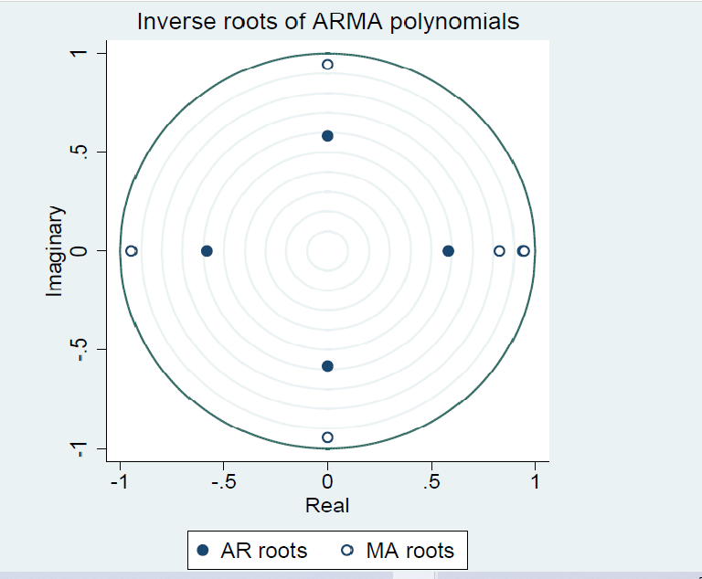
Figure6s: Eigenvalue stability test on Census number time series
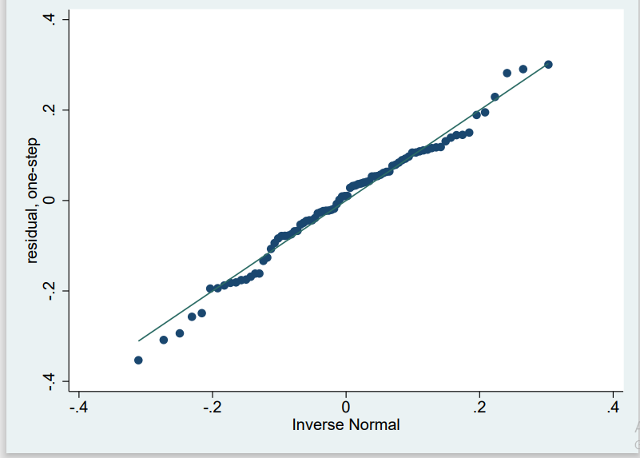

Figure 7s: Normal Q-Q plot of standardized residuals for length of stay at hospital
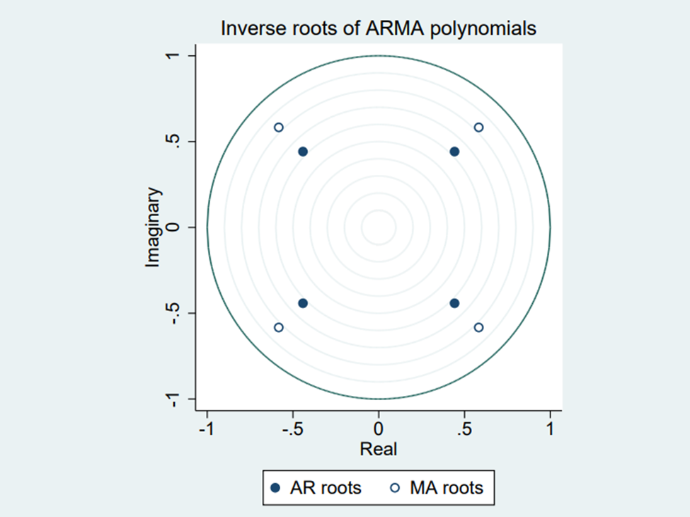
Figure8s: Eigenvalue stability test on length of stay at hospital time series
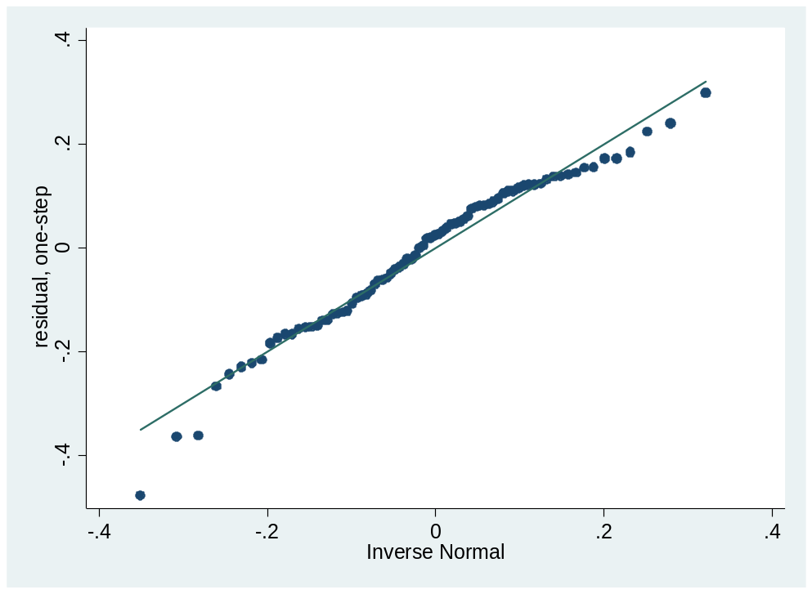
Figure9s: Normal Q-Q plot of standardized residuals for mortality proportion time series
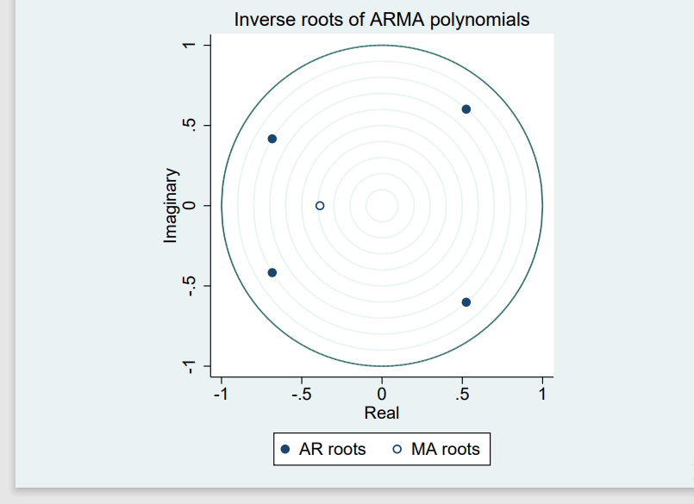
Figure 10s: Eigenvalue stability test mortality proportion time series

