Supplementary Figure S1. Comparison of physical activity and nutrition outcomes between the intervention group at post-intervention and the comparison group (matched sample n=38)
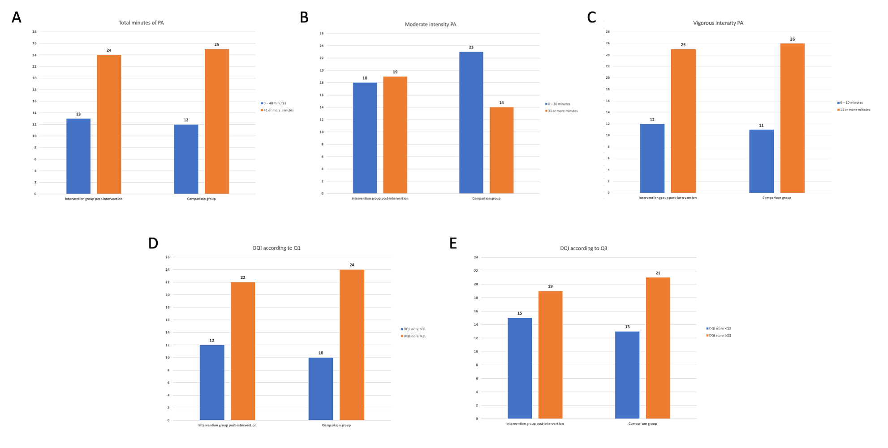
Note. PA, physical activity. Panel A depicts total minutes of PA. Panel B depicts minutes of moderate intensity PA. Panel C depicts minutes of vigorous intensity PA. Panel D depicts diet quality according to the Q1 threshold. Panel E depicts diet quality according to the Q3 threshold.

