Supplementary Table 1. The merge of MESH and non-MESH terms were used as follows:
("vitamin D" OR "cholecalciferol" OR "ergocalciferol" OR "25-hydroxyvitamin D" OR "25(OH)D") AND ("child*" OR "adolescen*" OR "youth" OR "pediatric" OR "teenager*" OR "school-aged children") AND ("obesity" OR "overweight" OR "BMI" OR "body mass index" OR "obese children" OR "childhood obesity" OR "adolescent obesity") AND ("cardiometabolic factors" OR "insulin resistance" OR "dyslipidemia" OR "glucose intolerance" OR "triglycerides" OR "cholesterol" OR "blood pressure" OR "cardiovascular disease" OR "metabolic syndrome").

Supplementary Figure 1. Subgroup based on type of vitamin D for FBS.

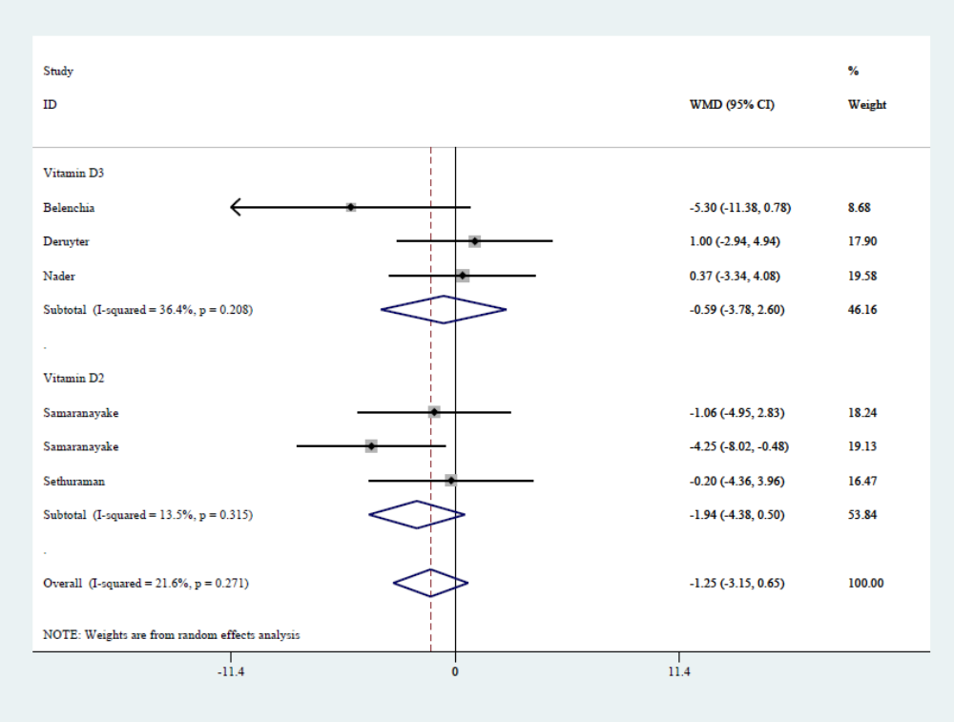

Supplementary Figure 2. Subgroup based on type of vitamin D for insulin.

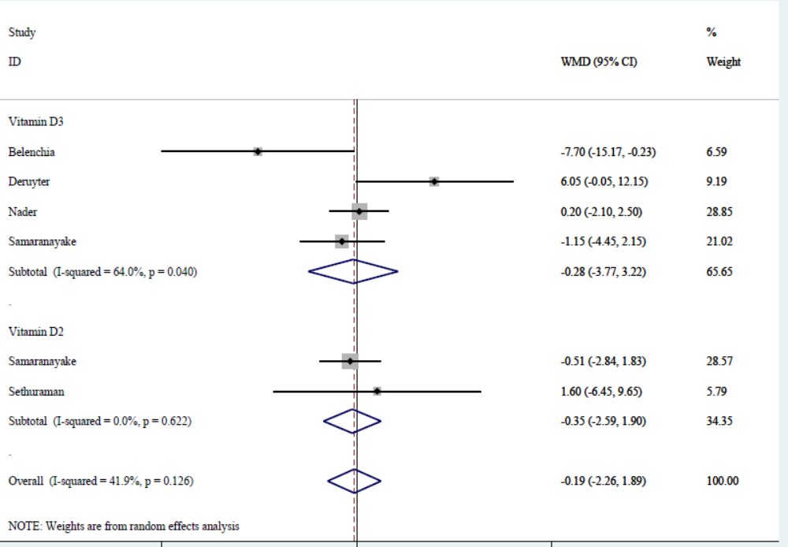

Supplementary Figure 3. Subgroup based on type of vitamin D for HOMA-IR.
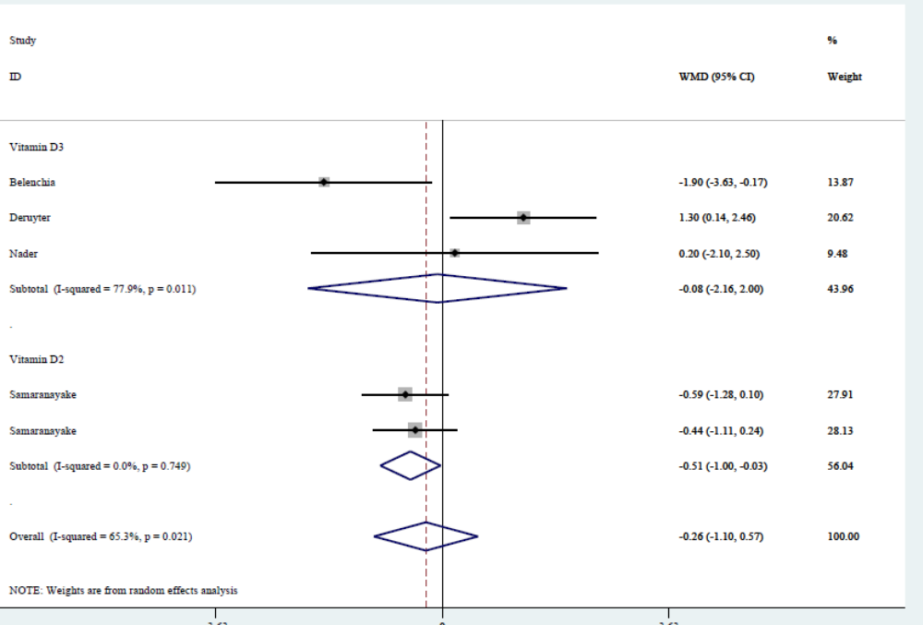

Supplementary Figure 4. Subgroup based on type of vitamin D for TC.

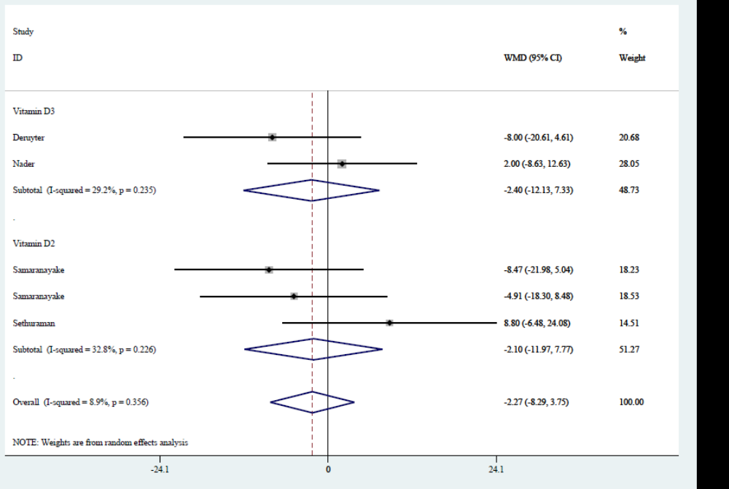

Supplementary Figure 5. Subgroup based on type of vitamin D for TG.
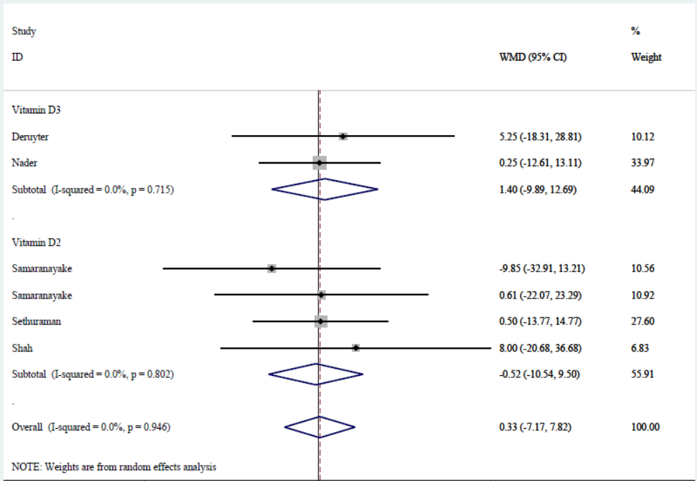

Supplementary Figure 6. Subgroup based on type of vitamin D for HDL-C.
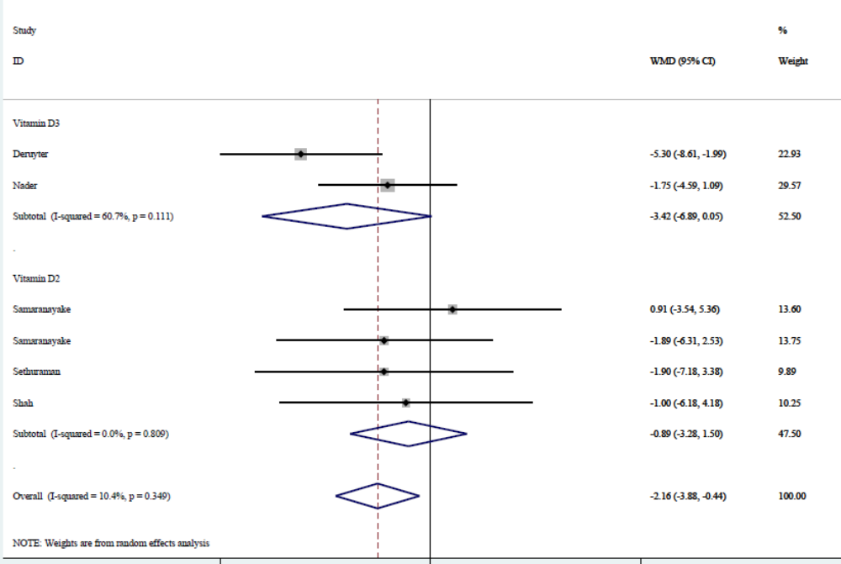

Supplementary Figure 7. Subgroup based on type of vitamin D for LDL-C.
