Appendix
Scales Used in the study

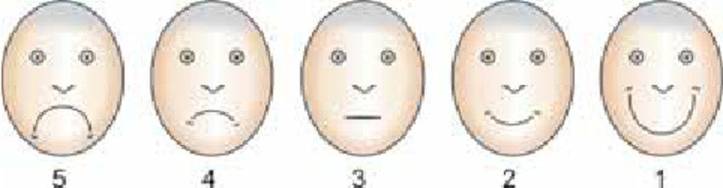
Facial Image Scale

The Venham Anxiety Rating Scale
Rating | Anxiety rating scale
0. | Relaxed, smiling, willing, and able to converse
1. | Uneasy, concerned. During stressful procedure may protest briefly and quietly  to indicate discomfort. Hands remain down or partially raised to signal  discomfort. Child willing and able to interpret experience as requested.  Tense facial expression, may have tears in eyes
2. | Child appears scared. Tone of voice, questions and answers reflect anxiety.  During stressful procedure, verbal protest, (quiet) crying, hands tense and raised,  (not interfering much may touch dentist’s hand or instrument, but not pull at it).  Child interprets situation with reasonable accuracy and continues to  work to cope with his/her anxiety
3. | Shows reluctance to enter situation, difficulty in correctly  assessing situational threat. Pronounced verbal protest, crying.  Using hands to try to stop procedure. Protest out of proportion to threat.  Copes with situation with great reluctance
4. | Anxiety interferes with ability to assess situation. General crying not related to treatment.  More prominent body movement. Child can be reached through verbal communication,  and eventually with reluctance and great effort he or she begins the workof coping with the threat
5. | Child out of contact with the reality of the threat. Genera1 loud crying,  unable to listen to verbal communication, makes no effort to cope with threat.  Actively involved in escape behavior. Physical restraint required

The Frankl behavior rating scale
Scoring | Observed behavior
4 Definitely positive | Good rapport with the dentist, interested in the dental procedures, laughing and enjoying the situation.
3 Positive | Acceptance of treatment; at times cautious, willingness to comply with the dentist, at times with reservation but patient follows the dentist's directions cooperatively.
2 Negative | Reluctant to accept treatment; uncooperative, some evidence of negative attitude but not pronounced, i.e. /sullen, withdrawn.
1 Definitely negative | Refusal of treatment, crying forcefully, fearful or any other overt evidence of extreme negativism.

The Venham Scale of Dental behavior
Rating | Definition (behavioral rating scale)
0. | Total cooperation, best possible working conditions, no crying or physical protest
1. | Mild, soft verbal protest or (quite) crying as a signal of discomfort, but does not obstruct progress.  Appropriate behavior for procedure
2. | Protest more prominent. Both crying and hand signals. May move head around making it hard to  administer treatment. Protest more distracting and troublesome. However, child still complies with request to cooperate
3. | Protest presents real problem to dentist. Complies with demands reluctantly,  requiring extra effort by dentist. Body movement
4. | Protest disrupts procedure, requires that all of the dentist attention be  directed toward the child behavior. Compliance eventuallyachieved after  considerable effort by dentist, but without much actual physical restraints.  More prominent body movement
5. | General protest, no compliance or cooperation. Physical restraint is required

The FLACC Pain scale
Criteria^{[1]} | Score 0 | Score 1 | Score 2
Face | No particular expression or smile | Occasional grimace or frown, withdrawn, uninterested | Frequent to constant quivering chin, clenched jaw
Legs | Normal position or relaxed | Uneasy, restless, tense | Kicking, or legs drawn up
Activity | Lying quietly, normal position, moves easily | Squirming, shifting, back and forth, tense | Arched, rigid or jerking
Cry | No cry (awake or asleep) | Moans or whimpers; occasional complaint | Crying steadily, screams or sobs, frequent complaints
Consolability | Content, relaxed | Reassured by occasional touching, hugging or being talked to, distractible | Difficult to console or comfort

