Supplementary file of “Sleep of Brazilian adolescents before and after COVID-19 pandemic: Repeated cross-sectional and longitudinal analyses”

Figure S1 – Flowchart of participants enrollment in the repeated cross-sectional sample.

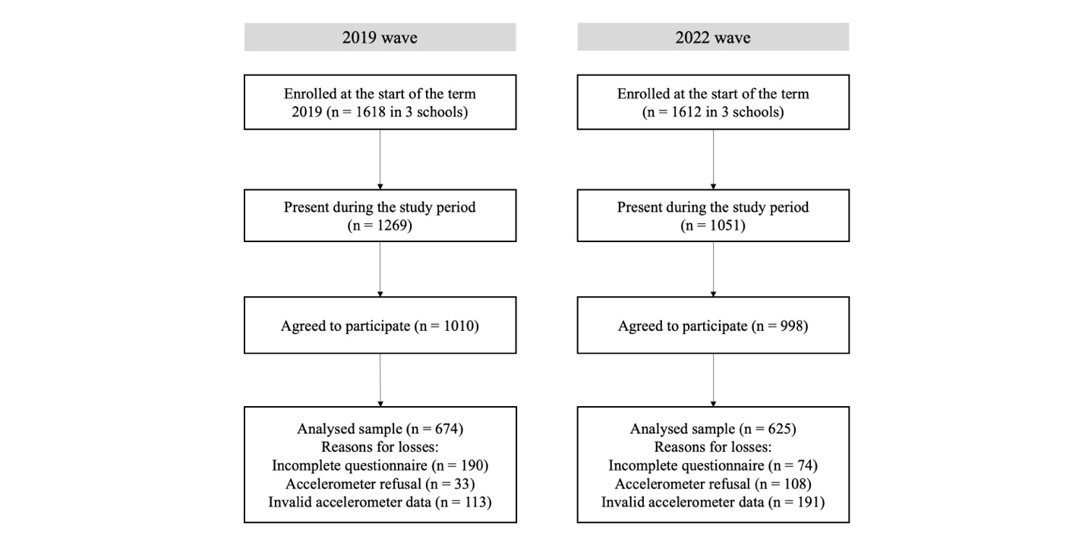

Figure S2 – Flowchart of participants enrollment in the prospective sample.

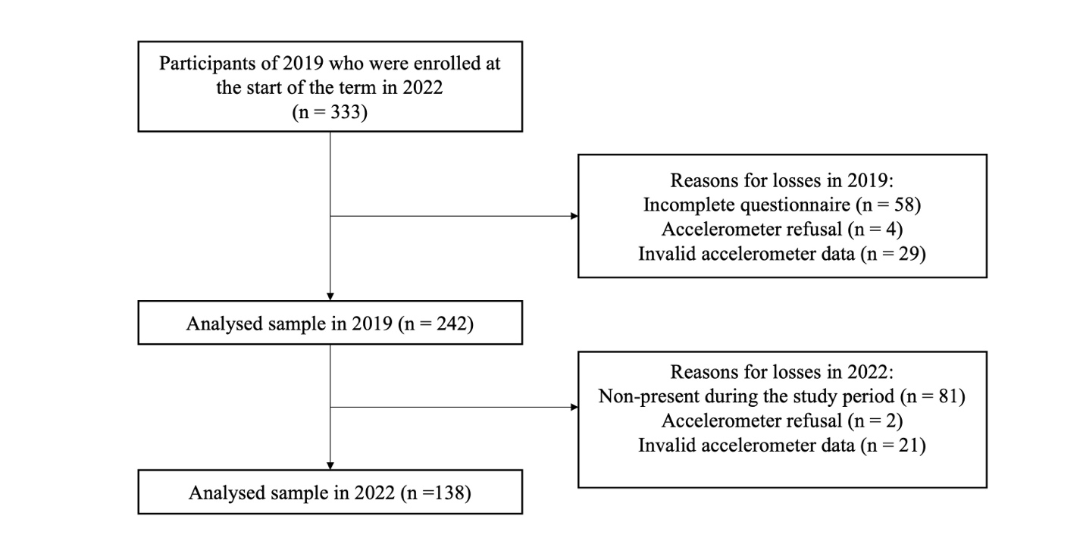

Table S1 – Interaction analyses to explore moderation effects.
Cross-sectional data
 | Sleep Regularity |  |  |  |  |  | Sleep Midpoint |  |  |  |  |  |  |  | Social jetlag |  |  |  | Catch-up sleep |  |  |  | Daytime Sleepness |  |  | Sleep Efficiency |  |  | Sleep Duration (Accelerometry) |  |  |  | Sleep Duration (Questionnaire) |  |  |  | Sleep Recommendation
Interactions | df |  | Chi |  | p-value |  | df |  | Chi |  |  | p-value | df |  |  | Chi | p-value | df |  | Chi | p-value | df |  | Chi | p-value |  | df | Chi | p-value | df | Chi | p-value |  |  | df | Chi |  | p-value | df |  | Chi |  | p-value
Survey*Sex | 1 |  | 5.8 |  | 0.01 |  | 1 |  | 0.2 |  |  | 0.62 | 1 |  |  | 0 | 0.91 | 1 |  | 0.1 | 0.76 | 1 |  | 0.2 | 0.65 |  | 1 | 0.3 | 0.61 | 1 | 0.5 | 0.48 |  |  | 1 | 1.1 |  | 0.29 | 1 |  | 0.4 |  | 0.55
Survey*Age | 1 |  | 0.1 |  | 0.72 |  | 1 |  | 3.5 |  |  | 0.06 | 1 |  |  | 3.2 | 0.07 | 1 |  | 3.8 | 0.05 | 1 |  | 4.4 | 0.04 |  | 1 | 0.2 | 0.68 | 1 | 1.5 | 0.22 |  |  | 1 | 0.3 |  | 0.6 | 1 |  | 3 |  | 0.08
Survey*SES | 1 |  | 0.2 |  | 0.66 |  | 1 |  | 0.3 |  |  | 0.56 | 1 |  |  | 3 | 0.08 | 1 |  | 1.6 | 0.2 | 1 |  | 0 | 0.89 |  | 1 | 0.6 | 0.43 | 1 | 0.9 | 0.34 |  |  | 1 | 0.9 |  | 0.33 | 1 |  | 0 |  | 0.89
Survey*School shift | 1 |  | 0 |  | 0.86 |  | 1 |  | 6.2 |  |  | 0.01 | 1 |  |  | 1.4 | 0.24 | 1 |  | 0.8 | 0.38 | 1 |  | 1.8 | 0.17 |  | 1 | 0 | 0.88 | 1 | 0.1 | 0.78 |  |  | 1 | 0.5 |  | 0.49 | 1 |  | 0.2 |  | 0.68
Prospective data
Survey*Sex |  | 1 |  | 1.3 |  | 0.26 |  | 1 |  | 0 | 0.91 |  |  | 1 |  | 0.1 | 0.74 | 1 |  | 0.5 | 0.46 | 1 |  | 0 | 0.87 |  | 1 | 0.6 | 0.43 | 1 | 1.2 | 0.27 |  | 1 |  | 2.9 | 0.09 |  |  | 1 |  | 0.1 |  | 0.77
Survey*SES |  | 1 |  | 0.2 |  | 0.63 |  | 1 |  | 0 | 0.97 |  |  | 1 |  | 1.1 | 0.29 | 1 |  | 3.1 | 0.08 | 1 |  | 0.8 | 0.36 |  | 1 | 0.5 | 0.49 | 1 | 0 | 0.94 |  | 1 |  | 7.7 | 0.01 |  |  | 1 |  | 0 |  | 0.89
Survey*School shift |  | 1 |  | 0 |  | 0.99 |  | 1 |  | 6 | 0.01 |  |  | 1 |  | 9.9 | 0.01 | 1 |  | 7.6 | 0.01 | 1 |  | 0.4 | 0.53 |  | 1 | 1.4 | 0.23 | 1 | 5.3 | 0.02 |  | 1 |  | 8.9 | 0.01 |  |  | 1 |  | 0 |  | 0.96

Table S2 – Significant sleep moderation effects in the study.
Variable | Repeated cross-sectional |  | Prospective
Variable | Estimate  (2022-2019) | p-value | Estimate (2022-2019) | p-value
Sleep Regularity Index
Male | 1.31 | 0.19
Female | -2.02 | 0.04
Sleep Midpoint
Morning | 0.10 | 0.20 | 0.32 | 0.02
Afternoon | -0.18 | 0.02 | -0.15 | 0.27
Daytime Sleepiness
Up to 18 years | -0.18 | 0.47
19 to 21 years | -5.03 | 0.01
Social Jetlag
Morning |  |  | -0.8 | <0.001
Afternoon |  |  | 0.17 | 0.42
Catch-up sleep
Morning |  |  | -0.85 | <0.001
Afternoon |  |  | 0.10 | 0.66
Sleep duration (accelerometry)
Morning |  |  | 0.08 | 0.42
Afternoon |  |  | -0.25 | 0.01
Sleep duration (questionnaire)
Morning |  |  | -0.1 | 0.46
Afternoon |  |  | -0.71 | <0.001
SES: 0-33 |  |  | -0.14 | 0.45
SES: 34-100 |  |  | -0.56 | <.0001

Table S3 – Comparison of sleep variables between participants and dropouts from the longitudinal sample

 | Longitudinal sample
Variables | Participants  (N = 138)¹ | Dropouts  (N = 104)¹ | p-value
Sleep Regularity Index [0-100] | 56.8 (12.2) | 55.4 (12.3) | 0.317
Sleep Midpoint (hours) | 27.7 (1.2) | 28.0 (12.3) | 0.236
Social Jetlag (hours) | 1.6 (1.5) | 1.7 (1.5) | 0.498
Catch-up Sleep (hours) | 0.9 (1.9) | 1.2 (1.8) | 0.211
Daytime Sleepiness (0-32) | 17.6 (4.9) | 18.4 (4.5) | 0.308
Sleep Efficiency (%) | 86.7 (4.7) | 87.8 (4.2) | 0.076
Sleep Duration (accelerometry) (hours/day) | 7.5 (0.8) | 7.6 (0.8) | 0.627
Sleep Duration (Questionnaire) (hours per day) | 8.2 (1.3) | 8.1 (1.2) | 0.471
Meeting sleep duration recommendation* | 65 (47.1%) | 49 (47.1%) | 0.998
Data are presented as mean (standard deviation).

