Table S1 specific search strategy
((("Rhinitis, Allergic"[Mesh]) OR ((((Rhinitis, Allergic[MeSH Terms]) OR (Allergic Rhinitides[Title/Abstract])) OR (Rhinitides, Allergic[Title/Abstract])) OR (Allergic Rhinitis[Title/Abstract]))) AND (("Child"[Mesh]) OR (((((Child[MeSH Terms]) OR (Children[Title/Abstract])) OR (Primary school Childe[Title/Abstract])) OR (Primary school Children[Title/Abstract])) OR (Primary school students[Title/Abstract])))) AND (("Risk Factors"[Mesh]) OR (((((((((((((((((((Risk Factors[MeSH Terms]) OR (Factor, Risk[Title/Abstract])) OR (Risk Factor[Title/Abstract])) OR (Population at Risk[Title/Abstract])) OR (Populations at Risk[Title/Abstract])) OR (Risk Scores[Title/Abstract])) OR (Risk Score[Title/Abstract])) OR (Score, Risk[Title/Abstract])) OR (Risk Factor Scores[Title/Abstract])) OR (Risk Factor Score[Title/Abstract])) OR (Score, Risk Factor[Title/Abstract])) OR (Health Correlates[Title/Abstract])) OR (Correlates, Health[Title/Abstract])) OR (Social Risk Factors[Title/Abstract])) OR (Factor, Social Risk[Title/Abstract])) OR (Factors, Social Risk[Title/Abstract])) OR (Risk Factor, Social[Title/Abstract])) OR (Risk Factors, Social[Title/Abstract])) OR (Social Risk Factor[Title/Abstract])))

Table S2 meta-regression
Variable | Coef | Std. Err. | P | 95% Conf. Interval
Year | -0.039 | 0.044 | 0.445 | [-1.792, 0.102]
Country | 0.834 | 0.210 | 0.029 | [0.165, 1.502]

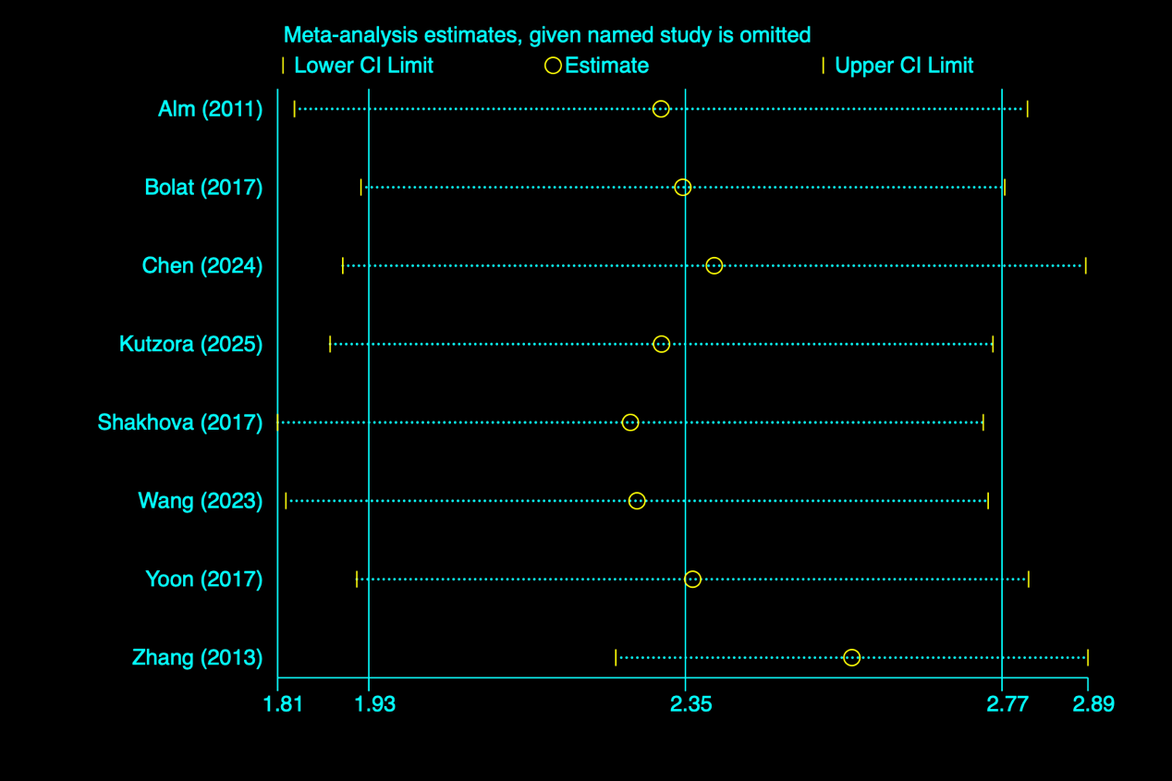
Figure S1 Parental allergic rhinitis Sensitivity analysis

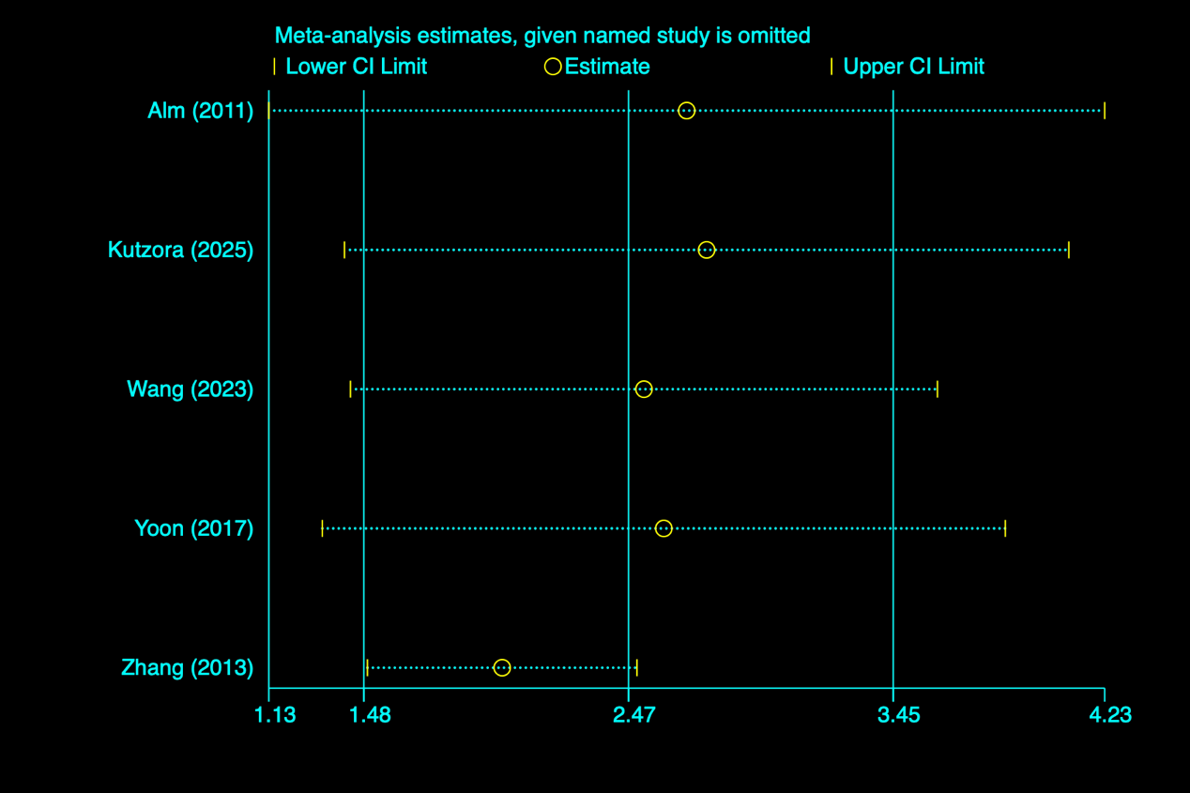
Figure S2 Parental asthma Sensitivity analysis

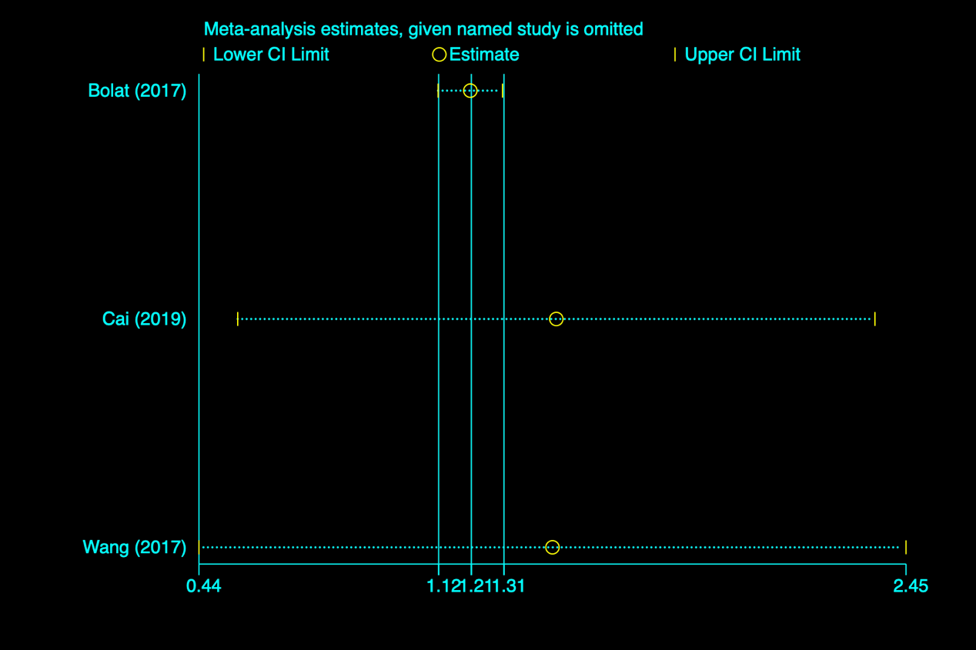
Figure S3 Dampness at Sensitivity analysis

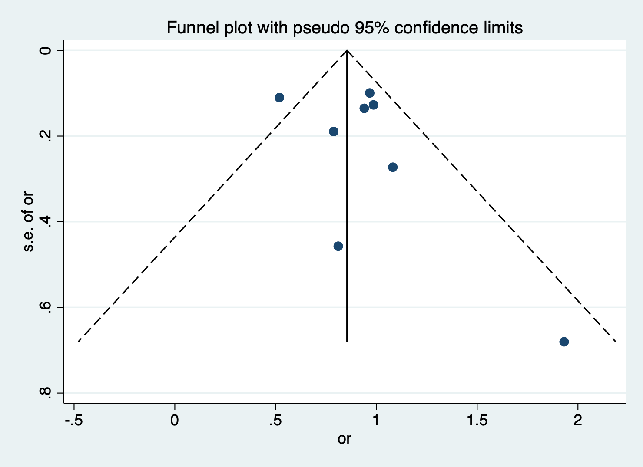
Figure S4 Funnel plot of Meta-analysis of Parental allergic rhinitis

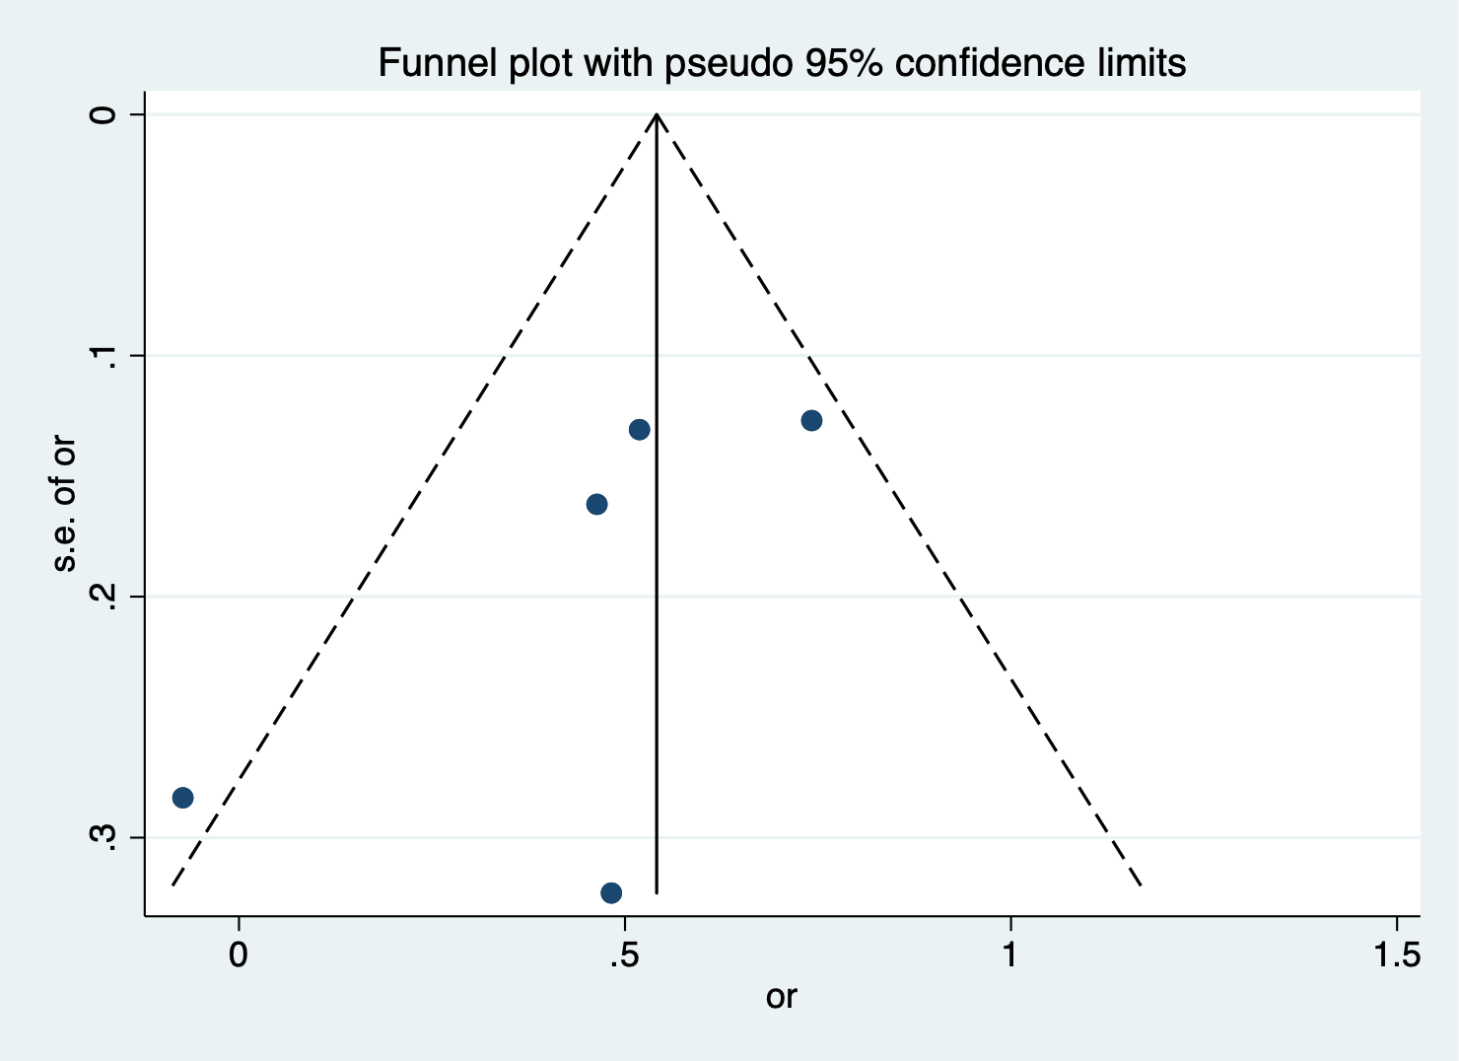
Figure S5 Funnel plot of Meta-analysis of Parental eczema

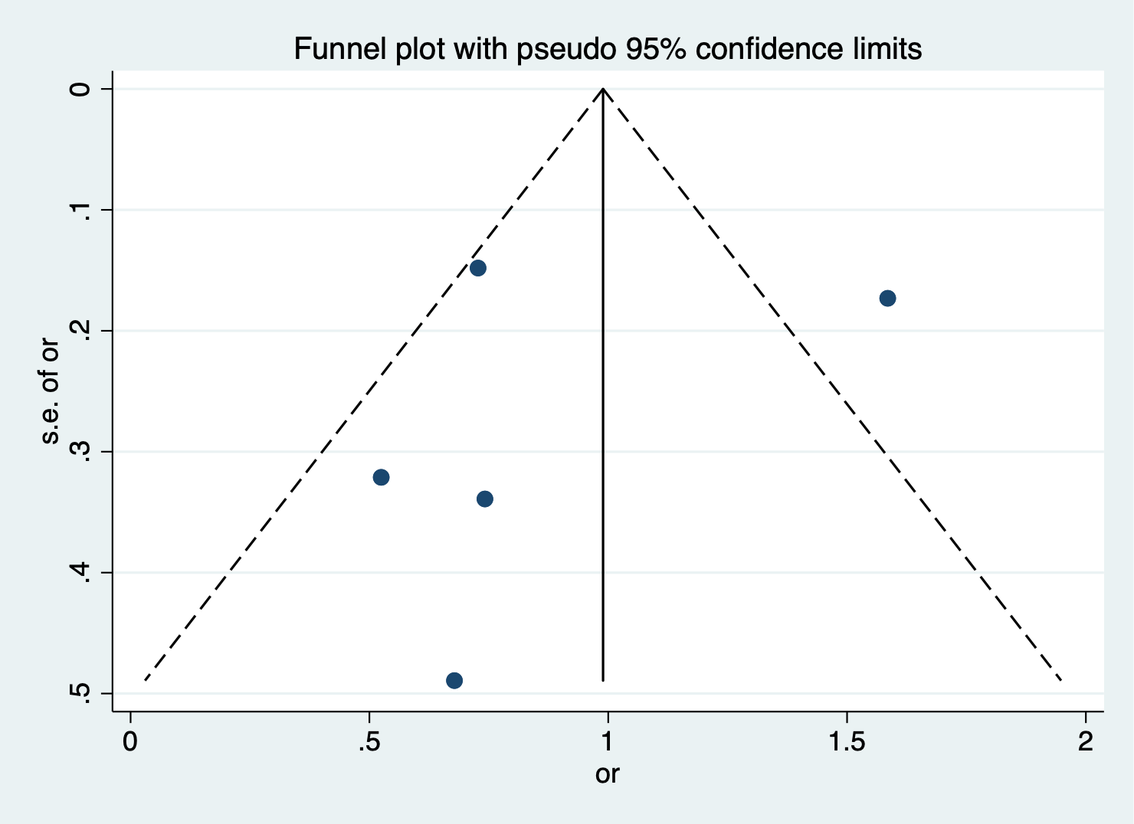
Figure S6 Funnel plot of Meta-analysis of Parental asthma

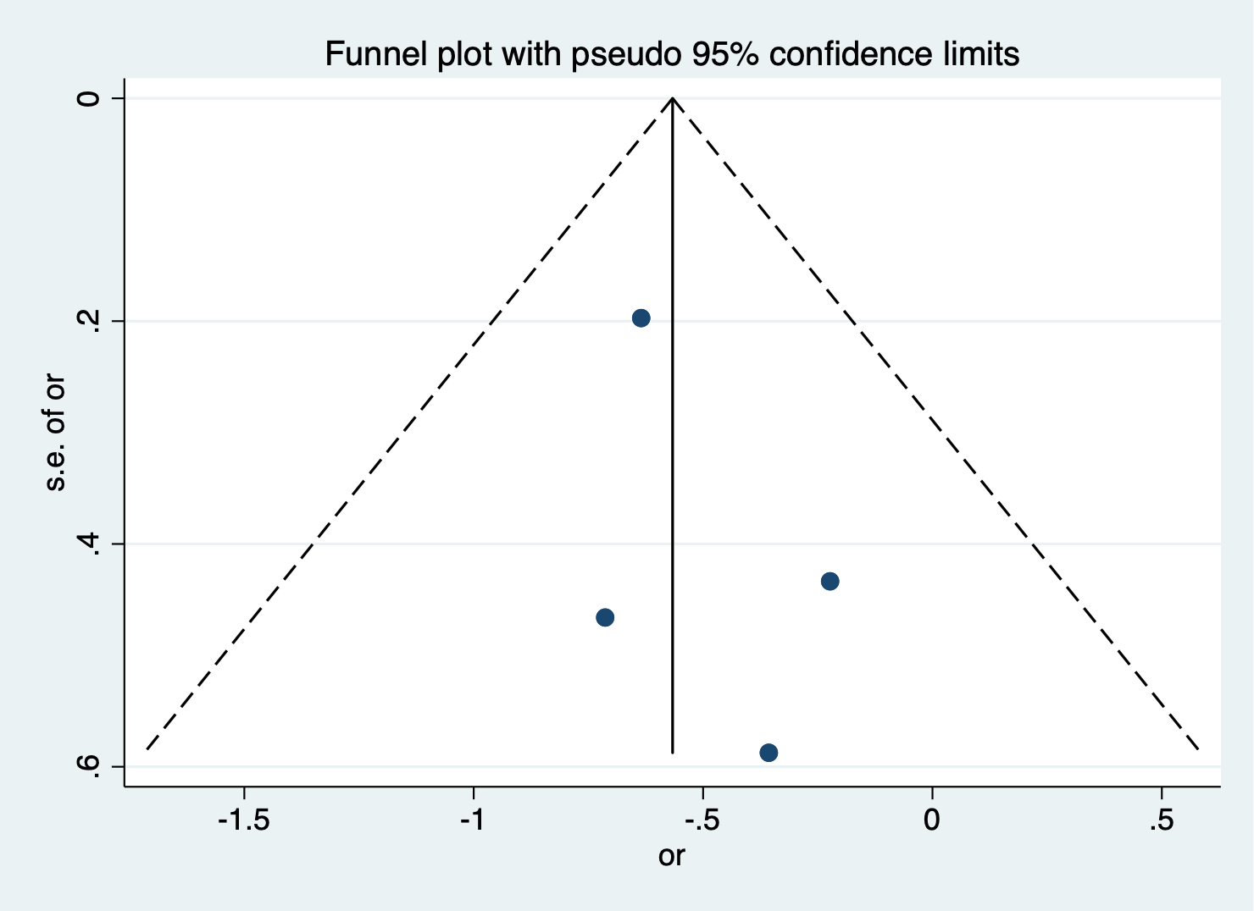
Figure S7 Funnel plot of Meta-analysis of pet

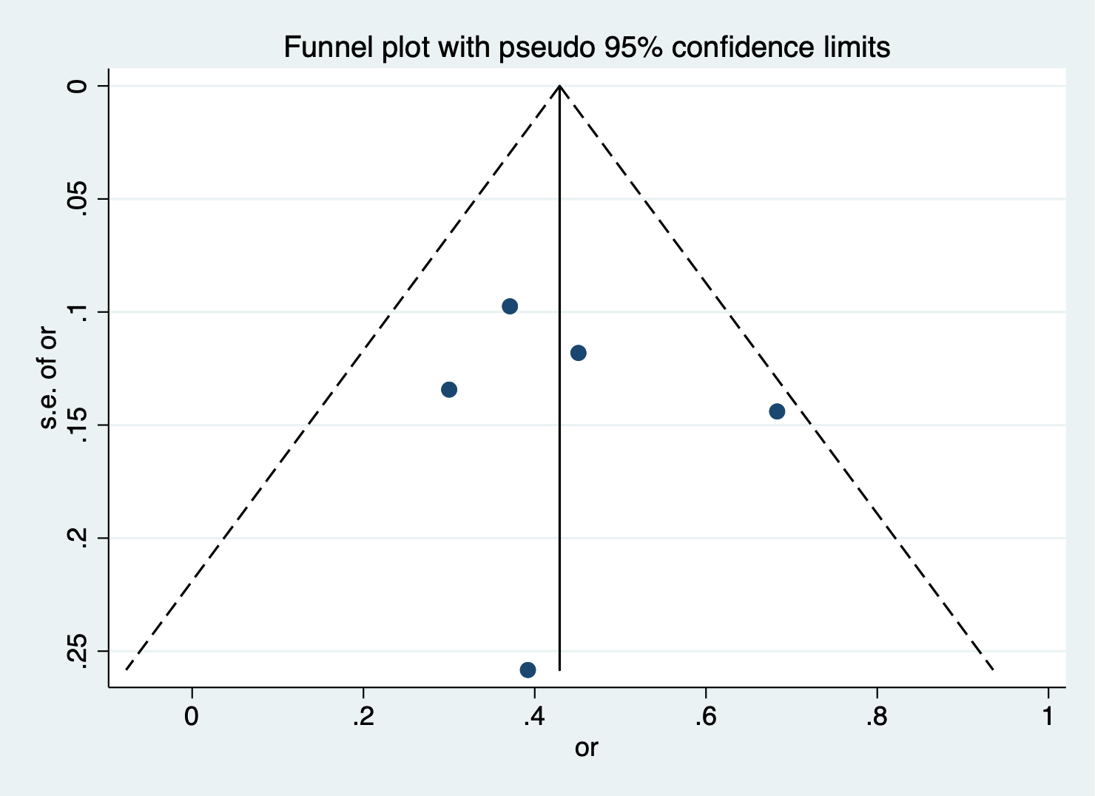
Figure S8 Funnel plot of Meta-analysis of male
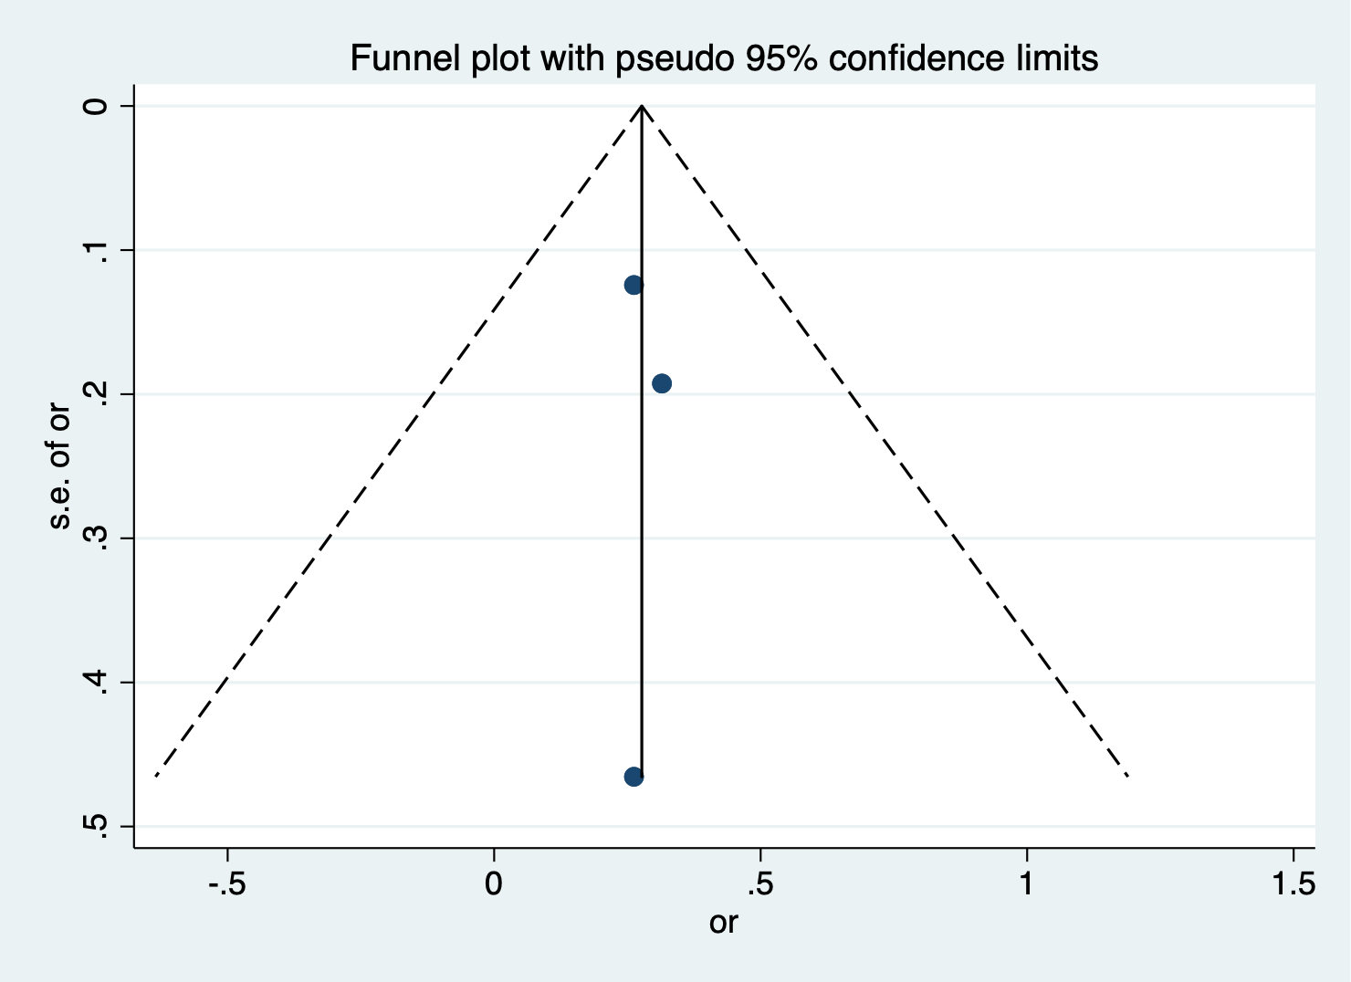
Figure S9 Funnel plot of Meta-analysis of Caesarean birth

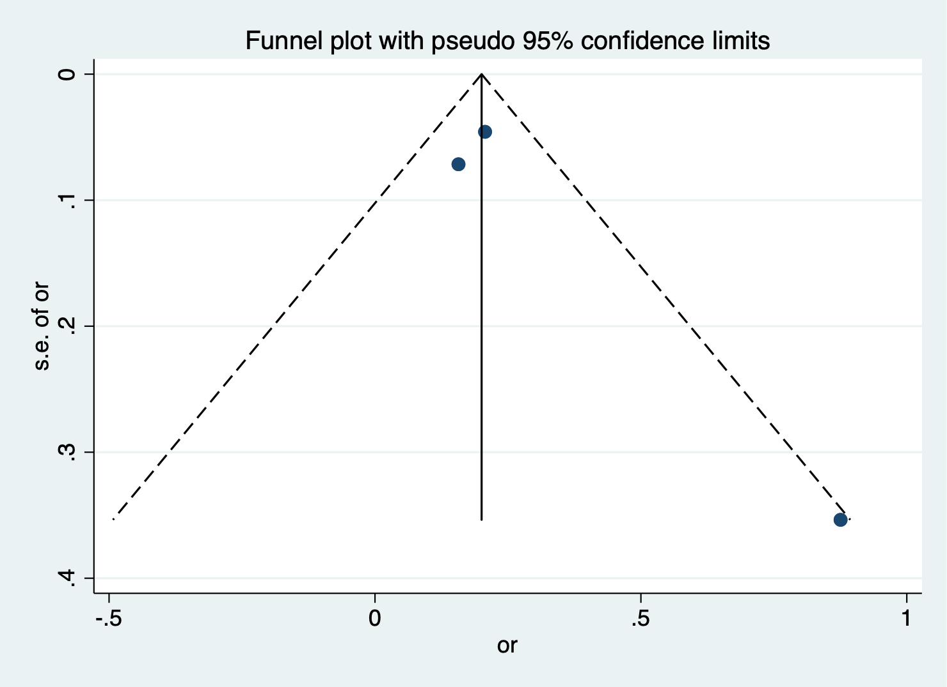
Figure S10 Funnel plot of Meta-analysis of Dampness at home

