Attachment file

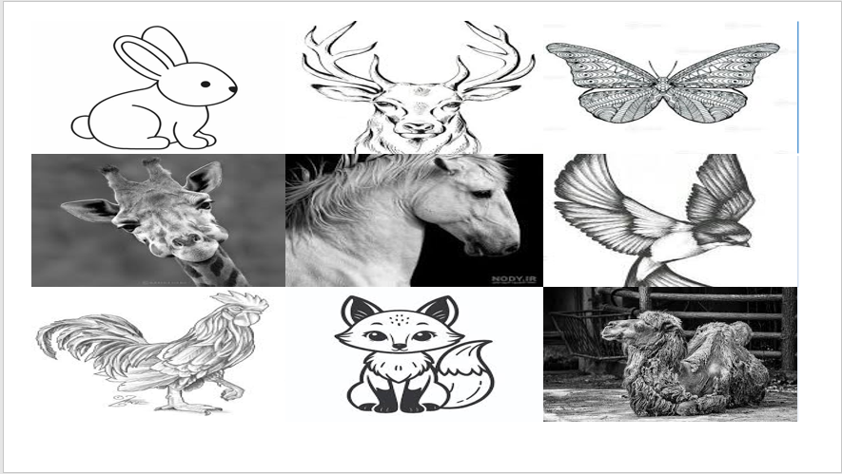
Figure 1. Futsal shooting practice position for all groups

