SUPPLEMENTARY DOCUMENT- UTILITY OF RENAL ANGINA INDEX AS COMPARED TO KDIGO IN CRITICALLY ILL CHILDREN AT A TERTIARY CARE HOSPITAL IN A LOW MIDDLE-INCOME COUNTRY

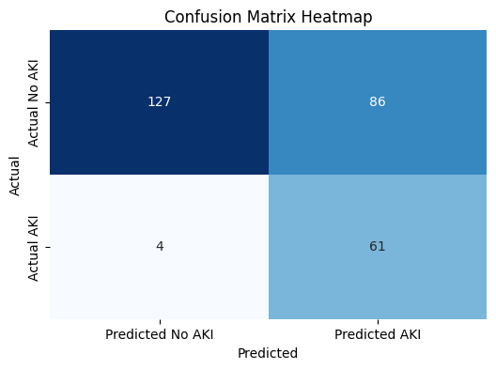
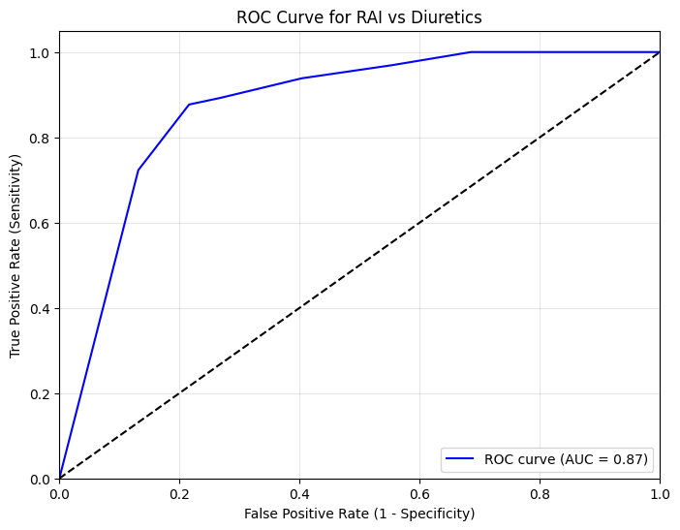

Confusion matrix- RAI and diuretic use
Confusion Matrix
[[127 86]
[ 4 61]]
Sensitivity: 0.94
Specificity: 0.60
PPV (Precision): 0.41
NPV: 0.97
AUC: 0.87 (95% CI: 0.83 – 0.91
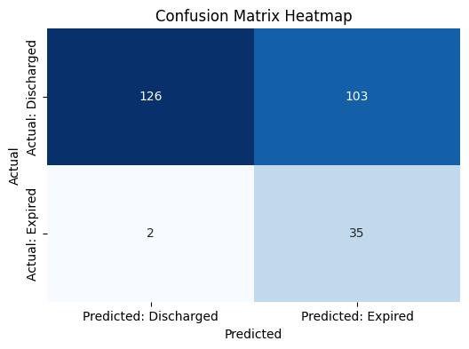
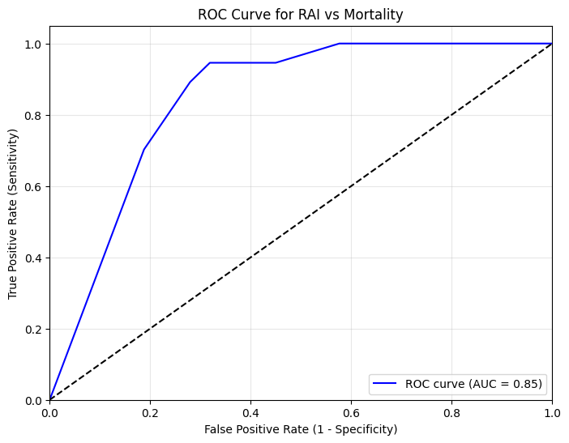

Confusion matrix- RAI and Mortality
Confusion Matrix:
[[126 103]
[ 2 35]]
Sensitivity: 0.95
Specificity: 0.55
PPV (Precision): 0.25
NPV: 0.98
AUC: 0.85
AUC: 0.85 (95% CI: 0.80 – 0.89)

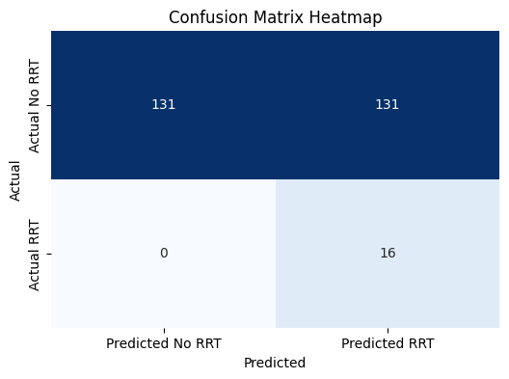
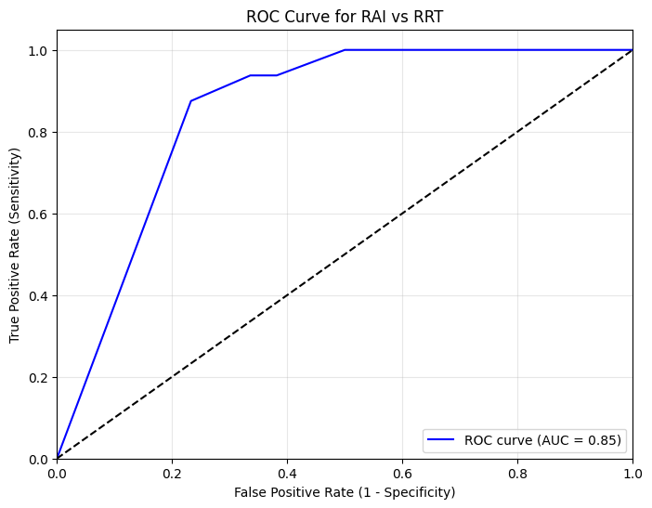
Confusion matrix- RAI and RRT
Confusion Matrix:
[[131 131]
[ 0 16]]
Sensitivity: 1.00
Specificity: 0.50
PPV (Precision): 0.11
NPV: 1.00
AUC: 0.85 (95% CI: 0.79 – 0.90)

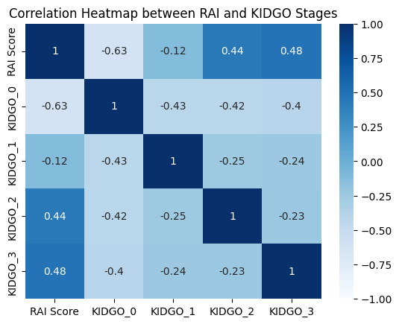

Correlation between RAI and KIDGO stages:
RAI Score KIDGO_0 KIDGO_1 KIDGO_2 KIDGO_3
RAI Score 1.000000 -0.630606 -0.122409 0.441537 0.480456
KIDGO_0 -0.630606 1.000000 -0.428152 -0.423359 -0.399206
KIDGO_1 -0.122409 -0.428152 1.000000 -0.249429 -0.235199
KIDGO_2 0.441537 -0.423359 -0.249429 1.000000 -0.232566
KIDGO_3 0.480456 -0.399206 -0.235199 -0.232566 1.000000

