Supplementary tables
Supplemental Table S1. Univariate analysis of CAR and 28-day mortality
Variables | HR (95%CI) | P value
Age(month) | 1.0009 (0.9989,1.003) | 0.377
Gender (Female) | 0.81 (0.66,0.99) | 0.042
Bacteremia | 1.19 (0.96,1.48) | 0.105
Vital signs
Temperature (℃) | 0.87 (0.82,0.91) | < 0.001
Respiratory rate(breaths/min) | 1.0026 (1.0016,1.0036) | < 0.001
Heart rate(beats/min) | 0.9991 (0.9956,1.0026) | 0.603
ICU Type
General ICU
PICU | 0.6 (0.48,0.75) | < 0.001
SICU | 0.36 (0.25,0.52) | < 0.001
CICU | 0.12 (0.07,0.21) | < 0.001
Laboratory data
WBC (×109) | 1.0029 (1.0013,1.0044) | < 0.001
PLT (×109) | 0.9991 (0.9985,0.9998) | 0.007
CRP (mg/L) | 1.0022 (1.0001,1.0042) | 0.037
ALB(g/L) | 0.96 (0.95,0.98) | < 0.001
CAR | 1.0062 (1.0022,1.0103) | 0.003
Potassium(mmol/L) | 1.26 (1.18,1.34) | < 0.001
Magnesium(mmol/L) | 1.0007 (1.0005,1.0009) | < 0.001
Phosphate(mmol/L) | 1.92 (1.74,2.13) | < 0.001
PH | 0.01 (0,0.01) | < 0.001
PO₂(mmHg) | 0.9948 (0.9931,0.9966) | < 0.001
Lactate(mmol/L) | 1.19 (1.17,1.21) | < 0.001
CK-MB(U/L) | 1.0005 (1.0003,1.0007) | < 0.001
Glucose(mmol/L) | 1.05 (1.04,1.07) | < 0.001
PTT(s) | 1.01 (1.01,1.02) | < 0.001
PT(s) | 1.02 (1.02,1.03) | < 0.001
Abbreviations: PICU, Pediatric Intensive Care Unit；SICU, Surgical Intensive Care Unit; CICU, Cardiac Intensive Care Unit；WBC, white blood cell count; PLT, platelet count; CRP, c-reactive protein; ALB, Albumin. CAR, c-reactive protein to Albumin. PO2, Partial Pressure of Oxygen; PTT, Partial Thromboplastin Time; PT, Prothrombin Time.

Supplemental Table S2 Comparison of AUC Values for the Baseline Risk Model and Models with Added CAR, CRP, and Albumin
Variables | AUC (95%CI) | P
Baseline risk model | 0.818(0.795,0.841)
+CAR | 0.820(0.798,0.843) | 0.078
+CRP | 0.819 (0.797,0.842) | 0.289
+ALB | 0.818(0.794,0.841) | 0.958
This table presents the area under the curve (AUC) values with 95% confidence intervals (CI) and P-values, comparing the baseline risk model (Model IV) with models that include CAR, CRP, and ALB.

Supplemental Figure S1. ROC curves comparing the baseline risk model with models incorporating CAR, CRP, and ALB
A B
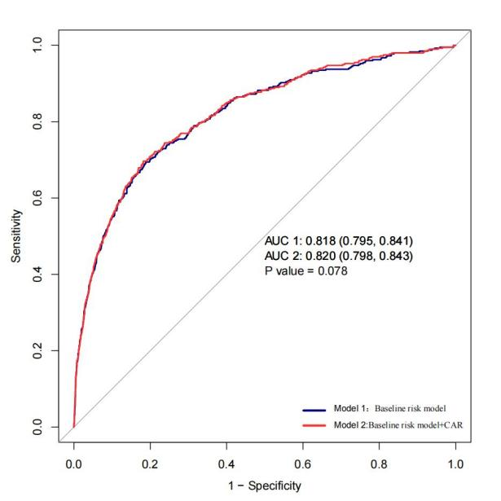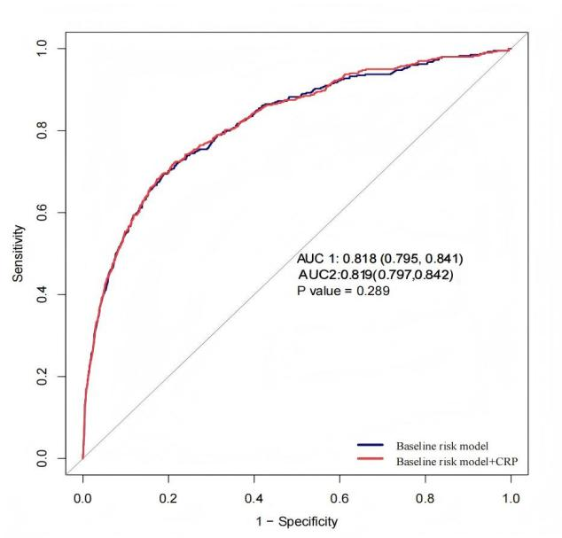
C
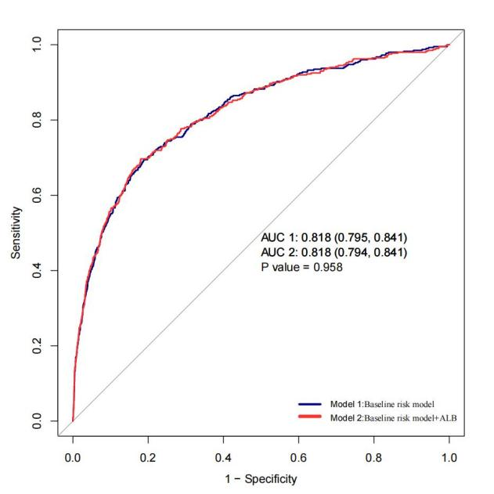

Receiver operating characteristic (ROC) curves comparing the baseline risk model (Model IV: adjusted for age, gender, temperature, respiratory rate, heart rate, bacteremia, WBC, PLT, potassium, phosphate, magnesium, pH, PO₂, lactate, CK-MB, glucose, PTT, and PT) with models that additionally included (A) CAR, (B) CRP, or (C) ALB. The area under the curve (AUC) with 95% confidence intervals (CI) and P-values are shown for each comparison.

Supplemental Table S3 Multivariable Cox regression for 28-day hospital mortality across CAR quartiles (supplementary analysis)
Variable | CAR  (n = 8,000) | Q1  (CAR <0.29) | Q2  (0.29≤CAR<1.38) | Q3  (1.38≤CAR<8.83) | Q4  (CAR≥8.83)
HR (95%CI) | 1.01 (1.002~1.01) | 1(Ref) | 1.2 (0.86~1.68) | 1.23 (0.89~1.72) | 1.56 (1.11~2.2)
P value | 0.002 | - | 0.275 | 0.214 | 0.011

Hazard ratios (HRs) were adjusted fo age, gender, temperature, respiratory rate, heart rate and bacteremia, WBC, PLT, potassium, phosphate, magnesium, PH, PO₂, lactate, CK-MB, glucose, PTT, PT. To account for potential confounding from baseline albumin levels, additional adjustments were made for liver disease, nephrotic syndrome, and malnutrition.

Supplemental Table S4 Association between CAR and 28-day hospital mortality in sensitivity analysis
Variable | Model Ⅰ |  | Mode Ⅱ |  | Model Ⅲ |  | Model Ⅳ
 | HR (95%CI) | P value | HR (95%CI) | P value | HR (95%CI) | P value | HR (95%CI) | P value
CAR (n=7809) | 1.01(1.002~1.01) | 0.001 | 1.01 (1.002~1.01) | 0.002 | 1.01 (1.002~1.01) | 0.007 | 1.01 (1.002~1.01) | 0.003
CAR4
Q1(CAR <0.29) | 1(Ref) |  | 1(Ref) |  | 1(Ref) |  | 1(Ref)
Q2(0.29≤CAR<1.38) | 1.44 (1.03~2.01) | 0.003 | 1.44 (1.03~2.01) | 0.033 | 1.47 (1.05~2.06) | 0.023 | 1.15 (0.81~1.61) | 0.433
Q3(1.38≤CAR<8.83) | 1.48 (1.07~2.05) | 0.018 | 1.48 (1.07~2.05) | 0.018 | 1.49 (1.07~2.06) | 0.017 | 1.26 (0.9 ~1.76) | 0.172
Q4(CAR≥8.83) | 1.56 (1.12~2.16) | 0.008 | 1.56 (1.12~2.16) | 0.008 | 1.55 (1.12~2.15) | 0.009 | 1.51 (1.07~2.13) | 0.02
P for trend test |  | 0.015 |  | 0.015 |  | 0.002 |  | 0.014

This sensitivity analysis excluded patients with liver disease, nephrotic syndrome, and malnutrition. Complete-case analysis was performed.
Model I had no adjusted covariates.
Model II adjusted for age, gender.
Model III adjusted for model II plus temperature, respiratory rate, heart rate and bacteremia.
Model IV adjusted for Model III plus WBC, PLT, potassium, phosphate, magnesium, PH, PO₂, lactate, CK-MB, glucose, PTT, PT.

Supplemental Table S5 Complete-case multivariable Cox regression analysis for 28-day hospital mortality across CAR quartiles
Variable | Model Ⅰ |  | Mode Ⅱ |  | Model Ⅲ |  | Model Ⅳ
 | HR (95%CI) | P value | HR (95%CI) | P value | HR (95%CI) | P value | HR (95%CI) | P value
CAR（n=4882） | 0.99 (0.98~1.01) | 0.462 | 1.001 (0.98~1.01) | 0.513 | 1.001 (0.98~1.01) | 0.658 | 1.001 (0.99~1.02) | 0.815
CAR4
Q1(CAR <0.29) | 1(Ref) |  | 1(Ref) |  | 1(Ref) |  | 1(Ref)
Q2(0.29≤CAR<1.38) | 1.15 (0.63~2.13) | 0.649 | 1.14 (0.62~2.11) | 0.673 | 1.21 (0.65~2.23) | 0.553 | 1.03 (0.52~1.9) | 0.989
Q3(1.38≤CAR<8.83) | 1.3 (0.72~2.34) | 0.391 | 1.35 (0.75~2.45) | 0.318 | 1.38 (0.76~2.51) | 0.285 | 1.48 (0.8~2.75) | 0.213
Q4(CAR≥8.83) | 0.89 (0.47~1.68) | 0.724 | 0.92 (0.49~1.74) | 0.798 | 0.96 (0.5~1.82) | 0.895 | 1.08 (0.54~2.16) | 0.818

This complete-case analysis excluded patients with missing covariate data.
Model I had no adjusted covariates.
Model II adjusted for age, gender.
Model III adjusted for model II plus temperature, respiratory rate, heart rate and bacteremia.
Model IV adjusted for Model III plus WBC, PLT, potassium, phosphate, magnesium, PH, PO₂, lactate, CK-MB, glucose, PTT, PT.

Supplementary Table S6 Discrimination performance (C-index) of the adjusted Cox regression model including CAR, compared with CRP and ALB
Model (all adjusted covariates in Model IV) | C-index (95%CI)
CAR | 0.816
CRP | 0.815
ALB | 0.812
CRP +ALB | 0.814

Model IV was adjusted for age, gender, temperature, respiratory rate, heart rate and bacteremia, WBC, PLT, potassium, phosphate, magnesium, PH, PO₂, lactate, CK-MB, glucose, PTT, PT.

Supplementary Table S7 Subgroup analysis of the association between CAR and 28-day mortality stratified by albumin infusion status
Subgroup | Variable | Total | Event (%) | HR (95%CI) | P value | P for interaction
Without albumin infusion |  |  |  |  |  | 0.28
 | Q1(CAR <0.29) | 1604 | 36 (2.2) | 1(Ref)
 | Q2(0.29≤CAR<1.38) | 1797 | 77 (4.3) | 1.22 (0.81~1.83) | 0.336
 | Q3(1.38≤CAR<8.83) | 1559 | 83 (5.3) | 1.54 (1.03~2.3) | 0.037
 | Q4(CAR≥8.83) | 1282 | 59 (4.6) | 1.61 (1.03~2.5) | 0.035
 | Trend test | 6242 | 255 (4.1) | 1.18 (1.03~1.35) | 0.015
With albumin infusion
 | Q1(CAR <0.29) | 357 | 18 (5) | 1(Ref)
 | Q2(0.29≤CAR<1.38) | 237 | 30 (12.7) | 1.3 (0.7~2.43) | 0.405
 | Q3(1.38≤CAR<8.83) | 446 | 39 (8.7) | 0.99 (0.55~1.78) | 0.98
 | Q4(CAR≥8.83) | 718 | 57 (7.9) | 1.19 (0.67~2.11) | 0.559
 | Trend test | 1758 | 144 (8.2) | 1.02 (0.86~1.22) | 0.797

Hazard ratios (HRs) were adjusted for age, gender, temperature, respiratory rate, heart rate, bacteremia, WBC, PLT, potassium, phosphate, magnesium, pH, PO₂, lactate, CK-MB, glucose, PTT, and PT. Albumin infusion was defined as intravenous albumin administration within the first 24h after PICU admission. P for interaction indicates whether the association between CAR and mortality differed according to albumin infusion status.
Supplementary Table S8. Multivariable Cox regression analysis of the association between CAR and 28-day mortality with additional adjustments

Variable | CAR (n = 8,000) |  | Q1(CAR <0.29)  (n = 1,961) |  | Q2(0.29≤CAR<1.38)  (n = 2,034) |  | Q3(1.38≤CAR<8.83)  (n = 2005) |  | Q4(CAR≥8.83)  (n = 2000)
 | HR (95%CI) | P value |  | P value | HR (95%CI) | P value | HR (95%CI) | P value | HR (95%CI) | P value
Model IV+General ICU | 1.005 (1.001~1.009) | 0.018 | Reference | - | 1.25 (0.89~1.75) | 0.19 | 1.19 (0.86~1.67) | 0.28 | 1.59 (1.13~2.25) | 0.008
Model IV+PICU | 1.006 (1.002~1.01) | 0.007 |  |  | 1.23 (0.88~1.72) | 0.22 | 1.23 (0.88~1.71) | 0.23 | 1.51 (1.07~2.13) | 0.019
Model IV+SICU | 1.006 (1.002~1.01) | 0.004 |  |  | 1.19 (0.85~1.66) | 0.32 | 1.23 (0.88~1.71) | 0.22 | 1.52 (1.08~2.15) | 0.017
Model IV +CICU | 1.007 (1.003~1.01) | 0.001 |  |  | 1.24 (0.89~1.72) | 0.21 | 1.36 (0.98~1.89) | 0.07 | 2.04 (1.44~2.89) | 0.001
Model IV +CK-MB | 1.006 (1.002~1.01) | 0.003 |  |  | 1.2 (0.86~1.68) | 0.29 | 1.25 (0.89~1.73) | 0.19 | 1.55 (1.10~2.18) | 0.013

Hazard ratios (HRs) were adjusted for age, gender, temperature, respiratory rate, heart rate and bacteremia, WBC, PLT, potassium, phosphate, magnesium, PH, PO2, lactate, CK-MB, glucose, PTT, PT. Additional adjustments were made for ICU categories (General ICU, PICU, SICU, CICU) and CK-MB levels to account for case-mix differences and cardiac injury.

