Table S2. The AAPC in hemolytic disease and other neonatal jaundice aged by sex from 1990 to 2021.
Sex name | Start year | End year | ASPR |  | ASDR
Sex name | Start year | End year | AAPC | Joinpoint Model | AAPC | Joinpoint Model
Both | 1990 | 2021 | 1.2466 1.2017,1.2915) | 3 | -3.0528 (-3.1285, -2.9772) | 5
Female | 1990 | 2021 | 1.2425 (1.2032,1.2819) | 3 | -3.0015 (-3.0797, -2.9231) | 5
Male | 1990 | 2021 | 1.2595 (1.2117, 1.3074) | 4 | -3.1045 (-3.1923, -3.0165) | 5
Note: AAPC: Average annual percentage change.
Table S3. The AAPC in hemolytic disease and other neonatal jaundice by SDI from 1990 to 2021.
Location name | Start year | End year | Prevalence |  | DALYs rates
Location name | Start year | End year | AAPC | Joinpoint Model | AAPC | Joinpoint Model
Global | 1990 | 2021 | 1.2466 (1.2017, 1.2915) | 3 | -3.0511 (-3.1045, -2.9976) | 4
High SDI | 1990 | 2021 | 0.4331 (0.4124, 0.4538) | 4 | -2.6599 (-2.8839, -2.4353) | 2
High-middle SDI | 1990 | 2021 | 0.2116 (0.1749, 0.2482) | 3 | -4.7631 (-4.9175, -4.6084) | 3
Low SDI | 1990 | 2021 | 1.0185 (0.9429, 1.0941) | 4 | -3.0704 (-3.1909, -2.9497) | 4
Low-middle SDI | 1990 | 2021 | 1.2322 (1.1808, 1.2835) | 3 | -3.2686 (-3.3704, -3.1666) | 4
Middle SDI | 1990 | 2021 | 1.3095 (1.2691, 1.3498) | 4 | -4.0529 (-4.163, -3.9426) | 4
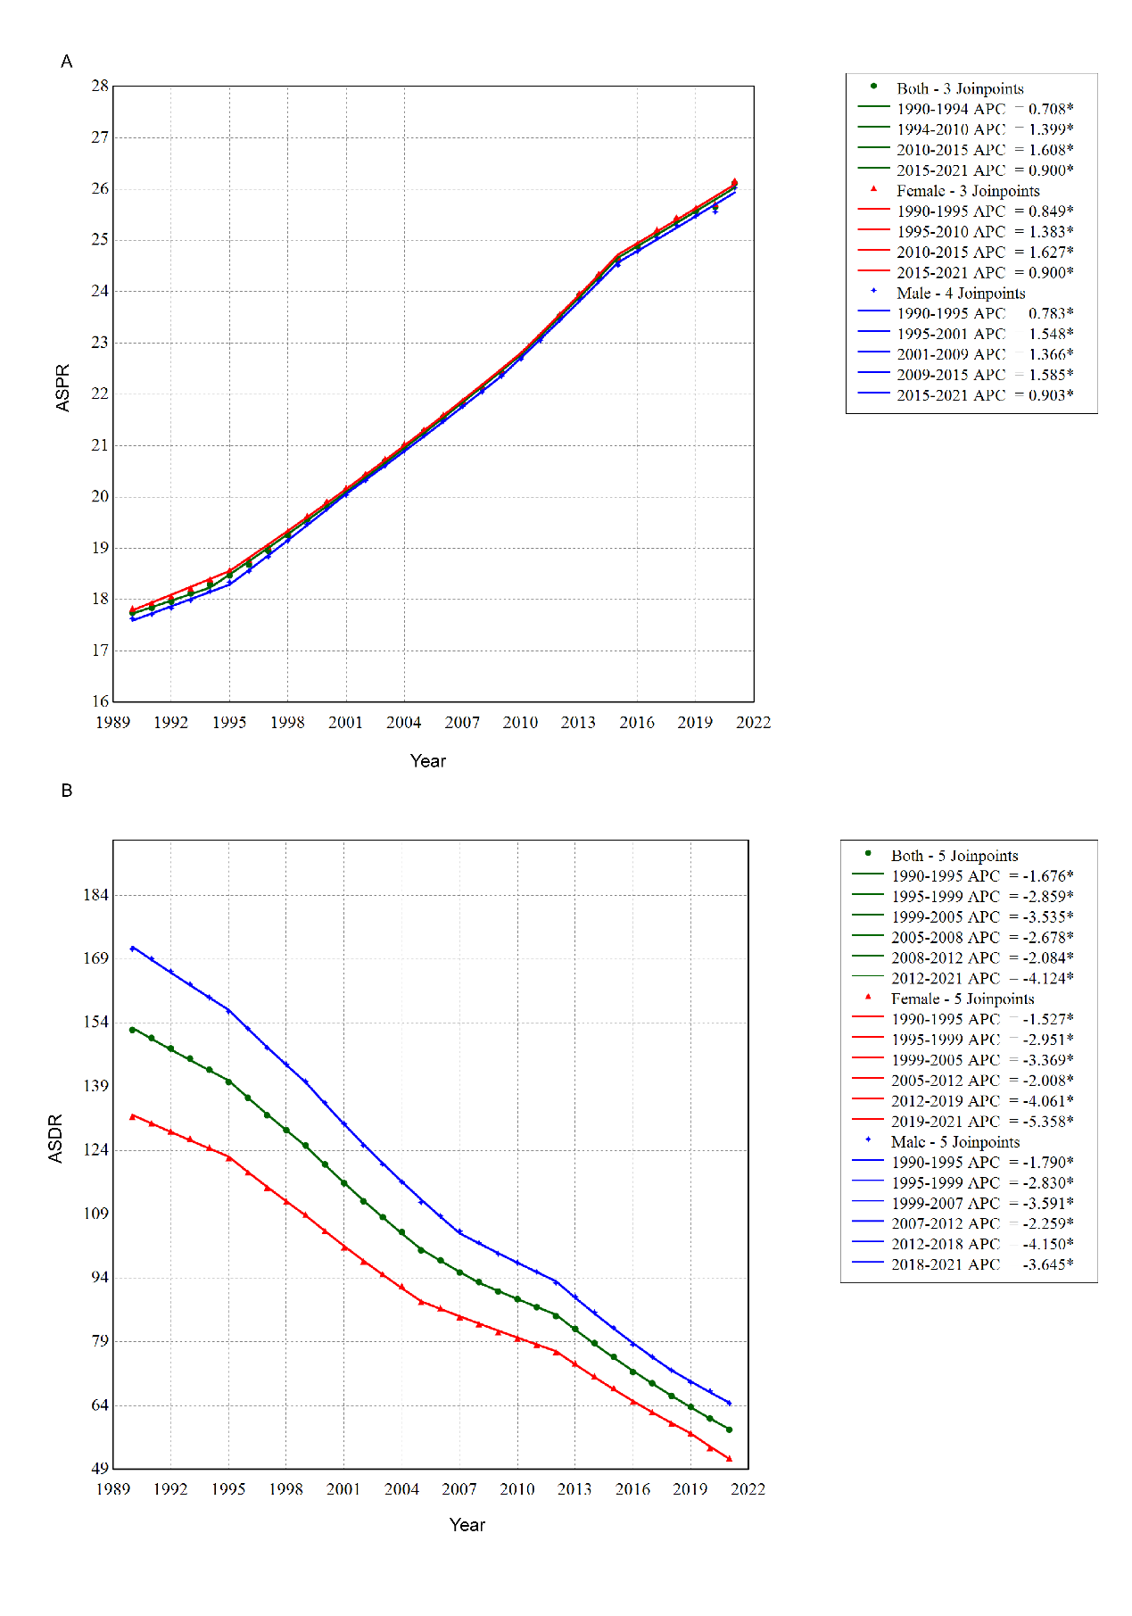
Fig S1. Temporal trends in hemolytic disease and other neonatal jaundice by sex from 1990 to 2021. (A) ASPR. (B) ASDR.
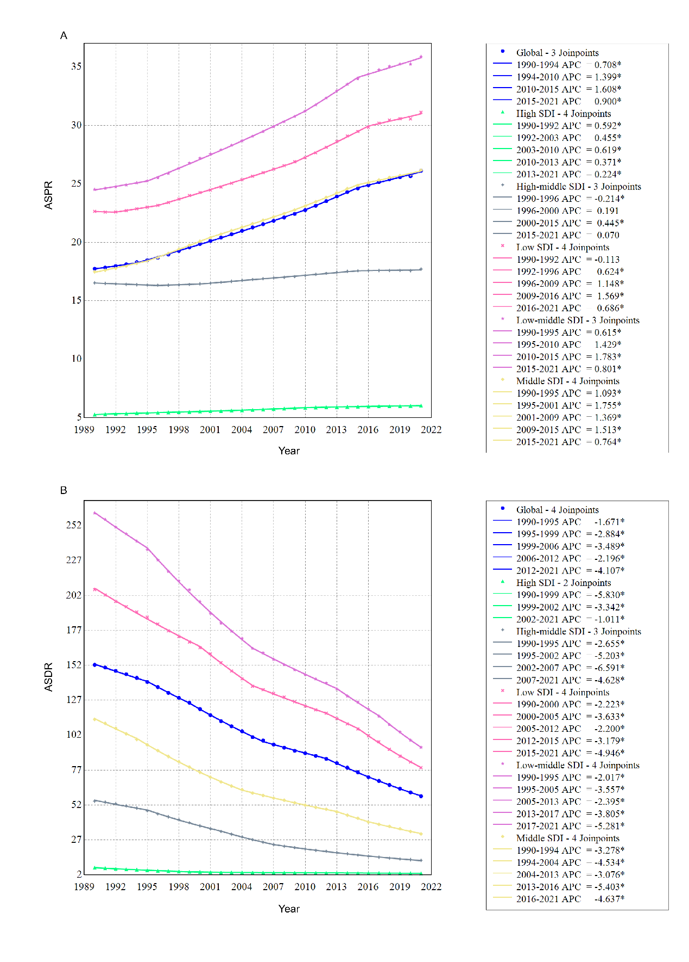
Fig S2. Temporal trends in hemolytic disease and other neonatal jaundice by SDI from 1990 to 2021. (A) ASPR. (B) ASDR.

