Supplementary Material

Methods

Table S1: Visit schedule
 | Clinical visit | SARS-CoV-2 Antibody Test | Food Frequenxy Questionnaire | Symptoms¹ | HrQoL | Screen time | Physical activity | COVID-19 exposure and appraisal | Parental mental health | Completion questionaire²
1 W | x | x | x | x | x | x | x | x | x
2 W |  |  |  | x
3 W |  |  |  | x
4 W |  | x |  | x | x | x | x | x
5 W |  |  |  | x
6 W |  |  |  | x
7 W |  |  |  | x
8 W |  | x |  | x | x | x | x | x
9 W |  |  |  | x
10 W |  |  |  | x
11 W |  |  |  | x
12 W | x | x |  | x | x | x | x | x
13 W |  |  |  | x
14 W |  |  |  | x
15 W |  |  |  | x
16 W |  | x |  | x | x | x | x | x
7 M ³ | x | x |  | X | x | x | x | x
10 M | x | x | x | X | x | x | x | x | x | X
W: weeks; M: months; x: scheduled at the timepoint
The COVID-19 symptom questionnaire is provided in Table S3.
2 The completion questionnaire is provided in Table S4. It surveys COVID-19-related symptoms over the last 6 months, meaning from Month 4 to Month 10; SARS-CoV-2 tests outside of this study, whether the children were in isolation or quarantine during the pandemic, and if so, where the contact with the SARS-CoV-2-positive person occurred and how old the positive person was. We also asked about SARS-CoV-2 vaccination status and the willingness of the child to be vaccinated, arguments for and against vaccination, and the child’s anxiety about COVID-19.
³ Only if an outpatient visit was scheduled.

Table S2: Questions on “Affection through and appraisal of COVID-19” (Schmidt et al. [19])
- Are you concerned that you could get sick with COVID-19?
- Are you concerned that your parents or another family member could get sick with COVID-19?
- Is your family affected with financial difficulties because of the COVID-19 pandemic?
- Does anyone in your family belong the COVID-10 risk group?

Table S3: Life events Scale
Below is a list of significant life events. Please indicate whether any of the following events occurred in your family in the 6 months prior to the COVID-19 pandemic: ^{1, 2}
- Own pregnancy or birth ²
- Own separation or divorce ²
- Own marriage/remarriage*
- Addition of a related or known person to your household*
- Significant change in family income*
- Serious debt*
- Relocation/change of residence*
- Own change of job or change of job of spouse*
- Own unemployment or unemployment of spouse*
- Serious illness or serious accident of a family member (other than your child)
- Death in the family or in a close acquaintance*
Change of school for one of your children*
¹ If asked at the study’s end, the parents were asked whether any of the following events had occurred in the last 6 months of study participation.
² All questions were answered dichotomously, requiring a “yes” or “no.”

Table S4: COVID-19 symptom questionnaire
- Have you been sick and/or had symptoms consistent with a viral infection in the last 7 days? (e.g., cold, sore throat, cough, diarrhea, aching limbs, or fever) ^{1, 2}
- Do you have a sore throat? ¹
- Do you have a cough? ¹
- Do you have shortness of breath? ¹
- Do you have a runny nose? ¹
- Do you have a headache? ¹
- Do you have diarrhea? ¹
- Do you suffer from loss of appetite or nausea? ¹
- Have you taken a fever? ¹
- What was the temperature?
- Do you have a feeling of fever? ¹
- Do you have aching limbs or muscles? ¹
- Is your sense of taste or smell impaired? ¹
- Do you have red or itchy eyes? ¹
- Do you feel listless? ¹
- Do you have any other symptoms? ¹
- Have you taken one or more of the following medications for these symptoms?
  - No
  - Ibuprofen (Brufen, Irfen, Algifor, ...)
  - Paracetamol (Dafalgan, Ben-u-ron, ...)
  - Other: Which?
- Have you seen a doctor for these symptoms? ¹
- Did you not go to work because of these symptoms? ¹
- Do you need new assistance with personal care or eating? ¹
- Are you currently hospitalized? ¹
¹ Answers were dichotomous, requiring a “yes” or “no.”
² If the answer was “yes,” the follow-up questions below were asked.

Table S5: Completion questionnaire
- In the last 6 months, have you been sick and/or had signs of illness, such as a cold, sore throat, cough, diarrhea, aching limbs, or fever? ^{1, 2}
- Do you think you have had a COVID-19 infection? ¹
- Have you had a COVID-19 smear test during the study period? ¹
- Were you sent to ISOLATION during the study period (i.e., did you have a positive test)? ¹
- Were you sent to QUARANTINE during the study period? ¹
- Can you briefly tell us about your school (type of school, location)?
- Were you tested for antibodies in your blood outside of this study? ¹
- Do you use the COVID app? ¹
- Did you have an alarm? ^{1, 3}
- If you had the option of COVID-19 vaccination, would you like to get vaccinated?
  - Yes, definitely
  - Would rather not
  - Probably yes
  - No way
  - I am already vaccinated
- What is your main argument FOR vaccination?
- What is your main argument AGAINST vaccination?
- How afraid are you of COVID-19? (answer on Likert scale: 1 (low)–5 (high))
- If we have any further questions, may we contact you? ¹
¹ Answers were dichotomous, requiring a “yes” or “no.”
² If the answer was yes, the COVID-19 symptoms questionnaire followed.
³ Only asked if the answer to the previous question was “yes.”

Results

Table S6: Results of Food Frequency Questionnaire
 | Phase 0 | Phase 5 | Reference values
DACH 1: 4 to below 7 years  n  Total daily kcal: median, mean  Carbs %:  Fats %:  Protein %  Fibre %:  Protein g: | 7  1555, 1412  48, 50  39, 37  13, 13  0.70, 0.93  45, 44 | 5 (and 1 exclusion)  1384, 1358  40, 45  45, 41  16, 15  0.70, 0.96  48, 49 | 1,300–1,400  45-60  30-35  No values in %  No values in %  18 g/d
DACH 2: 7 to below 10 years  n  Total daily kcal: median, mean  Carbs %:  Fats %:  Protein %  Fibre %:  Protein g: | 9  1710, 1739  48, 49  34, 35  15, 15  0.90, 0.94  59, 68 | 3 (and 2 exclusions)  1764, 1727  55, 52  32, 32  13, 16  1.00, 1.03  64, 66 | 1,500–1,700  45–60  30–35  No values in %  No values in %  26 g/d
DACH 3: 10 to below 13 years  n  Total daily kcal: median, mean  Carbs %:  Fats %:  Protein %  Fibre %:  Protein g: | 10 (and 1 exclusion)  1615, 1941  49, 47  37, 39  14, 14  0.80, 0.91  58, 71 | 5 (and 1 exclusion)  2046, 1910  50, 49  37, 37  14, 14  1.00, 0.98  68, 65 | 1,700–1,900  45–60  30–35  No values in %  No values in %  37 g/d (m), 38 g/d (f)
DACH 4: 13 to below 15 years  n  Total daily kcal: median, mean  Carbs %:  Fats %:  Protein %  Fibre %:  Protein g: | 3 (and 1 exclusion)  2172, 3266  52, 50  36, 38  13, 12  0.70, 0.60  75, 97 | 6 (and 4 exclusions)  1833, 2274  48, 48  38, 38  14, 15  0.85, 0.85  67, 87 | 1,900–2,300  45–60  30–35  No values in %  No values in %  50g/d (m), 49g/d (f)
DACH 5: 15 to below 19 years  n  Total daily kcal: median, mean  Carbs %:  Fats %:  Protein %  Fibre %:  Protein g: | 8 (and 1 exclusion)  1896, 1997  39, 49  43, 34  16, 15  0.60, 0.86  77, 75 | 5 (and 1 exclusions)  1926, 1997  43, 49  33, 34  15, 15  0.80, 0.86  74, 75 | 2,000–2,600  45–60  30  No values in %  No values in %  62 g/d (m), 48 g/d (f)
DACH: German-Austrian-Swiss reference Group; n: number of participants with available Food Frequency Questionnaires; g: grams; g/d: grams per day; m: male; f: female.
In bold, we highlighted the values that were elevated above the reference values.

Table S7: Descriptive Results for Affection through and Appraisal of Pandemic, and Parental Mental Health
 | 0  pre-COVID | 1  lock-  down | 2 normal | 3  slow-  down | 4  lock-  down | 5  normal
Affection through and appraisal of Pandemic (Schmidt et al.)
Child’s concern about being affected by COVID-19  n  Yes (%)  No (%) |  |  | 49  24.5  75.5 | 13  23.1  76.9 | 7  42.9  57.1 | 8  62.5  37.5
Child’s concern about their family to be affected through COVID  n  Yes (%)  No (%) |  |  | 49  46.9  53.1 | 13  76.9  23.1 | 7  85.7  14.3 | 36  30.6  69.4
Financ. affection by pandemic–child (n)  n  Yes (%)  No (%) |  |  | 49  8.2  91.8 | 13  0  100 | 7  14.3  85.7 | 36  2.8  97.2
Family members in at-risk population–child (n)  n  Yes (%)  No (%) |  |  | 49  46.9  53.1 | 13  38.5  61.5 | 7  57.1  42.9 | 36  27.8  72.2
Assessment in the completion questionnaire
Likert scale for fear of COVID-19–child  n  1 (no fear) (%)  2 (minimal fear) (%)  3 (moderate fear) (%)  4 (high fear) (%)  5 (severe fear) (%) |  |  |  |  |  | 41  39.0  29.3  22.0  7.3  2.4
Parental mental health
PHQ-9 parents  n  mean  score 0 (%)  score 1–4 (minimal) (%)  score 5–9 (mild) (%)  score 10–14 (moderate) (%)  score 15–27 (severe) (%) |  | 40  2.9  12.5  70  15  0  2.5 |  |  |  | 36  3.55  16.7  44.4  38.9  0  0
GAD-7 parents  n  mean  score 0–4 (minimal) (%)  score 5–9 (mild) (%)  score 10–14 (moderate) (%)  score 15+ (severe) (%) |  | 40  2.28  87.5  7.5  2.5  0 |  |  |  | 36  2.69  83.3  13.9  2.8  0
Life Events (Number of events)  n  mean |  | 40  0.7 |  |  |  | 40  0.5
n: number of children with available data per phase; PHQ-9: nine-question Patient Health Questionnaire used as a screening tool for the presence and severity of depression; GAD-7: Generalized Anxiety Disorder questionnaire with seven questions used as screening tool for the presence and severity of generalized anxiety disorder.

Survey on COVID-19 symptoms, contacts, and vaccination status
The symptoms most often reported until week 16, from most to least common, are rhinitis (58.9%), cough (35.7%), general weakness (33.0%), headache (26.8%), inappetence or nausea (23.2%), and sore throat (22.3%), and these are reported in detail in Table S8 and Figure S1. Anosmia was reported in four children (3.6%) but was not associated with SARS-CoV-2 seropositivity, isolation, or quarantine being reported on the questionnaires. Only one child had a positive SARS-CoV-2 antibody test later in the study. Of 112 symptomatic incidences, a total of six medical consultations and three hospitalizations were reported (Table S8). None of the hospitalizations was associated with COVID-19, and all of them were due to diabetes. Of the 39 children who answered the completion questionnaire, 14 children reported having experienced symptoms compatible with COVID-19 at least once between week 16 and month 10, and within the same period, one hospitalization occurred, which was not associated with COVID-19. In 14 children, self-reported contact with a SARS-CoV-2-positive individual occurred, after which ten remained negative in quarantine and four tested positive outside the study. Transmission of self-reported infections was reported to have occurred in a school setting in three of four cases, and the source of infection was unknown in one of four cases (Figure S2). The association between age and location with positive contact is shown in Figure S2. At the study’s end, eight of 39 completion questionnaires reported children being vaccinated, and 11 of 39 reported the wish to be vaccinated. The children’s main arguments for the SARS-CoV-2 vaccine were related to their security (9), having more opportunities for leisure activities and family visits (6), and solidarity with patients at risk (5) and those opposing vaccinated were related to the fear of side effects or harm (6), insufficient research (4), and other issues (5).

Table S8: COVID-19 symptoms, school absences, medical visits, and hospitalizations during the first 16 weeks
 | 05  2020 | 06  2020 | 07  2020 | 08  2020 | 09  2020 | 10  2020 | 11  2020 | 12  2020 | 01  2021 | 02  2021 | 03  2021 | 04 2021 | Total
number of participants reporting  presence / absence  of COVID-19-associated symptoms | 2/29 | 17/  24 | 17/  28 | 12/  33 | 11/  21 | 6/9 | 6/3 | 5/5 | 2/3 | 0/1 | 0/1 | 0/1 | 42/  16
number of participants expected to submit the questionnaire¹ | 31 | 48 | 53 | 54 | 54 | 25 | 9 | 5 | 4 | 2 | 2 | 1 | 55
sore throat (%) | 25 | 23.1 | 40 | 13.0 | 21.4 | 18.2 | 25 | 0 | 20 | 0 | 0 | 0 | 22.3
cough (%) | 25 | 46.2 | 50 | 26.1 | 50 | 18.2 | 25 | 0 | 20 | 0 | 0 | 0 | 35.7
dyspnoe (%) | 0 | 7.7 | 0 | 0 | 0 | 0 | 0 | 0 | 0 | 0 | 0 | 0 | 1.8
rhinitis (%) | 25 | 69.2 | 70 | 39.1 | 78.6 | 54.5 | 75 | 40 | 40 | 0 | 0 | 0 | 58.9
headache (%) | 25 | 19.2 | 30 | 13.0 | 35.7 | 18.2 | 50 | 40 | 80 | 0 | 0 | 0 | 26.8
diarrhea (%) | 0 | 7.7 | 0 | 8.7 | 0 | 9.1 | 0 | 0 | 80 | 0 | 0 | 0 | 8.0
inappetence, nausea (%) | 50 | 23.1 | 20 | 26.1 | 7.1 | 9.1 | 0 | 40 | 80 | 0 | 0 | 0 | 23.2
body aches (%) | 0 | 0 | 0 | 8.7 | 0 | 9.1 | 25 | 20 | 60 | 0 | 0 | 0 | 7.1
anosmia (%) | 0 | 3.8 | 5 | 0 | 0 | 0 | 0 | 20 | 20 | 0 | 0 | 0 | 3.6
conjunctivitis (%) | 25 | 3.8 | 20 | 0 | 14.3 | 0 | 25 | 20 | 40 | 0 | 0 | 0 | 10.7
weakness (%) | 75 | 34.6 | 20 | 26.1 | 42.9 | 9.1 | 50 | 60 | 60 | 0 | 0 | 0 | 33.0
number of participants reporting school absences | 2 | 4 | 1 | 3 | 3 | 1 | 1 | 2 | 1 | 0 | 0 | 0 | 18
number of participants reporting medical consultations | 0 | 0 | 1 | 0 | 1 | 1 | 1 | 0 | 1 | 0 | 0 | 0 | 5
number of participants reporting hospitalizations ² | 0 | 0 | 1 | 1 | 0 | 0 | 1 | 0 | 0 | 0 | 0 | 0 | 3
¹ This number represents the total participants who participated in the first 16 weeks of the study and were expected to answer the symptoms questionnaire. The discrepancy in December 2020 and January 2021, with higher numbers of answers than expected, is due to patients answering additionally. The discrepancy in the other months, with fewer answers than expected, is due to a lack of compliance or answers being submitted in the last days of the previous month.
² One additional hospitalization of a fourth child was reported on the completion questionnaire.

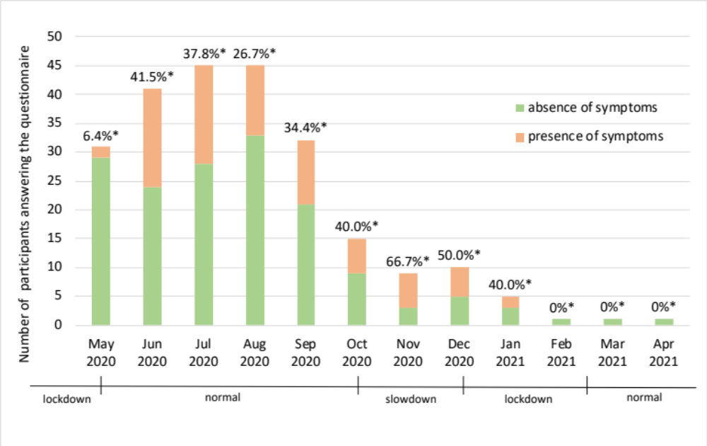

Figure S1: Reporting of COVID-19-associated symptoms on weekly questionnaires from week 0 to week 16. The percentage above the columns (*) shows the percentage of participants reporting COVID-19-related symptoms out of all participants who answered the questionnaire in the corresponding month.
:

Figure S2: Association between the location and age of the SARS-CoV-2-positive contact reported by study participants.
A total of 14 participants self-reported having had contact with a SARS-CoV-2-positive person.
Self-reported SARS-CoV-2 negative.
Self-reported SARS-CoV-2 positive. One more participant who self-reported as SARS-CoV-2 positive is not shown in this figure because with whom and where the contact occurred remains unknown.

Figure S2: Reporting of COVID-19-associated symptoms on weekly questionnaires from week 0 to week 16. The percentage above the columns (*) shows the percentage of participants reporting COVID-19-related symptoms out of all participants who answered the questionnaire in the corresponding month.
:

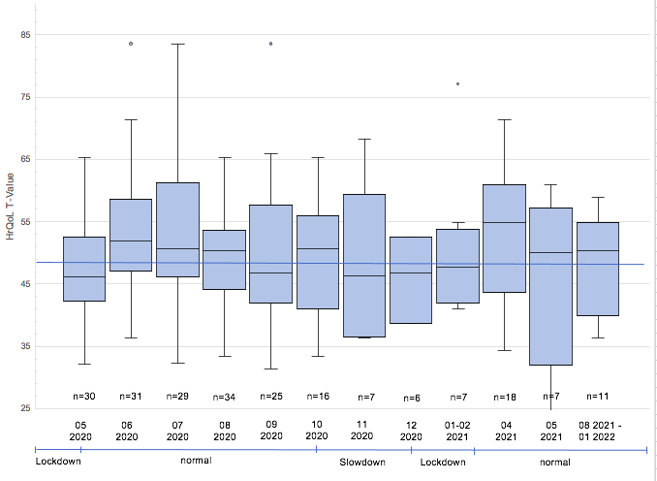
Figure S3: Boxplot diagram for HrQoL, shown in months. Values above 50 represent a better and below 50 a worse HrQoL than the mean value for the German-speaking Swiss pediatric population before the pandemic. The median HrQoL is lower than 50 during the lockdowns; the slowdown; and September 2020, after schools were opened.

