The Effect of Exercise Intervention on the Triglyceride-Glucose (TyG) Index in Adolescents with Overweight or Obesity: A Systematic Review and Bayesian Dose-Response Meta-Analysis

Appendix

Appendix 1: Search strategy 1
Appendix 2: Demographic characteristics of included studies 3
Appendix 3: Within-study risk of bias 5
Appendix 4: Publication bias 7
Appendix 5: Convergence and posterior distributions 9
Appendix 6: Included studies 12

Appendix 1: Search strategy
- PubMed
Search number | Query
1 | "Exercise"[Mesh] OR "Exercise Therapy"[Mesh] OR exercis[tiab] OR "physical activit"[tiab] OR "physical training"[tiab] OR "aerobic training"[tiab] OR "resistance training"[tiab]
2 | "Pediatric Obesity"[Mesh] OR "obesity"[Mesh] OR obes[tiab] OR "overweight"[tiab] OR "adiposity"[tiab] OR "body mass index"[tiab] OR "BMI"[tiab]
3 | "Adolescent"[Mesh] OR adolescen[tiab] OR teen[tiab] OR youth[tiab] OR "young people"[tiab] OR "high school"[tiab]
4 | "Triglycerides"[Mesh] OR "Blood Glucose"[Mesh] OR "triglyceride glucose index"[tiab] OR "TyG index"[tiab] OR "triglyceride-glucose"[tiab] OR "TG/HDL"[tiab] OR "triglyceride to glucose"[tiab]
5 | "randomized controlled trial[pt] OR controlled clinical trial[pt] OR randomized[tiab] OR randomly[tiab] OR trial[tiab] OR placebo[tiab]
6 | #1 AND #2 AND #3 AND #4AND #5

- Embase
Search number | Query
1 | 'exercise'/exp OR 'kinesiotherapy'/exp OR exercis:ti,ab OR 'physical activit':ti,ab OR 'physical training':ti,ab OR 'aerobic training':ti,ab OR 'resistance training':ti,ab
2 | 'pediatric obesity'/exp OR 'obesity'/exp OR obes*:ti,ab OR 'overweight':ti,ab OR 'adiposity':ti,ab OR 'body mass index':ti,ab OR 'bmi':ti,ab
3 | 'adolescent'/exp OR adolescen*:ti,ab OR teen:ti,ab OR youth:ti,ab OR 'young people':ti,ab OR 'high school':ti,ab
4 | 'triglyceride'/exp OR 'glucose blood level'/exp OR 'triglyceride glucose index':ti,ab OR 'tyg index':ti,ab OR 'triglyceride-glucose':ti,ab OR 'tg/hdl':ti,ab OR 'triglyceride to glucose':ti,ab
5 | 'randomized controlled trial'/exp OR random:ti,ab OR placebo:ti,ab OR 'clinical trial':ti,ab
6 | #1 AND #2 AND #3 AND #4 AND #5

- Cochrane Library
Search number | Query
1 | MeSH descriptor: [Exercise] explode all trees
2 | MeSH descriptor: [Exercise Therapy] explode all trees
3 | exercis:ti,ab,kw OR "physical activit":ti,ab,kw OR "physical training":ti,ab,kw OR "aerobic training":ti,ab,kw OR "resistance training":ti,ab,kw
4 | MeSH descriptor: [Pediatric Obesity] explode all trees
5 | MeSH descriptor: [Obesity] explode all trees
6 | obes:ti,ab,kw OR "overweight":ti,ab,kw OR "adiposity":ti,ab,kw OR "body mass index":ti,ab,kw OR "bmi":ti,ab,kw
7 | MeSH descriptor: [Adolescent] explode all trees
8 | adolescen:ti,ab,kw OR teen:ti,ab,kw OR youth:ti,ab,kw OR "young people":ti,ab,kw OR "high school":ti,ab,kw
9 | MeSH descriptor: [Triglycerides] explode all trees
10 | MeSH descriptor: [Blood Glucose] explode all trees
11 | "triglyceride glucose index":ti,ab,kw OR "tyg index":ti,ab,kw OR "triglyceride-glucose":ti,ab,kw OR "tg/hdl":ti,ab,kw OR "triglyceride to glucose":ti,ab,kw
12 | #1 OR #2 OR #3
13 | #4 OR #5 OR #6
14 | #7 OR #8
15 | #9 OR #10 OR #11
16 | #12 AND #13 AND #14 AND #15

- Web of Science
Search number | Query
1 | TS=(exercis* OR "physical activit" OR "physical training" OR "aerobic training" OR "resistance training") AND  TS=(obes OR "overweight" OR "adiposity" OR "body mass index" OR "BMI") AND  TS=(adolescen* OR teen* OR youth* OR "young people" OR "high school") AND  TS=("triglyceride glucose index" OR "TyG index" OR "triglyceride-glucose" OR "TG/HDL" OR "triglyceride to glucose") AND  TS=((randomi* NEAR/2 (trial* OR study OR control)) OR placebo OR "controlled trial" OR "clinical trial")

Appendix 2: Demographic characteristics of included studies
First Author(year) | Region | Design,&participants | Exercise Intervention Control | MET
Vasconcellos（2021） | Brazil | Intervention:n=6,age=13.9±1.6 yr,BMI=30.5±2.1 kg/m²;Control:n=7,age=14.7±2.3 yr,BMI=30.8±3.1 kg/m² | Intervention:Aerobic Exercise;Recreational Soccer Program:Small-sided games(2v2, 3v3,4v4),3 sessions/ week,60 min/ session,~85%HRmax.  Control:No structured exercise. | ~9 METs
Staiano  （2017） | USA | Intervention:n=22,age=14-18 yr,BMI percentile≥85th; Control:n=19 | Intervention:Aerobic Exercise;Dance Exergaming:Group-based dance video games,3 sessions/week,60 min/session,self-selected intensity  Control:No structured exercise. | ~3.5
Tadiotto  （2023） | Brazil | Intervention:HIIT:n=13;  MICT:n=15;Control:n=24 | Intervention:HIIT:Stationary cycling,3 sessions/week,~35 min/ session,intervals at 80-100% HRres; MICT:Stationary cycling,3 sessions/ week,60 min/session,intensity 35- 75%HRres.  Control:No structured exercise. | HIIT: ~8 (Vigorous-intensity); MICT: ~5 (Moderate-intensity)
Leite  （2022） | Brazil | Intervention:MICT:n=20;  HIIT:n=20;Control:n=16 | Intervention:MICT: Cycling/walking, 3 sessions/week, 90 min/session, 35-75%HRres (5.0 METs);  HIIT: ~45 min/session, 3 sessions/week, intervals at 100% MAS (8.0 METs) with decreasing recovery time.  Control:No structured exercise. | 8.0
Salus  （2022） | Estonia | Intervention:n=14,age=13.1±0.3 yr,BMI=30.3±0.9 kg/m²;Control:n=14,age=13.7±0.4 yr,BMI=32.6±1.6 kg/m² | Intervention:Sprint Interval Training:3 sessions/week for 12 weeks,4-6 sets of 30s all-out cycling sprints with 4min recovery.  Control:No structured exercise. | ~12 (during sprint bouts)
Pablos  （2018） | Spain | Intervention:n=82;  Control:n=76;5th or 6th grade | Intervention:HHP Program:8-month extracurricular program,twice/week, 75 min/session(150min/week),includ es health education and themed sport s games.  Control:No structured exercise. | 4.0
Emir Tas  （2023） | USA | Intervention:n=34;Control:n=6;age 13-18 yr,BMI=36.7±5.8 kg/m² | Intervention:HIIT:Supervised program,3 sessions/week for 4 weeks,45 min/session,10 sets of 1-min high-intensity exercise at 80-90%HRmax with 2min recovery.  Control:No structured exercise. | ~ 8–12 METs
da Silva  (2024) | Brazil | Intervention:ATG:n=20,  age=16.05±1.1 yr,50%female;STG:n=20,  age=16.95±1.1 yr,50%female;CTG:n=20,  age=16.63±1.1 yr,55%female;Control:n=20,  age=15.74±1.1  yr,55%female | Intervention:ATG:High-intensity aerobic training,4×/week,30 min/ session at 75%HRres; STG:High-intensity resistance training,4×/week,50 min/session at 85%1RM;CTG:Combined training,4×/week,40 min/session (20min aerobic+20min resistance).  Control:No structured exercise. | ATG : 5.0 METs  STG : 6.0 MET  CTG : 5.5 METs
Rong Xiangjiang  （2007） | China | Intervention:n=54;  Control:n=54;age 12-13 yr | Intervention:Aerobic Exercise:7 sessions/week for 3 months,40-50 min/session at 70-80%HRmax.  Control:No structured exercise. | 7.5
Liu Wen(2008) | China | Intervention:n=25;  Control:n=24;age 12-14 yr | Intervention:Combined Training:3 months high intensity(aerobic 5 days/week,strength 2 days/week) followed by 6 months low intensity (aerobic 4 days/week,strength 2 days/week).  Control:No structured exercise. | 3-7
Guojian He(2010) | China | Intervention:n=24,  age=12.27±1.53 yr;Control:n=24,  age=11.81±1.85 yr | Intervention:Aerobic Exercise:3 sessions/week,70 min/session(warm-up 10min+strength 20min+aerobic 30min+ relaxation 10min)at 30-40% HRmax.  Control:No structured exercise. | 3.0
Hongling Cheng(2012) | China | Intervention:n=30;  Control:n=30;age 13-14 yr | Intervention:Combined Training:2 additional sessions/week for 8 weeks, 60-70 min/session(resistance,aerobic and games).  Control:No structured exercise. | 5.2
Note：All the literature was included TG and TYG

Appendix 3: Within-study risk of bias
Study | D1 | D2 | D3 | D4 | D5 | Overall
Metabolites  2024 | Some  concerns | Some  concerns | Low risk | Low risk | Low  risk | Some  concerns
Hongling  Cheng2012 | Some  concerns | Some  concerns | Low risk | Low risk | Low  risk | Some  concerns
Leite2022 | High risk | Some  concerns | Some  concerns | Low risk | Low  risk | High risk
Pablos2018 | Some  concerns | Some  concerns | Low risk | Low risk | Low  risk | Some  concerns
Salus2022 | High risk | Some  concerns | Some  concerns | Low risk | Low  risk | High risk
Staiano2016 | Some  concerns | Some  concerns | Some  concerns | Low risk | Low  risk | Some  concerns
Tadiotto2023 | High risk | Some  concerns | Low risk | Low risk | Low  risk | High risk
Tas2023 | Low risk | Some  concerns | Some  concerns | Some  concerns | Low  risk | Low risk
Vasconcellos  2020 | Some  concerns | Some  concerns | Low risk | Low risk | Low  risk | Some  concerns
Liu Wen2008 | High risk | Some  concerns | Some  concerns | Low risk | Low  risk | High risk
Guojian  He2010 | Some  concerns | Some  concerns | Some  concerns | Low risk | Low  risk | Some  concerns
Xiangjiang  Rong2007 | High risk | Some  concerns | Low risk | Low risk | Low  risk | High risk
Figure S1. Risk of bias of FBG.

Study | D1 | D2 | D3 | D4 | D5 | Overall
Metabolites  2024 | Some  concerns | Some  concerns | Low risk | Low risk | Low  risk | Some  concerns
Hongling  Cheng2012 | Some  concerns | Some  concerns | Low risk | Low risk | Low  risk | Some  concerns
Leite2022 | High risk | Some  concerns | Some  concerns | Low risk | Low  risk | High risk
Pablos2018 | Some  concerns | Some  concerns | Low risk | Low risk | Low  risk | Some  concerns
Salus2022 | High risk | Some  concerns | Some  concerns | Low risk | Low  risk | High risk
Staiano2016 | Some  concerns | Some  concerns | Some  concerns | Low risk | Low  risk | Some  concerns
Tadiotto2023 | High risk | Some  concerns | Low risk | Low risk | Low  risk | High risk
Tas2023 | Low risk | Some  concerns | Some  concerns | Some  concerns | Low  risk | Low risk
Vasconcellos20 20 | Some  concerns | Some  concerns | Low risk | Low risk | Low  risk | Some  concerns
Wen Liu2008 | High risk | Some  concerns | Some  concerns | Low risk | Low  risk | High risk
Guojian He 2010 | Some  concerns | Some  concerns | Some  concerns | Low risk | Low  risk | Some  concerns
Xiangjiang  Rong2007 | High risk | Some  concerns | Low risk | Low risk | Low  risk | High risk
Figure S2. Risk of bias of TG.

Study | D1 | D2 | D3 | D4 | D5 | Overall
Metabolites  2024 | Some  concerns | Some  concerns | Low risk | Low risk | Low risk | Some  concerns
Hongling  Cheng 2012 | Some  concerns | Some  concerns | Low risk | Low risk | Low risk | Some  concerns
Leite2022 | High risk | Some  concerns | Some  concerns | Low risk | Low risk | High risk
Pablos2018 | Some  concerns | Some  concerns | Low risk | Low risk | Some  concerns | Some  concerns
Salus2022 | High risk | Some  concerns | Some  concerns | Low risk | Some  concerns | High risk
Staiano2016 | Some  concerns | Some  concerns | Some  concerns | Low risk | Some  concerns | Some  concerns
Tadiotto2023 | High risk | Some  concerns | Low risk | Low risk | Some  concerns | High risk
Tas2023 | Low risk | Some  concerns | Some  concerns | Some  concerns | Some  concerns | High risk
Vasconcellos 2020 | Some  concerns | Some  concerns | Low risk | Low risk | Low risk | Some  concerns
Wen Liu2008 | High risk | Some  concerns | Some  concerns | Low risk | Some  concerns | High risk
Guojian He 2010 | Some  concerns | Some  concerns | Some  concerns | Low risk | Some  concerns | Some  concerns
Xiangjiang  Rong2007 | High risk | Some  concerns | Low risk | Low risk | Some  concerns | High risk
Figure S3. Risk of bias of TYG.

Appendix 4: Publication bias

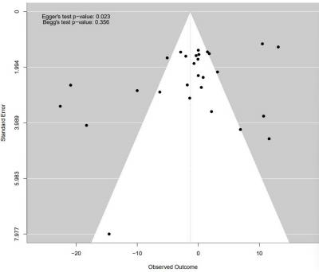
Figure S4. Funnel plot of FBG.

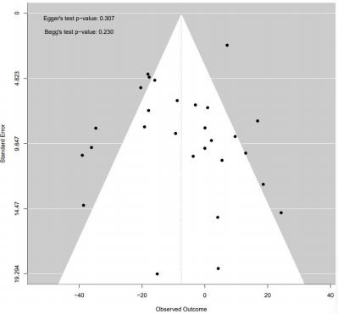
Figure S5. Funnel plot of TG.
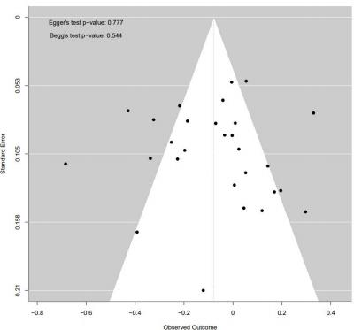

Figure S6. Funnel plot of TYG.

Appendix 5: Convergence and posterior distributions

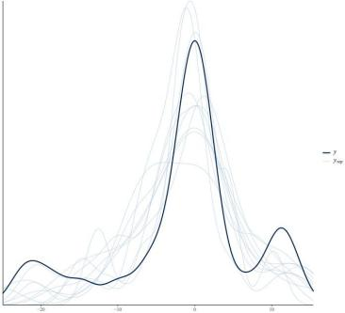
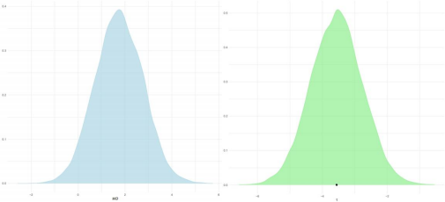
Figure S7. Posterior density and MCMC trace plots for model parameters of FBG.

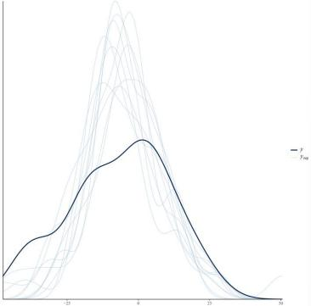

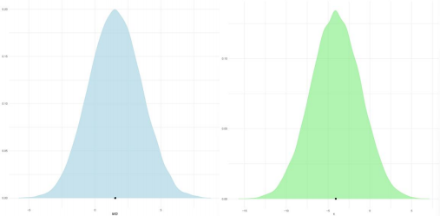
Figure S8. Posterior density and MCMC trace plots for model parameters of TG.

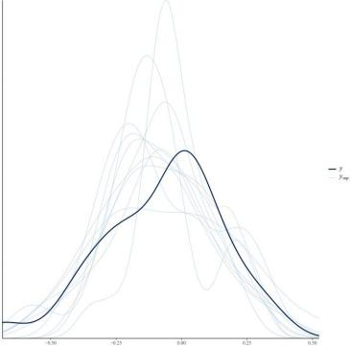

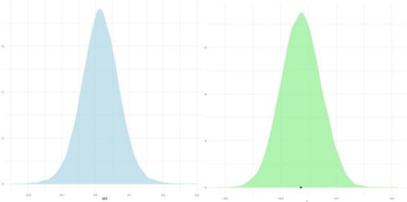
Figure S9. Posterior density and MCMC trace plots for model parameters of TYG.

Appendix 6: Included studies
- Lister NB,Baur LA,Felix JF,Hill AJ,Marcus C,Reinehr T,et al.Child and adolescent obesity.Nature Reviews Disease Primers.2023;9(1):24.DOI:10.1038/ s41572-023-00435-4.
- Organization WH.Obesity and overweight Geneva:World Health Organization; 2024 [updated 9 June 2024.Available from:https://www.who.int/news-room/ fact-sheets/detail/obesity-and-overweight.
- Cao W,Xu J,Xu P,Wang H,Yang T,Gan Q,et al.Trends of Overweight or Obesity Among Chinese Rural Children and Adolescents Aged 6 to 15 Years-the Central and Western Regions,China, 2012-2023.China CDC weekly.2025;7(1):10-4.DOI: 10.46234/ccdcw2025.003.
- Jebeile H,Kelly AS,O'Malley G,Baur LA.Obesity in children and adolescents: epidemiology, causes,assessment,and management.The Lancet Diabetes& Endocr inology.2022;10(5):351- 65.DOI: 10.1016/S2213-8587(22)00047-X.
- Luo Y,Luo D,Li M,Tang B.Insulin Resistance in Pediatric Obesity:From Mecha- nisms to Treat- ment Strategies.Pediatric diabetes.2024;2024:2298306.DOI:10.11 55 /2024/2298306.
- Tam CS,Xie W,Johnson WD,Cefalu WT,Redman LM,Ravussin E.Defining insul- in resistance from hyperinsulinemic-euglycemic clamps.Diabetes care.2012;35(7):1605-10.DOI:10.2337/dc11-233 9.
- Guerrero-Romero F, Simental-Mendía LE, González-Ortiz M, Martínez-Abundis E,Ramos-Zavala MG,Hernández-González SO,et al.The product of triglycerides and glucose,a simple measure of insulin sensitivity.Comparison with the euglyc emic-hyperinsulinemic clamp.The Journal of clinical endocri- nology and metabo- lism.2010;95(7):3347-51.DOI: 10.1210/jc.2010-0288.
- Kurniawan LB.Triglyceride-Glucose Index As A Biomarker Of Insulin Resistance,Diabetes Mellitus,Metabolic Syndrome,And Cardiovascular Disease:A Review.Ejifcc.2024;35(1):44-51. DOI.
- Mohd Nor NS,Lee S,Bacha F,Tfayli H,Arslanian S.Triglyceride glucose index as a surrogate measure of insulin sensitivity in obese adolescents with normoglyce- mia,prediabetes,and type 2 diab- etes mellitus:comparison with the hyperinsuli- nemic-euglycemic clamp.Pediatric diabetes.2016;17 (6):458-65.DOI: 10.1111/pe- di.12303.
- Dundar C,Terzi O,Arslan HN.Comparison of the ability of HOMA-IR,VAI,and TyG indexes to predict metabolic syndrome in children with obesity:a cross-sectional study.BMC Pediatrics.2023; 23(1):74.DOI: 10.1186/s12887-023-03892-8.
- Simental-Mendía LE,Hernández-Ronquillo G,Gómez-Díaz R,Rodríguez-Morán M,Guerrero-Ro mero F.The triglycerides and glucose index is associated with cardiovascular risk factors in normal-weight children and adolescents.Pediatric Research.2017;82(6):920-5.DOI:10.1038/pr.201 7.187.
- Hampl SE,Hassink SG,Skinner AC,Armstrong SC,Barlow SE,Bolling CF,et al. Clinical Practice Guideline for the Evaluation and Treatment of Children and Adolescents With Obesity. Pedia- trics.2023;151(2).DOI:10.1542/peds.2022-0606 40.
- Shouli MM,Shouli KM,Aqtam I,Ayed A.Effect of Nitro Counseling on Lifestyle of Obese Adolescence. SAGE open nursing.2024;10:23779608241228637.DOI:10.1177/23779608241228637.
- Bell LM,Watts K,Siafarikas A,Thompson A,Ratnam N,Bulsara M,et al.Exercise alone reduces insulin resistance in obese children independently of changes in body composition.The Journal of clinical endocrinology and metabolism. 2007; 92(11):4230-5.DOI: 10.1210/jc.2007-0779.
- Egan B,Zierath JR. Exercise metabolism and the molecular regulation of skeletal muscle adaptation. Cell metabolism.2013;17(2):162-84.DOI:10.1016/j.cmet.201 2.12.012.
- Richter EA,Hargreaves M.Exercise,GLUT4,and skeletal muscle glucose uptake. Physiological reviews. 2013;93(3):993-1017.DOI: 10.1152/physrev.00038.2012.
- Ladu MJ,Kapsas H,Palmer WK.Regulation of lipoprotein lipase in muscle and adipose tissue during exercise.Journal of applied physiology (Bethesda,Md:1985).1991;71(2):404-9.DOI:10. 1152/ jappl.1991.71.2.404.
- Gill JM,Hardman AE.Exercise and postprandial lipid metabolism:an update on potential mechanisms and interactions with high-carbohydrate diets (review).The Journal of nutritional bioche- mistry.2003;14(3):122-32.DOI:10.1016/s0955-2863 (02)00275-9.
- Yoon JS,Shim YS,Lee HS,Hwang IT,Hwang JS.A population-based study of TyG index distributi- on and its relationship to cardiometabolic risk factors in children and adolescents.Sci Rep. 2021; 11(1):23660.DOI:10.1038/s41598-021- 03138-6.
- García-Hermoso A,López-Gil JF,Izquierdo M,Ramírez-Vélez R,Ezzatvar Y.Exer- cise and Insulin Resistance Markers in Children and Adolescents With Excess Weight:A Systematic Review and Network Meta-Analysis.JAMA pediatrics.2023;177(12):1276-84.DOI:10.1001/jamapediatrics.2023. 40 38.
- Kazeminasab F,Sharafifard F,Miraghajani M,Behzadnejad N,Rosenkranz SK.The effects of exercise training on insulin resistance in children and adolescents with overweight or obesity:a systematic review and meta-analysis.Frontiers in endocrinology.2023;14:1178376.DOI:10.3389/fendo.2023.1178376.
- Liu X,Li Q,Lu F,Zhu D.Effects of aerobic exercise combined with resistance training on body composition and metabolic health in children and adolescents with overweight or obesity:systematic review and meta-analysis.Frontiers in public health.2024;12:1409660.DOI:10.3389/fpubh.2024.1409660.
- Yin J-L,Yang J,Song X-J,Qin X,Chang Y-J,Chen X,et al.Triglyceride-glucoseindex and health outcomes:an umbrella review of systematic reviews withmeta-analyses of observational studies.Cardiovascular Diabetology.2024;23(1):177.DOI:10.1186/s12933-024-02241-y.
- Cabanillas-Lazo M,Quispe-Vicuña C,Pascual-Guevara M,Cruzalegui-Bazán C,Duran-Pecho A,Paz-Ibarra J,et al.Diagnostic accuracy of triglyceride to glucose index and triglyceride/high-density lipoprotein index for insulin resistance among children and adolescents:A systematic review.PloS one.2025;20(6):e0326179.DOI:10.1371/journal.pone.0326179.
- Kelley GA,Kelley KS.Aerobic exercise and lipids and lipoproteins in children and adolescents:a meta-analysis of randomized controlled trials.Atherosclerosis.2007;191(2):447-53.DOI:10.1016/j.atherosclerosis.2006.04.019.
- Kelsey MM,Zeitler PS.Insulin Resistance of Puberty.Current diabetes reports.2016;16(7):64.DOI:10.1007/s11892-016-0751-5.
- Jeffery AN,Metcalf BS,Hosking J,Streeter AJ,Voss LD,Wilkin TJ.Age BeforeStage:Insulin Resistance Rises Before the Onset of Puberty:A 9-year longitudinal study (EarlyBird 26).Diabetes care.2012;35(3):536-41.DOI:10.2337/dc11-1281.
- Higgins J.Cochrane Handbook for Systematic Reviews of Interventions 2023[Available from:https://training.cochrane.org/handbook/current.
- Page MJ,Moher D,Bossuyt PM,Boutron I,Hoffmann TC,Mulrow CD,et al.PRISMA 2020 explanation and elaboration:updated guidance and exemplars forreporting systematic reviews.BMJ(Clinical research ed).2021;372:n160.DOI:10.1136/bmj.n160.
- Sterne JAC,Savović J,Page MJ,Elbers RG,Blencowe NS,Boutron I,et al.RoB2:a revised tool for assessing risk of bias in randomised trials.BMJ(Clinicalresearch ed).2019;366:l4898.DOI:10.1136/bmj.l4898.
- Guyatt GH,Oxman AD,Vist GE,Kunz R, Falck-Ytter Y,Alonso-Coello P,et al.GRADE:an emerging consensus on rating quality of evidence and strength of recommendations.BMJ (Clinical research ed).2008;336(7650):924-6.DOI:10.1136/bmj.39489.470347.AD.
- Araújo SP,Juvanhol LL,Bressan J,Hermsdorff HHM. Triglyceride glucose index:A new biomarker in predicting cardiovascular risk. Preventive medicinereports.2022;29:101941.DOI:10.1016/j.pmedr.2022.101941.
- Oehlert GW.A Note on the Delta Method.The American Statistician.1992;46(1):27-9.DOI:10.1080/00031305.1992.10475842.
- Cochrane Handbook for Systematic Reviews of Interventions.London:Cochrane;2024.Available from:https://www.cochrane.org/handbook.
- Bürkner P-C.brms:An R Package for Bayesian Multilevel Models Using Stan.Journal of Statistical Software.2017;80(1):1-28.DOI:10.18637/jss.v080.i01.
- Identifying and Quantifying Heterogeneity.Introduction to Meta-Analysis2009.p.107-25.
- Gelman A.Prior Distributions for Variance Parameters in Hierarchical Models.Bayesian Analysis.2006;1.DOI:10.1214/06-BA117A.
- Herrmann SD,Willis EA,Ainsworth BE,Barreira TV,Hastert M,Kracht CL,etal.2024 Adult Compendium of Physical Activities:A third update of the energy costs of human activities.Journal of sport and health science.2024;13(1):6-12.DOI:10.1016/j.jshs.2023.10.010.
- Soliman NM,Elsayied HAE,Shouli MM.Application of health belief model among youth at high risk for obesity in West Bank (Palestine).Am J Nurs Sci.2018;7(3):86-96.DOI.
- Wu S,Feng X,Sun X.Development and evaluation of the health belief model scale for exercise. Int J Nurs Sci.2020;7(Suppl 1):S23-s30.DOI:10.1016/j.ijnss.2020.07.006.
- Nordestgaard BG,Langsted A,Mora S,Kolovou G,Baum H,Bruckert E,et al.Fasting is not routinely required for determination of a lipid profile:clinical and laboratory implications including flagging at desirable concentration cutpointsa joint consensus statement from the European Atherosclerosis Society and European Federation of Clinical Chemistry and Laboratory Medicine.European heart journal.2016;37(25):1944-58.DOI:10.1093/eurheartj/ehw152.
- Mann S,Beedie C,Jimenez A.Differential effects of aerobic exercise,resistance training and combined exercise modalities on cholesterol and the lipid profile:review,synthesis and recommendations.Sports medicine (Auckland,NZ).2014;44(2):211-21.DOI:10.1007/s40279-013-0110-5.
- Chen Z,Zhou R,Liu X,Wang J,Wang L,Lv Y,et al.Effects of Aerobic Exercise on Blood Lipids in People with Overweight or Obesity:A Systematic Review and Meta-Analysis of Randomized Controlled Trials.Life (Basel,Switzerland).2025;15(2).DOI:10.3390/life15020166.
- Richter EA.Is GLUT4 translocation the answer to exercise-stimulated muscle glucose uptake?American journal of physiology Endocrinology and metabolism.2021;320(2):E240-e3.DOI:10.1152/ajpendo.00503.2020.
- Liu X,Zhang Y,Han B,Li L,Li Y,Ma Y,et al.Postprandial exercise regulates tissue-specific triglyceride uptake through angiopoietin-like proteins.JCI insight.2024;9(16).DOI:10.1172/jci.insight.181553.
- Reckziegel MB,Nepomuceno P,Machado T,Renner JDP,Pohl HH,Nogueira-de-Almeida CA,et al.The triglyceride-glucose index as an indicator of insulinresistance and cardiometabolic risk in Brazilian adolescents.Archives of endocrinology and metabolism.2023;67(2):153-61.DOI:10.20945/2359-3997000000506.
- Sánchez-García A,Rodríguez-Gutiérrez R,Mancillas-Adame L,González-NavaV,Díaz González-Colmenero A,Solis RC,et al.Diagnostic Accuracy of the Triglyceride and Glucose Index for Insulin Resistance:A Systematic Review.International journal of endocrinology.2020;2020:4678526.DOI:10.1155/2020/4678526.
- Brito ADM,Hermsdorff HHM,Filgueiras MS,Suhett LG,Vieira-Ribeiro SA,Franceschini S,et al.Predictive capacity of triglyceride-glucose(TyG) index forinsulin resistance and cardiometabolic risk in children and adolescents:a systematic review.Critical reviews in food science and nutrition.2021;61(16):2783-92.DOI:10.1080/10408398.2020.1788501.
- Liu X,Li Q,Lu F,Zhu D.Effects of aerobic exercise combined with resistance training on body composition and metabolic health in children and adolescents with overweight or obesity:systematic review and meta-analysis.Frontiers in public health.2024;Volume 12-2024.DOI:10.3389/fpubh.2024.1409660.
- Wan H,Cao H,Ning P.Superiority of the triglyceride glucose index over thehomeostasis model in predicting metabolic syndrome based on NHANES data analysis.Sci Rep.2024;14(1):15499.DOI:10.1038/s41598-024-66692-9.
- Bull FC,Al-Ansari SS,Biddle S,Borodulin K,Buman MP,Cardon G,et al.World Health Organization 2020 guidelines on physical activity and sedentary behaviour.British journal of sports medicine.2020;54(24):1451-62.DOI:10.1136/bjsports-2020-102955.

