Supplementary Material
1. Supplementary Tables

Table S1. Stratified analysis of associations between BCAAs, EAAs concentrations and ASD severity. *P<0.05
Amino Acids | Gender
Amino Acids | Male |  | Female |  | P_interaction
Amino Acids | OR (95% CI) | P-value | OR (95% CI) | P-value | P_interaction
BCAA | 1.004 (1.000-1.007) | 0.032 | 1.016 (1.002-1.030) | 0.022 | 0.217
Leucine/Isoleucine | 1.012 (1.005-1.019) | 0.001 | 1.018 (0.995-1.042) | 0.127 | 0.91
Valine | 1.002 (0.996-1.007) | 0.558 | 1.035 (1.008-1.063) | 0.012 | 0.045
EAA | 1.004 (1.000-1.008) | 0.037 | 1.007 (0.998-1.016) | 0.131 | 0.513
Glutamic Acid | 1.005 (1.001-1.009) | 0.017 | 1.006 (0.997-1.016) | 0.188 | 0.614
Aspartic Acid | 0.995 (0.981-1.010) | 0.536 | 1.029 (0.988-1.072) | 0.164 | 0.311
Age Group
 | >3 years |  | ≤3 years
BCAA | 1.003 (1.000-1.007) | 0.068 | 1.007 (1.001-1.013) | 0.026 | 0.293
Leucine/Isoleucine | 1.009 (1.002-1.016) | 0.014 | 1.022 (1.008-1.036) | 0.002 | 0.092
Valine | 1.003 (0.996-1.009) | 0.426 | 1.006 (0.997-1.014) | 0.207 | 0.529
EAA | 1.003 (1.000-1.007) | 0.083 | 1.007 (1.000-1.014) | 0.05 | 0.297
Glutamic Acid | 1.004 (1.000-1.008) | 0.067 | 1.010 (1.002-1.018) | 0.019 | 0.153
Aspartic Acid | 1.001 (0.985-1.018) | 0.879 | 0.987 (0.959-1.015) | 0.356 | 0.457
BMI Group
 | Low BMI |  | High BMI
BCAA | 1.005 (1.000-1.010) | 0.035 | 1.003 (0.999-1.008) | 0.152 | 0.857
Leucine/Isoleucine | 1.012 (1.003-1.021) | 0.012 | 1.011 (1.002-1.021) | 0.018 | 0.626
Valine | 1.005 (0.997-1.013) | 0.203 | 1.001 (0.994-1.009) | 0.736 | 0.563
EAA | 1.005 (1.000-1.010) | 0.031 | 1.002 (0.997-1.007) | 0.356 | 0.508
Glutamic Acid | 1.006 (1.001-1.012) | 0.024 | 1.003 (0.998-1.009) | 0.264 | 0.548
Aspartic Acid | 1.003 (0.982-1.024) | 0.782 | 0.996 (0.977-1.015) | 0.669 | 0.705
Age at Symptom Onset
 | Early-onset symptoms (≤2 years) |  | Late-onset symptoms (>2 years)
BCAA | 1.005 (1.000-1.009) | 0.036 | 1.005 (1.000-1.009) | 0.058 | 0.866
Leucine/Isoleucine | 1.012 (1.003-1.021) | 0.012 | 1.014 (1.004-1.024) | 0.006 | 0.587
Valine | 1.005 (0.998-1.012) | 0.175 | 1.003 (0.995-1.011) | 0.488 | 0.824
EAA | 1.007 (1.001-1.012) | 0.02 | 1.004 (1.000-1.009) | 0.061 | 0.504
Glutamic Acid | 1.008 (1.002-1.015) | 0.013 | 1.005 (1.000-1.010) | 0.06 | 0.329
Aspartic Acid | 1.001 (0.982-1.022) | 0.893 | 1.007 (0.985-1.030) | 0.535 | 0.503

Table S2. Sensitivity analysis of associations between amino acid concentrations and severe ASD after excluding children aged 1-2 years (n=389).
Amino Acid | Model1 |  | Model2 |  | Model3
Amino Acid | OR (95%CI) | P-value | OR (95%CI) | P-value | OR (95%CI) | P-value
BCAA | 1.004 (1.001, 1.007) | 0.020 | 1.004 (1.001, 1.007) | 0.020 | 1.004 (1.000, 1.007) | 0.027
EAA | 1.003 (1.000, 1.007) | 0.077 | 1.003 (1.000, 1.007) | 0.061 | 1.003 (1.000, 1.007) | 0.066
Leucine/Isoleucine | 1.010 (1.004, 1.016) | 0.002 | 1.010 (1.004, 1.016) | 0.002 | 1.011 (1.004, 1.017) | 0.001
Valine | 1.003 (0.998, 1.008) | 0.248 | 1.003 (0.998, 1.008) | 0.264 | 1.002 (0.997, 1.008) | 0.382
Glutamic Acid | 1.004 (1.000, 1.008) | 0.050 | 1.004 (1.000, 1.008) | 0.050 | 1.004 (1.001, 1.008) | 0.045
Aspartic Acid | 1.001 (0.988, 1.015) | 0.851 | 1.002 (0.989, 1.016) | 0.783 | 1.002 (0.988, 1.017) | 0.740

Table S3. Odds ratios (95% CI) for the risk of ASD associated with quartiles of BCAAs and EAAs.
Amino Acid | Model1 |  | Model2 |  | Model3
Amino Acid | OR (95%CI) | P-value | OR (95%CI) | P-value | OR (95%CI) | P-value
BCAA
Q1 | 1 |  | 1 |  | 1
Q2 | 1.48 (0.85, 2.59) | 0.172 | 1.47 (0.84, 2.59) | 0.181 | 1.45 (0.82, 2.60) | 0.206
Q3 | 1.54 (0.88, 2.72) | 0.13 | 1.57 (0.89, 2.77) | 0.12 | 1.54 (0.87, 2.77) | 0.143
Q4 | 2.45 (1.35, 4.55) | 0.004 | 2.59 (1.42, 4.85) | 0.002 | 2.55 (1.36, 4.87) | 0.004
P trend |  | 0.006 |  | 0.003 |  | 0.006
Leucine_Isoleucine
Q1 | 1 |  | 1 |  | 1
Q2 | 1.39 (0.81, 2.40) | 0.233 | 1.44 (0.83, 2.50) | 0.194 | 1.43 (0.81, 2.52) | 0.217
Q3 | 2.42 (1.36, 4.42) | 0.003 | 2.51 (1.40, 4.60) | 0.002 | 2.79 (1.52, 5.25) | 0.001
Q4 | 2.74 (1.52, 5.07) | 0.001 | 2.97 (1.63, 5.55) | <0.001 | 3.14 (1.68, 6.02) | <0.001
P trend |  | <0.001 |  | <0.001 |  | <0.001
Valine
Q1 | 1 |  | 1 |  | 1
Q2 | 1.05 (0.60, 1.83) | 0.874 | 0.99 (0.56, 1.75) | 0.981 | 0.87 (0.49, 1.56) | 0.644
Q3 | 1.59 (0.89, 2.90) | 0.121 | 1.57 (0.87, 2.87) | 0.134 | 1.50 (0.81, 2.80) | 0.197
Q4 | 1.39 (0.78, 2.49) | 0.26 | 1.41 (0.79, 2.53) | 0.246 | 1.30 (0.71, 2.38) | 0.396
P trend |  | 0.105 |  | 0.09 |  | 0.166
EAA
Q1 | 1 |  | 1 |  | 1
Q2 | 1.86 (1.05, 3.34) | 0.035 | 1.99 (1.12, 3.61) | 0.021 | 2.08 (1.15, 3.85) | 0.017
Q3 | 1.48 (0.85, 2.59) | 0.172 | 1.54 (0.88, 2.73) | 0.133 | 1.55 (0.87, 2.78) | 0.141
Q4 | 1.98 (1.11, 3.57) | 0.022 | 2.12 (1.18, 3.85) | 0.013 | 2.14 (1.18, 3.97) | 0.013
P trend |  | 0.021 |  | 0.012 |  | 0.017
Glutamic Acid
Q1 | 1 |  | 1 |  | 1
Q2 | 1.89 (1.08, 3.34) | 0.028 | 1.95 (1.11, 3.48) | 0.022 | 1.90 (1.05, 3.47) | 0.034
Q3 | 2.30 (1.29, 4.16) | 0.005 | 2.47 (1.38, 4.52) | 0.003 | 2.64 (1.44, 4.94) | 0.002
Q4 | 2.00 (1.14, 3.56) | 0.017 | 2.12 (1.20, 3.79) | 0.011 | 2.15 (1.20, 3.93) | 0.011
P trend |  | 0.008 |  | 0.005 |  | 0.008
Aspartic Acid
Q1 | 1 |  | 1 |  | 1
Q2 | 1.13 (0.63, 2.03) | 0.684 | 1.14 (0.64, 2.06) | 0.653 | 1.20 (0.66, 2.21) | 0.549
Q3 | 0.99 (0.56, 1.76) | 0.968 | 1.02 (0.57, 1.82) | 0.945 | 1.04 (0.57, 1.88) | 0.909
Q4 | 1.09 (0.61, 1.95) | 0.768 | 1.16 (0.65, 2.10) | 0.613 | 1.20 (0.66, 2.20) | 0.55
P trend |  | 0.577 |  | 0.742 |  | 0.700

Table S4. Odds ratios (95% CI) for the risk of ASD associated with tertiles of BCAAs and EAAs.
Amino Acid | Model1 |  | Model2 |  | Model3
Amino Acid | OR (95%CI) | P-value | OR (95%CI) | P-value | OR (95%CI) | P-value
BCAA
T1 | 1 |  | 1 |  | 1
T2 | 1.72 (1.05, 2.86) | 0.033 | 1.78 (1.08, 2.97) | 0.025 | 1.73 (1.03, 2.94) | 0.04
T3 | 1.66 (1.01, 2.75) | 0.046 | 1.75 (1.06, 2.91) | 0.03 | 1.76 (1.04, 2.99) | 0.037
P trend |  | 0.006 |  | 0.003 |  | 0.006
Leucine_Isoleucine
T1 | 1 |  | 1 |  | 1
T2 | 1.54 (0.95, 2.52) | 0.084 | 1.58 (0.97, 2.60) | 0.07 | 1.66 (1.00, 2.78) | 0.051
T3 | 2.07 (1.24, 3.48) | 0.006 | 2.25 (1.34, 3.83) | 0.002 | 2.29 (1.34, 3.97) | 0.003
P trend |  | <0.001 |  | <0.001 |  | <0.001
Valine
T1 | 1 |  | 1 |  | 1
T2 | 1.14 (0.69, 1.87) | 0.613 | 1.09 (0.66, 1.80) | 0.738 | 1.04 (0.62, 1.76) | 0.876
T3 | 1.30 (0.79, 2.17) | 0.305 | 1.31 (0.79, 2.20) | 0.292 | 1.22 (0.72, 2.08) | 0.465
P trend |  | 0.105 |  | 0.09 |  | 0.166
EAA
T1 | 1 |  | 1 |  | 1
T2 | 1.46 (0.89, 2.41) | 0.133 | 1.53 (0.93, 2.54) | 0.094 | 1.56 (0.93, 2.62) | 0.093
T3 | 1.63 (0.99, 2.71) | 0.058 | 1.71 (1.03, 2.86) | 0.039 | 1.70 (1.01, 2.89) | 0.046
P trend |  | 0.021 |  | 0.012 |  | 0.017
Glutamic Acid
T1 | 1 |  | 1 |  | 1
T2 | 2.65 (1.59, 4.49) | <0.001 | 2.79 (1.66, 4.76) | <0.001 | 2.97 (1.74, 5.16) | <0.001
T3 | 2.09 (1.28, 3.46) | 0.003 | 2.21 (1.34, 3.67) | 0.002 | 2.18 (1.31, 3.67) | 0.003
P trend |  | 0.008 |  | 0.005 |  | 0.008
Aspartic Acid
T1 | 1 |  | 1 |  | 1
T2 | 0.91 (0.55, 1.51) | 0.727 | 0.93 (0.56, 1.54) | 0.775 | 0.90 (0.53, 1.50) | 0.675
T3 | 0.99 (0.60, 1.65) | 0.974 | 1.06 (0.63, 1.77) | 0.837 | 1.08 (0.64, 1.83) | 0.78
P trend |  | 0.577 |  | 0.742 |  | 0.7

Table S5. Sensitivity analysis of associations between amino acid concentrations and severe ASD using CARS cutoff of 34.
Amino Acid | Model1 |  | Model2 |  | Model3
Amino Acid | OR (95%CI) | P-value | OR (95%CI) | P-value | OR (95%CI) | P-value
BCAA | 1.006 (1.001, 1.010) | 0.013 | 1.006 (1.002, 1.011) | 0.007 | 1.006 (1.002, 1.011) | 0.007
EAA | 1.004 (1.000, 1.009) | 0.095 | 1.005 (1.000, 1.010) | 0.064 | 1.005 (1.000, 1.010) | 0.049
Leucine/Isoleucine | 1.014 (1.005, 1.024) | 0.004 | 1.015 (1.006, 1.026) | 0.002 | 1.016 (1.007, 1.027) | 0.001
Valine | 1.006 (0.999, 1.014) | 0.099 | 1.007 (1.000, 1.014) | 0.077 | 1.007 (0.999, 1.015) | 0.086
Glutamic Acid | 1.006 (1.001, 1.012) | 0.035 | 1.006 (1.001, 1.012) | 0.025 | 1.007 (1.001, 1.013) | 0.019
Aspartic Acid | 0.990 (0.974, 1.008) | 0.234 | 0.991 (0.975, 1.010) | 0.322 | 0.991 (0.974, 1.011) | 0.359

Table S6. Sensitivity analysis of associations between amino acid concentrations and severe ASD using CARS cutoff of 35.
Amino Acid | Model1 |  | Model2 |  | Model3
Amino Acid | OR (95%CI) | P-value | OR (95%CI) | P-value | OR (95%CI) | P-value
BCAA | 1.003 (1.000, 1.006) | 0.094 | 1.003 (1.000, 1.007) | 0.066 | 1.003 (1.000, 1.007) | 0.073
EAA | 1.003 (0.999, 1.007) | 0.107 | 1.003 (1.000, 1.007) | 0.084 | 1.004 (1.000, 1.008) | 0.082
Leucine/Isoleucine | 1.009 (1.002, 1.016) | 0.012 | 1.010 (1.003, 1.018) | 0.006 | 1.011 (1.003, 1.018) | 0.005
Valine | 1.002 (0.996, 1.007) | 0.568 | 1.002 (0.996, 1.008) | 0.521 | 1.002 (0.996, 1.008) | 0.577
Glutamic Acid | 1.004 (1.000, 1.009) | 0.052 | 1.004 (1.000, 1.009) | 0.042 | 1.005 (1.000, 1.009) | 0.044
Aspartic Acid | 0.994 (0.980, 1.009) | 0.423 | 0.995 (0.980, 1.011) | 0.505 | 0.996 (0.981, 1.012) | 0.594

Table S7. Sensitivity analysis of associations between amino acid concentrations and severe ASD using CARS cutoff of 36.
Amino Acid | Model1 |  | Model2 |  | Model3
Amino Acid | OR (95%CI) | P-value | OR (95%CI) | P-value | OR (95%CI) | P-value
BCAA | 1.004 (1.000, 1.007) | 0.029 | 1.004 (1.001, 1.007) | 0.02 | 1.004 (1.001, 1.007) | 0.027
EAA | 1.004 (1.000, 1.007) | 0.048 | 1.004 (1.000, 1.008) | 0.035 | 1.004 (1.000, 1.008) | 0.038
Leucine/Isoleucine | 1.010 (1.003, 1.016) | 0.003 | 1.011 (1.004, 1.018) | 0.002 | 1.011 (1.005, 1.018) | 0.001
Valine | 1.003 (0.998, 1.008) | 0.287 | 1.003 (0.998, 1.008) | 0.264 | 1.002 (0.997, 1.008) | 0.383
Glutamic Acid | 1.004 (1.001, 1.008) | 0.025 | 1.005 (1.001, 1.009) | 0.019 | 1.005 (1.001, 1.009) | 0.021
Aspartic Acid | 0.997 (0.984, 1.011) | 0.671 | 0.998 (0.985, 1.013) | 0.796 | 0.998 (0.984, 1.013) | 0.808

Table S8. Sensitivity analysis of associations between amino acid concentrations and severe ASD using CARS cutoff of 38.
Amino Acid | Model1 |  | Model2 |  | Model3
Amino Acid | OR (95%CI) | P-value | OR (95%CI) | P-value | OR (95%CI) | P-value
BCAA | 1.004 (1.001, 1.006) | 0.007 | 1.004 (1.001, 1.007) | 0.003 | 1.004 (1.001, 1.007) | 0.006
EAA | 1.004 (1.001, 1.007) | 0.013 | 1.004 (1.001, 1.007) | 0.006 | 1.004 (1.001, 1.007) | 0.007
Leucine/Isoleucine | 1.009 (1.004, 1.015) | <0.001 | 1.010 (1.005, 1.016) | <0.001 | 1.011 (1.005, 1.017) | <0.001
Valine | 1.004 (0.999, 1.008) | 0.102 | 1.004 (1.000, 1.009) | 0.073 | 1.003 (0.999, 1.008) | 0.16
Glutamic Acid | 1.005 (1.001, 1.008) | 0.006 | 1.005 (1.002, 1.009) | 0.003 | 1.005 (1.002, 1.009) | 0.003
Aspartic Acid | 0.998 (0.986, 1.010) | 0.712 | 1.000 (0.988, 1.012) | 0.946 | 0.999 (0.987, 1.012) | 0.914

Table S9. Sensitivity analysis excluding extreme values of amino acid concentrations (below 5th percentile or above 95th percentile)
Amino Acid | Model1 |  | Model2 |  | Model3
Amino Acid | OR (95%CI) | P-value | OR (95%CI) | P-value | OR (95%CI) | P-value
BCAA | 1.003 (0.999, 1.007) | 0.102 | 1.004 (1.000, 1.008) | 0.059 | 1.004 (1.000, 1.008) | 0.053
EAA | 1.001 (0.998, 1.005) | 0.443 | 1.002 (0.998, 1.006) | 0.332 | 1.002 (0.998, 1.006) | 0.327
Leucine/Isoleucine | 1.008 (1.001, 1.015) | 0.032 | 1.009 (1.002, 1.016) | 0.017 | 1.010 (1.003, 1.018) | 0.008
Valine | 1.003 (0.996, 1.009) | 0.415 | 1.003 (0.997, 1.010) | 0.309 | 1.003 (0.996, 1.010) | 0.393
Glutamic Acid | 1.002 (0.998, 1.006) | 0.399 | 1.002 (0.998, 1.006) | 0.321 | 1.002 (0.998, 1.006) | 0.337
Aspartic Acid | 1.000 (0.983, 1.017) | 0.962 | 1.002 (0.985, 1.020) | 0.81 | 1.004 (0.986, 1.022) | 0.666

- Supplementary Figures
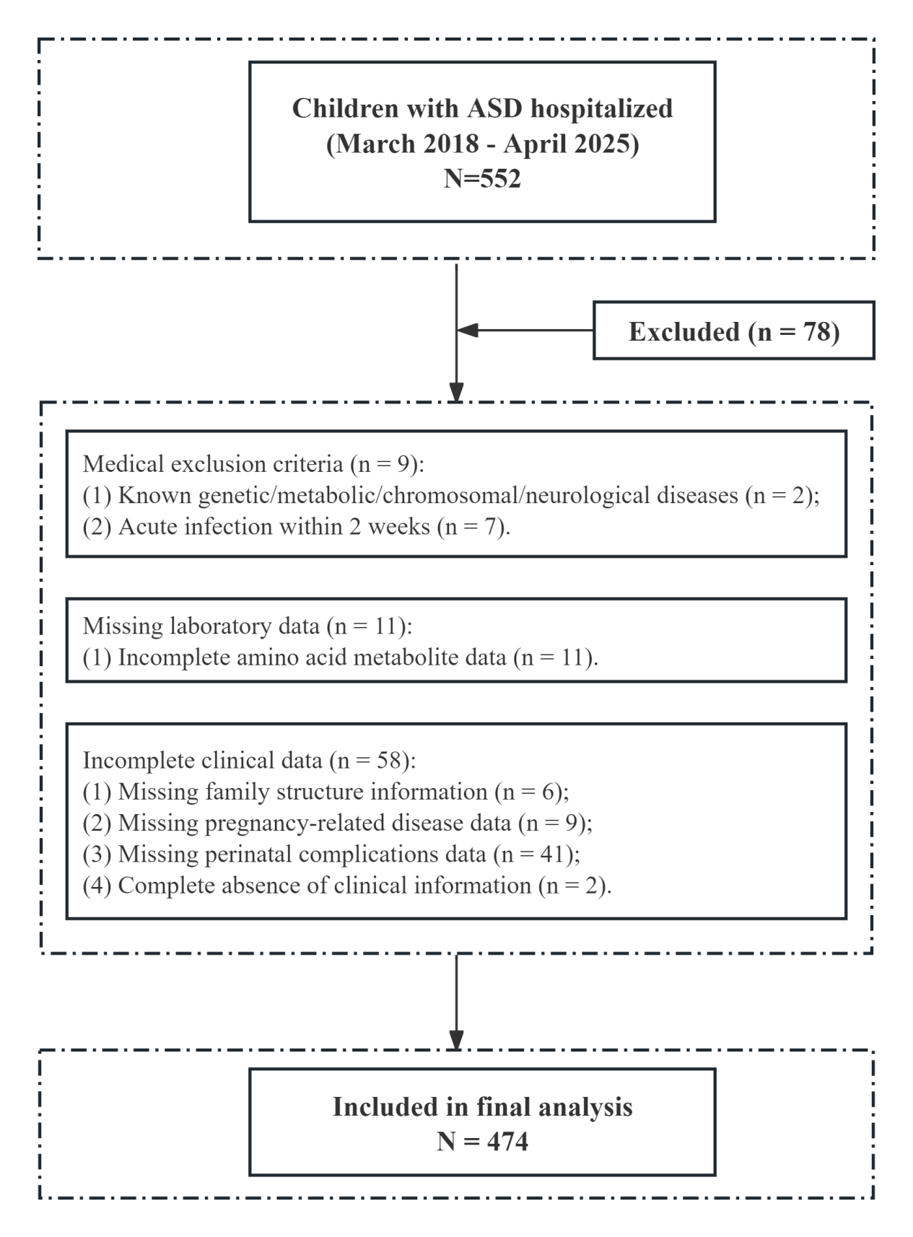
Figure S1. Flowchart for this study.
Figure S2. Performance analysis of amino acid prediction models across different subgroup populations.

