Supplementary Table 1. Baseline clinical characteristics and demographics of pediatric trauma patients with and without early hyponatremia.
Variables | Normonatremia (n = 334) | Early Hyponatremia (n = 135) | p - value
Demographics
Age (years), median [IQR] | 16.0 [14.0, 17.0] | 16.0 [14.0, 17.0] | 0.52
Sex, male, n (%) | 228 (68.3) | 84 (62.2) | 0.24
Height (cm), median [IQR] | 169.0 [159.0, 175.0] | 168.0 [160.0, 174.0] | 0.64
Weight (kg), median [IQR] | 60.0 [52.0, 70.0] | 60.0 [49.0, 67.0] | 0.70
BMI (kg/m²), median [IQR] | 22.0 [18.9, 24.0] | 21.0 [19.0, 24.0] | 0.60
Injury characteristics
Mechanism: Blunt trauma, n (%) | 326 (97.6) | 132 (97.8) | 1.000
GCS, median [IQR] | 15.0 [14.0, 15.0] | 14.0 [10.0, 15.0] | 0.001
GCS < 15 | 134 (40.1) | 75 (55.6) | 0.003
GCS < 9 | 39 (11.7) | 25 (18.5) | 0.05
ISS, median [IQR] | 17.0 [9.0, 22.0] | 19.0 [14.0, 29.0] | < 0.001
ISS severity, n (%) |  |  | < 0.001
Mild to moderate (1-15) | 158 (47.3) | 37 (27.4)
Severe (16-24) | 102 (30.5) | 45 (33.3)
Very severe (≥25) | 74 (22.2) | 53 (39.3)
AIS ≥ 3, n (%)
Head | 111 (33.2) | 42 (31.1) | 0.74
Face | 1 (0.3) | 2 (1.5) | 0.20
Chest | 122 (36.5) | 67 (49.6) | 0.01
Abdomen | 73 (21.9) | 49 (36.3) | 0.002
Extremity | 79 (23.7) | 59 (43.7) | < 0.001
External | 1 (0.3) | 0 (0.0) | 1.000
Resuscitation & Interventions, n (%)
Requiring surgery, n (%) | 235 (70.4) | 115 (85.2) | 0.001
Craniotomy, n (%) | 8 (2.4) | 5 (3.7) | 0.53
Transfusion within 4hours | 57 (17.1) | 45 (33.3) | 0.002
Transfusion within 24hours | 32 (9.6) | 31 (23.0) | 0.001
CRP, median [IQR] | 2.0 [0.6, 6.0] | 5.0 [2.0, 11.0] | < 0.001
Lactate, median [IQR] | 3.0 [1.7, 4.0] | 3.0 [2.0, 4.0] | 0.85
Abbreviations: IQR, Interquartile Range; BMI, body mass index; GCS, Glasgow Coma Scale; ISS, injury severity score; AIS, abbreviated injury scale; CRP, C-Reactive Protein
Supplementary Table 2. Comparison of clinical outcomes between pediatric trauma patients with and without early hyponatremia.
Variables | Normonatremia (n = 303) | Hyponatremia (n = 166) | p - value
Length of stay, median [IQR]
Hospital length of stay | 13 [9, 21] | 18 [14, 36] | < 0.001
ICU length of stay | 2 [1, 5] | 5 [3, 10] | < 0.001
Mechanical ventilation duration, median [IQR] | 0 [0, 1] | 1 [0, 5] | < 0.001
Mortality | 7 (2.1) | 7 (5.2) | 0.13
Abbreviations: IQR, Interquartile Range; ICU, Intensive Care Unit

Supplementary table 3. Multivariable logistic regression analysis of risk factors associated with hyponatremia in pediatric trauma patients.
Variables | Unadjusted |  | Adjusted
Variables | p-value | OR (95% CI) |  | p-value | OR (95% CI)
ISS severity
Severe (16-24) | 0.006 | 2.04 (1.23-3.41) |  | 0.020 | 1.85 (1.11-3.11)
Very severe (≥25) | < 0.001 | 5.02 (2.99-8.57) |  | 0.005 | 2.45 (1.32-4.58)
GCS | < 0.001 | 0.89 (0.84-0.94) |  | 0.118 | 0.95 (0.88-1.01)
Serum Lactate | 0.002 | 1.15 (1.05-1.26) |  | 0.397 | 0.96 (0.86-1.06)
Transfusion within 4 hours | < 0.001 | 4.46 (2.77-7.31) |  | 0.002 | 2.50 (1.40-4.49)
Requiring Surgery | < 0.001 | 3.62 (2.13-6.41) |  | 0.002 | 2.46 (1.42-4.42)
Abbreviation: OR, Odds ratio; CI, Confidence interval; ISS, Injury Severity Score; GCS, Glasgow Coma Scale

Supplementary Figure 1. PRISMA-style flow diagram of patient selection.

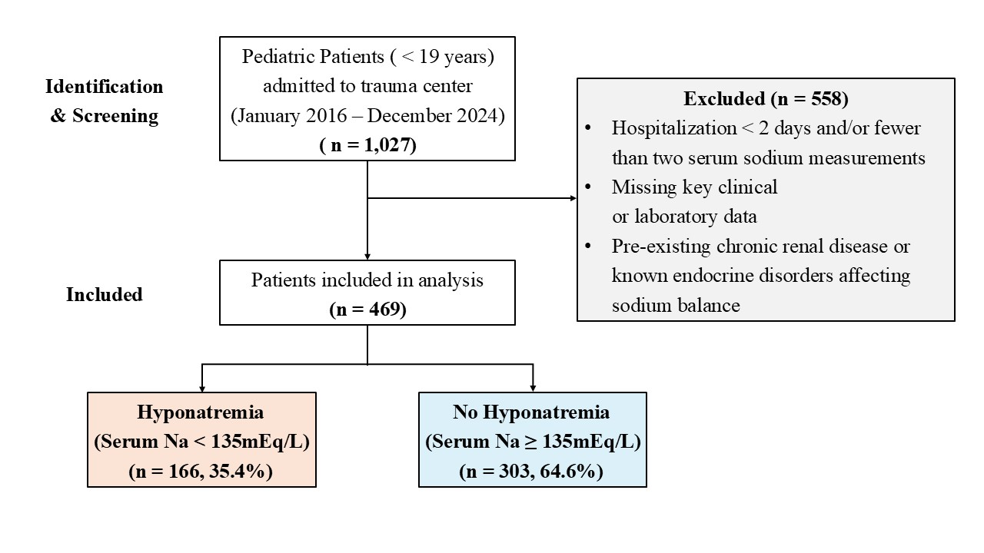

Supplementary Figure 2. Kaplan-Meier survival curves comparing survival outcomes between pediatric trauma patients with and without hyponatremia.
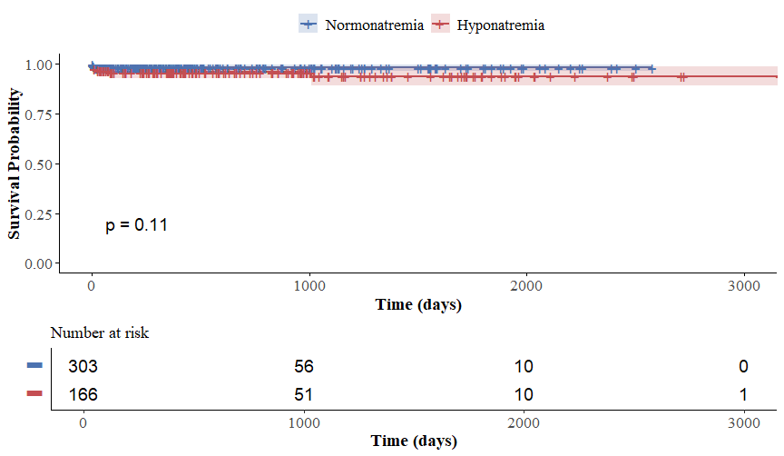

Supplementary Figure 3. Forest plot of Multivariable Cox regression (Firth’s penalized likelihood method) for mortality among pediatric trauma patients.
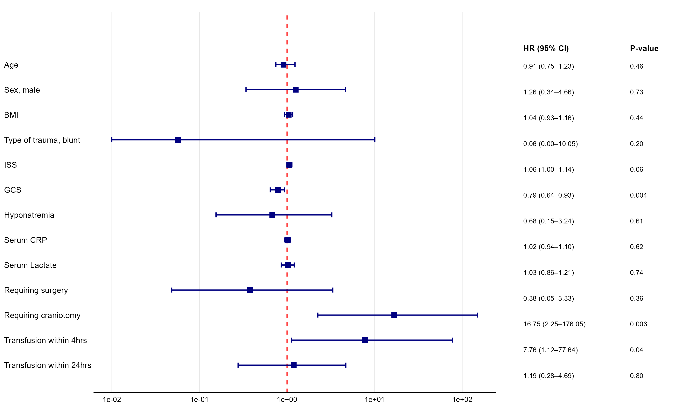
Abbreviation: HR, Hazard ratio; CI, Confidence interval; BMI, Body Mass Index; ISS, Injury Severity Score; GCS, Glasgow Coma Scale; CRP, C-Reactive Protein

Supplementary Figure 4. Receiver operating characteristic (ROC) curve of the multivariable logistic regression model for predicting hyponatremia in pediatric trauma patients.

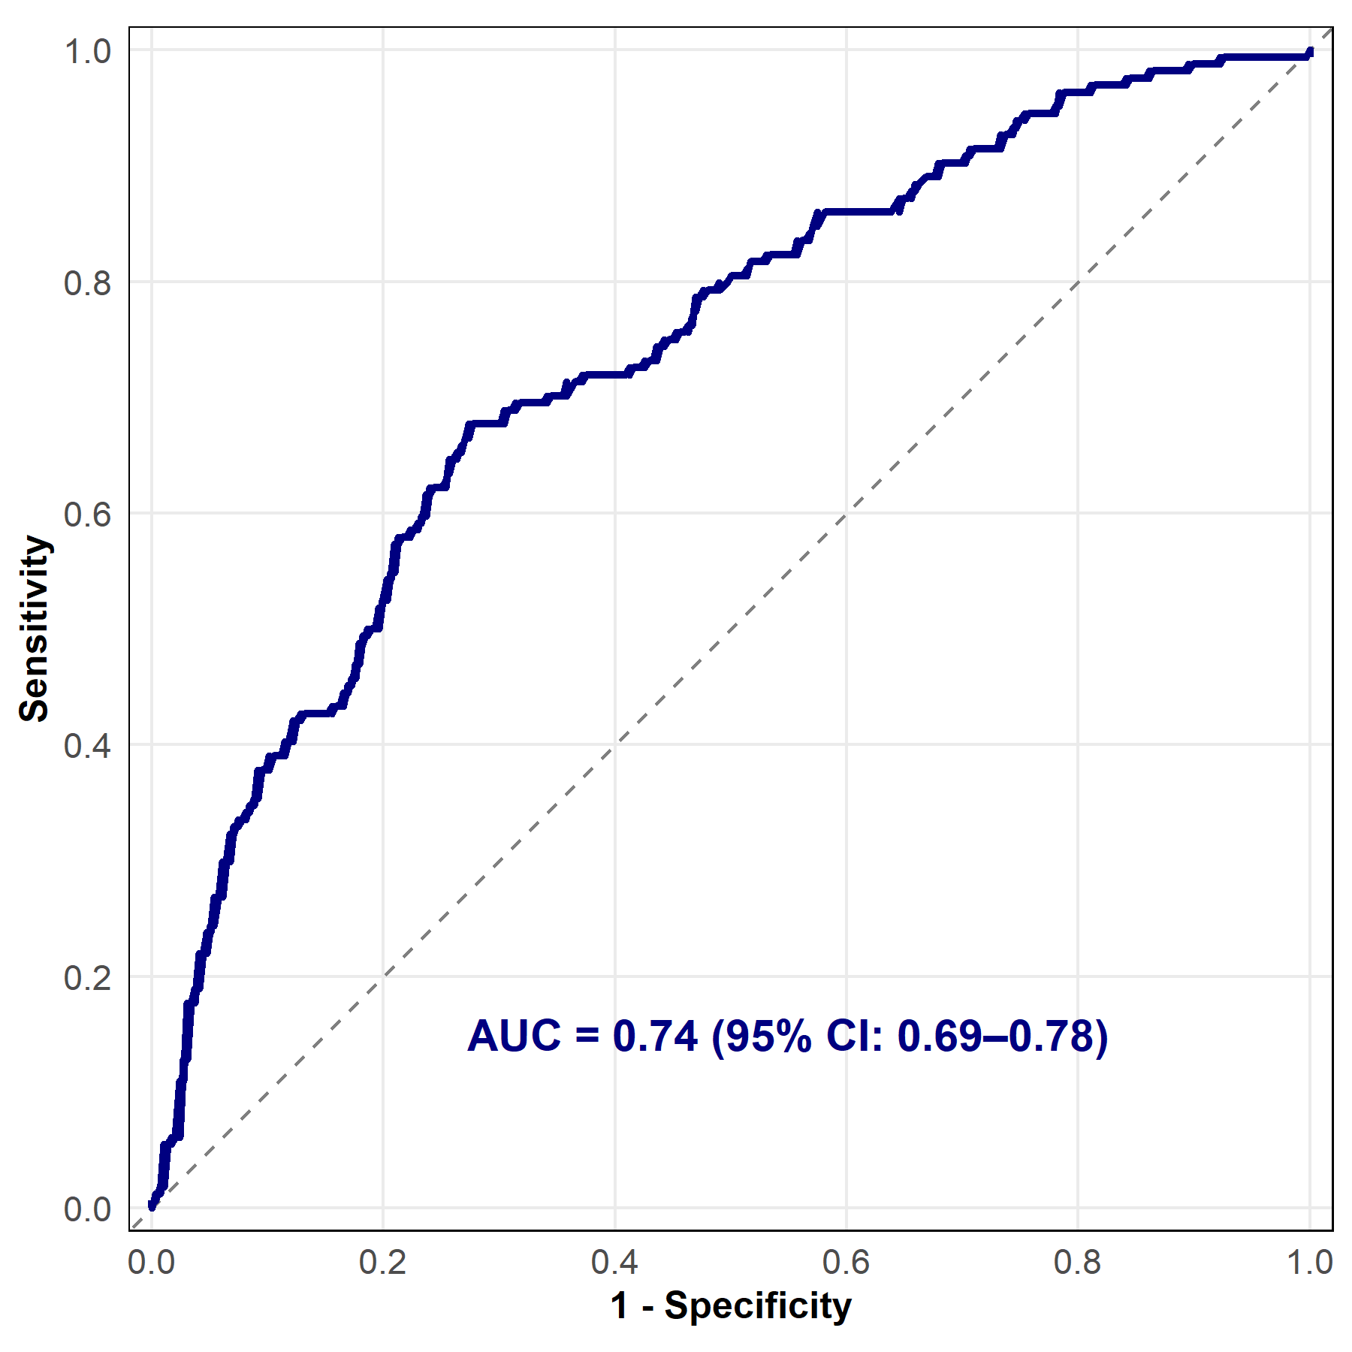
Abbreviation: AUC; Area Under the Curve, CI; Confidence interval

