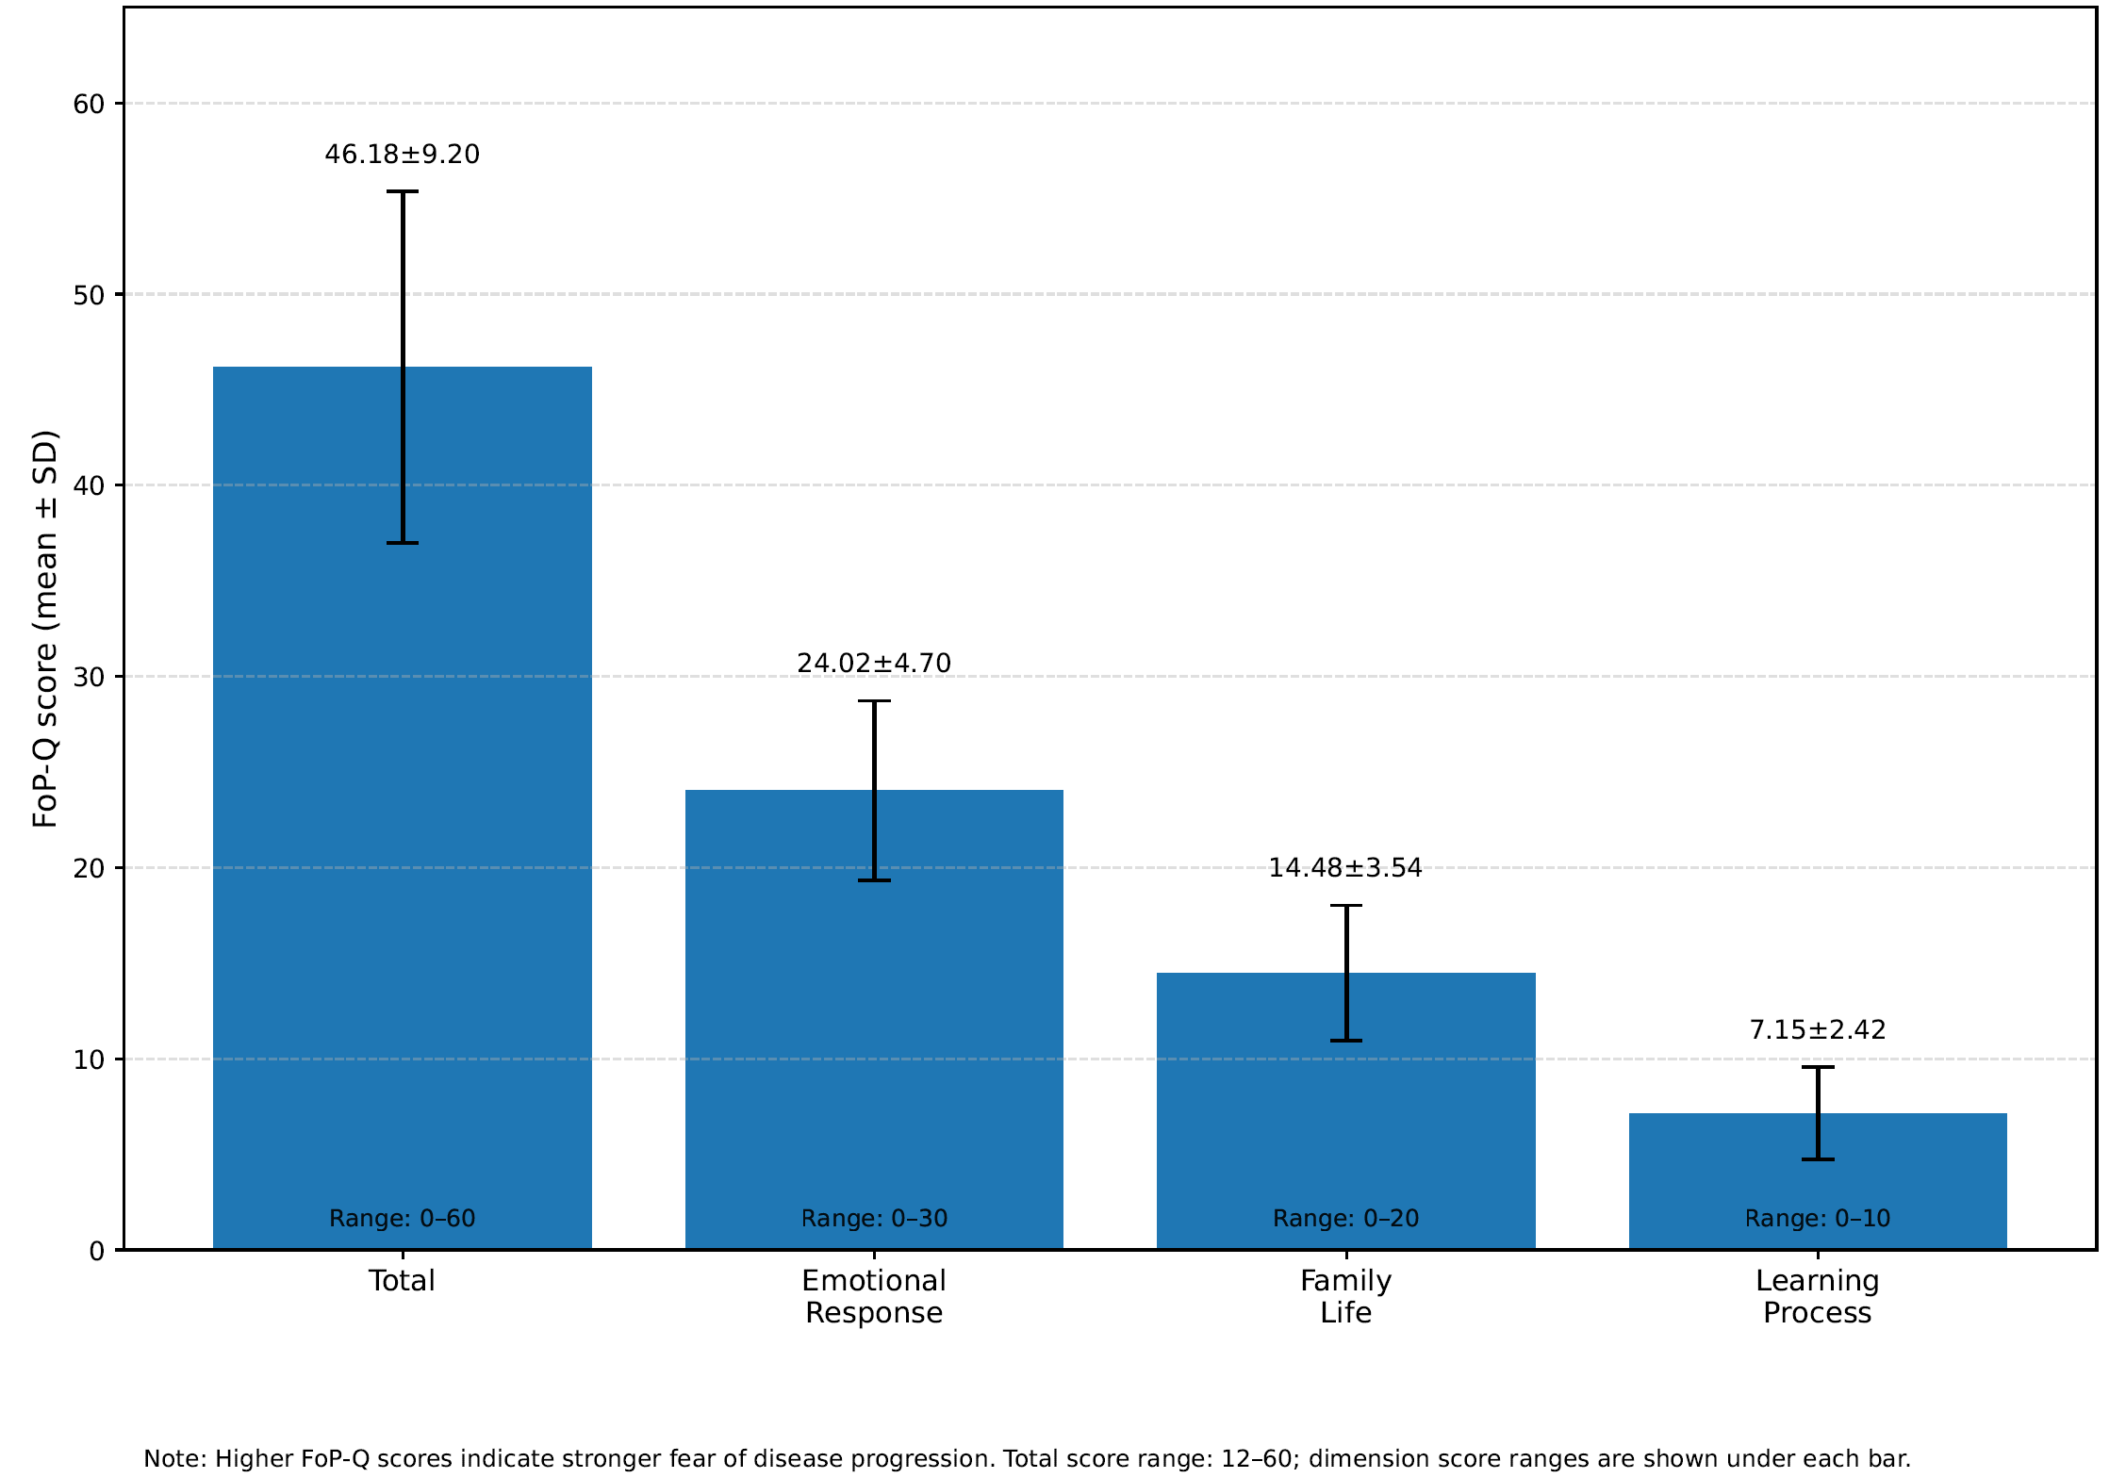
Supplementary Figure S1 Mean FoP-Q total and dimension scores among caregivers (n=214)

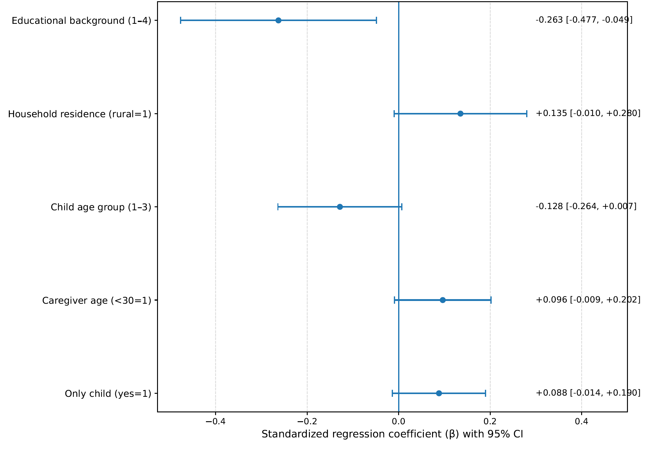
Supplementary Figure S2 Forest plot of predictors of caregivers' FoP-Q total score

