A
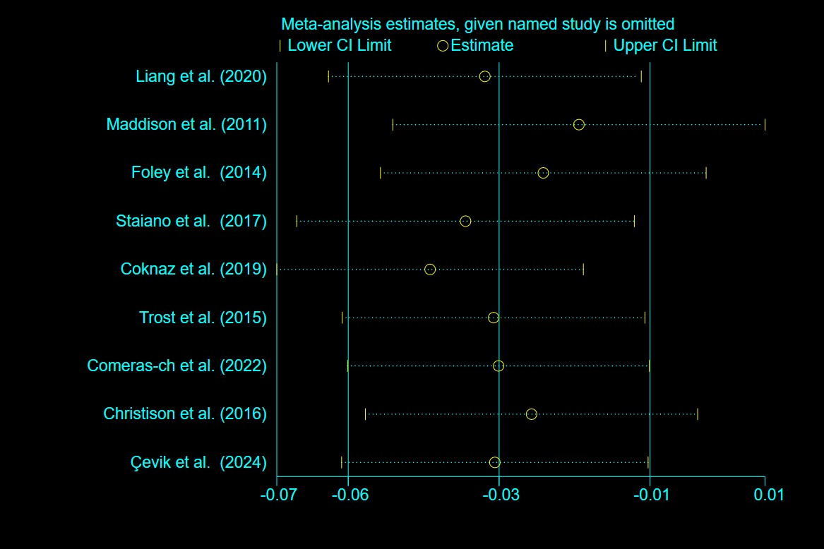
B
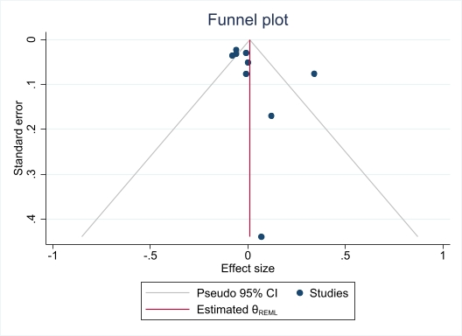
Supplementary Fig.1. Sensitivity analysis (A) and trim and fill test (B) for the effects of AVGs on zBMI
A
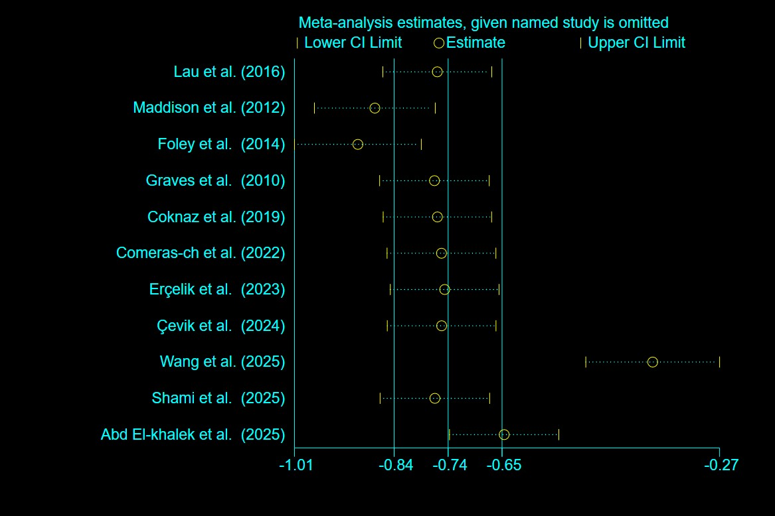
B
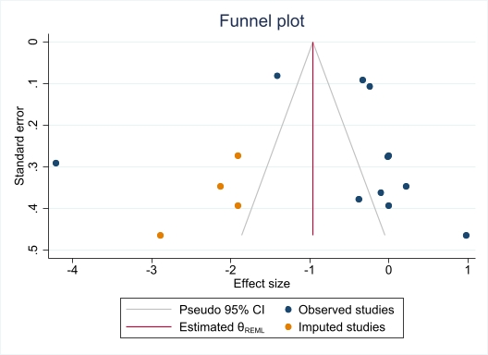
Supplementary Fig.2. Sensitivity analysis (A) and trim and fill test (B) for the effects of AVGs on BMI
A
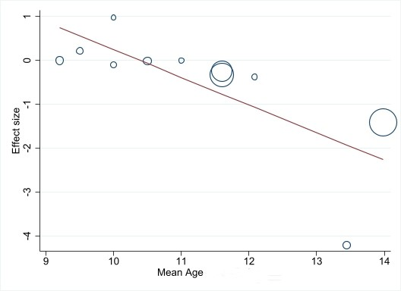
B
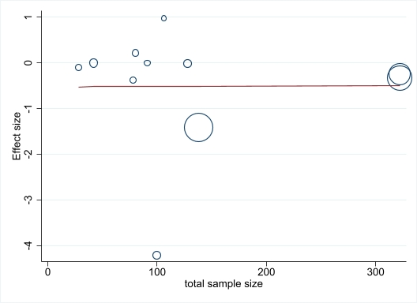
C
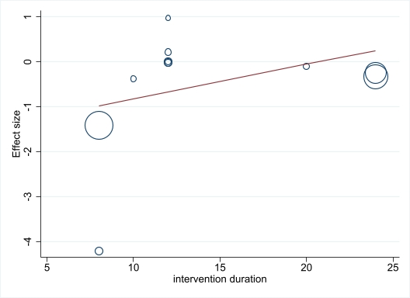
Supplementary Fig.3. Meta-regression of the association of mean age of participants (A), sample size (B), and intervention duration (C) with the effects of AVGs on BMI

A
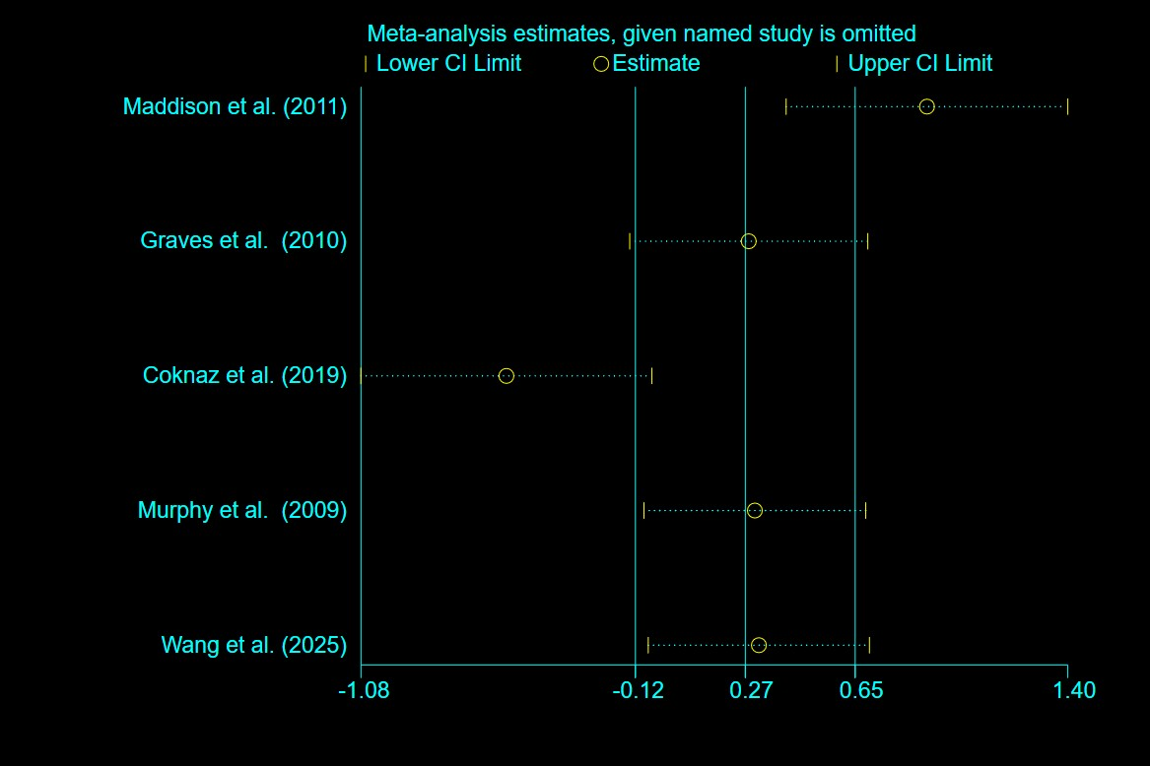
B
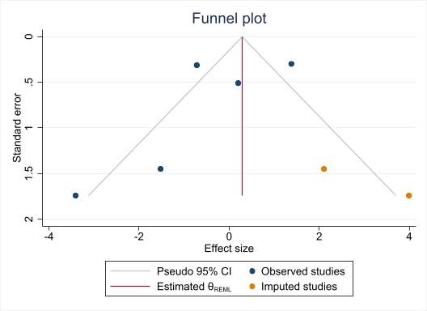
Supplementary Fig.4. Sensitivity analysis (A) and trim and fill test (B) for the effects of AVGs on weight
A
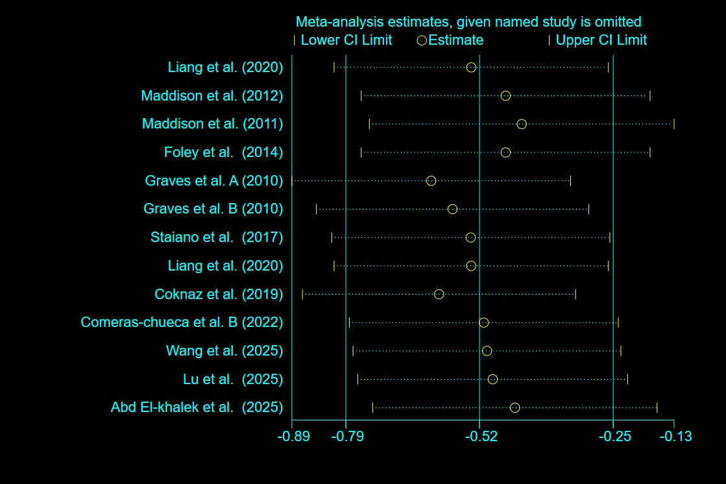
B
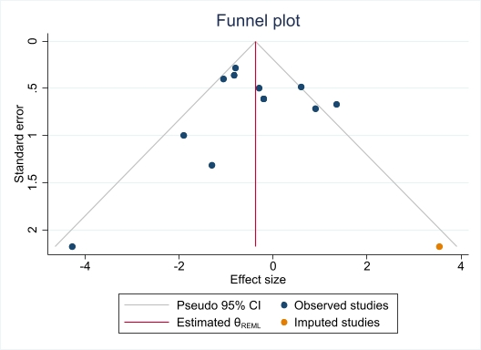
Supplementary Fig.5. Sensitivity analysis (A) and trim and fill test (B) for the effects of AVGs on body fat percentage
A
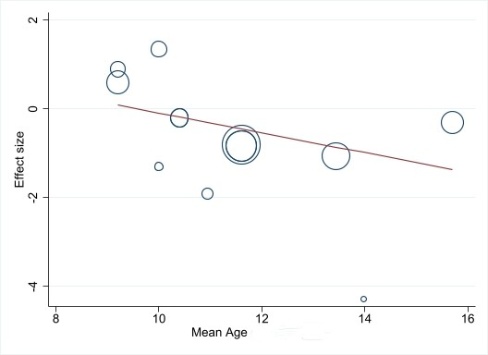
B
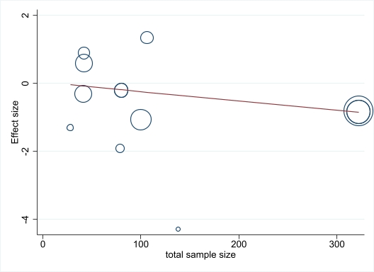
C
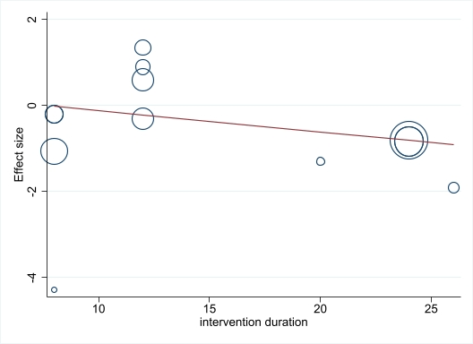
Supplementary Fig.6. Meta-regression of the association of sample size (A), mean age of participants (B), and intervention duration (C) with the effects of AVGs on body fat percentage

