Appendix (Online Supplementary Materials) for:
Psychometric properties of the Mandarin Chinese self-reported Pediatric Quality of Life Inventory™ Version 4.0 Generic Core Scales in school adolescents: based on the Rasch and bifactor measurement methods
Published in BMC Pediatrics

Authors
Di Wu¹, Yuhang Zhu², Zhenliang Qiu³, Jinling Wang⁴, Yueru Zhang⁵ and Juan Li⁶
¹The Second Teaching and Research Section of English Major, School of Foreign Languages, Shandong Second Medical University, No. 7166 Baotong West Street, Weicheng, Weifang, Shandong 261053, China
²Teaching and Research Section of Health Statistics, School of Public Health, Shandong Second Medical University, No. 7166 Baotong West Street, Weicheng, Weifang, Shandong 261053, China
³No. 1 High School of Anhui Sixian County, No. 172 Sishui Boulevard, Hongcheng Sub-district, Sixian, Suzhou, Anhui 234300, China
⁴Weifang Dongming School, No. 2933 Beigong East Street, Kuiwen, Weifang, Shandong 261061, China
⁵Office of Science and Technology Affairs, School of Health Management, Shandong Medical and Pharmaceutical University, No. 318 Gangcheng East Street, Laishan, Yantai, Shandong 264003, China
⁶Teaching and Research Section of Social Medicine and Health Management, School of Health Management, Shandong Medical and Pharmaceutical University, No. 318 Gangcheng East Street, Laishan, Yantai, Shandong 264003, China
Correspondence
Juan Li ()
E-mail: lijuan892@163.com

Contents
Appendix 1: How does this study meet the assumptions and requirements of the Rasch model? A1
Appendix 2: Parameter setting of the Rasch model A4
Appendix 3: Six features of the Rasch measurement method A6
Appendix 4: Ancillary bifactor measures about dimensionality A11
Appendix 5: Ancillary bifactor measures about model-based reliability A14
Appendix 6: Missing values and data distribution characteristics A16
Appendix 7: Detailed analysis process of data distribution A17
Appendix 8: Detailed results of the confirmatory factor analysis of the Mandarin Chinese self-reported Pediatric Quality of Life Inventory™ Version 4.0 Generic Core Scales (PedsQL™ 4.0) A18
Appendix 9: Item covariance matrix of the Mandarin Chinese self-reported Pediatric Quality of Life Inventory™ Version 4.0 Generic Core Scales (PedsQL™ 4.0) A29
Appendix 10: Category summary statistics of 25 items in the Mandarin Chinese self-reported Pediatric Quality of Life Inventory™ Version 4.0 Generic Core Scales (PedsQL™ 4.0) A35
Appendix 11: Measures and goodness-of-ﬁt statistics for each item of the Mandarin Chinese self-reported Pediatric Quality of Life Inventory™ Version 4.0 Generic Core Scales (PedsQL™ 4.0) A57
Appendix 12: Largest standardized residual correlations for items of the Mandarin Chinese self-reported Pediatric Quality of Life Inventory™ Version 4.0 Generic Core Scales (PedsQL™ 4.0) A60
Appendix 13: Person-item map (Wright map) of the Mandarin Chinese self-reported Pediatric Quality of Life Inventory™ Version 4.0 Generic Core Scales (PedsQL™ 4.0) A66
Appendix 14: Uniform differential item functioning analysis for the Mandarin Chinese self-reported Pediatric Quality of Life Inventory™ Version 4.0 Generic Core Scales (PedsQL™ 4.0) across gender and grade groups A72
Appendix 15: Detailed results of the bifactor model analysis of the Mandarin Chinese self-reported Pediatric Quality of Life Inventory™ Version 4.0 Generic Core Scales (PedsQL™ 4.0) A78
Appendix 16: References for Appendix A84

Appendix 1: How does this study meet the assumptions and requirements of the Rasch model?

The Rasch model has distinctive and attractive features, e.g., linear, additive, and invariant values on an interval-level measurement scale. However, these features only apply when the data fit the Rasch model’s requirements [1]. Consequently, the Rasch model necessitates specific research assumptions and prerequisites, including unidimensionality, local independence of each person’s (respondent’s) score, non-speed survey, equal item discrimination, and low susceptibility to guessing, which will be described as follows.
First, the unidimensionality of the four dimensions and two summary scores of the Mandarin Chinese self-reported Pediatric Quality of Life Inventory™ Version 4.0 Generic Core Scales (PedsQL™ 4.0 GCS) needs to be verified. Although Hao et al. [2] demonstrated that this version has a four-dimensional structure and that the Health-related Quality of Life (HRQoL) summary score is unidimensional, the unidimensionality of its individual subscales has not yet been examined. Therefore, before conducting Rasch analysis, this study conducted CFA (Verification of the unidimensionality assumption in the main text) to verify the unidimensionality assumption. Furthermore, the unidimensionality was re-verified in the subsequent Rasch measurement method.
Second, the local independence of each respondent’s score should be confirmed [1]. Local independence is the underlying assumption of latent variable models [3]. This study evaluated and examined it from two perspectives (measurement scenarios and statistical tests):
- From the measurement scenarios perspective, it is essential to ensure that each respondent’s response to each item (survey) is an independent decision, without any cheating or cooperation (pair, group, etc.) [4]. This study conducted a traditional anonymized paper-and-pencil self-administered survey in the school setting, providing a prerequisite for meeting the above requirements. Several effective measures were implemented during the field survey stage to maintain independence. Both the questionnaire and the survey administration manual emphasized the non-test nature of the survey (no right or wrong answers) as well as the completely voluntary participation and unconditional withdrawal at any time. While answering the questionnaire, interviewers always stood on the podium to answer questions and supervise. After completing the answer, the questionnaire was collected on the spot. Finally, during the preliminary screening, cleaning, and data entry process, great attention was paid to identifying questionnaires with the same handwriting or response style, especially adjacent ones. All these efforts minimize plagiarism and cooperation, thereby upholding participant answers’ independence.
- From the statistical tests perspective, local independence and unidimensionality are interlinked. The establishment of the unidimensionality assumption indirectly confirms the presence of local independence [5]. Therefore, by checking unidimensionality, information about local independence can be obtained. Furthermore, the most widely accepted method of evaluating local independence is the largest standardized residual correlations, also known as Yen’s Q₃ coefficient [6]. If the value of this coefficient between two items does not exceed 0.70, it indicates that the local independence assumption is not violated [7]. Detailed results are given in Table A31–A36 (Appendix 12).
Third, the survey should be non-speed-based, meaning respondents should not be subjected to time constraints during the survey [8]. In this study’s field survey stage, non-speed-based administration was employed. Both the questionnaire and the survey administration manual explicitly emphasized that “there is no time limit for filling in the questionnaire, so please don’t rush; take your time filling it in.”
Fourth, the two remaining requirements (equal item discrimination and low susceptibility to guessing) are specific to the Rasch model. The idealized nature of the Rasch model means that all items possess equal discrimination power in distinguishing persons (respondents) with more or less agreeability. The prevailing opinion for equal item discrimination is to assume that items exhibit model-specified item discrimination [7]. Furthermore, due to its low susceptibility to guessing requirements, the Rasch model cannot identify guesses only based on the respondent’s score. Therefore, the guessed answer is temporarily ignored. However, guessing is an essential off-trait behavior that produces measurement disturbances [1]. Thus, during this study’s field survey stage, the greatest efforts have been made to reduce this phenomenon.

Appendix 2: Parameter setting of the Rasch model

The polytomous counterparts of the Rasch model family include the rating scale model (RSM) and partial credit model (PCM) [9, 10]. This study used PCM and the joint maximum likelihood estimation (JMLE) method [10]. The self-reported PedsQL™ 4.0 GCS’s responses were categorized consistently on a 5-point rating scale. However, since using IRT (Rasch) in studies on the psychometric properties of the Mandarin Chinese self-reported PedsQL™ 4.0 GCS is rare, there is limited evidence regarding whether Chinese Mainland adolescent respondents interpret the rating scale in the same way. Based on the above, the more general PCM was chosen as the primary model over the specific RSM (a special case of PCM), with RSM additionally applied in subsequent analyses to further examine the results. Additionally, the PCM was deemed more appropriate to align with previous international studies on PedsQL™ 4.0, which predominantly use PCM [11–13].
According to the Rasch model, only two attributes can determine a person’s responses to an item—the person’s “ability” (or “agreeability”) and the item’s “difficulty” (or “endorsability”); they jointly constitute the latent trait’s estimation [1, 9, 10]. As a probabilistic model, Rasch can place a matrix of persons’ ability (agreeability) and items’ difficulty (endorsability) on the same linear scale [1, 9, 10].
The interpretation of the Rasch model varies subtly depending on the measurement scenario. In educational contexts assessing knowledge, the person represents the test-taker, while the item represents the test question. Test-takers have a higher probability of correctly answering “easier” test questions compared to “difficult” ones. Furthermore, test-takers with higher “abilities” exhibit a higher probability of answering test questions correctly, particularly when the questions are more challenging, compared to test-takers with lower “abilities” [1].
In the measurement of psychosocial constructs, as applied in this study, the person represents the respondent, and the item represents an item in the measurement instrument (scale or questionnaire). Regarding the person, it’s no longer a matter of “ability” but rather “agreeability,” which reflects their alignment with the latent trait being measured (e.g., the HRQoL in this study) and their tendency to support specific response options. Regarding items, it’s no longer a matter of “difficulty” but rather “endorsability,” which reflects their likelihood of being endorsed by respondents with varying levels of the latent trait (e.g., the HRQoL in this study).
In connection with this study, the basic mathematical formula used for constructing measures through responses to the PCM is [9, 10]:
$$\ln\left[\frac{P_{n_{i}(x_{i}=k)}}{P_{n_{i}(x_{i}=k-1)}}\right]=θ_{n}-δ_{ik}$$
Where:
$P_{n_{i}(x_{i}=k)}$ is the probability that person (respondent) $n$, on encountering item $i$, would be observed (or would respond) in category$k$;
$P_{n_{i}(x_{i}=k-1)}$is the probability that the observation (or response) would be in category $k-1$;
$θ_{n}$ is the “agreeability” measure of person (respondent) $n$;
$δ_{ik}$ is the “endorsability” measure of item$ⅈ$ with the impediment to being observed in category $k$ relative to $k-1$.
Rasch measures, represented as “logits” (log-odd units), capture the local distance differences between persons (respondents) and items. Typically, a score of 0 is conventionally assigned to the average endorsability of items or average agreeabilities of persons [1, 9, 10]. In essence, each ordinal raw score obtained from the rating scales is converted into an interval-level measure [1], that is, as a qualitative level of the latent trait’s expression (e.g., the HRQoL in this study), represented by a quantity or count.

Appendix 3: Six features of the Rasch measurement method

The Rasch measurement method involved six features: (1) rating scale analysis, (2) item response validity, (3) test unidimensionality and local independence, (4) Rasch-generated reliability, (5) hierarchical ordering and test targeting (person-item map), and (6) differential item functioning. These features ensured a comprehensive evaluation of the Mandarin Chinese self-reported PedsQL™ 4.0 GCS’s effectiveness in various contexts.
(1) Rating scale analysis
First and foremost, the self-reported PedsQL™ 4.0 GCS is the scale oriented with latent variable, which is “essential” for the four aspects of “measure and sample” (See Stage 1 of Table A1 for details) [14, 15]. In addition, this study analyzed the 5-point rating scales’ appropriateness of the Mandarin Chinese self-reported PedsQL™ 4.0 GCS’s items based on the other three-stage guidelines for rating scales [14–16]. Specifically, category frequency, average measures, and the outlier-sensitive fit mean-square (Outfit MnSq) values were examined to finalize a final rating scale structure that met the guidelines outlined in Stages 2–4 of Table A1.
Table A1 Guidelines for rating scales
Stage | Guideline |  | Importance
 |  |  | Measure |  |  | Sample
 |  |  | Measure stability | Measure accuracy (fit) |  | Description of  this sample | Inference for  next sample
1 | Scale oriented with latent variable |  | Essential | Essential |  | Essential | Essential
2 | At least 10 observations of each category |  | Essential | Helpful |  | — | Helpful
3 | Average measures advance monotonically with category |  | Helpful | Essential |  | Essential | Essential
4 | Outfit MnSq values of each category less than 2.0 |  | Helpful | Essential |  | Helpful | Helpful
Note. Outfit MnSq = outlier-sensitive fit mean-square.

(2) Item response validity
Once the rating scale performance was confirmed or optimized, goodness-of-fit statistics were used to examine how well the Mandarin Chinese self-reported PedsQL™ 4.0 GCS’s items fit the Rasch model’s expectations for hierarchical thresholds [1]. Fit statistics are routinely reported in two types of the mean-square (MnSq)—the inlier-sensitive fit (Infit) MnSq and outlier-sensitive fit (Outfit) MnSq, as well as their z-standardized values (Infit Zstd and Outfit Zstd) [17].
Generally, Inﬁt/Outﬁt MnSq values between 0.5 and 1.5, and/or associated with their Zstd values between −2 and 2, are regarded as acceptable when evaluating whether items of one instrument measure the same underlying unidimensional latent trait [1, 18, 19]. When 95% of the instrument’s items show an acceptable fit, the unidimensionality can also be guaranteed [20].
Items displaying MnSq > 1.5 and/or Zstd > 2 indicate responses are erratic (i.e., misﬁtting) or potential scoring inaccuracies, or belong to a different latent trait [18, 21]. Conversely, MnSq < 0.5 and/or Zstd < −2 indicates less variation (i.e., overfitting) [22]. In empirical research, overfitting may be acceptable for measuring certain abilities or psychosocial constructs [1]. Retaining overfitting items is justifiable as they do not affect unidimensionality and pose minimal risk to unpredictability and a distorted measurement system [17]. Thus, this study focused solely on identifying misfitting items of the Mandarin Chinese self-reported PedsQL™ 4.0 GCS, rather than addressing overﬁtting items.
(3) Test unidimensionality and local independence
The Rasch measurement method uniquely evaluates an instrument’s internal construct validity, particularly focusing on unidimensionality (i.e., the extent to which items in an instrument measure a single construct) [1, 22]. This study conducted the Rasch-based principal component analysis of residuals (PCAR) to examine the Mandarin Chinese self-reported PedsQL™ 4.0 GCS’s unidimensionality [23]. The PCAR expected that the Rasch-identified construct should account for over 50% of the total variance, and after removing principal components, the residuals for item/person interactions may be randomly distributed and show no structure [7, 24]. Additionally, the eigenvalue of the unexplained variance in the first contrast (the largest secondary dimension after the Rasch-derived construct is removed) is an important indicator of unidimensionality [7, 23]. Specifically, if the eigenvalue is < 2.0, these items are considered unidimensional; conversely, if the eigenvalue is > 2.0, additional dimension may be present [7, 23].
The most widely accepted method of evaluating local independence is Yen’s Q₃ coefficient [25]. This study used Yen’s Q₃ coefficient to assess the Mandarin Chinese self-reported PedsQL™ 4.0 GCS’s local independence. If the coefficient values between item pairs are ≤ 0.70, the local independence assumption is considered not to be violated [7].
(4) Rasch-generated reliability
The Rasch model provides two unbiased reliability indicators: the reliability coefficient and separation index [1, 18]. They are indicators of measurement precision, aiming to reflect the ability to separate people. Each reliability indicator involves person and item features, resulting in four indicators: person reliability coefficient (PR), item reliability coefficient (IR), person separation index (PS), and item separation index (IS) [1, 18].
PR is interpreted as the replicability of the person ordering, and IR provides information regarding the reliability of items; both range from 0 to 1.0 [1, 18]. Similar to Cronbach’s alpha (α), PR and IR values > 0.70 are considered acceptable, > 0.80 as good, and > 0.90 as excellent [1, 18]. Additionally, PR evaluates whether the instrument discriminates the sample into enough levels for the established purpose. PR values of 0.5 indicate that the persons can be distinguished into 1 or 2 levels, 0.8 indicates 2 or 3 levels, and 0.9 indicates 3 or 4 levels [7, 17, 21]. Low PR values (< 0.8) indicate a limited number of items or a narrow range of person measures (i.e., lacking sufficient persons with more extreme status) [1, 7, 18]. A low IR value implies that the sample size is insufficient for precisely locating the items on the latent trait [1, 7, 18].
PS and IS are valuable for assessing instrument function. Both indices have no ceiling effect, with a minimum of 0 and no maximum [1, 7, 18]. PS classifies the person, with values of 1.5 indicating an acceptable level, 2.0 indicating a good level, and 3.0 indicating an excellent level [1, 18, 22]. It is worth noting that low PS values (< 0.80) with a relevant person sample imply that the instrument may not be sensitive enough (perhaps due to a limited number of items or a narrow range of person measures) to distinguish between persons with high and low levels of the latent trait [18]. IS verifies the item hierarchy, and a low value (< 3.0) implies that the person sample is insufficient to conﬁrm the item endorsability hierarchy of the instrument [18].
(5) Hierarchical ordering and test targeting (person-item map)
In the Rasch model, the instrument’s unidimensional acceptable fit is eventually expressed as logit scores analysis and calibrated along a hierarchical order from mild to severe state (trait) [1, 18]. In this same linear interval-level measurement continuum (also referred to as a “person-item map” or “Wright map”) [1], the visual inspection evidence can be clearly obtained. In this study, this evidence can check whether the Mandarin Chinese self-reported PedsQL™ 4.0 GCS’s items adequately targeted (or encompassed) adolescent respondents’ HRQoL levels. Intuitively, a greater positive score indicates that adolescent respondents have higher HRQoL levels (better HRQoL). Ideally, the difference between person and item measures should be approximately 0.0 logits, indicating that the items are well-targeted to the adolescent respondents’ HRQoL levels. However, differences within a certain range are often tolerated in empirical studies. Specifically, a difference score < 1.0 logits indicates slight mistargeting, whereas a difference score ≥ 1.0 logits indicates significant mistargeting [1, 18].
(6) Differential item functioning
The Rasch-based differential item functioning (DIF) is utilized to assess whether different groups (stratified by age, gender, cultural or educational level, etc.) have systematically different responses despite having equal levels of the latent trait being measured [1, 18]. DIF can show that certain survey items do not reflect the same levels of the latent trait in different respondent groups, which poses challenges when combining or comparing data between groups, as it may compromise the validity and fairness of the measurement [1, 18].
In Rasch-based DIF studies, the null hypothesis assumes that for each item, there is no interaction between grouping variables and item function, and all subgroups’ local endorsability estimates are the same within error [7]. This hypothesis is rejected if the t-test (e.g., Rasch-Welch’s t-test) shows that the mean response levels of different subgroups are statistically different on some items [7, 26].
DIF can manifest in two forms: uniform DIF (UDIF) and non-uniform DIF (NUDIF) [27]. UDIF occurs when an item exhibits consistent DIF, regardless of the trait level. When NUDIF is present, the magnitude of the effect varies depending on the latent trait level [1, 18].
This study employed UDIF analysis to examine whether the endorsability calibrations of the Mandarin Chinese self-reported PedsQL™ 4.0 GCS’s items were stable or invariable across gender and grade groups. UDIF was identified by applying two recommended steps: First, paired t-tests were conducted using Rasch-Welch’s t-statistics to detect statistically significant differences [7]. Due to multiple comparisons of each item, the Bonferroni correction technique was applied [28]. Second, UDIF contrasts were employed, focusing on items with differences in endorsability measures of ≥ 0.50 logits (i.e., substantive UDIF) [7, 29].

Appendix 4: Ancillary bifactor measures about dimensionality

Regarding the auxiliary bifactor measures about dimensionality, indicators are divided into model level and item level. At the model level, these indicators include the explained common variance (ECV), the percent of uncontaminated correlations (PUC), and the average relative parameter bias (${ARPB}_{avg}$). At the item level, they include the item explained common variance (IECV) and the absolute relative parameter bias (${ARPB}_{abs}$).
(1) Model-level indicators
The ECV reflects the proportion of variance attributable to the general factor relative to the total common variance explained by both the general and specific factors. A high ECV value indicates that an instrument predominantly measures a single common construct, whereas lower values suggest the presence of multiple substantive dimensions [30–33]. For the general factor, this indicator equals ECV. For specific factors, ${ECV}_{S}$ reflects the strength of a specific factor relative to the total explained common variance of all items, including those not loading on the specific factor of interest [34]. According to Bonifay et al. [35], when ECV > 0.70, relative bias is typically < 10%, and when ECV > 0.80, relative bias is generally < 5%.
The PUC represents the proportion of covariance terms reflecting variance solely from the general factor. A higher PUC value indicates that the correlation matrix is more strongly dominated by general-factor information, thereby reducing the likelihood of biased parameter estimates under a unidimensional model [32]. Generally, a PUC > 0.80 suggests that a unidimensional model might be reasonable [36, 37].
In fact, along with ECV, PUC influences the degree of parameter bias in the unidimensional solution. Rodriguez, Reise, and Haviland state that “when general ECV is > 0.70 and PUC is > 0.70, relative bias will be slight, and the common variance can be regarded as essentially unidimensional” [32]. Additionally, Reise, Scheines, Widaman, and Haviland noted that “when PUC < 0.80, general ECV > 0.60 and ${\text{ω}}_{H}$ > 0.70 suggest that the presence of some multidimensionality is not severe enough to disqualify the interpretation of the instrument as primarily unidimensional” [36, 37]. Failure to meet these cutoffs suggests that the instrument is best conceptualized as multidimensional. Put simply, as PUC increases, a low ECV is less likely to indicate problems with claiming that an instrument measures a single dominant construct. When PUC is lower, a low ECV is more likely to correctly indicate that the instrument should not be interpreted as measuring a single dominant construct.
The ${ARPB}_{avg}$ quantifies the average bias across all items in a model. It provides a summary statistic indicating the overall degree of bias in parameter estimates when comparing a multidimensional (e.g., bifactor) model with a unidimensional model [31, 32]. This indicator is useful for assessing the general level of bias across a set of items, giving an overall sense of how much the multidimensional structure affects parameter estimates. An ${ARPB}_{avg}$ value close to 0 indicates that, on average, the parameters are unbiased. Typically, an ${ARPB}_{avg}$ < 0.10 is considered to indicate minimal bias, suggesting that the multidimensional structure does not meaningfully distort parameter estimates. According to Muthén et al., ${ARPB}_{avg}$ ≤ 0.15 is acceptable and poses no serious concern [38]. When ${ARPB}_{avg}$ > 0.15, the degree of multidimensionality may affect parameter estimates to an extent that is not acceptable, particularly when high precision is required.
(2) Item-level indicators
Unlike the ECV, the IECV provides information about the “extent to which an item’s responses are accounted for by variation on the latent general dimension alone, and thus acts as an assessment of unidimensionality at the individual item level” [39]. Put simply, IECV indicates whether an item primarily measures a single dominant construct or multiple subdimensions. According to Stucky and Edelen, selecting items with large loadings on the general factor and IECV “> 0.80 or 0.85 will typically yield a fairly unidimensional item set that reflects the content of the general dimension” [34].
${ARPB}_{abs}$, on the other hand, measures the absolute bias for each individual item’s parameter. It assesses the degree to which a specific item’s parameter estimate is biased due to the multidimensionality of the data [31, 32]. This indicator is particularly valuable when evaluating the reliability of individual items within a scale, allowing researchers to identify items that may not perform well in a multidimensional context. An ${ARPB}_{abs}$ value close to 0 suggests that the item’s parameter is stable and unbiased. Typically, an ${ARPB}_{abs}$ value < 0.10 indicates that the item’s parameter is relatively unaffected by multidimensionality, reflecting minimal impact; a value of 0.10–0.15 is considered acceptable and poses no serious concern [38]. When an ${ARPB}_{abs}$ value > 0.15, it suggests that multidimensionality of the data is affecting the parameter estimates to a degree that may not be acceptable, especially in contexts where high precision is required.

Appendix 5: Ancillary bifactor measures about model-based reliability

Several statistical indices have been proposed to examine the (potential) multidimensionality of the data and to determine the adequacy of a total score and the relative (additional) gain by scoring subscores when a bifactor structure with uncorrelated group factors is modeled [40]. These model-based reliability estimates can provide information about the reliability of multidimensional instruments (that conform to a bifactor structure) [41]. We calculated the coefficient omega ($\text{ω}$), the omega subscale coefficient (${\text{ω}}_{S}$), the omega hierarchical coefficient (${\text{ω}}_{H}$), the omega hierarchical subscale coefficient (${\text{ω}}_{H_{S}}$), the percentage of reliable variance (PRV), the factor determinacy (FD), and the construct reliability/replicability (H index) [31, 32, 42].
The $\text{ω}$ measures the proportion of raw total score variance that can be attributed to all common factors (i.e., true score variance, which excludes error variance). It is “a factor analytic model-based estimate of the reliability (true score variance over observed score variance) of unit-weighted test scores” [31, 32]. It can also be adapted to measure the proportion of raw subscale score variance that can be attributed to all common factors (i.e., ${\text{ω}}_{S}$). Put simply, it measures internal consistency (reliability) of multidimensional instruments in a manner that is more trustworthy, with a value > 0.70 indicating a reliable score [43].
The ${\text{ω}}_{H}$ measures the proportion of raw total score variance that can be attributed to the general factor when simultaneously accounting for the specific factors. It quantifies the degree to which the raw total score is a univocal indicator of the general factor [31, 32]. Put simply, it measures how reliably both summary scores reflect general conformity to Psychosocial Health (PSH) and HRQoL, respectively. When ${\text{ω}}_{H}$ is high (> 0.80), it suggests that the total scores can be considered essentially unidimensional [36].
The ${\text{ω}}_{H_{S}}$ measures the proportion of explained subscale score variance uniquely accounted for by the corresponding specific factor, after partialling out the variance accounted for by the general factor. A low ${\text{ω}}_{H_{S}}$ precludes a meaningful interpretation of the raw subscale score as a clear indicator of a specific factor [31, 32]. Put simply, it measures how reliably both specific summary scores’ subscale score measures conformity to the corresponding specific PSH and HRQoL.
The PRV in the raw total score that is due to the general factor is the ratio of ${\text{ω}}_{H}$ to $\text{ω}$. The PRV in each raw subscale score that is due to its intended specific factor is the ratio of ${\text{ω}}_{H_{S}}$ to ${\text{ω}}_{S}$ [31, 32]. No empirically derived guidelines exist for total score PRV. Li et al. chose PRV > 75% cutoff, showing over 75% of the reliable variance in the total score should be due to the general factor [44]. No empirically derived guidelines exist for subscale score PRV either. If the subscale score PRV < 50%, then less than 50% of the reliable variance in that subscale score is due to its specific factor, which means that the subscale score has questionable added value beyond the total score [45]. It should be noted that the PRV should be given more consideration, because it better accounts for the context (i.e., $\text{ω}$).
FD is the correlation between factor scores and the factors. An FD value > 0.90 indicates that the factor scores are reliable estimates of true individual differences on the factor, meaning that any observed differences in the scores reflect real differences among individuals [46]. Gorsuch suggests that factor score estimates should only be used when FD > 0.90 to ensure the scores are meaningful and reliable [46].
H index is a measure of construct replicability conceptualized by Hancock and Mueller [47], which “represents the correlation between a factor and an optimally-weighted item composite.” A H index > 0.80 would indicate that the latent variable is likely to be stable and replicable across studies and useful in a structural equation modeling (SEM) measurement model [31, 32, 47].

Appendix 6: Missing values and data distribution characteristics

Table A2 Distribution characteristics of the row data of the Mandarin Chinese self-reported PedsQL™ 4.0 GCS
Item & subscale label | N | MV  (%) | Distribution of responders (%) over the response options |  |  |  |  | M | SD | Mdn | IQR | Item-rest correlation |  |  | Skewness (SE) | z-value of skewness | Kurtosis (SE) | z-value of  kurtosis | D-  value | W-value
Item & subscale label | N | MV  (%) | 0 | 1 | 2 | 3 | 4 |  |  |  |  | Item- subscale | Item-  PSH | Item-HRQoL
PhF | 4312 | 1.7 | — | — | — | — | — | 28.25 | 3.13 | 29 | 27–30 | — | — | — | −1.879 (0.037) | −50.395 | 5.245 (0.075) | 70.344 | 0.187 | 0.835
PhF-01: Hard to walk more than one block | 4375 | 0.2 | NA | 0.1 | 0.7 | 3.8 | 95.4 | 3.95 | 0.27 | 4 | 4–4 | 0.476 | — | 0.334 | −5.626 (0.037) | −150.869 | 36.439 (0.075) | 488.710 | 0.535 | 0.206
PhF-02: Hard to run | 4374 | 0.3 | 0.0 | 0.3 | 3.4 | 13.3 | 82.9 | 3.79 | 0.51 | 4 | 4–4 | 0.685 | — | 0.521 | −2.609 (0.037) | −69.966 | 7.200 (0.075) | 96.566 | 0.490 | 0.467
PhF-03: Hard to do sports activity or exercise | 4374 | 0.3 | 0.1 | 0.6 | 5.5 | 43.8 | 50.0 | 3.43 | 0.64 | 3.5 | 3–4 | 0.733 | — | 0.524 | −0.897 (0.037) | −24.045 | 0.955 (0.075) | 12.803 | 0.315 | 0.734
PhF-04: Hard to lift something heavy | 4373 | 0.3 | 0.1 | 0.8 | 9.8 | 52.6 | 36.8 | 3.25 | 0.66 | 3 | 3–4 | 0.690 | — | 0.493 | −0.566 (0.037) | −15.169 | 0.386 (0.075) | 5.182 | 0.280 | 0.781
PhF-05: Hard to take a bath or shower | 4375 | 0.2 | NA | 0.0 | 0.6 | 7.9 | 91.5 | 3.91 | 0.31 | 4 | 4–4 | 0.625 | — | 0.479 | −3.541 (0.037) | −94.959 | 13.209 (0.075) | 177.155 | 0.530 | 0.315
PhF-06: Hard to do chores around the house | 4376 | 0.2 | NA | 0.1 | 2.7 | 15.4 | 81.9 | 3.79 | 0.47 | 4 | 4–4 | 0.626 | — | 0.510 | −2.268 (0.037) | −60.812 | 4.760 (0.075) | 63.841 | 0.490 | 0.485
PhF-07: Hurt or ache | 4373 | 0.3 | 0.1 | 1.6 | 12.0 | 60.6 | 25.6 | 3.10 | 0.66 | 3 | 3–4 | 0.588 | — | 0.488 | −0.512 (0.037) | −13.733 | 0.800 (0.075) | 10.735 | 0.304 | 0.785
PhF-08: Have low energy | 4376 | 0.2 | 0.1 | 2.6 | 13.5 | 61.7 | 22.2 | 3.03 | 0.68 | 3 | 3–3 | 0.638 | — | 0.548 | −0.582 (0.037) | −15.599 | 0.920 (0.075) | 12.333 | 0.319 | 0.789
EmF | 4325 | 1.4 | — | — | — | — | — | 13.30 | 3.52 | 14 | 10–16 | — | — | — | −0.579 (0.037) | −15.538 | −0.569 (0.074) | −7.647 | 0.177 | 0.938
EmF-01: Feel afraid or scared | 4374 | 0.3 | 0.2 | 3.4 | 24.9 | 56.3 | 15.2 | 2.83 | 0.72 | 3 | 2–3 | 0.785 | 0.723 | 0.691 | −0.385 (0.037) | −10.344 | 0.285 (0.074) | 3.832 | 0.308 | 0.829
EmF-02: Feel sad or blue | 4373 | 0.3 | 0.2 | 6.2 | 32.4 | 53.4 | 7.8 | 2.62 | 0.73 | 3 | 2–3 | 0.795 | 0.719 | 0.679 | −0.399 (0.037) | −10.711 | 0.152 (0.074) | 2.041 | 0.310 | 0.829
EmF-03: Feel angry | 4372 | 0.3 | 0.3 | 5.2 | 26.4 | 48.0 | 20.2 | 2.83 | 0.82 | 3 | 2–3 | 0.796 | 0.725 | 0.679 | −0.362 (0.037) | −9.731 | −0.172 (0.074) | −2.314 | 0.266 | 0.859
EmF-04: Trouble sleeping | 4371 | 0.3 | 0.8 | 11.7 | 23.1 | 42.3 | 22.2 | 2.73 | 0.96 | 3 | 2–3 | 0.708 | 0.671 | 0.639 | −0.456 (0.037) | −12.253 | −0.478 (0.074) | −6.424 | 0.254 | 0.875
EmF-05: Worry about what will happen | 4373 | 0.3 | 1.8 | 19.1 | 31.7 | 43.9 | 3.5 | 2.28 | 0.87 | 2 | 2–3 | 0.788 | 0.716 | 0.680 | −0.423 (0.037) | −11.356 | −0.544 (0.074) | −7.309 | 0.269 | 0.854
SoF | 4320 | 1.5 | — | — | — | — | — | 15.82 | 3.00 | 16 | 15–18 | — | — | — | −1.342 (0.037) | −36.018 | 1.612 (0.074) | 21.636 | 0.190 | 0.869
SoF-01: Trouble getting along with other teens | 4374 | 0.3 | 0.0 | 2.2 | 11.5 | 54.2 | 32.2 | 3.16 | 0.71 | 3 | 3–4 | 0.737 | 0.646 | 0.635 | −0.625 (0.037) | −16.783 | 0.479 (0.074) | 6.436 | 0.272 | 0.797
SoF-02: Other teens do not want to be friend | 4373 | 0.3 | 0.1 | 2.6 | 9.9 | 37.1 | 50.3 | 3.35 | 0.77 | 4 | 3–4 | 0.763 | 0.698 | 0.670 | −1.072 (0.037) | −28.770 | 0.752 (0.074) | 10.101 | 0.304 | 0.760
SoF-03: Other teens tease | 4368 | 0.4 | 0.1 | 3.4 | 15.5 | 72.1 | 8.9 | 2.86 | 0.61 | 3 | 3–3 | 0.639 | 0.608 | 0.585 | −0.912 (0.037) | −24.480 | 2.115 (0.074) | 28.398 | 0.399 | 0.711
SoF-04: Cannot do things that other teens can do | 4372 | 0.3 | 0.1 | 2.5 | 9.8 | 41.9 | 45.6 | 3.30 | 0.76 | 3 | 3–4 | 0.725 | 0.674 | 0.659 | −0.992 (0.037) | −26.632 | 0.831 (0.074) | 11.150 | 0.277 | 0.776
SoF-05: Hard to keep up with peers | 4371 | 0.3 | 0.2 | 4.4 | 9.9 | 52.6 | 32.9 | 3.14 | 0.78 | 3 | 3–4 | 0.746 | 0.677 | 0.666 | −0.903 (0.037) | −24.243 | 0.992 (0.074) | 13.320 | 0.285 | 0.794
ScF | 4335 | 1.1 | — | — | — | — | — | 14.63 | 2.48 | 15 | 13–16 | — | — | — | −0.703 (0.037) | −18.897 | 0.084 (0.074) | 1.130 | 0.161 | 0.945
ScF-01: Hard to pay attention in class | 4375 | 0.2 | 0.3 | 6.3 | 29.5 | 59.7 | 4.3 | 2.62 | 0.68 | 3 | 2–3 | 0.676 | 0.638 | 0.593 | −0.728 (0.037) | −19.584 | 0.535 (0.074) | 7.196 | 0.354 | 0.779
ScF-02: Forget things | 4372 | 0.3 | 0.2 | 6.0 | 29.5 | 59.9 | 4.5 | 2.63 | 0.67 | 3 | 2–3 | 0.654 | 0.649 | 0.618 | −0.696 (0.037) | −18.712 | 0.491 (0.074) | 6.606 | 0.354 | 0.778
ScF-03: Trouble keeping up with schoolwork | 4374 | 0.3 | 0.4 | 8.7 | 41.2 | 43.5 | 6.2 | 2.46 | 0.76 | 2 | 2–3 | 0.620 | 0.599 | 0.584 | −0.201 (0.037) | −5.396 | −0.066 (0.074) | −0.892 | 0.258 | 0.850
ScF-04: Miss school because of not feeling well | 4376 | 0.2 | NA | 0.4 | 6.4 | 55.5 | 37.6 | 3.30 | 0.60 | 3 | 3–4 | 0.486 | 0.474 | 0.533 | −0.362 (0.037) | −9.739 | −0.055 (0.074) | −0.745 | 0.317 | 0.752
ScF-05: Miss school to go to the doctor or hospital | 4378 | 0.2 | 0.1 | 0.1 | 2.8 | 31.9 | 65.1 | 3.62 | 0.56 | 4 | 3–4 | 0.567 | 0.522 | 0.565 | −1.244 (0.037) | −33.458 | 1.509 (0.074) | 20.296 | 0.405 | 0.648
PSH | 4212 | 3.9 | — | — | — | — | — | 43.84 | 7.73 | 46 | 39–49 | — | — | — | −0.880 (0.038) | −23.314 | 0.392 (0.075) | −5.202 | 0.124 | 0.942
HRQoL | 4145 | 5.5 | — | — | — | — | — | 72.15 | 9.68 | 74 | 67–79 | — | — | — | −1.077 (0.038) | −28.317 | 1.317 (0.076) | 17.313 | 0.125 | 0.932
Note. PedsQL™ 4.0 GCS = Pediatric Quality of Life Inventory™ Version 4.0 Generic Core Scales, MV = missing value, SE = standard error, z-value of skewness = skewness value/SE of skewness, z-value of kurtosis = kurtosis value/SE of kurtosis,
D-value = Lilliefors corrected Kolmogorov-Smirnov test statistic, W-value = Shapiro-Wilk test statistic.
PhF = Physical Functioning, EmF = Emotional Functioning, SoF = Social Functioning, ScF = School Functioning, PSH = Psychosocial Health, HRQoL = Health-related Quality of Life.
NA means no adolescent selected this rating category.
Missing values were handled using listwise (casewise) deletion.
Two kinds of data distribution tests (Lilliefors corrected Kolmogorov-Smirnov and Shapiro-Wilk) are statistically significant at p < 0.001 level.

Appendix 7: Detailed analysis process of data distribution

The distribution characteristics of the raw data were checked at the item, subscale, and summary score levels. Skewness and kurtosis values mostly fell within ±1.0, indicating approximate normality. However, most z-values for the skewness and kurtosis did not fall between −1.96 and +1.96. Additionally, both statistical tests of data distribution confirmed significant departures from normality, with all the p-values less than 0.05 (detailed results are presented in Table A2, Appendix 6). Both pieces of evidence mentioned later show that these raw data had skewed distribution. Visual inspections of histograms, box plots, P-P plots, and Q-Q plots further supported this conclusion. Even though many studies show that the latter two indicators are often attenuated with large samples [48], this study referenced the statistical values, hypothesis testing, and graphical evidence to determine that these data are distributed skewed ultimately.

Appendix 8: Detailed results of the confirmatory factor analysis of the Mandarin Chinese self-reported Pediatric Quality of Life Inventory™ Version 4.0 Generic Core Scales (PedsQL™ 4.0 GCS)

Physical Functioning subscale
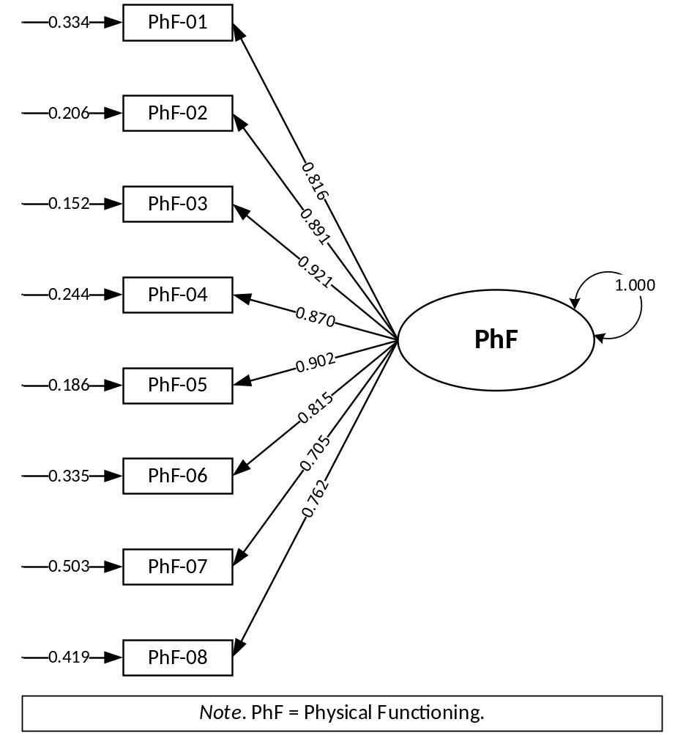

Figure A1 Fitting diagram of unidimensional confirmatory factor analysis for the Physical Functioning subscale (N = 4312)
Table A3 Parameter estimation for the CFA of the Physical Functioning subscale (N = 4312)
Subscale | Item abbreviation and label | Unstandardized |  |  |  | Standardized
 |  | Est. | SE | CR |  | Est. | δ
Factor loading
PhF | PhF-01: Hard to walk more than one block | 1.412 | 0.085 | 16.631*** |  | 0.816 | 0.334
PhF | PhF-02: Hard to run | 1.965 | 0.074 | 26.453*** |  | 0.891 | 0.206
PhF | PhF-03: Hard to do sports activity or exercise | 2.362 | 0.072 | 32.865*** |  | 0.921 | 0.152
PhF | PhF-04: Hard to lift something heavy | 1.762 | 0.048 | 36.913*** |  | 0.870 | 0.244
PhF | PhF-05: Hard to take a bath or shower | 2.095 | 0.136 | 15.431*** |  | 0.902 | 0.186
PhF | PhF-06: Hard to do chores around the house | 1.408 | 0.048 | 29.175*** |  | 0.815 | 0.335
PhF | PhF-07: Hurt or ache | 0.995 | 0.027 | 36.392*** |  | 0.705 | 0.503
PhF | PhF-08: Have low energy | 1.177 | 0.029 | 40.957*** |  | 0.762 | 0.419
Note. CFA = confirmatory factor analysis, PhF = Physical Functioning, Est. = estimate, SE = standard error, CR = critical ratio, equivalent to the common t-value, δ = residual.
Missing values were handled using listwise (casewise) deletion.
*** p < 0.001.

Table A4 Item polychoric correlation matrix of the Physical Functioning subscale (N = 4312)
 | PhF-01 | PhF-02 | PhF-03 | PhF-04 | PhF-05 | PhF-06 | PhF-07 | PhF-08
PhF-01 | —
PhF-02 | 0.818 | —
PhF-03 | 0.698 | 0.847 | —
PhF-04 | 0.668 | 0.687 | 0.842 | —
PhF-05 | 0.745 | 0.775 | 0.720 | 0.758 | —
PhF-06 | 0.648 | 0.691 | 0.651 | 0.685 | 0.824 | —
PhF-07 | 0.538 | 0.596 | 0.611 | 0.602 | 0.666 | 0.632 | —
PhF-08 | 0.629 | 0.699 | 0.648 | 0.595 | 0.747 | 0.647 | 0.573 | —
Note. PhF = Physical Functioning.
Categorical variables do not have variance parameters estimated, so the diagonal elements are empty, marked in the “—” symbol.
Missing values were handled using listwise (casewise) deletion.

Emotional Functioning subscale
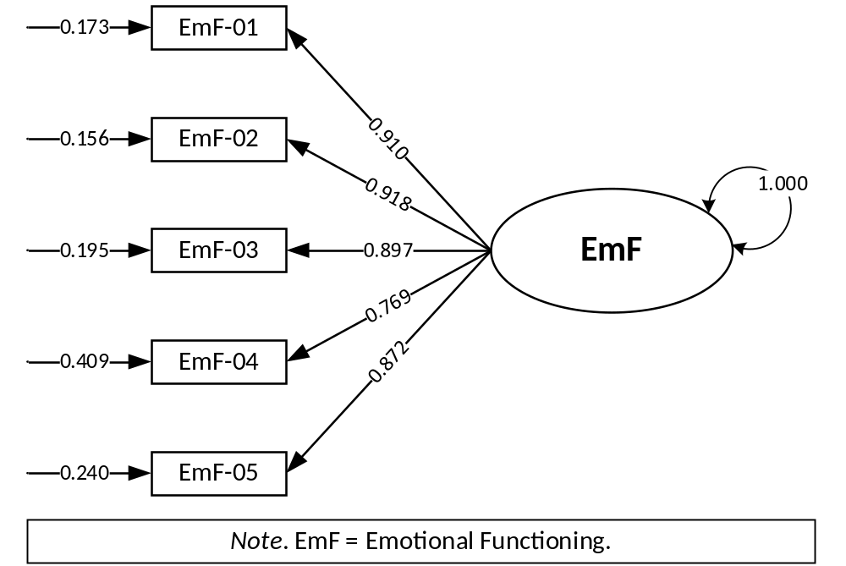

Figure A2 Fitting diagram of unidimensional confirmatory factor analysis for the Emotional Functioning subscale (N = 4325)

Table A5 Parameter estimation for the CFA of the Emotional Functioning subscale (N = 4325)
Subscale | Item abbreviation and label | Unstandardized |  |  |  | Standardized
Subscale | Item abbreviation and label | Est. | SE | CR |  | Est. | δ
Factor loading
EmF | EmF-01: Feel afraid or scared | 2.188 | 0.060 | 36.723*** |  | 0.910 | 0.173
EmF | EmF-02: Feel sad or blue | 2.323 | 0.064 | 36.225*** |  | 0.918 | 0.156
EmF | EmF-03: Feel angry | 2.030 | 0.051 | 40.147*** |  | 0.897 | 0.195
EmF | EmF-04: Trouble sleeping | 1.201 | 0.026 | 45.907*** |  | 0.769 | 0.409
EmF | EmF-05: Worry about what will happen | 1.779 | 0.043 | 41.694*** |  | 0.872 | 0.240
Note. CFA = confirmatory factor analysis, EmF = Emotional Functioning, Est. = estimate, SE = standard error, CR = critical ratio, equivalent to the common t-value, δ = residual.
Missing values were handled using listwise (casewise) deletion.
*** p < 0.001.

Table A6 Item polychoric correlation matrix of the Emotional Functioning subscale (N = 4325)
 | EmF-01 | EmF-02 | EmF-03 | EmF-04 | EmF-05
EmF-01 | —
EmF-02 | 0.843 | —
EmF-03 | 0.811 | 0.824 | —
EmF-04 | 0.680 | 0.681 | 0.718 | —
EmF-05 | 0.795 | 0.799 | 0.774 | 0.682 | —
Note. EmF = Emotional Functioning.
Categorical variables do not have variance parameters estimated, so the diagonal elements are empty, marked in the “—” symbol.
Missing values were handled using listwise (casewise) deletion.

Social Functioning subscale
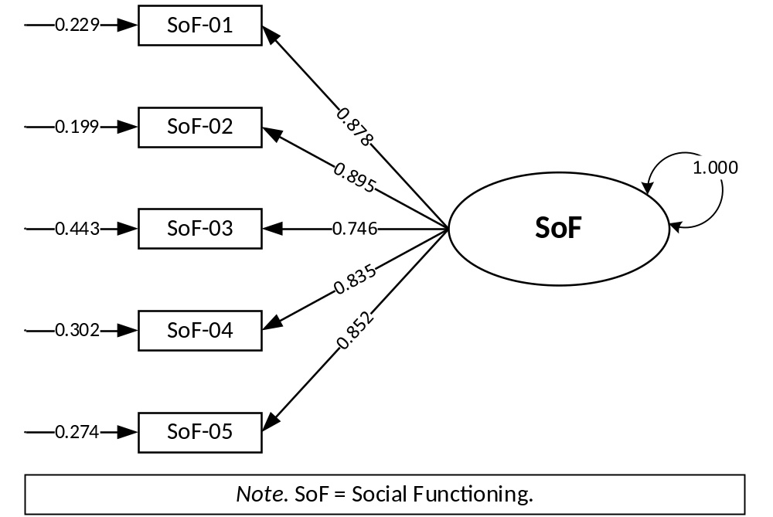

Figure A3 Fitting diagram of unidimensional confirmatory factor analysis for the Social Functioning subscale (N = 4320)

Table A7 Parameter estimation for the CFA of the Social Functioning subscale (N = 4320)
Subscale | Item abbreviation and label | Unstandardized |  |  |  | Standardized
 |  | Est. | SE | CR |  | Est. | δ
Factor loading
SoF | SoF-01: Trouble getting along with other teens | 1.835 | 0.060 | 30.364*** |  | 0.878 | 0.229
SoF | SoF-02: Other teens do not want to be friend | 2.007 | 0.072 | 27.792*** |  | 0.895 | 0.199
SoF | SoF-03: Other teens tease | 1.120 | 0.030 | 36.857*** |  | 0.746 | 0.443
SoF | SoF-04: Cannot do things that other teens can do | 1.519 | 0.046 | 32.692*** |  | 0.835 | 0.302
SoF | SoF-05: Hard to keep up with peers | 1.628 | 0.048 | 33.740*** |  | 0.852 | 0.274
Note. CFA = confirmatory factor analysis, SoF = Social Functioning, Est. = estimate, SE = standard error, CR = critical ratio, equivalent to the common t-value, δ = residual.
Missing values were handled using listwise (casewise) deletion.
*** p < 0.001.

Table A8 Item polychoric correlation matrix of the Social Functioning subscale (N = 4320)
 | SoF-01 | SoF-02 | SoF-03 | SoF-04 | SoF-05
SoF-01 | —
SoF-02 | 0.804 | —
SoF-03 | 0.662 | 0.670 | —
SoF-04 | 0.708 | 0.737 | 0.617 | —
SoF-05 | 0.737 | 0.745 | 0.630 | 0.749 | —
Note. SoF = Social Functioning.
Categorical variables do not have variance parameters estimated, so the diagonal elements are empty, marked in the “—” symbol.
Missing values were handled using listwise (casewise) deletion.

School Functioning subscale
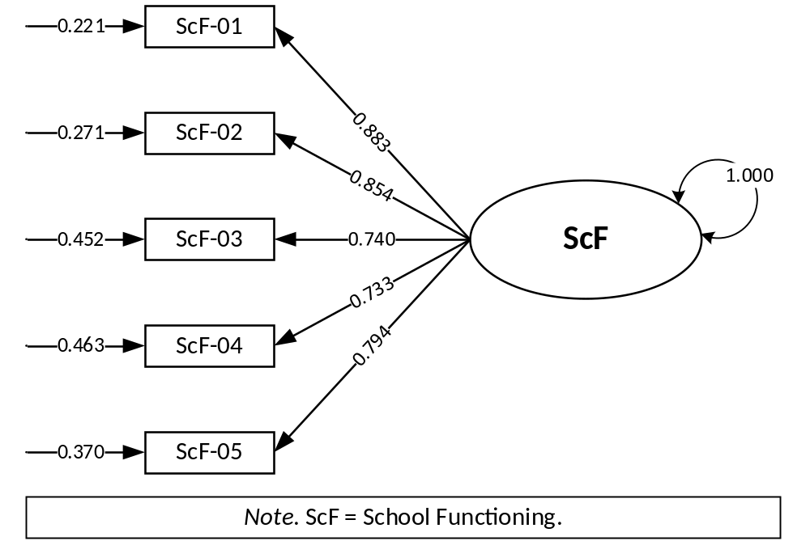

Figure A4 Fitting diagram of unidimensional confirmatory factor analysis for the School Functioning subscale (N = 4335)

Table A9 Parameter estimation for the CFA of the School Functioning subscale (N = 4335)
Subscale | Item abbreviation and label | Unstandardized |  |  |  | Standardized
 |  | Est. | SE | CR |  | Est. | δ
Factor loading
ScF | ScF-01: Hard to pay attention in class | 1.877 | 0.068 | 27.776*** |  | 0.883 | 0.221
ScF | ScF-02: Forget things | 1.639 | 0.053 | 30.657*** |  | 0.854 | 0.271
ScF | ScF-03: Trouble keeping up with schoolwork | 1.101 | 0.029 | 38.459*** |  | 0.740 | 0.452
ScF | ScF-04: Miss school because of not feeling well | 1.077 | 0.032 | 34.125*** |  | 0.733 | 0.463
ScF | ScF-05: Miss school to go to the doctor or hospital | 1.304 | 0.045 | 29.138*** |  | 0.794 | 0.370
Note. CFA = confirmatory factor analysis, ScF = School Functioning, Est. = estimate, SE = standard error, CR = critical ratio, equivalent to the common t-value, δ = residual.
Missing values were handled using listwise (casewise) deletion.
*** p < 0.001.

Table A10 Item polychoric correlation matrix of the School Functioning subscale (N = 4335)
 | ScF-01 | ScF-02 | ScF-03 | ScF-04 | ScF-05
ScF-01 | —
ScF-02 | 0.822 | —
ScF-03 | 0.705 | 0.644 | —
ScF-04 | 0.393 | 0.417 | 0.448 | —
ScF-05 | 0.530 | 0.523 | 0.527 | 0.792 | —
Note. ScF = School Functioning.
Categorical variables do not have variance parameters estimated, so the diagonal elements are empty, marked in the “—” symbol.
Missing values were handled using listwise (casewise) deletion.

Psychosocial Health summary score
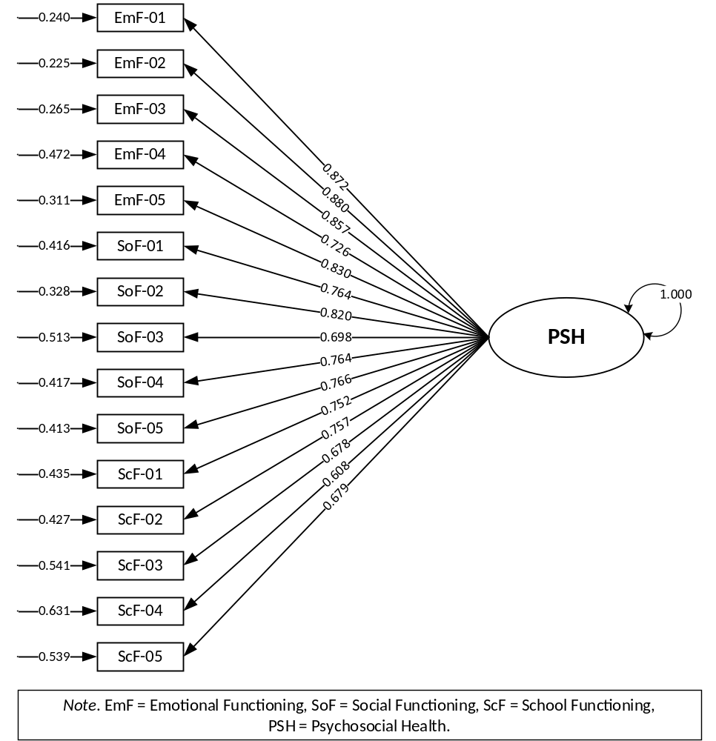

Figure A5 Fitting diagram of unidimensional confirmatory factor analysis for the Psychosocial Health summary score (N = 4212)
Table A11 Parameter estimation for the CFA of the Psychosocial Health summary score (N = 4212)
SS | Item abbreviation and label | Unstandardized |  |  |  | Standardized
 |  | Est. | SE | CR |  | Est. | δ
Factor loading
PSH | EmF-01: Feel afraid or scared | 1.781 | 0.040 | 45.021*** |  | 0.872 | 0.240
PSH | EmF-02: Feel sad or blue | 1.854 | 0.043 | 42.707*** |  | 0.880 | 0.225
PSH | EmF-03: Feel angry | 1.664 | 0.035 | 47.295*** |  | 0.857 | 0.265
PSH | EmF-04: Trouble sleeping | 1.057 | 0.021 | 49.259*** |  | 0.726 | 0.472
PSH | EmF-05: Worry about what will happen | 1.487 | 0.030 | 49.096*** |  | 0.830 | 0.311
PSH | SoF-01: Trouble getting along with other teens | 1.184 | 0.027 | 43.102*** |  | 0.764 | 0.416
PSH | SoF-02: Other teens do not want to be friend | 1.431 | 0.037 | 39.006*** |  | 0.820 | 0.328
PSH | SoF-03: Other teens tease | 0.974 | 0.025 | 38.965*** |  | 0.698 | 0.513
PSH | SoF-04: Cannot do things that other teens can do | 1.183 | 0.030 | 39.635*** |  | 0.764 | 0.417
PSH | SoF-05: Hard to keep up with peers | 1.191 | 0.028 | 42.059*** |  | 0.766 | 0.413
PSH | ScF-01: Hard to pay attention in class | 1.140 | 0.027 | 41.987*** |  | 0.752 | 0.435
PSH | ScF-02: Forget things | 1.157 | 0.027 | 42.428*** |  | 0.757 | 0.427
PSH | ScF-03: Trouble keeping up with schoolwork | 0.921 | 0.023 | 40.621*** |  | 0.678 | 0.541
PSH | ScF-04: Miss school because of not feeling well | 0.765 | 0.022 | 34.426*** |  | 0.608 | 0.631
PSH | ScF-05: Miss school to go to the doctor or hospital | 0.924 | 0.028 | 32.518*** |  | 0.679 | 0.539
Note. CFA = confirmatory factor analysis, SS = summary score, PSH = Psychosocial Health, EmF = Emotional Functioning, SoF = Social Functioning, ScF = School Functioning, Est. = estimate, SE = standard error, CR = critical ratio, equivalent to the common t-value, δ = residual.
Missing values were handled using listwise (casewise) deletion.
*** p < 0.001.

Table A12 Item polychoric correlation matrix of Psychosocial Health summary score (N = 4212)
 | EmF-01 | EmF-02 | EmF-03 | EmF-04 | EmF-05 | SoF-01 | SoF-02 | SoF-03 | SoF-04 | SoF-05 | ScF-01 | ScF-02 | ScF-03 | ScF-04 | ScF-05
EmF-01 | —
EmF-02 | 0.841 | —
EmF-03 | 0.807 | 0.822 | —
EmF-04 | 0.677 | 0.677 | 0.715 | —
EmF-05 | 0.793 | 0.800 | 0.774 | 0.678 | —
SoF-01 | 0.532 | 0.492 | 0.486 | 0.466 | 0.488 | —
SoF-02 | 0.565 | 0.559 | 0.559 | 0.517 | 0.532 | 0.803 | —
SoF-03 | 0.535 | 0.502 | 0.515 | 0.465 | 0.490 | 0.657 | 0.665 | —
SoF-04 | 0.522 | 0.519 | 0.542 | 0.479 | 0.513 | 0.707 | 0.736 | 0.614 | —
SoF-05 | 0.526 | 0.516 | 0.511 | 0.487 | 0.507 | 0.732 | 0.740 | 0.623 | 0.747 | —
ScF-01 | 0.516 | 0.541 | 0.544 | 0.498 | 0.510 | 0.453 | 0.550 | 0.472 | 0.532 | 0.503 | —
ScF-02 | 0.536 | 0.557 | 0.570 | 0.525 | 0.540 | 0.464 | 0.564 | 0.497 | 0.527 | 0.515 | 0.820 | —
ScF-03 | 0.496 | 0.537 | 0.506 | 0.433 | 0.516 | 0.448 | 0.510 | 0.447 | 0.493 | 0.489 | 0.701 | 0.64 | —
ScF-04 | 0.421 | 0.364 | 0.357 | 0.376 | 0.372 | 0.465 | 0.408 | 0.400 | 0.443 | 0.452 | 0.389 | 0.408 | 0.439 | —
ScF-05 | 0.482 | 0.455 | 0.460 | 0.428 | 0.450 | 0.404 | 0.494 | 0.416 | 0.499 | 0.449 | 0.530 | 0.521 | 0.525 | 0.791 | —
Note. EmF = Emotional Functioning, SoF = Social Functioning, ScF = School Functioning.
Categorical variables do not have variance parameters estimated, so the diagonal elements are empty, marked in the “—” symbol.
Missing values were handled using listwise (casewise) deletion.

Health-related Quality of Life summary score
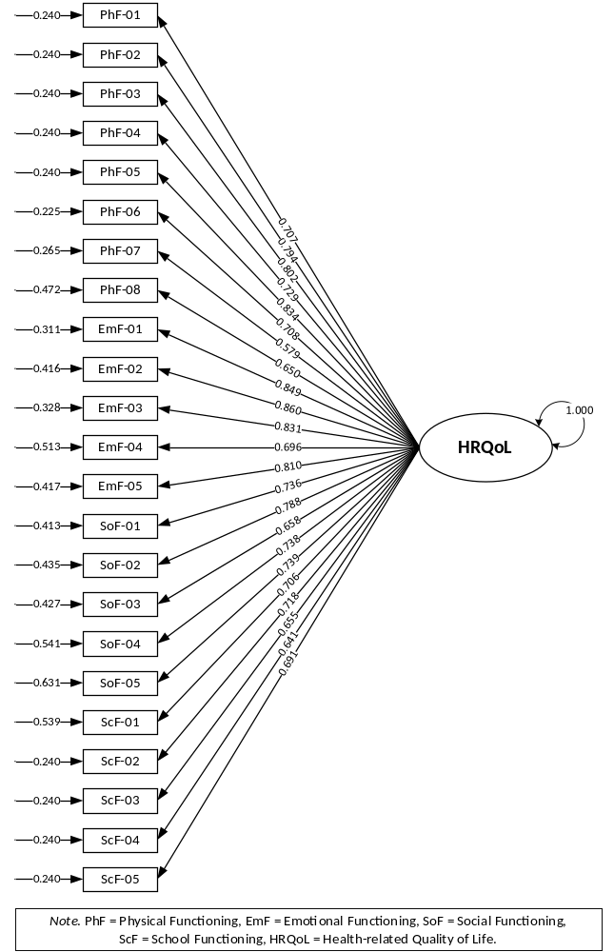

Figure A6 Fitting diagram of unidimensional confirmatory factor analysis for the Health-related Quality of Life summary score (N = 4145)

Table A13 Parameter estimation for the CFA of the Health-related Quality of Life summary score (N = 4145)
SS | Item abbreviation and label | Unstandardized |  |  |  | Standardized
 |  | Est. | SE | CR |  | Est. | δ
Factor loading
HRQoL | PhF-01: Hard to walk more than one block | 0.999 | 0.058 | 17.289*** |  | 0.707 | 0.501
HRQoL | PhF-02: Hard to run | 1.305 | 0.044 | 29.821*** |  | 0.794 | 0.370
HRQoL | PhF-03: Hard to do sports activity or exercise | 1.344 | 0.030 | 44.371*** |  | 0.802 | 0.356
HRQoL | PhF-04: Hard to lift something heavy | 1.066 | 0.024 | 44.346*** |  | 0.729 | 0.468
HRQoL | PhF-05: Hard to take a bath or shower | 1.513 | 0.083 | 18.131*** |  | 0.834 | 0.304
HRQoL | PhF-06: Hard to do chores around the house | 1.002 | 0.034 | 29.835*** |  | 0.708 | 0.499
HRQoL | PhF-07: Hurt or ache | 0.710 | 0.020 | 36.052*** |  | 0.579 | 0.665
HRQoL | PhF-08: Have low energy | 0.854 | 0.020 | 42.268*** |  | 0.650 | 0.578
HRQoL | EmF-01: Feel afraid or scared | 1.604 | 0.034 | 47.255*** |  | 0.849 | 0.280
HRQoL | EmF-02: Feel sad or blue | 1.685 | 0.037 | 45.226*** |  | 0.860 | 0.260
HRQoL | EmF-03: Feel angry | 1.496 | 0.031 | 48.772*** |  | 0.831 | 0.309
HRQoL | EmF-04: Trouble sleeping | 0.970 | 0.020 | 48.470*** |  | 0.696 | 0.515
HRQoL | EmF-05: Worry about what will happen | 1.381 | 0.028 | 48.613*** |  | 0.810 | 0.344
HRQoL | SoF-01: Trouble getting along with other teens | 1.086 | 0.025 | 44.089*** |  | 0.736 | 0.459
HRQoL | SoF-02: Other teens do not want to be friend | 1.280 | 0.031 | 41.369*** |  | 0.788 | 0.379
HRQoL | SoF-03: Other teens tease | 0.873 | 0.022 | 39.350*** |  | 0.658 | 0.567
HRQoL | SoF-04: Cannot do things that other teens can do | 1.093 | 0.026 | 41.628*** |  | 0.738 | 0.456
HRQoL | SoF-05: Hard to keep up with peers | 1.095 | 0.025 | 44.376*** |  | 0.739 | 0.455
HRQoL | ScF-01: Hard to pay attention in class | 0.996 | 0.024 | 42.318*** |  | 0.706 | 0.502
HRQoL | ScF-02: Forget things | 1.033 | 0.024 | 42.767*** |  | 0.718 | 0.484
HRQoL | ScF-03: Trouble keeping up with schoolwork | 0.867 | 0.021 | 40.528*** |  | 0.655 | 0.571
HRQoL | ScF-04: Miss school because of not feeling well | 0.836 | 0.022 | 37.858*** |  | 0.641 | 0.589
HRQoL | ScF-05: Miss school to go to the doctor or hospital | 0.955 | 0.028 | 34.716*** |  | 0.691 | 0.523
Note. CFA = confirmatory factor analysis, SS = summary score, HRQoL = Health-related Quality of Life, PhF = Physical Functioning, EmF = Emotional Functioning, SoF = Social Functioning, ScF = School Functioning, Est. = estimate, SE = standard error, CR = critical ratio, equivalent to the common t-value, δ = residual.
Missing values were handled using listwise (casewise) deletion.
*** p < 0.001.

Table A14 Item polychoric correlation matrix of Health-related Quality of Life summary score (N = 4145)
 | PhF-01 | PhF-02 | PhF-03 | PhF-04 | PhF-05 | PhF-06 | PhF-07 | PhF-08 | EmF-01 | EmF-02 | EmF-03 | EmF-04 | EmF-05 | SoF-01 | SoF-02 | SoF-03 | SoF-04 | SoF-05 | ScF-01 | ScF-02 | ScF-03 | ScF-04 | ScF-05
PhF-01 | —
PhF-02 | 0.816 | —
PhF-03 | 0.691 | 0.848 | —
PhF-04 | 0.660 | 0.683 | 0.842 | —
PhF-05 | 0.739 | 0.771 | 0.713 | 0.759 | —
PhF-06 | 0.645 | 0.687 | 0.644 | 0.678 | 0.824 | —
PhF-07 | 0.540 | 0.591 | 0.607 | 0.593 | 0.663 | 0.626 | —
PhF-08 | 0.619 | 0.692 | 0.639 | 0.585 | 0.740 | 0.639 | 0.572 | —
EmF-01 | 0.371 | 0.402 | 0.348 | 0.316 | 0.480 | 0.415 | 0.350 | 0.393 | —
EmF-02 | 0.311 | 0.392 | 0.318 | 0.312 | 0.450 | 0.398 | 0.328 | 0.381 | 0.840 | —
EmF-03 | 0.328 | 0.417 | 0.288 | 0.250 | 0.468 | 0.384 | 0.311 | 0.354 | 0.806 | 0.821 | —
EmF-04 | 0.303 | 0.397 | 0.317 | 0.271 | 0.451 | 0.365 | 0.290 | 0.340 | 0.676 | 0.676 | 0.714 | —
EmF-05 | 0.330 | 0.407 | 0.322 | 0.300 | 0.416 | 0.393 | 0.337 | 0.380 | 0.793 | 0.800 | 0.774 | 0.679 | —
SoF-01 | 0.334 | 0.359 | 0.410 | 0.402 | 0.437 | 0.412 | 0.376 | 0.357 | 0.530 | 0.491 | 0.484 | 0.463 | 0.489 | —
SoF-02 | 0.381 | 0.415 | 0.350 | 0.344 | 0.470 | 0.440 | 0.312 | 0.373 | 0.563 | 0.560 | 0.557 | 0.516 | 0.534 | 0.802 | —
SoF-03 | 0.253 | 0.325 | 0.325 | 0.292 | 0.406 | 0.400 | 0.305 | 0.331 | 0.531 | 0.498 | 0.510 | 0.461 | 0.486 | 0.657 | 0.663 | —
SoF-04 | 0.414 | 0.475 | 0.359 | 0.335 | 0.485 | 0.430 | 0.343 | 0.385 | 0.519 | 0.520 | 0.540 | 0.477 | 0.512 | 0.706 | 0.736 | 0.611 | —
SoF-05 | 0.418 | 0.428 | 0.373 | 0.338 | 0.473 | 0.416 | 0.353 | 0.393 | 0.524 | 0.515 | 0.510 | 0.486 | 0.505 | 0.732 | 0.742 | 0.620 | 0.748 | —
ScF-01 | 0.329 | 0.360 | 0.216 | 0.194 | 0.397 | 0.359 | 0.229 | 0.320 | 0.512 | 0.538 | 0.543 | 0.496 | 0.508 | 0.451 | 0.550 | 0.468 | 0.529 | 0.501 | —
ScF-02 | 0.404 | 0.392 | 0.268 | 0.244 | 0.434 | 0.397 | 0.266 | 0.366 | 0.532 | 0.555 | 0.569 | 0.525 | 0.538 | 0.463 | 0.564 | 0.492 | 0.524 | 0.514 | 0.819 | —
ScF-03 | 0.375 | 0.398 | 0.304 | 0.290 | 0.372 | 0.383 | 0.328 | 0.388 | 0.493 | 0.536 | 0.506 | 0.430 | 0.516 | 0.451 | 0.510 | 0.443 | 0.492 | 0.490 | 0.700 | 0.637 | —
ScF-04 | 0.389 | 0.451 | 0.518 | 0.492 | 0.537 | 0.498 | 0.468 | 0.460 | 0.417 | 0.361 | 0.356 | 0.376 | 0.370 | 0.468 | 0.408 | 0.398 | 0.446 | 0.452 | 0.389 | 0.408 | 0.440 | —
ScF-05 | 0.517 | 0.556 | 0.406 | 0.390 | 0.594 | 0.526 | 0.448 | 0.485 | 0.478 | 0.452 | 0.457 | 0.428 | 0.447 | 0.404 | 0.490 | 0.409 | 0.496 | 0.448 | 0.528 | 0.515 | 0.522 | 0.791 | —
Note. PhF = Physical Functioning, EmF = Emotional Functioning, SoF = Social Functioning, ScF = School Functioning.
Categorical variables do not have variance parameters estimated, so the diagonal elements are empty, marked in the “—” symbol.
Missing values were handled using listwise (casewise) deletion.

Appendix 9: Item covariance matrix of the Mandarin Chinese self-reported Pediatric Quality of Life Inventory™ Version 4.0 Generic Core Scales (PedsQL™ 4.0)

Table A15 Item correlation matrix of the Physical Functioning subscale
 | PhF-01 | PhF-02 | PhF-03 | PhF-04 | PhF-05 | PhF-06 | PhF-07 | PhF-08
PhF-01 | 1.000  (4375)
PhF-02 | 0.528** (4364) | 1.000  (4374)
PhF-03 | 0.364** (4364) | 0.607** (4363) | 1.000  (4374)
PhF-04 | 0.337** (4363) | 0.483** (4363) | 0.711** (4364) | 1.000  (4373)
PhF-05 | 0.448** (4366) | 0.546** (4364) | 0.448** (4365) | 0.440** (4363) | 1.000  (4375)
PhF-06 | 0.351** (4366) | 0.505** (4365) | 0.468** (4365) | 0.479** (4364) | 0.582** (4366) | 1.000  (4376)
PhF-07 | 0.262** (4363) | 0.421** (4362) | 0.491** (4363) | 0.494** (4362) | 0.402** (4364) | 0.441** (4365) | 1.000  (4373)
PhF-08 | 0.315** (4366) | 0.513** (4367) | 0.532** (4365) | 0.495** (4364) | 0.460** (4366) | 0.464** (4367) | 0.475** (4364) | 1.000  (4376)
Note. PhF = Physical Functioning. All Pearson correlation coefficients. Figures in brackets indicate paired cases.
Missing values were handled using listwise (casewise) deletion.
** p < 0.01.

Table A16 Item correlation matrix of the Emotional Functioning subscale
 | EmF-01 | EmF-02 | EmF-03 | EmF-04 | EmF-05
EmF-01 | 1.000  (4374)
EmF-02 | 0.727**  (4362) | 1.000  (4373)
EmF-03 | 0.707**  (4361) | 0.717**  (4360) | 1.000  (4372)
EmF-04 | 0.605**  (4360) | 0.613**  (4359) | 0.643**  (4358) | 1.000  (4371)
EmF-05 | 0.701**  (4362) | 0.709**  (4362) | 0.696**  (4360) | 0.640**  (4360) | 1.000  (4373)
Note. EmF = Emotional Functioning. All Pearson correlation coefficients. Figures in brackets indicate paired cases.
Missing values were handled using listwise (casewise) deletion.
** p < 0.01.

Table A17 Item correlation matrix of the Social Functioning subscale
 | SoF-01 | SoF-02 | SoF-03 | SoF-04 | SoF-05
SoF-01 | 1.000  (4374)
SoF-02 | 0.681**  (4362) | 1.000  (4373)
SoF-03 | 0.549**  (4357) | 0.569**  (4356) | 1.000  (4368)
SoF-04 | 0.605**  (4362) | 0.643**  (4360) | 0.534**  (4355) | 1.000  (4372)
SoF-05 | 0.635**  (4360) | 0.654**  (4359) | 0.549**  (4355) | 0.652**  (4358) | 1.000  (4371)
Note. SoF = Social Functioning. All Pearson correlation coefficients. Figures in brackets indicate paired cases.
Missing values were handled using listwise (casewise) deletion.
** p < 0.01.

Table A18 Item correlation matrix of the School Functioning subscale
 | ScF-01 | ScF-02 | ScF-03 | ScF-04 | ScF-05
ScF-01 | 1.000  (4375)
ScF-02 | 0.692**  (4362) | 1.000  (4372)
ScF-03 | 0.591**  (4364) | 0.535**  (4361) | 1.000  (4374)
ScF-04 | 0.317**  (4366) | 0.334**  (4363) | 0.361**  (4365) | 1.000  (4376)
ScF-05 | 0.408**  (4368) | 0.403**  (4365) | 0.400**  (4367) | 0.583**  (4369) | 1.000  (4378)
Note. ScF = School Functioning. All Pearson correlation coefficients. Figures in brackets indicate paired cases.
Missing values were handled using listwise (casewise) deletion.
** p < 0.01.

Table A19 Item correlation matrix of the Psychosocial Health summary score
 | EmF-01 | EmF-02 | EmF-03 | EmF-04 | EmF-05 | SoF-01 | SoF-02 | SoF-03 | SoF-04 | SoF-05 | ScF-01 | ScF-02 | ScF-03 | ScF-04 | ScF-05
EmF-01 | 1.000  (4374)
EmF-02 | 0.727**  (4362) | 1.000  (4373)
EmF-03 | 0.707**  (4361) | 0.717**  (4360) | 1.000  (4372)
EmF-04 | 0.605**  (4360) | 0.613**  (4359) | 0.643**  (4358) | 1.000  (4371)
EmF-05 | 0.701**  (4362) | 0.709**  (4362) | 0.696**  (4360) | 0.640**  (4360) | 1.000  (4373)
SoF-01 | 0.455**  (4363) | 0.419**  (4362) | 0.426**  (4361) | 0.410**  (4360) | 0.423**  (4362) | 1.000  (4374)
SoF-02 | 0.479**  (4362) | 0.470**  (4361) | 0.479**  (4360) | 0.448**  (4360) | 0.462**  (4361) | 0.681**  (4362) | 1.000  (4373)
SoF-03 | 0.439**  (4357) | 0.416**  (4356) | 0.426**  (4355) | 0.402**  (4354) | 0.415**  (4356) | 0.549**  (4357) | 0.569**  (4356) | 1.000  (4368)
SoF-04 | 0.447**  (4361) | 0.442**  (4360) | 0.467**  (4359) | 0.427**  (4358) | 0.445**  (4360) | 0.605**  (4362) | 0.643**  (4360) | 0.534**  (4355) | 1.000  (4372)
SoF-05 | 0.458**  (4360) | 0.442**  (4359) | 0.451**  (4358) | 0.438**  (4357) | 0.452**  (4359) | 0.635**  (4360) | 0.654**  (4359) | 0.549**  (4355) | 0.652**  (4358) | 1.000  (4371)
ScF-01 | 0.441**  (4364) | 0.459**  (4364) | 0.466**  (4362) | 0.441**  (4361) | 0.452**  (4363) | 0.388**  (4364) | 0.461**  (4363) | 0.388**  (4358) | 0.451**  (4362) | 0.438**  (4361) | 1.000  (4375)
ScF-02 | 0.459**  (4361) | 0.468**  (4360) | 0.486**  (4359) | 0.462**  (4358) | 0.475**  (4360) | 0.404**  (4361) | 0.471**  (4360) | 0.414**  (4355) | 0.455**  (4359) | 0.451**  (4358) | 0.692**  (4362) | 1.000  (4372)
ScF-03 | 0.429**  (4363) | 0.458**  (4362) | 0.438**  (4361) | 0.389**  (4360) | 0.453**  (4362) | 0.384**  (4363) | 0.431**  (4362) | 0.379**  (4357) | 0.419**  (4361) | 0.426**  (4360) | 0.591**  (4364) | 0.535**  (4361) | 1.000  (4374)
ScF-04 | 0.343**  (4365) | 0.299**  (4364) | 0.300**  (4363) | 0.322**  (4362) | 0.312**  (4364) | 0.377**  (4365) | 0.338**  (4364) | 0.327**  (4359) | 0.369**  (4363) | 0.380**  (4362) | 0.317**  (4366) | 0.334**  (4363) | 0.361**  (4365) | 1.000  (4376)
ScF-05 | 0.367**  (4367) | 0.346**  (4366) | 0.357**  (4365) | 0.349**  (4364) | 0.359**  (4366) | 0.316**  (4367) | 0.383**  (4366) | 0.328**  (4361) | 0.394**  (4365) | 0.362**  (4364) | 0.408**  (4368) | 0.403**  (4365) | 0.400**  (4367) | 0.583**  (4369) | 1.000  (4378)
Note. EmF = Emotional Functioning, SoF = Social Functioning, ScF = School Functioning. All Pearson correlation coefficients. Figures in brackets indicate paired cases.
Missing values were handled using listwise (casewise) deletion.
** p < 0.01.

Table A20 Item correlation matrix of the Health-related Quality of Life summary score
 | PhF-01 | PhF-02 | PhF-03 | PhF-04 | PhF-05 | PhF-06 | PhF-07 | PhF-08 | EmF-01 | EmF-02 | EmF-03 | EmF-04 | EmF-05 | SoF-01 | SoF-02 | SoF-03 | SoF-04 | SoF-05 | ScF-01 | ScF-02 | ScF-03 | ScF-04 | ScF-05
PhF-01 | 1.000  (4375)
PhF-02 | 0.528**  (4364) | 1.000  (4374)
PhF-03 | 0.364**  (4364) | 0.607**  (4363) | 1.000  (4374)
PhF-04 | 0.337**  (4363) | 0.483**  (4363) | 0.711**  (4364) | 1.000  (4373)
PhF-05 | 0.448**  (4366) | 0.546**  (4364) | 0.448**  (4365) | 0.440**  (4363) | 1.000  (4375)
PhF-06 | 0.351**  (4366) | 0.505**  (4365) | 0.468**  (4365) | 0.479**  (4364) | 0.582**  (4366) | 1.000  (4376)
PhF-07 | 0.262**  (4363) | 0.421**  (4362) | 0.491**  (4363) | 0.494**  (4362) | 0.402**  (4364) | 0.441**  (4365) | 1.000  (4373)
PhF-08 | 0.315**  (4366) | 0.513**  (4367) | 0.532**  (4365) | 0.495**  (4364) | 0.460**  (4366) | 0.464**  (4367) | 0.475**  (4364) | 1.000  (4376)
EmF-01 | 0.165**  (4365) | 0.279**  (4363) | 0.285**  (4363) | 0.274**  (4362) | 0.274**  (4364) | 0.291**  (4365) | 0.301**  (4362) | 0.337**  (4365) | 1.000  (4374)
EmF-02 | 0.134**  (4363) | 0.259**  (4362) | 0.261**  (4362) | 0.266**  (4361) | 0.245**  (4363) | 0.274**  (4364) | 0.286**  (4362) | 0.325**  (4364) | 0.727**  (4362) | 1.000  (4373)
EmF-03 | 0.140**  (4362) | 0.277**  (4362) | 0.245**  (4361) | 0.224**  (4361) | 0.259**  (4362) | 0.275**  (4363) | 0.268**  (4360) | 0.311**  (4363) | 0.707**  (4361) | 0.717**  (4360) | 1.000  (4372)
EmF-04 | 0.137**  (4361) | 0.273**  (4360) | 0.268**  (4360) | 0.245**  (4359) | 0.261**  (4361) | 0.270**  (4362) | 0.262**  (4359) | 0.307**  (4362) | 0.605**  (4360) | 0.613**  (4359) | 0.643**  (4358) | 1.000  (4371)
EmF-05 | 0.140**  (4363) | 0.276**  (4362) | 0.271**  (4362) | 0.262**  (4361) | 0.237**  (4363) | 0.278**  (4364) | 0.294**  (4361) | 0.328**  (4364) | 0.701**  (4362) | 0.709**  (4362) | 0.696**  (4360) | 0.640**  (4360) | 1.000  (4373)
SoF-01 | 0.149**  (4364) | 0.250**  (4363) | 0.322**  (4363) | 0.334**  (4362) | 0.250**  (4364) | 0.285**  (4365) | 0.310**  (4362) | 0.305**  (4365) | 0.455**  (4363) | 0.419**  (4362) | 0.426**  (4361) | 0.410**  (4360) | 0.423**  (4362) | 1.000  (4374)
SoF-02 | 0.167**  (4363) | 0.289**  (4362) | 0.286**  (4362) | 0.290**  (4361) | 0.271**  (4363) | 0.315**  (4364) | 0.264**  (4361) | 0.315**  (4364) | 0.479**  (4362) | 0.470**  (4361) | 0.479**  (4360) | 0.448**  (4360) | 0.462**  (4361) | 0.681**  (4362) | 1.000  (4373)
SoF-03 | 0.133**  (4358) | 0.244**  (4357) | 0.262**  (4357) | 0.258**  (4356) | 0.240**  (4358) | 0.291**  (4360) | 0.266**  (4356) | 0.286**  (4359) | 0.439**  (4357) | 0.416**  (4356) | 0.426**  (4355) | 0.402**  (4354) | 0.415**  (4356) | 0.549**  (4357) | 0.569**  (4356) | 1.000  (4368)
SoF-04 | 0.193**  (4362) | 0.336**  (4361) | 0.302**  (4361) | 0.292**  (4360) | 0.291**  (4362) | 0.311**  (4363) | 0.294**  (4360) | 0.330**  (4363) | 0.447**  (4361) | 0.442**  (4360) | 0.467**  (4359) | 0.427**  (4358) | 0.445**  (4360) | 0.605**  (4362) | 0.643**  (4360) | 0.534**  (4355) | 1.000  (4372)
SoF-05 | 0.205**  (4361) | 0.317**  (4360) | 0.313**  (4360) | 0.298**  (4359) | 0.289**  (4361) | 0.311**  (4362) | 0.311**  (4359) | 0.344**  (4362) | 0.458**  (4360) | 0.442**  (4359) | 0.451**  (4358) | 0.438**  (4357) | 0.452**  (4359) | 0.635**  (4360) | 0.654**  (4359) | 0.549**  (4355) | 0.652**  (4358) | 1.000  (4371)
ScF-01 | 0.163**  (4365) | 0.253**  (4364) | 0.193**  (4365) | 0.183**  (4363) | 0.220**  (4365) | 0.252**  (4366) | 0.208**  (4363) | 0.276**  (4366) | 0.441**  (4364) | 0.459**  (4364) | 0.466**  (4362) | 0.441**  (4361) | 0.452**  (4363) | 0.388**  (4364) | 0.461**  (4363) | 0.388**  (4358) | 0.451**  (4362) | 0.438**  (4361) | 1.000  (4375)
ScF-02 | 0.196**  (4362) | 0.278**  (4361) | 0.230**  (4361) | 0.226**  (4360) | 0.249**  (4362) | 0.279**  (4363) | 0.238**  (4360) | 0.315**  (4363) | 0.459**  (4361) | 0.468**  (4360) | 0.486**  (4359) | 0.462**  (4358) | 0.475**  (4360) | 0.404**  (4361) | 0.471**  (4360) | 0.414**  (4355) | 0.455**  (4359) | 0.451**  (4358) | 0.692**  (4362) | 1.000  (4372)
ScF-03 | 0.158**  (4364) | 0.259**  (4363) | 0.249**  (4363) | 0.250**  (4362) | 0.197**  (4364) | 0.257**  (4365) | 0.283**  (4362) | 0.329**  (4365) | 0.429**  (4363) | 0.458**  (4362) | 0.438**  (4361) | 0.389**  (4360) | 0.453**  (4362) | 0.384**  (4363) | 0.431**  (4362) | 0.379**  (4357) | 0.419**  (4361) | 0.426**  (4360) | 0.591**  (4364) | 0.535**  (4361) | 1.000  (4374)
ScF-04 | 0.193**  (4366) | 0.317**  (4365) | 0.406**  (4365) | 0.398**  (4364) | 0.318**  (4366) | 0.350**  (4367) | 0.382**  (4364) | 0.381**  (4367) | 0.343**  (4365) | 0.299**  (4364) | 0.300**  (4363) | 0.322**  (4362) | 0.312**  (4364) | 0.377**  (4365) | 0.338**  (4364) | 0.327**  (4359) | 0.369**  (4363) | 0.380**  (4362) | 0.317**  (4366) | 0.334**  (4363) | 0.361**  (4365) | 1.000  (4376)
ScF-05 | 0.271**  (4368) | 0.394**  (4367) | 0.326**  (4367) | 0.320**  (4366) | 0.368**  (4368) | 0.379**  (4370) | 0.354**  (4366) | 0.386**  (4369) | 0.367**  (4367) | 0.346**  (4366) | 0.357**  (4365) | 0.349**  (4364) | 0.359**  (4366) | 0.316**  (4367) | 0.383**  (4366) | 0.328**  (4361) | 0.394**  (4365) | 0.362**  (4364) | 0.408**  (4368) | 0.403**  (4365) | 0.400**  (4367) | 0.583**  (4369) | 1.000  (4378)
Note. PhF = Physical Functioning, EmF = Emotional Functioning, SoF = Social Functioning, ScF = School Functioning. All Pearson correlation coefficients. Figures in brackets indicate paired cases.
Missing values were handled using listwise (casewise) deletion.
** p < 0.01.

Appendix 10: Category summary statistics of 23 items in the Mandarin Chinese self-reported Pediatric Quality of Life Inventory™ Version 4.0 Generic Core Scales (PedsQL™ 4.0)

Partial Credit Model
Table A21 Category summary statistics of eight items in the Physical Functioning subscale (N = 4312)
Item label | Rating category  (five) | Category count (%) | Average measure | Infit MnSq | Outfit MnSq | Step calibration
PhF-01 | 0 = Always | NA | NA | NA | NA | NA
 | 1 = Often | 4 (0.1) | −3.593 | 0.91 | 0.88 | None
 | 2 = Sometimes | 30 (0.7) | 0.116 | 1.74 | 3.87 | −2.32
 | 3 = Seldom | 164 (3.8) | 1.548 | 1.14 | 2.81 | 0.06
 | 4 = Never | 4114 (95.4) | 6.308 | 1.35 | 1.23 | 2.26
PhF-02 | 0 = Always | 2 (0.0) | −5.108 | 0.40 | 0.39 | None
 | 1 = Often | 15 (0.3) | −1.102 | 1.21 | 1.18 | −4.02
 | 2 = Sometimes | 148 (3.4) | 0.536 | 1.03 | 1.17 | −1.75
 | 3 = Seldom | 574 (13.3) | 3.361 | 0.89 | 0.75 | 1.43
 | 4 = Never | 3573 (82.9) | 6.839 | 0.82 | 0.88 | 4.34
PhF-03 | 0 = Always | 4 (0.1) | −3.682 | 1.12 | 1.28 | None
 | 1 = Often | 27 (0.6) | −0.860 | 0.89 | 0.90 | −4.43
 | 2 = Sometimes | 237 (5.5) | 0.924 | 0.64 | 0.57 | −2.47
 | 3 = Seldom | 1888 (43.8) | 5.035 | 0.66 | 0.49 | 0.78
 | 4 = Never | 2156 (50.0) | 7.981 | 0.76 | 0.75 | 6.13
PhF-04 | 0 = Always | 4 (0.1) | −3.791 | 0.93 | 1.06 | None
 | 1 = Often | 33 (0.8) | −0.905 | 0.77 | 0.73 | −5.08
 | 2 = Sometimes | 421 (9.8) | 2.190 | 0.92 | 0.89 | −2.96
 | 3 = Seldom | 2268 (52.6) | 5.690 | 0.79 | 0.76 | 1.37
 | 4 = Never | 1586 (36.8) | 8.371 | 0.79 | 0.74 | 6.67
PhF-05 | 0 = Always | NA | NA | NA | NA | NA
 | 1 = Often | 1 (0.0) | −4.328 | 0.95 | 1.04 | None
 | 2 = Sometimes | 28 (0.6) | −1.209 | 0.88 | 1.00 | −3.99
 | 3 = Seldom | 339 (7.9) | 1.877 | 0.92 | 1.32 | −0.03
 | 4 = Never | 3944 (91.5) | 6.512 | 0.83 | 0.87 | 4.01
PhF-06 | 0 = Always | NA | NA | NA | NA | NA
 | 1 = Often | 4 (0.1) | −2.794 | 0.93 | 1.14 | None
 | 2 = Sometimes | 116 (2.7) | 0.260 | 1.09 | 1.03 | −4.22
 | 3 = Seldom | 662 (15.4) | 3.523 | 1.06 | 1.27 | 0.26
 | 4 = Never | 3530 (81.9) | 6.815 | 1.07 | 1.06 | 3.96
PhF-07 | 0 = Always | 3 (0.1) | −2.176 | 2.08 | 2.32 | None
 | 1 = Often | 71 (1.6) | −0.016 | 1.16 | 1.13 | −6.34
 | 2 = Sometimes | 517 (12.0) | 3.092 | 1.18 | 1.16 | −2.40
 | 3 = Seldom | 2615 (60.6) | 6.250 | 1.15 | 1.13 | 1.45
 | 4 = Never | 1106 (25.6) | 8.172 | 1.22 | 1.38 | 7.29
PhF-08 | 0 = Always | 3 (0.1) | −3.754 | 0.80 | 0.79 | None
 | 1 = Often | 111 (2.6) | −0.233 | 0.67 | 0.63 | −6.84
 | 2 = Sometimes | 582 (13.5) | 3.298 | 0.99 | 0.98 | −2.02
 | 3 = Seldom | 2660 (61.7) | 6.535 | 1.14 | 1.13 | 1.49
 | 4 = Never | 956 (22.2) | 7.977 | 1.34 | 1.64 | 7.37
Note. PhF = Physical Functioning, Infit MnSq = inlier-sensitive fit mean-square, Outfit MnSq = outlier-sensitive fit mean-square.
The average measure values are expressed as Rasch estimated logits.
NA means no adolescent selected this rating category.
Missing values were handled using listwise (casewise) deletion.

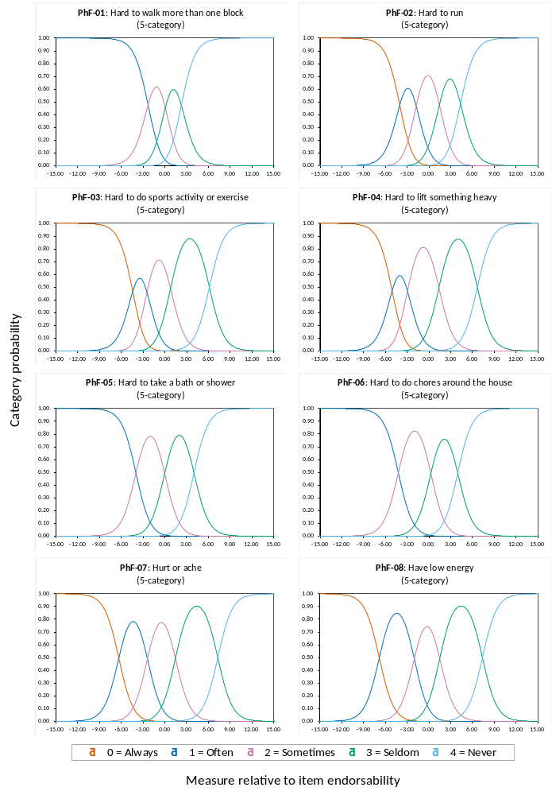

Figure A7 The category probability curves for the Physical Functioning subscale (N = 4312)
Table A22 Category summary statistics of five items in the Emotional Functioning subscale (N = 4325)
Item label | Rating category  (five) | Category count (%) | Average measure | Infit MnSq | Outfit MnSq | Step calibration
EmF-01 | 0 = Always | 8 (0.2) | −7.145 | 0.65 | 0.59 | None
 | 1 = Often | 148 (3.4) | −4.090 | 0.97 | 0.90 | −7.04
 | 2 = Sometimes | 1076 (24.9) | −1.312 | 0.74 | 0.61 | −3.60
 | 3 = Seldom | 2436 (56.3) | 4.698 | 0.81 | 0.78 | 1.92
 | 4 = Never | 657 (15.2) | 7.627 | 0.95 | 0.96 | 8.73
EmF-02 | 0 = Always | 10 (0.2) | −6.691 | 0.72 | 0.77 | None
 | 1 = Often | 267 (6.2) | −3.663 | 0.91 | 0.83 | −8.00
 | 2 = Sometimes | 1402 (32.4) | 0.006 | 0.88 | 0.90 | −3.60
 | 3 = Seldom | 2310 (53.4) | 5.455 | 0.80 | 0.78 | 2.67
 | 4 = Never | 336 (7.8) | 8.441 | 0.78 | 0.70 | 8.92
EmF-03 | 0 = Always | 12 (0.3) | −6.512 | 0.75 | 0.73 | None
 | 1 = Often | 223 (5.2) | −3.892 | 0.85 | 0.79 | −6.96
 | 2 = Sometimes | 1141 (26.4) | −0.732 | 0.88 | 0.85 | −3.16
 | 3 = Seldom | 2075 (48.0) | 4.639 | 0.87 | 0.86 | 2.28
 | 4 = Never | 874 (20.2) | 7.474 | 0.87 | 0.83 | 7.84
EmF-04 | 0 = Always | 34 (0.8) | −4.567 | 1.41 | 1.39 | None
 | 1 = Often | 507 (11.7) | −2.606 | 1.23 | 1.23 | −6.72
 | 2 = Sometimes | 997 (23.1) | 0.265 | 1.33 | 1.38 | −2.16
 | 3 = Seldom | 1829 (42.3) | 4.922 | 1.43 | 2.09 | 2.09
 | 4 = Never | 958 (22.2) | 6.861 | 1.26 | 1.24 | 6.79
EmF-05 | 0 = Always | 76 (1.8) | −4.506 | 1.11 | 1.17 | None
 | 1 = Often | 824 (19.1) | −2.094 | 0.92 | 0.93 | −7.73
 | 2 = Sometimes | 1373 (31.7) | 2.470 | 0.92 | 0.90 | −2.58
 | 3 = Seldom | 1899 (43.9) | 6.208 | 0.93 | 0.91 | 2.27
 | 4 = Never | 153 (3.5) | 8.401 | 1.03 | 0.97 | 8.04
Note. EmF = Emotional Functioning, Infit MnSq = inlier-sensitive fit mean-square, Outfit MnSq = outlier-sensitive fit mean-square.
The average measure values are expressed as Rasch estimated logits.
Missing values were handled using listwise (casewise) deletion.

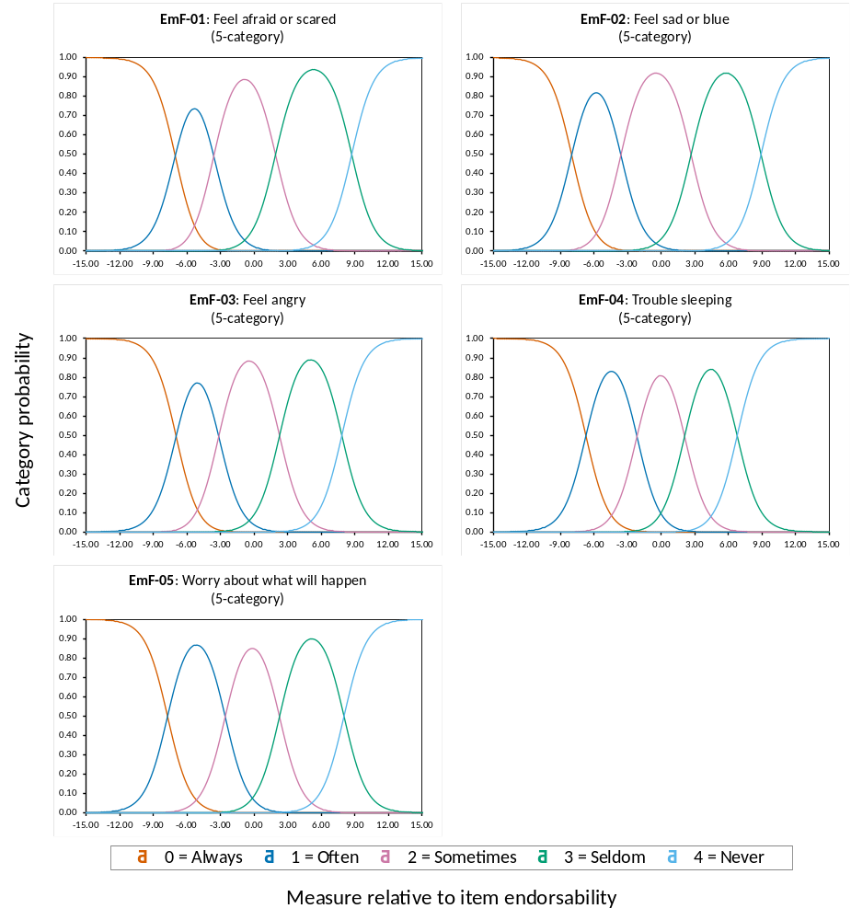
Figure A8 The category probability curves for the Emotional Functioning subscale (N = 4325)
Table A23 Category summary statistics of five items in the Social Functioning subscale (N = 4320)
Item label | Rating category  (five) | Category count (%) | Average measure | Infit MnSq | Outfit MnSq | Step calibration
SoF-01 | 0 = Always | 1 (0.0) | −6.648 | 0.51 | 0.60 | None
 | 1 = Often | 93 (2.2) | −2.732 | 0.99 | 1.00 | −7.77
 | 2 = Sometimes | 496 (11.5) | −0.103 | 0.81 | 0.74 | −2.79
 | 3 = Seldom | 2340 (54.2) | 5.827 | 0.88 | 0.84 | 2.21
 | 4 = Never | 1390 (32.2) | 8.460 | 0.92 | 0.84 | 8.34
SoF-02 | 0 = Always | 3 (0.1) | −5.163 | 0.81 | 0.76 | None
 | 1 = Often | 113 (2.6) | −2.745 | 0.90 | 0.86 | −6.57
 | 2 = Sometimes | 428 (9.9) | −0.213 | 0.79 | 0.79 | −2.34
 | 3 = Seldom | 1602 (37.1) | 5.123 | 0.87 | 0.80 | 1.99
 | 4 = Never | 2174 (50.3) | 7.923 | 0.90 | 0.88 | 6.93
SoF-03 | 0 = Always | 3 (0.1) | −3.968 | 1.15 | 1.04 | None
 | 1 = Often | 146 (3.4) | −2.178 | 1.18 | 1.20 | −8.20
 | 2 = Sometimes | 671 (15.5) | 1.820 | 1.28 | 1.54 | −3.45
 | 3 = Seldom | 3115 (72.1) | 6.706 | 1.44 | 1.55 | 2.00
 | 4 = Never | 385 (8.9) | 8.628 | 1.13 | 1.41 | 9.65
SoF-04 | 0 = Always | 6 (0.1) | −4.534 | 1.00 | 1.23 | None
 | 1 = Often | 110 (2.5) | −2.467 | 1.07 | 1.08 | −6.03
 | 2 = Sometimes | 425 (9.8) | −0.213 | 0.95 | 0.91 | −2.65
 | 3 = Seldom | 1810 (41.9) | 5.380 | 1.01 | 1.18 | 1.65
 | 4 = Never | 1969 (45.6) | 7.958 | 1.01 | 0.99 | 7.02
SoF-05 | 0 = Always | 8 (0.2) | −4.059 | 0.99 | 1.01 | None
 | 1 = Often | 190 (4.4) | −2.284 | 0.95 | 0.94 | −6.64
 | 2 = Sometimes | 426 (9.9) | 0.616 | 0.85 | 0.79 | −2.25
 | 3 = Seldom | 2273 (52.6) | 5.875 | 0.90 | 0.82 | 1.52
 | 4 = Never | 1423 (32.9) | 8.378 | 1.00 | 1.06 | 7.37
Note. SoF = Social Functioning, Infit MnSq = inlier-sensitive fit mean-square, Outfit MnSq = outlier-sensitive fit mean-square.
The average measure values are expressed as Rasch estimated logits.
Missing values were handled using listwise (casewise) deletion.

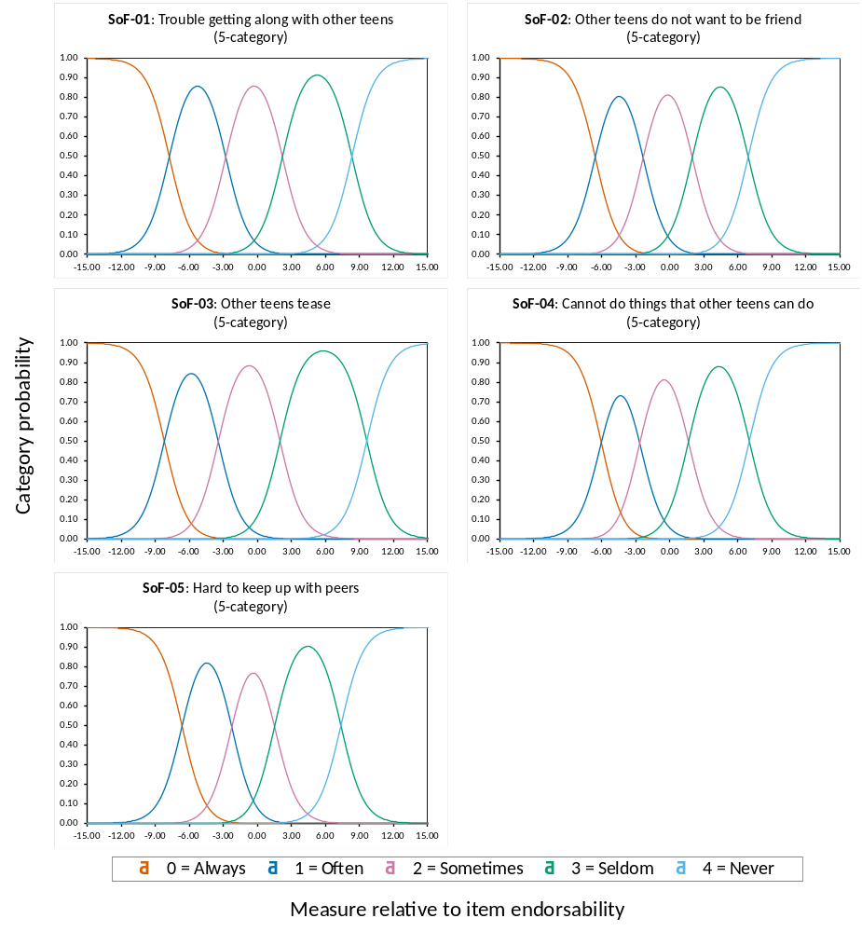
Figure A9 The category probability curves for the Social Functioning subscale (N = 4320)
Table A24 Category summary statistics of five items in the School Functioning subscale (N = 4335)
Item label | Rating category  (five) | Category count (%) | Average measure | Infit MnSq | Outfit MnSq | Step calibration
ScF-01 | 0 = Always | 11 (0.3) | −2.358 | 1.17 | 1.16 | None
 | 1 = Often | 272 (6.3) | −1.275 | 0.96 | 0.94 | −6.22
 | 2 = Sometimes | 1278 (29.5) | 1.000 | 0.78 | 0.64 | −2.65
 | 3 = Seldom | 2587 (59.7) | 4.584 | 0.73 | 0.76 | 1.11
 | 4 = Never | 187 (4.3) | 7.238 | 1.09 | 1.17 | 7.76
ScF-02 | 0 = Always | 8 (0.2) | −3.151 | 0.84 | 0.86 | None
 | 1 = Often | 259 (6.0) | −1.271 | 1.01 | 0.99 | −6.42
 | 2 = Sometimes | 1278 (29.5) | 1.048 | 0.87 | 0.81 | −2.61
 | 3 = Seldom | 2595 (59.9) | 4.505 | 0.82 | 0.83 | 1.21
 | 4 = Never | 195 (4.5) | 7.410 | 1.01 | 0.98 | 7.82
ScF-03 | 0 = Always | 19 (0.4) | −1.694 | 1.43 | 1.53 | None
 | 1 = Often | 375 (8.7) | −1.011 | 0.91 | 0.91 | −6.16
 | 2 = Sometimes | 1787 (41.2) | 1.902 | 0.92 | 0.89 | −2.54
 | 3 = Seldom | 1887 (43.5) | 4.811 | 0.96 | 0.98 | 1.96
 | 4 = Never | 267 (6.2) | 7.704 | 0.81 | 0.72 | 6.75
ScF-04 | 0 = Always | NA | NA | NA | NA | NA
 | 1 = Often | 17 (0.4) | −3.379 | 0.67 | 0.58 | None
 | 2 = Sometimes | 279 (6.4) | −0.957 | 1.05 | 1.04 | −4.03
 | 3 = Seldom | 2408 (55.5) | 2.426 | 1.18 | 2.04 | −1.01
 | 4 = Never | 1631 (37.6) | 5.258 | 1.35 | 1.61 | 5.04
ScF-05 | 0 = Always | 3 (0.1) | −2.349 | 1.67 | 2.66 | None
 | 1 = Often | 5 (0.1) | −2.609 | 1.10 | 1.34 | −1.40
 | 2 = Sometimes | 123 (2.8) | −1.628 | 0.98 | 0.97 | −2.93
 | 3 = Seldom | 1383 (31.9) | 1.048 | 1.01 | 2.06 | −0.28
 | 4 = Never | 2821 (65.1) | 4.557 | 1.17 | 1.18 | 4.61
Note. ScF = School Functioning, Infit MnSq = inlier-sensitive fit mean-square, Outfit MnSq = outlier-sensitive fit mean-square.
The average measure values are expressed as Rasch estimated logits.
NA means no adolescent selected this rating category.
Missing values were handled using listwise (casewise) deletion.

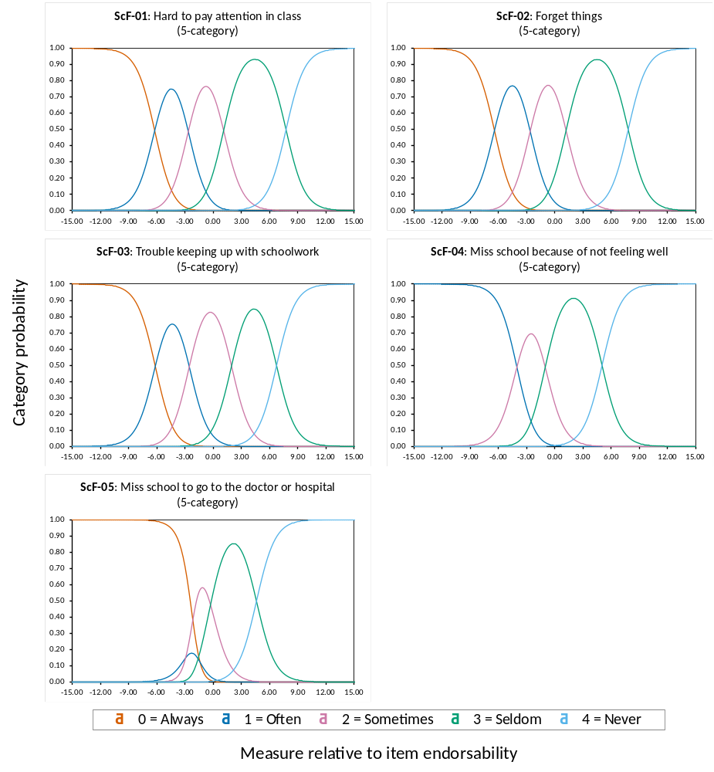
Figure A10 The category probability curves for the School Functioning subscale (N = 4335)
Table A25 Category summary statistics of 15 items in the Psychosocial Health summary score (N = 4212)
Item label | Rating category  (five) | Category count (%) | Average measure | Infit MnSq | Outfit MnSq | Step calibration
EmF-01 | 0 = Always | 7 (0.2) | −1.961 | 0.92 | 0.92 | None
 | 1 = Often | 138 (3.3) | −0.571 | 1.11 | 1.10 | −4.30
 | 2 = Sometimes | 1032 (24.5) | 0.696 | 0.64 | 0.60 | −1.97
 | 3 = Seldom | 2387 (56.7) | 3.167 | 0.72 | 0.71 | 1.20
 | 4 = Never | 648 (15.4) | 4.656 | 0.93 | 0.93 | 5.07
EmF-02 | 0 = Always | 9 (0.2) | −1.038 | 1.31 | 1.36 | None
 | 1 = Often | 248 (5.9) | −0.271 | 1.10 | 1.09 | −4.98
 | 2 = Sometimes | 1359 (32.3) | 1.227 | 0.75 | 0.71 | −1.83
 | 3 = Seldom | 2266 (53.8) | 3.493 | 0.67 | 0.68 | 1.37
 | 4 = Never | 330 (7.8) | 5.152 | 0.84 | 0.83 | 5.43
EmF-03 | 0 = Always | 11 (0.3) | −1.582 | 1.04 | 1.06 | None
 | 1 = Often | 208 (4.9) | −0.316 | 1.19 | 1.19 | −4.24
 | 2 = Sometimes | 1101 (26.1) | 0.902 | 0.67 | 0.65 | −1.57
 | 3 = Seldom | 2040 (48.4) | 3.155 | 0.75 | 0.74 | 1.37
 | 4 = Never | 852 (20.2) | 4.528 | 0.91 | 0.92 | 4.44
EmF-04 | 0 = Always | 32 (0.8) | −0.135 | 2.08 | 1.61 | None
 | 1 = Often | 483 (11.5) | 0.097 | 1.16 | 1.14 | −4.12
 | 2 = Sometimes | 968 (23.0) | 1.358 | 0.91 | 0.90 | −0.65
 | 3 = Seldom | 1789 (42.5) | 3.308 | 1.02 | 1.29 | 1.07
 | 4 = Never | 940 (22.3) | 4.177 | 1.17 | 1.15 | 3.70
EmF-05 | 0 = Always | 72 (1.7) | −0.440 | 1.42 | 1.24 | None
 | 1 = Often | 792 (18.8) | 0.387 | 0.81 | 0.76 | −4.67
 | 2 = Sometimes | 1333 (31.6) | 2.235 | 0.93 | 0.90 | −1.07
 | 3 = Seldom | 1863 (44.2) | 3.842 | 0.82 | 0.84 | 0.76
 | 4 = Never | 152 (3.6) | 5.224 | 0.98 | 0.95 | 4.98
SoF-01 | 0 = Always | 1 (0.0) | −2.771 | 0.62 | 0.74 | None
 | 1 = Often | 87 (2.1) | −1.184 | 0.94 | 0.91 | −4.87
 | 2 = Sometimes | 477 (11.3) | −0.131 | 0.62 | 0.58 | −1.03
 | 3 = Seldom | 2288 (54.3) | 2.645 | 0.93 | 1.01 | 0.93
 | 4 = Never | 1359 (32.3) | 3.913 | 1.24 | 1.25 | 4.96
SoF-02 | 0 = Always | 3 (0.1) | −2.235 | 0.89 | 0.91 | None
 | 1 = Often | 109 (2.6) | −1.154 | 0.88 | 0.87 | −3.95
 | 2 = Sometimes | 408 (9.7) | −0.145 | 0.66 | 0.61 | −0.68
 | 3 = Seldom | 1566 (37.2) | 2.203 | 0.92 | 0.88 | 0.87
 | 4 = Never | 2126 (50.5) | 3.736 | 1.14 | 1.11 | 3.76
SoF-03 | 0 = Always | 3 (0.1) | −2.223 | 0.76 | 0.82 | None
 | 1 = Often | 136 (3.2) | −1.023 | 0.86 | 0.76 | −5.02
 | 2 = Sometimes | 648 (15.4) | 0.696 | 0.99 | 1.04 | −1.57
 | 3 = Seldom | 3049 (72.4) | 3.034 | 0.89 | 0.97 | 0.47
 | 4 = Never | 376 (8.9) | 4.379 | 1.14 | 1.14 | 6.13
SoF-04 | 0 = Always | 6 (0.1) | −1.946 | 1.02 | 1.24 | None
 | 1 = Often | 107 (2.5) | −1.148 | 0.88 | 0.85 | −3.46
 | 2 = Sometimes | 406 (9.6) | −0.100 | 0.72 | 0.72 | −0.92
 | 3 = Seldom | 1766 (41.9) | 2.340 | 0.93 | 1.16 | 0.57
 | 4 = Never | 1927 (45.8) | 3.759 | 1.18 | 1.16 | 3.82
SoF-05 | 0 = Always | 8 (0.2) | −2.296 | 0.70 | 0.81 | None
 | 1 = Often | 178 (4.2) | −1.022 | 0.79 | 0.74 | −3.92
 | 2 = Sometimes | 411 (9.8) | 0.222 | 0.74 | 0.71 | −0.60
 | 3 = Seldom | 2222 (52.8) | 2.604 | 0.86 | 0.97 | 0.26
 | 4 = Never | 1393 (33.1) | 3.967 | 1.18 | 1.17 | 4.26
Continued

Table A25 Continued
Item label | Rating category  (five) | Category count (%) | Average measure | Infit MnSq | Outfit MnSq | Step calibration
ScF-01 | 0 = Always | 10 (0.2) | −0.249 | 1.81 | 2.58 | None
 | 1 = Often | 248 (5.9) | −0.087 | 1.32 | 1.44 | −5.05
 | 2 = Sometimes | 1241 (29.5) | 1.276 | 0.91 | 0.86 | −1.96
 | 3 = Seldom | 2530 (60.1) | 3.460 | 0.91 | 0.92 | 0.97
 | 4 = Never | 183 (4.3) | 4.867 | 1.05 | 1.06 | 6.05
ScF-02 | 0 = Always | 7 (0.2) | −1.520 | 1.05 | 1.06 | None
 | 1 = Often | 243 (5.8) | −0.167 | 1.29 | 1.39 | −5.30
 | 2 = Sometimes | 1233 (29.3) | 1.283 | 0.91 | 0.86 | −1.89
 | 3 = Seldom | 2541 (60.3) | 3.438 | 0.93 | 0.93 | 1.05
 | 4 = Never | 188 (4.5) | 4.992 | 1.00 | 0.98 | 6.13
ScF-03 | 0 = Always | 16 (0.4) | 0.142 | 1.90 | 2.04 | None
 | 1 = Often | 342 (8.1) | 0.036 | 1.17 | 1.18 | −5.00
 | 2 = Sometimes | 1745 (41.4) | 1.893 | 1.06 | 1.05 | −1.87
 | 3 = Seldom | 1845 (43.8) | 3.536 | 1.13 | 1.13 | 1.69
 | 4 = Never | 264 (6.3) | 5.161 | 0.89 | 0.89 | 5.18
ScF-04 | 0 = Always | NA | NA | NA | NA | NA
 | 1 = Often | 15 (0.4) | −1.608 | 0.95 | 1.01 | None
 | 2 = Sometimes | 260 (6.2) | −0.168 | 1.04 | 1.06 | −3.26
 | 3 = Seldom | 2345 (55.7) | 2.317 | 1.20 | 1.33 | −0.77
 | 4 = Never | 1592 (37.8) | 3.665 | 1.37 | 1.46 | 4.03
ScF-05 | 0 = Always | 3 (0.1) | −1.556 | 1.37 | 1.88 | None
 | 1 = Often | 5 (0.1) | −0.327 | 1.65 | 2.05 | −0.71
 | 2 = Sometimes | 116 (2.8) | −0.244 | 1.29 | 1.29 | −2.51
 | 3 = Seldom | 1338 (31.8) | 1.424 | 1.11 | 1.29 | −0.36
 | 4 = Never | 2750 (65.3) | 3.392 | 1.28 | 1.24 | 3.58
Note. EmF = Emotional Functioning, SoF = Social Functioning, ScF = School Functioning, Infit MnSq = inlier-sensitive fit mean-square, Outfit MnSq = outlier-sensitive fit mean-square.
The average measure values are expressed as Rasch estimated logits.
Missing values were handled using listwise (casewise) deletion.

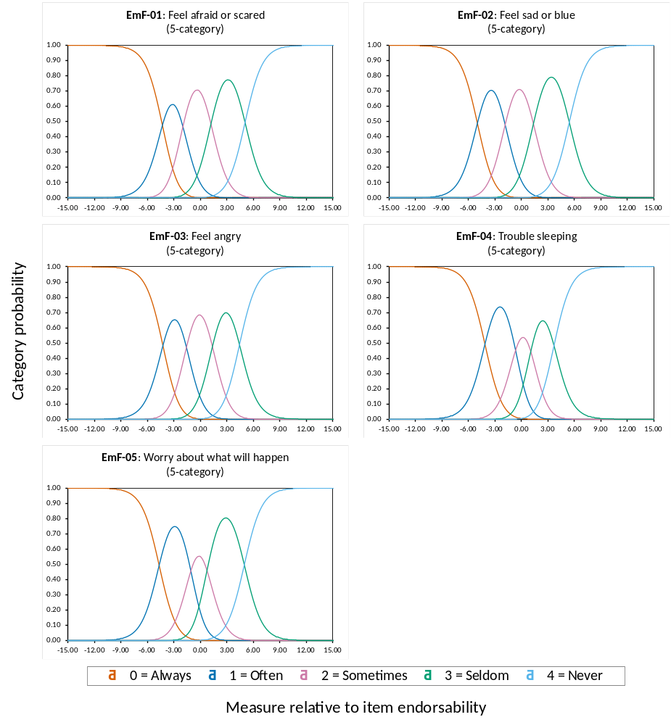
Figure A11 The category probability curves for the Psychosocial Health summary score (Emotional Functioning subscale) (N = 4212)
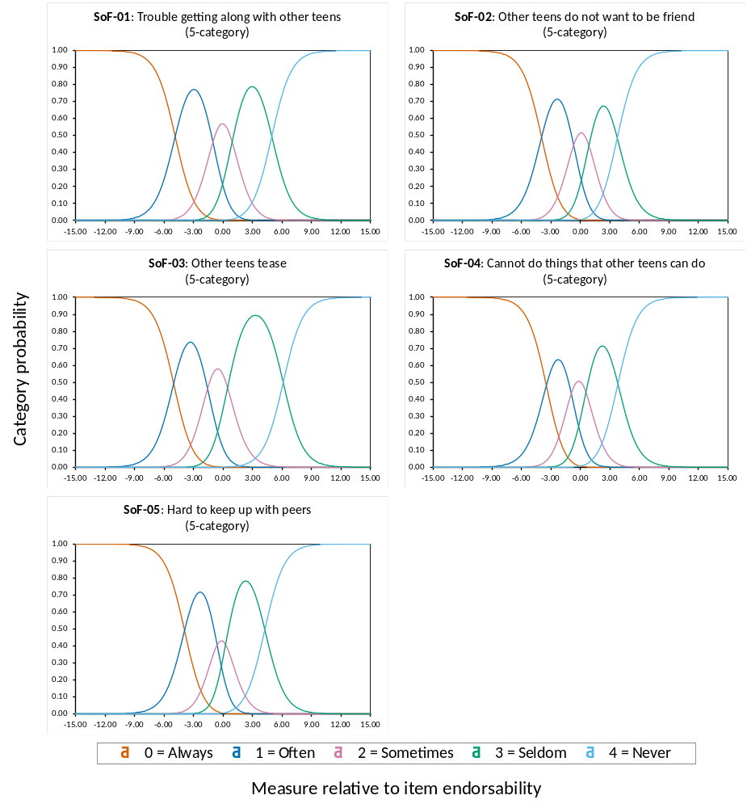
Figure A12 The category probability curves for the Psychosocial Health summary score (Social Functioning subscale) (N = 4212)
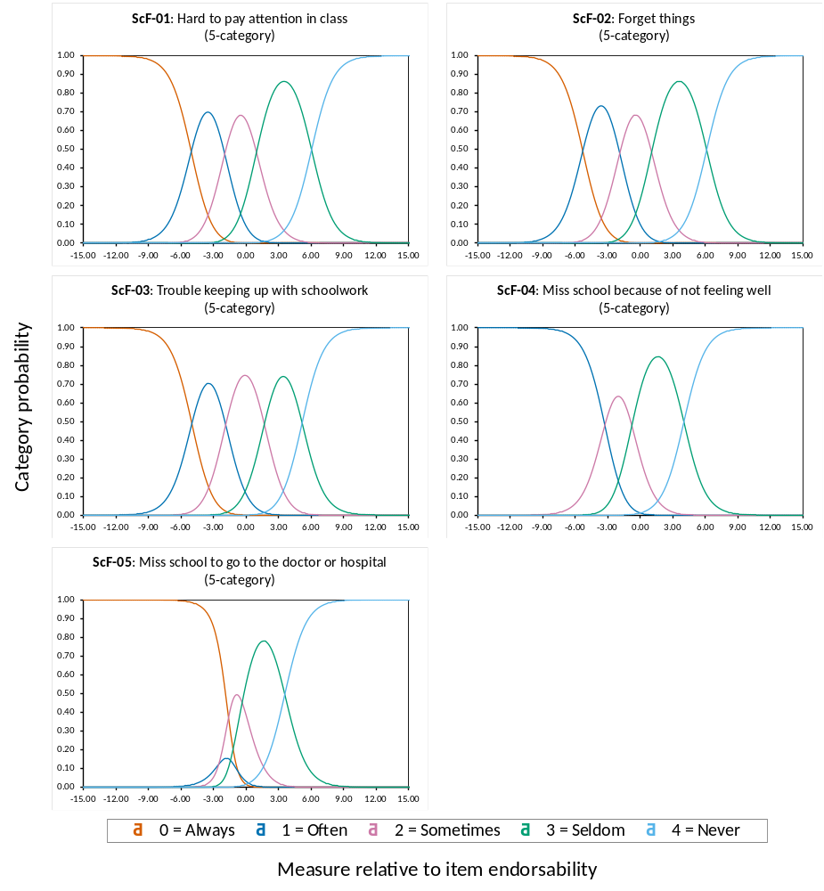
Figure A13 The category probability curves for the Psychosocial Health summary score (School Functioning subscale) (N = 4212)
Table A26 Category summary statistics of 23 items in the Health-related Quality of Life summary score (N = 4145)
Item label | Rating category  (five) | Category count (%) | Average measure | Infit MnSq | Outfit MnSq | Step calibration
PhF-01 | 0 = Always | NA | NA | NA | NA | NA
 | 1 = Often | 4 (0.1) | −1.362 | 1.05 | 1.69 | None
 | 2 = Sometimes | 30 (0.7) | 0.265 | 1.36 | 3.73 | −1.05
 | 3 = Seldom | 152 (3.7) | 0.815 | 0.95 | 1.26 | 0.44
 | 4 = Never | 3959 (95.5) | 3.027 | 1.00 | 1.01 | 0.61
PhF-02 | 0 = Always | 2 (0.0) | −2.513 | 0.44 | 0.40 | None
 | 1 = Often | 15 (0.4) | 0.032 | 1.67 | 2.07 | −1.76
 | 2 = Sometimes | 136 (3.3) | 0.192 | 1.02 | 1.28 | −1.06
 | 3 = Seldom | 545 (13.1) | 1.577 | 1.04 | 1.29 | 0.84
 | 4 = Never | 3447 (83.2) | 3.258 | 1.03 | 1.02 | 1.98
PhF-03 | 0 = Always | 4 (0.1) | −1.487 | 0.92 | 1.48 | None
 | 1 = Often | 27 (0.7) | −0.528 | 0.96 | 0.99 | −2.20
 | 2 = Sometimes | 219 (5.3) | 0.362 | 0.78 | 0.74 | −1.36
 | 3 = Seldom | 1813 (43.7) | 2.496 | 1.11 | 1.07 | 0.00
 | 4 = Never | 2082 (50.2) | 3.615 | 1.32 | 1.28 | 3.57
PhF-04 | 0 = Always | 4 (0.1) | −1.551 | 0.88 | 1.11 | None
 | 1 = Often | 28 (0.7) | −0.388 | 0.96 | 0.94 | −2.42
 | 2 = Sometimes | 391 (9.4) | 1.001 | 1.07 | 1.08 | −2.00
 | 3 = Seldom | 2178 (52.5) | 2.733 | 1.06 | 1.05 | 0.41
 | 4 = Never | 1544 (37.2) | 3.746 | 1.36 | 1.32 | 4.01
PhF-05 | 0 = Always | NA | NA | NA | NA | NA
 | 1 = Often | 1 (0.0) | −2.259 | 0.63 | 0.49 | None
 | 2 = Sometimes | 25 (0.6) | −0.653 | 0.90 | 0.77 | −1.89
 | 3 = Seldom | 318 (7.7) | 0.792 | 0.91 | 0.79 | 0.00
 | 4 = Never | 3801 (91.7) | 3.125 | 0.82 | 0.92 | 1.89
PhF-06 | 0 = Always | NA | NA | NA | NA | NA
 | 1 = Often | 4 (0.1) | −0.696 | 1.21 | 1.20 | None
 | 2 = Sometimes | 108 (2.6) | −0.065 | 0.95 | 0.90 | −2.40
 | 3 = Seldom | 617 (14.9) | 1.619 | 1.09 | 1.14 | 0.35
 | 4 = Never | 3416 (82.4) | 3.256 | 1.03 | 1.02 | 2.05
PhF-07 | 0 = Always | 3 (0.1) | −1.435 | 0.96 | 1.11 | None
 | 1 = Often | 63 (1.5) | −0.200 | 0.96 | 0.93 | −3.57
 | 2 = Sometimes | 487 (11.7) | 1.378 | 1.18 | 1.21 | −1.43
 | 3 = Seldom | 2515 (60.7) | 2.881 | 1.03 | 1.05 | 0.50
 | 4 = Never | 1077 (26.0) | 3.911 | 1.30 | 1.24 | 4.50
PhF-08 | 0 = Always | 3 (0.1) | −1.305 | 1.05 | 1.33 | None
 | 1 = Often | 100 (2.4) | −0.326 | 0.78 | 0.70 | −4.06
 | 2 = Sometimes | 553 (13.3) | 1.465 | 1.10 | 1.12 | −1.11
 | 3 = Seldom | 2568 (62.0) | 2.968 | 1.06 | 1.10 | 0.57
 | 4 = Never | 921 (22.2) | 4.035 | 1.19 | 1.16 | 4.60
Continued

Table A26 Continued
Item label | Rating category  (five) | Category count (%) | Average measure | Infit MnSq | Outfit MnSq | Step calibration
EmF-01 | 0 = Always | 7 (0.2) | −0.602 | 1.15 | 1.17 | None
 | 1 = Often | 136 (3.3) | 0.322 | 1.03 | 1.02 | −3.89
 | 2 = Sometimes | 1007 (24.3) | 1.366 | 0.67 | 0.62 | −1.66
 | 3 = Seldom | 2359 (56.9) | 3.304 | 0.72 | 0.72 | 1.02
 | 4 = Never | 636 (15.3) | 4.566 | 0.93 | 0.93 | 4.53
EmF-02 | 0 = Always | 9 (0.2) | 0.300 | 1.52 | 1.52 | None
 | 1 = Often | 242 (5.8) | 0.621 | 1.04 | 1.01 | −4.50
 | 2 = Sometimes | 1335 (32.2) | 1.774 | 0.76 | 0.72 | −1.56
 | 3 = Seldom | 2235 (53.9) | 3.567 | 0.70 | 0.71 | 1.15
 | 4 = Never | 324 (7.8) | 5.001 | 0.86 | 0.86 | 4.90
EmF-03 | 0 = Always | 11 (0.3) | −0.325 | 1.23 | 1.23 | None
 | 1 = Often | 205 (4.9) | 0.617 | 1.14 | 1.14 | −3.81
 | 2 = Sometimes | 1079 (26.0) | 1.528 | 0.71 | 0.68 | −1.29
 | 3 = Seldom | 2009 (48.5) | 3.300 | 0.78 | 0.77 | 1.18
 | 4 = Never | 841 (20.3) | 4.413 | 0.95 | 0.95 | 3.92
EmF-04 | 0 = Always | 32 (0.8) | 0.891 | 2.17 | 1.80 | None
 | 1 = Often | 471 (11.4) | 0.876 | 1.06 | 1.04 | −3.65
 | 2 = Sometimes | 954 (23.0) | 1.875 | 0.87 | 0.85 | −0.47
 | 3 = Seldom | 1764 (42.6) | 3.433 | 0.97 | 1.21 | 0.88
 | 4 = Never | 924 (22.3) | 4.141 | 1.16 | 1.14 | 3.24
EmF-05 | 0 = Always | 72 (1.7) | 0.538 | 1.42 | 1.28 | None
 | 1 = Often | 775 (18.7) | 1.126 | 0.81 | 0.74 | −4.13
 | 2 = Sometimes | 1311 (31.6) | 2.548 | 0.92 | 0.90 | −0.92
 | 3 = Seldom | 1836 (44.3) | 3.860 | 0.81 | 0.84 | 0.53
 | 4 = Never | 151 (3.6) | 5.136 | 0.97 | 0.95 | 4.52
SoF-01 | 0 = Always | 1 (0.0) | −0.333 | 1.38 | 1.16 | None
 | 1 = Often | 85 (2.1) | −0.012 | 1.08 | 1.06 | −4.58
 | 2 = Sometimes | 465 (11.2) | 0.713 | 0.64 | 0.60 | −0.71
 | 3 = Seldom | 2257 (54.5) | 2.844 | 0.89 | 0.90 | 0.86
 | 4 = Never | 1337 (32.3) | 4.011 | 1.10 | 1.08 | 4.43
SoF-02 | 0 = Always | 2 (0.0) | −2.211 | 0.46 | 0.72 | None
 | 1 = Often | 105 (2.5) | 0.031 | 1.04 | 0.99 | −3.98
 | 2 = Sometimes | 400 (9.7) | 0.699 | 0.69 | 0.60 | −0.33
 | 3 = Seldom | 1543 (37.2) | 2.511 | 0.93 | 0.87 | 0.93
 | 4 = Never | 2095 (50.5) | 3.799 | 1.04 | 1.03 | 3.38
SoF-03 | 0 = Always | 3 (0.1) | −1.819 | 0.67 | 0.71 | None
 | 1 = Often | 131 (3.2) | 0.091 | 0.96 | 0.80 | −4.64
 | 2 = Sometimes | 634 (15.3) | 1.310 | 0.90 | 0.88 | −1.25
 | 3 = Seldom | 3006 (72.5) | 3.227 | 0.90 | 0.99 | 0.34
 | 4 = Never | 371 (9.0) | 4.240 | 1.18 | 1.13 | 5.55
SoF-04 | 0 = Always | 6 (0.1) | −0.474 | 1.38 | 1.60 | None
 | 1 = Often | 103 (2.5) | −0.075 | 0.97 | 0.93 | −3.17
 | 2 = Sometimes | 396 (9.6) | 0.727 | 0.72 | 0.67 | −0.66
 | 3 = Seldom | 1739 (42.0) | 2.619 | 0.92 | 1.04 | 0.51
 | 4 = Never | 1901 (45.9) | 3.829 | 1.06 | 1.04 | 3.32
SoF-05 | 0 = Always | 8 (0.2) | −1.436 | 0.69 | 0.79 | None
 | 1 = Often | 174 (4.2) | 0.025 | 0.88 | 0.81 | −3.58
 | 2 = Sometimes | 401 (9.7) | 0.955 | 0.69 | 0.63 | −0.31
 | 3 = Seldom | 2189 (52.8) | 2.852 | 0.87 | 0.94 | 0.17
 | 4 = Never | 1373 (33.1) | 4.001 | 1.10 | 1.06 | 3.73
Continued

Table A26 Continued
Item label | Rating category  (five) | Category count (%) | Average measure | Infit MnSq | Outfit MnSq | Step calibration
ScF-01 | 0 = Always | 10 (0.2) | 0.672 | 1.82 | 2.59 | None
 | 1 = Often | 244 (5.9) | 0.797 | 1.22 | 1.30 | −4.58
 | 2 = Sometimes | 1213 (29.3) | 1.835 | 0.92 | 0.88 | −1.67
 | 3 = Seldom | 2496 (60.2) | 3.545 | 0.89 | 0.91 | 0.75
 | 4 = Never | 182 (4.4) | 4.592 | 1.11 | 1.10 | 5.49
ScF-02 | 0 = Always | 6 (0.1) | −1.150 | 0.78 | 0.83 | None
 | 1 = Often | 237 (5.7) | 0.687 | 1.16 | 1.25 | −4.95
 | 2 = Sometimes | 1209 (29.2) | 1.835 | 0.89 | 0.85 | −1.56
 | 3 = Seldom | 2508 (60.5) | 3.531 | 0.89 | 0.90 | 0.88
 | 4 = Never | 185 (4.5) | 4.765 | 1.04 | 1.04 | 5.63
ScF-03 | 0 = Always | 15 (0.4) | 0.860 | 1.80 | 1.84 | None
 | 1 = Often | 334 (8.1) | 0.843 | 1.06 | 1.06 | −4.52
 | 2 = Sometimes | 1709 (41.2) | 2.281 | 1.01 | 1.01 | −1.62
 | 3 = Seldom | 1827 (44.1) | 3.617 | 1.02 | 1.02 | 1.44
 | 4 = Never | 260 (6.3) | 5.051 | 0.88 | 0.89 | 4.69
ScF-04 | 0 = Always | NA | NA | NA | NA | NA
 | 1 = Often | 15 (0.4) | −1.238 | 0.72 | 0.61 | None
 | 2 = Sometimes | 254 (6.1) | 0.365 | 0.79 | 0.80 | −2.87
 | 3 = Seldom | 2304 (55.6) | 2.626 | 1.05 | 1.11 | −0.68
 | 4 = Never | 1572 (37.9) | 3.809 | 1.17 | 1.20 | 3.55
ScF-05 | 0 = Always | 3 (0.1) | −1.579 | 0.99 | 1.45 | None
 | 1 = Often | 5 (0.1) | −0.549 | 1.14 | 1.27 | −0.66
 | 2 = Sometimes | 112 (2.7) | 0.120 | 0.89 | 0.84 | −2.24
 | 3 = Seldom | 1311 (31.6) | 1.919 | 1.00 | 1.10 | −0.25
 | 4 = Never | 2714 (65.5) | 3.533 | 1.03 | 1.03 | 3.15
Note. PhF = Physical Functioning, EmF = Emotional Functioning, SoF = Social Functioning, ScF = School Functioning, Infit MnSq = inlier-sensitive fit mean-square, Outfit MnSq = outlier-sensitive fit mean-square.
The average measure values are expressed as Rasch estimated logits.
NA means no adolescent selected this rating category.
Missing values were handled using listwise (casewise) deletion.

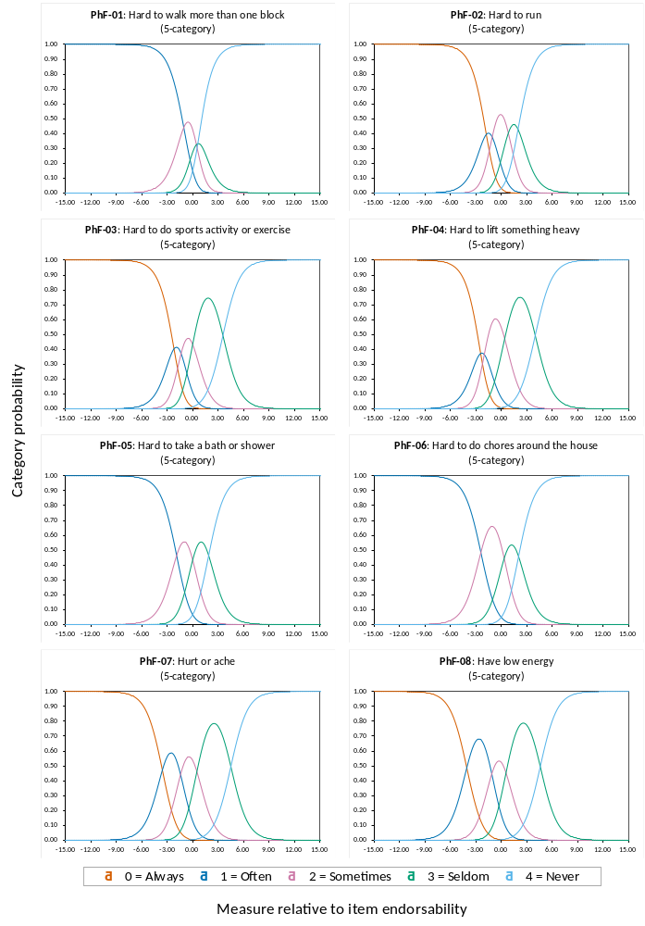
Figure A14 The category probability curves for the Health-related Quality of Life summary score (Physical Functioning subscale) (N = 4145)
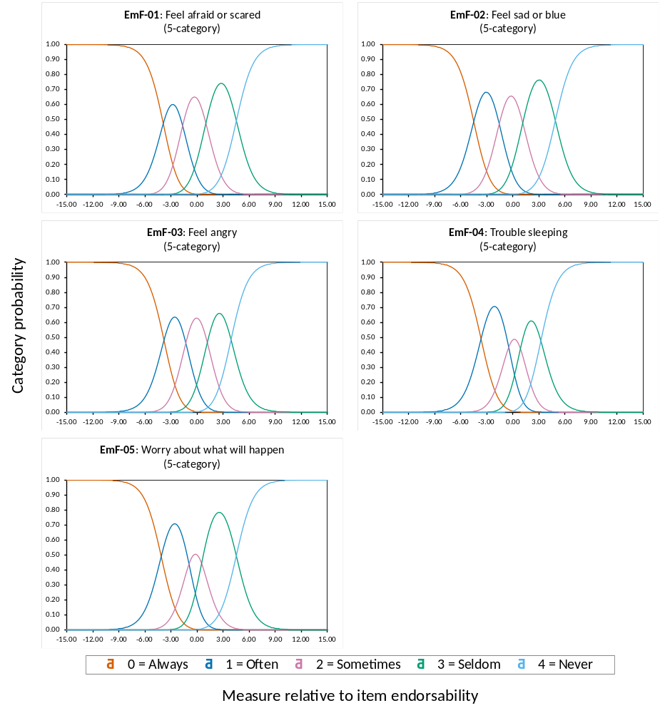
Figure A15 The category probability curves for the Health-related Quality of Life summary score (Emotional Functioning subscale) (N = 4145)
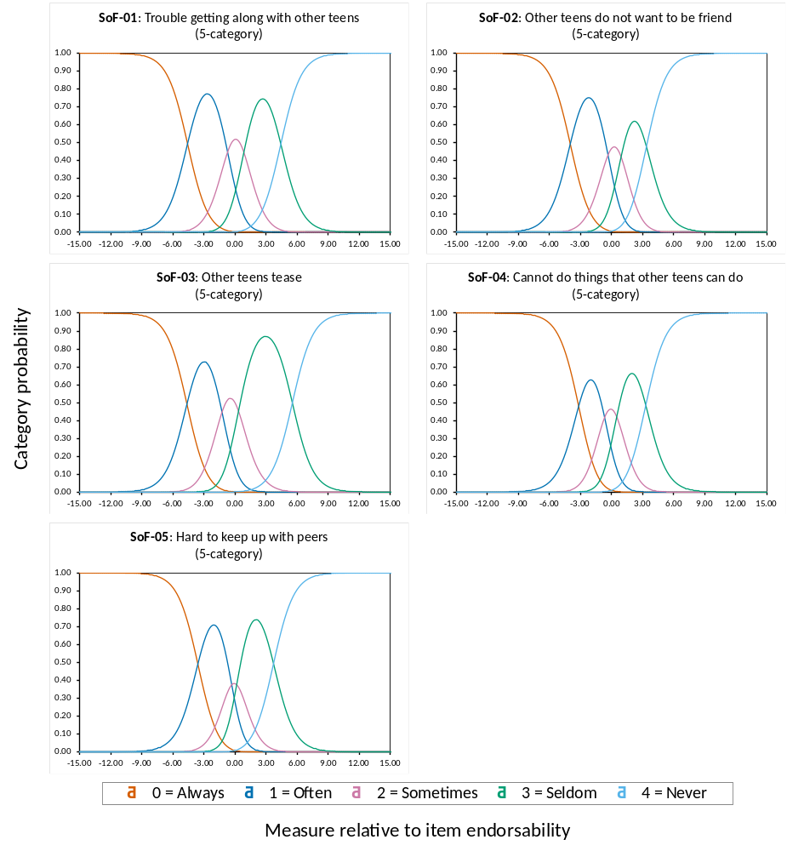
Figure A16 The category probability curves for the Health-related Quality of Life summary score (Social Functioning subscale) (N = 4145)
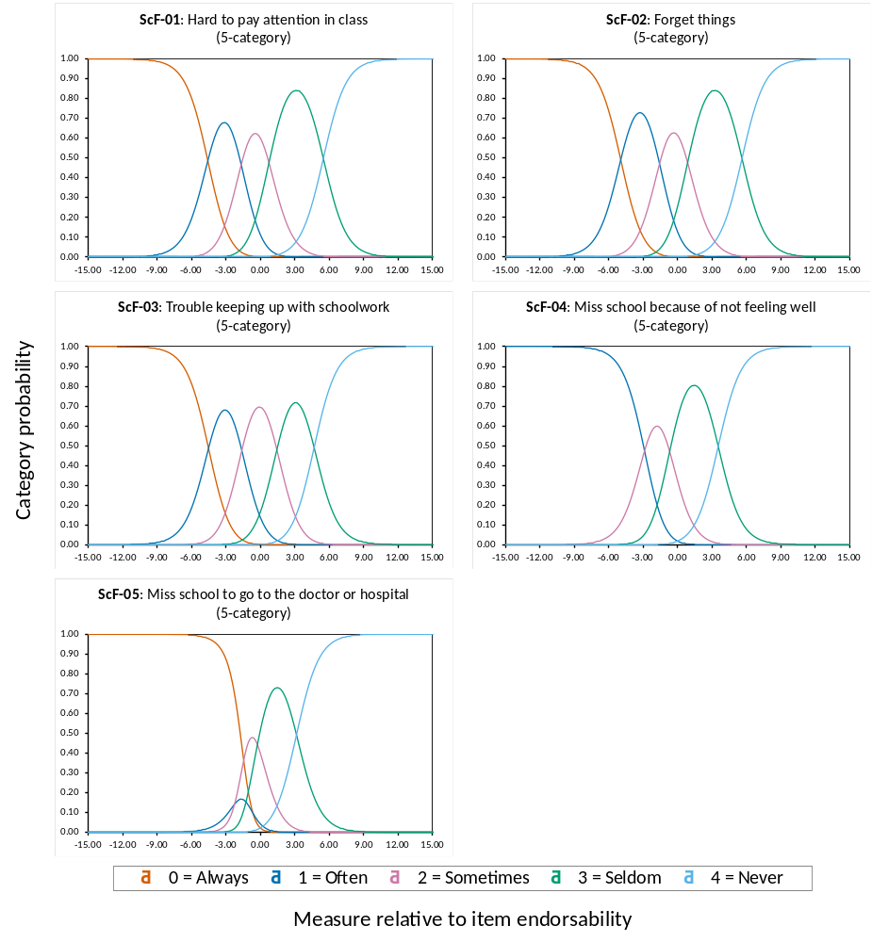
Figure A17 The category probability curves for the Health-related Quality of Life summary score (School Functioning subscale) (N = 4145)
Rating Scale Model
Table A27 Category summary statistics of 23 items in the Mandarin Chinese self-reported Pediatric Quality of Life Inventory™ Version 4.0 Generic Core Scales
Subscale label | Rating category  (five) | Category count (%) | Average measure | Infit MnSq | Outfit MnSq | Step calibration
PhF | 0 = Always | 16 (0.0) | −5.754 | 1.98 | 2.23 | None
 | 1 = Often | 266 (0.8) | −1.994 | 1.28 | 1.30 | −7.02
 | 2 = Sometimes | 2079 (6.0) | 1.943 | 1.11 | 1.13 | −2.47
 | 3 = Seldom | 11170 (32.4) | 5.541 | 0.92 | 1.16 | 2.16
 | 4 = Never | 20965 (60.8) | 10.540 | 0.95 | 0.99 | 7.32
EmF | 0 = Always | 140 (0.6) | −5.608 | 1.22 | 1.25 | None
 | 1 = Often | 1969 (9.1) | −3.194 | 1.00 | 0.99 | −7.15
 | 2 = Sometimes | 5989 (27.7) | 0.112 | 0.95 | 0.94 | −2.77
 | 3 = Seldom | 10549 (48.8) | 5.041 | 0.96 | 0.96 | 2.12
 | 4 = Never | 2978 (13.8) | 7.701 | 1.02 | 1.01 | 7.80
SoF | 0 = Always | 21 (0.1) | −4.859 | 1.44 | 1.49 | None
 | 1 = Often | 652 (3.0) | −2.714 | 1.34 | 1.39 | −7.86
 | 2 = Sometimes | 2446 (11.3) | 0.584 | 1.15 | 1.17 | −2.88
 | 3 = Seldom | 11140 (51.6) | 6.378 | 0.94 | 0.89 | 2.32
 | 4 = Never | 7341 (34.0) | 9.172 | 0.90 | 0.88 | 8.42
ScF | 0 = Always | 41 (0.2) | −3.115 | 1.75 | 1.76 | None
 | 1 = Often | 928 (4.3) | −2.223 | 1.01 | 1.00 | −6.44
 | 2 = Sometimes | 4745 (21.9) | 0.565 | 0.90 | 0.84 | −2.47
 | 3 = Seldom | 10860 (50.1) | 4.373 | 0.94 | 1.32 | 1.58
 | 4 = Never | 5101 (23.5) | 8.765 | 1.11 | 1.15 | 7.33
PSH | 0 = Always | 188 (0.3) | −1.606 | 1.70 | 1.66 | None
 | 1 = Often | 3339 (5.3) | −0.782 | 1.19 | 1.20 | −4.67
 | 2 = Sometimes | 12738 (20.2) | 0.756 | 0.86 | 0.83 | −1.36
 | 3 = Seldom | 31835 (50.4) | 3.172 | 0.93 | 0.98 | 1.12
 | 4 = Never | 15080 (23.9) | 5.195 | 1.06 | 1.06 | 4.91
HRQoL | 0 = Always | 201 (0.2) | −1.154 | 1.79 | 1.78 | None
 | 1 = Often | 3504 (3.7) | −0.379 | 1.16 | 1.18 | −4.24
 | 2 = Sometimes | 14428 (15.1) | 0.964 | 0.91 | 0.95 | −1.14
 | 3 = Seldom | 42089 (44.1) | 3.028 | 0.93 | 0.91 | 0.97
 | 4 = Never | 35113 (36.8) | 5.787 | 1.05 | 1.04 | 4.41
Note. PhF = Physical Functioning, EmF = Emotional Functioning, SoF = Social Functioning, ScF = School Functioning, PSH = Psychosocial Health, HRQoL = Health-related Quality of Life.
Infit MnSq = inlier-sensitive fit mean-square, Outfit MnSq = outlier-sensitive fit mean-square.
The average measure values are expressed as Rasch estimated logits.
N_{(PhF)} = 4312, N_{(EmF)} = 4325, N_{(SoF)} = 4320, N_{(ScF)} = 4335, N_{(PSH)} = 4212, N_{(HRQoL)} = 4145.
Missing values were handled using listwise (casewise) deletion.

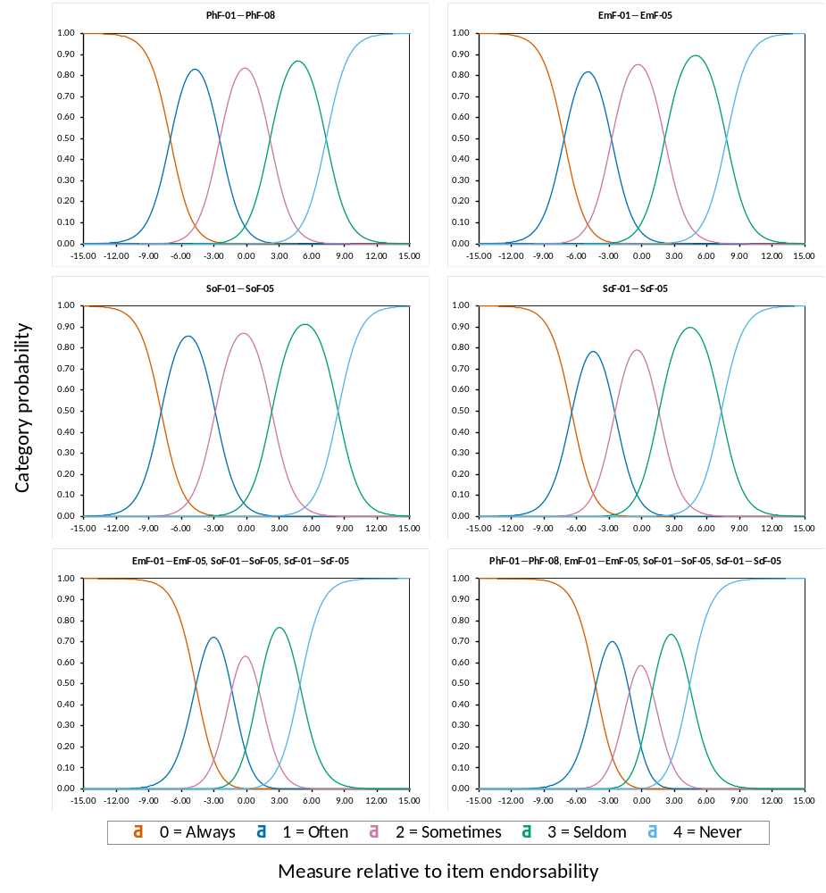

Figure A18 The category probability curves for the Mandarin Chinese self-reported Pediatric Quality of Life Inventory™ Version 4.0 Generic Core Scales

Appendix 11: Measures and goodness-of-ﬁt statistics for each item of the Mandarin Chinese self-reported Pediatric Quality of Life Inventory™ Version 4.0 Generic Core Scales (PedsQL™ 4.0 GCS)

Table A28 Measures and goodness-of-ﬁt statistics for each item of the four subscales
Item abbreviation  and label | Item  measure | SE | Inﬁt statistics |  |  | Outﬁt statistics
Item abbreviation  and label | Item  measure | SE | MnSq | Zstd |  | MnSq | Zstd
PhF-01 | −1.700 | 0.086 | 1.32 | 4.15 |  | 2.76 | 8.47
PhF-02 | −0.880 | 0.049 | 0.90 | −2.86 |  | 0.79 | −1.77
PhF-03 | 0.509 | 0.038 | 0.71 | −9.90 |  | 0.61 | −9.90
PhF-04 | 1.086 | 0.037 | 0.82 | −8.41 |  | 0.78 | −8.42
PhF-05 | −2.100 | 0.072 | 0.89 | −2.21 |  | 1.27 | 1.81
PhF-06 | −0.340 | 0.050 | 1.07 | 1.96 |  | 1.22 | 1.75
PhF-07 | 1.547 | 0.038 | 1.19 | 7.46 |  | 1.24 | 7.36
PhF-08 | 1.878 | 0.037 | 1.12 | 4.99 |  | 1.24 | 7.31
EmF-01 | −1.087 | 0.039 | 0.86 | −6.26 |  | 0.81 | −5.82
EmF-02 | −0.085 | 0.039 | 0.84 | −6.76 |  | 0.81 | −6.05
EmF-03 | −0.823 | 0.036 | 0.87 | −6.22 |  | 0.84 | −5.91
EmF-04 | −0.001 | 0.033 | 1.33 | 9.90 |  | 1.54 | 9.90
EmF-05 | 1.996 | 0.036 | 0.95 | −2.43 |  | 0.93 | −2.41
SoF-01 | −0.498 | 0.038 | 0.89 | −5.08 |  | 0.83 | −6.08
SoF-02 | −0.573 | 0.037 | 0.87 | −6.16 |  | 0.82 | −4.92
SoF-03 | 0.950 | 0.044 | 1.26 | 8.42 |  | 1.47 | 8.67
SoF-04 | −0.281 | 0.037 | 1.00 | 0.22 |  | 1.07 | 2.15
SoF-05 | 0.401 | 0.036 | 0.93 | −3.09 |  | 0.92 | −3.00
ScF-01 | 0.999 | 0.035 | 0.84 | −7.00 |  | 0.82 | −5.94
ScF-02 | 0.872 | 0.036 | 0.89 | −4.58 |  | 0.87 | −4.29
ScF-03 | 1.400 | 0.032 | 0.93 | −3.50 |  | 0.91 | −4.10
ScF-04 | −0.693 | 0.037 | 1.20 | 8.53 |  | 1.66 | 9.90
ScF-05 | −2.579 | 0.041 | 1.07 | 2.61 |  | 1.73 | 7.33
Note. PhF = Physical Functioning, EmF = Emotional Functioning, SoF = Social Functioning, ScF = School Functioning.
Measure = Rasch estimated logits, SE = standard error, Infit = information-weighted fit, Outfit = outlier-sensitive fit, MnSq = mean-square, Zstd = z-standardized.
The item measure values are expressed as Rasch estimated logits.
N_{(PhF)} = 4312, N_{(EmF)} = 4325, N_{(SoF)} = 4320, N_{(ScF)} = 4335.
Missing values were handled using listwise (casewise) deletion.

Table A29 Measures and goodness-of-ﬁt statistics for each item of the Psychosocial Health summary score (N = 4212)
Item abbreviation  and label | Item  measure | SE | Inﬁt statistics |  |  | Outﬁt statistics
Item abbreviation  and label | Item  measure | SE | MnSq | Zstd |  | MnSq | Zstd
EmF-01 | 0.058 | 0.030 | 0.80 | −9.37 |  | 0.79 | −9.90
EmF-02 | 0.621 | 0.030 | 0.81 | −8.90 |  | 0.79 | −9.60
EmF-03 | 0.192 | 0.028 | 0.84 | −8.16 |  | 0.83 | −8.56
EmF-04 | 0.710 | 0.025 | 1.09 | 4.14 |  | 1.13 | 5.68
EmF-05 | 1.977 | 0.027 | 0.90 | −4.70 |  | 0.88 | −5.30
SoF-01 | −1.124 | 0.030 | 0.98 | −1.06 |  | 1.01 | 0.23
SoF-02 | −1.113 | 0.030 | 0.93 | −2.92 |  | 0.90 | −3.17
SoF-03 | −0.146 | 0.035 | 0.98 | −0.62 |  | 1.03 | 1.02
SoF-04 | −0.864 | 0.030 | 0.97 | −1.38 |  | 1.06 | 2.17
SoF-05 | −0.473 | 0.029 | 0.93 | −2.96 |  | 0.97 | −1.09
ScF-01 | 0.797 | 0.032 | 1.02 | 1.00 |  | 1.02 | 0.63
ScF-02 | 0.683 | 0.032 | 1.00 | −0.15 |  | 0.98 | −0.80
ScF-03 | 1.072 | 0.029 | 1.08 | 3.75 |  | 1.09 | 3.82
ScF-04 | −0.526 | 0.034 | 1.24 | 9.90 |  | 1.33 | 9.90
ScF-05 | −1.861 | 0.037 | 1.21 | 7.22 |  | 1.28 | 5.50
Note. EmF = Emotional Functioning, SoF = Social Functioning, ScF = School Functioning.
Measure = Rasch estimated logits, SE = standard error, Infit = information-weighted fit, Outfit = outlier-sensitive fit, MnSq = mean-square, Zstd = z-standardized.
The item measure values are expressed as Rasch estimated logits.
Missing values were handled using listwise (casewise) deletion.

Table A30 Measures and goodness-of-ﬁt statistics for each item of the Health-related Quality of Life summary score (N = 4145)
Item abbreviation  and label | Item  measure | SE | Inﬁt statistics |  |  | Outﬁt statistics
Item abbreviation  and label | Item  measure | SE | MnSq | Zstd |  | MnSq | Zstd
PhF-01 | −1.942 | 0.068 | 1.08 | 1.03 |  | 1.47 | 2.67
PhF-02 | −1.443 | 0.040 | 1.06 | 1.50 |  | 1.26 | 2.93
PhF-03 | −0.651 | 0.032 | 1.12 | 4.99 |  | 1.09 | 3.30
PhF-04 | −0.363 | 0.030 | 1.18 | 7.70 |  | 1.16 | 6.71
PhF-05 | −2.315 | 0.058 | 0.88 | −2.51 |  | 0.79 | −1.86
PhF-06 | −1.384 | 0.042 | 1.04 | 1.02 |  | 1.09 | 1.16
PhF-07 | −0.142 | 0.030 | 1.17 | 7.03 |  | 1.16 | 6.62
PhF-08 | 0.020 | 0.030 | 1.08 | 3.55 |  | 1.10 | 3.87
EmF-01 | 0.608 | 0.029 | 0.81 | −8.82 |  | 0.80 | −9.54
EmF-02 | 1.117 | 0.029 | 0.82 | −8.21 |  | 0.81 | −8.95
EmF-03 | 0.729 | 0.026 | 0.87 | −6.37 |  | 0.86 | −6.85
EmF-04 | 1.199 | 0.024 | 1.06 | 2.61 |  | 1.08 | 3.75
EmF-05 | 2.354 | 0.025 | 0.89 | −5.14 |  | 0.87 | −5.86
SoF-01 | −0.493 | 0.029 | 0.93 | −3.11 |  | 0.92 | −3.77
SoF-02 | −0.553 | 0.028 | 0.92 | −3.35 |  | 0.88 | −4.36
SoF-03 | 0.427 | 0.033 | 0.98 | −0.60 |  | 0.98 | −0.74
SoF-04 | −0.205 | 0.028 | 0.94 | −2.86 |  | 0.96 | −1.38
SoF-05 | 0.155 | 0.028 | 0.92 | −3.76 |  | 0.91 | −3.85
ScF-01 | 1.291 | 0.030 | 1.02 | 0.77 |  | 1.02 | 0.85
ScF-02 | 1.140 | 0.031 | 0.97 | −1.39 |  | 0.96 | −1.37
ScF-03 | 1.505 | 0.028 | 1.01 | 0.69 |  | 1.01 | 0.64
ScF-04 | 0.082 | 0.032 | 1.04 | 1.98 |  | 1.07 | 3.10
ScF-05 | −1.138 | 0.035 | 0.99 | −0.23 |  | 1.06 | 1.38
Note. PhF = Physical Functioning, EmF = Emotional Functioning, SoF = Social Functioning, ScF = School Functioning.
Measure = Rasch estimated logits, SE = standard error, Infit = information-weighted fit, Outfit = outlier-sensitive fit, MnSq = mean-square, Zstd = z-standardized.
The item measure values are expressed as Rasch estimated logits.
Missing values were handled using listwise (casewise) deletion.

Appendix 12: Largest standardized residual correlations for items of the Mandarin Chinese self-reported Pediatric Quality of Life Inventory™ Version 4.0 Generic Core Scales (PedsQL™ 4.0 GCS)

Table A31 Largest standardized residual correlations for items of the Physical Functioning subscale (N = 4312)
Paired number | Paired item | Correlation
1 | PhF-01 & PhF-02 | 0.08
2 | PhF-02 & PhF-05 | −0.06
3 | PhF-06 & PhF-07 | −0.07
4 | PhF-01 & PhF-07 | −0.07
5 | PhF-01 & PhF-03 | −0.07
6 | PhF-01 & PhF-08 | −0.08
7 | PhF-05 & PhF-07 | −0.09
8 | PhF-06 & PhF-08 | −0.11
9 | PhF-02 & PhF-06 | −0.12
10 | PhF-04 & PhF-06 | −0.12
11 | PhF-02 & PhF-08 | −0.13
12 | PhF-03 & PhF-05 | −0.14
13 | PhF-02 & PhF-04 | −0.19
14 | PhF-07 & PhF-08 | −0.20
15 | PhF-02 & PhF-07 | −0.20
16 | PhF-03 & PhF-06 | −0.23
17 | PhF-04 & PhF-07 | −0.28
18 | PhF-03 & PhF-08 | −0.29
19 | PhF-03 & PhF-07 | −0.31
20 | PhF-04 & PhF-08 | −0.33
Note. PhF = Physical Functioning.
Missing values were handled using listwise (casewise) deletion.

Table A32 Largest standardized residual correlations for items of the Emotional Functioning subscale (N = 4325)
Paired number | Paired item | Correlation
1 | EmF-01 & EmF-02 | −0.08
2 | EmF-02 & EmF-03 | −0.15
3 | EmF-01 & EmF-03 | −0.16
4 | EmF-01 & EmF-05 | −0.18
5 | EmF-02 & EmF-05 | −0.19
6 | EmF-03 & EmF-04 | −0.27
7 | EmF-03 & EmF-05 | −0.28
8 | EmF-01 & EmF-04 | −0.33
9 | EmF-02 & EmF-04 | −0.34
10 | EmF-04 & EmF-05 | −0.35
Note. EmF = Emotional Functioning.
Missing values were handled using listwise (casewise) deletion.

Table A33 Largest standardized residual correlations for items of the Social Functioning subscale (N = 4320)
Paired number | Paired item | Correlation
1 | SoF-01 & SoF-02 | −0.14
2 | SoF-04 & SoF-05 | −0.18
3 | SoF-01 & SoF-03 | −0.20
4 | SoF-02 & SoF-03 | −0.22
5 | SoF-02 & SoF-04 | −0.26
6 | SoF-01 & SoF-05 | −0.26
7 | SoF-03 & SoF-04 | −0.26
8 | SoF-02 & SoF-05 | −0.27
9 | SoF-01 & SoF-04 | −0.28
10 | SoF-03 & SoF-05 | −0.28
Note. SoF = Social Functioning.
Missing values were handled using listwise (casewise) deletion.

Table A34 Largest standardized residual correlations for items of the School Functioning subscale (N = 4335)
Paired number | Paired item | Correlation
1 | ScF-04 & ScF-05 | 0.14
2 | ScF-01 & ScF-02 | 0.09
3 | ScF-01 & ScF-03 | −0.13
4 | ScF-02 & ScF-03 | −0.23
5 | ScF-03 & ScF-05 | −0.25
6 | ScF-02 & ScF-05 | −0.28
7 | ScF-01 & ScF-05 | −0.30
8 | ScF-03 & ScF-04 | −0.34
9 | ScF-02 & ScF-04 | −0.39
10 | ScF-01 & ScF-04 | −0.46
Note. ScF = School Functioning.
Missing values were handled using listwise (casewise) deletion.

Table A35 Largest standardized residual correlations for items of the Psychosocial Health summary score (N = 4212)
Paired number | Paired item | Correlation
1 | ScF-01 & ScF-02 | 0.38
2 | ScF-04 & ScF-05 | 0.36
3 | EmF-01 & EmF-02 | 0.32
4 | EmF-02 & EmF-03 | 0.28
5 | SoF-01 & SoF-02 | 0.27
6 | EmF-01 & EmF-03 | 0.26
7 | EmF-02 & EmF-05 | 0.25
8 | ScF-01 & ScF-03 | 0.24
9 | EmF-01 & EmF-05 | 0.24
10 | EmF-05 & SoF-02 | −0.22
11 | EmF-01 & SoF-04 | −0.22
12 | EmF-05 & SoF-01 | −0.22
13 | EmF-05 & SoF-05 | −0.22
14 | EmF-01 & SoF-05 | −0.22
15 | EmF-02 & SoF-01 | −0.23
16 | EmF-02 & SoF-05 | −0.23
17 | EmF-03 & ScF-04 | −0.23
18 | EmF-02 & ScF-04 | −0.23
19 | EmF-03 & SoF-05 | −0.24
20 | EmF-03 & SoF-01 | −0.25
Note. EmF = Emotional Functioning, SoF = Social Functioning, ScF = School Functioning.
Missing values were handled using listwise (casewise) deletion.

Table A36 Largest standardized residual correlations for items of the Health-related Quality of Life summary score (N = 4145)
Paired number | Paired item | Correlation
1 | PhF-03 & PhF-04 | 0.58
2 | ScF-01 & ScF-02 | 0.44
3 | EmF-01 & EmF-02 | 0.40
4 | EmF-02 & EmF-03 | 0.37
5 | EmF-01 & EmF-03 | 0.34
6 | ScF-04 & ScF-05 | 0.34
7 | EmF-02 & EmF-05 | 0.34
8 | EmF-01 & EmF-05 | 0.32
9 | SoF-01 & SoF-02 | 0.32
10 | PhF-02 & PhF-03 | 0.31
11 | EmF-03 & EmF-05 | 0.30
12 | ScF-01 & ScF-03 | 0.29
13 | PhF-04 & PhF-07 | 0.26
14 | PhF-04 & EmF-01 | −0.24
15 | PhF-04 & EmF-02 | −0.24
16 | PhF-03 & EmF-02 | −0.26
17 | PhF-04 & ScF-01 | −0.27
18 | PhF-03 & ScF-01 | −0.27
19 | PhF-03 & EmF-03 | −0.30
20 | PhF-04 & EmF-03 | −0.32
Note. PhF = Physical Functioning, EmF = Emotional Functioning, SoF = Social Functioning, ScF = School Functioning.
Missing values were handled using listwise (casewise) deletion.

Appendix 13: Person-item map (Wright map) of the Mandarin Chinese self-reported Pediatric Quality of Life Inventory™ Version 4.0 Generic Core Scales (PedsQL™ 4.0 GCS)

Physical Functioning subscale
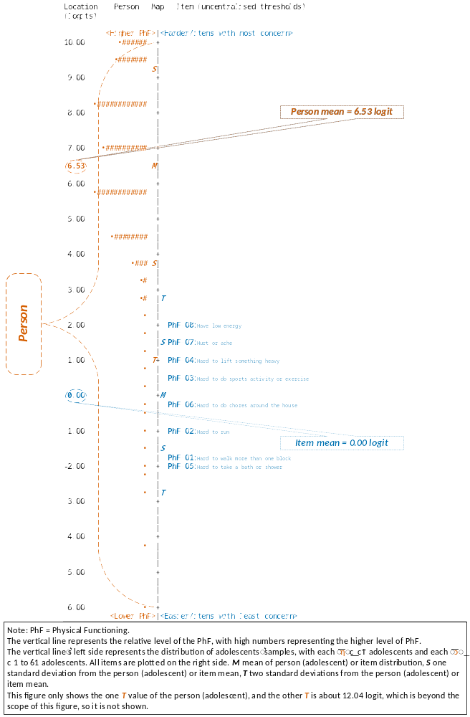

Figure A19 Person-item map (Wright map) of the Physical Functioning subscale (N = 4312)

Emotional Functioning subscale
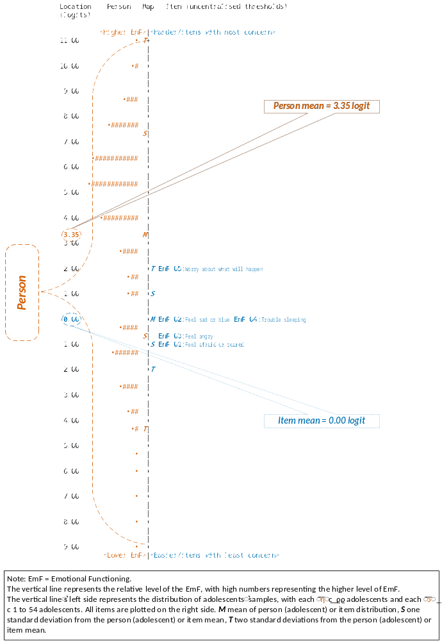

Figure A20 Person-item map (Wright map) of the Emotional Functioning subscale (N = 4325)

Social Functioning subscale
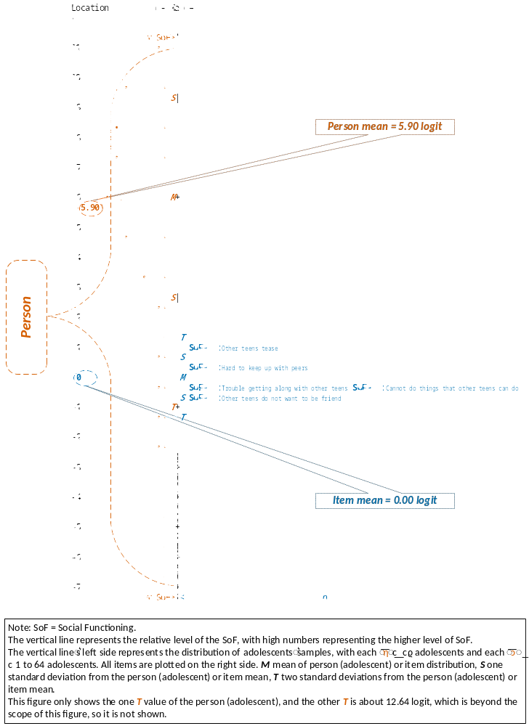

Figure A21 Person-item map (Wright map) of the Social Functioning subscale (N = 4320)

School Functioning subscale
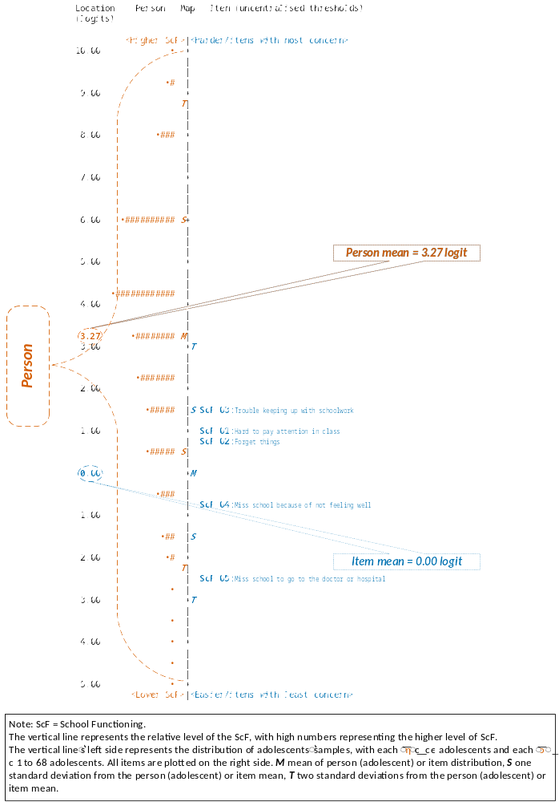

Figure A22 Person-item map (Wright map) of the School Functioning subscale (N = 4335)
Psychosocial Health summary score
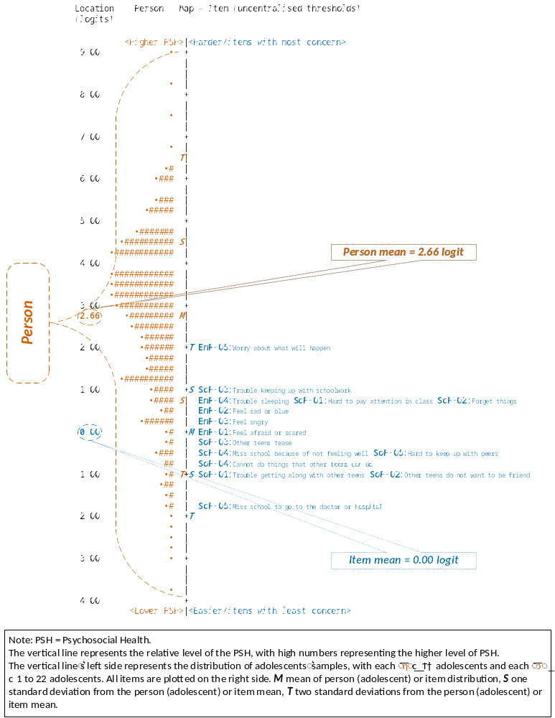

Figure A23 Person-item map (Wright map) of the Psychosocial Health summary score (N = 4212)

Health-related Quality of Life summary score
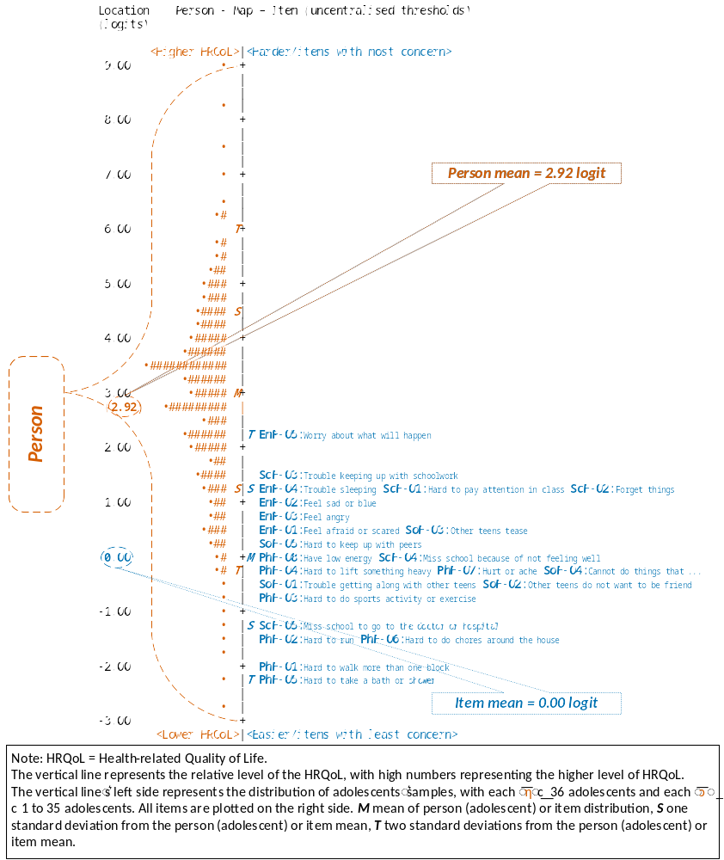

Figure A24 Person-item map (Wright map) of the Health-related Quality of Life summary score (N = 4145)

Appendix 14: Uniform differential item functioning analysis for the Mandarin Chinese self-reported Pediatric Quality of Life Inventory™ Version 4.0 Generic Core Scales (PedsQL™ 4.0 GCS) across gender and grade groups

Uniform differential item functioning analysis across gender group
Table A37 The UDIF analysis across gender group of the four subscales
Item  abbreviation | Rasch-calibration UDIF (SE) |  |  | UDIF contrastª  (∆ _{vs.} ) | Rasch-Welch’s t  ( vs. ) | p-value^{b}
Item  abbreviation | Male | Female
PhF-01 | −1.729 (0.135) | −1.700 (0.111) |  | −0.029 | −0.16 | 0.870
PhF-02 | −0.992 (0.078) | −0.813 (0.063) |  | −0.179 | −1.79 | 0.073
PhF-03 | 0.396 (0.057) | 0.593 (0.052) |  | −0.197 | −2.55 | 0.011
PhF-04 | 0.926 (0.055) | 1.217 (0.051) |  | −0.290 | −3.90 | <0.001
PhF-05 | −1.972 (0.110) | −2.202 (0.096) |  | 0.230 | 1.58 | 0.114
PhF-06 | −0.144 (0.075) | −0.494 (0.067) |  | 0.350 | 3.49 | 0.001
PhF-07 | 1.680 (0.055) | 1.423 (0.052) |  | 0.257 | 3.41 | 0.001
PhF-08 | 1.917 (0.055) | 1.839 (0.051) |  | 0.079 | 1.05 | 0.295
EmF-01 | −1.087 (0.057) | −1.087 (0.053) |  | 0.000 | 0.00 | 1.000
EmF-02 | −0.173 (0.057) | −0.011 (0.054) |  | −0.162 | −2.07 | 0.039
EmF-03 | −0.792 (0.053) | −0.857 (0.049) |  | 0.065 | 0.90 | 0.367
EmF-04 | −0.001 (0.049) | −0.001 (0.045) |  | 0.000 | 0.00 | 1.000
EmF-05 | 2.051 (0.052) | 1.948 (0.048) |  | 0.103 | 1.44 | 0.149
SoF-01 | −0.518 (0.054) | −0.498 (0.052) |  | −0.021 | −0.28 | 0.783
SoF-02 | −0.596 (0.053) | −0.573 (0.051) |  | −0.023 | −0.31 | 0.757
SoF-03 | 1.034 (0.064) | 0.867 (0.061) |  | 0.167 | 1.88 | 0.060
SoF-04 | −0.281 (0.053) | −0.281 (0.051) |  | 0.000 | 0.00 | 1.000
SoF-05 | 0.360 (0.053) | 0.431 (0.050) |  | −0.071 | −0.98 | 0.329
ScF-01 | 1.094 (0.051) | 0.911 (0.049) |  | 0.183 | 2.59 | 0.010
ScF-02 | 0.836 (0.052) | 0.901 (0.049) |  | −0.066 | −0.92 | 0.358
ScF-03 | 1.400 (0.047) | 1.400 (0.045) |  | 0.000 | 0.00 | 1.000
ScF-04 | −0.693 (0.054) | −0.693 (0.052) |  | 0.000 | 0.00 | 1.000
ScF-05 | −2.623 (0.060) | −2.547 (0.056) |  | −0.075 | −0.91 | 0.362
Note. PhF = Physical Functioning, EmF = Emotional Functioning, SoF = Social Functioning, ScF = School Functioning, UDIF = uniform differential item functioning, SE = standard error.
The Rasch-calibration UDIF values are expressed in logits.
N_{(PhF)} = 4312 [n_{(Male)} = 2022, n_{(Female)} = 2290]; N_{(EmF)} = 4325 [n_{(Male)} = 2025, n_{(Female)} = 2300]; N_{(SoF)} = 4320 [n_{(Male)} = 2025, n_{(Female)} = 2295]; N_{(ScF)} = 4335 [n_{(Male)} = 2031, n_{(Female)} = 2304].
ª Difference in Rasch calibration of item (first group minus second group) with those differences of 0.50 logits or more bolded.
^{b} Bonferroni correction was applied, giving a significant p-value of 0.00625 (0.05/8) for each item of the PhF to identify statistical differences; giving a significant p-value of 0.01 (0.05/5) for each item of the remaining three subscales to identify statistical differences.
Missing values were handled using listwise (casewise) deletion.

Table A38 The UDIF analysis across gender group of the Psychosocial Health summary score
Item  abbreviation | Rasch-calibration UDIF (SE) |  |  | UDIF contrastª  (∆ _{vs.} ) | Rasch-Welch’s t  ( vs. ) | p-value^{b}
Item  abbreviation | Male | Female
EmF-01 | −0.080 (0.044) | 0.173 (0.041) |  | −0.253 | −4.22 | <0.001
EmF-02 | 0.433 (0.044) | 0.780 (0.041) |  | −0.347 | −5.77 | <0.001
EmF-03 | 0.071 (0.041) | 0.292 (0.038) |  | −0.221 | −3.99 | <0.001
EmF-04 | 0.570 (0.037) | 0.825 (0.034) |  | −0.255 | −5.05 | <0.001
EmF-05 | 1.886 (0.040) | 2.054 (0.036) |  | −0.168 | −3.13 | 0.002
SoF-01 | −1.000 (0.044) | −1.244 (0.042) |  | 0.244 | 4.01 | <0.001
SoF-02 | −1.002 (0.043) | −1.221 (0.041) |  | 0.218 | 3.67 | <0.001
SoF-03 | 0.040 (0.050) | −0.321 (0.048) |  | 0.362 | 5.22 | <0.001
SoF-04 | −0.732 (0.043) | −0.992 (0.041) |  | 0.260 | 4.39 | <0.001
SoF-05 | −0.375 (0.042) | −0.568 (0.040) |  | 0.193 | 3.32 | 0.001
ScF-01 | 0.899 (0.046) | 0.702 (0.044) |  | 0.197 | 3.07 | 0.002
ScF-02 | 0.683 (0.047) | 0.683 (0.044) |  | 0.000 | 0.00 | 1.000
ScF-03 | 1.072 (0.042) | 1.072 (0.040) |  | 0.000 | 0.00 | 1.000
ScF-04 | −0.526 (0.049) | −0.549 (0.046) |  | 0.023 | 0.34 | 0.734
ScF-05 | −1.861 (0.055) | −1.861 (0.051) |  | 0.000 | 0.00 | 1.000
Note. EmF = Emotional Functioning, SoF = Social Functioning, ScF = School Functioning, UDIF = uniform differential item functioning, SE = standard error.
The Rasch-calibration UDIF values are expressed in logits.
N_{(PSH)} = 4212 [n_{(Male)} = 1970, n_{(Female)} = 2242].
ª Difference in Rasch calibration of item (first group minus second group) with those differences of 0.50 logits or more bolded.
^{b} Bonferroni correction was applied, giving a significant p-value of 0.0033 (0.05/15) for each item of the Psychosocial Health to identify statistical differences.
Missing values were handled using listwise (casewise) deletion.

Table A39 The UDIF analysis across gender group of the Health-related Quality of Life summary score
Item  abbreviation | Rasch-calibration UDIF (SE) |  |  | UDIF contrastª  (∆ _{vs.} ) | Rasch-Welch’s t  ( vs. ) | p-value^{b}
Item  abbreviation | Male | Female
PhF-01 | −2.075 (0.105) | −1.846 (0.089) |  | −0.229 | −1.66 | 0.097
PhF-02 | −1.690 (0.063) | −1.266 (0.051) |  | −0.424 | −5.24 | <0.001
PhF-03 | −0.921 (0.048) | −0.439 (0.042) |  | −0.482 | −7.56 | <0.001
PhF-04 | −0.656 (0.045) | −0.124 (0.041) |  | −0.532 | −8.71 | <0.001
PhF-05 | −2.392 (0.088) | −2.262 (0.078) |  | −0.131 | −1.11 | 0.268
PhF-06 | −1.444 (0.062) | −1.342 (0.056) |  | −0.103 | −1.23 | 0.220
PhF-07 | −0.232 (0.045) | −0.069 (0.042) |  | −0.163 | −2.68 | 0.007
PhF-08 | −0.109 (0.044) | 0.127 (0.041) |  | −0.237 | −3.95 | <0.001
EmF-01 | 0.542 (0.042) | 0.661 (0.039) |  | −0.119 | −2.08 | 0.037
EmF-02 | 1.005 (0.042) | 1.209 (0.039) |  | −0.205 | −3.57 | <0.001
EmF-03 | 0.675 (0.039) | 0.772 (0.036) |  | −0.097 | −1.84 | 0.065
EmF-04 | 1.132 (0.035) | 1.253 (0.032) |  | −0.122 | −2.56 | 0.011
EmF-05 | 2.326 (0.037) | 2.377 (0.034) |  | −0.051 | −1.01 | 0.315
SoF-01 | −0.327 (0.042) | −0.647 (0.040) |  | 0.320 | 5.49 | <0.001
SoF-02 | −0.401 (0.041) | −0.695 (0.039) |  | 0.293 | 5.21 | <0.001
SoF-03 | 0.651 (0.048) | 0.217 (0.046) |  | 0.434 | 6.56 | <0.001
SoF-04 | −0.034 (0.040) | −0.365 (0.039) |  | 0.331 | 5.89 | <0.001
SoF-05 | 0.300 (0.040) | 0.020 (0.038) |  | 0.281 | 5.09 | <0.001
ScF-01 | 1.447 (0.044) | 1.149 (0.042) |  | 0.298 | 4.91 | <0.001
ScF-02 | 1.192 (0.045) | 1.091 (0.042) |  | 0.102 | 1.66 | 0.097
ScF-03 | 1.568 (0.040) | 1.446 (0.038) |  | 0.122 | 2.20 | 0.028
ScF-04 | 0.153 (0.047) | 0.013 (0.044) |  | 0.140 | 2.17 | 0.030
ScF-05 | −1.090 (0.052) | −1.189 (0.049) |  | 0.099 | 1.39 | 0.163
Note. PhF = Physical Functioning, EmF = Emotional Functioning, SoF = Social Functioning, ScF = School Functioning, UDIF = uniform differential item functioning, SE = standard error.
The Rasch-calibration UDIF values are expressed in logits.
N_{(HRQoL)} = 4145 [n_{(Male)} = 1940, n_{(Female)} = 2205].
ª Difference in Rasch calibration of item (first group minus second group) with those differences of 0.50 logits or more bolded.
^{b} Bonferroni correction was applied, giving a significant p-value of 0.0022 (0.05/23) for each item of the Health-related Quality of Life to identify statistical differences.
Missing values were handled using listwise (casewise) deletion.

Uniform differential item functioning analysis across grade group
Table A40 The UDIF analysis across grade group of the four subscales
Item  abbreviation | Rasch-calibration UDIF (SE) |  |  |  | UDIF contrastª |  |  |  | Pairwise Rasch-Welch’s t (p-value^{b})
Item  abbreviation | Primary  school | Junior secondary school | Senior secondary school |  | ∆ _{vs.} | ∆ _{vs.} | ∆ _{vs.} |  | vs. | vs. | vs.
PhF-01 | −2.823 (0.337) | −1.161 (0.098) | −3.175 (0.250) |  | −1.662 | 0.352 | 2.015 |  | −4.74 (<0.001) | 0.84 (0.401) | 7.49 (<0.001)
PhF-02 | −1.353 (0.115) | −0.744 (0.066) | −0.812 (0.097) |  | −0.609 | −0.541 | 0.068 |  | −4.59 (<0.001) | −3.59 (<0.001) | 0.58 (0.564)
PhF-03 | 0.853 (0.077) | 0.208 (0.055) | 0.727 (0.074) |  | 0.645 | 0.125 | −0.519 |  | 6.79 (<0.001) | 1.17 (0.240) | −5.64 (<0.001)
PhF-04 | 1.442 (0.076) | 1.187 (0.053) | 0.571 (0.073) |  | 0.254 | 0.871 | 0.617 |  | 2.75 (0.006) | 8.29 (<0.001) | 6.86 (<0.001)
PhF-05 | −2.513 (0.186) | −2.009 (0.094) | −2.043 (0.144) |  | −0.505 | −0.470 | 0.035 |  | −2.42 (0.016) | −2.00 (0.046) | 0.20 (0.840)
PhF-06 | −0.526 (0.107) | −0.025 (0.066) | −0.946 (0.113) |  | −0.500 | 0.420 | 0.920 |  | −3.99 (<0.001) | 2.70 (0.007) | 7.02 (<0.001)
PhF-07 | 1.846 (0.079) | 1.427 (0.054) | 1.505 (0.071) |  | 0.419 | 0.341 | −0.078 |  | 4.38 (<0.001) | 3.21 (0.001) | −0.88 (0.381)
PhF-08 | 1.348 (0.080) | 1.702 (0.053) | 2.605 (0.071) |  | −0.354 | −1.257 | −0.903 |  | −3.70 (<0.001) | −11.80 (<0.001) | −10.20 (<0.001)
EmF-01 | −0.891 (0.081) | −1.137 (0.056) | −1.175 (0.072) |  | 0.247 | 0.285 | 0.038 |  | 2.51 (0.012) | 2.64 (0.008) | 0.42 (0.676)
EmF-02 | −0.236 (0.082) | −0.152 (0.056) | 0.145 (0.074) |  | −0.084 | −0.381 | −0.297 |  | −0.85 (0.395) | −3.46 (0.001) | −3.22 (0.001)
EmF-03 | −1.235 (0.076) | −0.731 (0.052) | −0.660 (0.067) |  | −0.505 | −0.575 | −0.071 |  | −5.49 (<0.001) | −5.67 (<0.001) | −0.83 (0.407)
EmF-04 | 0.188 (0.071) | −0.022 (0.048) | −0.115 (0.061) |  | 0.210 | 0.303 | 0.093 |  | 2.47 (0.013) | 3.25 (0.001) | 1.20 (0.231)
EmF-05 | 2.147 (0.080) | 2.018 (0.050) | 1.858 (0.065) |  | 0.129 | 0.289 | 0.160 |  | 1.36 (0.173) | 2.80 (0.005) | 1.95 (0.051)
SoF-01 | 0.309 (0.079) | −0.802 (0.055) | −0.674 (0.070) |  | 1.111 | 0.983 | −0.128 |  | 11.51 (<0.001) | 9.29 (<0.001) | −1.44 (0.151)
SoF-02 | −1.361 (0.087) | −0.305 (0.053) | −0.474 (0.067) |  | −1.056 | −0.887 | 0.169 |  | −10.40 (<0.001) | −8.13 (<0.001) | 1.99 (0.047)
SoF-03 | 0.524 (0.099) | 1.122 (0.061) | 0.910 (0.082) |  | −0.598 | −0.386 | 0.212 |  | −5.13 (<0.001) | −3.01 (0.003) | 2.08 (0.038)
SoF-04 | −0.334 (0.076) | −0.210 (0.053) | −0.366 (0.067) |  | −0.124 | 0.032 | 0.156 |  | −1.34 (0.180) | 0.31 (0.754) | 1.82 (0.070)
SoF-05 | 0.583 (0.076) | 0.209 (0.053) | 0.556 (0.067) |  | 0.373 | 0.027 | −0.346 |  | 4.06 (<0.001) | 0.27 (0.788) | −4.05 (<0.001)
ScF-01 | 0.098 (0.087) | 1.136 (0.050) | 1.269 (0.062) |  | −1.038 | −1.171 | −0.133 |  | −10.40 (<0.001) | −10.90 (<0.001) | −1.67 (0.095)
ScF-02 | 0.115 (0.087) | 1.102 (0.050) | 0.919 (0.063) |  | −0.987 | −0.804 | 0.183 |  | −9.89 (<0.001) | −7.49 (<0.001) | 2.27 (0.023)
ScF-03 | 1.127 (0.070) | 1.368 (0.046) | 1.662 (0.061) |  | −0.241 | −0.535 | −0.294 |  | −2.88 (0.004) | −5.78 (<0.001) | −3.85 (<0.001)
ScF-04 | 1.077 (0.080) | −1.172 (0.054) | −1.377 (0.073) |  | 2.250 | 2.454 | 0.204 |  | 23.31 (<0.001) | 22.69 (<0.001) | 2.24 (0.025)
ScF-05 | −2.669 (0.103) | −2.482 (0.057) | −2.697 (0.073) |  | −0.187 | 0.028 | 0.214 |  | −1.58 (0.114) | 0.22 (0.827) | 2.32 (0.020)
Note. PhF = Physical Functioning, EmF = Emotional Functioning, SoF = Social Functioning, ScF = School Functioning, UDIF = uniform differential item functioning, SE = standard error.
The Rasch-calibration UDIF values are expressed in logits.
N_{(PhF)} = 4312 [n_{(Primary school)} = 940, n_{(Junior secondary school)} = 2136, n_{(Senior secondary school)} = 1236]; N_{(EmF)} = 4325 [n_{(Primary school)} = 952, n_{(Junior secondary school)} = 2126, n_{(Senior secondary school)} = 1247]; N_{(SoF)} = 4320 [n_{(Primary school)} = 953, n_{(Junior secondary school)} = 2123, n_{(Senior secondary school)} = 1244]; N_{(ScF)} = 4335 [n_{(Primary school)} = 956, n_{(Junior secondary school)} = 2133, n_{(Senior secondary school)} = 1246].
ª Difference in Rasch calibration of item (first group minus second group) with those differences of 0.50 logits or more bolded.
^{b} Bonferroni correction was applied, giving a significant p-value of 0.00625 (0.05/8) for each item of the PhF to identify statistical differences; giving a significant p-value of 0.01 (0.05/5) for each item of the remaining three subscales to identify statistical differences.
Missing values were handled using listwise (casewise) deletion.

Table A41 The UDIF analysis across grade group of the Psychosocial Health summary score
Item  abbreviation | Rasch-calibration UDIF (SE) |  |  |  | UDIF contrastª |  |  |  | Pairwise Rasch-Welch’s t (p-value^{b})
Item  abbreviation | Primary  school | Junior secondary school | Senior secondary school |  | ∆ _{vs.} | ∆ _{vs.} | ∆ _{vs.} |  | vs. | vs. | vs.
EmF-01 | −0.017 (0.065) | 0.058 (0.043) | 0.085 (0.055) |  | −0.075 | −0.103 | −0.027 |  | −0.97 (0.333) | −1.21 (0.228) | −0.39 (0.694)
EmF-02 | 0.293 (0.067) | 0.621 (0.043) | 0.828 (0.054) |  | −0.327 | −0.534 | −0.207 |  | −4.13 (<0.001) | −6.21 (<0.001) | −3.00 (0.003)
EmF-03 | −0.309 (0.062) | 0.303 (0.039) | 0.349 (0.050) |  | −0.612 | −0.657 | −0.046 |  | −8.38 (<0.001) | −8.27 (<0.001) | −0.71 (0.476)
EmF-04 | 0.638 (0.057) | 0.744 (0.036) | 0.710 (0.045) |  | −0.106 | −0.072 | 0.035 |  | −1.58 (0.114) | −0.99 (0.325) | 0.60 (0.550)
EmF-05 | 1.913 (0.062) | 2.028 (0.038) | 1.931 (0.048) |  | −0.114 | −0.018 | 0.097 |  | −1.58 (0.113) | −0.23 (0.819) | 1.57 (0.115)
SoF-01 | −0.230 (0.065) | −1.400 (0.044) | −1.359 (0.057) |  | 1.171 | 1.129 | −0.042 |  | 14.98 (<0.001) | 13.14 (<0.001) | −0.58 (0.564)
SoF-02 | −1.425 (0.075) | −0.964 (0.041) | −1.202 (0.053) |  | −0.462 | −0.223 | 0.239 |  | −5.41 (<0.001) | −2.43 (0.015) | 3.55 (<0.001)
SoF-03 | −0.095 (0.078) | −0.104 (0.049) | −0.260 (0.063) |  | 0.009 | 0.165 | 0.156 |  | 0.10 (0.920) | 1.64 (0.101) | 1.95 (0.051)
SoF-04 | −0.616 (0.066) | −0.864 (0.042) | −1.057 (0.054) |  | 0.249 | 0.441 | 0.193 |  | 3.20 (0.001) | 5.19 (<0.001) | 2.82 (0.005)
SoF-05 | −0.029 (0.063) | −0.652 (0.042) | −0.502 (0.053) |  | 0.624 | 0.473 | −0.151 |  | 8.25 (<0.001) | 5.75 (<0.001) | −2.23 (0.026)
ScF-01 | −0.006 (0.075) | 0.898 (0.045) | 1.084 (0.056) |  | −0.904 | −1.090 | −0.186 |  | −10.30 (<0.001) | −11.60 (<0.001) | −2.59 (0.010)
ScF-02 | −0.031 (0.076) | 0.866 (0.045) | 0.791 (0.057) |  | −0.898 | −0.823 | 0.075 |  | −10.20 (<0.001) | −8.69 (<0.001) | 1.03 (0.301)
ScF-03 | 0.840 (0.062) | 1.024 (0.041) | 1.321 (0.054) |  | −0.185 | −0.482 | −0.297 |  | −2.48 (0.013) | −5.87 (<0.001) | −4.38 (<0.001)
ScF-04 | 0.835 (0.069) | −0.919 (0.049) | −1.021 (0.064) |  | 1.754 | 1.856 | 0.102 |  | 20.67 (<0.001) | 19.74 (<0.001) | 1.27 (0.204)
ScF-05 | −2.154 (0.100) | −1.790 (0.051) | −1.861 (0.065) |  | −0.363 | −0.293 | 0.071 |  | −3.24 (0.001) | −2.46 (0.014) | 0.85 (0.394)
Note. EmF = Emotional Functioning, SoF = Social Functioning, ScF = School Functioning, UDIF = uniform differential item functioning, SE = standard error.
The Rasch-calibration UDIF values are expressed in logits.
N_{(PSH)} = 4212 [n_{(Primary school)} = 931, n_{(Junior secondary school)} = 2060, n_{(Senior secondary school)} = 1221].
ª Difference in Rasch calibration of item (first group minus second group) with those differences of 0.50 logits or more bolded.
^{b} Bonferroni correction was applied, giving a significant p-value of 0.0033 (0.05/15) for each item of the Psychosocial Health to identify statistical differences.
Missing values were handled using listwise (casewise) deletion.

Table A42 The UDIF analysis across grade group of the Health-related Quality of Life summary score
Item  abbreviation | Rasch-calibration UDIF (SE) |  |  |  | UDIF contrastª |  |  |  | Pairwise Rasch-Welch’s t (p-value^{b})
Item  abbreviation | Primary  school | Junior secondary school | Senior secondary school |  | ∆ _{vs.} | ∆ _{vs.} | ∆ _{vs.} |  | vs. | vs. | vs.
PhF-01 | −3.078 (0.296) | −1.462 (0.075) | −3.202 (0.233) |  | −1.616 | 0.124 | 1.741 |  | −5.29 (<0.001) | 0.33 (0.742) | 7.12 (<0.001)
PhF-02 | −1.648 (0.109) | −1.278 (0.052) | −1.680 (0.076) |  | −0.370 | 0.032 | 0.402 |  | −3.07 (0.002) | 0.24 (0.810) | 4.38 (<0.001)
PhF-03 | 0.194 (0.063) | −0.855 (0.046) | −0.995 (0.060) |  | 1.049 | 1.189 | 0.140 |  | 13.53 (<0.001) | 13.73 (<0.001) | 1.86 (0.062)
PhF-04 | 0.559 (0.062) | −0.334 (0.043) | −1.182 (0.059) |  | 0.893 | 1.741 | 0.848 |  | 11.78 (<0.001) | 20.21 (<0.001) | 11.56 (<0.001)
PhF-05 | −2.708 (0.171) | −2.134 (0.075) | −2.510 (0.112) |  | −0.573 | −0.198 | 0.375 |  | −3.07 (0.002) | −0.97 (0.334) | 2.78 (0.006)
PhF-06 | −1.262 (0.104) | −1.113 (0.053) | −2.060 (0.090) |  | −0.149 | 0.798 | 0.947 |  | −1.28 (0.201) | 5.81 (<0.001) | 9.04 (<0.001)
PhF-07 | 0.753 (0.065) | −0.259 (0.043) | −0.640 (0.058) |  | 1.011 | 1.393 | 0.381 |  | 12.97 (<0.001) | 16.06 (<0.001) | 5.28 (<0.001)
PhF-08 | 0.385 (0.065) | −0.124 (0.043) | −0.012 (0.055) |  | 0.510 | 0.397 | −0.113 |  | 6.57 (<0.001) | 4.66 (<0.001) | −1.62 (0.106)
EmF-01 | 0.357 (0.063) | 0.608 (0.041) | 0.762 (0.052) |  | −0.251 | −0.405 | −0.154 |  | −3.36 (0.001) | −4.96 (<0.001) | −2.33 (0.020)
EmF-02 | 0.630 (0.064) | 1.117 (0.041) | 1.426 (0.052) |  | −0.487 | −0.797 | −0.310 |  | −6.41 (<0.001) | −9.65 (<0.001) | −4.72 (<0.001)
EmF-03 | 0.089 (0.059) | 0.827 (0.037) | 0.998 (0.048) |  | −0.738 | −0.909 | −0.171 |  | −10.50 (<0.001) | −11.90 (<0.001) | −2.82 (0.005)
EmF-04 | 0.951 (0.054) | 1.224 (0.034) | 1.314 (0.043) |  | −0.274 | −0.363 | −0.090 |  | −4.31 (<0.001) | −5.27 (<0.001) | −1.64 (0.100)
EmF-05 | 2.095 (0.058) | 2.390 (0.036) | 2.455 (0.046) |  | −0.295 | −0.360 | −0.065 |  | −4.31 (<0.001) | −4.86 (<0.001) | −1.12 (0.264)
SoF-01 | 0.161 (0.062) | −0.746 (0.042) | −0.571 (0.054) |  | 0.907 | 0.732 | −0.174 |  | 12.12 (<0.001) | 8.93 (<0.001) | −2.55 (0.011)
SoF-02 | −1.009 (0.071) | −0.434 (0.039) | −0.510 (0.050) |  | −0.575 | −0.499 | 0.076 |  | −7.07 (<0.001) | −5.71 (<0.001) | 1.19 (0.234)
SoF-03 | 0.314 (0.076) | 0.460 (0.046) | 0.427 (0.061) |  | −0.145 | −0.113 | 0.033 |  | −1.64 (0.101) | −1.16 (0.246) | 0.43 (0.666)
SoF-04 | −0.161 (0.063) | −0.205 (0.040) | −0.255 (0.051) |  | 0.043 | 0.094 | 0.051 |  | 0.58 (0.561) | 1.15 (0.248) | 0.78 (0.434)
SoF-05 | 0.396 (0.060) | −0.006 (0.040) | 0.246 (0.050) |  | 0.402 | 0.150 | −0.252 |  | 5.57 (<0.001) | 1.92 (0.056) | −3.95 (<0.001)
ScF-01 | 0.374 (0.073) | 1.372 (0.042) | 1.675 (0.053) |  | −0.998 | −1.301 | −0.302 |  | −11.80 (<0.001) | −14.40 (<0.001) | −4.44 (<0.001)
ScF-02 | 0.293 (0.073) | 1.293 (0.042) | 1.371 (0.054) |  | −1.000 | −1.078 | −0.078 |  | −11.80 (<0.001) | −11.80 (<0.001) | −1.13 (0.260)
ScF-03 | 1.090 (0.060) | 1.466 (0.039) | 1.867 (0.051) |  | −0.376 | −0.777 | −0.401 |  | −5.22 (<0.001) | −9.85 (<0.001) | −6.22 (<0.001)
ScF-04 | 1.158 (0.067) | −0.263 (0.047) | −0.220 (0.061) |  | 1.422 | 1.378 | −0.043 |  | 17.33 (<0.001) | 15.22 (<0.001) | −0.56 (0.573)
ScF-05 | −1.606 (0.094) | −1.083 (0.049) | −1.008 (0.062) |  | −0.523 | −0.598 | −0.075 |  | −4.91 (<0.001) | −5.28 (<0.001) | −0.94 (0.347)
Note. PhF = Physical Functioning, EmF = Emotional Functioning, SoF = Social Functioning, ScF = School Functioning, UDIF = uniform differential item functioning, SE = standard error.
The Rasch-calibration UDIF values are expressed in logits.
N_{(HRQoL)} = 4145 [n_{(Primary school)} = 906, n_{(Junior secondary school)} = 2038, n_{(Senior secondary school)} = 1201].
ª Difference in Rasch calibration of item (first group minus second group) with those differences of 0.50 logits or more bolded.
^{b} Bonferroni correction was applied, giving a significant p-value of 0.0022 (0.05/23) for each item of the Health-related Quality of Life to identify statistical differences.
Missing values were handled using listwise (casewise) deletion.

Appendix 15: Detailed results of the bifactor model analysis of the Mandarin Chinese self-reported Pediatric Quality of Life Inventory™ Version 4.0 Generic Core Scales (PedsQL™ 4.0)

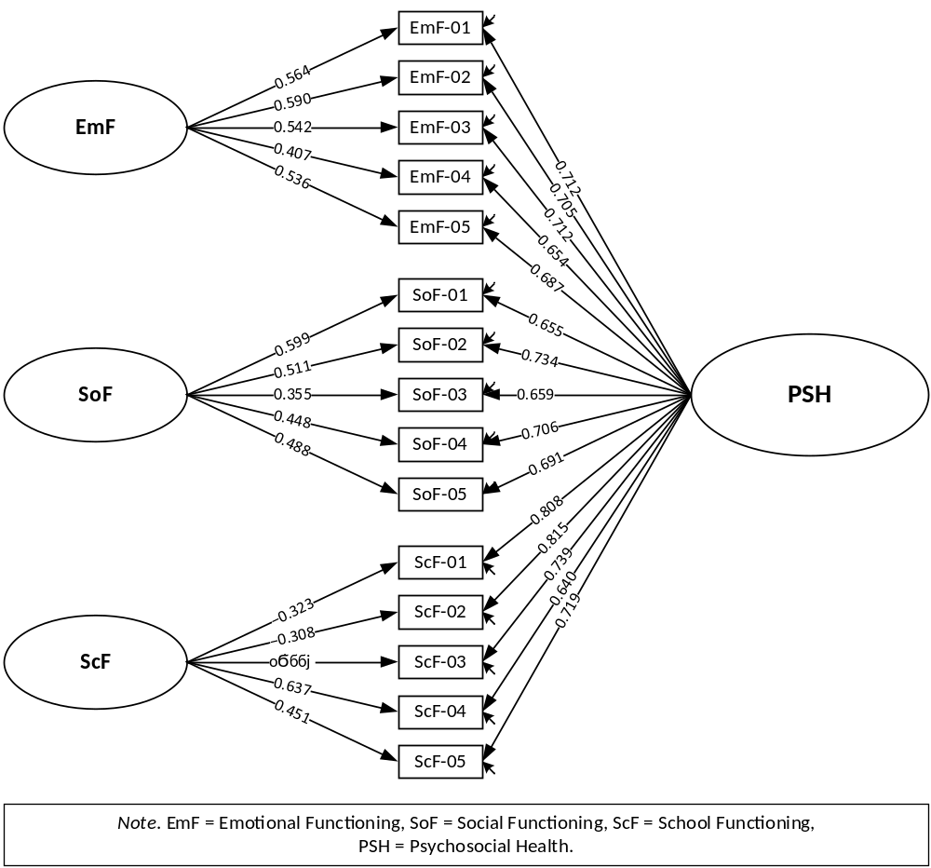

Figure A25 Fitting diagram of bifactor model analysis for the Psychosocial Health summary score
(N = 4212)
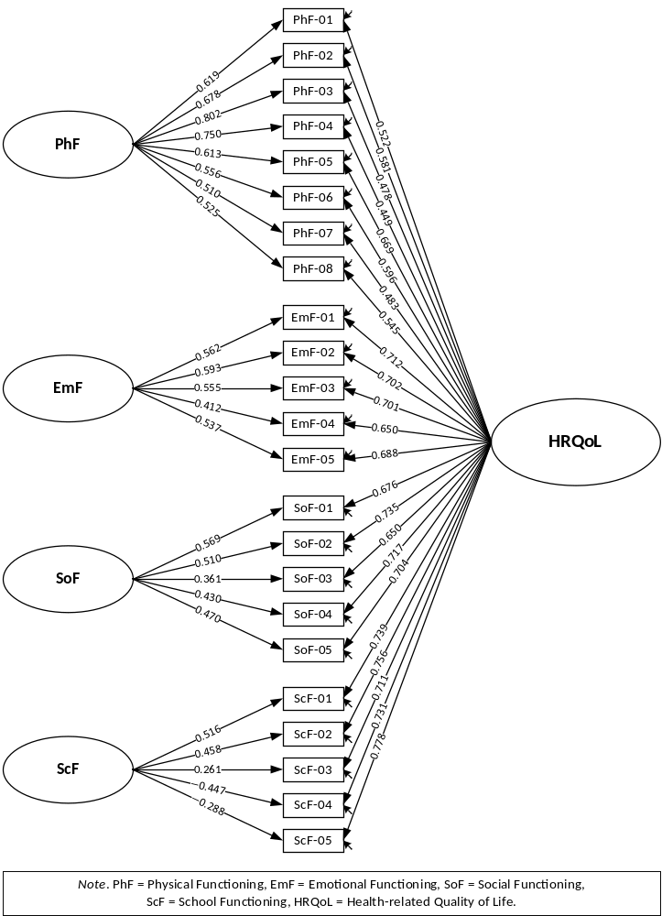

Figure A26 Fitting diagram of bifactor model analysis for the Health-related Quality of Life summary score (N = 4145)
Table A43 Parameter estimation for the bifactor model of the Psychosocial Health summary score (N = 4212)
Spec.  factors | Gen.  factor | Item abbreviation and label | Unstandardized |  |  |  |  |  |  |  | Standardized
Spec.  factors | Gen.  factor | Item abbreviation and label | Spec.  factors |  |  |  | Gen.  factor |  |  |  | Est. |  | δ
Spec.  factors | Gen.  factor | Item abbreviation and label | Est. | SE | CR |  | Est. | SE | CR |  | Spec.  factors | Gen.  factor | δ
Factor loading
EmF | PSH | EmF-01: Feel afraid or scared | 1.346 | 0.048 | 28.049*** |  | 1.698 | 0.052 | 32.925*** |  | 0.564 | 0.712 | 0.176
 |  | EmF-02: Feel sad or blue | 1.500 | 0.053 | 28.173*** |  | 1.794 | 0.057 | 31.361*** |  | 0.590 | 0.705 | 0.155
 |  | EmF-03: Feel angry | 1.212 | 0.040 | 30.670*** |  | 1.592 | 0.045 | 35.313*** |  | 0.542 | 0.712 | 0.200
 |  | EmF-04: Trouble sleeping | 0.638 | 0.026 | 24.438*** |  | 1.026 | 0.026 | 39.630*** |  | 0.407 | 0.654 | 0.407
 |  | EmF-05: Worry about what will happen | 1.095 | 0.038 | 28.692*** |  | 1.403 | 0.038 | 36.998*** |  | 0.536 | 0.687 | 0.240
SoF |  | SoF-01: Trouble getting along with other teens | 1.300 | 0.067 | 19.472*** |  | 1.420 | 0.055 | 25.825*** |  | 0.599 | 0.655 | 0.212
 |  | SoF-02: Other teens do not want to be friend | 1.144 | 0.056 | 20.590*** |  | 1.643 | 0.061 | 27.009*** |  | 0.511 | 0.734 | 0.200
 |  | SoF-03: Other teens tease | 0.536 | 0.030 | 18.096*** |  | 0.995 | 0.030 | 33.147*** |  | 0.355 | 0.659 | 0.439
 |  | SoF-04: Cannot do things that other teens can do | 0.816 | 0.039 | 21.130*** |  | 1.285 | 0.041 | 31.293*** |  | 0.448 | 0.706 | 0.302
 |  | SoF-05: Hard to keep up with peers | 0.916 | 0.041 | 22.071*** |  | 1.295 | 0.040 | 32.357*** |  | 0.488 | 0.691 | 0.284
ScF |  | ScF-01: Hard to pay attention in class | −0.655 | 0.047 | −13.856*** |  | 1.640 | 0.060 | 27.353*** |  | −0.323 | 0.808 | 0.243
 |  | ScF-02: Forget things | −0.627 | 0.045 | −13.860*** |  | 1.658 | 0.059 | 28.023*** |  | −0.308 | 0.815 | 0.241
 |  | ScF-03: Trouble keeping up with schoolwork | −0.176 | 0.027 | −6.562*** |  | 1.115 | 0.031 | 36.303*** |  | −0.117 | 0.739 | 0.440
 |  | ScF-04: Miss school because of not feeling well | 1.484 | 0.216 | 6.885*** |  | 1.489 | 0.163 | 9.152*** |  | 0.637 | 0.640 | 0.184
 |  | ScF-05: Miss school to go to the doctor or hospital | 0.852 | 0.070 | 12.150*** |  | 1.359 | 0.080 | 16.928*** |  | 0.451 | 0.719 | 0.280
Note. Gen. = General, Spec.= Specific, EmF = Emotional Functioning, SoF = Social Functioning, ScF = School Functioning, PSH = Psychosocial Health, Est. = estimate, SE = standard error, CR = critical ratio, equivalent to the common t-value, δ = residual.
Missing values were handled using listwise (casewise) deletion.
*** p < 0.001.

Table A44 Parameter estimation for the bifactor model of the Health-related Quality of Life summary score (N = 4145)
Spec.  factors | Gen.  factor | Item abbreviation and label | Unstandardized |  |  |  |  |  |  |  | Standardized
Spec.  factors | Gen.  factor | Item abbreviation and label | Spec.  factors |  |  |  | Gen.  factor |  |  |  | Est. |  | δ
Spec.  factors | Gen.  factor | Item abbreviation and label | Est. | SE | CR |  | Est. | SE | CR |  | Spec.  factors | Gen.  factor | δ
Factor loading
PhF | HRQoL | PhF-01: Hard to walk more than one block | 1.056 | 0.064 | 16.481*** |  | 0.891 | 0.075 | 11.889*** |  | 0.619 | 0.522 | 0.344
 |  | PhF-02: Hard to run | 1.504 | 0.061 | 24.844*** |  | 1.290 | 0.069 | 18.823*** |  | 0.678 | 0.581 | 0.203
 |  | PhF-03: Hard to do sports activity or exercise | 2.248 | 0.097 | 23.222*** |  | 1.341 | 0.066 | 20.350*** |  | 0.802 | 0.478 | 0.127
 |  | PhF-04: Hard to lift something heavy | 1.544 | 0.050 | 31.005*** |  | 0.925 | 0.040 | 22.967*** |  | 0.750 | 0.449 | 0.236
 |  | PhF-05: Hard to take a bath or shower | 1.457 | 0.106 | 13.805*** |  | 1.589 | 0.136 | 11.680*** |  | 0.613 | 0.669 | 0.177
 |  | PhF-06: Hard to do chores around the house | 0.960 | 0.039 | 24.445*** |  | 1.028 | 0.048 | 21.521*** |  | 0.556 | 0.596 | 0.336
 |  | PhF-07: Hurt or ache | 0.716 | 0.026 | 27.445*** |  | 0.678 | 0.026 | 26.437*** |  | 0.510 | 0.483 | 0.507
 |  | PhF-08: Have low energy | 0.803 | 0.027 | 29.757*** |  | 0.834 | 0.027 | 30.884*** |  | 0.525 | 0.545 | 0.427
EmF |  | EmF-01: Feel afraid or scared | 1.335 | 0.047 | 28.263*** |  | 1.690 | 0.052 | 32.691*** |  | 0.562 | 0.712 | 0.177
 |  | EmF-02: Feel sad or blue | 1.506 | 0.054 | 27.807*** |  | 1.783 | 0.057 | 31.144*** |  | 0.593 | 0.702 | 0.155
 |  | EmF-03: Feel angry | 1.239 | 0.041 | 30.182*** |  | 1.565 | 0.045 | 34.455*** |  | 0.555 | 0.701 | 0.201
 |  | EmF-04: Trouble sleeping | 0.646 | 0.026 | 24.739*** |  | 1.018 | 0.027 | 38.369*** |  | 0.412 | 0.650 | 0.408
 |  | EmF-05: Worry about what will happen | 1.097 | 0.038 | 28.948*** |  | 1.406 | 0.039 | 35.670*** |  | 0.537 | 0.688 | 0.239
SoF |  | SoF-01: Trouble getting along with other teens | 1.214 | 0.061 | 19.760*** |  | 1.443 | 0.054 | 26.750*** |  | 0.569 | 0.676 | 0.219
 |  | SoF-02: Other teens do not want to be friend | 1.141 | 0.057 | 19.974*** |  | 1.645 | 0.062 | 26.651*** |  | 0.510 | 0.735 | 0.200
 |  | SoF-03: Other teens tease | 0.541 | 0.031 | 17.592*** |  | 0.972 | 0.029 | 32.990*** |  | 0.361 | 0.650 | 0.447
 |  | SoF-04: Cannot do things that other teens can do | 0.785 | 0.040 | 19.846*** |  | 1.308 | 0.041 | 31.560*** |  | 0.430 | 0.717 | 0.301
 |  | SoF-05: Hard to keep up with peers | 0.885 | 0.042 | 21.183*** |  | 1.325 | 0.040 | 32.730*** |  | 0.470 | 0.704 | 0.283
ScF |  | ScF-01: Hard to pay attention in class | 1.189 | 0.087 | 13.740*** |  | 1.704 | 0.087 | 19.478*** |  | 0.516 | 0.739 | 0.188
 |  | ScF-02: Forget things | 0.979 | 0.061 | 15.961*** |  | 1.618 | 0.068 | 23.728*** |  | 0.458 | 0.756 | 0.219
 |  | ScF-03: Trouble keeping up with schoolwork | 0.401 | 0.028 | 14.321*** |  | 1.091 | 0.031 | 34.811*** |  | 0.261 | 0.711 | 0.425
 |  | ScF-04: Miss school because of not feeling well | −0.867 | 0.076 | −11.444*** |  | 1.416 | 0.072 | 19.625*** |  | −0.447 | 0.731 | 0.266
 |  | ScF-05: Miss school to go to the doctor or hospital | −0.515 | 0.038 | −13.486*** |  | 1.392 | 0.057 | 24.479*** |  | −0.288 | 0.778 | 0.312
Note. Gen. = General, Spec.= Specific, PhF = Physical Functioning, EmF = Emotional Functioning, SoF = Social Functioning, ScF = School Functioning, HRQoL = Health-related Quality of Life, Est. = estimate, SE = standard error, CR = critical ratio, equivalent to the common t-value, δ = residual.
Missing values were handled using listwise (casewise) deletion.
*** p < 0.001.

Table A45 Item polychoric correlation matrix of the Psychosocial Health summary score (N = 4212)
 | EmF-01 | EmF-02 | EmF-03 | EmF-04 | EmF-05 | SoF-01 | SoF-02 | SoF-03 | SoF-04 | SoF-05 | ScF-01 | ScF-02 | ScF-03 | ScF-04 | ScF-05
EmF-01 | —
EmF-02 | 0.841 | —
EmF-03 | 0.807 | 0.822 | —
EmF-04 | 0.677 | 0.677 | 0.715 | —
EmF-05 | 0.793 | 0.800 | 0.774 | 0.678 | —
SoF-01 | 0.532 | 0.492 | 0.486 | 0.466 | 0.488 | —
SoF-02 | 0.565 | 0.559 | 0.559 | 0.517 | 0.532 | 0.803 | —
SoF-03 | 0.535 | 0.502 | 0.515 | 0.465 | 0.490 | 0.657 | 0.665 | —
SoF-04 | 0.522 | 0.519 | 0.542 | 0.479 | 0.513 | 0.707 | 0.736 | 0.614 | —
SoF-05 | 0.526 | 0.516 | 0.511 | 0.487 | 0.507 | 0.732 | 0.740 | 0.623 | 0.747 | —
ScF-01 | 0.516 | 0.541 | 0.544 | 0.498 | 0.510 | 0.453 | 0.550 | 0.472 | 0.532 | 0.503 | —
ScF-02 | 0.536 | 0.557 | 0.570 | 0.525 | 0.540 | 0.464 | 0.564 | 0.497 | 0.527 | 0.515 | 0.820 | —
ScF-03 | 0.496 | 0.537 | 0.506 | 0.433 | 0.516 | 0.448 | 0.510 | 0.447 | 0.493 | 0.489 | 0.701 | 0.64 | —
ScF-04 | 0.421 | 0.364 | 0.357 | 0.376 | 0.372 | 0.465 | 0.408 | 0.400 | 0.443 | 0.452 | 0.389 | 0.408 | 0.439 | —
ScF-05 | 0.482 | 0.455 | 0.460 | 0.428 | 0.450 | 0.404 | 0.494 | 0.416 | 0.499 | 0.449 | 0.530 | 0.521 | 0.525 | 0.791 | —
Note. EmF = Emotional Functioning, SoF = Social Functioning, ScF = School Functioning.
Categorical variables do not have variance parameters estimated, so the diagonal elements are empty, marked in the “—” symbol.
Missing values were handled using listwise (casewise) deletion.

Table A46 Item polychoric correlation matrix of the Health-related Quality of Life summary score (N = 4145)
 | PhF-01 | PhF-02 | PhF-03 | PhF-04 | PhF-05 | PhF-06 | PhF-07 | PhF-08 | EmF-01 | EmF-02 | EmF-03 | EmF-04 | EmF-05 | SoF-01 | SoF-02 | SoF-03 | SoF-04 | SoF-05 | ScF-01 | ScF-02 | ScF-03 | ScF-04 | ScF-05
PhF-01 | —
PhF-02 | 0.816 | —
PhF-03 | 0.691 | 0.848 | —
PhF-04 | 0.660 | 0.683 | 0.842 | —
PhF-05 | 0.739 | 0.771 | 0.713 | 0.759 | —
PhF-06 | 0.645 | 0.687 | 0.644 | 0.678 | 0.824 | —
PhF-07 | 0.540 | 0.591 | 0.607 | 0.593 | 0.663 | 0.626 | —
PhF-08 | 0.619 | 0.692 | 0.639 | 0.585 | 0.740 | 0.639 | 0.572 | —
EmF-01 | 0.371 | 0.402 | 0.348 | 0.316 | 0.480 | 0.415 | 0.350 | 0.393 | —
EmF-02 | 0.311 | 0.392 | 0.318 | 0.312 | 0.450 | 0.398 | 0.328 | 0.381 | 0.840 | —
EmF-03 | 0.328 | 0.417 | 0.288 | 0.250 | 0.468 | 0.384 | 0.311 | 0.354 | 0.806 | 0.821 | —
EmF-04 | 0.303 | 0.397 | 0.317 | 0.271 | 0.451 | 0.365 | 0.290 | 0.340 | 0.676 | 0.676 | 0.714 | —
EmF-05 | 0.330 | 0.407 | 0.322 | 0.300 | 0.416 | 0.393 | 0.337 | 0.380 | 0.793 | 0.800 | 0.774 | 0.679 | —
SoF-01 | 0.334 | 0.359 | 0.410 | 0.402 | 0.437 | 0.412 | 0.376 | 0.357 | 0.530 | 0.491 | 0.484 | 0.463 | 0.489 | —
SoF-02 | 0.381 | 0.415 | 0.350 | 0.344 | 0.470 | 0.440 | 0.312 | 0.373 | 0.563 | 0.560 | 0.557 | 0.516 | 0.534 | 0.802 | —
SoF-03 | 0.253 | 0.325 | 0.325 | 0.292 | 0.406 | 0.400 | 0.305 | 0.331 | 0.531 | 0.498 | 0.510 | 0.461 | 0.486 | 0.657 | 0.663 | —
SoF-04 | 0.414 | 0.475 | 0.359 | 0.335 | 0.485 | 0.430 | 0.343 | 0.385 | 0.519 | 0.520 | 0.540 | 0.477 | 0.512 | 0.706 | 0.736 | 0.611 | —
SoF-05 | 0.418 | 0.428 | 0.373 | 0.338 | 0.473 | 0.416 | 0.353 | 0.393 | 0.524 | 0.515 | 0.510 | 0.486 | 0.505 | 0.732 | 0.742 | 0.620 | 0.748 | —
ScF-01 | 0.329 | 0.360 | 0.216 | 0.194 | 0.397 | 0.359 | 0.229 | 0.320 | 0.512 | 0.538 | 0.543 | 0.496 | 0.508 | 0.451 | 0.550 | 0.468 | 0.529 | 0.501 | —
ScF-02 | 0.404 | 0.392 | 0.268 | 0.244 | 0.434 | 0.397 | 0.266 | 0.366 | 0.532 | 0.555 | 0.569 | 0.525 | 0.538 | 0.463 | 0.564 | 0.492 | 0.524 | 0.514 | 0.819 | —
ScF-03 | 0.375 | 0.398 | 0.304 | 0.290 | 0.372 | 0.383 | 0.328 | 0.388 | 0.493 | 0.536 | 0.506 | 0.430 | 0.516 | 0.451 | 0.510 | 0.443 | 0.492 | 0.490 | 0.700 | 0.637 | —
ScF-04 | 0.389 | 0.451 | 0.518 | 0.492 | 0.537 | 0.498 | 0.468 | 0.460 | 0.417 | 0.361 | 0.356 | 0.376 | 0.370 | 0.468 | 0.408 | 0.398 | 0.446 | 0.452 | 0.389 | 0.408 | 0.440 | —
ScF-05 | 0.517 | 0.556 | 0.406 | 0.390 | 0.594 | 0.526 | 0.448 | 0.485 | 0.478 | 0.452 | 0.457 | 0.428 | 0.447 | 0.404 | 0.490 | 0.409 | 0.496 | 0.448 | 0.528 | 0.515 | 0.522 | 0.791 | —
Note. PhF = Physical Functioning, EmF = Emotional Functioning, SoF = Social Functioning, ScF = School Functioning.
Categorical variables do not have variance parameters estimated, so the diagonal elements are empty, marked in the “—” symbol.
Missing values were handled using listwise (casewise) deletion.

Appendix 16: References for Appendix

- Bond TG, Yan Z, Heene M. Applying the Rasch model: fundamental measurement in the human sciences. 4th ed. New York: Routledge; 2021.
- Hao Y, Tian Q, Lu Y, Chai Y, Rao S. Psychometric properties of the Chinese version of the Pediatric Quality of Life Inventory™ 4.0 Generic Core Scales. Qual Life Res. 2010;19:1229–33. https://doi.org/10.1007/s11136-010-9672-y.
- Sobel ME. Measurement, causation and local independence in latent variable models. In: Berkane M, editor. Latent variable modeling and applications to causality. New York: Springer; 1997. p. 11–28. https://doi.org/10.1007/978-1-4612-1842-5_2.
- Wikipedia. Item response theory. https://en.wikipedia.org/wiki/Item_response_theory. Accessed 27 Oct 2025.
- Streiner DL, Norman GR, Cairney J. Health measurement scales: a practical guide to their development and use. 5th ed. Oxford: Oxford University Press; 2015.
- Yen WM. Scaling performance assessments: strategies for managing local item dependence. J Educ Meas. 1993;30(3):187–213. https://doi.org/10.1111/j.1745-3984.1993.tb00423.x.
- Linacre JM. A user’s guide to Winsteps® Ministep Rash-Model Computer Programs: Program Manual 5.6.4. winsteps.com; 2023. https://www.winsteps.com/manuals.htm. Accessed 27 Oct 2025.
- Hambleton RK. Principles and selected applications of item response theory. In: Linn RL, editor. Educational measurement. New York: American Council on Education 3rd ed; 1989. p. 147–200.
- Andrich D. A rating formulation for ordered response categories. Psychometrika.1978;43(4):561–73. https://doi.org/10.1007/BF02293814.
- Masters GN. A Rasch model for partial credit scoring. Psychometrika. 1982;47(2):149–74. https://doi.org/10.1007/BF02296272.
- Amin L, Rosenbaum P, Barr R, Sung L, Klaassen RJ, Dix DB, Klassen A. Rasch analysis of the PedsQL: an increased understanding of the properties of a rating scale. J Clin Epidemiol. 2012;65(10):1117–23. https://doi.org/10.1016/j.jclinepi.2012.04.014.
- Landfeldt E, Iff J, Henricson E, Cooperative International Neuromuscular Research Group Investigators. Rasch analysis of the Pediatric Quality of Life Inventory 4.0 Generic Core Scales administered to patients with Duchenne muscular dystrophy. Value Health. 2021;24(10):1490–8. https://doi.org/10.1016/j.jval.2021.05.016.
- Vélez CM, Villada Ramírez AC, Amaya Arias AC, Eslava-Schmalbach JH. Validación por modelo de Rasch del Cuestionario de Calidad de Vida (PedsQL 4.0®) en niños y adolescentes colombianos [Rasch model in the validation of the Paediatric Quality of Life Inventory™ 4.0 (PedsQL 4.0™) in Colombian children and adolescents]. Rev Colomb Psiquiatr. 2016;45(3):186–93. https://doi.org/10.1016/j.rcp.2015.12.0020034-7450/.
- Linacre JM. FIM levels as ordinal categories. J Outcome Meas. 2000;4(2):616–33. https://www.winsteps.com/a/Linacre-FIM-levels.pdf.
- Linacre JM. Optimizing rating scale category effectiveness. J Appl Meas. 2002;3(1):85–106. https://citeseerx.ist.psu.edu/document?repid=rep1&type=pdf&doi=5778427ee30e063c3af1108be44a0146814a503a.
- Adams RJ, Wu ML, Wilson M. The Rasch rating model and the disordered threshold controversy. Educ Psychol Meas. 2012;72(4):547–73. https://doi.org/10.1177/0013164411432166.
- Boone WJ, Staver JR, Yale MS. Rasch analysis in the human sciences. Dordrecht: Springer Science & Business Media; 2013. https://doi.org/10.1007/978-94-007-6857-4.
- Bragstad LK, Lerdal A, Gay CL, Kirkevold M, Lee KA, Lindberg MF, et al. Psychometric properties of a short version of Lee Fatigue Scale used as a generic PROM in persons with stroke or osteoarthritis: assessment using a Rasch analysis approach. Health Qual Life Outcomes. 2020;18:168. https://doi.org/10.1186/s12955-020-01419-8.
- Krumlinde‐Sundholm L, Holmefur M, Kottorp A, Eliasson AC. The Assisting Hand Assessment: current evidence of validity, reliability, and responsiveness to change. Dev Med Child Neurol. 2007;49(4):259–64. https://doi.org/10.1111/j.1469-8749.2007.00259.x.
- Chao J, Siu AMH, Leung O, Lo A, Chu M, Lee WK, et al. Chinese version of the recovery self-assessment scale: psychometric evidence from Rasch analysis and reliability estimates. J Ment Health. 2019;28(2):206–12. https://doi.org/10.1080/09638237.2018.1521931.
- Rodger S, Chien CW, Turpin M, Copley J, Coleman A, Brown T, Caine AM. Establishing the validity and reliability of the Student Practice Evaluation Form-Revised (SPEF-R) in occupational therapy practice education: a Rasch analysis. Eval Health Prof. 2016;39(1):33–48. https://doi.org/10.1177/0163278713511456.
- Linacre JM. What do infit and outfit, mean-square and standardized mean? Rasch Meas Trans, 2002;16(2): 878. https://www.rasch.org/rmt/rmt162f.htm.
- Smith EV Jr. Detecting and evaluating the impact of multidimensionality using item fit statistics and principal component analysis of residuals. J Appl Meas. 2002;3(2):205–31. https://pubmed.ncbi.nlm.nih.gov/12011501/.
- Boone WJ, Staver JR. Advances in Rasch analyses in the human sciences. Cham: Springer; 2020. https://doi.org/10.1007/978-3-030-43420-5.
- Yen WM. Scaling performance assessments: strategies for managing local item dependence. J Educ Meas. 1993;30(3):187–213. https://doi.org/10.1111/j.1745-3984.1993.tb00423.x.
- Aryadoust V. Differential item functioning in while-listening performance tests: the case of the International English Language Testing System (IELTS) listening module. Int J Fit. 2012;26(1):40–60. https://doi.org/10.1080/10904018.2012.639649.
- Berger M, Tutz G. Detection of uniform and nonuniform differential item functioning by item-focused trees. J Educ Behav Stat. 2016;41(6):559–92. https://doi.org/10.3102/1076998616659371.
- Bland JM, Altman DG. Multiple significance tests: the Bonferroni method. BMJ. 1995;310(6973):170. https://doi.org/10.1136/bmj.310.6973.170.
- Rouquette A, Hardouin JB, Vanhaesebrouck A, Sébille V, Coste J. Differential item functioning (DIF) in composite health measurement scale: recommendations for characterizing DIF with meaningful consequences within the Rasch model framework. Plos One. 2019;14(4):e0215073. https://doi.org/10.1371/journal.pone.0215073.
- Reise SP. The rediscovery of bifactor measurement models. Multivariate Behav Res. 2012;47(5):667–96. https://doi.org/10.1080/00273171.2012.715555.
- Rodriguez A, Reise SP, Haviland MG. Evaluating bifactor models: calculating and interpreting statistical indices. Psychol Methods. 2016;21(2):137–50. https://doi.org/10.1037/met0000045.
- Rodriguez A, Reise SP, Haviland MG. Applying bifactor statistical indices in the evaluation of psychological measures. J Pers Assess. 2016;98(3):223–37. https://doi.org/10.1080/00223891.2015.1089249.
- Reise SP, Moore TM, Haviland MG. Bifactor models and rotations: exploring the extent to which multidimensional data yield univocal scale scores. J Pers Assess. 2010;92(6):544–59. https://doi.org/10.1080/00223891.2010.496477.
- Stucky BD, Edelen MO. Using heierarchical IRT models to create unidimensional measures from multidimensional data. In: Reise SP, Revicki DA, editors. Handbook of item response theory modeling: applications to typical performance assessment. New York: Routledge; 2015. p. 183–206.
- Bonifay WE, Reise SP, Scheines R, Meijer RR. When are multidimensional data unidimensional enough for structural equation modeling? An evaluation of the DETECT multidimensionality index. Struct Equ Model. 2015;22(4):504–516. https://doi.org/10.1080/10705511.2014.938596.
- Reise SP, Bonifay WE, Haviland MG. Scoring and modeling psychological measures in the presence of multidimensionality. J Pers Assess. 2013;95(2):129–40. https://doi.org/10.1080/00223891.2012.725437.
- Reise SP, Scheines R, Widaman KF, Haviland MG. Multidimensionality and structural coefficient bias in structural equation modeling: a bifactor perspective. Educ Psychol Meas. 2013;73(1):5–26. https://doi.org/10.1177/0013164412449831.
- Muthén B, Kaplan D, Hollis M. On structural equation modeling with data that are not missing completely at random. Psychometrika. 1987;52(3):431–62. https://doi.org/10.1007/BF02294365.
- Stucky BD, Thissen D, Orlando Edelen M. Using logistic approximations of marginal trace lines to develop short assessments. Appl Psychol Meas. 2013;37(1):41–57. https://doi.org/10.1177/0146621612462759.
- Keller F, Langmeyer AN. An item response theory analysis of the Strength and Difficulties Questionnaire (SDQ). Eur J Psychol Assess. 2017;35(2):266–279. https://doi.org/10.1027/1015-5759/a000390.
- Hammer JH, Heath PJ, Vogel DL. Fate of the total score: Dimensionality of the Conformity to Masculine Norms Inventory-46 (CMNI-46). Psychol Men Masculinity. 2018;19(4):645–51. https://doi.org/10.1037/men0000147.
- Gignac GE. On the inappropriateness of using items to calculate total scale score reliability via coefficient alpha for multidimensional scales. Eur J Psychol Assess. 2014;30(2):130–9. https://doi.org/10.1027/1015-5759/a000181.
- Gu H, Wen Z, Fan X. Structural validity of the Machiavellian Personality Scale: a bifactor exploratory structural equation modeling approach. Pers Individ Dif. 2017;105:116–123. https://doi.org/10.1016/j.paid.2016.09.042.
- Li C. The short grit scale: a dimensionality analysis [Thesis on the Internet]. Lexington: University of Kentucky; 2015. https://uknowledge.uky.edu/edp_etds/33/. Accessed 27 Oct 2025.
- Hammer JH, Toland MD. Internal structure and reliability of the Internalized Stigma of Mental Illness Scale (ISMI-29) and Brief Versions (ISMI-10, ISMI-9) among Americans with depression. Stigma Health. 2017;2(3):159–74. https://doi.org/10.1037/sah0000049.
- Gorsuch RL. Factor analysis. 2nd ed. Hillsdale: Lawrence Erlbaum; 1983.
- Hancock GR, Mueller RO. Rethinking construct reliability within latent variable systems. In Cudeck R, du Toit S, Sörbom D, editors. Structural equation modeling: present and future. Lincolnwood: Scientific Software International; 2001. p. 195–216.
- Morgan GA, Leech NL, Gloeckner GW. IBM SPSS for introductory statistics: use and interpretation. 6th ed. New York: Routledge; 2019.

