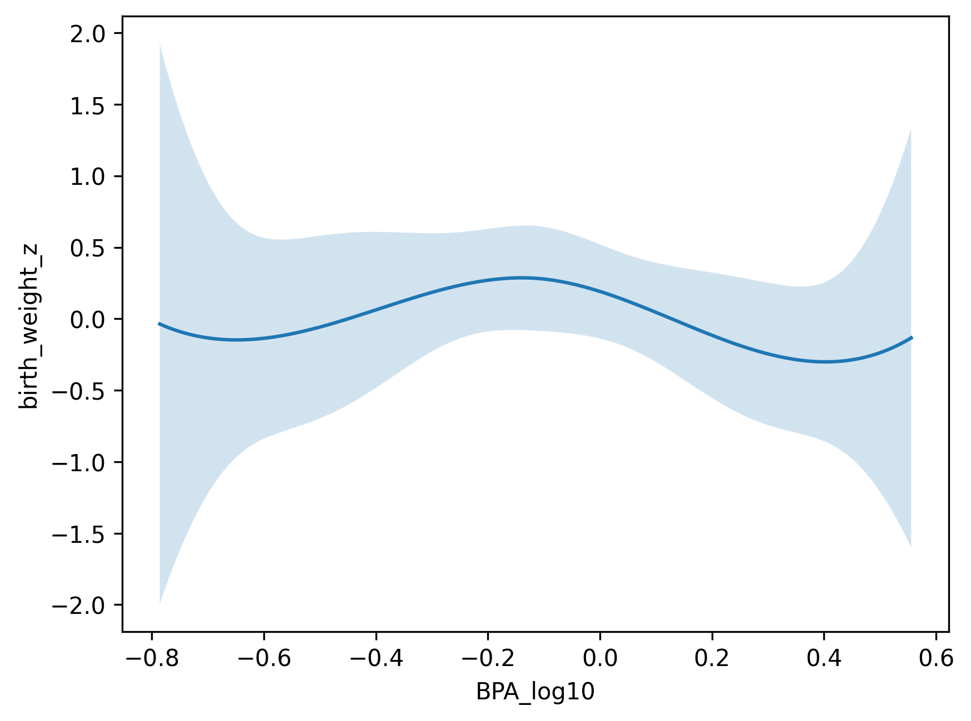

Supplementary Figure S1. Adjusted restricted cubic spline model showing the association between log₁₀-transformed cord blood BPA concentrations and birth weight z-scores. The solid line represents the adjusted estimate, and the shaded area indicates the 95% confidence interval. Models were adjusted for gestational age, maternal age, pre-pregnancy BMI, parity, smoking during pregnancy, infant sex, and maternal occupation. A non-linear association was observed (p for non-linearity = 0.03).

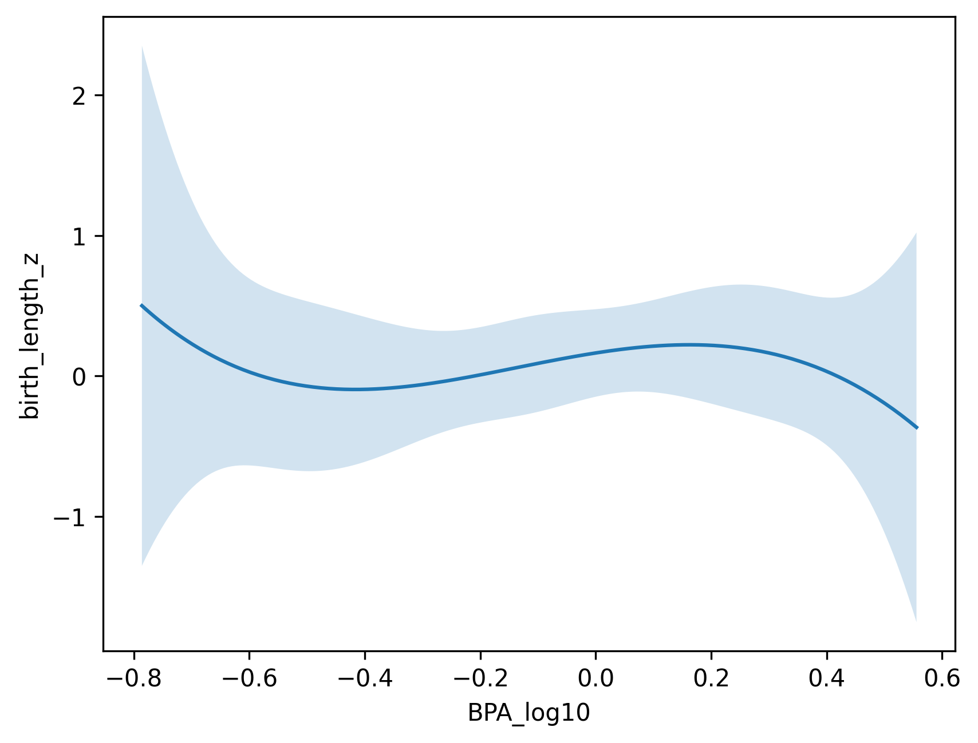
Supplementary Figure S2. Adjusted restricted cubic spline analysis illustrating the association between log₁₀-transformed cord blood BPA concentrations and birth length z-scores. The relationship appeared predominantly linear across the exposure range. Models were adjusted for gestational age, maternal age, pre-pregnancy body mass index, parity, smoking during pregnancy, infant sex, and maternal occupation. The shaded area denotes the 95% confidence interval.

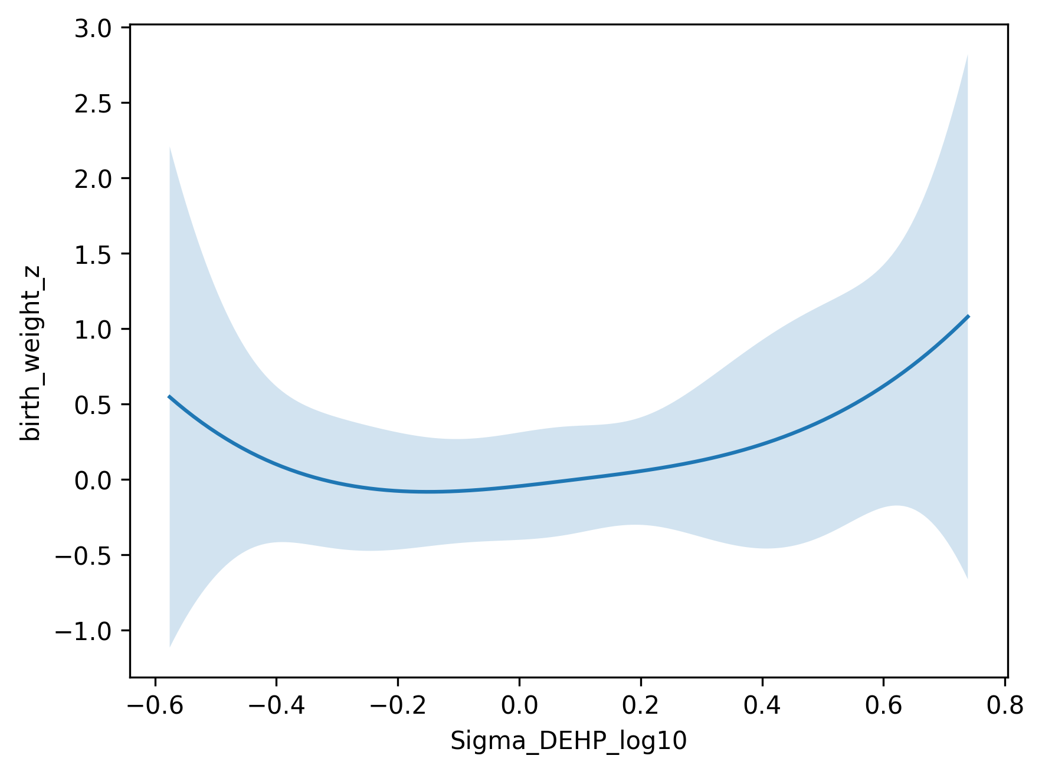
Supplementary Figure S3. Adjusted restricted cubic spline analysis illustrating the association between log₁₀-transformed ΣDEHP concentrations and birth weight z-scores. No statistically significant non-linear association was identified (p for non-linearity > 0.05). Models were adjusted for gestational age, maternal age, pre-pregnancy body mass index, parity, smoking during pregnancy, infant sex, and maternal occupation. The shaded area denotes the 95% confidence interval.

